✨ My Magic Mark Affirmations ✨
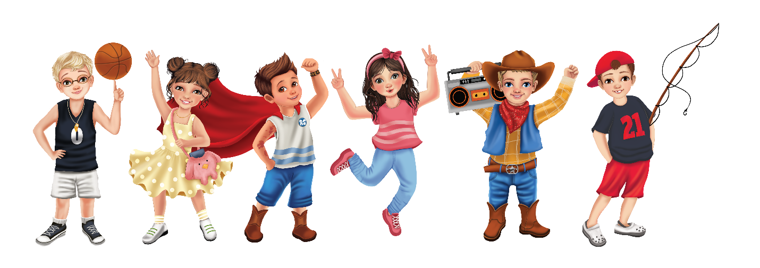
Words I can say to remind myself how special I am.
🌟 I Am Unique
- I am special because I am me.
- There is no one else exactly like me.
- My differences make me wonderful.
- I have strengths that make me shine.
- My ideas, feelings, and dreams matter.
- I have something special to share with the world.
- My “magic mark” is what makes me unique.
- I am proud of who I am becoming.
💛 I Am Confident
- I can try new things, even when they feel hard.
- I believe in myself.
- I can learn and grow every day.
- Mistakes help me learn and become stronger.
- I am brave enough to use my voice.
- I can do things I once thought I couldn’t.
- I am proud of my efforts.
- I can face challenges with courage.
🌈 I Belong
- I am an important part of my classroom community.
- My thoughts and feelings are valued.
- I am welcomed, included, and cared for.
- I help make my classroom a better place.
- I belong exactly where I am.
- I can be myself around others.
- My kindness helps others feel they belong.
🤝 I Show Kindness
- My words can make someone’s day brighter.
- I can use my helping hands to make a difference.
- I can show kindness in small and big ways.
- I can listen with my heart.
- I can be a good friend.
- I can help others feel special.
- I choose kindness because kindness matters.
🌻 I Practice Gratitude
- I can find something good in every day.
- I notice the little things that bring me joy.
- I am thankful for the people who care for me.
- I appreciate my strengths and talents.
- I can share gratitude with others.
- I can look for the good around me.
- My grateful heart helps me shine.

🌟 Adult & Child Call-and-Response Affirmations
Adult: What makes you special?
Child: I am special because I am me!
Adult: What happens when something feels difficult?
Child: I can try, learn, and grow!
Adult: Do you have something important to share?
Child: Yes! My voice and ideas matter!
Adult: How can you make someone feel valued today?
Child: I can use kindness and my helping hands!
Adult: What makes our classroom special?
Child: Everyone belongs and everyone shines!

🎨 Creative Classroom Idea: “My Magic Mark Affirmation Cards”
Create small cards students can choose from each morning:
✨ Today I will remember…
☐ I am brave.
☐ I am kind.
☐ I am creative.
☐ I am a good friend.
☐ I am a problem solver.
☐ I am important.
☐ I can learn new things.
☐ I can help others shine.

