Rider's Magic Mark Vocabulary Word Searches (Advanced)

Rider
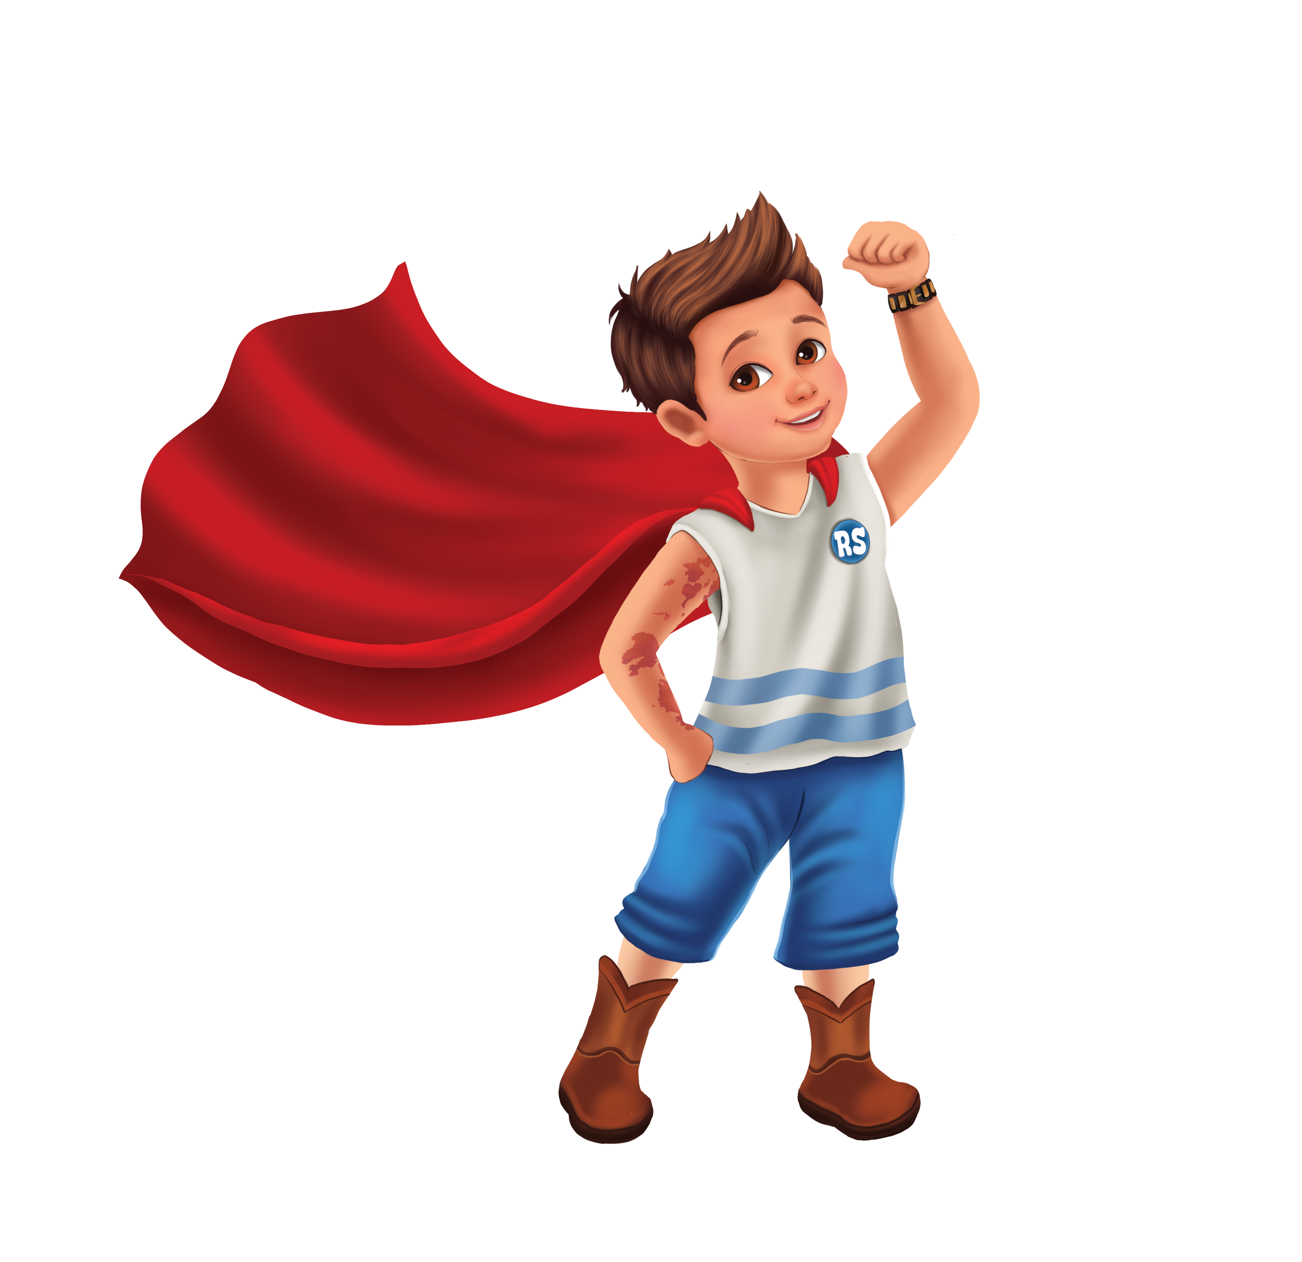
Words to find: MAGIC, MARK, DISCOVER, UNIQUE, SPECIAL, CONFIDENCE, COURAGE, BELIEVE, JOURNEY, GROW, SHINE, BRIGHT, KINDNESS, FRIENDSHIP, STRENGTH, WONDER, IMAGINE, DREAM, ADVENTURE, HOPE, SELF, POSSIBILITY, CHANGE, SPARK, TRANSFORMATION
B Y J S L I C E D O Q R K B F D R E A M
V E W S P A R K G Y R V N U N I Q U E D
T Z W M W S T R E N G T H Y K V I I F P
Q I L Y P O S S I B I L I T Y D L O Q L
T K M P C V S D L W N U F E T E M N X C
F R N A F V I C O N F I D E N C E K C S
S K A A G S A I L N T A N J O J I J Y E
H P E N C I Y W F P A S H O S N K M O L
W B E O S V N T P R R D T M D H Y A J A
D L V C S F J E S W I F V N A R I P V Y
Y E N E I O O M O B W E E E T R A N C G
R U L U U A A R R K P S N G N L K X E W
J F F R T G L I M B S B M D B T A P B O
C G N K I K G C B A Q U U E S D U F X N
B E G C H H O O S P T G L B A H Y R Y D
Y F R Z T G A U I M S I S C K X I Q E E
U Y O P T J H R H D E P O V X H O P E R
L D W W G C T A H V Y X D N N D Y B J U
L A Z X S W J G E G R V J L Q A T J O R
C H A N G E N E P Z I W J G N G E T S B

Jensen
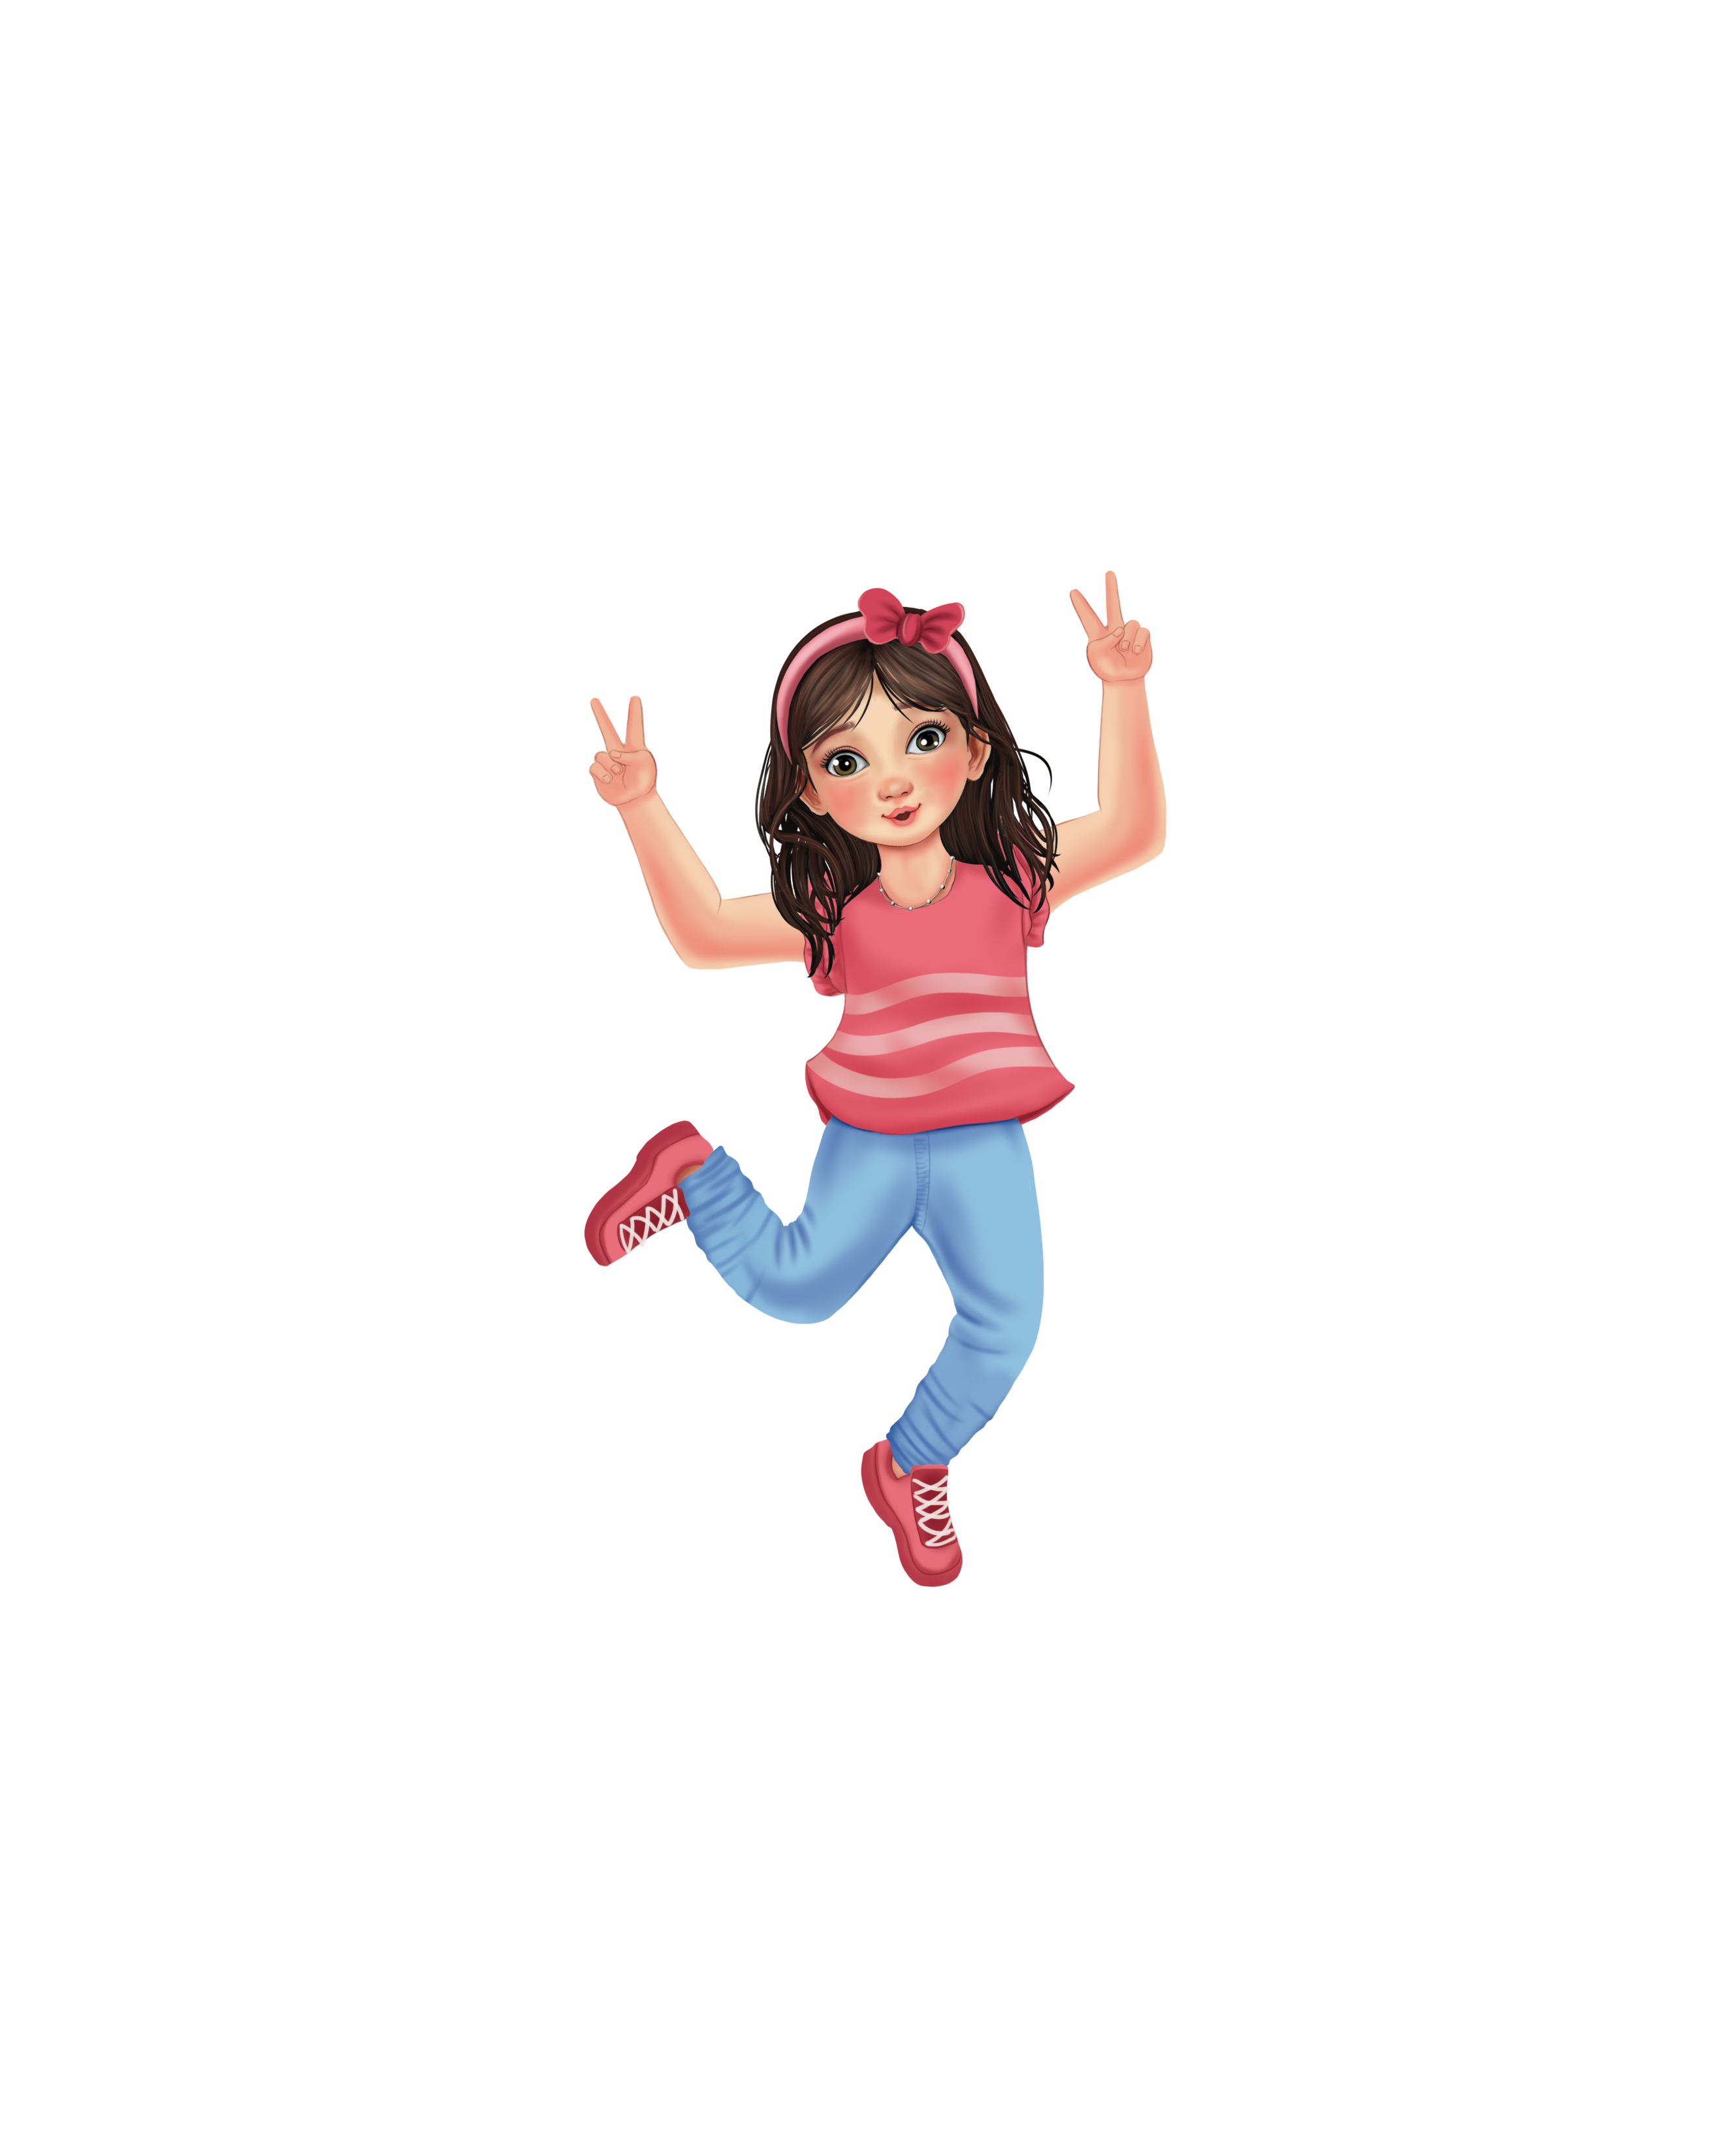
Words to Find: BRAVE, COURAGE, CONFIDENT, RESILIENT, PERSISTENCE, FEARLESS, DETERMINED, CHALLENGE, GOAL, ACHIEVE, PERSEVERE, INITIATIVE, LEADER, STRONG, TRY, BELIEVE, SUCCESS, OVERCOME, BOLD, FOCUS, MOTIVATED, CAPABLE, RISK, ADVENTURE, RESILIENCE

O P F U E B W H I F Z K S G V Z K E R Q
O W U O E S I N I T I A T I V E R N R V
S V S U C C E S S M X R E J J M P K E W
S P S B Q U N Z X L O P L Y U N Q B S C
T R V A H T S V Q U L W E O N Q S J G M
R R E A N W G L Q V A L E R B X B P H I
O Y I C O U R A G E E T A X S R G O A L
N K E S D W D Z L P J D K K J E A Q L O
G V A M K R E S I L I E N T T H V V R D
A C H A L L E N G E R W O Q C O T E E V
P E R S I S T E N C E L H U R X Q L R P
G G L G W X T S D E T E R M I N E D G E
X B L E O B L D X K F L E B E L I E V E
N J U G Y M N C O N F I D E N T Z X C V
O V E R C O M E G N S V C A P A B L E C
A H P W X D Q A C H I E V E L Y V W U C
A D V E N T U R E G H M O T I V A T E D
L J T T C B M U I T P H N P D P W B I A
M H R R E S I L I E N C E L E A D E R C
B Y F Z F E A R L E S S I Q I S X R Q C

Kash
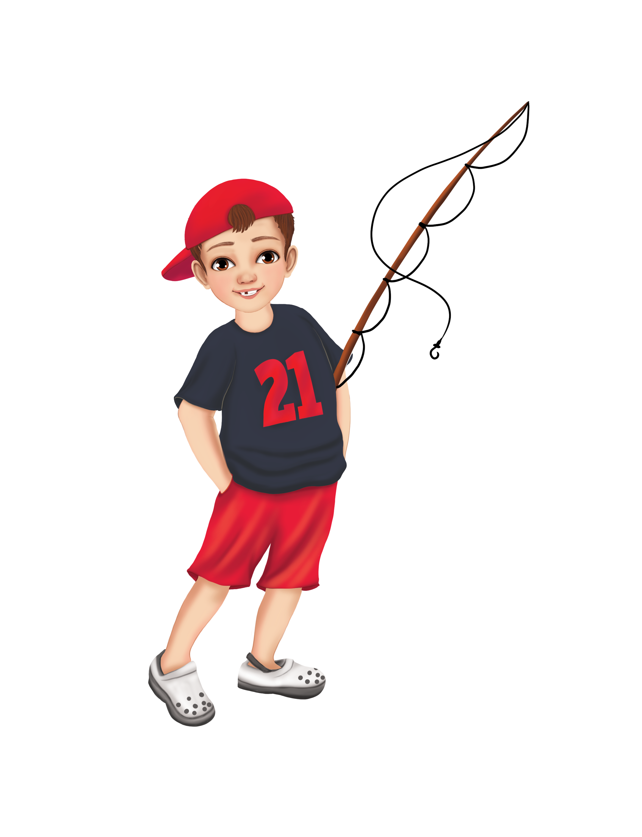
Words to Find: LISTEN, EMPATHY, RESPECT, CARING, UNDERSTAND, COMMUNICATE, PATIENCE, THOUGHTFUL, SUPPORT, TRUST, KINDNESS, FRIENDSHIP, COMPASSION, ENCOURAGE, PEACEFUL, CALM, VOICE, HEART, NOTICE, ATTENTION, HELPFUL, COOPERATE, CONNECT, INCLUDE, ACTIVELISTENING
X F N F Z H G W R D L J H W E V O P K P
Z U H L S U K H Y H H T A K X O H G J D
L L D A C T I V E L I S T E N I N G E B
Q I N C L U D E A W G Z Q B U C L N R R
H Z A L W H K U T R U S T Q A E C G E U
K U H T C M A K N Z F U E C O O V S J B
I D E M T O H C O D J C K A U N P W E D
N Y L Z W E M W O F E L O R W E G M Y F
D S P C X D N P Q M L R A N C Y P J U S
N B F A P T T T A Q M G S T N A N B F U
E P U L E N H N I S E U O T T E U F R P
S A L M A H O Q C O S Y N H A J C L I P
S T T I C Z U T P O N I Y I B N I T E O
X I W Q E P G S I W O N O Z C S D U N R
S E F S F E H F U C U P Y N T A S P D T
H N C R U O T D Q N E S E E I X T Q S H
W C I R L M F Z K H S O N R I K J E H E
Z E B A J V U Q C B X I A Q A R W U I A
P Z W G Z Z L P C A R I N G M T T V P R
H Y E Q J I Y Y A X U O N Z J U E I J T

Cooper
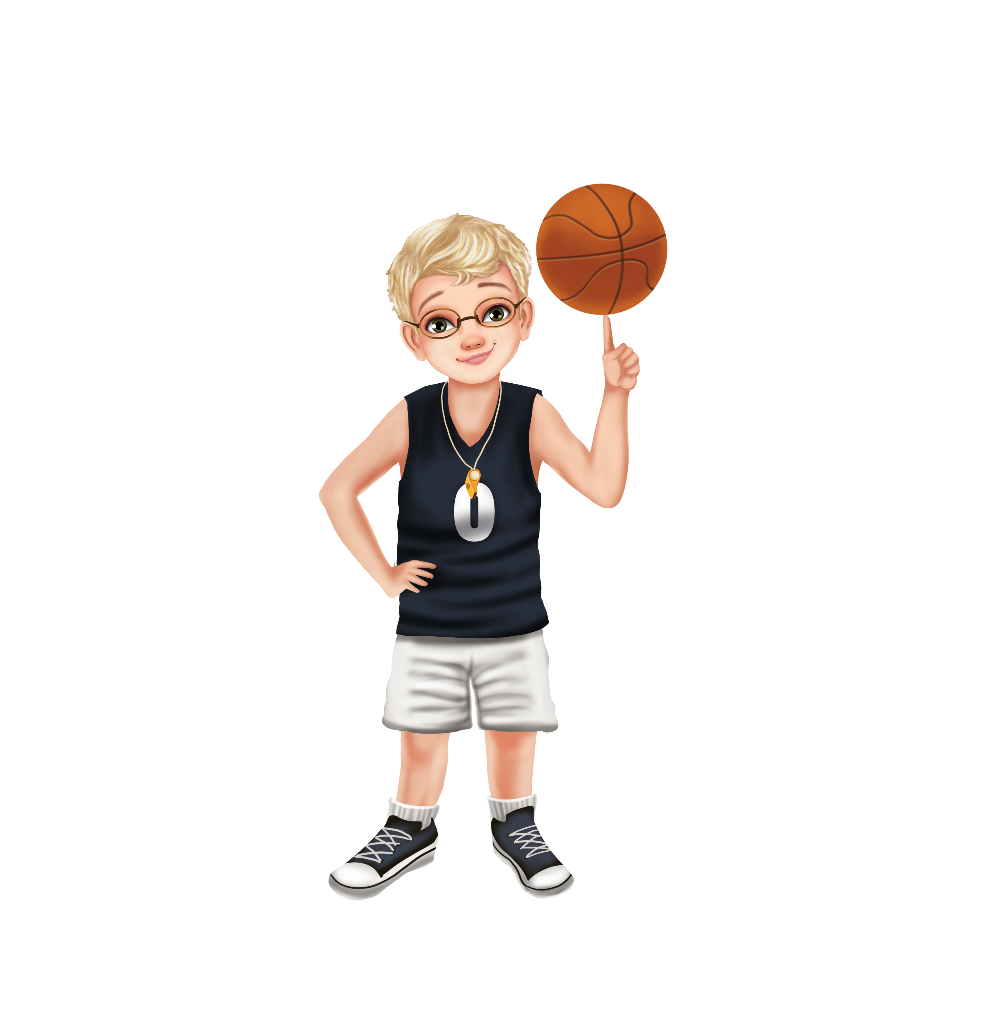
Words To find: HELPFUL, ENCOURAGE, MENTOR, LEADER, GENEROUS, SUPPORTIVE, TEAMWORK, CONFIDENCE, INSPIRE, GUIDE, SHARE, LIFT, SERVE, CARE, FRIEND, COMMUNITY, POSITIVE, RESPECTFUL, BELIEVE, SUCCESS, STRONGER, UNITY, COMPASSION, KINDNESS, EMPOWERMENT
V Y M W U Y V O C J X W M Q M E S K W L
T E P L L N L G N F C N U E R G L Q E D
Q M B G S M I R T O H F N N U G H A K S
T P I R Z U F T M C X T I I A V D A E H
R O E Y J P P M Y A O W D P S E N S J A
I W Q O B Z U P B R K E I E R A O Z Y R
U E Z C P N Y C O E H T E A M W O R K E
N R P G I V W I O R S P S F R I E N D A
V M W T Y M C N N M T P O U K Y L C N H
O E Y T Z K C O B S P I L S C J W U Y F
P N W N M G V F N E P A V B I C C F R S
S T R O N G E R R F L I S E L T E T I H
R E S P E C T F U L I I R S S T I S L P
T Y E N C O U R A G E D E E I N Z V S P
G E N E R O U S S T I Y E V I O W K E Q
N X H E L P F U L C J M R N E E N C O M
B G E M Z B F G B R P U L F C P C M O I
Q Y Q K I N D N E S S I V E J E V G A A
S E R V E M A Z H I F J A K J B O Z F T
N Z Q L K W V V T T G O V U V P M R J A

Cameron
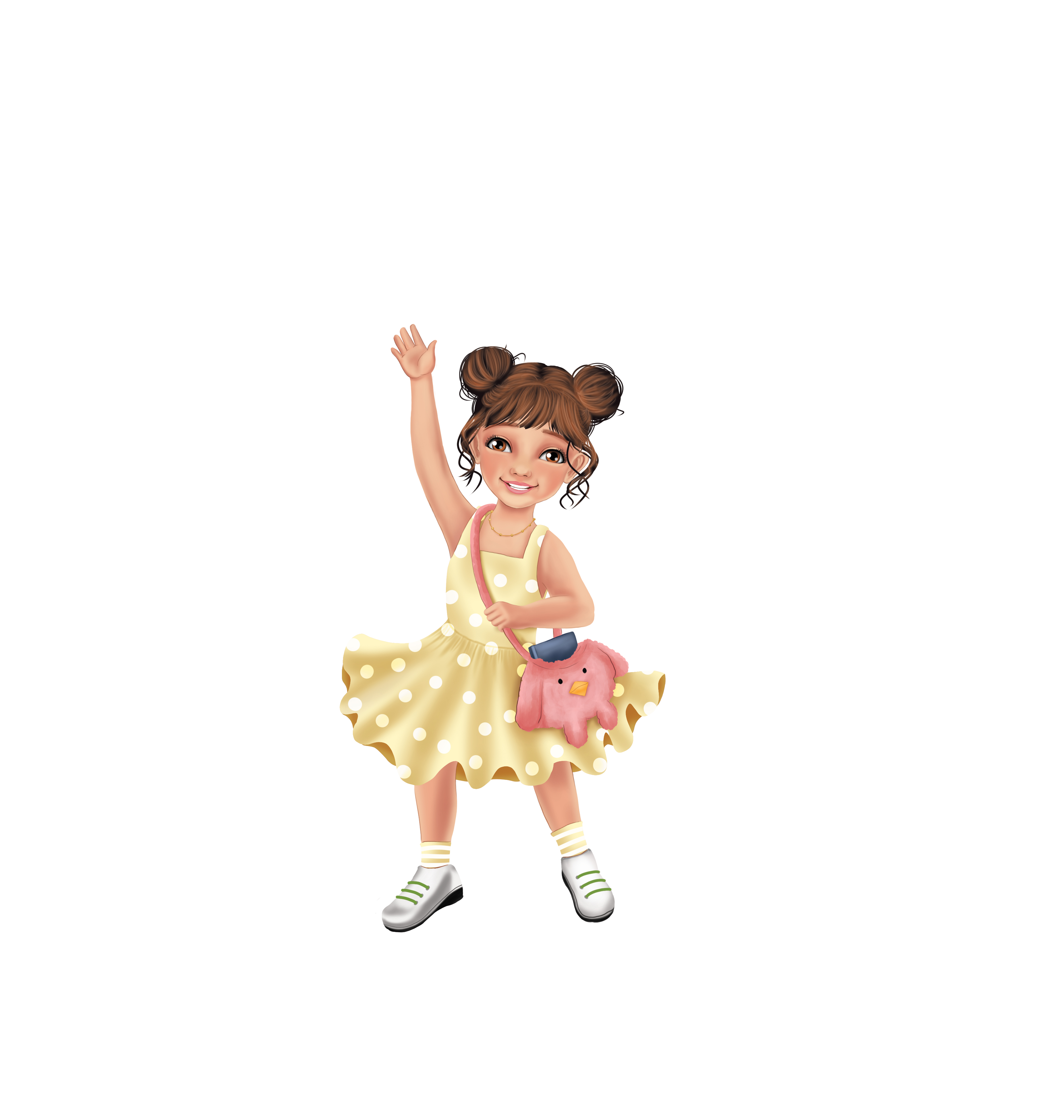
Words to Find: CREATE, CREATIVITY, IMAGINATION, ARTIST, DESIGN, DRAW, PAINT, COLOR, MASTERPIECE, INNOVATION, ORIGINAL, VISION, INSPIRE, EXPRESS, CURIOUS, IDEA, SKETCH, PICTURE, BEAUTIFUL, DISCOVER, POSSIBILITY, THINK, BUILD, INVENT

A W P D D R A W I O T B E A U T I F U L
B O V A B O L G D I M I Y C B A Q V P W
G C U R I O U S E W A Q I O J P S B O P
H G C U T N F K A T V M S W O J S S P Z
H G W J O H T T T R A D W S P U K O G E
Q P T Y R P I X M G T I S V I S I O N B
B F E T L K V N I V N I C K A Q D J E O
U C R E A T E N K N B K S D R I M N G Q
I R E Q O D A E O I J S E T S Q C F E H
L E A Y V T P V L N V S I C I U G X A M
D A Q Z I A A I B W I N O E P X P N A M
W T O O N T T N I G V V C I G R Z S O G
X I N R I Y R V N E E C C T E Q T Q U R
O V X O I I O I N R F T O S D E D J S D
Y I N J O G N T F L U K S L R I M G K L
G T U N E S I N B R O P P P O X G B E N
Y Y X L P X H N E R D G I M Q R O Z T X
Y R H I W W B G A R A E Z E N G B H C L
U K R X O V J H K L C M M E X G S Z H P
M E U S N F Q M C E Q F F I Z Q Q H T P

Tripp
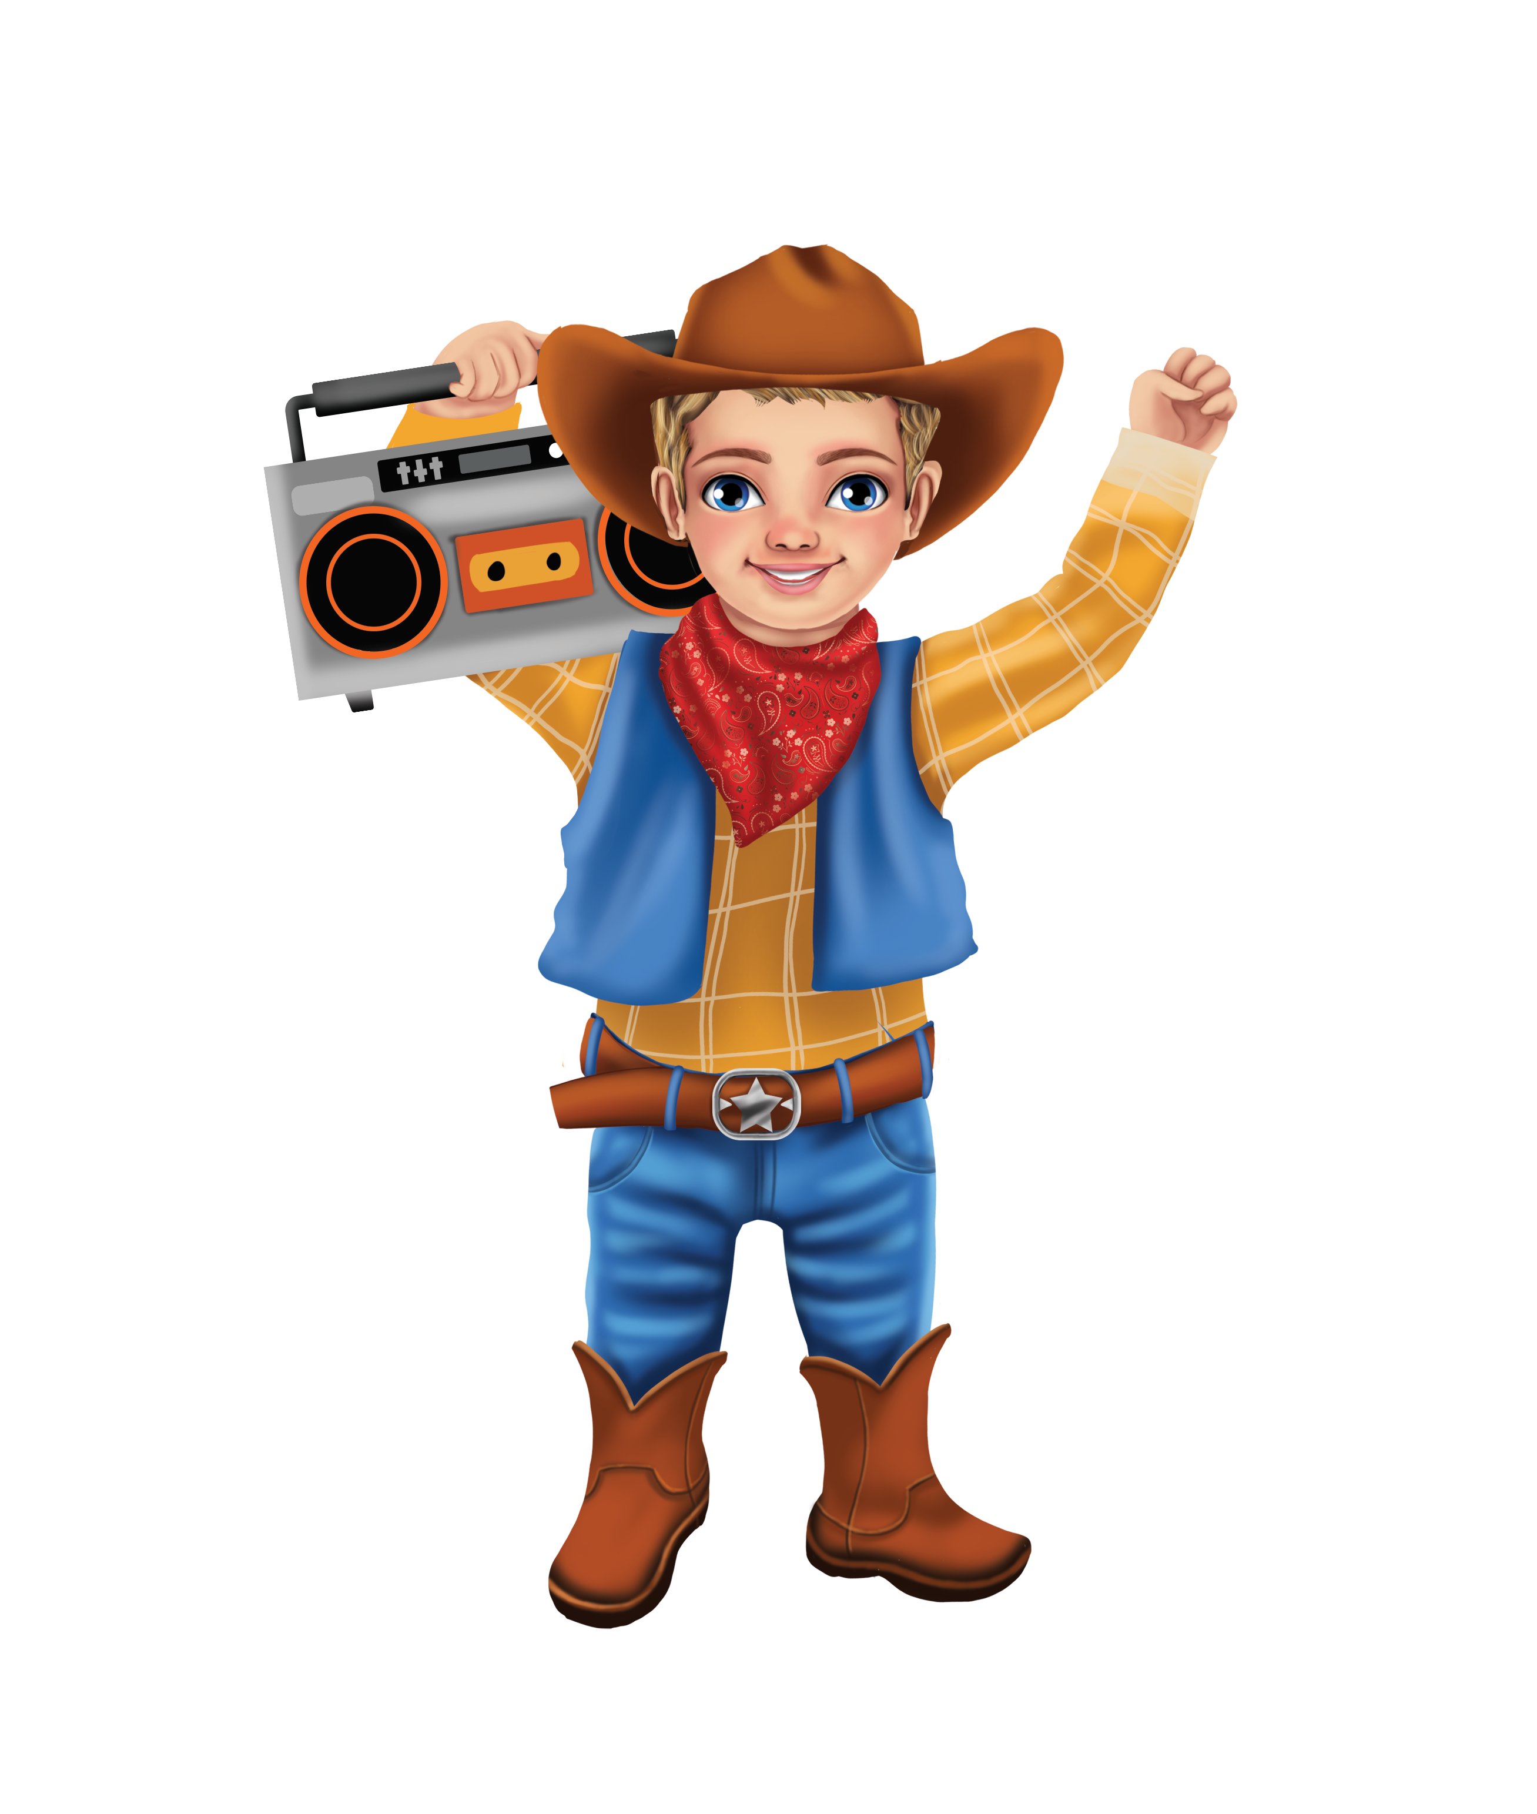
Words to Find: LAUGH, HUMOR, JOYFUL, FUNNY, SMILE, WITTY, HAPPINESS, CHEERFUL, POSITIVE, ENERGY, PLAYFUL, FRIENDLY, JOKE, SILLY, LAUGHTER, DELIGHT, SPARKLE, SHARE, SUNSHINE, ENCOURAGE, HAPPY, CELEBRATE, TOGETHER, GRATEFUL, OPTIMISM

O C H E E R F U L V I F T O B V Y K E S
J O Y F U L M L U S R T C C H I J W J H
X L P S X G B A V Z E T A P C X F O A V
J F U N N Y S I I K R U Q G H K K P I F
P E S M I L E U D B O D E K H E P O I N
T Q Y R J U C S N P B N L A U I B T W L
I O L R L Q H E T S E T F S N B R I A Q
H N G M K A F I L R H R T E S J N U Z W
A N D E R E M H G E I I S Q N W G S E C
P T S E T I T Y S E B S N T I H H I N C
Q F T Q S H R H N T Z R F E T W R L C T
D L P M K T E D A R U C A E Z I C L O M
I D G L P M L R I P J F R T E T L Y U N
E E K R L Y V H L Z P Z Z V E T W J R K
G L Y M A E D O I M W Y Y A E Y M N A T
L I I K Y T K K P O S I T I V E F U G C
X G R J F X E T Y E D Q E L W O C B E D
M H K I U C W F S I W T Z L A U G H J D
U T C F L N H H U M O R U Y W U L Z K M
C R Q Y S P A R K L E V M B R Q C L U L

