Rider's Magic Mark Vocabulary Word Searches (Age app)

Rider
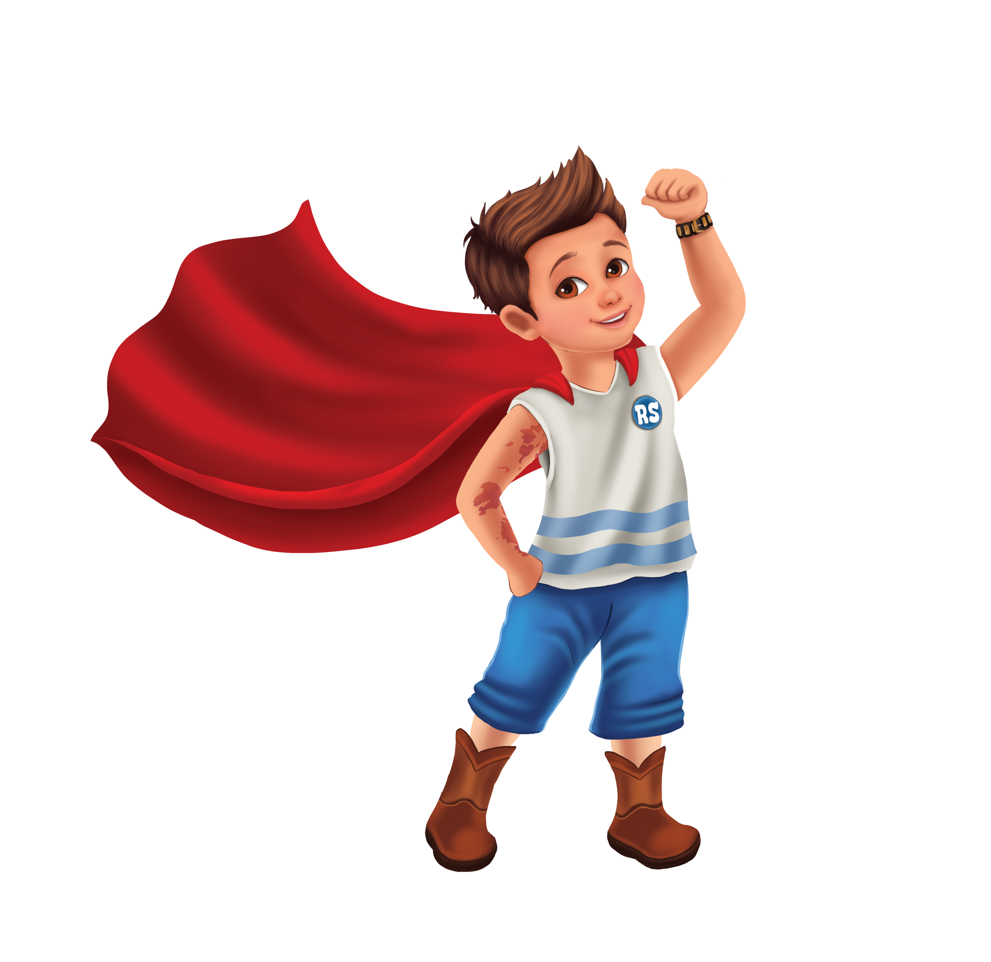
Words: RIDER, MAGIC, MARK, FRIENDS, BRAVE, SHINE
R I D E R M A G I C
X F R I E N D S Q W
B R A V E T Y U I O
M A R K L P S H I N
Z X C V B N M A S D
Q W E R T Y U I O P
A S D F G H J K L Z
P O I U Y T R E W Q
L K J H G F D S A M
S H I N E X C V B N

Jensen
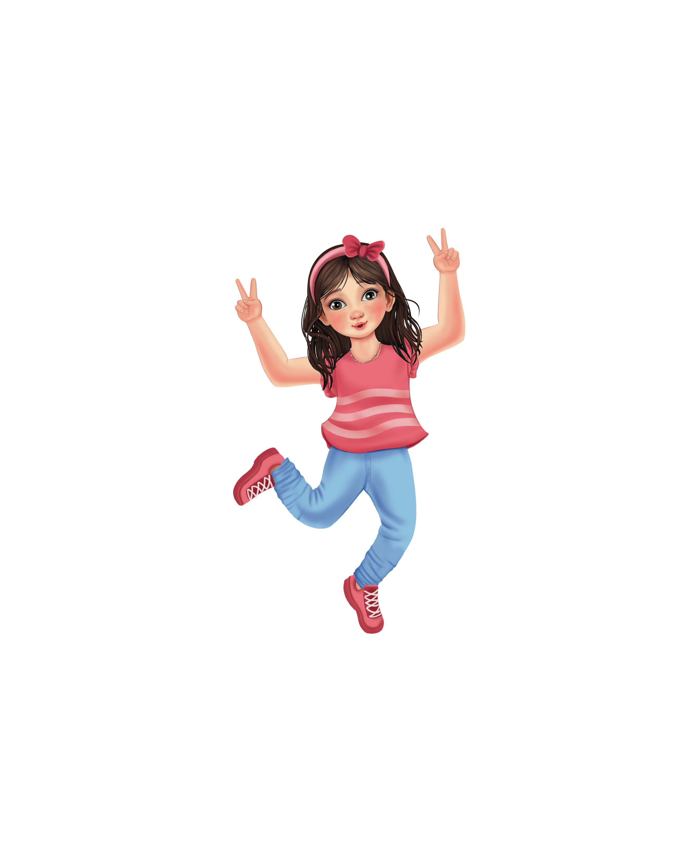
Words: JENSEN, BRAVE, GREEN, COURAGE, FRIEND, STRONG
J E N S E N Q W E R
B R A V E A S D F G
G R E E N Z X C V B
C O U R A G E M N H
F R I E N D L K J H
S T R O N G P O I U
A S D F G H J K L Z
Q W E R T Y U I O P
L K J H G F D S A M
Z X C V B N M Q W E

Kash
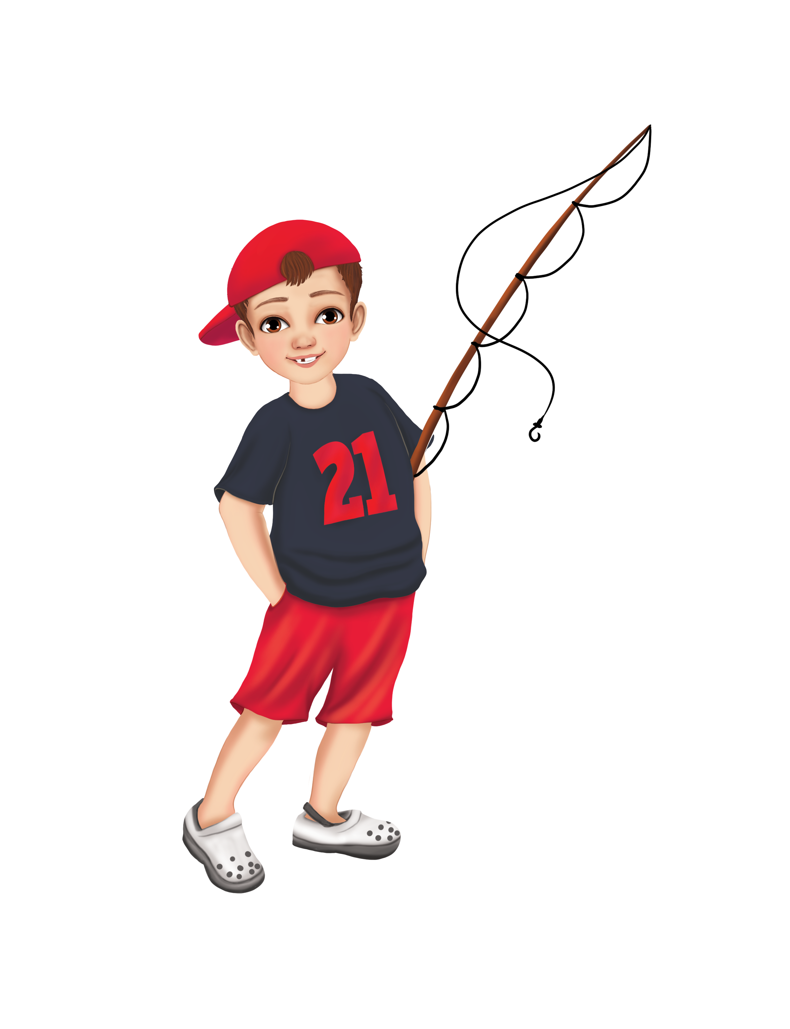
Words: KASH, LISTEN, BLUE, KIND, FRIEND, HELP
K A S H Q W E R T Y
L I S T E N A S D F
B L U E Z X C V B N
K I N D M N H J K L
F R I E N D P O I U
H E L P A S D F G H
Q W E R T Y U I O P
A S D F G H J K L Z
Z X C V B N M Q W E
L K J H G F D S A M

Cooper
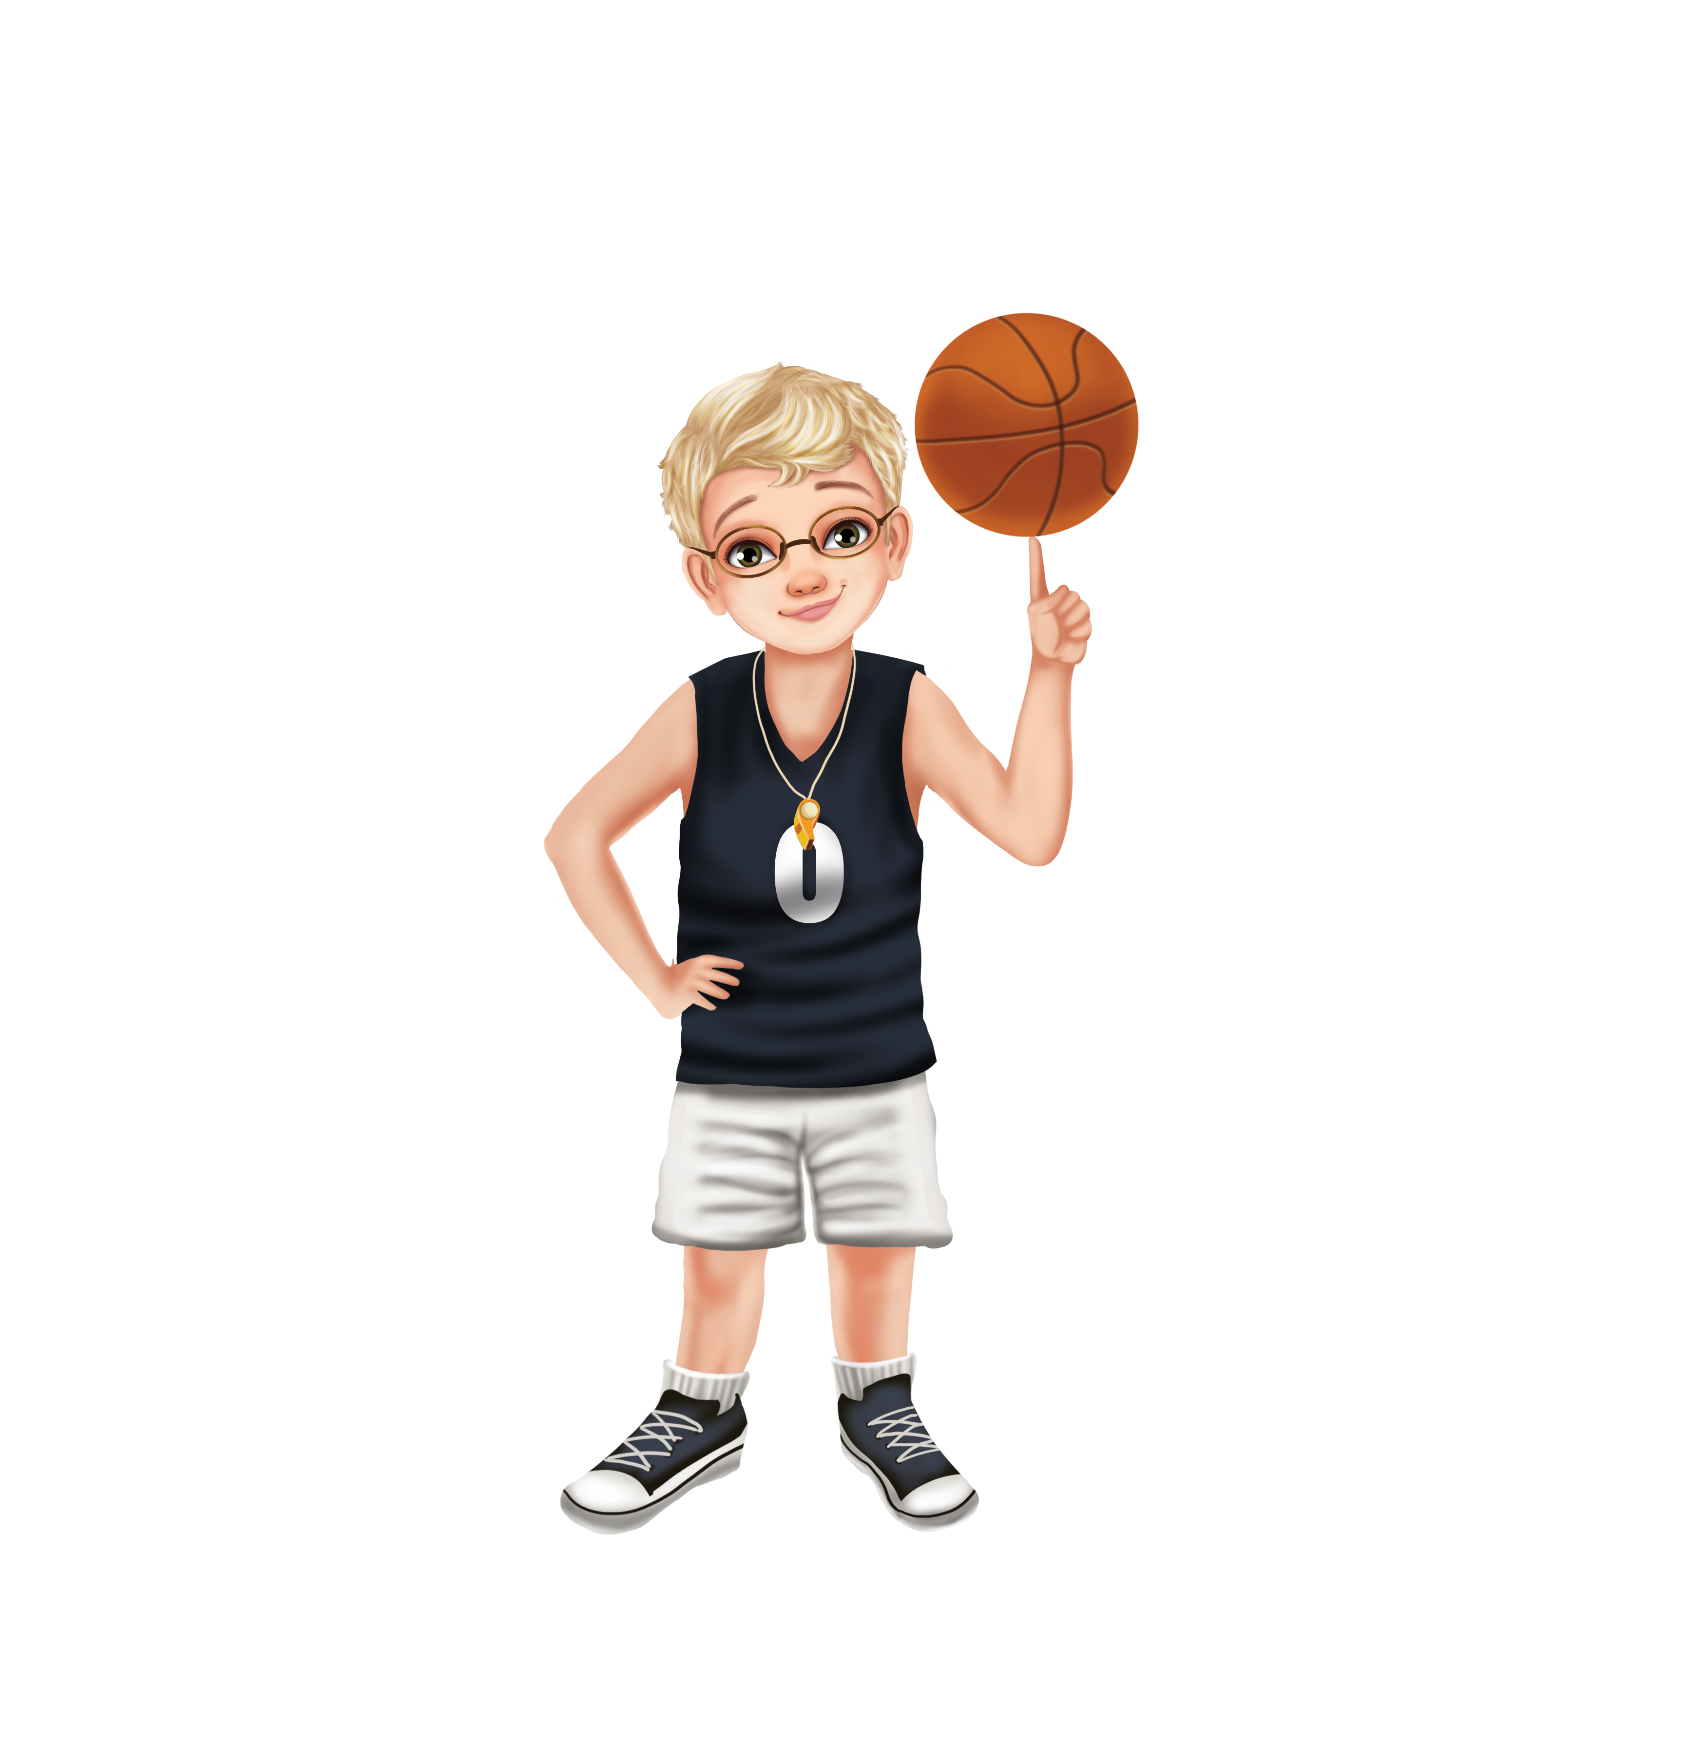
Words: COOPER, GLASSES, HELP, HOOP, GOLD, KIND
C O O P E R Q W E R
G L A S S E S A S D
H E L P Z X C V B N
H O O P M N B V C X
G O L D P O I U Y T
K I N D L K J H G F
A S D F G H J K L Z
Q W E R T Y U I O P
Z X C V B N M A S D
L K J H G F D S A M

Cameron
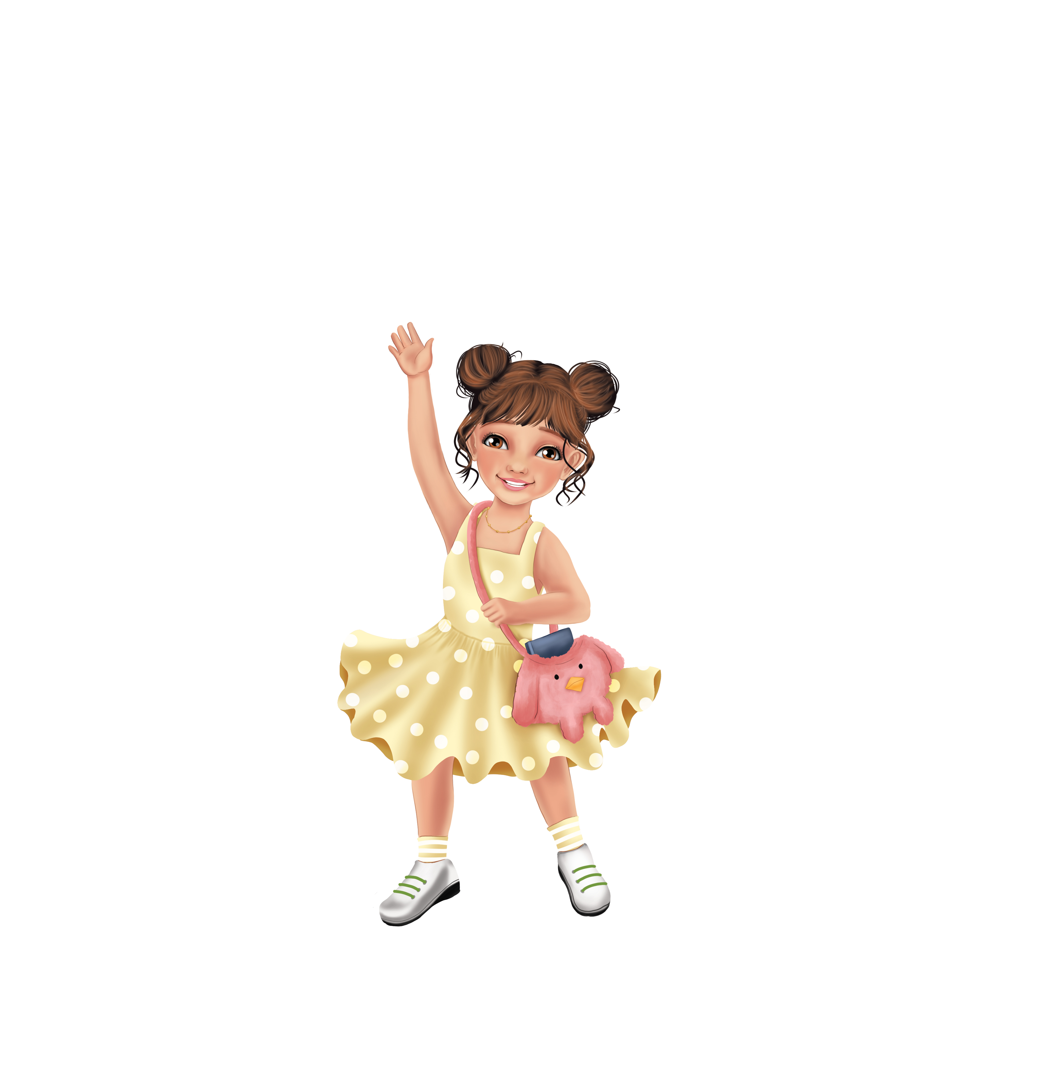
Words: CAMERON, CREATIVE, DRAW, ART, SILVER, IMAGINE
C A M E R O N Q W E
C R E A T I V E A S
D R A W Z X C V B N
A R T M N B V C X Z
S I L V E R P O I U
I M A G I N E L K J
H G F D S A M Q W E
R T Y U I O P A S D
Z X C V B N M Q W E
L K J H G F D S A M

Tripp
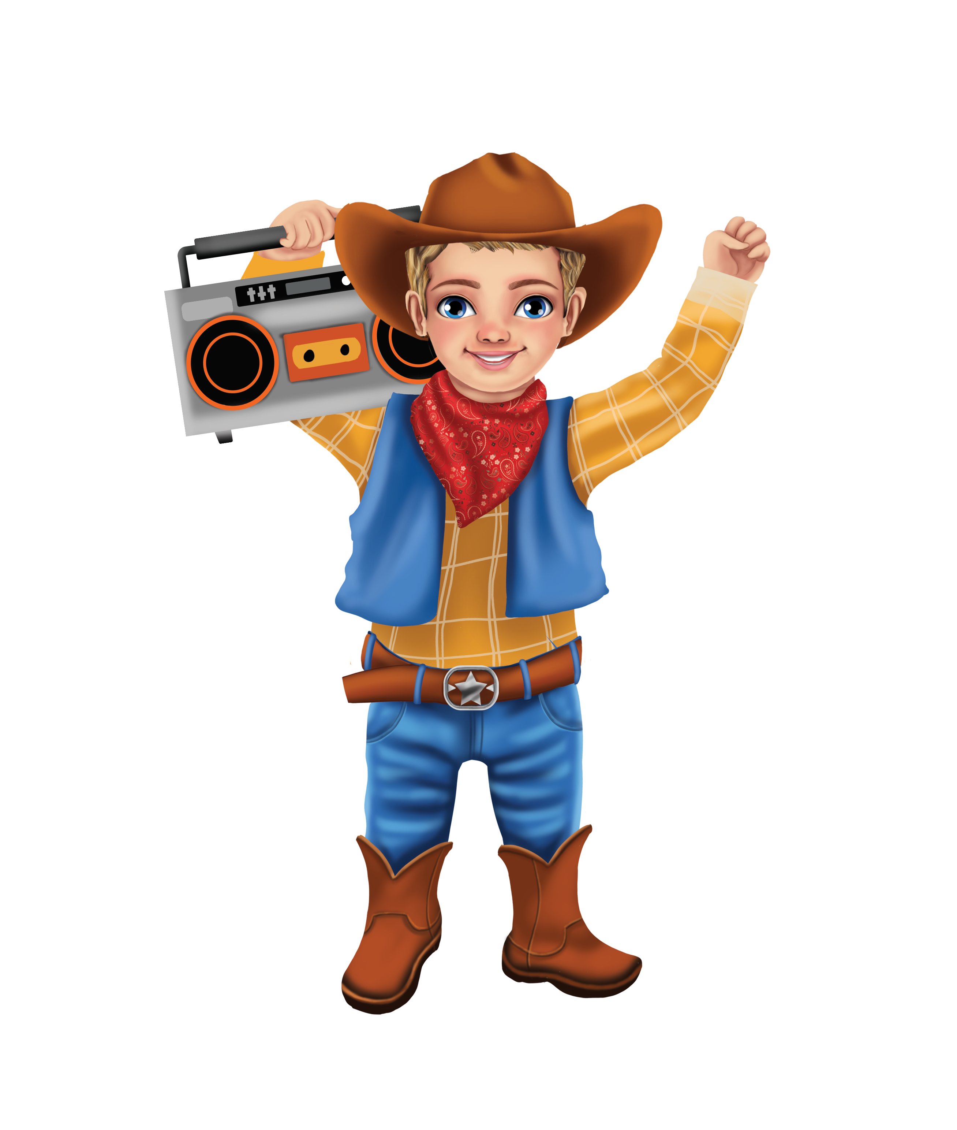
Words: TRIPP, FUNNY, RED, LAUGH, STORY, JOY
T R I P P Q W E R T
F U N N Y A S D F G
R E D Z X C V B N M
L A U G H P O I U Y
S T O R Y L K J H G
J O Y A S D F G H J
Q W E R T Y U I O P
Z X C V B N M A S D
L K J H G F D S A M
P O I U Y T R E W Q
✨ 1. “My Magic Mark Reflection” (best overall)
After they find the words, students complete:
- My favorite character is __________ because __________.
- One word I found that describes them is __________.
- My own magic strength is __________.

Draw or Write about Your Magic Mark!

