CYCLONE

CYCLONE (Complete and Dynamic Multicloud Application Management) is a project which is developed by the European Commission. It is a Horizon 2020 innovation action that aims to combine cloud management tools for deploying, managing and using the multi-cloud apps. It is very complex to deploy and manage the apps on multiple cloud infrastructures. CYCLONE solves the problem and offers many advantages e.g. scability, portability of cloud apps. CYCLONE enables a united management of apps on federated clouds using integrated cloud management software and tools.

CYCLONE is based on another integrated components such as SlipStream, Stratuslab, TCTP, OpenNaaS and enables to combine this components in a single platform.

SlipStream

Slipstream is the main component of CYCLONE which is developed by SixSq. SlipStream is a open source software and can be used for managing the whole lifecycle of cloud applications. It includes deployment engine, a app store and a service catalog. SlipStream provides many services e.g defining the application topologies. It allows to access all resources for deploying the application. SlipStream makes easier to manage the configuration of deployed application. In addition, SlipStream reduces the administration load with integrated brokering, checking, and matchmaking features. The users can focus on their application rather than the configuration of the virtual machines. It aims to improve the security of cloud infrastructure and enables the implementation, configuration, and using the complex cloud applications.

OpenNaas

OpenNaaS is a open source software and it is software-defined network controller that provides automated deployment and configuration of network infrastructures. It aims to reduce the configuration complexity and provides services for provisioning dynamic network resources.

Benefits

Configuration Management: The tools Chef and Puppet are used for configuration management.

Distributed Logging:

Specification of Interfaces for Brokering, Deployment, and Management

SlipStream and Nuv.la

This chapter describes the interfaces which are used for the deployment and configuration of cloud-based app within SlipStream. SlipStream includes web interface and REST API and can be used through the Nuv.la Online Application Deployment Platform. It manages the whole lifecycle of apps. The application developers can directly use the Nuv.la and deploy the application. To deploy an application, a deployment plan will be created in SlipStream.

Deployment plan

* In this step, the application is defined by the application developer. The description includes the components such as virtual machines, storages and services and it describes how they will communicate with each other. The SlipStream users and app developers can choice the cloud provider and save the description of the app within Nuv.la
* Slipstream can create the deployment plan for provisioning of all resources , when application developer selected the defined application.
* When the deployment plan is created, SlipStream can configure all components of application.
* SlipStream users can monitor the state of all components. SlipStream can periodically check the state of all resources via the metrics such as CPU, RAM.
* The application developers can select how the resources should be allocated to components because the load of components can be changed at any moment. The description of resource allocation can be defined manually or through defined rule. The resources can be scale up or scale down depending on what it needs. SlipStream allows to users to scale a running instance horizontally and vertically. Horizontal scaling happens when the virtual machines can be added or removed by SlipStream. Vertical scaling occurs when the CPU, RAM or disk space can be changed by SlipStream.
* If the components are no longer needed, the users can terminate them.

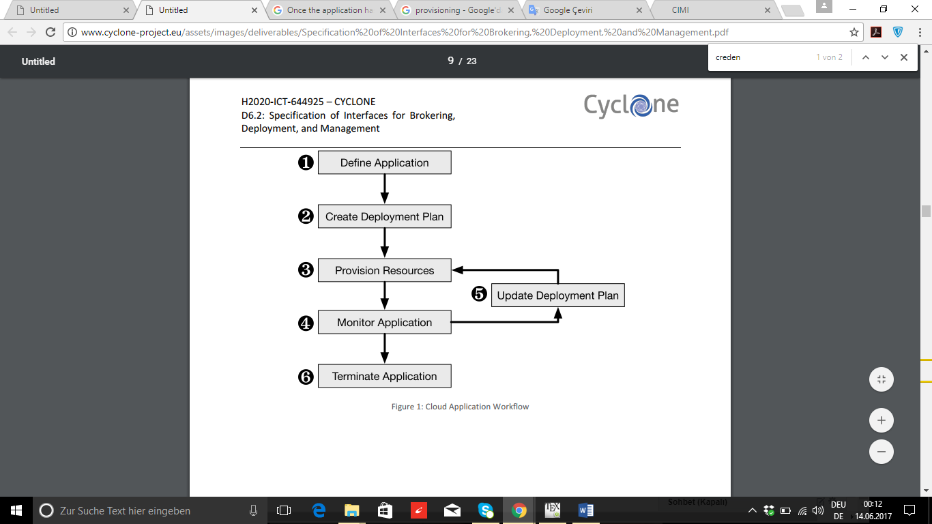

Limited Services of Nuv.la

The settings of running instances on SlipStream can be changed by the application developer. SlipStream allows to make changes to the running instances via defined application livecycle and API. There are some restrictions of services of Nuv.la, it is written in the next under chapter, which changes can be made and which not.

**Limitation of Migration**

The users can move the application from one cloud provider to another cloud provider for reducing the costs by moving to cheap cloud provider or to move to better cloud provider with lower-latency connections. But there may be some technical problems when the user moves direct the application to another cloud. CYCLONE doesn’t support pure migration. CYCLONE allows to make changes to the environmental sharing of resources. The changes can be made via horizontal scaling capability. The users can select a another cloud provider and/or in different area. When the new virtual machines are running in another region / on cloud provider successfully without technical barries, the old virtual machines can be stopped.

Update

CYCLONE is not able to perform security updates for running applications. The defined application and SlipStream API are focusing only on the deployment and management of the application. There some tools can be used such as Chef and Puppet for performing security updates.

CYCLONE Objectives

CYCLONE enables to improve the application deployment lifecycle in the Infrastructure as a Service (IaaS) layer using the integrated network infrastructure. The integrated tools allow to SlipStream users to merge their resources, e.g. mutual authentication techniques and dynamic distribution of bandwidth among cloud providers. In addition, cyclone applications can be scaled the components can be placed automatically.