Real Time Emotion Detection

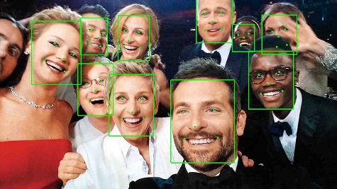Face recognition is a computer technology that is used in almost every area. Beside the detection of the faces, face detection, identification and emotions.. can be detected. We can determine this as specific case of object-class detection, the task is to find the locations and sizes of all objects in an image that belong to a given class.

In this project, real time emotion detection is obtained. To create this project, as a language Python is selected and for the environment Jupyter Notebook is selected over the Anaconda. For real time computer vison, to detect the faces real time, OpenCV library and for deep learning and training purpose, TensorFlow library is used with the transfer learning option. To detect the faces “haarcascade_frontalface_default.xml” file is used under the OpenCv library. For training purpose, almost 36000 images stand for 7 emotions are taken from the Kaggle*. However, because of the memory errors, the number of images has been reduced to in total almost 1500. With different amount of data four model is created, but the second one gives the most appropriate result for the real time face emotion detection. In the Figure1 Confusion Matrix of one of the four models(version1). Figure 2 shows the training loss and accuracy plot of one of the four models(version4). In those faulty models one or two emotions can be detected out of seven emotions.

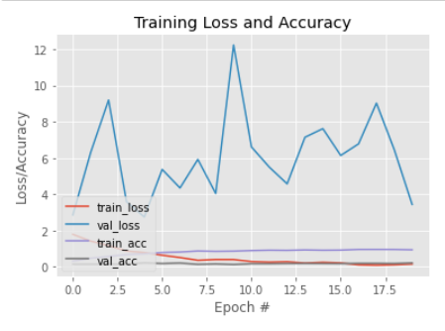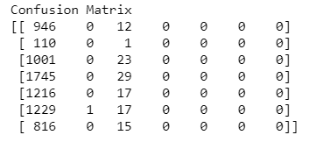

Figure 1

Figure 2

In the second version model, most of the emotions can be detected. However, some of the look a like emotions can be confused by the detector.

Some example screen shots from the application.

