**Number of survey questions:** 27  
**Survey settings:**

* Questions are shown based on previous responses. For details, refer to the survey question document outlining the workflow.
* Participants are not required to answer all questions.
* However, the first four questions are mandatory for all participants.
* Participants must submit responses for all questions they are shown.
* Depending on the workflow, some participants may answer as few as 4 questions.
* Participants can pause and resume the survey later, but only within a specific time frame. If they don’t complete the survey before the deadline, their answers are automatically submitted.
* Incomplete or inconsistent responses, which arise due to th previous setting, can be filtered using survey metadata such as Finished, Start Date, End Date, and Recorded Date.

**Question types:**

* Multiple choice,
* Free text entry,
* Combination of multiple choice and free text entry,
* Combination of free text entry and scaling.

**Results:**

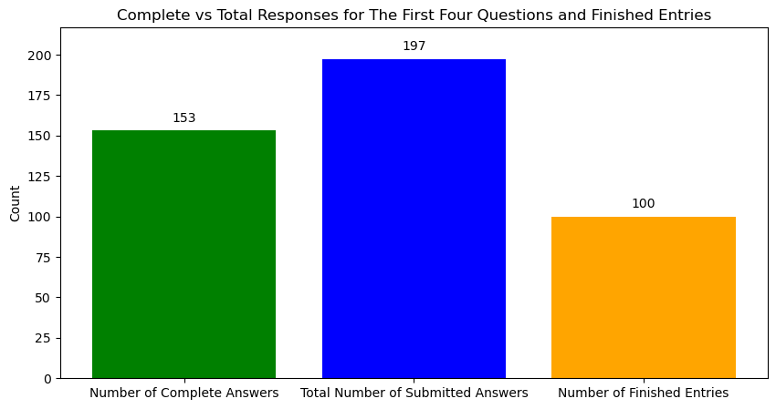

Results where the first four questions are complete:

Question 1

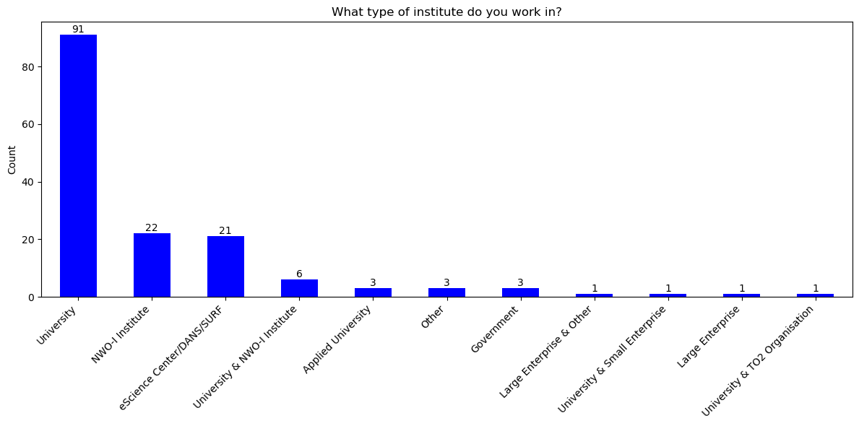

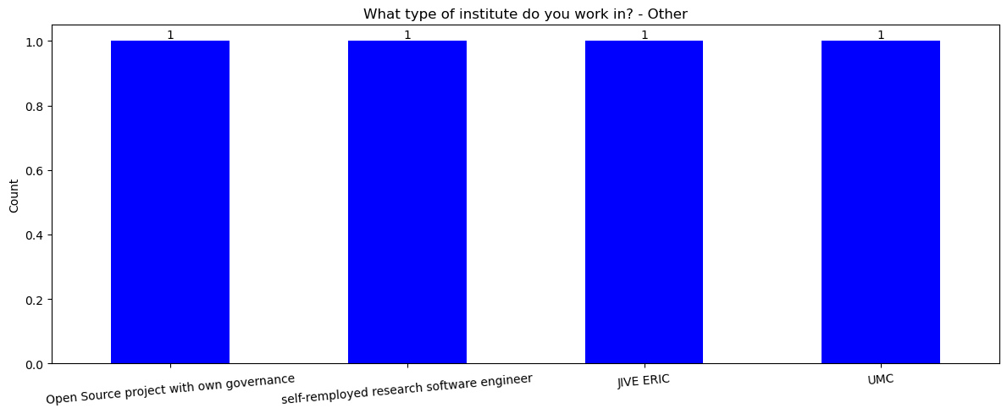

Question 2

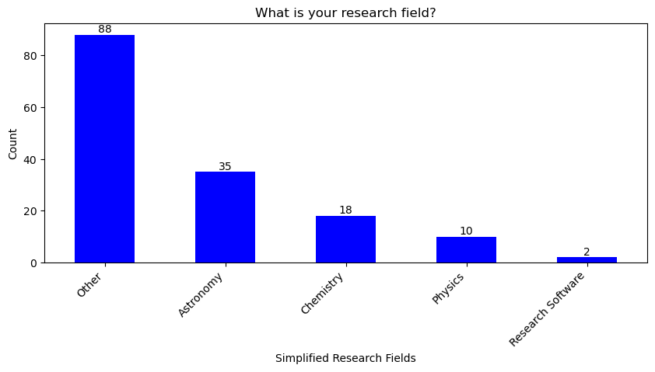

Answers under 'Other':

'geo-informatics' 'statistics' 'computational science' 'bioinformatics'

'open quantum systems' 'life sciences' 'software engineering'

'social sciences' 'computer science' 'geosciences' 'climate science'

'imaging' 'none' 'natural sciences & engineering'

'artificial intelligence' 'earth observation' 'sensors and smart systems'

'data science' 'journalism studies' 'environment and sustainability'

'earth and environment' 'fluid dynamics' 'mathematics'

'natural language processing' 'coastal engineering' 'fusion' 'hydrology'

'hpc' 'sustainability' 'hydrometeorology'

'geoinformation processing applied to water sanitation and health'

'environmental and geosciences'

'applied mathematics + scientific computing'

'formal logic and cognitive science' 'computational mathematics'

'environmental sciences' 'numerical mathematics' 'machine learning'

'design engineering science (industrial design)' 'applied mathematics'

'cross-domain research' 'medical science' 'all'

'civil/environmental engineering' 'hydroinformatics' 'natural sciences'

'no research field i am support staff' 'neurolinguistics'

'applied cryptography' 'energy system integration'

'interconnectivity and predictive ai' 'granular materials' 'applied cs'

'mechanical engineering' 'j' 'asdf' 'material discovery' 'nes'

'sustainability sciences' 'theoretical macroecology and ecotoxicology'

'medical biology' 'industrial ecology' 'research data management'

'symmetric cryptography' 'computing science / cryptography'

'privacy and security' 'fusion science' 'information retrieval'

'public health and environment' 'radar' 'urban ecology'

'computational biology']

Question 3

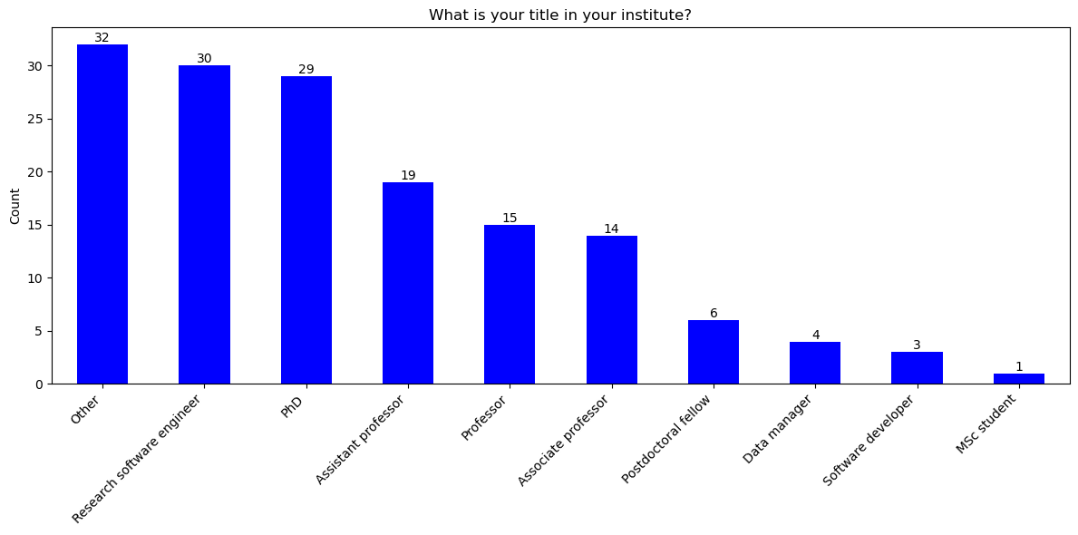

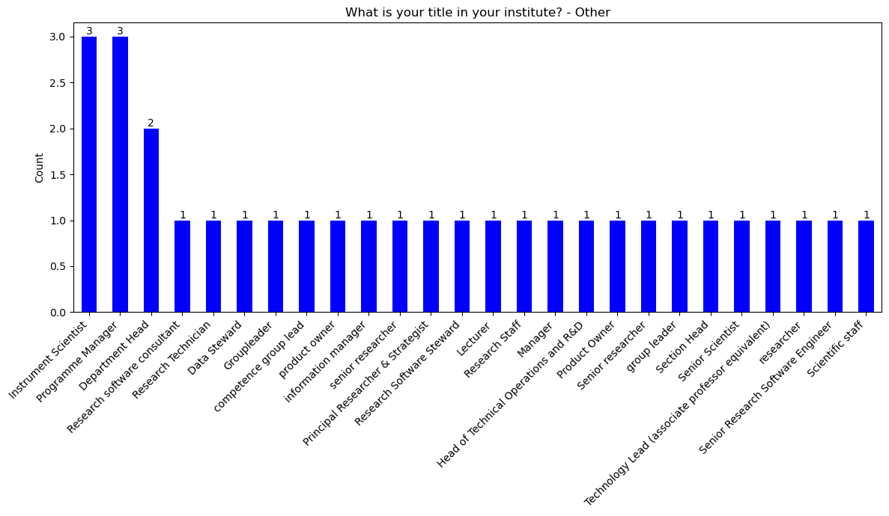

Question 4

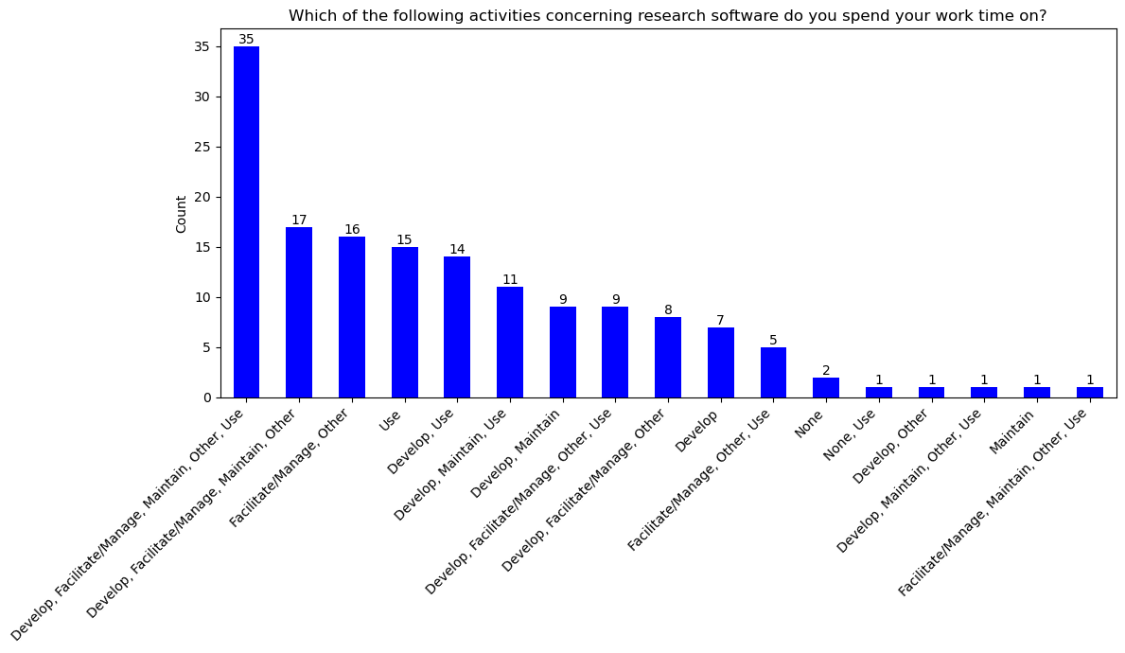

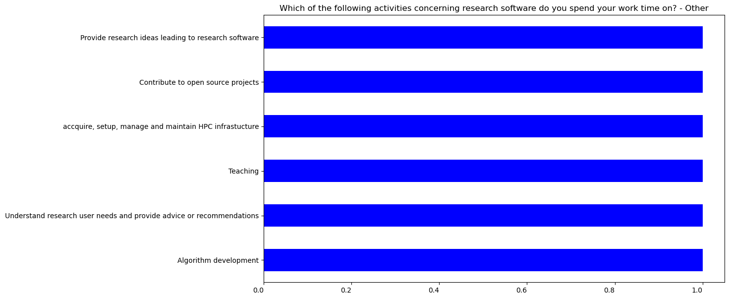

Results for the Finished entries

Question 1

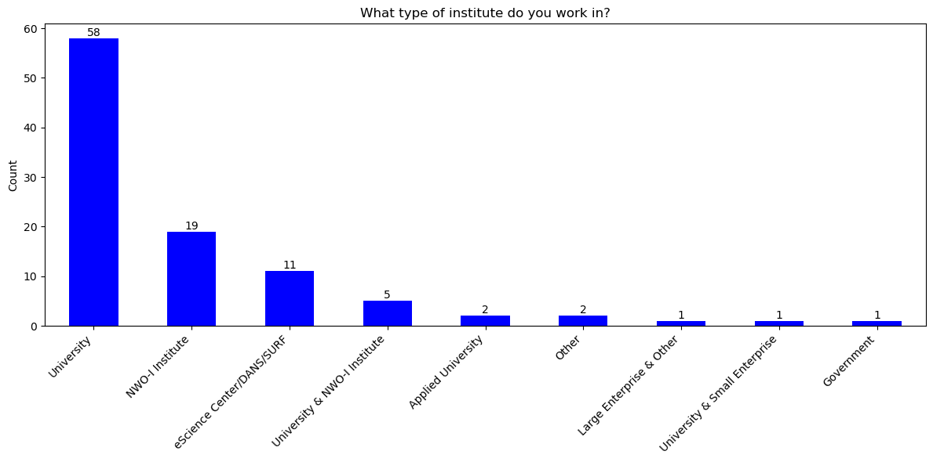

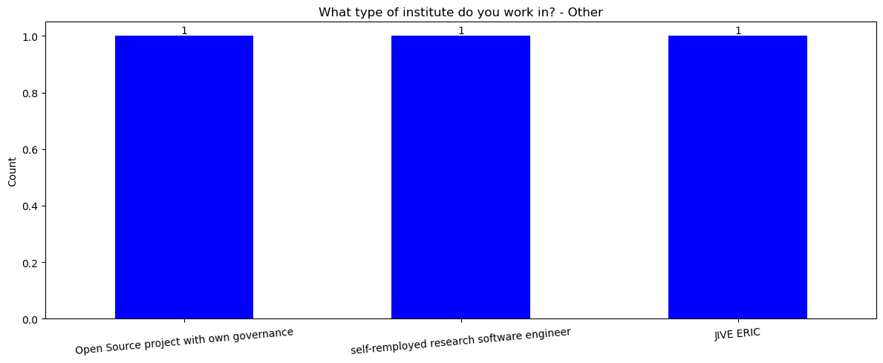

Question 2

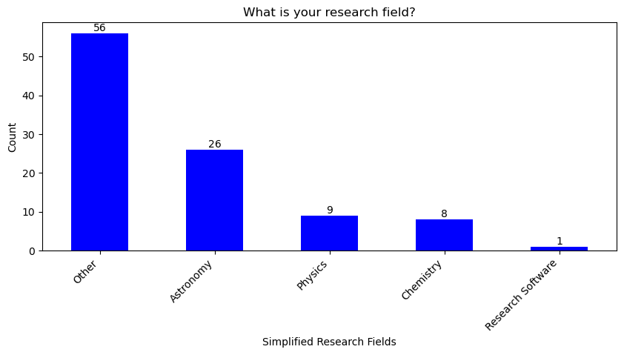

Answers under 'Other':

['geo-informatics' 'statistics' 'computational science' 'bioinformatics'

'open quantum systems' 'life sciences' 'software engineering'

'social sciences' 'computer science' 'geosciences' 'climate science'

'imaging' 'none' 'natural sciences & engineering'

'artificial intelligence' 'earth observation' 'sensors and smart systems'

'data science' 'mathematics' 'coastal engineering' 'fusion' 'hydrology'

'hydrometeorology'

'geoinformation processing applied to water sanitation and health'

'environmental and geosciences'

'applied mathematics + scientific computing'

'formal logic and cognitive science' 'computational mathematics'

'environmental sciences' 'numerical mathematics' 'machine learning'

'design engineering science (industrial design)' 'applied mathematics'

'cross-domain research' 'granular materials' 'applied cs'

'mechanical engineering' 'material discovery' 'sustainability sciences'

'theoretical macroecology and ecotoxicology' 'medical biology'

'industrial ecology' 'research data management' 'symmetric cryptography'

'computing science / cryptography' 'privacy and security'

'fusion science' 'information retrieval']

Question 3

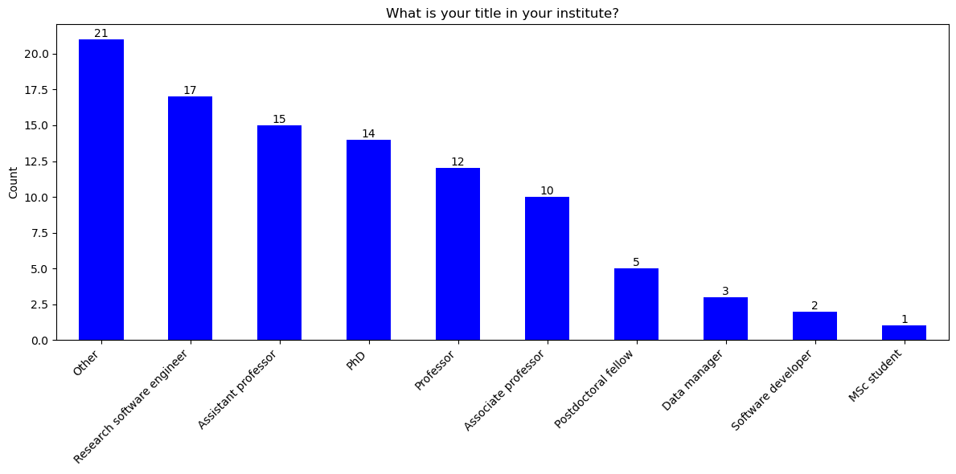

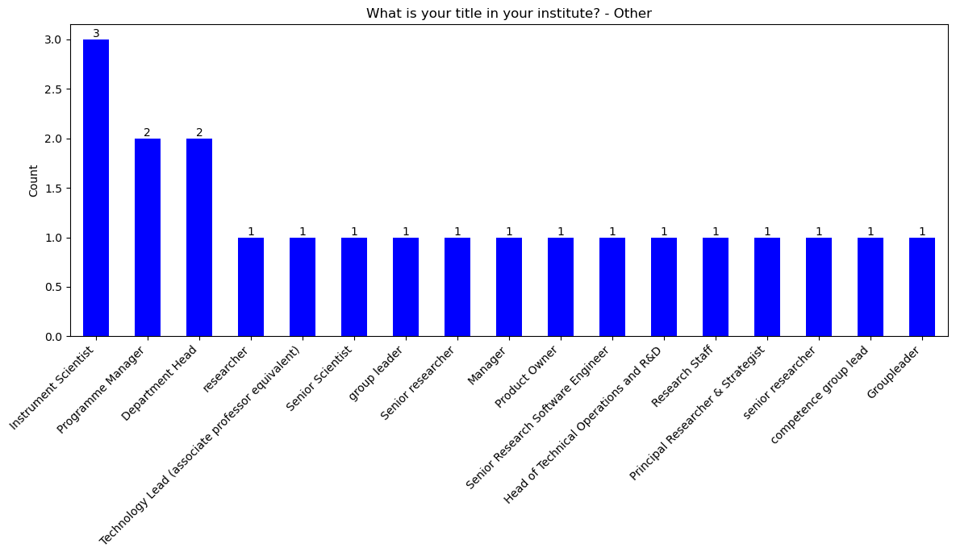

Question 4

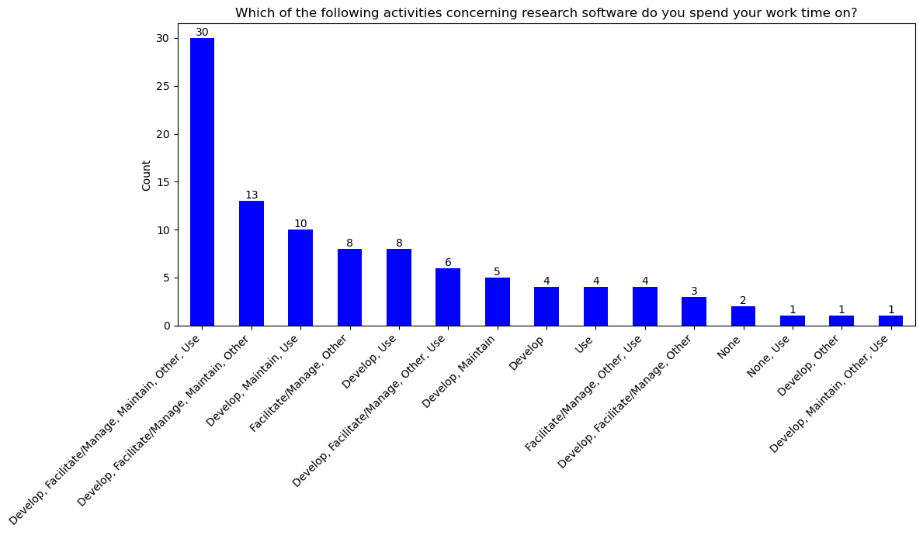

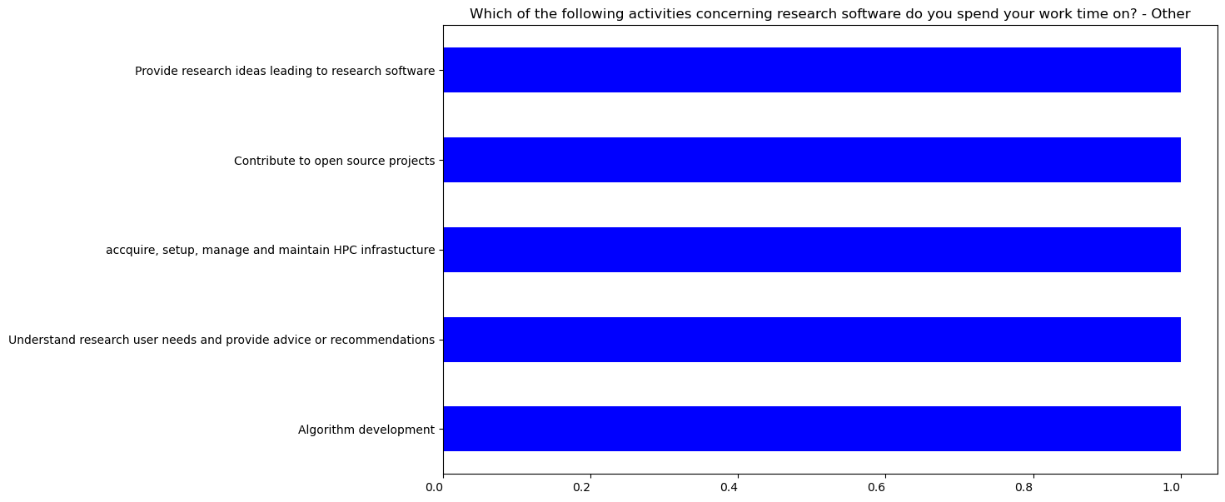

Question 5

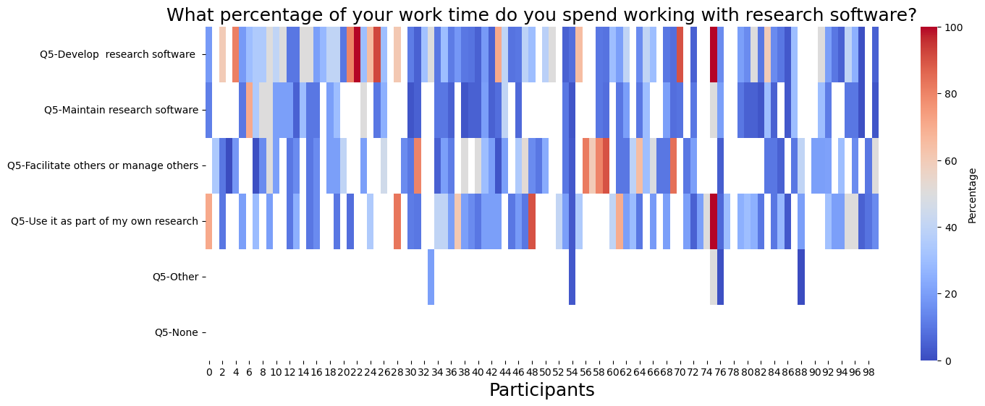

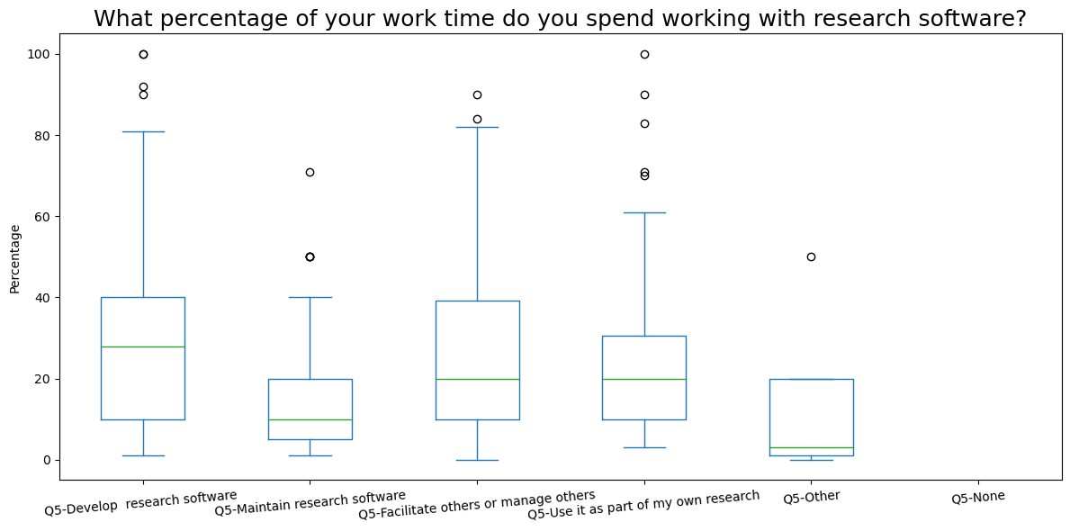

Question 6

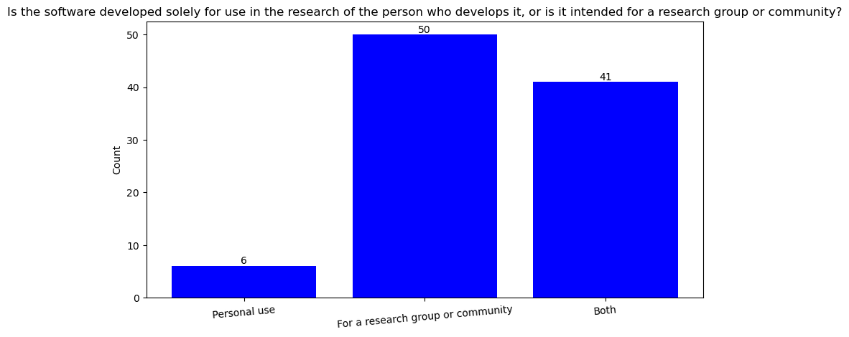

Question 7

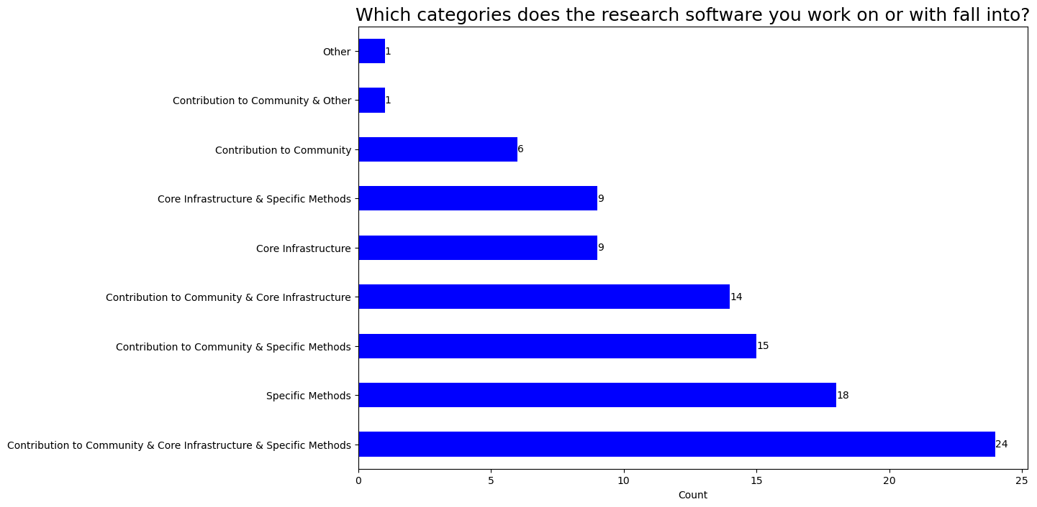

Question 8

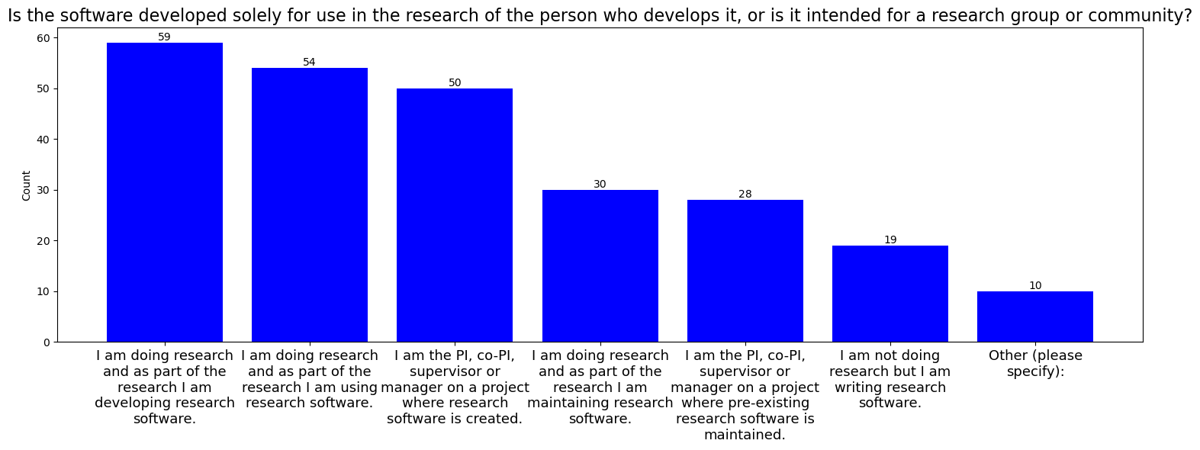

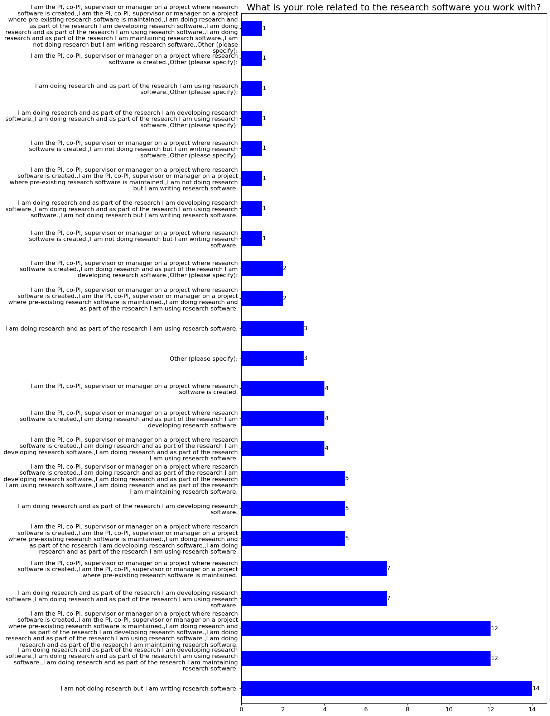

Question 9

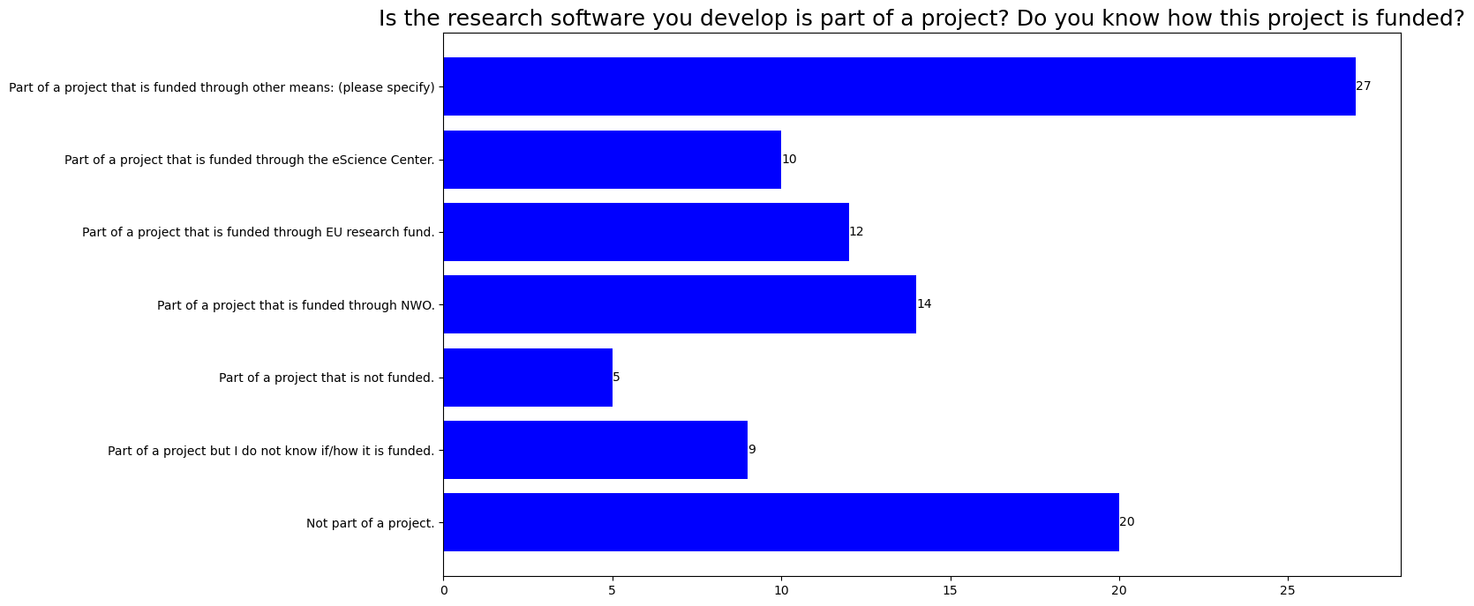

Follow-up question if the the software developed is not part of a project

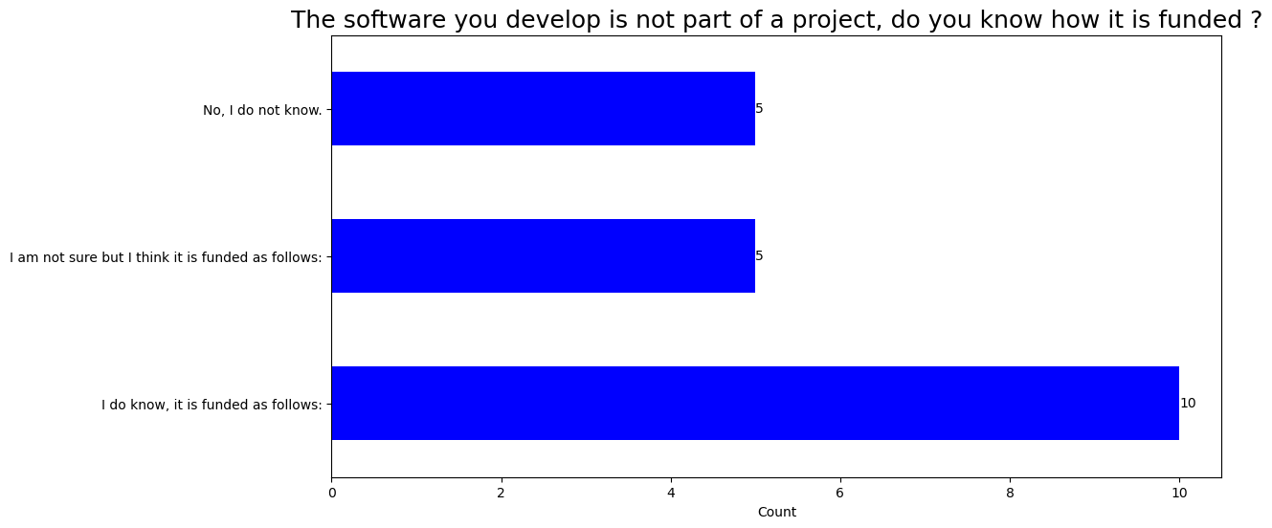

Follow-up question if the answer is I know that it is funded as follows

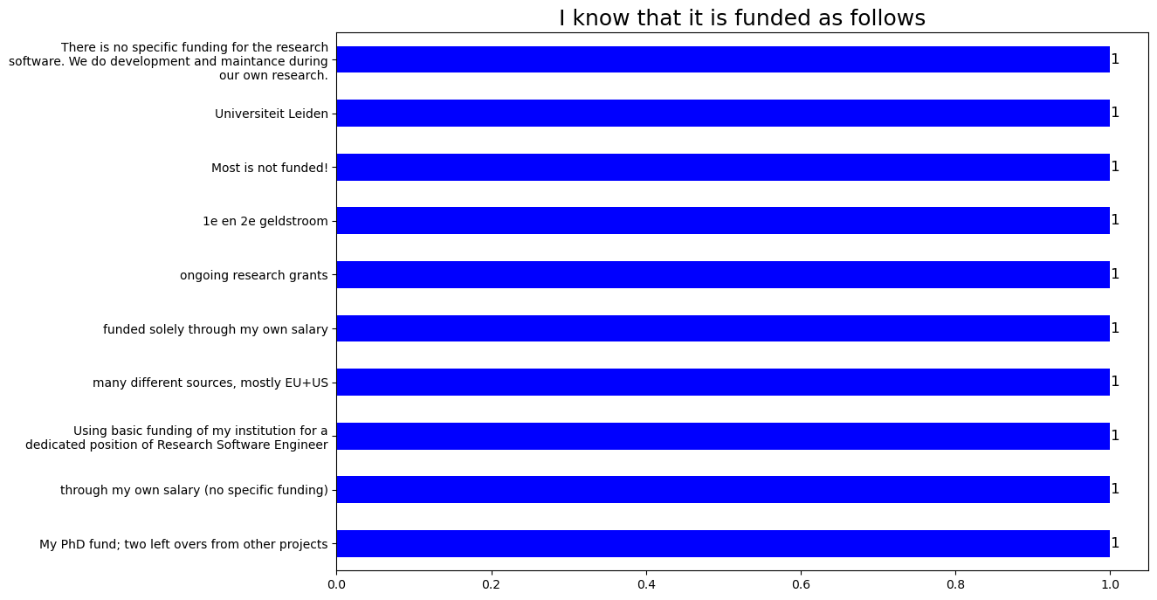

Follow-up question if the answer is I am not sure but I think it is funded as follows

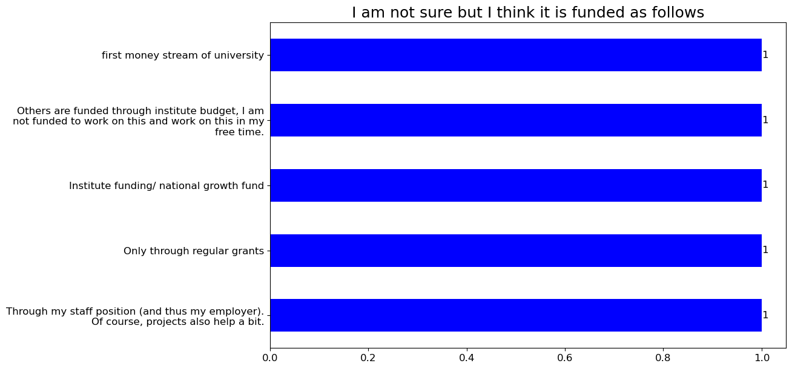

Question 11

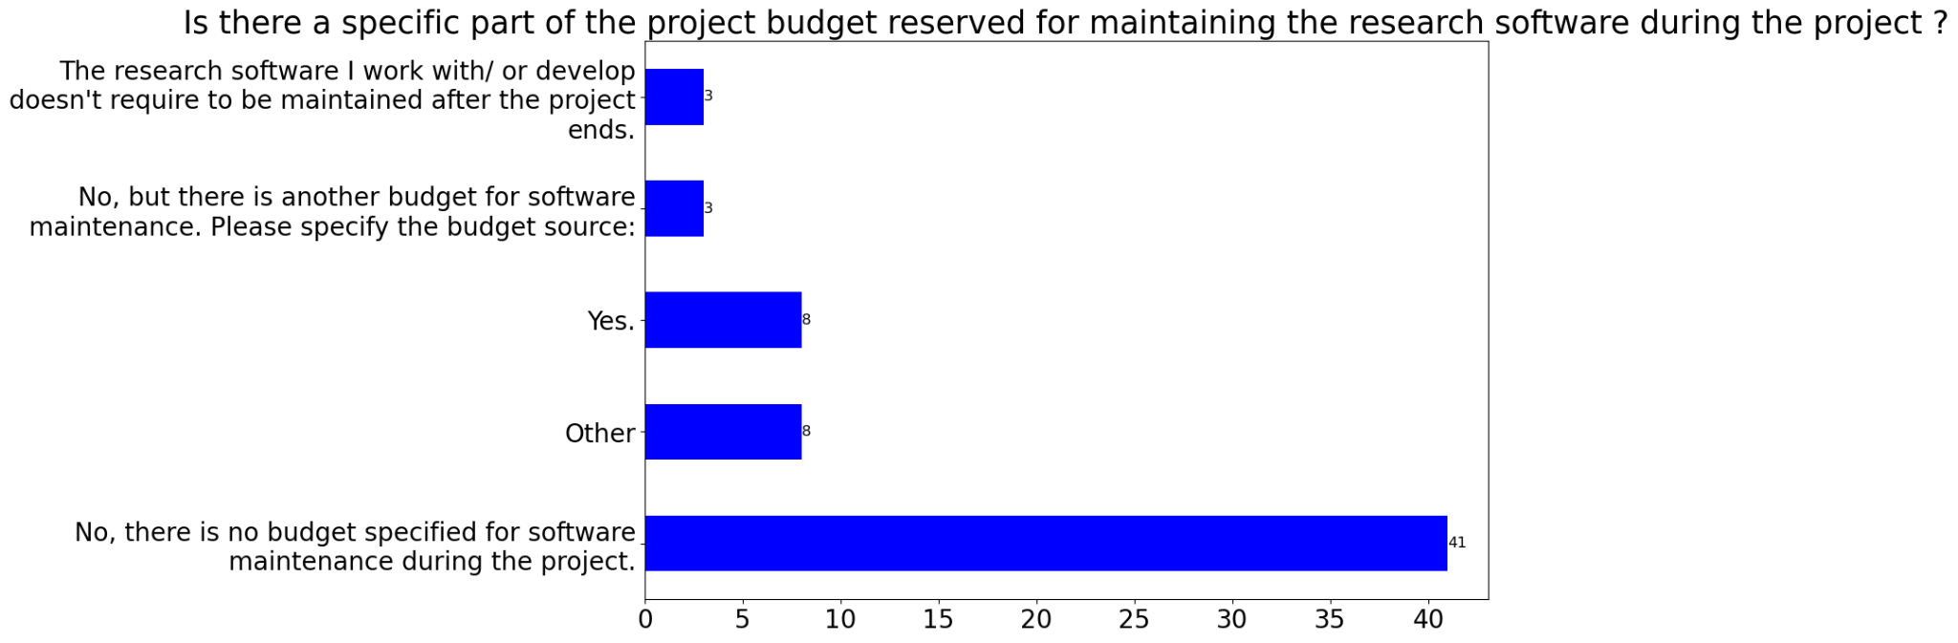

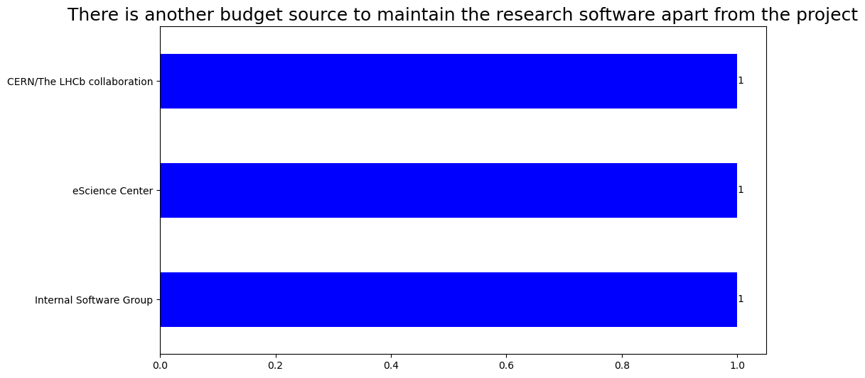

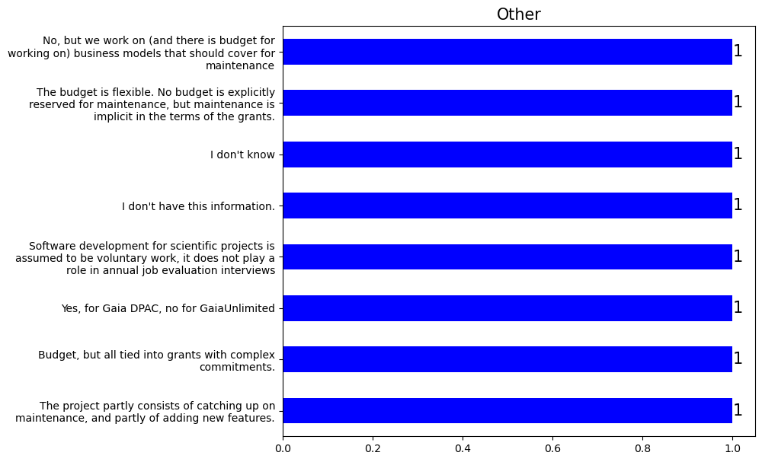

Question 12

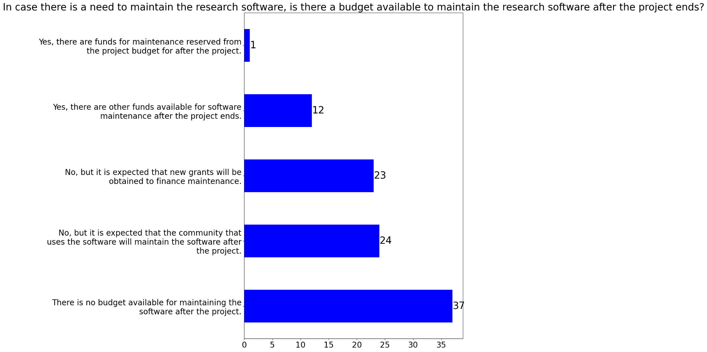

Question 13

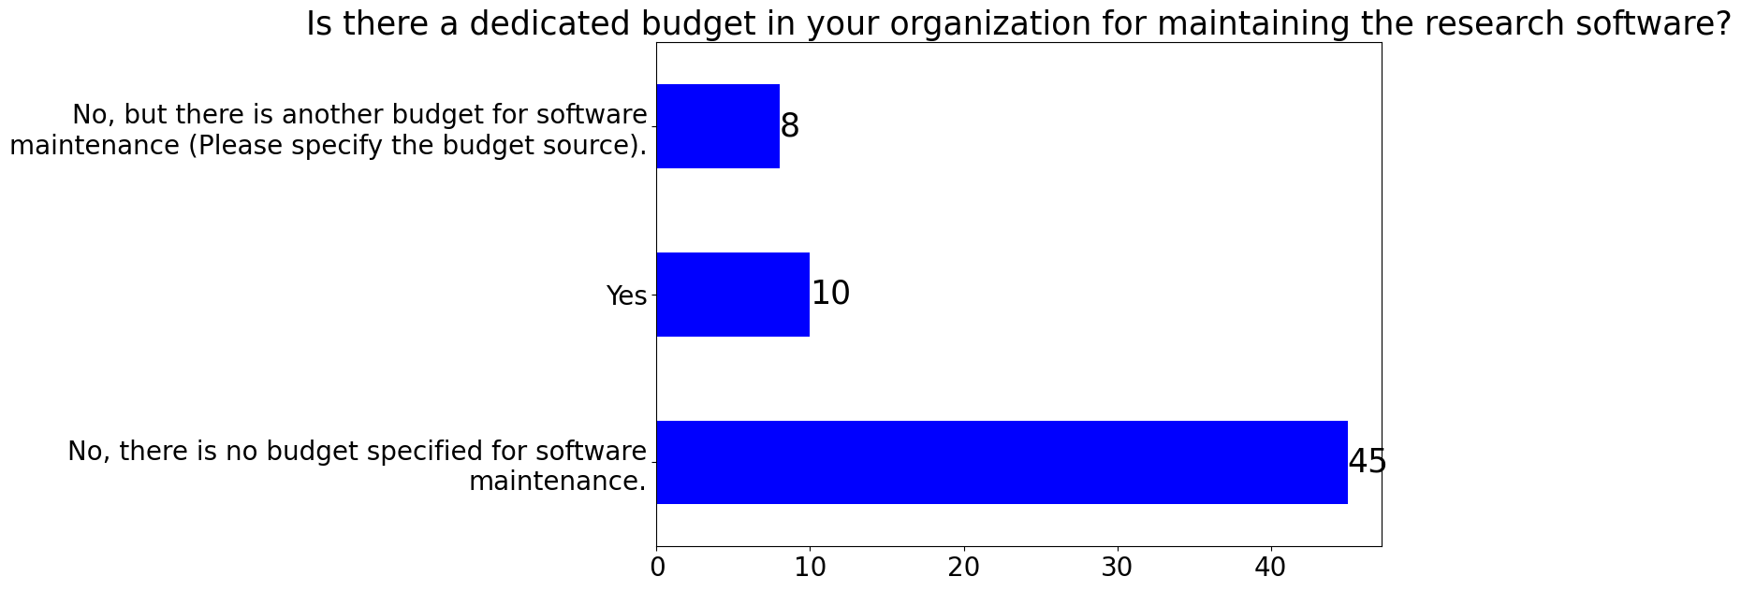

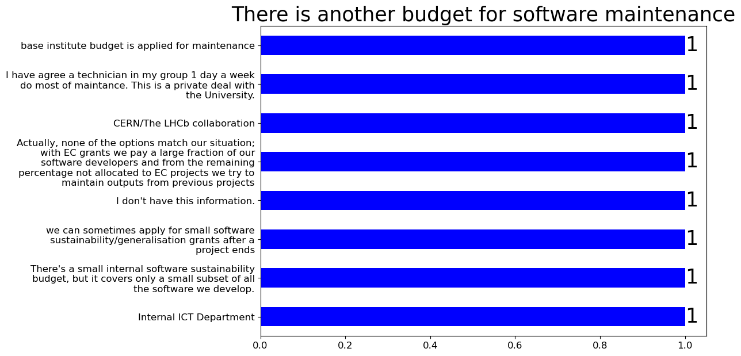

Question 14

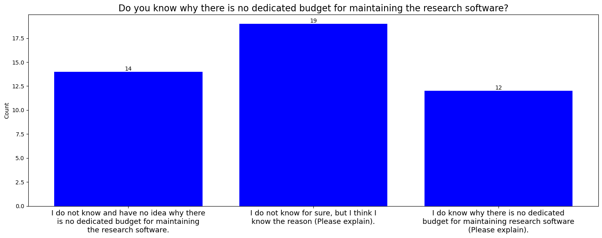

Question 15

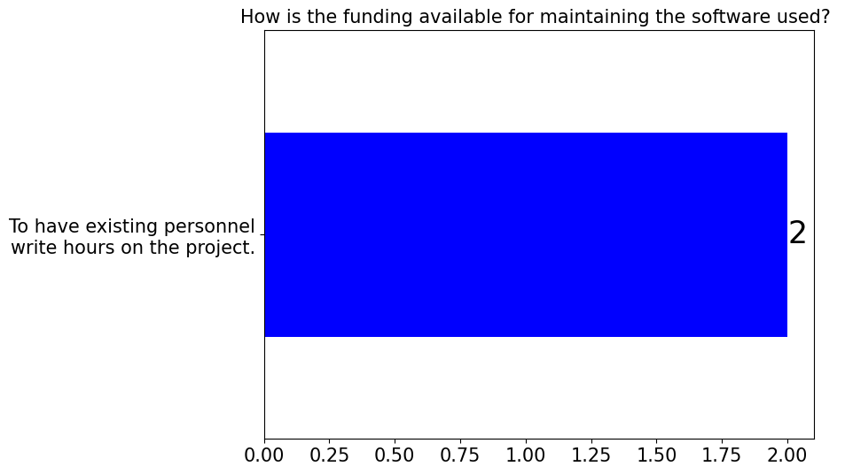

Question 16

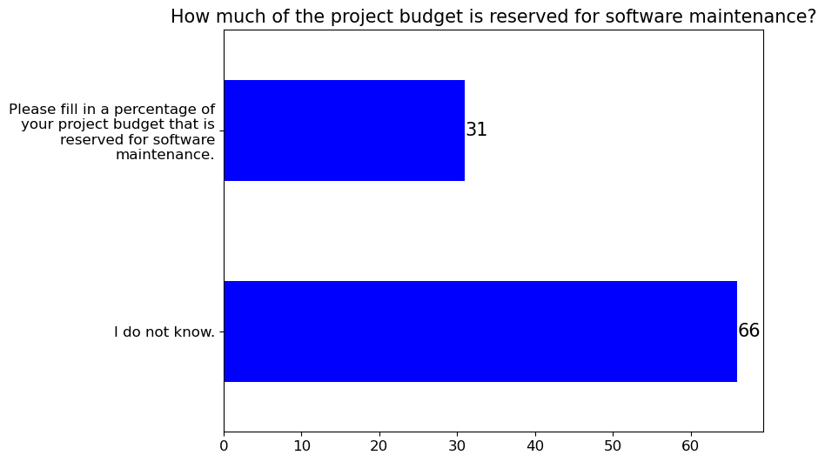

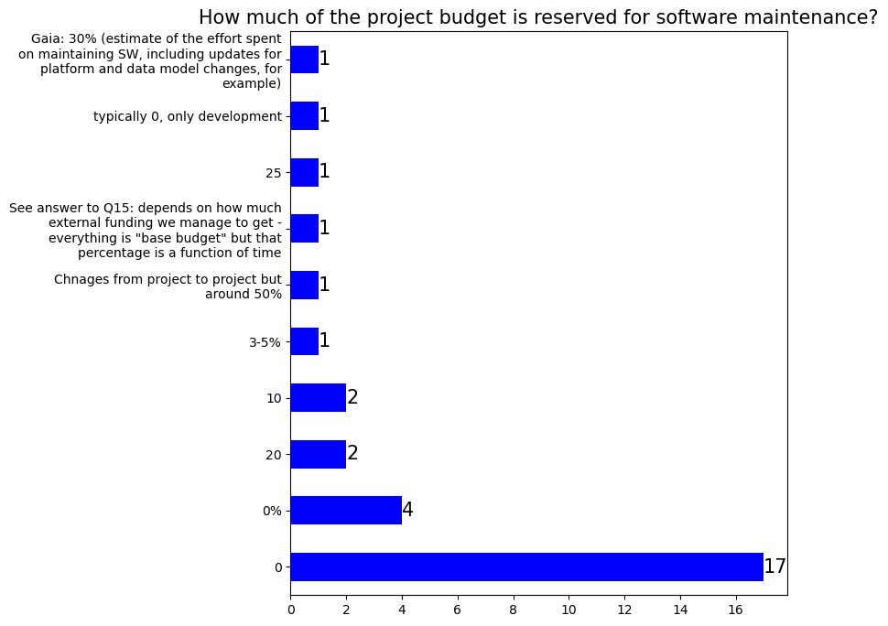

Question 17

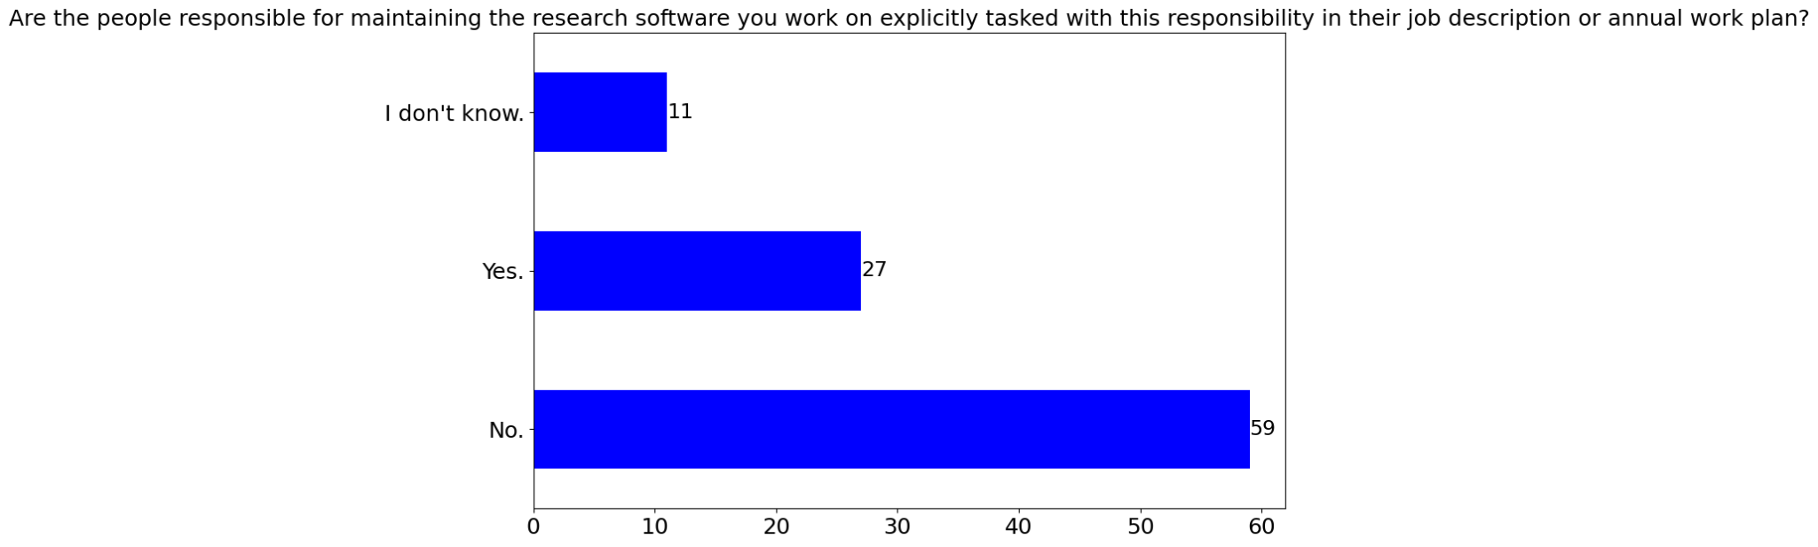

Question 18

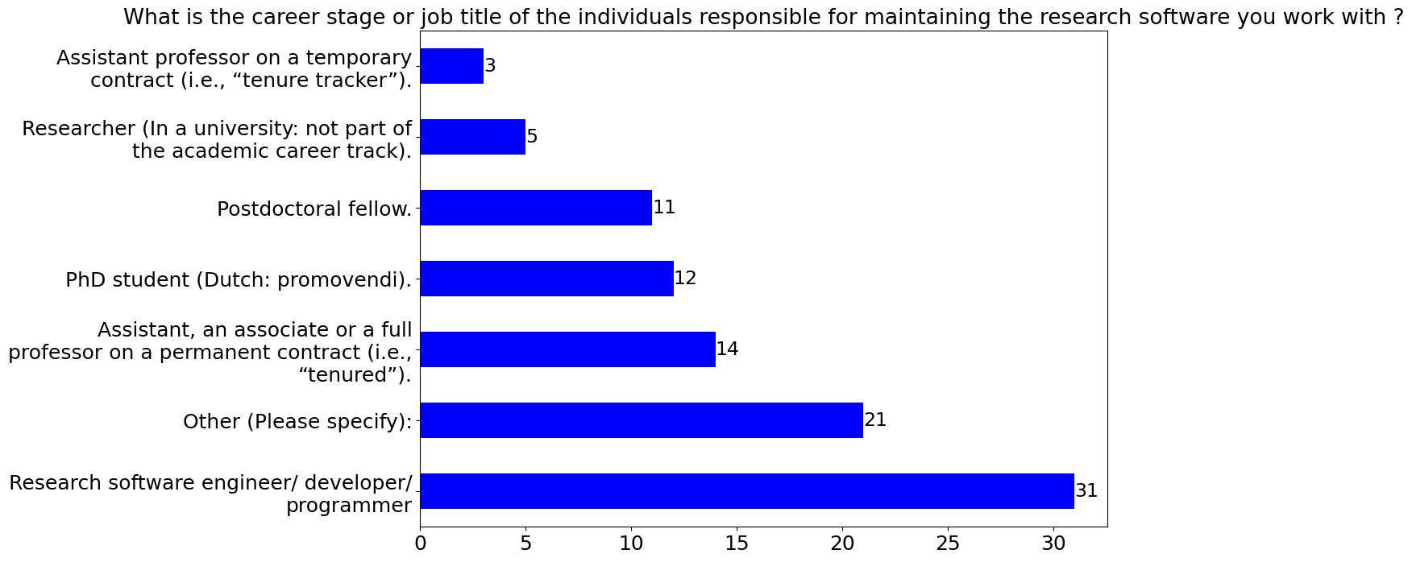

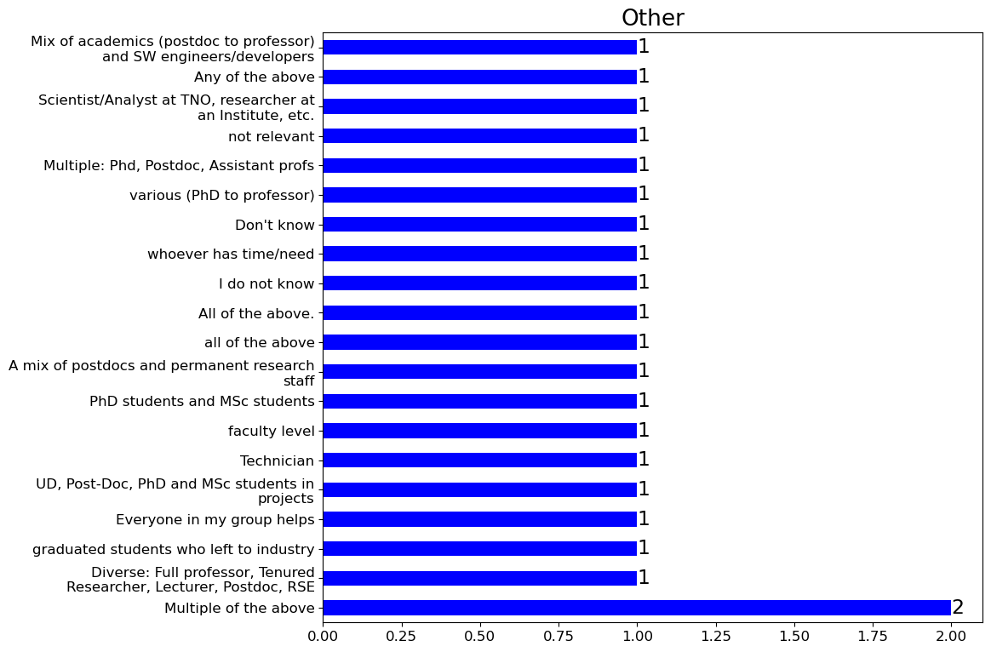

Question 19

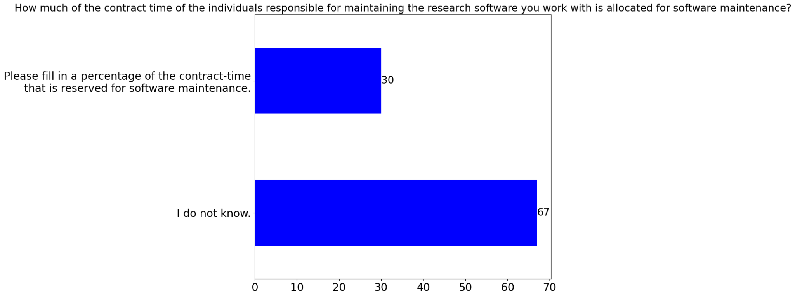

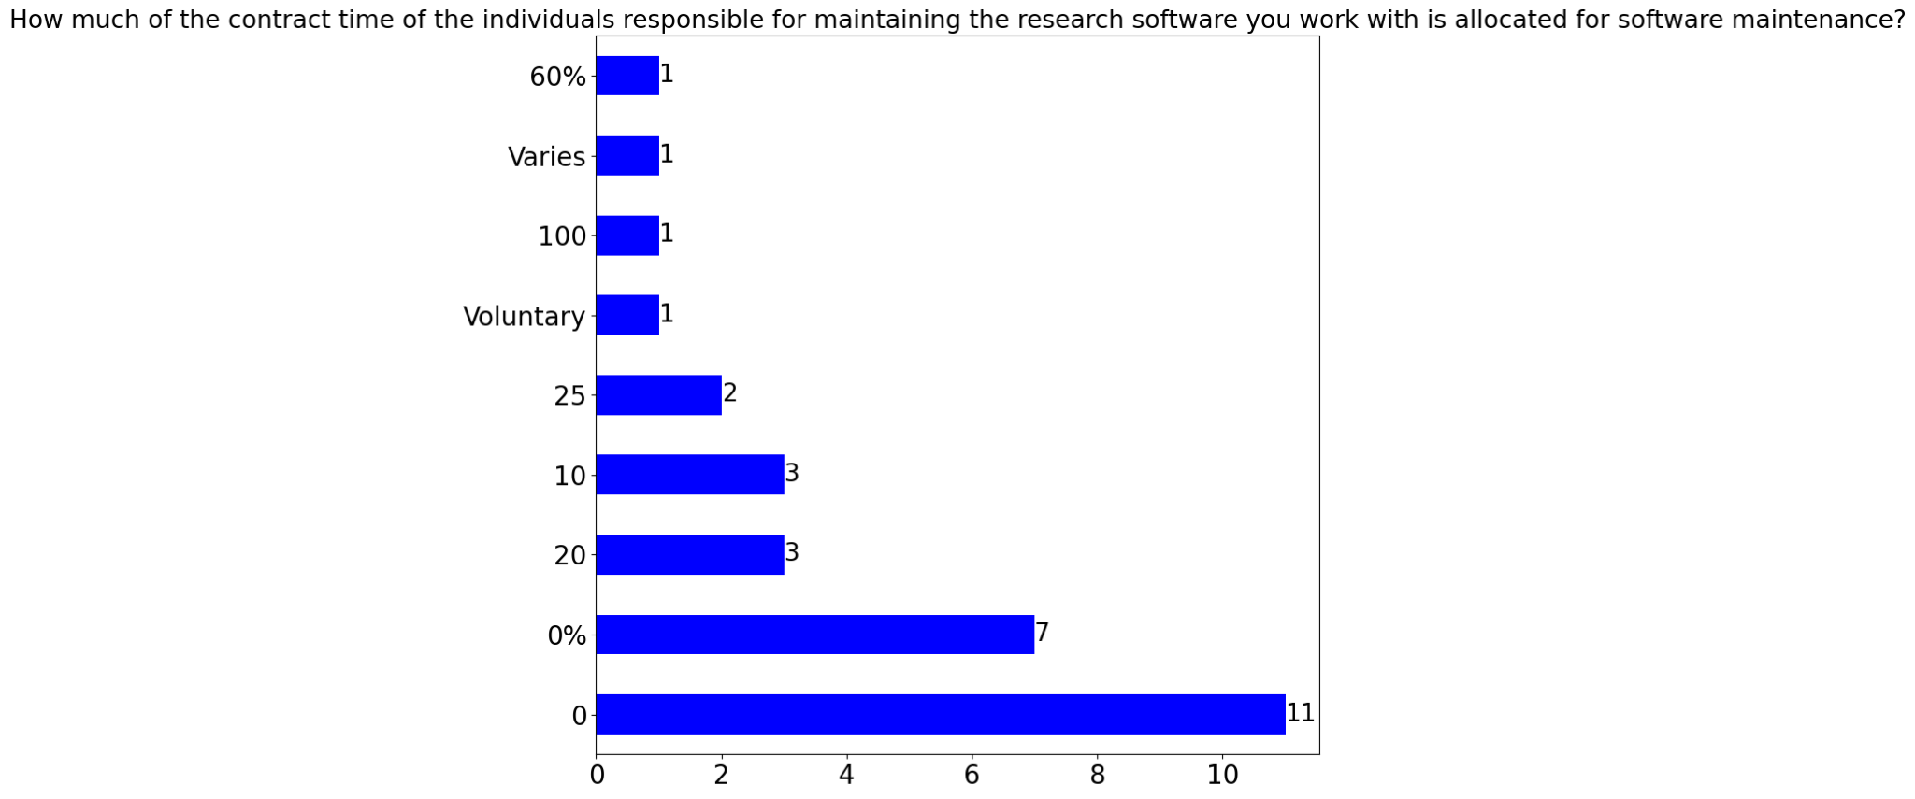

Question 20

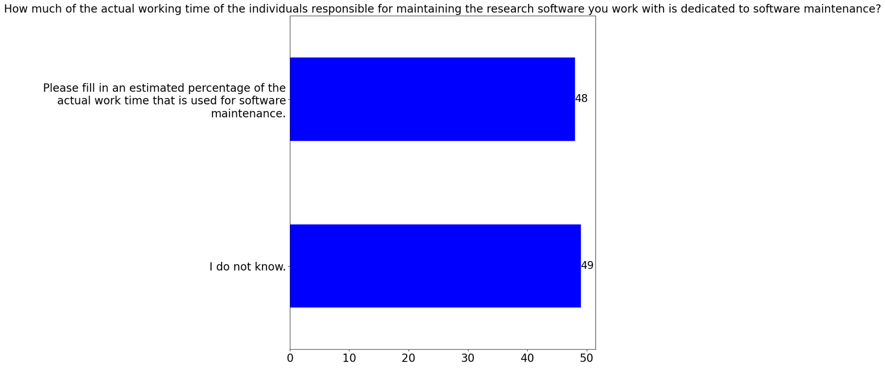

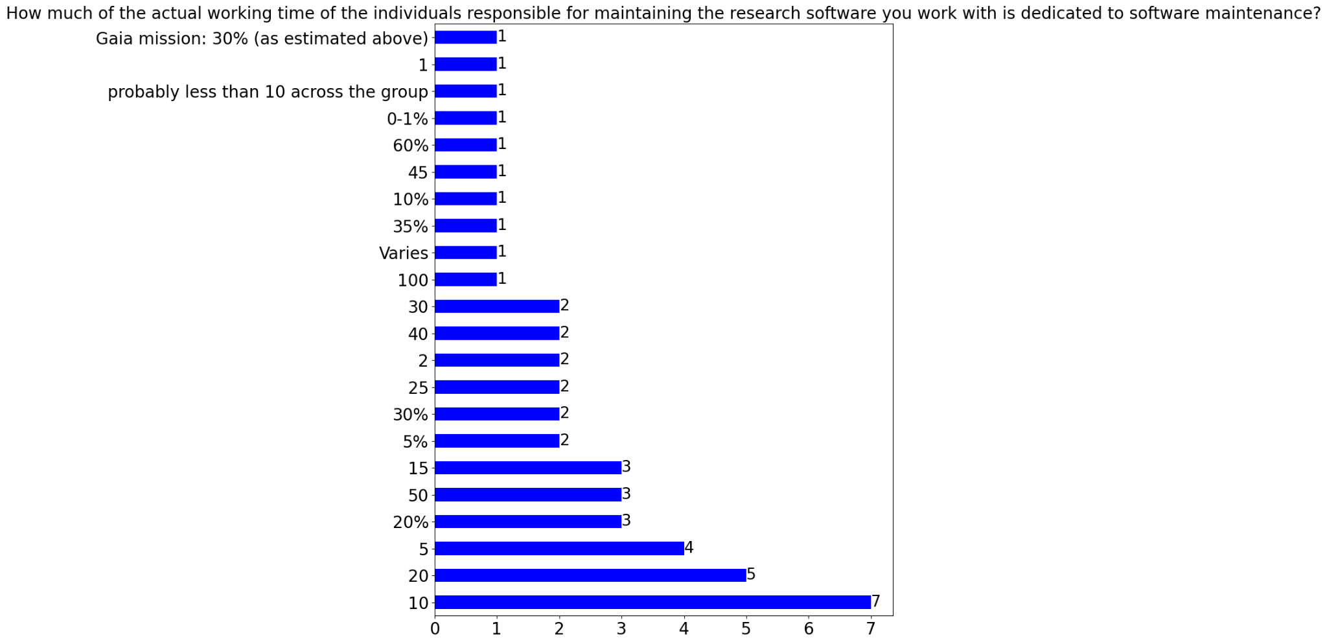

Question 21

Question 22

Question 23

Question 24

Question 25