MedSyn Interactive Dialogue Analysis (Session 2 & Session 4)

This report focuses on interaction dynamics in the MedSyn user experiments, emphasizing dialogue structure and turn-level quality signals rather than final-answer accuracy or completion time.

1. Analysis goals
We quantify how physicians interact with MedSyn during case solving, with a particular focus on:
- Dialogue effort: number of turns per case and how it differs between residents and senior clinicians.
- Dialogue style: what types of questions are asked (detail-seeking vs suggestion-seeking).
- Turn-level quality: Faithfulness and Answer Relevancy per turn, using the clinical note as the 'retrieved context'.
- Interaction utility: qualitative examples (especially hard/rare cases) where interaction appears to help—or fails due to misdirected questioning.

2. Data sources and preprocessing
Inputs:
- Merged dialogue logs (one JSONL per user) for Session 2 and Session 4.
- Case-level clinical notes and ground-truth discharge diagnoses (primary diagnosis used when available).
Dialogue parsing rules:
- Case boundaries are detected via system messages CASE_START and CASE_END.
- A turn is a (user question → MedSyn response) pair. 'final answer:' user messages are excluded from turn counts and turn-level scoring.
- Residents are inferred from user IDs starting with 'res'; senior clinicians from 'phy'.

3. Dialogue metrics
3.1 Turn counts and time
For each (user, case), we compute the number of turn pairs and the case duration (CASE_START → CASE_END).
3.2 Physician question taxonomy
Each user question is classified into one of four heuristic categories:
- detail_request: asks for a specific lab/imaging/report item (e.g., “CT report?”, “troponin?”).
- info_request: asks for general clinical info (e.g., demographics, symptom onset, exam findings).
- suggestion: asks for interpretation/differential/next steps (e.g., “what is the diagnosis?”, “differential?”).
- other: short acknowledgements or ambiguous prompts.
3.3 Turn-level grounding proxies (offline, reproducible)
Because LLM-as-judge scoring requires an external model call, the baseline run computes two deterministic proxies:
- Context overlap (proxy for faithfulness/grounding): fraction of answer content tokens that appear in the clinical note context.
- Question overlap (proxy for relevancy): fraction of answer content tokens that appear in the question.
3.4 LLM-judge Faithfulness and Answer Relevancy (OpenRouter, reproducible)
The codebase includes an optional OpenRouter-backed judge that returns per-turn Faithfulness and Answer Relevancy scores in [0,1], following the RAGAS metric concepts (faithfulness = factual consistency with retrieved context; answer relevancy = pertinence to the question).

4. Quantitative results
4.1 Turn counts by group and session
Table 1. Case-level interaction effort (mean turns per case).
session | group | n_cases | mean_turns | median_turns | mean_duration_min
2 | clinician | 39 | 6.23 | 5.00 | 3.96
2 | resident | 52 | 4.54 | 4.00 | 4.26
4 | clinician | 39 | 4.05 | 4.00 | 3.40
4 | resident | 52 | 3.69 | 4.00 | 3.99

Figure 1. Mean turns per case by group and session.
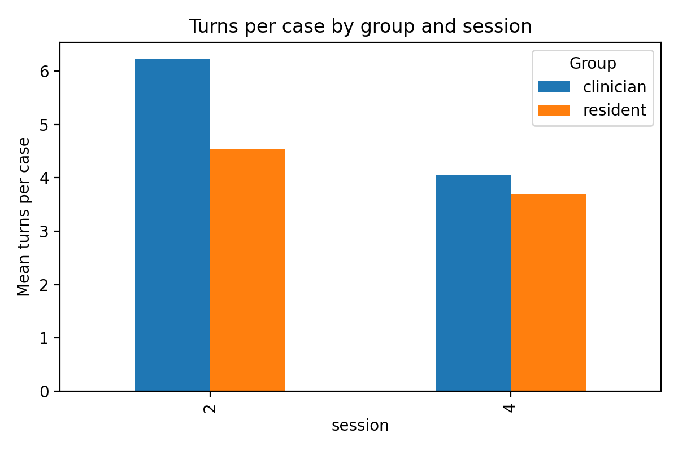

Key observations:
- Senior clinicians used more turns per case than residents in both sessions (Session 2: 6.23 vs 4.54; Session 4: 4.05 vs 3.69).
- Residents tended to take longer per case despite fewer turns, suggesting longer between-turn deliberation or interruptions.
4.2 Question types (detail-seeking vs suggestion-seeking)
Table 2. Physician question-type distribution (percentage of questions).
session | group | detail_req | info_req | other | suggestion
2 | clinician | 22.5 | 41.9 | 23.6 | 12.0
2 | resident | 23.0 | 25.5 | 36.1 | 15.3
4 | clinician | 24.6 | 23.5 | 32.8 | 19.1
4 | resident | 16.0 | 29.4 | 32.5 | 22.1

Figure 2. Stacked distribution of question categories.
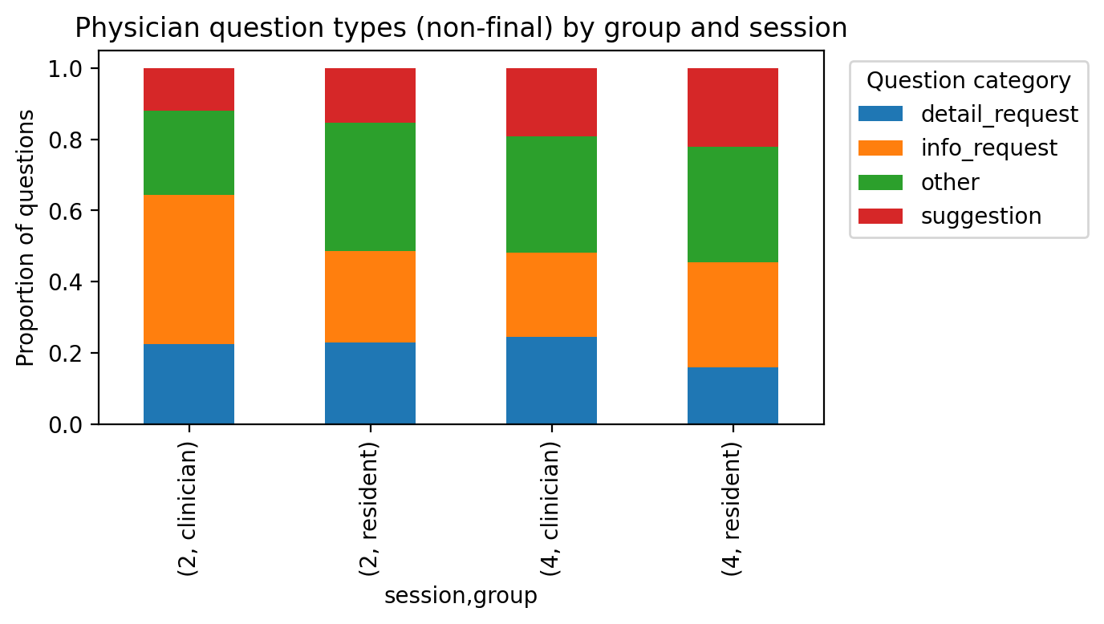

Key observations:
- Residents asked a higher fraction of suggestion-seeking questions in Session 4 (22.1%) than clinicians (19.1%).
- Clinicians asked relatively more detail requests than residents in Session 4 (24.6% vs 16.0%), consistent with hypothesis that seniors probe specific investigations.
4.3 Turn-level grounding and specificity proxies
Table 3. Turn-level proxies (context overlap, note-citation rate, and specificity).
session | group | n_turns | mean_overlap_ctx | prop_has_note | prop_not_in_note | mean_specificity
2 | clinician | 243 | 0.410 | 0.860 | 0.115 | 0.599
2 | resident | 236 | 0.375 | 0.805 | 0.136 | 0.641
4 | clinician | 158 | 0.411 | 0.741 | 0.190 | 0.656
4 | resident | 192 | 0.381 | 0.693 | 0.109 | 0.606

Figure 3. Mean context overlap (grounding proxy).
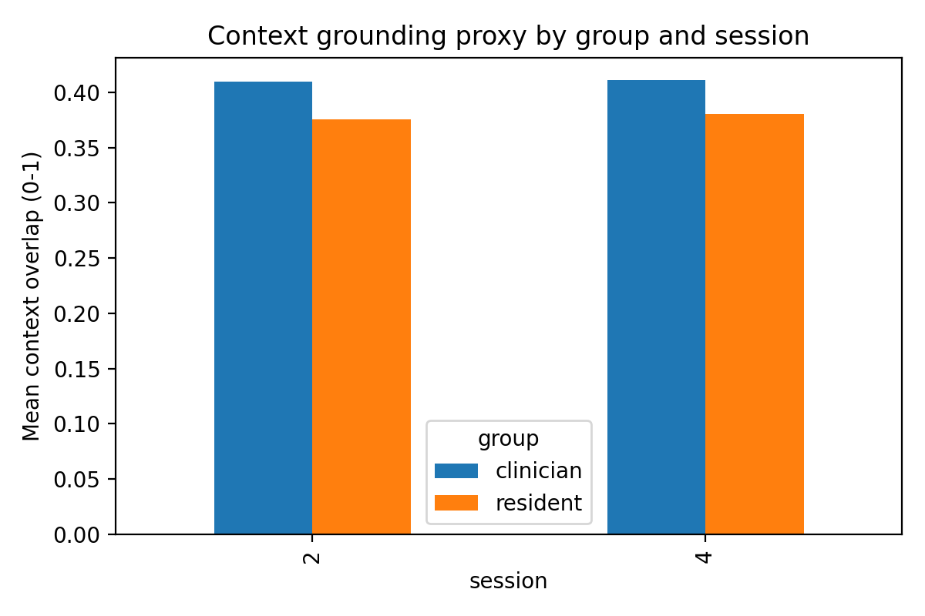

Figure 4. Answer specificity by question type and group (boxplots).
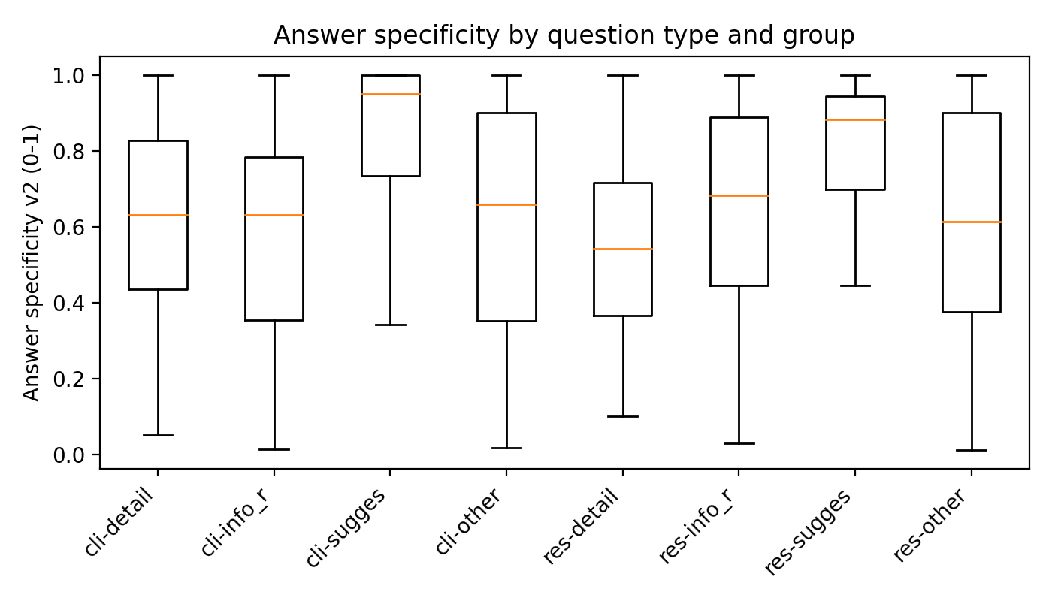

Interpretation:
- Context overlap was moderate (~0.38–0.41), suggesting MedSyn answers are often anchored to the note but also include extrapolations or generic phrasing.
- ‘Not reported / not documented in the note’ responses were non-trivial (≈11–19% of turns depending on group/session). This is desirable when correct, but can also signal gaps in note coverage.
- Answer specificity varied by question type: detailed requests tended to elicit denser, more data-driven responses when the note contained the relevant section.
4.4 Does more interaction improve outcomes?
Using a conservative string-similarity proxy for agreement between the final answer and the primary discharge diagnosis, we did not observe a consistent positive association between number of turns and correctness. In several settings, more turns coincided with difficult cases and uncertainty rather than better outcomes.

5. Qualitative interaction vignettes (hard/rare cases)
The following examples illustrate how interactive access to note-grounded details can help (or fail) depending on whether physicians ask the right discriminative questions.

5.1 Session 2 — Spontaneous coronary artery dissection (SCAD)
Case note_id: 12162372-DS-5 (Hard).
Failure mode (resident): many turns focused on non-discriminative imaging; the system hinted the key test, but it was not pursued.
Example turn (resident res6):
Q: "How is the angioTC?"
A (excerpt): "CT angiography ... Not reported ... However, the note includes cardiac catheterization, detailed separately ..."
In contrast, another resident (res5) asked more targeted cardiology questions, and MedSyn surfaced the key invasive finding, supporting a correct final diagnosis.
Example turn (resident res5) excerpt: MedSyn referenced coronary angiography identifying spontaneous coronary artery dissection in the LAD, reducing ambiguity between unstable angina and SCAD.

5.2 Session 4 — Myasthenia gravis
Case note_id: 10229726-DS-6 (Hard).
A resident (res6) queried successive investigations; MedSyn provided discriminative neurophysiology cues consistent with a neuromuscular junction disorder.
Example turn (excerpt):
Q: "How is elettromiography?"
A: "Significant decremental response on low-frequency repetitive nerve stimulation ... consistent with a postsynaptic neuromuscular junction disorder."
Such note-grounded interpretive summaries can reduce the expertise gap by translating specialized tests into diagnostic implications.

5.3 Session 4 — Viral meningoencephalitis
Case note_id: 12595391-DS-3 (Hard).
A clinician (phy2) iteratively tested hypotheses using LP and MRI evidence. MedSyn returned a structured CSF summary (lymphocytic pleocytosis, elevated protein, negative bacterial studies), supporting a viral process and narrowing the differential.
Example turn (excerpt): MedSyn summarized CSF results and negative PCR/cultures, then answered a follow-up (“it can be viral?”) by connecting those findings to viral meningoencephalitis.

6. Reproducibility and how to run LLM-judge metrics
The accompanying code produces:
- turn_level.csv (one row per question-response pair, with optional LLM-judge scores)
- case_level.csv (aggregated case-level interaction metrics)
- figures/ (PNG plots used in this report)
To enable OpenRouter-based Faithfulness and Answer Relevancy scoring, set OPENROUTER_API_KEY and run the script with --run_llm_judge. The script caches results to avoid repeated charges and ensures full reproducibility by logging model, temperature, and prompt templates.

7. Limitations and reporting guidance for npj Digital Medicine
Key limitations to report transparently:
- Heuristic question taxonomy and grounding proxies are deterministic but imperfect; they are intended as a baseline and should be complemented by LLM-judge scoring.
- LLM-judge metrics depend on the chosen judge model and prompt; report model/version, temperature, and whether the judge had access to the full clinical note.
- Turn counts can reflect case difficulty, user interruptions, or UI friction; interpret associations with effectiveness cautiously.
Recommended paper integration: report group-level turn statistics (median/IQR), question category proportions, and per-turn faithfulness/relevancy distributions (with confidence intervals and sensitivity analysis across judge models).

