Purpose and Scope:

The purpose of this standard is to provide cosmetic requirements for printed components on TAZ 6. See 'Cosmetic Specification Requirements' document for definitions not included in this document. This does not include specifications for secondary operations such as inserts.

Components:

Z Upper

Z Lower

Z Carriage Idler

Z Carriage Motor

Z Gaskets

LCD Bezel:

Surface A as indicated should be free of any defects. All other surfaces not noted are defined as a 'D' surface.

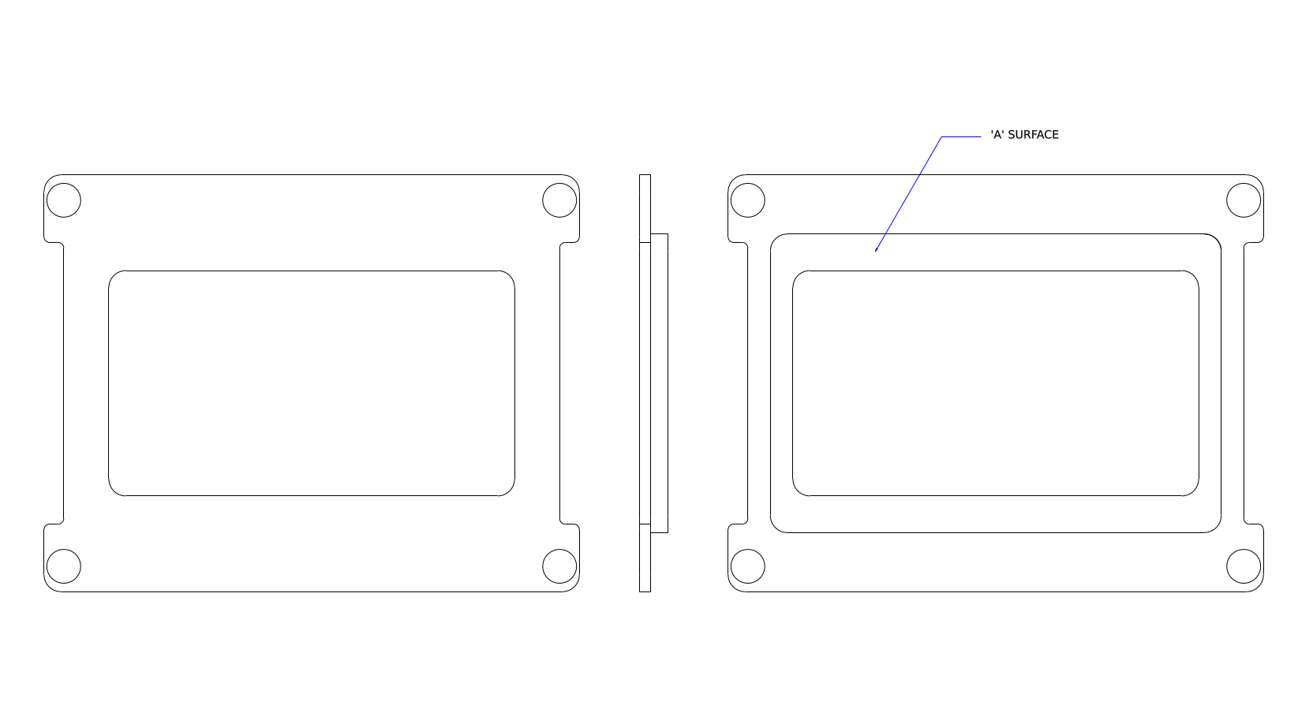

LCD Knob

SD Card

Lift: Lifting along an edge with a visible ridge.

(need sample picture)

Over squish: A solid first layer is present, the outside perimeter tapers out.

(need sample picture)

Resonance: See Ringing

(need sample picture)

Ringing: Wavy pattern after side face cutouts/holes.

(need sample picture)

Warp: Curling of the print at stressed locations of the print.

(need sample picture)

Wrinkling: Waving in the perimeter wall

(need sample picture)

II. Surface identifications and Classification of Surface Finish

“A” Surface – The top or front, most often viewed surface

“B” Surface – Generally the front edge and sides of a part. Not Viewed as often as an “A” surface but easily seen by user.

“C” Surface – Most often the back and bottom surface

“D” Surface - Internal surfaces. Normally D surfaces are not inspected for cosmetic attributes. Where necessary, D surfaces will be specified as an exception.

III. Standard Viewing Condition

A. Lighting Intensity

All quality decisions of cosmetic acceptability will be made under normal lighting conditions (80-120 footcandles) in white fluorescent light.

B. Viewing Angle

All viewing will take place with direct overhead lighting. Viewing angle is dependent on surface classification.
In every case, parts will be held such that the light is NOT REFLECTED directly to the viewer.

“A” Surface – Hold part 30º from the horizontal plane. Part is in direct line with your eyes.

ROTATE part 30º to the right and to the left about the vertical axis.

“B” Surface – Hold part 90º from the horizontal plane. Part is in direct line with your eyes. DO NOT rotate the part.

“C” Surface – Hold part 90º from the horizontal plane. Part is NOT in direct line with your eyes. Part is held 45º below the plane of your eyes. DO NOT rotate the part.

C. Viewing Distance

“A” Surface – 18 Inches
“B” Surface – 24 Inches
“C” Surface – 30 Inches

D. Inspection Interval (time)

Inspection interval is a function of surface area

SURFACE AREA | “A” Surfaces | Non - “A” Surfaces
≤ 4 in² ( | 2 sec | 1 sec
4-16 in² | 4 sec | 2 sec
16-64 in² | 6 sec | 3 sec
64-144 in² | 8 sec | 4 sec
> 144 in² | 10 sec | 5 sec

