Som, Johnjimy
GEOG 380 – 01
Fall 2018
Instructor: Ban
October 30, 2018

PM1: Choose a map to criticize in PM2 and provide its URL
(the map should be a full map, not a part of a map)
Source of the map (URL) (10 points):

http://www.esri.com/news/arcnews/fall12articles/european-cities-are-getting-warmer.html

Image of the map or screenshot (10 points):

Map of Europe in ArcGIS (large scale)

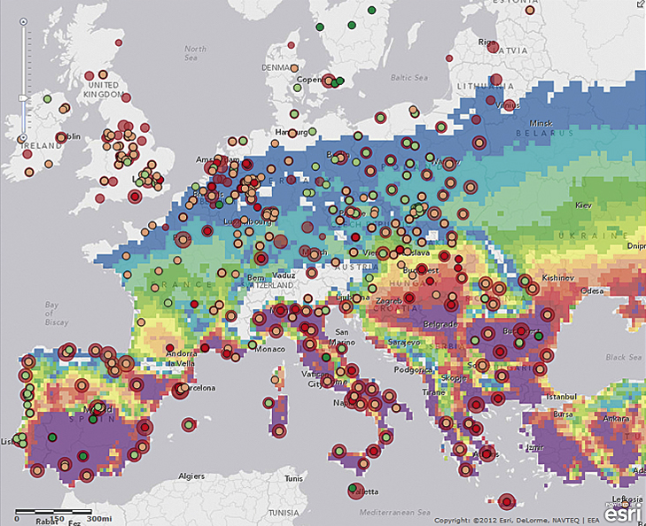

ArcGIS Online with legend:
