Som, Johnjimy

GEOG 380 – 01

Fall 2018

Instructor: Hyowan Ban

**Lab 1: Planning a Cartography Project**

**Q1.**

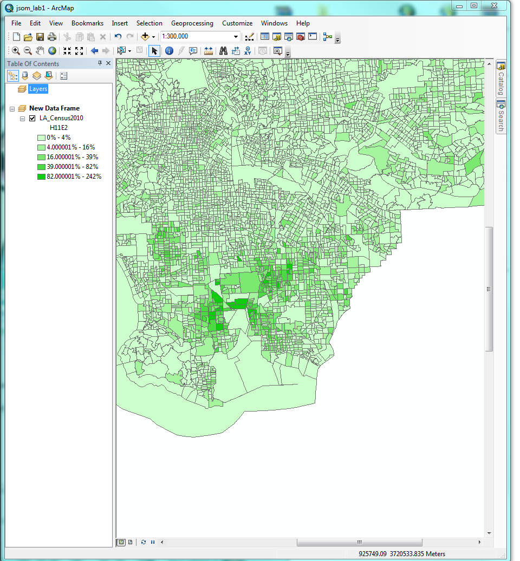

**Q3.**

