Som, Johnjimy

GEOG 380 -01

Instructor: Dr. Ban

Fall 2018

**Lab 2: “Getting Started with Cartographic Representations”**

**Q1.**

Step 7:



Step 8:



Step 9:



**Q2. Dropbox**

**Q3.**

Step 6:



Step 9:



expected

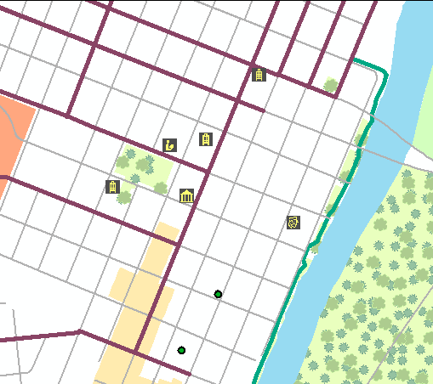

Step 13:

**Q4. Dropbox**

Additional :Notes (optional)

