Som, Johnjimy

11/6/18

**GEOG380 Map Interpretation & Analysis** FA2018

**Study guide for Test2**

(Test2 on **Nov. 6, 2018** 6:00pm~6:40pm. 15~20 questions for 100 points)

(Scope: lectures between 08 Data Generalization and Mapping ~ 16 Effective Graphing)

The following questions are from the lecture notes and the textbook. Please make sure you cover the bullet points and let me know if you have any questions. Good luck!

* What are the types of generalization operations for spatial data? Think about when each type of generalization would be useful.
* **Selection – nessassary for your point “Is the feature necessary to make your point?”**
* **Simplification – too much info makes it confusing “Weeding out unnecessary details”**
* **Smoothing – “Can you smooth a feature ...”**
* **Displacement – “Are features interfering?” Will displacement … make features easier to distinguish?**
* **Enhancement – “Do you know enough to enhance a feature?”**
* **Dimension change / Collapse – “Does dimensional change … remove unnecessary detail?”**
* **Merging – “Keeping old classes creates too many/small units”**
* **Classification – “structure of the message” how the message is projected to readers.**
* How can you evaluate a map design in terms of map elements, layout, and composition?

**Map elements combine to make a useful map**

* Require appropriate selection and use of Title, Legend,

Orientation, Explanatory text, Scale, Source, Inset/Location map,

and Borders

**Map layout**

* Optical center, eye movement, sight lines, and balance
* What are the concepts of Gestalt Principles, visual hierarchy, figure-ground organization, contrast, visual balance, and internal organization? How can we effectively utilize/interpret them in mapping (refer the figures in the lecture note 10)?
  + **The meaning of graphic symbols as “unified whole”,**

**or a visual group**

* + **Closure, Common fate, Contunuity, Figure-ground, Proximity, Similarity**

**Smallness/Area, Symmetry**

**Figure-Ground Organization**

* **A way of organizing perception into a hierarchy of figures**
* **and grounds**
* **Figures: things that are more important and dominating**
* **Ground: things that are less important**
* **Planar Organization: Visual Balance within a level**
* **Location of features**
* **Size**
* **Color, interest, and isolation**
* **Shape**
* What are additive colors and subtractive colors? How can you make certain colors in RGB and CMYK color systems?
  + **Overlap red,green,blue, to get other hues of color (additive colors)**
  + **Reverse Cyan, magenta, yellow for (subtractive colors)**
  + **adding black, or subtracting black colors (0,0,0)**
* What are four classification methods? Think about when each type of the classification methods would be useful.

**Equal** **Interval**: plot frequencies and divide the range of data to series of equal intervals

**Normalization**: Ratio figures but not raw values.

**Mean-Standard Deviation:**

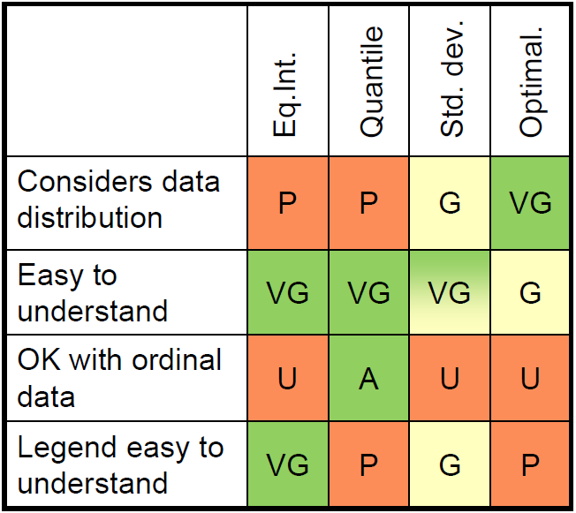**Quantile:**

Some common classification methods for choropleth

mapping

* **Equal intervals**
* **Quantiles**
* **Standard deviation**

**Optimal classification:**

* **Minimize within-class variation**
* **Maximize between-class var.**
* **Similar to clustering techniques**
* How can you choose appropriate color schemes based on four quantitative suggestions?

**Color Scheme and Classification**

* Sequential color scheme

1. Logically arranged from high to low, and should be represented by sequential lightness steps
2. Low data values are usually represented by light colors and high values by dark colors
3. Transitions between hues may be used in a sequential scheme,but the light-to-dark progression should dominate the scheme

* How can you evaluate good/bad label designs and their placements in maps?
  + **Sequential Color Scheme**
  1. t is acceptable if hues span a continuous portion of color wheel (but not the entire wheel)
* What are effect of MAUP in choropleth mapping, illusion of regional total and colors, and their good/bad map-design examples?

**MAUP (Modifiable Areal Unit Problem)**

* Assumption: data is evenly distributed across space
* Maps draw attention to larger areas
* Maps may not represent actual underlying spatial phenomenon
*  Ex) distributions of individual observations, directions, densities...
* Can have a dramatic effect on trends or patterns based on size
*  Information may change or disappear
* How dot-density maps and choropleth maps are different from each other?
  + **choropleth maps are for “areas” mapping**
  + **spatial proxy pptx chpt 10,**
  + **, depends how many dots represent in observations.**
* How can you decide data unit, dot size, and dot values in a dot-density map?

**Dot map legends**

All legends should include:

 A statement that tells the unit value of one dot

A disclaimer for the reader

* **Recall MAUP!**
* **The smaller the statistical unit in**

**relation to the overall size of the**

**map, the greater the accuracy of**

**dot distribution in the map**

* How would you place dots in a dot-density map?

**Placing dots**

Point location

*  **Uniform (random)**
  +  Not optimal because in reality

patterns are not uniform

*  **Geographically** **weighted** (principle of

spatial autocorrelation)

*  Higher values tend to be located

near other high values based on the

uniform pattern

 **Geographically** **based**

*  Use above principles, but also use

ancillary information of areas where

the observations might locate in

reality to place the dot

* What are differences between true-point mapping and conceptual-point mapping?
  + **True points are always at correct (true) locations**
  + **Conceptual points can “move” around the map**
* How each of proportional symbol mapping and dot-density mapping is useful?
* What are good legend designs & symbolization in dot-density & proportional symbol mapping?

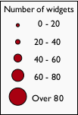

**Range-graded symbols** can avoid the

perceptual problem



E.g., choropleth mapping

* Divide data into groups or classes and represent them with symbols with different sizes
* Symbols only convey ordination, actual values (value ranges) found in the legend as labels
* How are types in mathematical scaling and perceptual scaling different from each other?

**Mathematical scaling**

* Area of points proportional to data(cont.)
  + E.g. if data value is 10 times the other data value, then the area of the

point symbol is 10 times as large.

* **user’s underestimation”(?)**
* What are good designs for graphs and charts in mapping?
  + **Figure-ground**
  + **Symbolization, labeling**
* How to choose an appropriate type of chart for certain types of data?
  + Match the type of chart with data and its purpose
  + Graphs often provide useful complement to map
    - Further insight into mapped or other variables
* What is chartjunk in mapping?

Things to beware: **chartjunk (Tufte, 1983)**

**Data-ink**

* How large proportion of the “ink” used in the graph is actually

devoted to data, non-redundant? (effectiveness of materials used)

**The grid and graph area**

* Grids often not necessary for the purpose – think critically before

including

* Gray shades of graph background typically not helpful, especially in

print

**Moire effects**

* Many hatch-patterns create unwanted noise
* 3D and perspective views
* Check any misleading units, scaling, and cutting axes