Software Engineering Using Rationale System
Programmer’s Guide

Dr. Janet Burge
Miami University
burgeje@muohio.edu

Version 2
Table of Contents

1 Introduction 1
1.1 Purpose of the System 1
1.2 Definitions, Acronyms, and Abbreviations 2
1.3 References 3
1.3.1 SEURAT Information 3
1.3.2 Rationale Information 3
1.3.3 Eclipse 3
1.4 Document Overview 4
1.5 Modification History 4
2 System Installation 4
3 System Deployment 5
4 Software Configuration Management Plan 5
5 Software Requirements 6
5.1 Functional Requirements 7
5.1.1 Rationale Structure 7
5.1.2 Rationale Input 8
5.1.3 Rationale Inference 9
5.1.4 Status Reporting 11
5.1.5 Rationale Queries 11
5.1.6 Rationale Integration 12
5.1.7 Other 13
5.1.8 Report Generation 13
5.2 Non-Functional Requirements 14
6 User Interface Design 14
6.1 Graphical User Interface 14
6.1.1 Rationale Explorer 15
6.1.2 Package Explorer 17
6.1.3 Editor 18
6.1.4 Search Options 18
6.1.5 Rationale Task List 19
6.1.6 Bookmarks 19
6.1.7 SEURAT Preferences 19
6.1.8 SEURAT On-Line Help 21
6.2 Reports Generated 22
6.2.1 Requirements Traceability Matrix Report 22
6.2.2 Rationale Tree Report 23
7 Software Design 23
7.1 System Architecture 24
7.2 Design Goals 26
7.3 Eclipse Integration 27
7.4 Persistent Data Management 27
8 Software Structure 28
8.1 Java Code 28
8.1.1 SEURAT 28
8.1.2 SEURAT.actions 28
8.1.3 SEURAT.api 28
8.1.4 SEURAT.decorators 28
8.1.5 SEURAT.editors 29
8.1.6 SEURAT.search 29
8.1.7 SEURAT.search.commonArguments 29
8.1.8 SEURAT.search.entities 30
8.1.9 SEURAT.search.importanceOverrides 30
8.1.10 SEURAT.search.requirements 30
8.1.11 SEURAT.search.statusOverrides 30
8.1.12 SEURAT.editors.unused 30
8.1.13 SEURAT.events 30
8.1.14 SEURAT.inference 31
8.1.15 SEURAT.queries 31
8.1.16 SEURAT.rationaleData 31
8.1.17 SEURAT.reports 32
8.1.18 SEURAT.tasks 32
8.1.19 SEURAT.views 32
8.1.20 instrumentation 33
8.1.21 SEURAT.popup.actions 33
8.1.22 SEURAT.preferences 33
8.1.23 SEURAT.xmlIO 33
8.2 DatabaseData 33
8.3 doc 33
8.4 html 33
8.5 icons 33
8.6 Main Directory 33
8.6.1 plugin.xml 34
8.6.2 toc*.xml files 38
8.6.3 argument-ontology.xml 38
9 Regression Test Procedure 39
A. SQL Table Creation Script 71

List of Figures

Figure 1: SEURAT User Interface 15
Figure 2: Graphical Rationale View 16
Figure 3: SEURAT Preferences 20
Figure 4: SEURAT Preferences (Local DB) 20
Figure 5: SEURAT Preferences (MySQL DB) 20
Figure 6: SEURAT Help Pages 21
Figure 7: Requirements Traceability Matrix Report in SEURAT 22
Figure 8: Requirements Traceability Matrix Output Selection 22
Figure 9: Rationale Tree Generation prompt 23
Figure 10: Example Rationale Tree Report in plain text 23
Figure 11: SEURAT System Architecture 24
Figure 12: SEURAT Software Architecture 25
Figure 13: Plugin Definition XML 34
Figure 14: SEURAT View Definition 34
Figure 15: Rationale Marker Definition 35
Figure 16: SEURAT Annotation Extensions 35
Figure 17: Rationale Decorator Definition 36
Figure 18: Bookmark View Extension - Pop-up Menu 36
Figure 19: Package Explorer Extension - Pop-up Menu 36
Figure 20: Preference Page Extensions 37
Figure 21: Requirement Editor Extension XML 37
Figure 22: Search Page Extension XML 37
Figure 23: Entity Search Result Page XML 38
Figure 24: Open SEURAT Search Action XML 38
Figure 25: On-Line Help Extension XML 38

Introduction
The Software Engineering System (SEURAT) was first developed as a research prototype as part of Dr. Burge’s PhD work. SEURAT is an Eclipse plugin that captures rationale for decisions made while developing software and inferences over it to detect potential problems in system and to perform impact analysis when requirements, assumptions, or other decision criteria change.

Purpose of the System

The rationale for a system provides the reasons behind the choices made when the system was designed and developed. Standard system documentation captures a static snapshot of the system – what the system does and what the structure is. Rationale augments this information by also providing the why. In argumentation-format rationale, such as that used by SEURAT, the rationale also captures alternative choices that could have been made and why they were not chosen.

SEURAT operates as an Eclipse Plugin. The goal was to be able to integrate rationale capture and use into the same environment that a software developer would use. This increases the likelihood that they would capture and use the rationale. SEURAT provides the following major elements of functionality:

- Rationale editing – the developer can create and modify the elements of the SEURAT rationale argumentation
- Rationale inference – SEURAT automatically inferences over the rationale as it is created and modified to point out any potential problems to the developer
- Rationale-Code association – alternative solutions captured in SEURAT can be mapped to the code that implements them. This is currently done using the Eclipse bookmarks. The bookmarks can be used to jump directly from the bookmark describing the rationale to the code. Also, the presence of the bookmark in code will alert the user that rationale is present and allow them to view the alternative description by moving the mouse over the bookmark.
- Rationale-Project association – SEURAT rationale databases can be mapped to the Eclipse projects that implement them. This is done by an addition to the context menus for projects in the Eclipse Package Explorer. By selecting an item on the project’s context menu, the user can automatically open the associated rationale database, and if the database does not exist SEURAT will create it.
- Rationale queries – the developer can perform a number of queries about the rationale with different criteria, such as which requirements are violated, what arguments are used the most often, etc.
- Rationale reports – the developer can request and obtain several printable reports about the rationale, including a requirements traceability matrix and the rationale tree itself. In addition, SEURAT has a graphical rationale function which displays relationships between rationale elements in a manner that is easier to read and can be more representative of their nature than a tree.
SEURAT stores the rationale in the user’s choice of a MySQL database or a local database using Apache Derby. This was done for scalability reasons and so the rationale could be shared between users. SEURAT supports remote MySQL databases as well as local ones. To deal with the issue of bookmarks (since that information is stored locally by Eclipse) SEURAT automatically stores and reads associations from the database to generate the bookmarks when a database is loaded, and it updates the associations in the database when a change such as a refactoring is made to the associated code. The system is not currently capable of sending notifications when changes are made remotely, so if multiple users are accessing a database at the same time they must manually refresh.

For more information on SEURAT, see the SEURAT web site:

http://www.users.muohio.edu/burgeje/SEURAT

Definitions, Acronyms, and Abbreviations

Alternative | An alternative solution to a decision problem
Argument | An argument for or against an alternative. Arguments can refer to requirements (meets, addresses, violates), claims (supports, denies), assumptions (supports, denies), other alternatives (pre-supposes, opposes), and other arguments (supports, denies).
Argument Ontology | The argument ontology contains a hierarchy of non-functional requirements at different levels of abstraction
Assumption | Something that is believed to be true about the system or the environment it will be operating in
Claim | A claim that something applies, or does not apply, to an alternative. These are a type of argument that relate to non-functional requirements. Ex: an alternative IS usable; an alternative IS NOT easy to code.
Decision | A decision that needs to be made while developing or updating the system. Decisions are often in the form of questions. Decisions are often referred to as “decision problems.”
Non functional requirement (NFR) | A non-functional requirement, or NFR, are also known as quality requirements, quality attributes, “ilities”, and soft-goals. An NFR refers to a quality of the system that do not refer to a specific piece of functionality provided but rather to something that applies to the entire system or a significant part of it. These are also referred to as “cross-cutting requirements” because they cross-cut functionality.
Ontology | An ontology is a set of terms and the relationship between them
Question | Questions indicate where more information is needed before making a decision. Questions can apply to decisions or alternatives.
Requirement | A requirement is something that must be done by the system

References

SEURAT Information
SEURAT web site: http://www.users.muohio.edu/burgeje/SEURAT

The publications link on this web site lists most SEURAT publications.

Rationale Information
Survey papers about rationale:

Lee, J: 1997, Design rationale systems: understanding the issues, IEEE Expert 12(3): 78-85.
Burge, J. & D.C. Brown (1998), Design Rationale: Types and Tools, Technical Report, Worchester Polytechnic Institute, Computer Science Dept., http://web.cs.wpi.edu/Research/aidg/DR-Rpt98.html. Retrieved on 2007-06-08

Books about rationale:
Dutoit, AH; McCall R, Mistrík I, Paech B (2006). Rationale Management in Software Engineering. Heidelberg: Springer-Verlag.
Conklin, J (2005). Dialogue Mapping. Weinheim: Wiley-VCH Verlag.
Kirschner, PA; Buckingham-Shum SJ, Carr CS (2003). Visualizing Argumentation: Software Tools for Collaborative and Educational Sense-Making. London: Springer-Verlag.
Moran, T; Carroll J (1996). Design Rationale Concepts, Techniques, and Use. NJ: Lawrence Erlbaum Associates.

Eclipse
Eclipse Web Site: http://www.eclipse.org

Numerous Eclipse Corner articles: http://www.eclipse.org/articles/

Specifically:

Gauthier, L. (2003), Building and Delivering a Table Editor with SWT/JFace

Glozic, D., McAffer, J., (2001), Mark My Words: Using markers to tell users about problems and tasks

Grindstaff, C. (2002), How to use the Jface Tree Viewer
Krish-Sampath, B. (2003), Understanding Decorators in Eclipse

MacLeod, C. (2001), Understanding Layouts in SWT

Books on Eclipse:

Shavor, S., D’Anjou, J., Fairbrother, S., Kehn, D., Kellerman, J., McCarthy, P. (2003) The Java Developer’s Guide to Eclipse. Addison Wesley

Clayber E., Rubel, Dan, (2004). Eclipse: Buliding Commercial-Quality Plug-ins. Addison-Wesley

Document Overview

This document is intended to provide documentation to developers working on SEURAT. It supplements but does not replace the documentation provided by the JavaDoc and the SEURAT On-Line Help. The first two sections after this one describe installation (Section 2) and deployment (Section 3). Section 4 describes the Software Configuration Management plan – how the code should be stored and managed using Subversion. Section 5 gives the Requirements (functional and non-functional) while Section 6 describes the User Interface Design. Section 7 describes the system design at a high level while Section 8 gets into the implementation details by describing each Java Package. Section 9 gives the regression test procedure that should be run whenever a new version is released to make sure that no new defects are being reduced. Appendix A gives a script that can be used to set up the database.

Modification History

Version | Date | Reason
1.0 | August, 2007 | Initial Version
1.1 | October, 2007 | Team 1 additions including local database and reports  Team 1: Sean Hanna, Trey Moler, Ryan Wagner
1.2 | December, 2007 | Team 1 additions including rationale-project associations and new Eclipse-style editor windows
1.21 | January, 2008 | Team 1 minor edits and revisions to version 1.2
1.3 | March, 2008 | Team 1 additions including graphical rationale view, dynamic updating of editors, import/export of argument ontology from XML to the DB, and remote databases
1.4 | May, 2008 | Team 1 improvements to version 1.3 features and additions including multi-user rationale (persistent associations) and integrated search
2.0 | January, 2011 | Moved Team 1 specific install site information

System Installation

Instructions for installing SEURAT can be found in the download section of the SEURAT web site:
http://www.users.muohio.edu/burgeje/SEURAT/Downloads.html

The URL for the installation site, for the latest version, is:

http://www.users.muohio.edu/burgeje/SEURAT_5_0

System Deployment

SEURAT is deployed using an Install Site like other plugins. This is done as follows:

- You must get all features working and compiling first!
- Create a new API Baseline. Go to Preferences → Plugin Development → API Baselines, add a base line, give it a name and click “Reset”.
- Create a new feature for your plugin. Give it a name that makes sense like SEURAT_x_y (where x_y is the version number). Also specify the version number (which should be higher than one that it is replacing).
- On the overview screen, select “Synchronize” and choose the force feature option.
- Provide the description for the feature on the information page. Also specify the copyright notice and license agreement text.

The next steps very depending on if this is a new install site. If it is new, do the following:

- Create a new Install Site (there will be a link to do this from your feature)
- Name the site and browse to the location where it should be located (on whatever drive contains your web space)
- Optional: Create a new category, and drag the package to the newly created category. Give the site a description to get rid of the error.
- Then hit Synchronize from the site.xml file
- And then choose “Build All”

If you are adding a new version to an existing install site, do the following:

- Open the site.xml file for your install site.
- Select the old feature and right click to remove it.
- Add your new feature to the site.
- Synchronize
- Build all

Software Configuration Management Plan

Software Configuration Management for the SEURAT project will be performed using Subversion (svn). There will be two primary interfaces into Subversion: through the Subclipse plug-in and through the command line. All SEURAT source code will be stored in Subversion. On-line help pages must also be stored in Subversion. The Javadoc files, with the exception of the package.html file for each package, will not be stored in Subversion because it is re-generated each time and can easily be restored from the source code. The package.html file for each package must be written by the developer and for that reason must be kept under version control.

The Subversion repository location is https://svn.csamu.org/burgeje/SEURAT. Under the main repository directory there are three subdirectories: trunk, which contains the main version of the SEURAT code, branches, which will contain versions of SEURAT developed by student teams, and tags, which will contain versions of SEURAT released to the customer or instructor. SEURAT developers are also encouraged to create tags for other reasons such as just before and just after major revisions.

SEURAT development by student teams should only take place within their branch of the repository. There should not be any code committed into or merged into the trunk.

Use of Subversion for SEURAT development is MANDATORY. This is non-negotiable. Each team can negotiate among themselves about when source files should be committed into the repository. There are two strategies that can be employed: committing only working code and updating your local copy frequently and before making any changes, and committing code more frequently but not updating with the latest version until your teammates say it is ready. There are arguments in favor of each strategy – committing the code allows you to easily retract any changes and puts your code on a computer that is backed up regularly but you will need to coordinate with each other and tag religiously so it is easy to back up to a working version if there are conflicts. Submitting all the code as a whole right before the software is released is not a recommended strategy and is only a marginal improvement over not using version control at all.

When code is committed, there should be an explanation of the changes entered in the comments field. This can prove invaluable later on if problems are found and it is necessary to back out versions. Often comments provided during check-in are the only source of rationale for why the code needed to be changed. Comments like “fixed bug” or “new version” are to be avoided. Instead, describe what was changed and why.

Any new versions released for grading or to an install site MUST be tagged with a name that can be mapped to the release. Tagging is done by making a copy of that version of the code and storing it, along with its name, to the tags directory.

Here is an example of how to create a tag:

svn move –m “Tagging Release 2.0” https://svn.csamu.org/burgeje/SEURAT/trunk https://svn.csamu.org/burgeje/SEURAT/tags/Release_2_0

Software Requirements

The following sections describe the requirements for SEURAT. Note that additions added to SEURAT to support the Ontology supported Rationale for Collaborative Argumentation (ORCA) system are not described here although some of the ORCA functionality is implemented in the software. Prior to resuming work on ORCA the requirements for the system should be defined and documented.

Functional Requirements

Rationale Structure
- The rationale shall be displayed in a tree view with the following elements:
  - Requirements
  - Decisions
  - Alternatives
  - Arguments
  - Claims
  - Assumptions
  - Questions
- An Argument Ontology shall contain a hierarchy of non-functional requirements at different levels of abstraction.
- Background knowledge in the form of Tradeoff and Co-occurrence Relationships shall be stored in the rationale.
- Requirements shall contain a name, description, type {functional or non-functional}, status {addressed, satisfied, undecided, violated, retracted, rejected}, and an indicator showing if it is enabled or disabled.
- Decisions shall contain a name, description, type {single or multiple choice}, status {resolved, unresolved, non-resolvable, retracted, addressed}
- Alternatives shall contain a name, description, artifact, and status {adopted, at-issue, rejected}
- Arguments shall contain a name, description, type {supports, denies, opposes, addresses, satisfies, violates, pre-supposes} , importance {default, low, moderate, high, essential}, and category {requirement, claim, assumption, alternative, argument}, plausibility {low, medium, high, certain}, amount {1-10}
- Valid argument type/category combinations shall be limited to the following:
  - requirement – addresses, satisfies, or violates;
  - claim – supports or denies;
  - assumption – supports or denies;
  - alternative – opposes or pre-supposes;
  - argument – supports or denies.
- Claims shall contain a name, description, direction {is, not}, importance {default, low, moderate, high, essential}, and an argument ontology entry.
- Assumptions shall contain a name, description, importance {low, moderate, high, essential}, and an indicator if the assumption is enabled or disabled.
- Questions shall contain a name, description (the question), a procedure for answering it, an answer, and a status {answered, unanswered}.
- The following relationships shall be supported:
  - Requirements can have arguments
  - Decisions can have alternatives
  - Decisions can have questions
  - Decisions can have sub-decisions
  - Alternatives can have arguments
  - Alternatives can have questions
  - Arguments can have questions
  - Arguments can have arguments
  - Alternatives can have decisions
- Argument ontology entries (aka ontology entries) shall contain a name, description, and importance {low, moderate, high, essential}
- An argument ontology entry can have child entries.
- An argument ontology entry can appear more than once in the hierarchy
- Tradeoffs shall contain a name, description, symmetry {symmetric, not symmetric}, and the two ontology entries being traded off
- Co-occurrences shall contain a name, description, symmetry {symmetric, not-symmetric}, and the two ontology entries that must appear in arguments together

Rationale Input
- Editing displays shall be provided for each of the rationale elements:
  - Requirements
  - Decisions
  - Alternatives
  - Arguments
  - Claims
  - Assumptions
  - Questions
  - Ontology entries
  - Tradeoffs
  - Co-occurrence relationships
- No two rationale elements of the same type shall be allowed to have the same name and an error shall be reported if this is attempted. This applies to all elements:
  - Requirements
  - Decisions
  - Alternatives
  - Arguments
  - Claims
  - Assumptions
  - Questions
  - Ontology entries
  - Tradeoffs
  - Co-occurrence relationships
- The status, type, and category elements described shall be the only valid values that will be accepted by the system and the user will not be allowed to choose any other values. This applies to:
  - Requirements
  - Decisions
  - Alternatives
  - Arguments
  - Questions
- If the user changes the status of a rationale element, the system shall request that they enter an explanation. This applies to:
  - Requirements
  - Decisions
  - Alternatives
  - Questions
- When a rationale element is added or modified, the system shall perform any applicable inferencing to identify how the change would affect the status of any affected rationale elements.
- All rationale shall be stored persistently.
- Rationale editors shall follow certain specifications:
a. Editors shall be integrated with and use the Eclipse editor window framework.
b. Editors shall be capable of accommodating the dimensions of the Eclipse editor workspace desired by the user.
c. Editors shall be automatically updated in real-time if changes occur elsewhere.

Rationale Inference
The system shall support detection of the following problems:
- No Reason For Selection - This applies when an alternative has been selected where there are no arguments for the alternative. Used to detect when a poor decision has been made. This could either indicate that the wrong alternative was selected or that the rationale is not complete. In either case, this is an error and should be reported. This shall be checked automatically when an alternative is selected and applies to selected alternatives. This shall be reported as an error.
- Selection Contradicted - This applies when an alternative has been selected where there are arguments against the alternative but no arguments for the alternative. Used to detect when a poor decision has been made. This could either indicate that the wrong alternative was selected or that the rationale is not complete. In either case, this is an error and should be reported. This shall be checked automatically when an alternative is selected and applies to selected alternatives. This shall be reported as an error.
- No Selected Alternative - Indicates that the rationale and/or the design is not complete. In this case, there is a decision where a selected alternative has not been specified. This shall be checked as soon as the decision is created. This means that there will be errors reported because the rationale is incomplete, but that is considered an advantage because the error messages remind the developer that they need to make the decision. This applies to decisions and shall be reported as an error.
- Too Many Selected Alternatives - Indicates that two alternatives have been selected for a decision when the decision is only supposed to have one. This shall be checked whenever any of the alternatives is edited. This applies to decisions and shall be reported as an error.
- Missing Sub-Decisions - Indicates that a decision which is supposed to be expanded by sub-decisions does not have any sub-decisions listed in the rationale. This indicates that the rationale is incomplete. This shall be checked whenever a decision is edited or created and will be made for the updated decision and, if applicable, its parent decision. This applies to decisions and shall be reported as an error.
- Unanswered Questions - Indicates that there is a question in the rationale that has not been answered. This shall be checked as soon as the question is created and will remind the developer that they need to answer the question in order to make their decision. This applies to decisions and alternatives and shall be reported as an error.
- Best Supported Alternative not Selected - Indicates that the alternative that was selected is not as well supported as one or more of the other alternatives for the decision. This shall be checked as soon as an alternative is selected for the decision. It also shall be checked whenever any of the arguments for any of the alternatives for the decision are modified. This allows detection of problems introduced if a requirement or assumption is disabled or if new arguments are added. This applies to the decision and is reported as a warning.
- Requirements Violation - Indicates that that an alternative was selected that violates a requirement. This shall be checked each time an alternative and/or its arguments are edited. This includes a check whenever an alternative is selected. This applies to alternatives and requirements and is reported as an error.
- Contradictory Arguments - Looks to see if the same argument is used both for and against an alternative. This indicates a probable error in the rationale. This shall be checked whenever an alternative or one of its arguments is modified. It applies to alternatives and is reported as an error.
- Duplicate Arguments - Looks to see if the same argument is used multiple times for an alternative. This indicates a probable error in the rationale. This is checked whenever an alternative or one of its arguments is modified. It applies to alternatives and is reported as an error.
- Pre-supposed Not Selected - looks to see if there is an alternative that requires that another alternative is selected that is not (i.e., the first alternative pre-supposes the latter). This is done by checking in both directions (making sure the alternative does not pre-suppose another and that no alternatives pre-suppose it). This shall be checked whenever a selected alternative or one of its arguments is modified to ensure that it does not depend on a non-selected alternative. It applies to alternatives and is reported as an error.
- Opposed Selected - looks to see if there is an alternative that requires that another alternative must not be selected. This shall be checked whenever a selected alternative or one of its arguments is modified to ensure that it is not opposed by another alternative is selected. This is done by checking in both directions to make sure that each alternative is not opposed by, or in opposition to, another selected. This applies to an alternative and is reported as an error.
- Co-occurrence Relationship Violation - Makes use of background knowledge to detect arguments that have co-occurrence relationships. In this case, these arguments must go together on the same side of the argument. This shall be checked whenever arguments are edited. It applies to a decision and is reported as an error.
- Co-occurrence Relationship Missing - Makes use of background knowledge to detect arguments that have co-occurrence relationships. In this case, these arguments must go together on the same side of the argument and one is missing. This shall be checked whenever arguments are edited. It applies to a decision and is reported as an error.
- Tradeoff Relationship Violation - Makes use of background knowledge to detect arguments that have tradeoff relationships. In this case, these arguments must go together on opposite sides of the argument. This shall be checked whenever arguments are edited. It applies to a decision and is reported as an error.
- Tradeoff Relationship Missing - Makes use of background knowledge to detect arguments that have tradeoff relationships. In this case, these arguments must go together on opposite sides of the argument and one is missing. This shall be checked whenever arguments are edited. It applies to a decision and is reported as an error.

Status Reporting
- Status changes shall be reported to the user when they occur.
- The user shall be able to override any status message so that it no longer is displayed as a warning or error.
- The user shall be able to find any overrides and undo them if necessary.

Rationale Queries
The following queries about the rationale shall be supported:

- The user shall be able to request a list of all rationale entities of a specific type and select an item from that list to edit. This applies to:
  - Requirements
  - Decisions
  - Alternatives
  - Arguments
  - Claims
  - Assumptions
  - Questions
  - Ontology entries
  - Tradeoffs
  - Co-occurrence relationships
- The user shall be able to request a list of requirements with a specific status and select a requirement from that list to edit. The status values are:
  - Addresses
  - Satisfies
  - Violates
  - Undecided
- The user shall be able to request a list of arguments sorted by frequency of occurrence for all, or selected, alternatives. The types of arguments this applies to are:
  - Assumptions
  - Claims
  - Ontology-entries
- The user shall be able to find any arguments where the default importance was overridden for an
  - Argument, or
  - Claim.
- The user shall be able to list all alternatives that relate to a specific requirement and the nature of the relationship.
- The user shall be able to display the history for the following rationale elements:
  - Requirements
  - Decisions
  - Alternatives
  - Questions
- The user shall be able to request a list of all rationale entities of a specific type and select an item from that list to show expanded in the rationale tree. This applies to:
  - Requirements
  - Decisions
  - Alternatives
  - Arguments
  - Claims
  - Assumptions
  - Questions
  - Ontology entries
  - Tradeoffs
  - Co-occurrence relationships

Rationale Integration
- It shall be possible to create, edit, and display rationale from within the same software development environment used to write the software it describes.
- The system shall allow association between a selected alternative and the code that implements it.
- The system shall indicate which code has associated rationale.
- If the user is editing a piece of code with associated rationale, this shall be indicated within the editor.
- The user shall be able to easily find and edit the code associated with an alternative.
- The user can perform associations with the file being associated with open in the editor or closed.
- The user shall be able to delete associations.
- The system shall allow associate between an Eclipse project and a set of rationale. The associated rationale databases shall have the name of the project with “_Rat” appended to the end.
- Associations between alternatives and artifacts shall be stored persistently and a function shall be provided to restore these if in a multi-user environment.

Other
- If an importance value of “default” is given for an argument that is about a claim or assumption, the importance shall be inherited from the claim or assumption.
- The importance for an argument about a requirement shall always be “essential.”
- The importance for an argument that refers to another alternative (opposes or pre-supposes) will be essential if the related alternative is selected or not important if the alternative is not selected.
- If an importance value of “default” is given for a claim, the importance shall be inherited from the argument ontology entry associated with the claim.
- The user shall be able create a new set of rationale that will contain a fully-populated Argument Ontology.
- The user shall be able to change from one set of rationale to another.
- The system shall warn the user if they attempt to change the status of an alternative from rejected to selected.
- The system shall calculate support for each alternative and display that score in the editor for the associated decision. The score will be the value of the arguments for the alternative minus the value of the arguments against the alternative.
- The system shall recalculate support for alternatives when the following elements are disabled:
  - Requirements
  - Assumptions
- The system shall allow the user to set Preferences for database parameters.
- The system shall provide on-line help.
- If the user changes the importance of a claim from “Default” to a value, the argument will inherit that value.
- If the user changes the importance of an argument from “Default” to a value, the score will be computed from that value and not inherited.
- The system shall allow the user to switch between using three types of databases:
  - Apache Derby, a local database that can be installed with SEURAT
  - Database on a MySQL server available at the address localhost
  - Database on a remote MySQL server with user-specified address and port
- The user shall be able to use an Argument Ontology that they specify.
  - An XML-format Argument Ontology included with the plug-in will be used in favor of the hard-coded ontology when a new database is created.
  - The user will be able to edit the Argument Ontology in SEURAT and save their changes to an XML file, which can then be used for new databases.
- The system shall provide a graphical rationale visualization option which displays the rationale in a graphical “map” format that is cleaner than the tree view.

Report Generation
- It shall be possible to generate a report containing the requirements traceability matrix, which is a table containing the fields Requirement, Alternative, Relationship, and Associated Artifact.
- It shall be possible to generate a report containing the rationale tree. Users shall be able to select between two options:
  - Report containing the entire tree
  - Report containing only the sub-tree(s) currently selected in the Rationale Explorer
- It shall be possible to export these reports in some sort of text format.

Non-Functional Requirements

There were several NFRs that are important to the development of SEURAT:

- Usability. The system needs to be intuitive and easy to learn. On-line help must be provided to describe system features and how to learn them.
- Consistency. Views created in SEURAT should match the look and feel of the IDE it interfaces with as much as possible.
- Scalability. SEURAT needs to be able to handle large amounts of rationale and, eventually, multiple users all accessing that information simultaneously.
- Affordability. Since we wish to be able to evaluate SEURAT at multiple sites, it is important when using COTS products that we use software that can be obtained for free. This might not be possible when it comes to choosing a UML tool.
- Portability. SEURAT should run in any environment that can run the development environment it is integrated with. It has been evaluated on Windows and Mac OS.

User Interface Design

Systems can interface with users in more than one way. What is typically thought of as the UI is the GUI. Systems may also produce other types of output that are used by their users. For SEURAT, the UI design is described in two main sections: the Graphical User Interface (GUI) and the Reports.

Graphical User Interface

This section describes the design of the SEURAT GUI. Since SEURAT was developed as an Eclipse plug-in, it is important that it be designed to be consistent with the Eclipse environment. Figure 1 shows the main SEURAT interface with four of the five views that it impacts. The views can be re-arranged to different positions in the window.

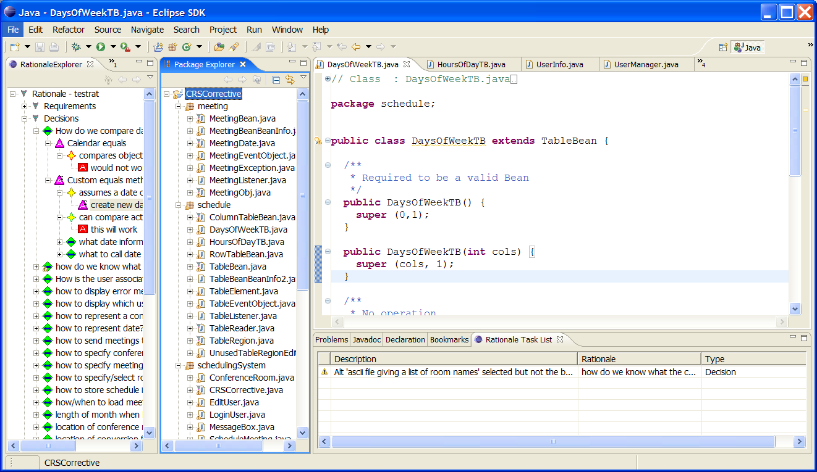
Figure 1: SEURAT User Interface

The view to the far left is the Rationale Explorer. This view displays the rationale argumentation in a tree format. The next view over to the right is the Package Explorer. This is the Eclipse Java Package Explorer with some extensions. The editor window to the upper right is the Eclipse editor and the window to the lower right is the Rationale Task List which displays all warnings and errors detected in the rationale.

Rationale Explorer

The tree was chosen format was chosen for the Rationale Explorer because it is a natural way to display argumentation. It is also a format familiar to most software developers who are used to working with trees in software development environments. The different icons represent the different types of rationale elements. Icon overlays and outlines give additional information about the element. For example, disabled elements (requirements and assumptions) have a “D” overlay. Selected alternatives have an “S” overlay. The argument direction is indicated by the color around the icon border – red signifying against, green signifying for. When a problem is detected with the rationale, the appropriate error or warning icon is overlaid on the rationale element icon that has the problem. This was done to be consistent with how compilation warnings and errors are reported by Eclipse.

At the upper right hand corner of the Rationale Explorer there is a downward pointing arrow. This brings up a menu of queries and other operations that can be performed on the rationale. These elements are as follows:

- Reload Rationale DB – choosing this option re-loads the rationale database whose name was provided on the preference page.
- Create New Rationale DB – this option prompts the user for a new database name. Then SEURAT creates a new database with this name that contains the tables needed to create the rationale elements and a fully populated argument ontology.
- Restore Associations – this option restores the bookmarks and associations from a set stored in the database. This should only be used when working with a multi-user database in order to have the most recent set of associations.
- Input Rationale – this option is used to read in an XML file containing rationale and store it in the database. This option needs further testing.
- Generate Traceability Matrix – brings up a display where the user can view the requirements traceability matrix of this rationale database, with the option of outputting the traceability matrix to a data file in a similar format.
- Show Graphical Rationale – brings up a display where the user can view the rationale, and rationale elements' relationships with other elements, in a more accessible graphical format. Figure 2 shows a demonstration of this view.

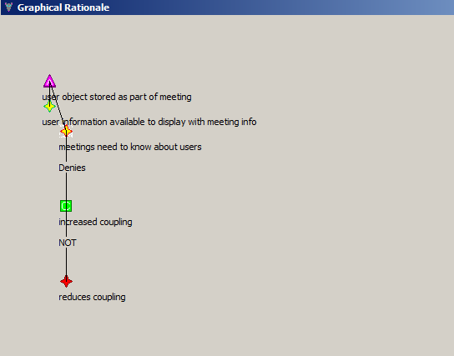Figure 2: Graphical Rationale View
Each rationale element in the Rationale Explorer also has a context-sensitive pop-up menu. Elements can be edited using the “Edit” option as well as by double-clicking on the element name. “Export Rationale Tree from Here” and “Show Graphical Rationale from Here” are available for all elements and will generate these reports with the selected element as the root of the tree. In addition, the following options are available for specific rationale element types:

Requirements:

- New Argument – adds new sub-arguments under the requirement
- Delete – deletes the requirement
- Find Relationships – lists arguments the requirement is involved in
- Show History – shows the history of status changes to the requirement

Decisions:

- Delete – deletes the decision
- New Alternative – create an alternative solution
- New Decision – create a sub-decision (this option is only available if the decision indicates that sub-decisions are required)
- New Question – create a question about the decision
- Show History – shows the history of status changes to the decision

Alternatives:

- Delete – deletes the alternative
- New Argument – create an argument for or against the alternative
- New Decision – create a decision that needs to be made after the alternative is selected
- New Question – create a question about the alternative
- Show History – shows the history of status changes to the alternative
Arguments:

- Delete – deletes the argument
- New Argument – create an argument for or against this argument

Questions:

- Delete – deletes the question
- Show History – shows a history of status changes to the question

Tradeoff/Co-occurrence:

- Delete – deletes the tradeoff or co-occurrence
Argument-Ontology

- Export Ontology to XML – saves the current Argument-Ontology to an XML file

Package Explorer

The view that is second to the left is the Package Explorer. This is the standard Eclipse Package Explorer with four extensions: a rat overlay icon appears on files that have associated rationale and there are three new pop-up menu items: Associate, Remove Association, and Open Rationale. The Associate option will associate the resource selected in the Package Explorer (a file, method, or attribute) with a rationale alternative. If no alternatives are selected, the user will be prompted with a list of alternatives allowing them to choose the one involved in the association. The Open Rationale option will appear only for projects and will open the rationale database associated with the selected project, or create one if an associated database does not exist.

Editor

The main editor is the standard Eclipse editor with one addition – the bookmarks are created using the Associate menu items and indicate when rationale has been associated with the code. If the mouse is moved over a bookmark, the name of the associated alternative is displayed.

Search Options

SEURAT integrates with Eclipse's search interface to provide several different options by which the user can query the rationale database. SEURAT Search is accessed by “Search -> SEURAT Search” from the Eclipse main menu bar. The SEURAT search page contains several different search types and parameters for those searches:

- Entity – allows the user to search for a type of entity (specified in the Parameters drop-down box). Selecting Search brings up a list of entities of that type in alphabetical order. The user can choose to Show an element, which expands it in the Rationale Explorer so it can be seen in the hierarchy, or Edit an element, which brings it up in an editor.
- Requirement – allows the user to select a type of status they are interested in (Addressed, Satisfied, Violated, Undecided, Retracted, Rejected). Then a list of requirements that have that status are shown, along with the argument that gave them that status.
- Common Argument – allows the user to select the type of argument (Assumption, Claim, or Ontology Entry) and if they are only interested in seeing arguments for selected alternatives. After making their selection they can view a list of the arguments of that type and how many times they appear in total, for alternatives, and against alternatives. They are also given the option of displaying any of the arguments in an editor.
- Status Override – brings up a list showing any rationale error or warning messages that were overridden by the user. The user has the option to remove the override so the message appears on the Rationale Task List.
- Importance Override – when defining arguments and claims, the user has the option of setting an importance value or inheriting it from a lower level item (claim for argument, ontology entry for claim). The Importance Override option brings up list of argument and claim overrides – arguments and claims where the importance is not ‘default”. The user can select an argument or claim to edit it.

Rationale Task List

The Rationale Task List was modeled after the Task List in an earlier version of Eclipse that displayed compilation errors and warnings. That view has since been renamed to Problems. The Rationale Task List displays errors and warnings about the rationale. The icons used to indicate errors and warnings are taken from Eclipse and also appear on elements in the Rationale Explorer. The user can select any of the error or warning messages, right click, and select “Override” to remove the message from the list. Overriding a warning or error message will also remove any warning or error icon overlays associated with it. Overridden messages are not removed from the system and can be retrieved and reinstated using the “Status Overrides” search query available from SEURAT Search under the main Eclipse search menu. The user can also bring up an editor for the element that has an error by right clicking on the error message and requesting “Edit.”

Bookmarks

The associations between alternatives and rationale are displayed as Bookmarks in Eclipse. Bookmarks generated by SEURAT describe the alternative, the resource, the source folder where the resource is stored, and the name of the artifact.

SEURAT Preferences

The preferences are accessed along with other Eclipse Preference settings by choosing Window->Preferences. For SEURAT, the only preference settings that currently exist are for choosing which DBMS SEURAT should connect to. In the future, there may be more preferences that can be displayed on additional pages. Figure 3 shows the SEURAT main preference page, where the database type can be selected. The options available are Derby (a local, embedded Java database) and MySQL.

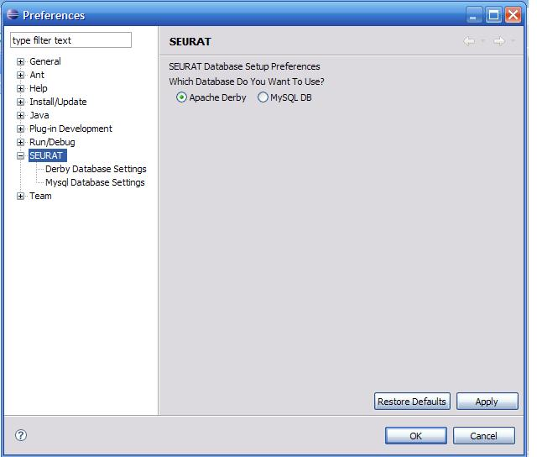
Figure 3: SEURAT Preferences

Figures 4 and 5 show the SEURAT DBMS Preference pages; each provides the ability to control how SEURAT communicates with their respective DBMS. (Derby or MySQL)
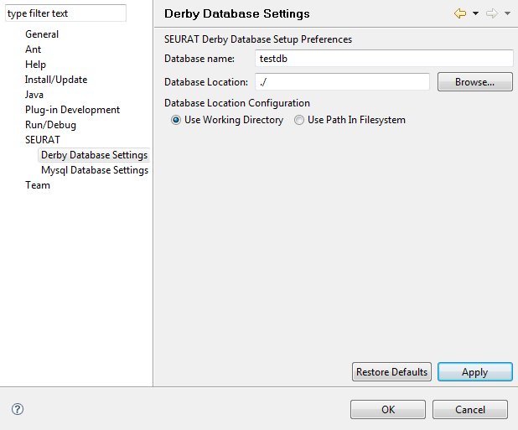
Figure 4: SEURAT Preferences (Local DB)
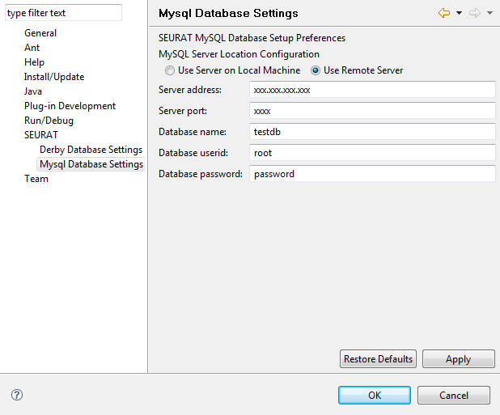
Figure 5: SEURAT Preferences (MySQL DB)
The Derby Preferences screen (Figure 4) can configure SEURAT to use a repository anywhere in the file system. By default SEURAT will store the database files in your Eclipse working directory. You can also provide another folder in the file system by selecting the radio button labeled Absolute Path. There is a text box immediately above the radio buttons which controls what absolute path SEURAT uses to load and save the database. SEURAT will automatically append a ‘/’ character to the absolute path name; omitting the trailing slash of an absolute path is preferred in this case.

The MySQL Preferences screen (Figure 5) can configure SEURAT to connect to a local or remote MySQL database. To use a remote database, select the “Use Remote Server” radio button and make sure to enter a valid IP address and port. If you are using a local database, you only need to select the “Use Server on Local Machine” button (the address and port will be ignored). The password is echoed as a string of asterisks. The username specified must have INSERT, UPDATE, CREATE, ALTER, SELECT and DELETE rights to obtain the full functionality of SEURAT. It may be possible to utilize SEURAT in a read-only setting, but this has not been tested and is not officially supported.

Common to both database preference pages is a database name. These two fields are treated independently by Eclipse and the database layer. Changing the Derby database name will not affect the one used when connecting to a MySQL database, and vice versa.

If the user changes the database name or type in the preferences, SEURAT will automatically load the new database, thus saving the user an extra step.

SEURAT On-Line Help

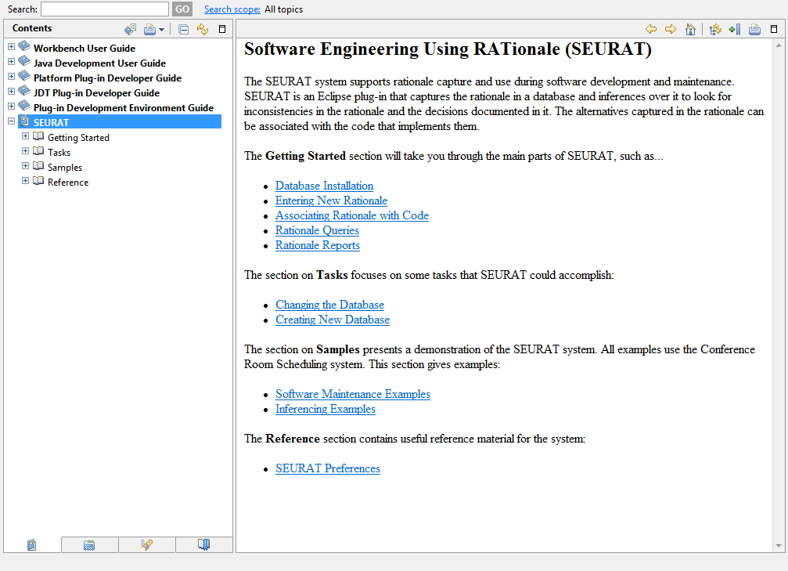
The SEURAT help pages can be viewed through the Help pull-down menu along with other help pages used in Eclipse. Figure 6 shows the main help page for SEURAT.
Figure 6: SEURAT Help Pages

Reports Generated

This section describes the design of the reports SEURAT generates.

Requirements Traceability Matrix Report
The requirements traceability matrix report is a requirements traceability matrix in tabular format. It displays the relationships between requirements and the alternatives that are currently selected, the type of those relationships, and the artifacts associated with the alternatives. The report can be generated in SEURAT by selecting “Generate Traceability Matrix” from the Rationale Explorer pull-down menu. The report is then generated and displayed (see Figure 7). Clicking the button “Output” will prompt the user for an output path and filename.
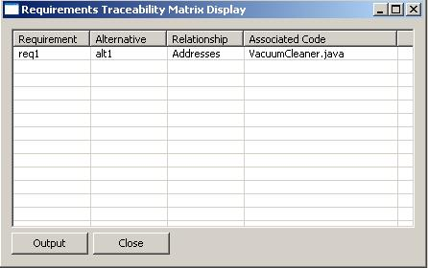
Figure 7: Requirements Traceability Matrix Report in SEURAT
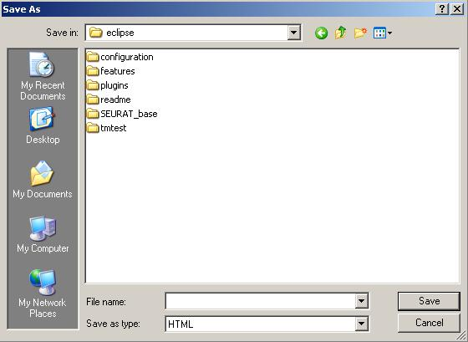
Figure 8: Requirements Traceability Matrix Output Selection
SEURAT will then generate an HTML document containing the report.

Rationale Tree Report
SEURAT can also generate a Rationale Tree Report which exports the Rationale Tree of the current database, or some selected sub-tree, into text format. This can be done by right-clicking on the rationale element that will serve as the root of the sub-tree, and clicking “Generate Rationale Tree From Here.” To export the entire rationale tree, just use the root element containing the database name. Figure 9 shows the Rationale Tree Report generation prompt. Figure 10 shows an example output in plain text format.

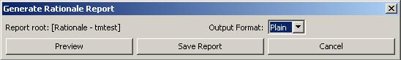
Figure 9: Rationale Tree Generation prompt

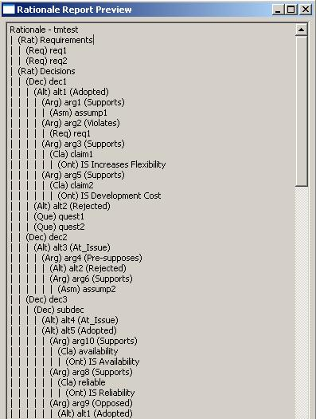

Figure 10: Example Rationale Tree Report in plain text

Software Design

The initial planning of the SEURAT system was done before the Eclipse IDE was available. Eclipse provided the ability to have the development environment integration necessary to make rationale capture and use an integral part of the development process. The following sections describe the SEURAT design in more detail.

System Architecture

The initial system architecture for SEURAT is shown in Figure 11. This consists of four components: the Argument Editor and Analyzer responsible for editing and display of the rationale, the Inference Engine that inferences over the rationale to look for errors and inconsistencies in the rationale and the design, the Rationale Repository that stores the rationale, and an Argument Ontology that stores a re-usable hierarchy of common reasons for making choices during software development.

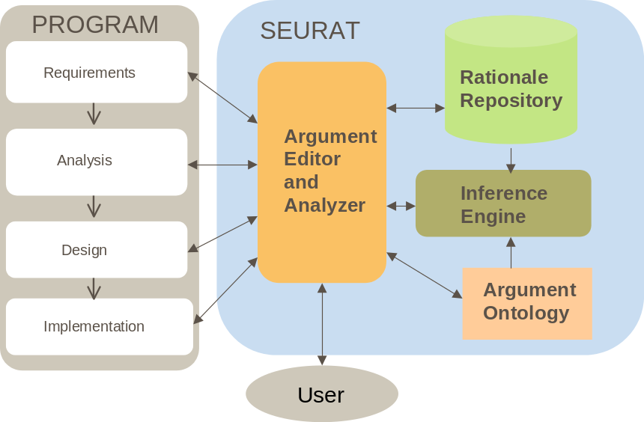
Figure 11: SEURAT System Architecture

The SEURAT software architecture maps these functions on to the different displays and software components that were developed within the Eclipse Framework. Figure 12 shows the Software Architecture.

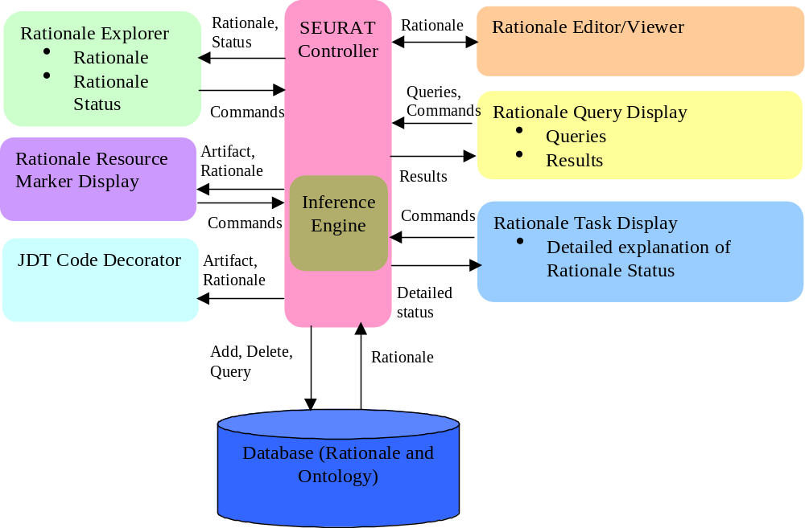
Figure 12: SEURAT Software Architecture

This diagram contains the following parts:

- SEURAT Controller and Inference Engine – this serves as the main point of control for the SEURAT application. It performs any inferencing needed to maintain the rationale status and respond to rationale queries.
- Rationale Explorer – this will give a tree-format view into the Rationale. It will serve two main purposes in the SEURAT system: it provides a way to access the rationale by selecting rationale items in the tree and editing them, and also provides a high-level picture of the rationale status. The status will be indicated by small graphical status indicators that will appear in the tree next to the affected rationale elements. The icons used to indicate errors and warnings on the rationale are the same as those used to indicate errors and warnings within the code.
- Rationale Resource Marker Display – there are several ways that the associations between the rationale and the code are displayed. One is by having a “decorator” icon overlay the icon for the code associated with the rationale. This is shown in the Eclipse package explorer. Another is by putting a “bookmark” on the associated code – this is shown by having the bookmark added to a list of bookmarks maintained by Eclipse and by having a bookmark indicator shown next to the code when it is edited. When the maintainer puts their mouse over this indicator, the applicable rationale is displayed.
- Rationale Editor/Viewer – this is the primary means of editing and viewing elements of rationale. This can be invoked in a variety of ways, the primary one via the Rationale Explorer.

- Rationale Query Display – this is the means for querying the rationale for specific combinations of information. It will have an interface that allows the user to build common types of queries. The results will be a list of rationale elements that meet the query criteria. This list can then be used to invoke the Rationale Editor/Viewer to look at specific elements.

- Rationale Task Display – this display provides a list and description of any problems (errors or warnings) with the rationale. These are listed as tasks that the SEURAT user should consider doing. This is analogous to the way that compilation errors and warnings are displayed by Eclipse. The display will be updated automatically when the rationale changes. The user can use this list to invoke the Rationale Editor/Viewer to look at the elements causing the problem

Design Goals

The system design was intended to address a number of important design goals:

- Selection of off-the-shelf components – the decision was made early on that SEURAT needed to be integrated with the same development environment that was used to build and maintain the software that the rationale would be describing. It was also key to be able to know when the rationale was available without having to bring up a separate tool to search for it. A secondary goal was to choose software that was free. The evaluation plan for SEURAT required that it be run in several different locations and we did not want to run into issues with licensing. As a result, the Eclipse IDE was chosen as the primary platform for SEURAT integration. Eclipse was open-source and offered the ability to build plug-ins that integrated with the Java IDE available in Eclipse.
- Mapping of sub-system to hardware – the initial version of Eclipse was run on one computer and was not distributed. The goal for distribution is to have the database available on a server but to have all other processing done on the client side. This works well in the case of the rationale and a system has been designed and developed to make it also work with the locally-stored bookmarks (see Persistent Data Management, section 7.4). However, there is currently no way for the clients to dynamically update when remote changes are made to the database. This could potentially be addressed with a new table in the database that keeps track of when changes were made, and having the clients query it periodically.
- Design of a persistent data management infrastructure – to provide scalability to large amounts of rationale we decided to use a relational database as the rationale repository. To meet our goals of only using software available free of charge, we choose MySQL as the database provider, and Apache Derby as a local database option. MySQL also provides SEURAT with multi-user database capability.
- Specification of an access control policy – since SEURAT is currently run stand-alone, there is no access control. When the system migrates to a multi-user system, there may be authentication requirements.
- Design of the global control flow – the two main sub-systems in SEURAT are the two Eclipse views generated – the Rationale Task View and the Rationale Explorer. These views both know about the tree of rationale; however there are some events used to bring up rationale editing screens.
- Handling of boundary conditions – Eclipse handles starting and closing views. The database connection is handled by a database control singleton class that opens a connection to the database the first time it is accessed.

Eclipse Integration

The Rationale Explorer and the Rationale Task List are written as Eclipse Views. When SEURAT is installed, the views can be accessed using Show View -> Other, and then choosing the appropriate views. SEURAT integrates with the Package Explorer by adding additional menu items of “Open Rationale,” “Associate,” and “Remove Association” and by adding a rat decorator icon to files that contain rationale. SEURAT also integrates with the Bookmarks view by allowing new bookmarks to be added when associations were made. Earlier versions of SEURAT allowed associations to be removed via the Bookmarks view but that functionality does not work with more recent versions of Eclipse.

SEURAT's editor windows integrate with Eclipse's editor UI by using the Eclipse editor framework and appearing in tabs in the same window pane. Similarly, SEURAT's search page and search results integrate with Eclipse's search UI by using its framework. The search page appears as a tab and has its own main menu option as well. SEURAT also adds SEURAT on-line help pages and preference settings to the Eclipse IDE.

For more details on how SEURAT extends Eclipse, see the section of this document that describes the plugin.xml file.

Persistent Data Management

There are two types of persistent storage utilized by SEURAT. The first is the rationale itself. The rationale is stored using either a MySQL or Apache Derby DBMS. Appendix A gives scripts for setting up database tables in MySQL. This script-based method of creating a database has been deprecated in favor of a database differencing engine. SEURAT can be configured to automatically create missing fields and tables when connecting to an empty or incomplete database. SEURAT utilizes JDBC to create and interact with more than one DBMS.

The second type is via Eclipse markers. These markers capture the associations and are what are used to add the rat decorator to the source code and store the bookmark information. While this is an easy and flexible way to store the associations, it has a significant drawback in that all marker information is stored locally to the Eclipse workspace. SEURAT gets around this by saving the associations to the database and restoring them on database load or whenever the “Restore Associations” menu option is chosen. SEURAT also has a system that integrates with the JDT API and listens for changes to individual Java elements. When code is refactored or otherwise changed, the system determines whether it contains associations, and if it does, the associations are updated in the database. This is a complicated process, but it is necessary for multi-user rationale to function properly.

Software Structure

More on the details of the software can be found in the JavaDoc for the system. The following sections give some additional insight into the system structure. Most of the package names start with edu.wpi.cs.jburge.SEURAT, the edu.wpi.cs.jburge has been omitted from this description for the sake of brevity (and because there may be some refactoring in the future).

Java Code

SEURAT
This package contains code that sets up the SEURAT plugin. Much of it is boiler plate – code taken from plugin demos. One class in the package that is not boiler plate is the SEURATElementChangedManager class, which provides association persistence through refactoring. The class listens for changes to individual Java elements and is instantiated in the SEURAT plugin constructor, where it is added as a listener to the JDT Core.

SEURAT.actions
Most code that implements SEURAT actions is located in the monster class that sets up the Rationale Explorer view. This package gives code for actions that create, remove, and restore associations, as well as opening a rationale database from an Eclipse project.

SEURAT.api
This package sets up a simplified API that we were experimenting with on another project.

SEURAT.decorators
This package handles decorator management for SEURAT. The only decorator used in the current version is the Rat icon that is overlaid on files when rationale is associated with them. The rationale elements in the Rationale Explorer also have what appear to be decorators that give their status but these are actually “fake” – they are icons that contain the overlays. This is because Eclipse (or Eclipse 2.8, the version of use when this code was originally written) only supports decoration of resources – like Java files – and does not allow decorators on custom elements like the rationale.

SEURAT.editors
In the current version of the SEURAT code, there are two editors packages. A new editors package was created for the tabbed SWT editors, but in order to have the option of reverting to the old pop-up editors, and because not all of the pop-up editors have been replaced, the original editors package has not yet been removed.

The original editors package (edu.wpi.cs.jburge.SEURAT.editors) contains pop-up editors for the different rationale entities. There are a couple of “helper” classes that are also in this package. One is the ConstraintChecker – this class is used to check to make sure that all rationale elements of a particular type have unique names. Another is the SelectItem display – this is a generic selection display that is used whenever the user needs to select a specific rationale element from a list of elements of that type.

The new editors package (SEURAT.editors) contains “Eclipse-style” SWT editors for several, but not all, of the rationale element types. The package also contains three other classes. RationaleEditorBase is the base class that is extended by all of the SWT editors. RationaleEditorInput is the base class for editor inputs, and each of the editors has an inner class that extends this class. OpenRationaleEditorAction is a “helper” class that was designed to facilitate the transition from the Rationale Explorer to the new editors. This class uses reflection to determine the editor window class being opened and the rationale element that is going to be added or edited.

SEURAT.search
SEURAT has been extended to integrated the search functionality with the Eclipse searching interface. The SEURAT.search package is the root of all of this searching functionality. A number of classes are present in this root repository because they are accessed by subpackages. Other classes have no relevant location in a sub-package.
The classes used by one or more of the integrated search features include the sorting, content provider, and resize listener classes. Each of these types of classes defines somewhat generic methods of formatting a table. In the future additional common functionality could be implemented in this package as well.
Classes which have no relevance in this package includes the OpenSeuratSearchAction and SearchPage classes. These classes are gateway classes that are responsible for instantiating the specialized searching functionality.

SEURAT.search.commonArguments
This package contains all of the relevant classes implementing Eclipse search API functionality for the common argument search. This consists of query, match, result set and result page classes which interact to provide a common method for displaying the relevant search results.

SEURAT.search.entities
This package contains all of the relevant classes implementing Eclipse search API functionality for the entity search. This consists of query, match, result set and result page classes which interact to provide a common method for displaying the relevant search results.

SEURAT.search.importanceOverrides
This package contains all of the relevant classes implementing Eclipse search API functionality for the importance override search. This consists of query, match, result set and result page classes which interact to provide a common method for displaying the relevant search results.

SEURAT.search.requirements
This package contains all of the relevant classes implementing Eclipse search API functionality for the requirement search. This consists of query, match, result set and result page classes which interact to provide a common method for displaying the relevant search results.

SEURAT.search.statusOverrides
This package contains all of the relevant classes implementing Eclipse search API functionality for the status override search. This consists of query, match, result set and result page classes which interact to provide a common method for displaying the relevant search results.

SEURAT.editors.unused
This package contains editors that are currently not used but that we plan to use at a later date as the SWT editor development progresses. Right now the package only contains one class, which is the AssumptionEditor.

SEURAT.events
The SEURAT.events package contains the definition of a very generic publish subscriber class called PublishSubscribeManager. In addition, there are two helper classes which facilitate the application of the publisher-subscriber design pattern to SEURAT. The RationaleUpdateEvent is a concrete definition of a publication, and describes a modification to a RationaleElement. The RationaleElementUpdateEventGenerator is a helper class which simplifies the semantics of creating a RationaleUpdateEvent for common scenarios in which a rationale element has changed. Lastly, a class PublishSubscribeManagerTest is included in this package which consists of unit tests for the PublishSubscribeManager class. In the future, this subsystem will contain additional classes which will facilitate message passing between different SEURAT subsystems.

SEURAT.inference
The inference package contains classes to check to see if changes made to a rationale element result in status changes. When an element is updated, the appropriate inferencing method is called to look for a change in status. That method then inferences over associated elements to see if their status changes. A vector of RationaleStatus elements is added to each time an error or warning is detected for an element.

For example, when an Alternative is modified, updateAlternative is called with that alternative as a parameter. The update method looks for any sub-decisions relating to the alternative (choosing an alternative is likely to spawn more decisions that have to be made) and calls updateDecision on those, the updateAlternative method then goes on to check if this alternative is involved in any opposed or pre-supposed relationships, checks to see if there are contradictory arguments, requirement violations, etc. When a problem is detected, a RationaleStatus element describing the problem is added to the vector.

One important class in this package is the UpdateManager. The UpdateManager is a Singleton class responsible for keeping track of which elements might have status changes that need to be reflected in the rationale tree shown in the RationaleExplorer. At the end of each inferencing method, the id, name, and type of the rationale entity is sent to the UpdateManager. The manager uses this information later to go to the database to find out what the status is for those elements. It also has a handle to the Tree shown in the RationaleExplorer and updates it with the new status updates when requested. The tree status updates are requested when the user overrides a status element, when the user deletes a rationale element, and when a rationale element is edited.

SEURAT.queries
This package implements various rationale queries (find entity, find overrides, etc.) that are accessed via the pull-down menu on the RationaleExplorer.

SEURAT.rationaleData
This package contains the definitions for all the rationale elements. It also contains enumerated type definitions.

Most rationale elements are subclasses of RationaleElement. RationaleElement defines common attributes such as ID, name, description, history, and the enabled flag. Common methods that must be implemented by the rationale elements that inherit are fromDatabase (read in the element from the database), toDatabase (write the element to the database), display (display the element in the editor), create (brings up an editor for a new element), updateStatus (calls the appropriate inferencing methods), and updateOnDelete (performs necessary inferences when an element is deleted).

New elements can be created using the RationaleElementFactory which, given an element type, returns the appropriate subclass.

The largest class in this package is RationaleDB. This is a singleton class that interfaces with the MySQL database to perform many, although hardly all, of the database functions needed. To make the RationaleDB class a little smaller, two additional classes are included: RationaleDBCreate, which contains statements used when creating a new rationale database, and RationaleDBUtil, which contains some important utility methods.

SEURAT.reports
This package implements various rationale reports (currently only the traceability matrix and rationale tree) that are accessed via the pull-down menu on the RationaleExplorer or, in the case of the rationale tree report, by right-clicking on an element in the tree.

SEURAT.tasks
This package sets up the RationaleTask view. The main class that sets up the view, RationaleTaskView, is actually in the views package. This should probably be moved.

SEURAT.views
This package sets up the RationaleExplorer and handles operations within it. The RationaleExplorer class contains code that defines and, in many cases, handles the various menu options within SEURAT. The bulk of that window contains a tree view.

One thing that SEURAT uses that is not standard for a tree view is the RationaleTreeMap. The map is needed because it is possible for a rationale element to appear multiple times in the tree. For example, a requirement will appear in the list of requirements but will also appear under any arguments that are about it (violates, etc.). If the element is updated, all the references to it in the tree need to be updated as well. Updates can be status changes but they might also be a change in the element name. The TreeMap maintains pointers (handles really) to all the tree elements so they can all be found given the name and type of an element.

This package also defines the RationaleUpdateEvent and RationaleUpdateNotifier that are used so that information that affects multiple views can be disseminated. The three types of event are Edit, Find, and Associate. The Edit event updates the rationale tree based on edits, the Find event Expands the tree to show the node, and the Associate event associates an alternative with the rationale.

Lastly, this package defines the GraphicalRationale view which is where the graphical rationale visualization function is implemented. The GraphicalRationalePop class is a pop-up window version of the view. Currently, the GraphicalRationale class is not used because of issues encountered with the SWT editors and graphics drawing (attempting to draw on the integrated version would result in a blank view), but if these can be solved, the functionality in the GraphicalRationalePop class will be moved there.

instrumentation
This package contains some logging code that was used during the initial evaluation experiments but is currently turned off.

SEURAT.popup.actions
The only class here is RemoveAssociationUsingBookmark. This code used to work but for some reason Eclipse is ignoring attempts to add a menu item to a bookmark. It is unclear if this is a problem with the newer versions of Eclipse or with the code.

SEURAT.preferences
This package sets up the preference pages for SEURAT. The preference pages are currently only used to set some database parameters.

SEURAT.xmlIO
This package contains a class to read in rationale from an XML file. This is how rationale was stored prior to using MySQL. This code has not been very well tested. XML might be a good way to do some data conversions into other formats so we can generate reports from SEURAT.

DatabaseData

This directory contains all the database data that is currently stored in SVN. This isn’t actually where SEURAT would use the data from – these directories would need to be copied into the data directory under the system’s MySQL installation.

doc
This is where the Javadoc goes when generated from Eclipse.

html
This subdirectory contains the html files used for the SEURAT On-Line help system.

icons
This directory contains most, but not all, icons used by SEURAT. Many of the icon files here are older versions of the icons that are not currently in use.

Main Directory
There are several files here, some created by Eclipse, some not. The build.properties file is used to create the .jar files needed when building an install site. The “real” one is the build.properties file, the others appear to have been created under erroneous conditions.

Preference.txt is the way that preferences were set up in the original version of SEURAT. This file is no longer used.

plugin.xml
This is the file that defines the SEURAT plugin. The plugin.xml file defines all the extension points to Eclipse that are used in SEURAT. In this section, the file is broken down to demonstrate this. X shows the first part of the file. This defines the main class for the plugin, the author, the name, and the version number. The version number is used when building a new installation site so that customers will recognize a new version as such.

<plugin
id="SEURAT"
name="SEURAT Plug-in"
version="2.0.0"
provider-name="Janet Burge"
class="edu.wpi.cs.jburge.SEURAT.SEURATPlugin">
Figure 13: Plugin Definition XML
The two views used in SEURAT are set up as extension points. Figure 14 shows the XML defining the views. They are both set up to appear under the SEURAT category and to use the same rat icon that is used as a decorator on the code.

<extension
point="org.eclipse.ui.views">
<category
name="SEURAT"
id="edu.wpi.cs.jburge.SEURAT">
</category>
<view
name="RationaleExplorer"
icon="icons/Rat.gif"
category="edu.wpi.cs.jburge.SEURAT"
class="edu.wpi.cs.jburge.SEURAT.views.RationaleExplorer"
id="edu.wpi.cs.jburge.SEURAT.views.RationaleExplorer">
</view>
<view
name="Rationale Task List"
icon="icons/Rat.gif"
category="edu.wpi.cs.jburge.SEURAT"
class="edu.wpi.cs.jburge.SEURAT.views.RationaleTaskView"
id="edu.wpi.cs.jburge.SEURAT.views.RationaleTaskView">
</view>
</extension>
Figure 14: SEURAT View Definition

The next section of the XML defines the subclass of Bookmark that indicates when rationale is present in a file. This is shown in Figure 15.

<extension
id="SEURAT.ratmarker"
name="Rationale Marker"
point="org.eclipse.core.resources.markers">
<super
type="org.eclipse.core.resources.bookmark">
</super>
<super
type="org.eclipse.core.resources.problemmarker">
</super>
<super
type="org.eclipse.core.resources.textmarker">
</super>
<persistent
value="true">
</persistent>
<attribute
name="alternative">
</attribute>
</extension>
Figure 15: Rationale Marker Definition

In order to give the SEURAT rationale markers a unique icon (as opposed to the standard bookmark) the annotationTypes and markerAnnotationSpecification extension points are used. See Figure 16. This has been changed from the extension point that was previously used (markerImageProviders) since it did not work correctly. An interesting consequence of defining the ratMarker as an annotation is that, in the future, it could be changed to appear in the code itself like some annotations do, instead of as a bookmark.

<extension point="org.eclipse.ui.editors.annotationTypes">
<type markerType="SEURAT.ratmarker"
name="SEURAT.ratmarkerAnnotation">
</type>
</extension>

<extension
point="org.eclipse.ui.editors.markerAnnotationSpecification">
<specification
annotationType="SEURAT.ratmarkerAnnotation"
icon="icons/Rat.gif"
...
Figure 16: SEURAT Annotation Extensions

When rationale is associated with Java source code, a rat icon is overlaid on the java icon as a decorator. Figure 17 shows the XML that defines the decorator.
<extension
point="org.eclipse.ui.decorators">
<decorator
lightweight="true"
objectClass="org.eclipse.core.resources.IResource"
location="TOP_LEFT"
adaptable="true"
label="%SEURATDecorator.rat"
state="true"
class="edu.wpi.cs.jburge.SEURAT.decorators.SEURATLightWeightDecorator"
id="edu.wpi.cs.jburge.SEURAT.decorators.ratdecorator">
<description>
The SEURAT decorator indicating rationale presence
</description>
</decorator>
</extension>
Figure 17: Rationale Decorator Definition

SEURAT extends two of the Eclipse views to add pop-up menu items. Figure 18 shows the XML to add a new item to the menu in the Bookmarks View. This currently is not working – it worked in earlier versions of Eclipse but not in the more recent ones.

<extension
point="org.eclipse.ui.popupMenus">
<viewerContribution id="edu.wpi.cs.jburge.SEURAT.action.contribution.popup.bookmark"
targetID="org.eclipse.ui.views.BookmarkNavigator">
<action
label="Remove Association" class="edu.wpi.cs.jburge.SEURAT.actions.RemoveBookmarkAssociation"
menubarPath="additions"
enablesFor="+" id="edu.wpi.cs.jburge.SEURAT.actions.RemoveBookmarkAssociation">
</action>
</viewerContribution>
</extension>
Figure 18: Bookmark View Extension - Pop-up Menu

The extensions to the Package Explorer are working. Figure 19 shows one of them – adding the

<extension
point="org.eclipse.ui.popupMenus">
<viewerContribution
id="edu.wpi.cs.jburge.SEURAT.action.contribution.popup.explorer"
targetID="org.eclipse.jdt.ui.PackageExplorer">
<action
label="Remove Association"
class="edu.wpi.cs.jburge.SEURAT.actions.RemoveRationaleAssociation"
menubarPath="additions"
enablesFor="+"
id="edu.wpi.cs.jburge.SEURAT.actions.RemoveRationaleAssociation">
</action>
</viewerContribution>
</extension>
Figure 19: Package Explorer Extension - Pop-up Menu

Two extensions are needed add the SEURAT preference pages to the other preference pages available through Eclipse. Figure 20 shows the XML to set up the preference page extensions.

<extension
point="org.eclipse.ui.preferencePages">
<page
class="SEURAT.preferences.SEURATPreferencePage"
id="SEURAT.preferences.SEURATPreferencePage"
name="SEURAT"/>
</extension>

<extension
point="org.eclipse.core.runtime.preferences">
<initializer class="SEURAT.preferences.PreferenceInitializer"/>
</extension>
Figure 20: Preference Page Extensions

Extensions are also needed for each of the SEURAT editors that use the Eclipse editor window framework. These extensions use org.eclipse.ui.editors as their extension point. Figure 21 shows the XML for the Requirement Editor.

<extension
point="org.eclipse.ui.editors">
<editor
class="SEURAT.editors.RequirementEditor"
default="true"
extensions="seurat_requirement_editor"
icon="icons/newReq.gif"
id="SEURAT.editors.RequirementEditor"
name="SEURAT Requirement Editor">
</editor>
Figure 21: Requirement Editor Extension XML

There are several extensions for the integrated SEURAT search functionality. First, an extension is needed for the unified search page itself. See Figure 22:

<extension point="org.eclipse.search.searchPages">
<page id="SEURAT.search.searchPage"
icon="icons/ratSearch.gif"
label="SEURAT Search Page"
sizeHint="460,160"
extensions="seurat_requirement_editor:90, seurat_decision_editor:90, seurat_alternative_editor:90, seurat_argument_editor:90, seurat_tradeoff_editor:90, seurat_question_editor:90"
showScopeSection="false"
canSearchEnclosingProjects="false"
class="SEURAT.search.SearchPage">
</page>
</extension>
Figure 22: Search Page Extension XML

Next, each of the SEURAT search result views needs to be defined as an extension. Figure 23 shows one of these extensions, for the entity search result page:

<extension point="org.eclipse.search.searchResultViewPages">
<viewPage
id="SEURAT.search.entities.EntitySearchResultPage"
searchResultClass="SEURAT.search.entities.EntitySearchResultSet"
class="SEURAT.search.entities.EntitySearchResultPage">
</viewPage>
Figure 23: Entity Search Result Page XML

Lastly, an extension to the Eclipse menu bar action set, as seen in Figure 24, allows convenient access to the unified search page.

<extension point = "org.eclipse.ui.actionSets">
<actionSet id="SEURAT.search.OpenSeuratSearchAction"
label="Open SEURAT Search"
visible="true">
<action id="SEURAT.search.OpenSeuratSearchAction"
menubarPath="org.eclipse.search.menu/dialogGroup"
label="SEURAT Search"
tooltip="Open The SEURAT Search Window"
icon="icons/ratSearch.gif"
class="SEURAT.search.OpenSeuratSearchAction"
>
</action>
</actionSet>
</extension>
Figure 24: Open SEURAT Search Action XML

The final extension point adds the SEURAT On-line Help pages to the other help pages available through Eclipse. Figure 25 shows the XML.

<extension
point="org.eclipse.help.toc">
<toc
file="toc.xml"
primary="true"/>
<toc file="tocgettingstarted.xml"/>
<toc file="tocreference.xml"/>
<toc file="toctasks.xml"/>
<toc file="tocsamples.xml"/>
</extension>
Figure 25: On-Line Help Extension XML

toc*.xml files
The XML files starting with toc define the On-Line Help pages. These will need to be edited if new categories are added to the help pages.

argument-ontology.xml
The argument-ontology XML file contains the XML format version of the argument ontology. This is included in the build of the plug-in and is the file that SEURAT imports and exports the argument-ontology from and to.

Regression Test Procedure

SEURAT Regression Tests
Date:
Tester:
Note: The correct way to write these regression tests would be to have a test for each Use Case. This way was a bit more ad-hoc than would usually be acceptable.

Test Step | Expected Result | Actual Result (if different) | Requirement
Create a New Database
Create a new database using the “Create New Rationale DB” menu item.  Name:_____________________ | A new, empty database is created. The basic rationale structure is there along with a fully populated Argument Ontology |  | 5.1.1-2  5.1.7-5
Local Database Functionality
Go to Window -> Preferences and select the SEURAT tab. | The SEURAT Database Setup Preferences main page will appear, with a radio button for database type.
Select the “Local Database” radio button. |  |  | 5.1.7-14
Select the MySQL Database Settings subpage from the “tree view” on the left side of the Eclipse preferences page. | SEURAT Database Setup Preferences for a MySQL database will appear, with fields for database name, userid, password, and directory.
Select the Derby Database Settings subpage. | SEURAT Database Setup Preferences for a Derby database will appear, with fields for database name, location, and configuration.
Select the “Working Directory” radio button.
Enter “testdb” in the “Database Name” text box.
Click “Apply” and then click “OK.” | SEURAT will automatically load the new database (causing a slight hang) and then the preferences window will close with the changes applied.
Create a new requirement, “req1” | The requirement is displayed in the Rationale Explorer.
Exit Eclipse.
Start Eclipse back up. | The database is reloaded and contains the rationale that we added before closing Eclipse. |  | 5.1.7-14-a
Create Rationale Elements
Create a new requirement, “req1”. Verify that the correct fields are present | New requirement is added |  | 5.1.1-4  5.1.2-1-a
Create a new decision, “dec1”. Verify that the correct fields are present | New decision is added; Error because it has no selected alternatives |  | 5.1.1-5  5.1.3-3  5.1.2-1-b
Create a new alternative, “alt 1” for the decision. Verify that the correct fields are present. | New alternative is added. |  | 5.1.1-6  5.1.1-12-b  5.1.2-1-c
Create a new argument, “arg1” for that alternative that contains a new assumption, “assump1”. In both editors (argument and assumption) verify that correct fields are present. The only options available for assumption arguments are supports/denies. Choose supports. | New argument and new assumptions are added. The argument color outline is green because it is for the alternative. |  | 5.1.1-7  5.1.1-8-c  5.1.1-10  5.1.1-12-e  5.1.2-1-d  5.1.2-1-f
Create a new argument, “arg2” for “alt1” that violates our requirement. The only argument types for requirement are satisfies, addresses, and violates. | New argument is added with the requirement under it. The argument color outline is red because it is against the alternative. |  | 5.1.1-8-a
Create a new argument, “arg3”, for that alternative, “alt1”, with a new claim that points to the ontology entry “increases flexibility” (under adaptability and modifiability in the ontology). Verify that the claim fields are correct. Choose ‘supports’ | New argument is added with the new claim under it. The argument color outline is green because it supports the alternative. |  | 5.1.1-8-b  5.1.1-9  5.1.2-1-e  5.1.1-14
Test Inferencing
Create a new alternative, “alt2” | A new alternative is shown under the decision
Edit “alt2” and change its status to “Adopted” - | The system asks for a reason.  The no alternative selected error goes away. A new warning appears to indicate that an alternative is selected with no arguments in its favor. |  | 5.1.2-4-c  5.1.3-1  5.1.4-1
Edit the first alternative (“alt1”) – change the status to “Adopted” | There should be an error saying that multiple alternatives are selected. There should also be two errors warning of the requirement violation. There are also error icons on the requirement and the decision. |  | 5.1.3-4  5.1.3-8  5.1.4-1
Edit “alt1” again and change the status to “Rejected” | error goes away, warning comes back. |  | 5.1.4-1
Add new tradeoff – “flexibility vs. development cost” (choosing the corresponding ontology entries). Verify correctness of tradeoff fields | A new tradeoff is shown. |  | 5.1.1-16  5.1.1-3
Edit the second alternative, “alt2” and change its status to rejected | The no alternative selected error comes back.
Edit the first alternative, “alt1” and change its status to adopted | you should be warned that the alternative had been rejected; you should see a warning indicating a tradeoff violation; you should see an error because of the violated requirement |  | 5.1.3-16  5.1.7-7
Create a second decision. Try to give it the same name as the first (“dec1”) | you should get an error message |  | 5.1.2-2-b
Fix the name of the decision, changing it to “dec2” and save it | there should be an error that no alternatives have been selected for it
Create an alternative, for that decision. Choose a name that already exists (“alt2”) | You should get an error. |  | 5.1.2.2-c
Fix the name, changing it to “alt3”
Create an argument, “arg4” for the new alternative that depends on an alternative, “alt2” for the earlier decision that has not been selected. The relationship (Type) should be “pre-supposes”.
Select “alt3” | you should get an error that the decision depends on an alternative that has not been selected.; should see a warning about a selected alternative that has no supporting arguments |  | 5.1.3-11
Select “dec1” to look at the score for arg1. Then disable the requirement “r1” and edit “dec1” to check the score again. | violation goes away; arg1 score goes up |  | 5.1.7-9
Disable the assumption “assump1” and edit “dec1” to check the score | violation goes away; arg1 score goes down |  | 5.1.7-9
Un-select “alt3” | Conflict errors go away. Now there is an error about no alternatives being selected.
Add new argument, “arg5” to “alt1” denying it and saying that it does NOT reduce development cost (create a new claim, “claim2”, in order to do this) | Tradeoff violation goes away.
Add a new argument as a sub-argument to the argument (“alt3”) under your second decision. Create a new assumption with a name that matches the assumption already in there (“assump1”) and have that as part of the argument. | The assumption can not be created with a duplicate name |  | 5.1.2.2-f
Fix the assumption name, setting it to “assump2”. Try to give the argument a name that matches an existing argument, such as “arg3” | The argument can not be created with a duplicate name |  | 5.1.2.2-d
Fix the argument name, setting it to “arg6” and save. You now have an argument under another argument. |  |  | 5.1.1-12-h
Create a question, “quest1”, associated with the first decision (“dec1”). Check that required fields are present | A new question is created. A warning says that the question is not answered. |  | 5.1.1-11  5.1.1-12-c  5.1.3-6  5.1.2.1-g
Change the question status to answered | The warning goes away |  | 5.1.2-5
Create a question associated with the first alternative, “alt1”. Give it the same name as the first question. | An error message is displayed |  | 5.1.2.2-g
Change the question name to “quest2” | A warning is displayed about the unanswered question. |  | 5.1.1.12-f
Select the question warning in the RationaleTaskList and choose “override” | The warning goes away | FIXED: QuestionEditor now correctly updates status and no longer throws error. The parent is now loaded correctly as well. | 5.1.4-2
Open the Eclipse search window and select the SEURAT search tab | A window is displayed containing all of the currently available search operations.
Select the search type “Status Override” and click the search button to display the search results page with all status overrides | The warning that was overridden is in the list of search results
Remove the override and close the search result page | The warning re-appears on the Rationale Task List |  | 5.1.4-3
Create a question, “quest3” associated with an argument | A question appears under the argument, another warning is displayed. | There is no menu option for adding a question to an argument. | 5.1.1-12-g -> VIOLATED
Create a new decision, “dec3”, and check the box that indicates that sub-decisions are required. | The new decision is displayed but has an error because sub-decisions are required but not specified |  | 5.1.3-5  5.1.1.12-d
Create a new sub-decision, “subdec” under the decision that needs them. | A new sub-decision is created. The error on its parent goes away but a new error message appears because the sub-decision does not have a selected alternative
Create a new alternative, “alt4” under the new sub-decision (“subdec”) | A new alternative is created.
Create an argument (arg7) against “alt4”. Create a new claim called “unreliable” that has the “NOT” relationship with the ontology entry “Reliability” with an argument type of “denies” | A new argument and new claim are created. The argument icon outline should be red
Select the alternative, “alt4”, you just added an argument for | An error message indicates that an alternative has been selected with arguments against it and none for it. |  | 5.1.3-2
Create a co-occurrence relationship using “Reliability” and “Availability” as the ontology entries (both are Dependability criteria) | A new co-occurrence is created. A warning appears that the second element of the co-occurrence is missing.
Create a new alternative, “alt5”, for the sub-decision “subdec” | A new alternative is created
Add an argument for that alternative, “arg8”, with a new claim called “reliable” with the ontology relationship of “IS” reliability. The argument should be “supports” | A new warning appears that the previously selected alternative is not the best supported. |  | 5.1.3-7  5.1.3-14
Add a new argument, “arg9” – choose the previously created “unreliable” claim. The argument should be “denies” | An error message informs the user that the same argument appears on opposite sides of an argument |  | 5.1.3-9
Delete the argument, “arg9” just created | The error goes away. The previously opened argument editor is closed.
Unselect “alt4”, select “alt5”
Add a new argument, “arg10” for the alternative “alt5” with a new claim of “available” with the ontology relationship of “IS” availability. The argument should be supporting. | The co-occurrence error goes away
Delete “arg10” | The co-occurrence error comes back
Create a new argument, “arg11” for a selected alternative, “alt5”, that opposes another alternative that has been selected, “alt1” | An error message reports that there is a conflict |  | 5.1.3-12
Unselect the opposed alternative, “alt1” | The error goes away
Create a new availability argument, “arg13” with a new claim “availability” and an ontology relationship of IS availability. The argument should be supporting.
For the selected alternative with a reliability and availability argument for it, add another availability argument. Give the argument a different name, “availability2” and create a different Claim but map to the same ontology entry | An error is reported saying there is a duplicate argument |  | 5.1.3-10
Delete the duplicate | The error goes away
Change the availability argument to “Denies” and the claim to “NOT” | A co-occurrence violation appears
Change the argument back
For the first alternative, “alt1” change the cost argument, “arg5” to IS and supports | A tradeoff violation appears | This actually doesn’t happen until the alternative is selected – a bug.  (Fixed?) | 5.1.3-15
Rationale Queries
From the Search item in the Eclipse main menu, click the item “SEURAT Search” | The Eclipse search window opens with the SEURAT Search Page tab selected
Select the search type Entity and set the Entity Search Parameter to Requirement. Click the Search button. | The search results view is displayed with a list of requirements.
Right click a requirement and select “Show Rationale in Rationale Explorer” | The Rationale Tree expands to show the requirement | (Bug?) | 5.1.5-7-9
Double click a requirement | The requirement editor is displayed |  | 5.1.5-1-a
Right click a requirement and select Open Rationale in Editor | The requirement editor is displayed |  | 5.1.5-1-a
Click on each of the column headings a few times | The search results will be sorted on that column. Clicking multiple times on a column heading will reverse the sorting order.
Repeat the previous steps for the search parameter Decision | You can display, show, and edit a decision |  | 5.1.5-1-b  5.1.5-7-b
Repeat the previous steps for Alternatives | You can display, show, and edit an alternative |  | 5.1.5-1-c  5.1.5-7-c
Repeat the previous steps for the search parameter Argument | You can display, show, and edit an argument |  | 5.1.5-1-d  5.1.5-7-d
Repeat the previous steps for the search parameter Claim | You can display, show, and edit claims |  | 5.1.5-1-e  5.1.5-7-e
Repeat the previous steps for the search parameter Assumption | You can display, show, and edit an assumption |  | 5.1.5-1-f  5.1.5-7-f
Repeat the previous steps for the search parameter ontology entry | You can display, show, and edit an ontology entry | This display has some issues… | 5.1.5-1-h  5.1.5-7-f
Repeat the previous steps for the search parameter tradeoff | You can display, show, and edit a tradeoff | The tradeoffs and co-occurrences are combined – bug! | 5.1.5-1-i  5.1.5-7-i
Repeat the previous steps for the search parameter co-occurrence | You can display, show, and edit a co-occurrence | Same bug as above | 5.1.5-1-j  5.1.5-7-j
Repeat the previous steps for the search parameter question | You can display, show, and edit a question |  | 5.1.5-1-g  5.1.5-7-g
Open the SEURAT Search window. Select the Show Common Arguments search type and set the the common argument parameters to Assumption and the find selected alternatives only checkbox unchecked. | The search results view is opened and contains a table of assumptions, with columns describing the frequency which they occur |  | 5.1.5-3-a
Double click on one of the assumptions. | An assumption editor is opened containing the assumption which was clicked
Right click on one of the assumptions and select Open Rationale In Editor | An assumption editor is opened containing the assumptions which were selected
Click on each of the column headings a few times. | When the column heading clicked the search results are sorted on that column. Clicking the column heading multiple times reverses the sorting order.
Open the SEURAT Search Window and select the search type Common Arguments with the parameter Assumption and the find selected alternatives only checkbox checked | The list of assumptions only references those that are involved in arguments for or against selected alternatives, in this case it will be “assump1” |  | 5.1.5-3-a
Double click on one of the assumptions. | An assumption editor is opened containing the assumption which was clicked
Right click on one of the assumptions and select Open Rationale In Editor | An assumption editor is opened containing the assumptions which were selected
Click on each of the column headings a few times. | When the column heading clicked the search results are sorted on that column. Clicking the column heading multiple times reverses the sorting order.
Repeat the previous steps using the common arguments parameter ‘claim’ instead of ‘assumption’ | You can display edit and sort the correct set of claims |  | 5.1.5-3-b
Repeat the previous steps using the common arguments parameter ‘ontology entry’ instead of ‘assumption’ | You can display edit and sort the correct set of ontology entries |  | 5.1.5-3-c
Use the Preferences (Window->Preferences in Eclipse) for SEURAT to change the database to testrat | The preferences give you the option of specifying a database name as well as other access information such as repository location, user, password, and bin directory |  | 5.1.7-10
Expand the Rationale Explorer tree to show all the rationale elements | The rationale contains requirements, decisions, alternatives, arguments, claims, assumptions, and questions |  | 5.1.1-1 (a-g)
Enable the requirement “View Meeting Information” | The disable icon goes away
Open the SEURAT Search Page and set the search type to requirement. Set the requirement search parameter to violated | The Eclipse search results view is opened and contains the “View Meeting Information” requirement.
Double click on a requirement | The requirement editor is opened and contains the requirement which was clicked on. |  | 5.1.5-2-c
Right click on a requirement and select Open Rationale In Editor | The requirement editor is opened and contains the selected requirement.
Right click on a requirement and select Open Argument | If no argument is associated with the requirement then no exceptions are generated. If there is an argument associated with the requirement an argument editor is opened containing the correct argument.
Right click on a requirement and select “Open All Associated Rationale” | A requirement editor is opened containing the correct requirement element. If there is an argument associated with the selection an argument is editor is opened containing the applicable argument.
Click on each of the column headings a few times. | Clicking on a column heading results in the list of arguments being sorted on that column. Multiple clicks on a column heading causes the sorting order to be reversed.
Repeat the previous steps for the requirement search type with the search parameter addressed. | The user is able to display, edit and sort the correct requirements.
Repeat the previous steps for the requirement search type with the search parameter undecided. | The user is able to display, edit and sort the correct requirements.
Open the SEURAT search window and set the search type to Importance Overrides. Click the search button. | The Eclipse search results view is opened with the Arguments and Claims where the user has changed the importance from Default to some other value
Double click the rows in the search results. | An editor is opened containing the rationale element which was clicked and the importance is not set to Default |  | 5.1.5-4-a
In the Rationale Explorer, select the requirement “View Meeting Information” and select the Show Relationships option from the pop-up menu (right click) | The alternative that relates to the requirement is displayed, along with the type of relationship |  | 5.1.5-5
Rationale History
Change back to the initial test database by entering its name in the preferences (and switching back to Derby if necessary) | The test data is displayed again
Select the requirement, “req1” in the Rationale Explorer, right-click, and choose “History” | The history shows the initial entry and when the status was changed to violated | There is no history entry for the status change – that is done automatically and doesn’t go into the history – it probably should | 5.1.5-6-a
Edit the first decision, “dec1”, and change its status to “Resolved” | The user is prompted for a reason.
Enter a reason. Then select the decision in the Rationale Explorer, right-click, and choose “History” | The history shows the initial entry of the decision and the new status change |  | 5.1.5-6-b
Select the first alternative, “alt1”, in the Rationale Explorer, right-click, and choose “History” | The history is displayed |  | 5.1.5-6-c
Select the answered question, “quest1”, in the Rationale Explorer, right-click, and choose “History” | The initial entry of the question is shown and when the status changed to answered |  | 5.1.5-6-d
Rationale-Code Associations
Open a Java project in the Package Explorer. Select a file that does not currently have any rationale associations (shown by the “rat” icon). Do NOT open the file in the editor.
Select an alternative, “alt1” in the rationale and right click on “Associate” | The system prompts the user with the name of the alternative and the name of the file for confirmation.
Confirm. | A rat icon overlay appears on the file and a new bookmark is created giving the alternative, the resource (the file in this case), and its location. |  | 5.1.6-2  5.1.6-3
Double-click on the new bookmark | The code appears in the editor with the cursor positioned at the class definition and showing a bookmark marking the association |  | 5.1.6-5
Move the mouse over the bookmark in the editor | The alternative name is given |  | 5.1.6-4
Select another file with no associations and open it in the editor | The file contents are displayed
Expand the class in the Package Explorer to show methods and attributes | The methods and attributes are displayed.
Select a method or attribute. Then select an alternative in the Rationale Explorer and choose Associate | The system prompts for confirmation
Confirm | The rat icon appears on the file, and a bookmark is created that points to the method or attribute selected
Double-click the new bookmark to see if it opens to the right place in the code | The bookmark takes you to the method or attribute
Edit the alternative | The associated artifact is shown
Select the file the association was just made to and choose “Remove Association” | The user is prompted for confirmation
Confirm | The rat icon goes away, and the bookmarks are removed
Edit the alternative that had been associated | The artifacts that were just un-associated are no longer shown
Select an alternative in the rationale, “alt2”, then select a file in the Package Explorer that has no rationale and is open for editing. Select the Associate option in the Package Explorer | The association was made with the icon and bookmark created correctly.
Edit “alt2” to verify the presence of the artifact | The artifact is shown
Select an element in the rationale other than an alternative. Then select a file in the Package Explorer with no associations that is not open for editing. Choose the Associate option in the Package Explorer | The system shows a list of alternatives
Select the alternative used in the previous association, “alt2” | The association is made with the new bookmark and rat icon.
Select Remove Associations for the file and confirm | The associations are removed – no icon, no bookmark
Edit the alternative to make sure that the association made to a different file is still there | The other association is still displayed in the editor | OK
Calculation of Support
Create a new decision called “support” | A new decision is created, it has an error because there is not a selected alternative
Create a new alternative called “supalt” under the decision | A new alternative is created
Edit the decision – verify that the alternative is listed with a score of zero | The alternative is displayed with a score of zero
Create an argument, “suparg” for the alternative that “satisfies” a requirement (make sure the requirement chosen is enabled) | The new argument is displayed
Check the score for the alternative now – it should have a value of “10” because the requirement has an importance of “Essential” | The score for the alternative is 10 |  | 5.1.7-2
Change the status of the argument so it violates the alternative and edit the decision to check its score | The score should now be -10
Create a new alternative “supalt2” and create an argument for it, “suparg2” that relates to a new assumption “supassump” and supports the alternative | The new alternative, argument, and assumption are created. | The assumption importance is defaulting to Moderate when it should be default
Edit the decision and verify that the importance of the new alternative is 5 (assumptions have a moderate importance) | The support score is 5 |  | 5.1.7-1
Edit the argument and change the importance to “Essential”; edit the decision | The support score for “supalt2” changes to 10
Create a new alternative “supalt3” and create an argument for it, “suparg3” that relates to a new claim “suppclaim” which relates to the ontology entry “Upgrade Cost.” Let the argument support the alternative. | The new alternative, argument, and claim are created.
Edit the decision and check the score for the new alternative | The score is set to 5 |  | 5.1.7-4
Edit the ontology entry and verify that the score is indeed Moderate. Then edit the importance to be “Not” | The importance was Moderate and has been changed to “Not”
Edit the decision and verify that the score for “supalt3” is now zero | The score for “supalt3” is zero.
Edit the claim and set its importance to “Moderate” and edit the decision to check the score | The score for “supalt3” is back to 5, indicating that the argument now inherits the importance from the claim, not the ontology entry |  | 5.1.7-1  5.1.7-12
Edit the argument and set its importance to “Essential” and edit the decision to check the score | The score is now set to 10, indicating that the evaluation is using the importance from the argument. |  | 5.1.7-13
Open the Eclipse Search Window and select the SEURAT Search Page tab. Set the search type to Importance Overrides and click the search button. | Our two new overrides are shown
Edit the requirement referred to by the “supalt” argument and disable it. Edit the decision and check the score for the alternative. | The score is now zero because the requirement is disabled. |  | 5.1.7-9-a
Edit the assumption referred to by the ‘supalt2” argument and disabled it. Edit the decision and check the score for the alternative. | The score is now zero because the assumption has been disabled. |  | 5.1.7-9b
Create a new argument, “suparg4”, against the alternative “supalt3” that argues that it denies a new assumption, “supassump2” | The new argument and assumption are created
Edit the decision and verify that the score for “supalt3” has been reduced from 10 to 5 because the value of the new argument against the alternative has been subtracted from the one for it. | The score is now 5 |  | 5.1.7-8
Add a new argument, “suparg5” to “supalt” that relates to “supalt2” with a status of “Opposed” | The new argument is added
Verify that the score for the alternative “supalt” is still zero by editing the decision. | The score is still zero |  | 5.1.7-3
Change the status of “supalt2” to “Adopted” | The system asks for a reason and then changes the status
Edit the decision and note that the score for “supalt” is now -10 because an opposing alternative is selected | The score is now -10 |  | 5.1.7-3
Change the type of the argument opposing supalt2 to pre-supposes; Edit the decision | The score is set to zero.
Un-select “supalt2” and edit the decision | The score for “supalt” is now -10 because it pre-supposes an alternative that is not selected | OK | 5.1.7-3
Eclipse Style Editors
In the Rationale Explorer right-click on the root node for requirements labeled ‘Requirements’ and select the ‘new requirement’ action. | An eclipse style editor is opened and contains all fields necessary for editing a requirement. The editor window should be called ‘*new requirement editor’ with the asterisk indicating that the data needs saved.
Name the requirement ‘autoreq’ and save the requirement. | The requirement is added to the rationale explorer. The window is renamed to ‘Requirement: autoreq’ and there is no asterisk indicating that a save is needed.
Find the description field for ‘autoreq’ and type in the description field the text ‘automatic updates’ | The name of the window changes to ‘*Requirement: autoreq’ indicating that a save is needed.
Save the requirement ‘autoreq’ with the new description. | The name of the window changes back to ‘Requirement: autoreq’.
Do not close the requirement editor for ‘autoreq’. | The requirement editor for ‘autoreq’ will not be closed for the remainder of this section of the regression test.
From the Rationale Explorer right-click the root node for decisions labeled ‘Decisions’ and select the ‘New Decision’ action from the menu. | An editor window is opened with the tital ‘*New Decision Editor’. The editor window has all necessary fields and uses the SEURAT decision icon.
Enter a name of ‘autodec’ into the name field of the editor and save. | A new decision called ‘autodec’ is added to the rationale explorer. The title of the window changes to ‘Decision: autodec’.
Find the description field in the decision editor for ‘autodec’ and type the text ‘extensive testing’. | The editor window changes to ‘*Decision: autodec’ | BUG. Must reopen editor after creating a new decision.
Save the decision ‘autodec’ with the new description. | The name of the window changes back to ‘Decision: autodec’
Do not close the decision editor for ‘autodec’ | The decision editor for ‘autodec’ will not be closed for the remainder of this section of the regression test.
Right click the decision node labeled ‘autodec’ in the Rationale Explorer and select the ‘new alternative’ action. | An editor window is opened with the title ‘*New Alternative Editor’. The editor has all the necessary fields and uses the SEURAT alternative icon.
Enter the name ‘autoalt1’ and save the alternative. | A new alternative node labeled ‘autoalt1’ is added to the rationale explorer and is a child of the decision node ‘autodec’. The window title changes to ‘Alternative: autoalt1’.
Type the text ‘use regression test’ into the description field of the ‘autoalt1’ editor. | The window title changes to ‘*Alternative: autoalt1’.
Save the alternative ‘autoalt1’ with the newly created description. | The window title changes back to ‘Alternative: autoalt1’.
Do not close the ‘autoalt1’ alternative editor. | The alternative editor for ‘autoalt1’ will not be closed for the remainder of this section of the regression test.
Right-click the alternative node labeled ‘autoalt1’ in the Rationale Explorer and select the ‘New Argument’ action. | An editor window is opened with the title ‘*New Argument Editor’. The editor has all the necessary fields and uses the SEURAT argument icon.
Enter the name ‘autoarg1’ for this argument, and set the argument type to requirement, click the select button and choose the ‘autoreq’ requirement. Save. | An argument node labeled ‘autoarg1’ is added to the rationale explorer and is a child of the alternative node ‘autoalt1’. The editor window’s title changes to ‘Argument: autoarg1’.
Enter the text ‘requirement testing’ in the description field. | The window title changes to ‘*Argument: autoarg1’.
Save the argument ‘autoarg1’ with the new description. | The window title changes back to ‘Argument: autoarg1’
Do not close the argument editor for ‘autoarg1’. | The argument editor for ‘autoarg1’ will not be closed for the remainder of this section of the regression test.
Right click the requirement node labeled ‘autoreq’ in the rationale explorer and select the ‘New Argument’ action. | A new argument editor is opened
Enter the name ‘autoreq_arg1’, use the argument type assumption and select assump1. Set the argument to supporting and save. | An argument node labeled ‘autoreq_arg1’ is added to the rationale explorer and is parented to the requirement ‘autoreq’. The requirement editor for ‘autoreq’ now has ‘autoreq_arg1’ in its list of arguments for that requirement.
Right click the requirement node labeled ‘autoreq’ in the rationale explorer and select the ‘New Argument’ action. | A new argument editor is opened
Enter the name ‘autoreq_arg2’, use the argument type of claim and select claim2. Set the argument to supporting and save. | An argument node labeled ‘autoreq_arg2’ is added to the rationale explorer and is parented to the requirement ‘autoreq’. The requirement editor for ‘autoreq’ now has ‘autoreq_arg2’ in its list of arguments for that requirement.
Right click the requirement node labeled ‘autoreq’ in the rationale explorer and select the ‘New Argument’ action. | A new argument editor is opened
Enter the name ‘autoreq_arg3’, use the argument type of requirement and select req1. Set the argument to satisfies and save. | An argument node labeled ‘autoreq_arg3’ is added to the rationale explorer and is parented to the requirement ‘autoreq’. The requirement editor for ‘autoreq’ now has ‘autoreq_arg3’ in its list of arguments for that requirement.
Change the argument ‘autoreq_arg3’ to violates and save. | The requirement editor for ‘autoreq’ now has ‘autoreq_arg3’ in its list of arguments against that requirement.
Change the argument ‘autoreq_arg2’ to denies and save. | The requirement editor for ‘autoreq’ now has ‘autoreq_arg2’ in its list of arguments against that requirement.
Change the argument ‘autoreq_arg1’ to denies and save. | The requirement editor for ‘autoreq’ now has ‘autoreq_arg1’ in its list of arguments against that requirement. | OK.
Report Generation
Select the Requirements Traceability Matrix option on the Rationale Explorer pull-down menu. | A table is shown with the Requirement, Alternative, Type, and Associated Artifact for all selected alternatives in the current database that have an associated requirement. The display also has an option to output. |  | 5.1.8-1
Select “Output.” | A window pops up allowing navigation and filename entry.
Enter a filename and click OK. | A new document is created at the given file path, containing a version of the table seen previously. |  | 5.1.8-3
Right-click the root element of the database (it will be named, for example, “Rationale – testdb”) and click on “Generate Rationale Report from Here.” | A dialog appears with options for the type of report to generate and location to which the report will be exported. |  | 5.1.8-2a
Select Plain in the Output Format combo box, and click “Output.” | A window pops up allowing navigation and filename entry.
Enter a filename and click OK. | A new document is created at the given file path, containing the Rationale Tree Report for the entire system in plain text format. |  | 5.1.8-3
Right-click on an item in the Rationale Tree and select “Export Rationale Subtree from Here” | A dialog appears with options for the type of report to generate and location to which the report will be exported. |  | 5.1.8-2b
Select Plain in the Output Format combo box, and click “Preview.” | A preview of the Rationale Tree Report for the selected sub-tree is displayed.
Cancel out of the dialog. |  | OK.
Project-Rationale Associations
Open the SEURAT Rationale Explorer view.
With the Rationale Explorer opened, switch to the Eclipse Package Explorer tab and create a new Java Project. Give it a name like “testProject”.
Once the project is created, right-click on it and click “Open Rationale.” | SEURAT will create a new, empty rationale database with the same name as the project. |  | 5.1.6-8a
Click on the Rationale Explorer tab. | The database is loaded and displayed.

Test Step | Expected Result | Actual Result (if different) | Requirement
Project-Rationale Associations
Open the SEURAT Rationale Explorer view.
With the Rationale Explorer opened, switch to the Eclipse Package Explorer tab and create a new Java Project. Give it a name like “testProject”.
Once the project is created, right-click on it and click “Open Rationale.” | SEURAT will create a new, empty rationale database with the same name as the project. |  | 5.1.6-8a
Click on the Rationale Explorer tab. | The database is loaded and displayed.
Switch back to the Package Explorer and create a new project.
Right-click on the project and click “Open Rationale.”
Click on the Rationale Explorer tab. | A new database is created and loaded, as before.
Switch back to the Package Explorer.
Right-click on the first project you used (the one that is associated with the DB that you added some rationale to) and click Open Rationale.
Click on the Rationale Explorer tab. | The database is reloaded and still contains all the rationale that you added to it (i.e. SEURAT does not replace it with a new, empty database).
Argument-Ontology/XML Export and Import
Edit one of the ontology entries or add a new ontology entry as needed, then save the entry. | The entry is changed.
Right-click on the root of the ontology (the “Argument-Ontology” element) and click “Export Ontology to XML.” Save it to the default location. | A message appears saying that the ontology has been saved. |  | 5.1.7-15b
Create a new database.
Check the new database’s Argument-Ontology and ensure that the changes you exported are there. | The changes that were saved have now been used in the new database’s ontology. |  | 5.1.7-15a
Graphical Rationale View
Click on the Rationale Explorer’s drop-down menu. Select “Show Graphical Rationale.” | A view of the current database appears, drawn in a graphical format using SWT graphics. | This view has some scalability issues. | 5.1.7-16
Multi-User Rationale and Association Persistence
Navigate to Window -> Preferences -> SEURAT ->  MySQL Preferences. | The preference page shows the current MySQL preferences.
Select the “Use Remote Server” radio button.
Enter a valid server address, port, userid, password, and database name (use an empty database if possible). Click OK. | SEURAT connects to the remote MySQL database and populates the rationale tree. | An error may occur with this depending on what preferences you are switching from. If it does, just select “Reload Rationale DB”. | 5.1.7-14c
In the Rationale Explorer, create a new decision “dec” and new alternatives “alt1” and “alt2”. Select “alt1”.
In the Eclipse Package Explorer, create a new Java project and two new Java files: Class1.java and Class2.java
Right-click on Class1.java and select “Associate.” | Ratmarkers appear on the class and the file's Package Explorer icon.
Create a new method in Class1.java: public void test1(Class2 arg)
Create a new method in Class2.java: public void test2()
Commit this code to a Subversion repository, copy the project folder, or use some other method of transportation so that your “second user” can get it.
Once your “second user” has the code, have them open it in the Package Explorer, and have them connect to the same database you are connected to. | When the database is loaded, the same ratmarkers (and associations) will appear. |  | 5.1.6-9
Have your “second user” close Eclipse, and switch back to your “first user”.
Right-click on Class1, go to “Refactor -> Rename” and rename it to Class3.
Click on the button to expand the class in the Package Explorer. Find the method test1 and associate it with alt2. | A ratmarker is created on test1.
Double-click on Class2 so that it its editor is open, and then switch back to Class3.
Right-click on test1, go to “Refactor -> Move” and move the method to Class2. | The ratmarker is also moved. | If Class2 is not open, this will not update the ratmarker or the association.
Right-click on test1 again (it should now be in Class2), go to “Refactor -> Rename” and rename the method to test3.
Open alt1 and alt2 in the Rationale Explorer. | test3 shows up as an associated artifact for alt2, and Class3 for alt1. | These will dynamically update when associations are added/removed, but not always if they're renamed.
Commit the changes to the code. Switch back to your “second user” and have them check out the code.
Have your “second user” open Eclipse and connect to the database again. | Ratmarkers appear on test3 and Class3. | Sometimes there will still be ratmarkers for old associations. These disappear on restart.
Have the “second user” open alt1 and alt2. | Class3 and test3 appear in the correct artifact boxes.
- SQL Table Creation Script

This script sets up the database tables. Note that after creating the tables, they are all altered to increase the size of some of the fields. This last part of the script was run on its own to update existing tables and then appended to the commands that created them. The script should probably be modified to create the tables with the larger field lengths in the first place.

CREATE TABLE Arguments (
id INT UNSIGNED AUTO_INCREMENT NOT NULL PRIMARY KEY,
name VARCHAR(80),
description VARCHAR(120),
ptype ENUM("Requirement", "Decision", "Alternative", "Argument"),
parent INT UNSIGNED DEFAULT NULL,
type ENUM("Denies", "Supports", "Pre-supposes", "Pre-supposed-by", "Opposed", "Opposed-by", "Addresses", "Satisfies", "Violates"),
plausibility ENUM("Low", "Medium", "High", "Certain"),
importance ENUM("Default", "Not", "Low", "Moderate", "High", "Essential"),
amount INT UNSIGNED,
argtype ENUM("Claim", "Alternative", "Requirement", "Assumption"),
claim INT UNSIGNED DEFAULT NULL,
alternative INT UNSIGNED DEFAULT NULL,
requirement INT UNSIGNED DEFAULT NULL,
assumption INT UNSIGNED DEFAULT NULL,
index (ptype, parent));

CREATE TABLE Assumptions (
id INT UNSIGNED AUTO_INCREMENT NOT NULL PRIMARY KEY,
name VARCHAR(80),
description VARCHAR(120),
importance ENUM("Default", "Not", "Low", "Moderate", "High", "Essential"),
enabled ENUM ("False", "True"),
index (name),
index (id));

CREATE TABLE Claims (
id INT UNSIGNED AUTO_INCREMENT NOT NULL PRIMARY KEY,
name VARCHAR(80),
description VARCHAR(120),
direction ENUM("IS", "NOT"),
importance ENUM("Default", "Not", "Low", "Moderate", "High", "Essential"),
ontology INT UNSIGNED,
enabled ENUM ("False", "True"),
index (name),
index (id));

CREATE TABLE Decisions (
id INT UNSIGNED AUTO_INCREMENT NOT NULL PRIMARY KEY,
name VARCHAR(80),
description VARCHAR(120),
type ENUM("SingleChoice", "MultipleChoice"),
status ENUM("Resolved", "Unresolved", "Non-resolvable", "Retracted", "Addressed"),
phase ENUM("Requirements", "Analysis", "Design", "Implementation", "Test", "Maintenance"),
subdecreq ENUM("Yes", "No"),
ptype ENUM("None", "Requirement", "Decision", "Alternative"),
parent INT UNSIGNED,
index (name),
index (ptype, parent));

CREATE TABLE History (
ptype ENUM("Requirement", "Decision", "Alternative", "Question"),
parent INT UNSIGNED,
date TIMESTAMP,
reason VARCHAR(80),
status VARCHAR(20),
index (ptype, parent));

CREATE TABLE OntEntries (
id INT UNSIGNED AUTO_INCREMENT NOT NULL PRIMARY KEY,
name VARCHAR(80),
description VARCHAR(120),
importance ENUM("Default", "Not", "Low", "Moderate", "High", "Essential"),
index (name),
index (id));

CREATE TABLE Questions (
id INT UNSIGNED AUTO_INCREMENT NOT NULL PRIMARY KEY,
name VARCHAR(80),
description VARCHAR(120),
status ENUM("Unanswered", "Answered"),
proc VARCHAR(80),
answer VARCHAR(80),
ptype ENUM("None", "Requirement", "Decision", "Alternative", "Argument"),
parent INT UNSIGNED DEFAULT NULL,
index (name),
index (ptype, parent));

CREATE TABLE OntRelationships (
parent INT UNSIGNED,
child INT UNSIGNED);

CREATE TABLE Requirements (
id INT UNSIGNED AUTO_INCREMENT NOT NULL PRIMARY KEY,
name VARCHAR(80),
description VARCHAR(120),
type ENUM("FR", "NFR"),
status ENUM("Satisfied", "Violated", "Addressed", "Retracted", "Rejected", "Undecided", "Deferred"),
artifact VARCHAR(80),
ptype ENUM("None", "Requirement"),
parent INT UNSIGNED,
enabled ENUM ("False", "True"),
index (name),
index (ptype, parent));

CREATE TABLE Status (
parent INT UNSIGNED,
ptype ENUM("Requirement", "Decision", "Alternative"),
date TIMESTAMP,
type ENUM("Information", "Warning", "Error"),
description VARCHAR(255),
status VARCHAR(40),
override ENUM("Yes", "No"),
index (ptype, parent, status));

CREATE TABLE Alternatives (
id INT UNSIGNED AUTO_INCREMENT NOT NULL PRIMARY KEY,
name VARCHAR(80),
description VARCHAR(120),
status ENUM("Valid", "Adopted", "At_Issue", "Rejected", "Retracted"),
evaluation FLOAT,
ptype ENUM("None", "Decision"),
parent INT UNSIGNED,
index (name),
index (ptype, parent));

CREATE TABLE Tradeoffs (
id INT UNSIGNED AUTO_INCREMENT NOT NULL PRIMARY KEY,
name VARCHAR(80),
description VARCHAR(120),
ontology1 INT UNSIGNED,
ontology2 INT UNSIGNED,
type ENUM("Tradeoff", "Co-Occurrence"),
symmetric ENUM ("False", "True"));

CREATE TABLE Associations (
alternative INT UNSIGNED,
artifact VARCHAR(255),
artResource VARCHAR(120),
artName VARCHAR(120),
assocMessage VARCHAR(255),
lineNumber INT UNSIGNED);

CREATE TABLE OntConRel (
constr INT UNSIGNED,
ontEntry INT UNSIGNED);

create table altconstrel (
id int unsigned,
name varchar(255),
alternative int unsigned,
constr int unsigned,
units varchar(255),
amount float unsigned);

create table constraintrelationships (
parent int unsigned,
child int unsigned);

CREATE TABLE DesignComponentRelationships (
parent INT UNSIGNED,
child INT UNSIGNED);

CREATE TABLE Constraints (
id INT UNSIGNED AUTO_INCREMENT NOT NULL PRIMARY KEY,
name VARCHAR(255),
description VARCHAR(255),
type INT UNSIGNED,
subsys INT UNSIGNED,
amount INT UNSIGNED);

CREATE TABLE Contingencies (
id INT UNSIGNED AUTO_INCREMENT NOT NULL PRIMARY KEY,
name VARCHAR(255),
description VARCHAR(255),
amount FLOAT UNSIGNED);

CREATE TABLE DesignComponents (
id INT UNSIGNED AUTO_INCREMENT NOT NULL PRIMARY KEY,
name VARCHAR(255),
description VARCHAR(255),
index (name),
index (id));

CREATE TABLE ConDecRelationships (
decision INT UNSIGNED,
constr INT UNSIGNED);

CREATE TABLE DesignerProfiles (
id INT UNSIGNED AUTO_INCREMENT NOT NULL PRIMARY KEY,
name VARCHAR(255),
corpPosition VARCHAR(255),
projPosition VARCHAR(255),
exprHere INT UNSIGNED,
exprTotal INT UNSIGNED,
index (name),
index (id));

CREATE TABLE areaexp (
id INT UNSIGNED AUTO_INCREMENT NOT NULL PRIMARY KEY,
name varchar(255),
des INT UNSIGNED,
area INT UNSIGNED,
level INT UNSIGNED,
index (name),
index (id));

ALTER TABLE Decisions add column subsys INT UNSIGNED, add column designer int unsigned;

ALTER TABLE Alternatives add column designType int UNSIGNED, add column designer int unsigned;

ALTER TABLE Arguments add column designer int unsigned;

ALTER TABLE Alternatives modify name varchar(255);
ALTER TABLE Alternatives modify description varchar(255);

ALTER TABLE Tradeoffs modify name varchar(255);
ALTER TABLE Tradeoffs modify description varchar(255);

ALTER TABLE Arguments modify name varchar(255);
ALTER TABLE Arguments modify description varchar(255);

ALTER TABLE Assumptions modify name varchar(255);
ALTER TABLE Assumptions modify description varchar(255);

ALTER TABLE Claims modify name varchar(255);
ALTER TABLE Claims modify description varchar(255);

ALTER TABLE Decisions modify name varchar(255);
ALTER TABLE Decisions modify description varchar(255);

ALTER TABLE OntEntries modify name varchar(255);
ALTER TABLE OntEntries modify description varchar(255);

ALTER TABLE Questions modify name varchar(255);
ALTER TABLE Questions modify description varchar(255);
ALTER TABLE Questions modify proc varchar(255);
ALTER TABLE Questions modify answer varchar(255);

ALTER TABLE Requirements modify name varchar(255);
ALTER TABLE Requirements modify description varchar(255);

ALTER TABLE Status modify status varchar(255);
ALTER TABLE Tradeoffs modify description varchar(255);

ALTER TABLE History modify reason varchar(255);
ALTER TABLE History modify status varchar(255);

