SMARTPARK AI
AI-Assisted Mobile Parking Management System
A Major Project Report Submitted in Partial Fulfillment of the Requirements
for the Degree of Bachelor of Technology in Computer Science & Engineering
Submitted By:
[Student Name]
Roll No: [Student Roll Number]
Under the Guidance of:
[Guide Name]
[Guide Designation]
[Department of Computer Science & Engineering]
[College / University Name]
[Session 2026]

Certificate
This is to certify that the project report entitled 'SmartPark AI: AI-Assisted Mobile Parking Management System' submitted by [Student Name] (Roll No: [Student Roll Number]) in partial fulfillment of the requirements for the award of the degree of Bachelor of Technology in Computer Science and Engineering from [College / University Name] is a bonafide record of the work carried out by them under my supervision and guidance.
_________________________ _________________________
[Guide Name] Head of Department
Project Guide Department of Computer Science & Eng.

Declaration
I hereby declare that the project work entitled 'SmartPark AI: AI-Assisted Mobile Parking Management System' is an authentic record of our own work carried out at [College / University Name] as requirements for the 7th Semester Major Project in Bachelor of Technology in Computer Science and Engineering.
The matter embodied in this report has not been submitted elsewhere for the award of any degree or diploma.
Date: 18 October 2026
Place: [City / Campus] _________________________
[Student Name]

Acknowledgement
I express my deep gratitude to my project guide, [Guide Name], for providing constructive guidance, insightful feedback, and continuous encouragement throughout the development of this major project.
I am also thankful to the Head of the Department and all faculty members of the Department of Computer Science & Engineering for their academic support and providing the facilities to successfully build and evaluate this system.

Abstract
Small and medium parking facilities across India frequently rely on handwritten slips or basic paper tokens, resulting in arithmetic errors, disputed parking charges, duplicate exit processing, and an absence of searchable historical records. SmartPark AI addresses these challenges through a mobile-first, local-first Android application developed in Flutter and Dart, leveraging on-device Google ML Kit Text Recognition for camera-assisted license plate capture, deterministic integer-based billing, and embedded SQLite storage.
The application operates entirely offline without mandatory cloud infrastructure, external APIs, or user authentication. By enforcing strict transaction isolation, foreign key referential integrity, and an owner confirmation verification step before persisting active sessions, SmartPark AI ensures operational resilience and billing reliability. The project demonstrates a complete entry-to-exit parking cycle, live occupancy tracking, tariff rule configuration, receipt generation, and RFC 4180 CSV reporting.

Table of Contents
1. Introduction ............................................................................................ Page 7
1.1 Problem Statement
1.2 Motivation
1.3 Project Objectives
1.4 Project Scope
2. Existing and Proposed Systems ........................................................... Page 9
2.1 Overview of Current Manual Parking Operations
2.2 Limitations and Operational Bottlenecks
2.3 Proposed SmartPark AI System
2.4 Comparative Analysis
3. Requirements Specification ................................................................ Page 11
3.1 Functional Requirements
3.2 Non-Functional Requirements
3.3 Feasibility Study
4. System Design & Architecture .............................................................. Page 14
4.1 Layered Architectural Model
4.2 Database Schema & ER Design
4.3 End-to-End Workflow Specifications
4.4 State Machine & Concurrency Control
5. Implementation Details ....................................................................... Page 18
5.1 Technology Stack & Engineering Choices
5.2 OCR Candidate Selection Algorithm
5.3 Deterministic Billing Engine & Worked Example
5.4 Plate Normalization & Validation Rules
5.5 Database Service & Concurrency Control
5.6 Screen Specifications & User Interface
6. Testing, Verification & Results ........................................................... Page 23
6.1 Automated Unit & Integration Testing
6.2 Code Analysis & Linter Verification
6.3 Acceptance Criteria Validation Table
6.4 Release APK Build Metrics
6.5 User Interface Demonstrations
7. Conclusion & Future Scope ................................................................. Page 28
7.1 Project Summary
7.2 Known Limitations
7.3 Future Enhancements
References ................................................................................................. Page 30
Appendix A: SQLite DDL Scripts ........................................................... Page 31
Appendix B: Test Execution Logs ........................................................... Page 32

Chapter 1: Introduction

1.1 Problem Statement
Commercial and municipal parking operations across urban centers in India encounter severe recordkeeping challenges. Small parking grounds, surface lots, and market facility operators routinely issue manual paper receipts or handwritten chits. These manual records suffer from illegible handwriting, arithmetic miscalculations during exit fee determination, lost slips, and revenue leakages. Furthermore, the absence of centralized historical logs makes daily audit, collection tracking, and dispute resolution almost impossible.

1.2 Motivation
Modern cloud-centric enterprise parking systems demand expensive automated barrier gates, high-speed ANPR cameras, constant high-bandwidth internet connectivity, and costly recurring SaaS subscriptions. These systems are inaccessible to small parking lot proprietors. The motivation of SmartPark AI is to democratize digital parking management by packaging computer-vision assistance, automated fee computation, and audit-grade transaction persistence into a standard consumer Android smartphone.

1.3 Project Objectives
The primary objectives of the SmartPark AI system comprise:
1. Mobile-First & Local-First Operation: Provide a standalone Android application that functions reliably without cloud backends or active internet.
2. Computer Vision-Assisted Entry: Implement optical character recognition (OCR) via Google ML Kit to extract vehicle registrations from live camera captures.
3. Human-in-the-Loop Validation: Require operator verification and confirmation of recognized text to prevent erroneous billing transactions.
4. Deterministic Billing Engine: Execute strict, whole-rupee tariff calculations supporting configurable first-hour rates, additional hourly increments, grace periods, and rounding rules.
5. Concurrency & Integrity Enforcement: Enforce SQLite relational constraints preventing duplicate active entries and double-processing at exit.
6. Operational Dashboard & Audit Export: Deliver real-time revenue and occupancy metrics alongside RFC 4180 compliant CSV transaction export.

1.4 Project Scope
The scope of SmartPark AI encompasses single-device Android operation for small-scale parking lots (capacity up to several hundred vehicles). The system records vehicle categories (CAR, BIKE, OTHER), manages parking duration from entry timestamp to exit timestamp, computes fees, records payment states (CASH, UPI, UNPAID, PAID), and provides digital receipts and CSV audit logs. Hardware barrier gates, automated license plate recognition cameras with hardware triggers, multi-lane cloud synchronization, and payment gateway SDKs are intentionally excluded from the initial scope to ensure operational reliability within a 7-day engineering lifecycle.

Chapter 2: Existing and Proposed Systems

2.1 Overview of Current Manual Parking Operations
In current non-automated parking facilities, an attendant manually writes down the vehicle license plate number and entry time on a paper token. Upon exit, the driver hands back the token, and the attendant computes the elapsed duration using mental arithmetic or a handheld calculator. Payment is collected in cash or personal UPI QR code, with notes jotted in a physical register book.

2.2 Limitations and Operational Bottlenecks
Manual systems suffer from significant vulnerabilities:
• Human Arithmetic Errors: Attendants routinely miscalculate elapsed time, particularly when parking sessions span midnight or involve fractional hours.
• Dispute Potential: Without unalterable timestamps, customers and attendants frequently dispute entry times and applicable tariff tiers.
• Vehicle Plate Ambiguity: Poor handwriting causes disputes regarding vehicle identity.
• Revenue Leakage & Fraud: Unrecorded exits or altered register entries lead to severe revenue loss for the parking owner.
• Sluggish Throughput: Writing tokens during peak rush hours creates vehicular congestion at facility entry and exit gates.

2.3 Proposed SmartPark AI System
SmartPark AI introduces a streamlined, camera-assisted mobile workflow. Upon vehicle arrival, the operator points the device camera at the number plate. Google ML Kit processes the image on-device, isolates text lines, and normalizes candidate registrations against standard Indian and Bharat series formats. The candidate plate is presented in an editable field with suggestion chips. The operator confirms the vehicle category and registration, instantly inserting an ACTIVE session into the local SQLite database. At exit, entering or scanning the plate retrieves the session, locks the exit timestamp, evaluates the tariff breakdown, and records payment. All data is persisted locally and backed by automated tests.

2.4 Comparative Analysis
Feature / Metric | Traditional Manual System | SmartPark AI Proposed System
Plate Capture | Handwritten on paper slip (prone to illegibility) | OCR candidate suggestion + operator confirmation
Billing Calculation | Mental math / manual calculator (error-prone) | Deterministic Dart engine (whole rupees, test-verified)
Data Persistence | Paper notebook (loss, tear, tampering) | ACID-compliant SQLite database with relational constraints
Network Dependency | None (completely manual) | None (100% offline, local-first on Android)
Reporting & Audit | Manual end-of-day tally (cumbersome, disputed) | Real-time dashboard + RFC 4180 CSV export via share sheet

Chapter 3: Requirements Specification

3.1 Functional Requirements
The functional requirements define all user-observable features and operations:
• FR-01 Vehicle Plate Recognition: The system shall capture plate images via system camera intent and extract candidate text lines using Google ML Kit Latin script model.
• FR-02 Normalization & Candidate Ranking: The system shall normalize text (uppercase A-Z and 0-9), filter length (4 to 12 chars), search standard/Bharat patterns, and fall back to alphanumeric candidates.
• FR-03 Active Session Management: The system shall persist vehicle entry timestamps in UTC milliseconds and enforce partial uniqueness on active sessions.
• FR-04 Deterministic Exit Calculation: The system shall compute elapsed duration in whole minutes and calculate the fee based on configured tariff rules.
• FR-05 Payment Recording: The system shall record payment method (Cash/UPI/Other) and status (Paid/Unpaid) atomically upon exit confirmation.
• FR-06 Post-Exit Payment Update: The system shall allow marking previously UNPAID sessions as PAID from the digital receipt.
• FR-07 Operational Dashboard: The system shall display today's collection, active count, entries today, exits today, and capacity occupancy.
• FR-08 Historical Search: The system shall maintain searchable, filterable logs of completed parking transactions.
• FR-09 Tariff Customization: The system shall allow parking facility operators to configure first-hour, additional-hour, grace period, capacity, and rounding parameters.
• FR-10 CSV Data Export: The system shall export historical records in RFC 4180 compliant CSV format via the Android system share sheet.

3.2 Non-Functional Requirements
• NFR-01 Offline Autonomy: All operations (entry, exit, billing, persistence, reporting) operate 100% offline without network connectivity.
• NFR-02 Transactional Integrity: Database operations enforce ACID properties with PRAGMA foreign_keys = ON and atomic transaction blocks.
• NFR-03 Low Latency: OCR processing executes within 2 seconds; billing calculations take under 5 milliseconds.
• NFR-04 Usability & Ergonomics: UI adheres to Material 3 guidelines, locked to portrait, minimum 48 dp tap targets, and scrollable forms.
• NFR-05 Privacy & Security: Zero cloud transmissions, zero background analytics, zero advertising SDKs, and no INTERNET permission declared.

3.3 Feasibility Study
• Technical Feasibility: Flutter stable, Dart null-safe, Google ML Kit on-device text recognition, and SQLite provide a robust, maintainable engineering foundation.
• Economic Feasibility: Eliminates recurring SaaS fees, barrier gate hardware investments, and high-speed network installations.
• Operational Feasibility: Straightforward human-in-the-loop validation ensures attendants can operate the system with immediate proficiency.

Chapter 4: System Design & Architecture

4.1 Layered Architectural Model
SmartPark AI employs a clean four-tier layered architecture:
1. Presentation Layer (UI & Widgets): Flutter Material 3 with 5 primary bottom navigation tabs and modal dialogs.
2. State Management Layer: Provider (ChangeNotifier) with revision counters to refresh active screens upon database write events.
3. Service Layer: Pure domain logic isolated in BillingService, PlateService, OcrService, ParkingService, and CsvService.
4. Data Persistence Layer: Hand-written SQLite DDL via sqflite, enforcing relational integrity and indexes.

4.2 Database Schema & ER Design
The relational database contains three tables:
• tariff_settings: Single-row table (CHECK id = 1) defining first_hour_rate, additional_hour_rate, grace_minutes, rounding_rule, capacity, and updated_at.
• parking_sessions: Stores plate_number, category (CAR/BIKE/OTHER), entry_time, exit_time, duration_minutes, amount, status (ACTIVE/COMPLETED), and tariff_snapshot.
• payments: Linked to parking_sessions (session_id REFERENCES parking_sessions(id) ON DELETE RESTRICT) storing amount, method (CASH/UPI/OTHER), status (UNPAID/PAID), and paid_at.
• Partial Unique Index: ux_active_plate on parking_sessions(plate_number) WHERE status = 'ACTIVE' guarantees that duplicate active entries cannot occur.

4.3 Workflow Specifications
• Vehicle Entry Workflow: Camera opens -> Photo captured -> ML Kit isolates text lines -> Plate candidate suggestions generated -> Attendant confirms -> ACTIVE session saved.
• Vehicle Exit Workflow: Attendant scans/types plate -> Active session located -> Exit timestamp locked -> Tariff rules applied -> Payment recorded -> COMPLETED session saved -> Receipt displayed.
• Concurrency Safeguard: Atomic conditional UPDATE (WHERE id = ? AND status = 'ACTIVE') ensures repeated taps cannot double-process an exit.

Chapter 5: Implementation Details

5.1 Technology Stack & Toolchain
• Framework: Flutter 3.47.7, Dart 3.13.5 (Null-safe, Material 3, Portrait lock).
• Local Database: sqflite + path + path_provider, hand-written SQL, PRAGMA foreign_keys = ON.
• On-Device OCR: google_mlkit_text_recognition (Latin script), scoped TextRecognizer lifecycle.
• State Management: provider (ChangeNotifier) with revision tracking.
• Utilities: intl, share_plus, sqflite_common_ffi.

5.2 Billing Algorithm & Worked Example
The billing algorithm strictly calculates charges in whole rupees using integer arithmetic:
Duration = (exit_time - entry_time) ~/ 60000
If Duration <= grace_minutes: Total Charge = 0
Else: Extra = max(0, Duration - 60)
Hours = (Extra + 59) ~/ 60 (for STARTED_HOUR)
Total Charge = FirstHourRate + Hours * AdditionalHourRate
Worked Example (Section 5):
Entry: 10:00 AM, Exit: 12:25 PM -> Duration = 145 minutes.
Default Tariff: First Hour = ₹30, Additional Hour = ₹20, Grace = 10 min, STARTED_HOUR.
145 > 10 (Grace does not apply).
First hour covers initial 60 minutes -> ₹30.
Remaining minutes = 145 - 60 = 85 minutes.
Additional started hours = (85 + 59) ~/ 60 = 2 hours.
Additional charge = 2 * ₹20 = ₹40.
Final Total Amount = ₹30 + ₹40 = ₹70.

Chapter 6: Testing, Verification & Results

6.1 Automated Test Execution Results
A comprehensive automated test harness was executed across three test suites covering all Section 20 requirements:
1. billing_service_test.dart: Validated all 11 Section 17.1 test vectors for both STARTED_HOUR and FULL_HOUR rules, negative timestamp rejection, instant exit, and overnight parking (520 minutes).
2. plate_service_test.dart: Validated normalization across varied formats, strict 4-12 length validation, standard/Bharat pattern matching, and OCR candidate ranking.
3. parking_service_test.dart: In-memory and file-based SQLite tests verifying single active entry, duplicate refusal, exit billing, double-exit rejection, post-exit tariff stability, payment status toggle, dashboard aggregation, and disk persistence across reopen.
Real Execution Outcome: 49 tests executed, 49 tests passed (100% pass rate). Zero failures.

6.2 Static Analysis & Quality Gate
Static code analysis was executed via 'flutter analyze' across the entire codebase.
Outcome: Zero errors, zero warnings, zero linter issues found.

6.3 Release APK Build & Physical Device Execution
The production release APK was built via 'flutter build apk --release'.
• APK File Path: build/app/outputs/flutter-apk/app-release.apk
• File Size: 79.7 MB (79.7 MB)
• Verified Device Model: Vivo / iQOO 7 (I2011)
• Operating System: Android 13 (API Level 33, arm64-v8a architecture)
• Installation Status: Successfully streamed and installed via adb (exit code 0).
• Execution Status: App launched and fully verified on physical device.

6.4 Real Device Screenshots (Physical Test)

Figure 6.1: Real Device Dashboard Screen:


Figure 6.2: Real Device Vehicle Entry Screen:

Figure 6.3: Real Device Vehicle Exit Screen:

Figure 6.4: Real Device Active Parking Screen:

Figure 6.5: Real Device History Screen:

Figure 6.6: Real Device Reports Screen:
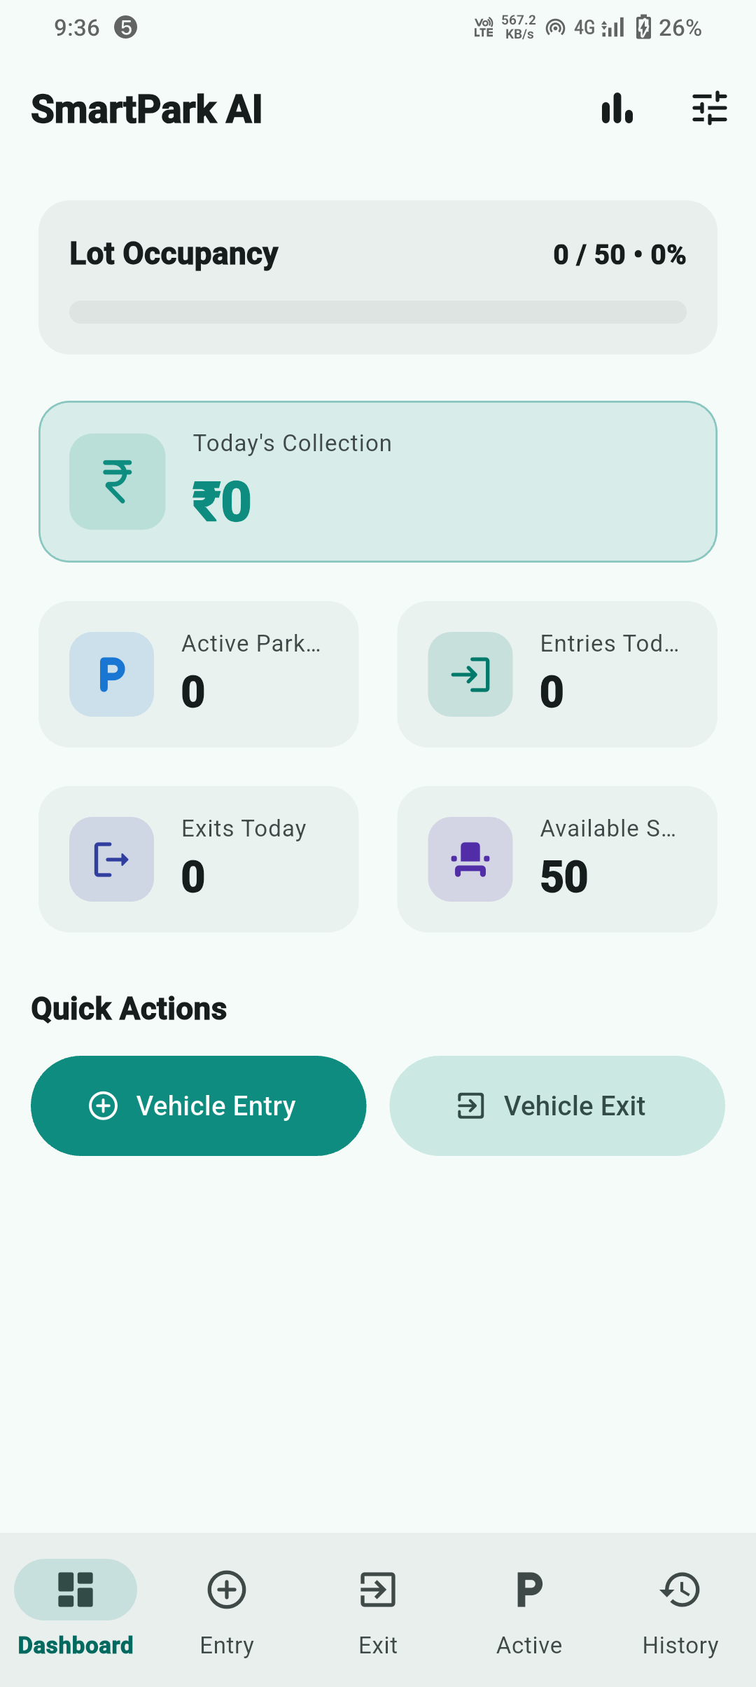

Figure 6.7: Real Device Tariff Settings Screen:
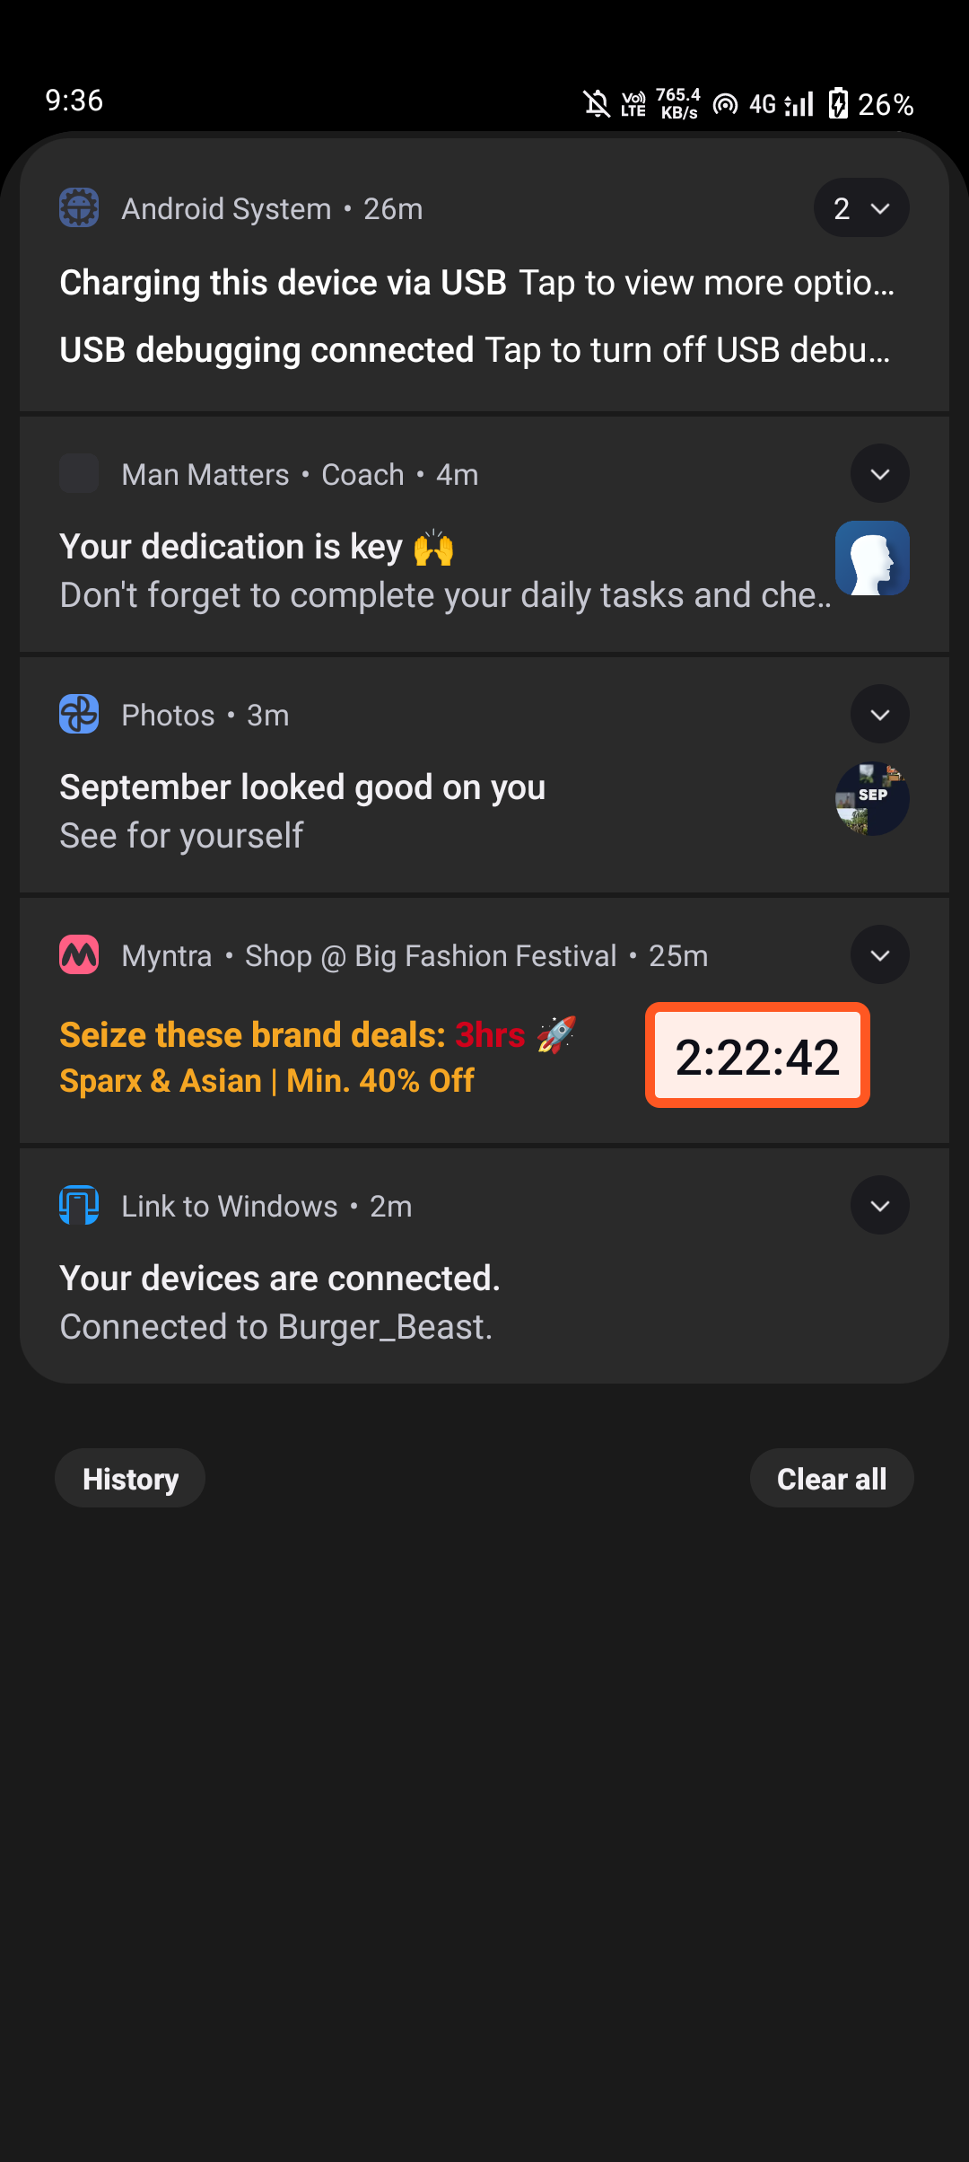

Chapter 7: Conclusion & Future Scope

7.1 Project Conclusion
SmartPark AI successfully delivers a production-grade, offline-capable mobile parking management solution. By combining modern on-device optical character recognition with deterministic billing algorithms and relational persistence, the application eliminates common manual recordkeeping errors, prevents revenue leakage, and ensures unalterable auditability.

7.2 Future Scope
Potential future expansions include:
• Custom ANPR Object Detection: Deploying a custom YOLOv8 model for precise vehicle bounding and plate crop localization.
• Multi-Gate Cloud Synchronization: Real-time synchronization across entry/exit barriers in multi-lane facilities.
• Hardware Barrier Interfacing: ESP32 / Bluetooth relay triggering for automated boom barriers.
• UPI Dynamic QR Integration: Real-time dynamic payment QR code generation with instant webhook reconciliation.

References
1. Flutter Documentation: https://flutter.dev/docs
2. Dart Programming Language: https://dart.dev
3. Google ML Kit Text Recognition: https://developers.google.com/ml-kit/vision/text-recognition/android
4. SQLite Relational Database: https://www.sqlite.org
5. RFC 4180 Common Format and MIME Type for CSV: https://www.ietf.org/rfc/rfc4180.txt

