本篇推送是2016年的真题，仅供参考

题目一、二有答案且仅供参考
题目三、四以作业形式上交，所以暂无答案

祝大家都过！

2016上学年专业英语考题
一、将下面的关键字进行英汉互译（30分，每小题2分）
计算机 | 管理科学与工程
1. Machine Learning | 1. Design Science
2. Ant Colony Algorithm | 2. Social Embededness
3. Semantic Network | 3. Outsourcing
4. Swarm Intelligence | 4. Technique Adoption Model
5. Information retrieval | 5. Game Theory
6. Complex Adaptive System | 6. Social Survey Research
7. Deep Learning | 7. Questionaire
8. Pattern Recogonition | 8. Case Study
9. 决策树 | 9. 供应链管理
10. 贝叶斯网络 | 10. 结构方程
11. 软件生命周期 | 11. 面向服务的架构
12. 监督学习 | 12. 收益管理
13. 系统架构 | 13. 有限理性
14. 图挖掘 | 14. 层次分析法
15. 遗传算法 | 15. 人机交互
参考答案 -
ps: 点击图片缩放查看高清版
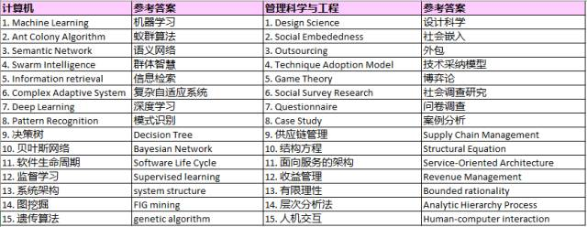
二、将下列英文片段翻译成中文（20分）
Confidence in financial institutions has only recently been introduced in computational models studying the stability of financial networks. Here we add realism to a model of interbank markets by introducing uncertainty into what banks know about other banks. In our model, information spreads through the lending network and the quality of information depends on the proximity of the information source. Instead of having complete information banks receive information that is delayed, noisy, or local. This affects their confidence and the resulting lending decisions. We show that introducing uncertainty leads to a substantial increase in the probability of whole-system collapse after an idiosyncratic bank failure. In contrast, when the same shock is distributed among multile smaller banks, uncertainty mitigates the impact of the shock. The consequences of a large bank's failure are the most difficult to predict.
参考答案 -
金融机构的信心最近才被引入研究金融网络稳定性的计算模型。 在这里，我们通过引入银行对其他银行了解的不确定性增加了银行间市场模型的现实主义。 在我们的模型中，信息通过贷款网络传播，信息的质量取决于信息源的接近程度。 银行接收到的是延迟的，有噪声的或本地的信息，而不是完整的信息。 这影响了他们的信心和产生的贷款决定。 研究表明，引入不确定性会导致在一个银行倒闭后整个系统崩溃的概率大大增加。 相反，当同样的冲击分布在多个小银行之间时，不确定性减轻了冲击的影响。 大型银行倒闭的后果是最难预测的。

三、选择一篇论文写中文的读书笔记（即阅读提纲）（25分）
主要涉及如下几个方面：所研究的问题(What's the problem)、问题的研究动机和意义（motivations）、问题的解决方案（solutions ）、论文的主要贡献（Contributions）主要结论以及其他的一些相关评论。请注明所选文章的题目。 (可选文章已经预先发给大家）
ps: 可选文章请后台回复“专业英语”

四、结合所学专业，就自己感兴趣的问题，用英文写一个研究计划提纲（25分）
（题目（Title）、所要研究问题（What is the problem? Or research questions）、研究动因(Motivations)、拟采用研究方法和主要想法 (research methodology& main idea) 、评价方法 (evaluation criteria) 、主要贡献(contributions)以及预期结论(Conclusions) etc.）
Title: Self-Supervised Learning: An Overview

What is the Problem? Self-supervised learning is a type of unsupervised machine learning technique which allows a computer to learn from unlabeled data. It is a form of unsupervised learning that can be used to create models and applications without the need for human-labeled data.

Motivations: The main motivation for self-supervised learning is that it can be used to learn from large amounts of unlabeled data. This is especially useful for domains where data is scarce or expensive to label, or for tasks which require a large amount of labeled data, such as natural language processing.

Research Methodology: Self-supervised learning methods are typically based on deep learning and artificial neural networks. Some examples of self-supervised learning methods include auto-encoders, contrastive learning, generative models, and reinforcement learning.

Main Idea: The main idea behind self-supervised learning is to learn from unlabeled data by leveraging the intrinsic structure of the data. This is done by trying to reconstruct the data, or by learning representations of the data that can be used for downstream tasks.

Evaluation Criteria: The evaluation criteria for self-supervised learning methods are typically based on the task that the method is used for. For example, if the method is used for natural language processing, then the evaluation criteria may include accuracy, precision, and recall.

Contributions: Self-supervised learning has been shown to be effective in many tasks, such as natural language processing, computer vision, and reinforcement learning. It has also been used to improve the performance of supervised learning algorithms.

Conclusions: Self-supervised learning is a powerful technique for learning from unlabeled data. It is a promising area of research that can be used to create models and applications without the need for labeled data.

