**QMD-EKO GUI**

* Login to the remote terminal.

Ssh -X username@hostname (-Y if -X fails to work)

**Flowchart:**

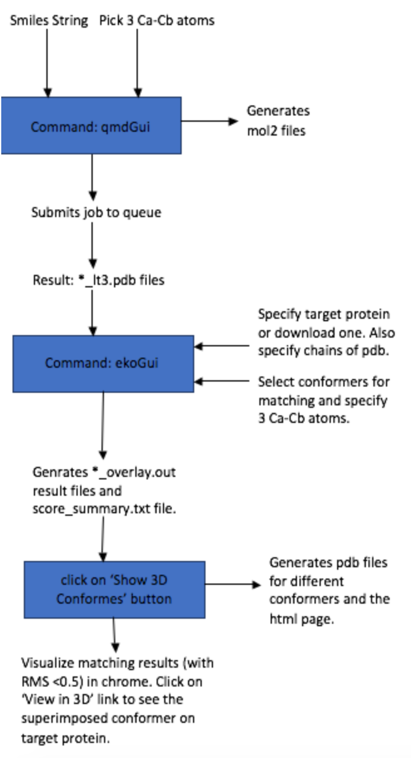

**Dependencies:**

The GUI requires access to some Javascript files and html pages. These files are present in the following directory:

/apps/burgess/eko_qmd_gui on lms machine.

The required files are following:

* base64.js
* jsmol/
* selectatoms.html
* JSMOLscripting.html

The path to use these dependencies is set as an environment variable in the following files:

* ekoGui.py
* qmdGui.py

**QMD GUI**

* To run QMD, run the following command:

qmdGui

This will load up the the Gui which would look something like this:

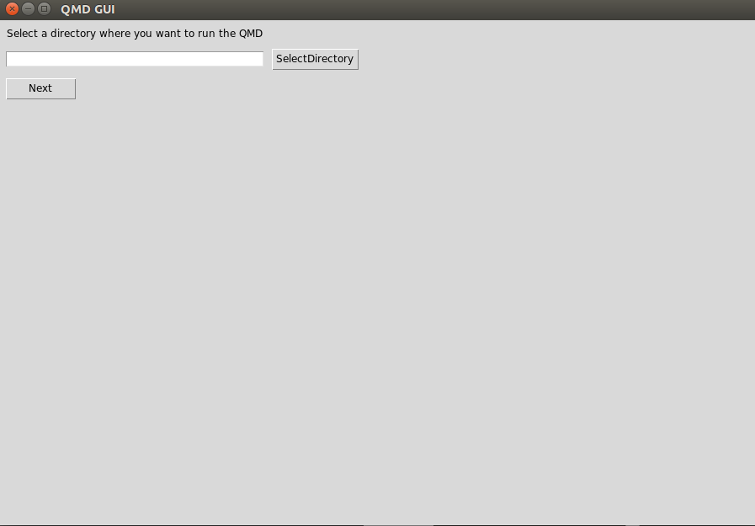

* Now select the directory where you want to store the results of the QMD and click on the next button.

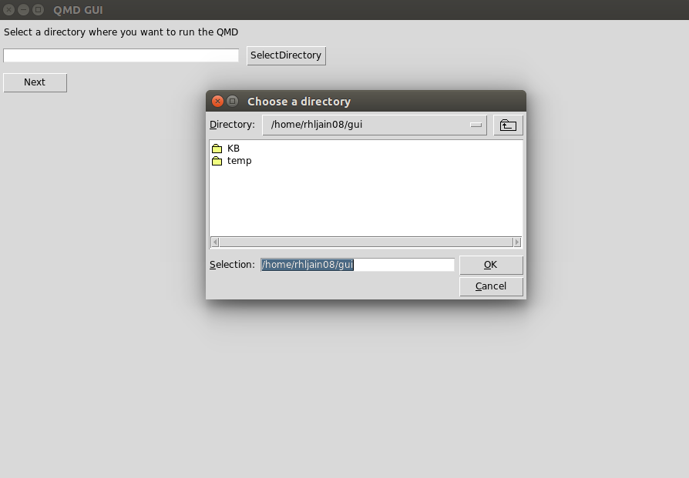

* On the next page, enter the Mimic Id and the Smiles String for the mimic.

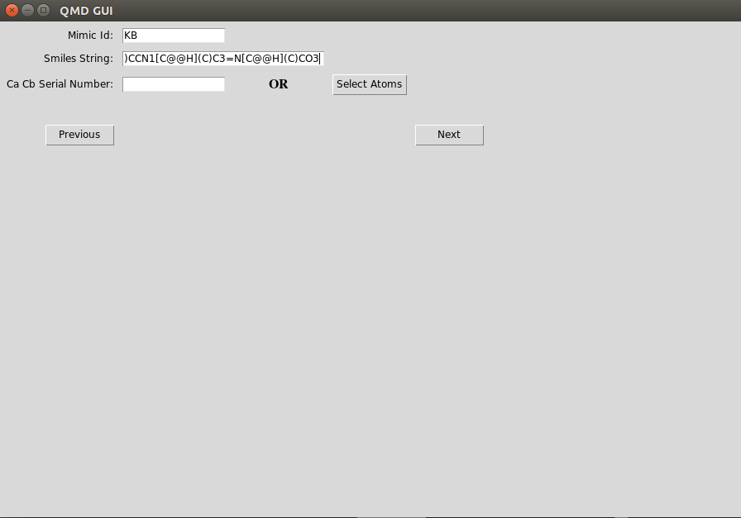

To enter the Ca Cb Serial Number, you can either enter it manually (comma separated) in the field provided or click on the ‘Select Atoms’ button. When you click on the button, a browser will open up.

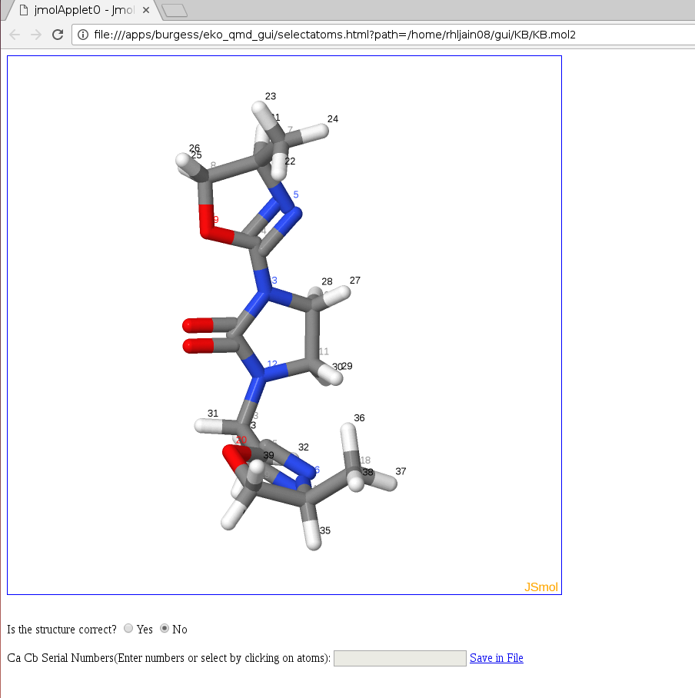

Before selecting the atoms, you need to check if the structure uploaded is correct. The structure displayed might be incorrect because of any mistake in the smiles string entered. If the structure is incorrect, then you can close the browser and re-enter the correct smiles string.

If the structure is correct, click on ‘yes’. The hydrogens displayed in the structure will now disappear and you can click on the Ca-Cb atoms to select them.

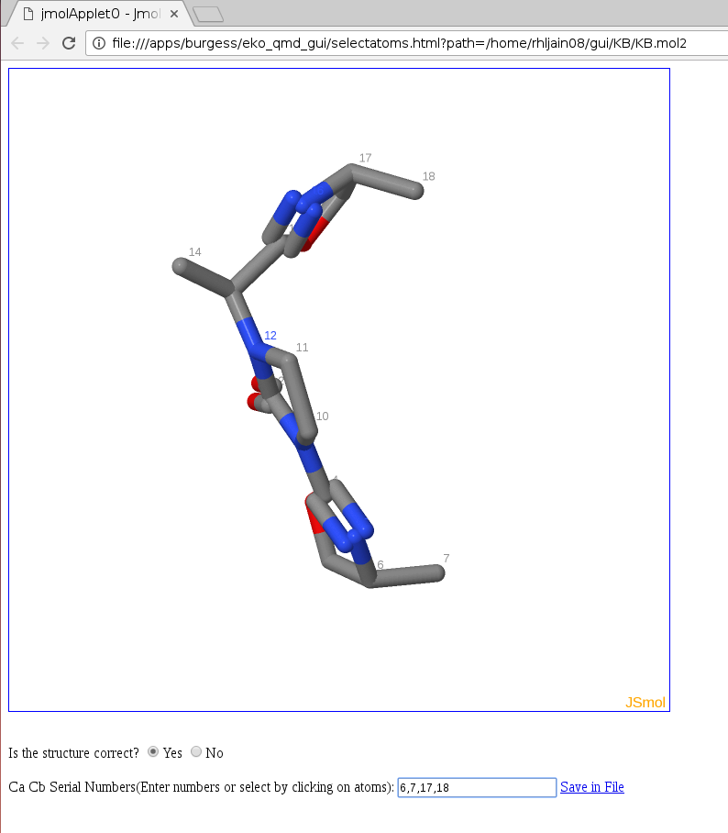

You can also enter the atom numbers (comma separated) in the field provided. Once you are done selecting the atoms, click on the ‘Save in File’ link. This will download a file containing the serial numbers. Once the file is downloaded, close the browser. The atom number will be automatically populated in the Gui.

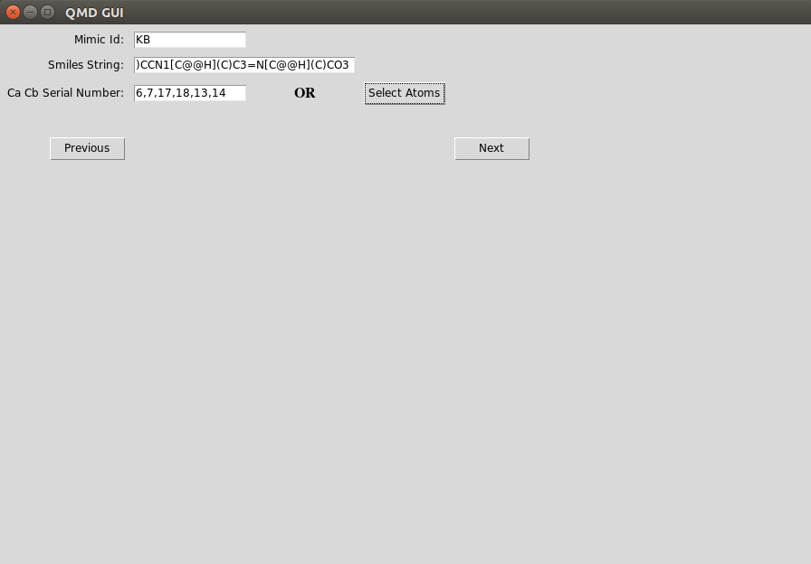

* Click on the ‘Next’ button once all the fields are correctly populated. This will take you to the next page.

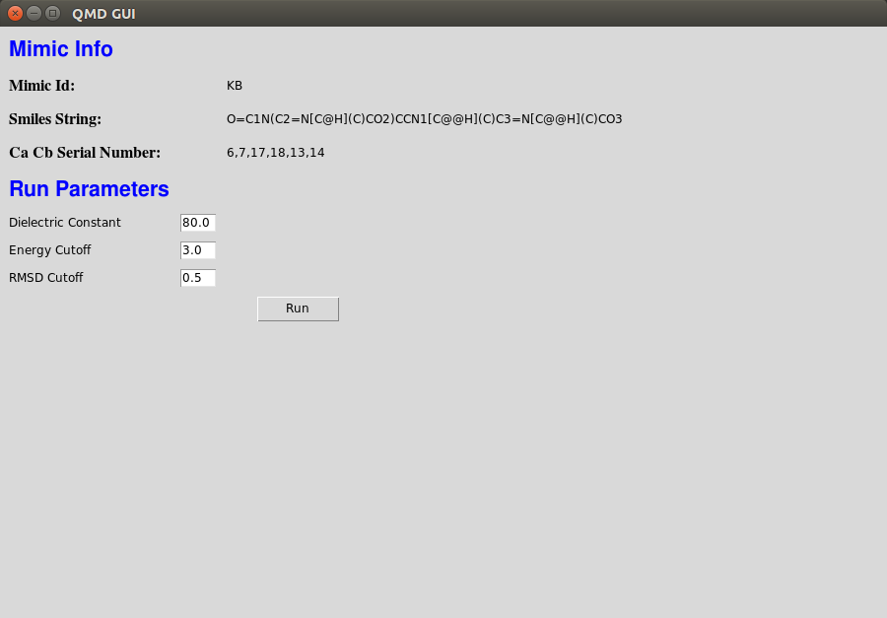

On this page, you can verify the information and change the run parameters if required. Once the run parameters are decided, click on the ‘Run’ button.

* After the ‘Run’ button is clicked, your job will be submitted to the queue.

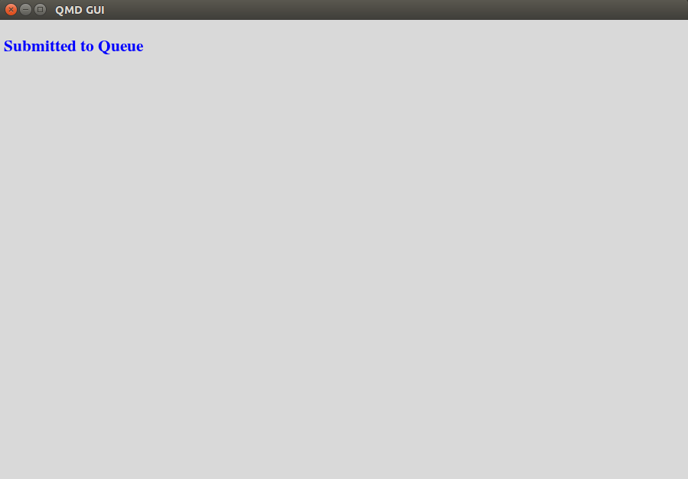

To check if the job is still running or has been finished, you can go the directory with the name <Mimic Id> inside the directory whose path you provided in the beginning and run command ‘qstat’ on the terminal. It will show your job in the list if it is still running. Once, the job is finished, this directory will be updated with the result files.

**EKO GUI**

* To run EKO, run the following command:

ekoGui

This will load up the the Gui which would look something like this:

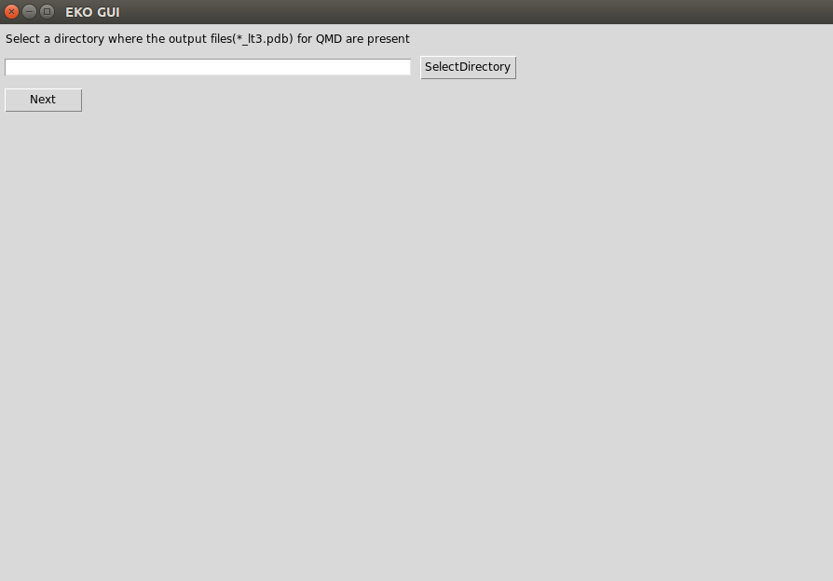

* Now select the directory where *_lt3.pdb files (result of QMD) are present and click on the next button.

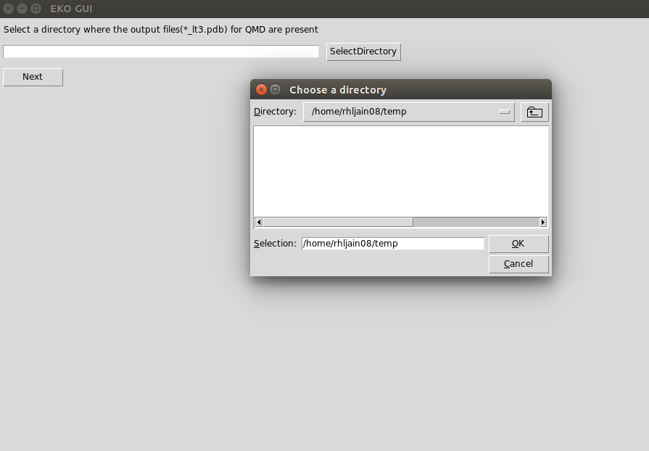

* On the next page, you can select the target protein, the conformer on which you want to run the EKO along with the parameters to run it.

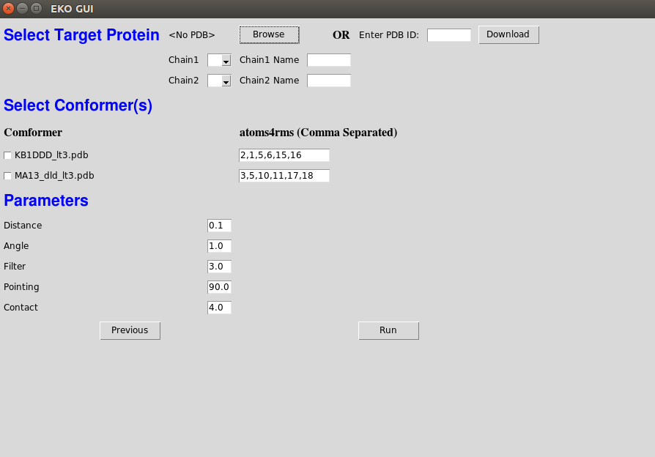

* To select target protein, you can click on the ‘Browse’ button and go to the directory where the target protein is present.

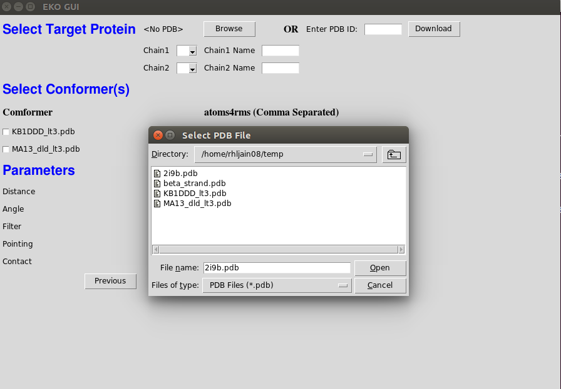

If the target protein is not already present on the system, you can also download it by entering the ID of the PDB in the field provided and clicking on the download button.

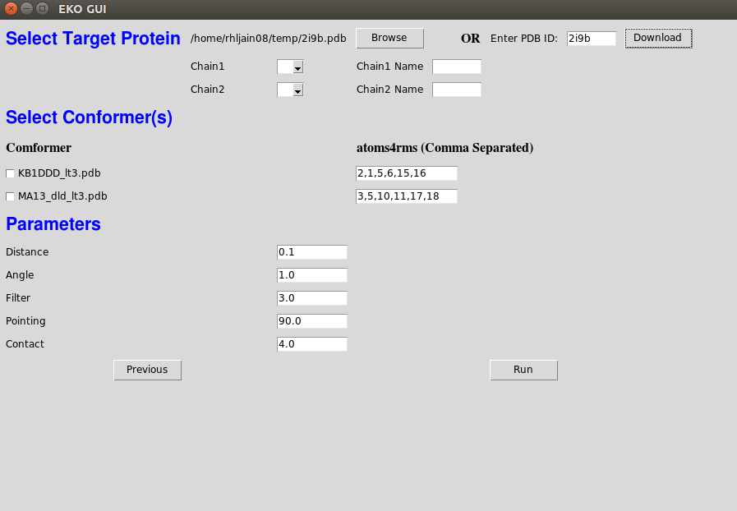

* Once the protein is selected or downloaded, the chain dropdown (Chain1 and Chain2) will be automatically populated and you can then select the chains. You can also give names to the chains of your liking which will then be displayed on the result page.

You can select multiple conformers for which you want to run the EKO and specify the atoms4rms (Ca Cb Serial Number) for them. The atoms4rms field will be already populated if a ‘.in’ file is present in the directory in the required format.

You can also change the run parameters if you wish to. Once all the fields are correctly filled, click on the ‘Run’ button to run the EKO.

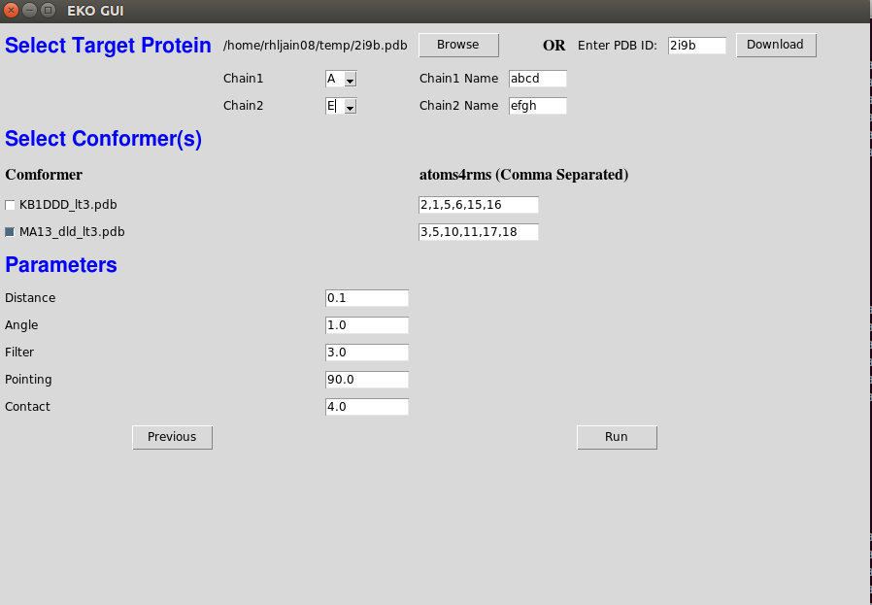

* The EKO program will run and the output files will be generated. Once the EKO has been completed, a ‘Show 3D Conformers’ button will appear on the screen.

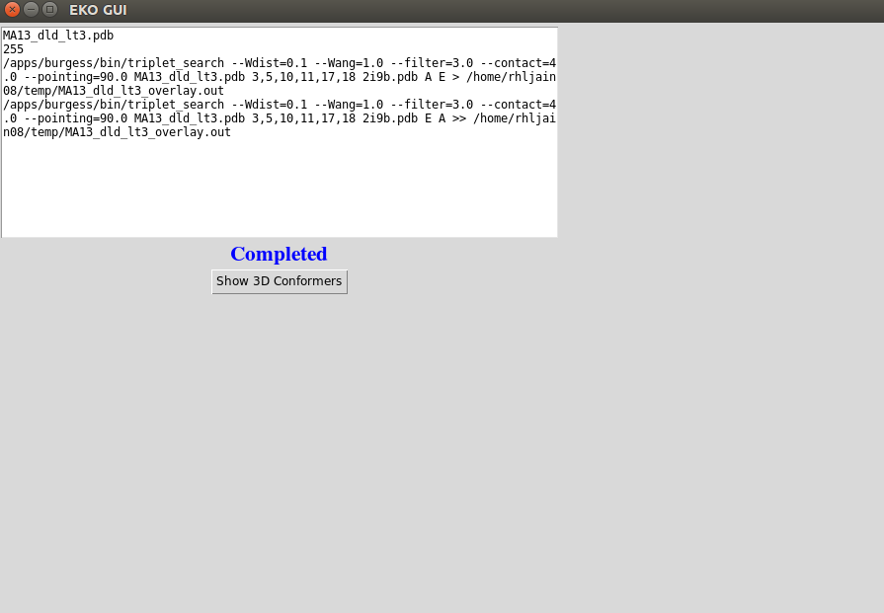

* Clicking on the ‘Show 3D Conformers’ button will create a folder called ‘conformers’ in the directory whose path was provided initially. This conformers directory will contain a separate file for each conformer that was the result of the program. A html page called viewconformers.html is created which contains all the info of the resultant conformers.

A browser will open up and display the page viewconformers.html. This page contains all the information about the resultant conformers in a tabular format. Only the conformers which have RMS < 0.5 are displayed on the page.

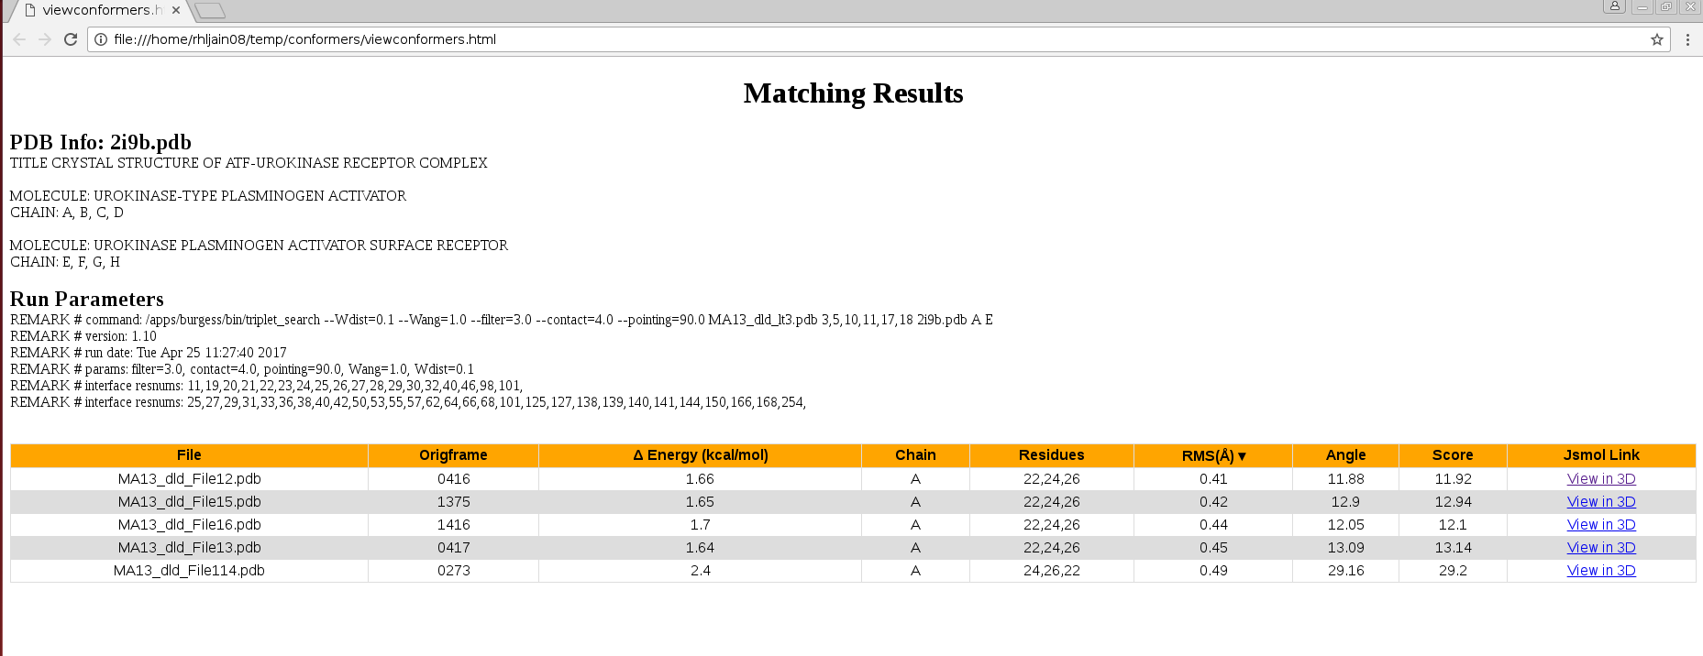

The results in the page can be sorted by various parameters such as RMS score, angle, etc., by clicking on the column header.

* By clicking on the ‘View in 3D’ link a new page will open, which will display the conformer superimposed on the pdb in JSMol.

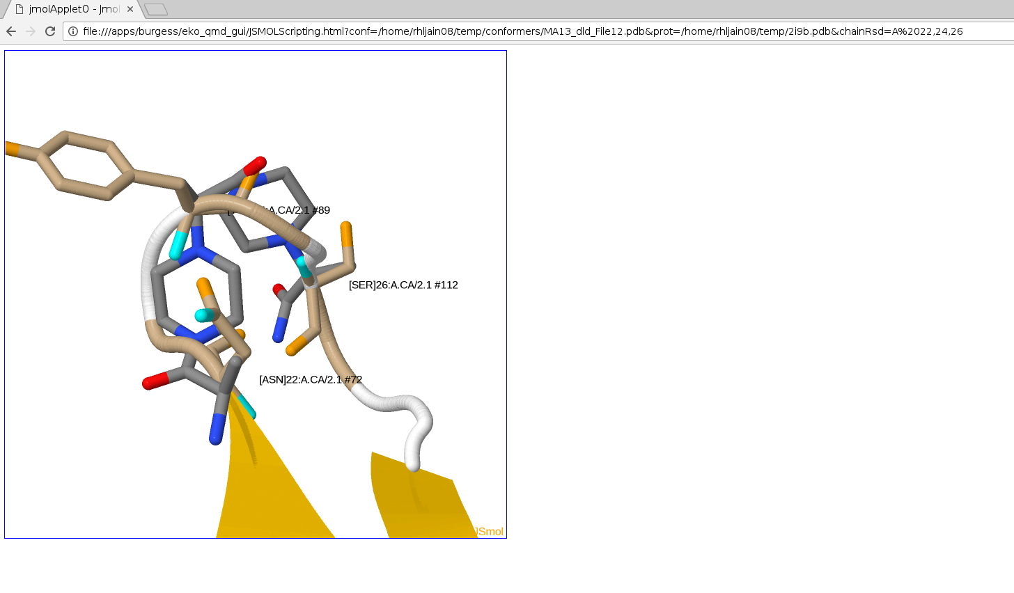

In 3D view, only the participating chain/ template is shown for the pdb. The residues which are in contact are shown in stick while the rest of the chain is shown in ribbons. The conformer is shown is the sticks format.