This offer is (2) Royal Jelly Scar Balms

|  |  |  |  |
| --- | --- | --- | --- |
| Quantity 2 | 24780 | Royal Jelly Scar Balm |  |
| 2813 |  | Royal Jelly Scar Balm | 1 fl. oz. |
| 2813 |  | Royal Jelly Scar Balm | 1 fl. oz. |

Choice options not coming through.

|  |  |  |  |
| --- | --- | --- | --- |
|  | 24846 | Skid Duo: |  |
|  | NUPL24846 | **Choose One:** |  |
| 25678 |  | Skid Champ EDT | 1.7 fl. oz. |
| 15890 |  | Skid Rock EDT | 1.7 fl. oz. |
| 11286 |  | Skid EDT | 1.7 fl. oz. |
| NOT ON KENTICO | NUPL24846 | **Choose One: Choice not coming thru in Kentico** |  |
| 12262 |  | Skid Hair Styling Gel | 3.3 fl. oz. |
| 25645 |  | Skid Rock Hair Gel | 3.3 fl. Oz. |

Compents in NW

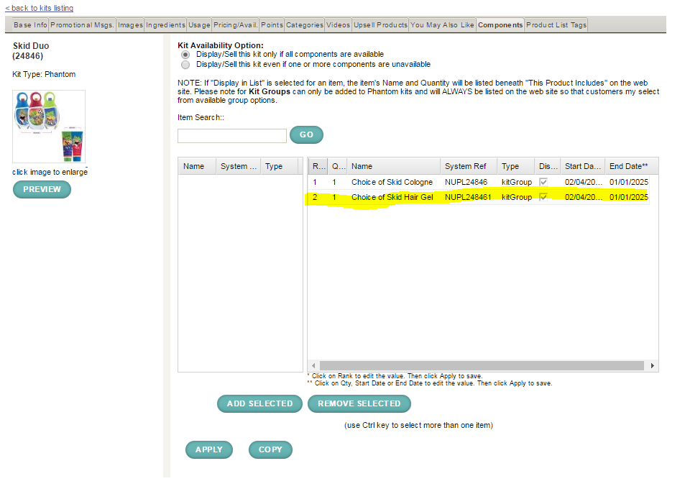

Transformer Que

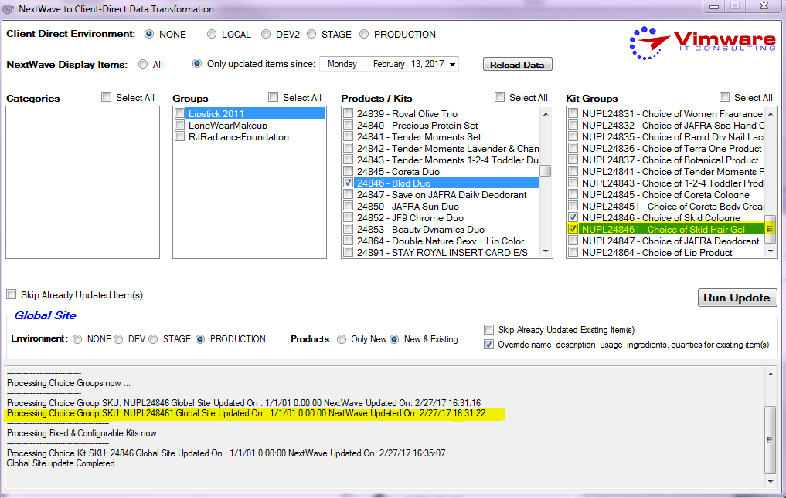

Kentico admin page, hair gel choice not coming through

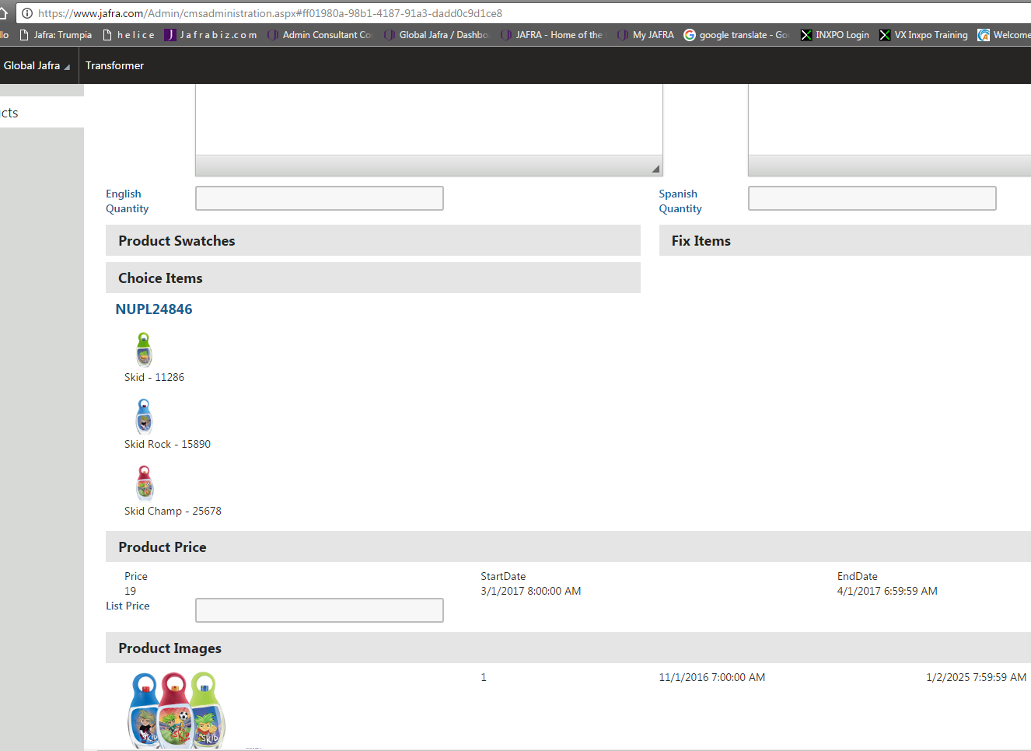

|  |  |  |  |
| --- | --- | --- | --- |
|  | 24845 | Coreta |  |
|  | NUPL24845 | **Choose One:** |  |
| 25685 |  | Coreta Cologne | 1.7 fl. oz. |
| 25686 |  | Coreta Heart Cologne | 1.7 fl. oz. |
| 25679 |  | Coreta Spirit Cologne | 1.7 fl. oz. |
| NOT ON KENTICO | NUPL248451 | **Choose One: Choice not coming thru in Kentico** |  |
| 2911 |  | Coreta Heart Glitter Body Cream | 2.5 fl. oz. |
| 13224 |  | Coreta Glitter Body Cream | 2.5 fl. oz. |
|  |  | **FREE:** |  |
| 21687 |  | 2016 Girl's Cross-Body Bag | NYA |

Transformer Que

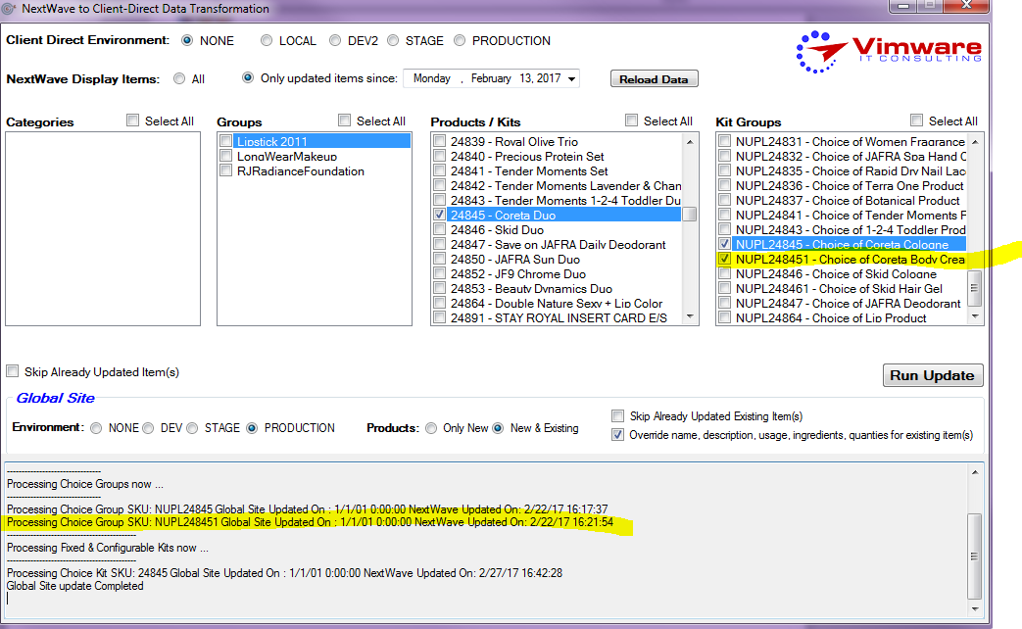

Components in kentico

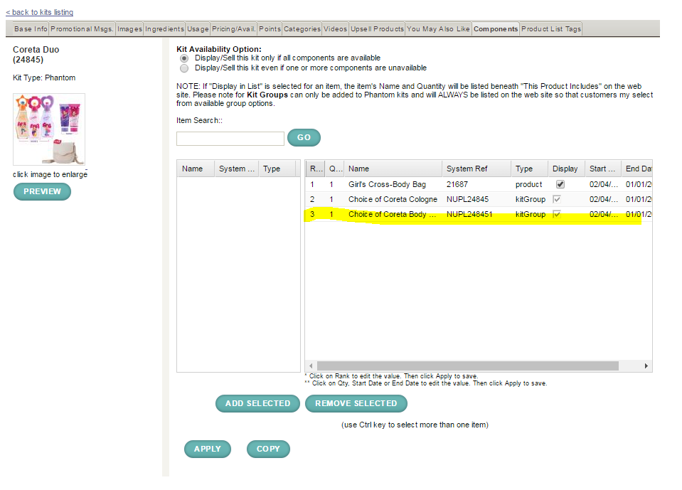

Body cream choice options not coming through

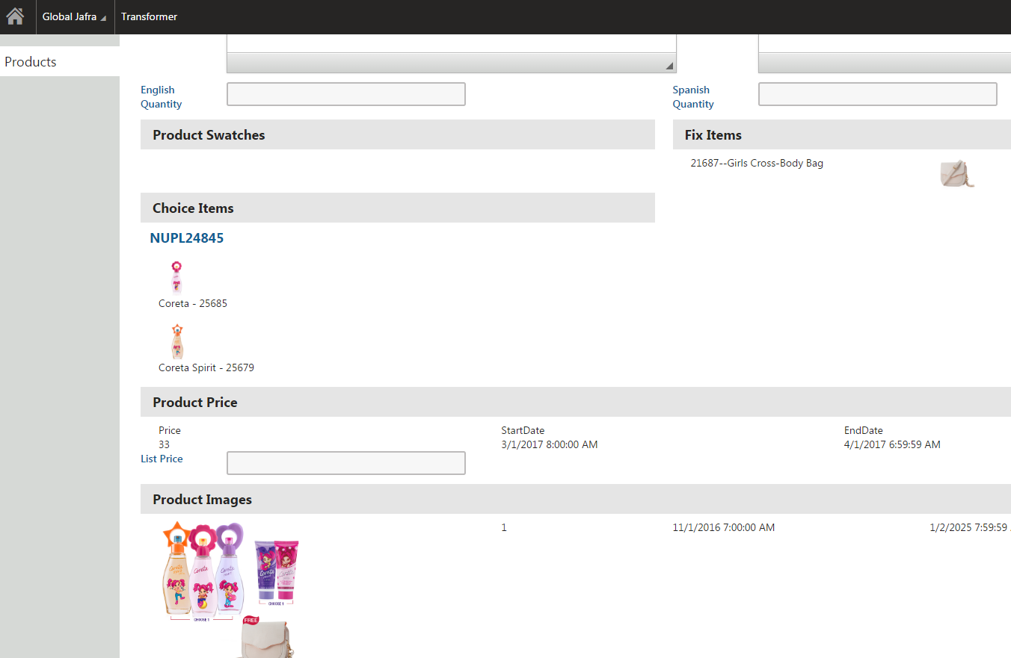

|  |  |  |  |
| --- | --- | --- | --- |
|  | 24816 | JF9 Set with a Free Mini: |  |
|  | NUPL24816 | **Choose One:** |  |
| 2060 |  | JF9 Red Cologne | 3.3 fl. oz. |
| 1649 |  | JF9 Cologne | 3.3 fl. oz. |
| 6566 |  | JF9 Black Cologne | 3.3 fl. oz. |
| 25567 |  | JF9 Chrome Cologne | 3.3 fl. oz. |
|  | NUPL24816 | **Choose One:** |  |
| 2060 |  | JF9 Red Cologne | 3.3 fl. oz. |
| 1649 |  | JF9 Cologne | 3.3 fl. oz. |
| 6566 |  | JF9 Black Cologne | 3.3 fl. oz. |
| 25567 |  | JF9 Chrome Cologne | 3.3 fl. oz. |
| NOT ON KENTICO |  | **Choose One FREE: Choice not coming thru in Kentico** |  |
| 26056 |  | JF9 Red Mini | .23 fl. oz. |
| 26057 |  | JF9 Mini | .23 fl. oz. |
| 41071 |  | JF9 Chrome Mini | .23 fl. oz. |
| 41096 |  | JF9 Black Mini | .23 fl. oz. |

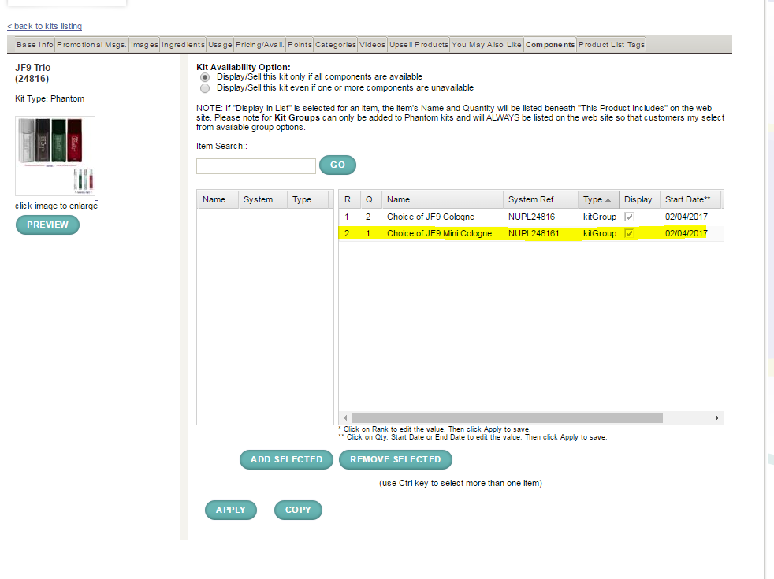

|  |  |  |  |
| --- | --- | --- | --- |
|  | 24807 | Young Women Fragrance: |  |
|  | NUPL24807 | **Choose One:** |  |
| 48006 |  | Double Nature Glam EDT | 1.7 fl. oz. |
| 47986 |  | Double Nature Rock EDT | 1.7 fl. oz. |
| 14005 |  | Double Nature Tender EDT | 1.7 fl. oz. |
| 14004 |  | Double Nature Sexy EDT | 1.7 fl. oz. |
| NOT ON KENTICO | NUPL248071 | **Choose One Free: Choice not coming thru in Kentico** |  |
| 26003 |  | Double Nature Tender Mini | .23 fl. oz. |
| 26004 |  | Double Nature Sexy Mini | .23 fl. oz. |
| 26005 |  | Double Nature Glam Mini | .23 fl. oz. |
| 26006 |  | Double Nature Rock Mini | .23 fl. oz. |

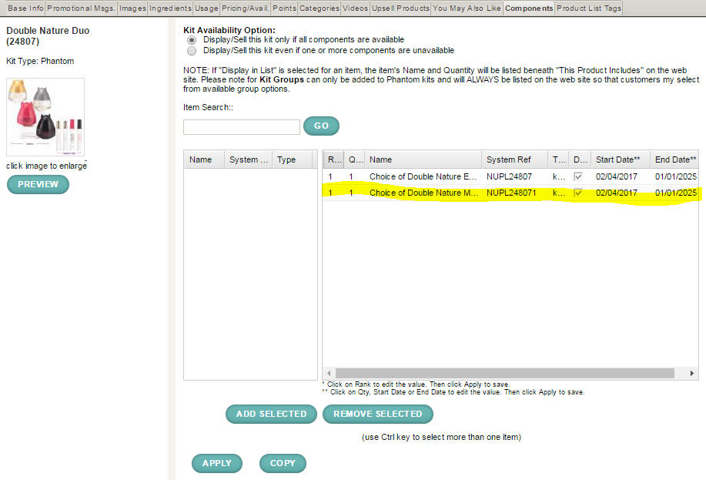

Transformer Que

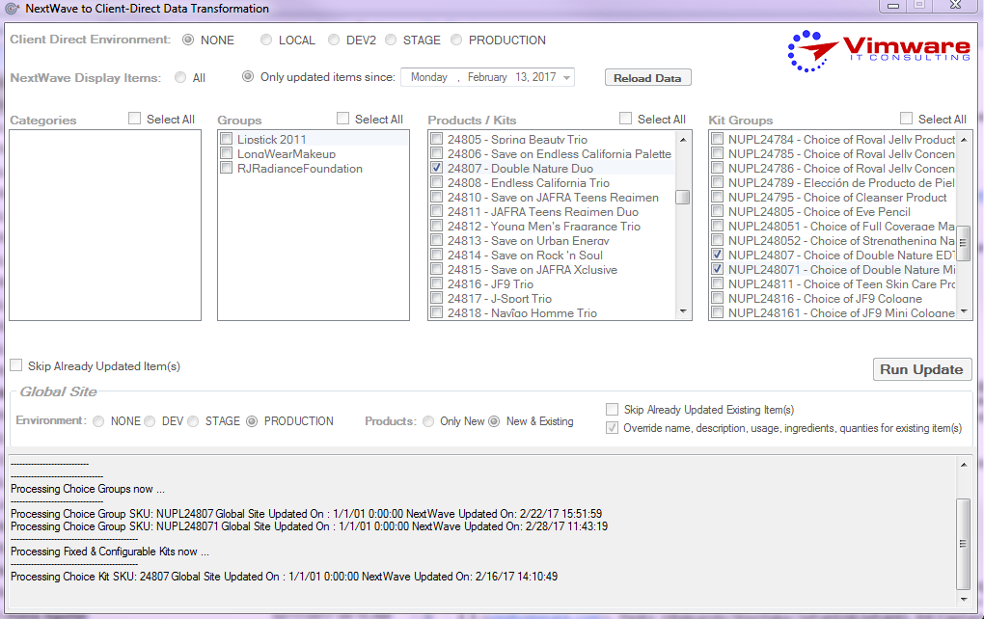

Kentico admin page no mini fragrance choice coming through

