**Hungry Cat Helping Rat**

Burhanuddin Beawerwala

Naveen Sampath

High Concept

Be the kind rat and feed the hungry cat whatever you can find (Except yourself!).

Genre

*Time Based Puzzle Game*. Feed the hungry cat with help of the rat before you run out of time.

Platform

iPad (*landscape* mode)

Game Story

The cat is extremely hungry, and you need to help your new found best friend to not starve. Will you be able to feed the cat in time avoiding obstacles that stop you from it?

Game Mechanics

Hold and move the rat with your finger to interact with objects. The Rat can pass through cheese but not traps, while food can move through traps and not cheese. Chocolates are to be used as puzzle elements and is deadly to the cat. Navigate through the environment and feed the cat collecting as many stars as you can to finish the level.

Characters and Game elements

* Rat: The main protagonist. Move him around and using collision, take food to the cat by any means possible. He can pass through cheese but will be unable to go past traps.
* Cat: The main protagonist’s best friend. The cat is extremely hungry and is relying on you to feed it whatever you can find.
* Rat trap: An object that does not allow the rat to pass through. It allows food to pass through it though.
* Cheese: An area in the level through which a mouse can bite through. Rat can pass through cheese, but rest of the elements in the game cannot.
* Chocolate: An object that the rat can use to mouse around. It can also trigger switches. Chocolate is lethal to cat and should not be fed.
* Switch: An element in the game that moves a movable platform when enabled.
* Fan blades: Spins at its pivot when pushed.
* Cookie/Milk: Food available for the hungry cat to feed on.

Game Flow

Actions that the playing character can perform are:

* Move around to accessible locations
* Collide with other physics bodies
* Race against time

These actions are used to feed the hungry cat and complete the level.

Gameplay

* Mechanics: The player needs to drag and move the rat around make it collide with other physics bodies to be capable to feed the cat.
* Control: Touch & drag.
* Onboarding:

1. Help is available at the main menu for a quick look.
2. Whenever a level introduces any new element to the game, it shows during the level start.

* Player learning:  The player should get the hang of the game elements quite easily. Finishing levels should not be much of a challenge. Collecting all stars and finishing the level can be tricky.

Game Graphics

## **Assets:**

## Purr sound:[Skymary](https://freesound.org/people/skymary/) : <https://freesound.org/people/skymary/sounds/412016/>

Background music [Dpsa](https://freesound.org/people/dpsa/) : <https://freesound.org/people/dpsa/sounds/341596/>

Motor [Undead505](https://freesound.org/people/undead505/) : <https://freesound.org/people/undead505/sounds/338986/>

Game over [Fins](https://freesound.org/people/fins/) : <https://freesound.org/people/fins/sounds/133283/> (gameOver)

Level complete [Tuudurt](https://freesound.org/people/Tuudurt/) : <https://freesound.org/people/Tuudurt/sounds/258142/>

Munch sound [IneQuation](https://freesound.org/people/IneQuation/) : <https://freesound.org/people/IneQuation/sounds/27877/>

**All art is made by Naveen.**

## **Our Personalization:**

* We have designed our icons using photoshop.
* All the background and user interface images are reworked by the team.

Development:

Both of us have put a lot of effort and hours in this game. A brief breakdown of it is as below:

* The art and assets, including the customization of all the screens were mainly done by Naveen.
* Sound and score integration was done by Burhan.
* Animation and change in scenes were done by Naveen and Burhan.
* Adoption of the custom SKNode was done by Naveen.
* Level design was done by Naveen.
* Physics integration in levels was done by Burhan.
* The splash screen was done by Naveen.
* The controls of the player were done by Burhan.
* Custom font integration was done by Naveen.
* Code clean-up, commenting and organizing was done equally by both of us.

The above is a rough segregation of the work done by us. Both teammates had a role to play in every aspect of it.

Struggles:

Coding the player movement, pausing the game properly, designing the help scenes and level designs were challenging. Git was not very helpful and ran into trouble often

Failures:

The movement occasionally does unintended things. We have minimized them as much as possible, but occasional glitches we could help.

Self-Grading

**Burhan:**

I would give myself around 100 out of 100 for the following reasons:

* 1. Spent a lot of time to figure out how to make the movement of rat possible with physics such that it does not pass through objects.
  2. Made a single GameScene.swift file to accommodate all the levels, and the physics interactions regarding each element in the game.
  3. Re-used and optimized as much of the code as possible, and spent a good amount of time in researching and implementing different kinds of interactions.

**Naveen:**

I would give myself around 100 out of 100. I have spent a lot of time in level design, design art and user interface. It gives me an huge vision for level design.

User Interface

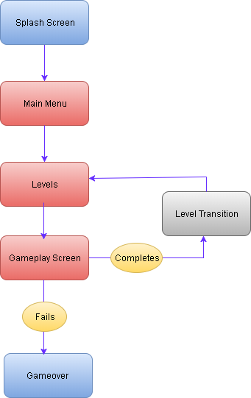

About the developers

**Naveen:** MS in GDD, is fascinated by programming and pencil sketching. Loves to play football and badminton.

**Burhan:** MS in GDD, loves programming (especially C++). Plays soccer and table tennis, and enjoy playing the guitar.