

Wright Engineering MCP Qualification Status Report
Curated engineering integrations and verified product design chains
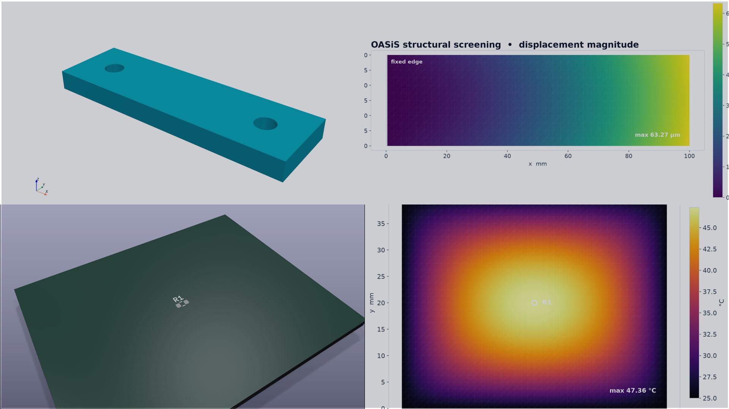
Captured outputs from BREP, OASiS, KiCad and the Wright process chain qualification.
10  qualified MCP servers | 3  verified design chains | 30 of 30  successful MCP calls
Status. Wright now has a dependable core portfolio of ten engineering MCP servers. Five of those integrations were exercised together across three realistic product design chains, with every tool call, artifact handoff and independent output oracle passing.

Current portfolio status
The catalog contains 77 reviewed integrations. Ten meet the current curation policy, 55 remain in a controlled follow up queue, and 12 are marked for removal. Curation means the recorded qualification is current for its declared platform and operating scope; it does not claim universal host application or physical hardware coverage.
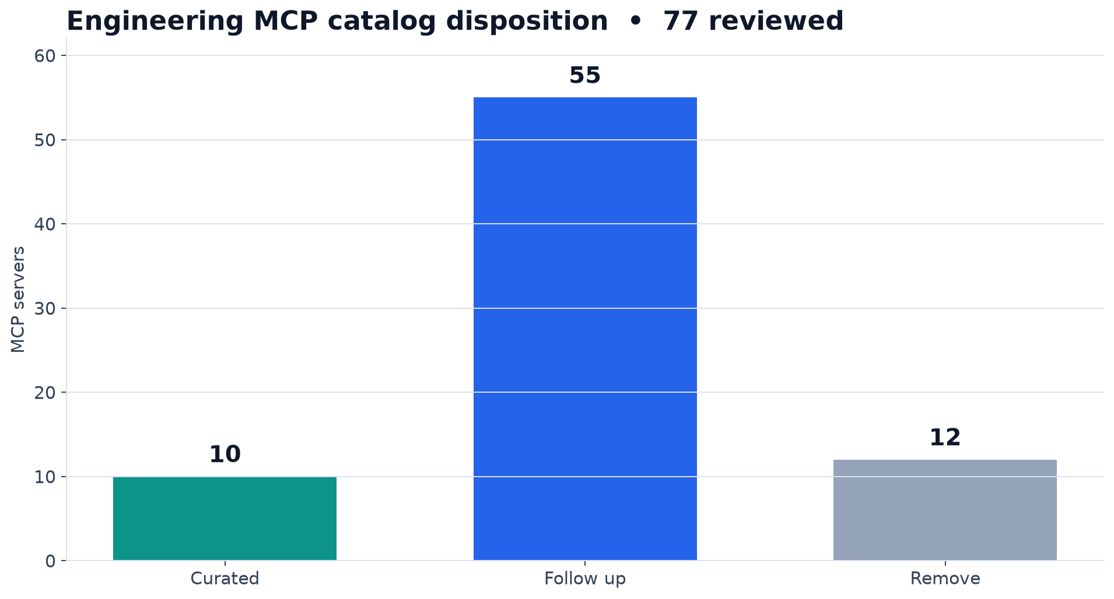
Catalog disposition from the generated curation report dated 8 September 2026.
114  tools visible in the chain workspace | 7  accepted cross tool handoffs | 7  corrupted manifests rejected

What the result supports
- Wright can expose a selected engineering tool portfolio through its production gateway and workspace policy.
- The selected servers can produce CAD, CAE, ECAD, fabrication, review and field evidence artifacts that independent parsers accept.
- Artifact identities, revisions, units and hashes survive the transitions between tools.

Qualified engineering MCP portfolio
The current shortlist emphasizes CAD, simulation and engineering data. Each row below passed the qualification defined for its platform and scope.
No | Integration | Engineering coverage | Status
1 | AutoCAD MCP Pro | design, manufacturing | passed
2 | Autodesk Product Help MCP | requirements, design | passed
3 | Blender 3D Mesh Copilot | design | passed
4 | BREP MCP | design | passed
5 | FreeCAD Python Server | design | passed
6 | KiCad MCP by blwfish | design, manufacturing, test quality, release | passed
7 | OASiS Open FEM Agent | simulation | passed
8 | OpenSCAD Rendering Engine | design | passed
9 | Rhino MCP | design | passed
10 | ROSBag MCP | test quality, operations | passed

Portfolio boundary
The end to end chains use BREP MCP, OASiS Open FEM Agent, AutoCAD MCP Pro, KiCad MCP and ROSBag MCP. The other five qualified servers broaden requirements and design coverage and remain independently qualified until a future scenario requires them in a multi tool chain.

Qualification and handoff method
The authoritative run used Wright revision ef6503cf in a fresh disposable Linux container created from the recorded image digest. Only the selected prerequisites were installed in that container. The runner discovered live tool schemas, built a temporary Wright database and workspace, enabled only the five required servers, passed Wright approval checks, executed every call through GatewayService, and removed the temporary workspace after shutdown.
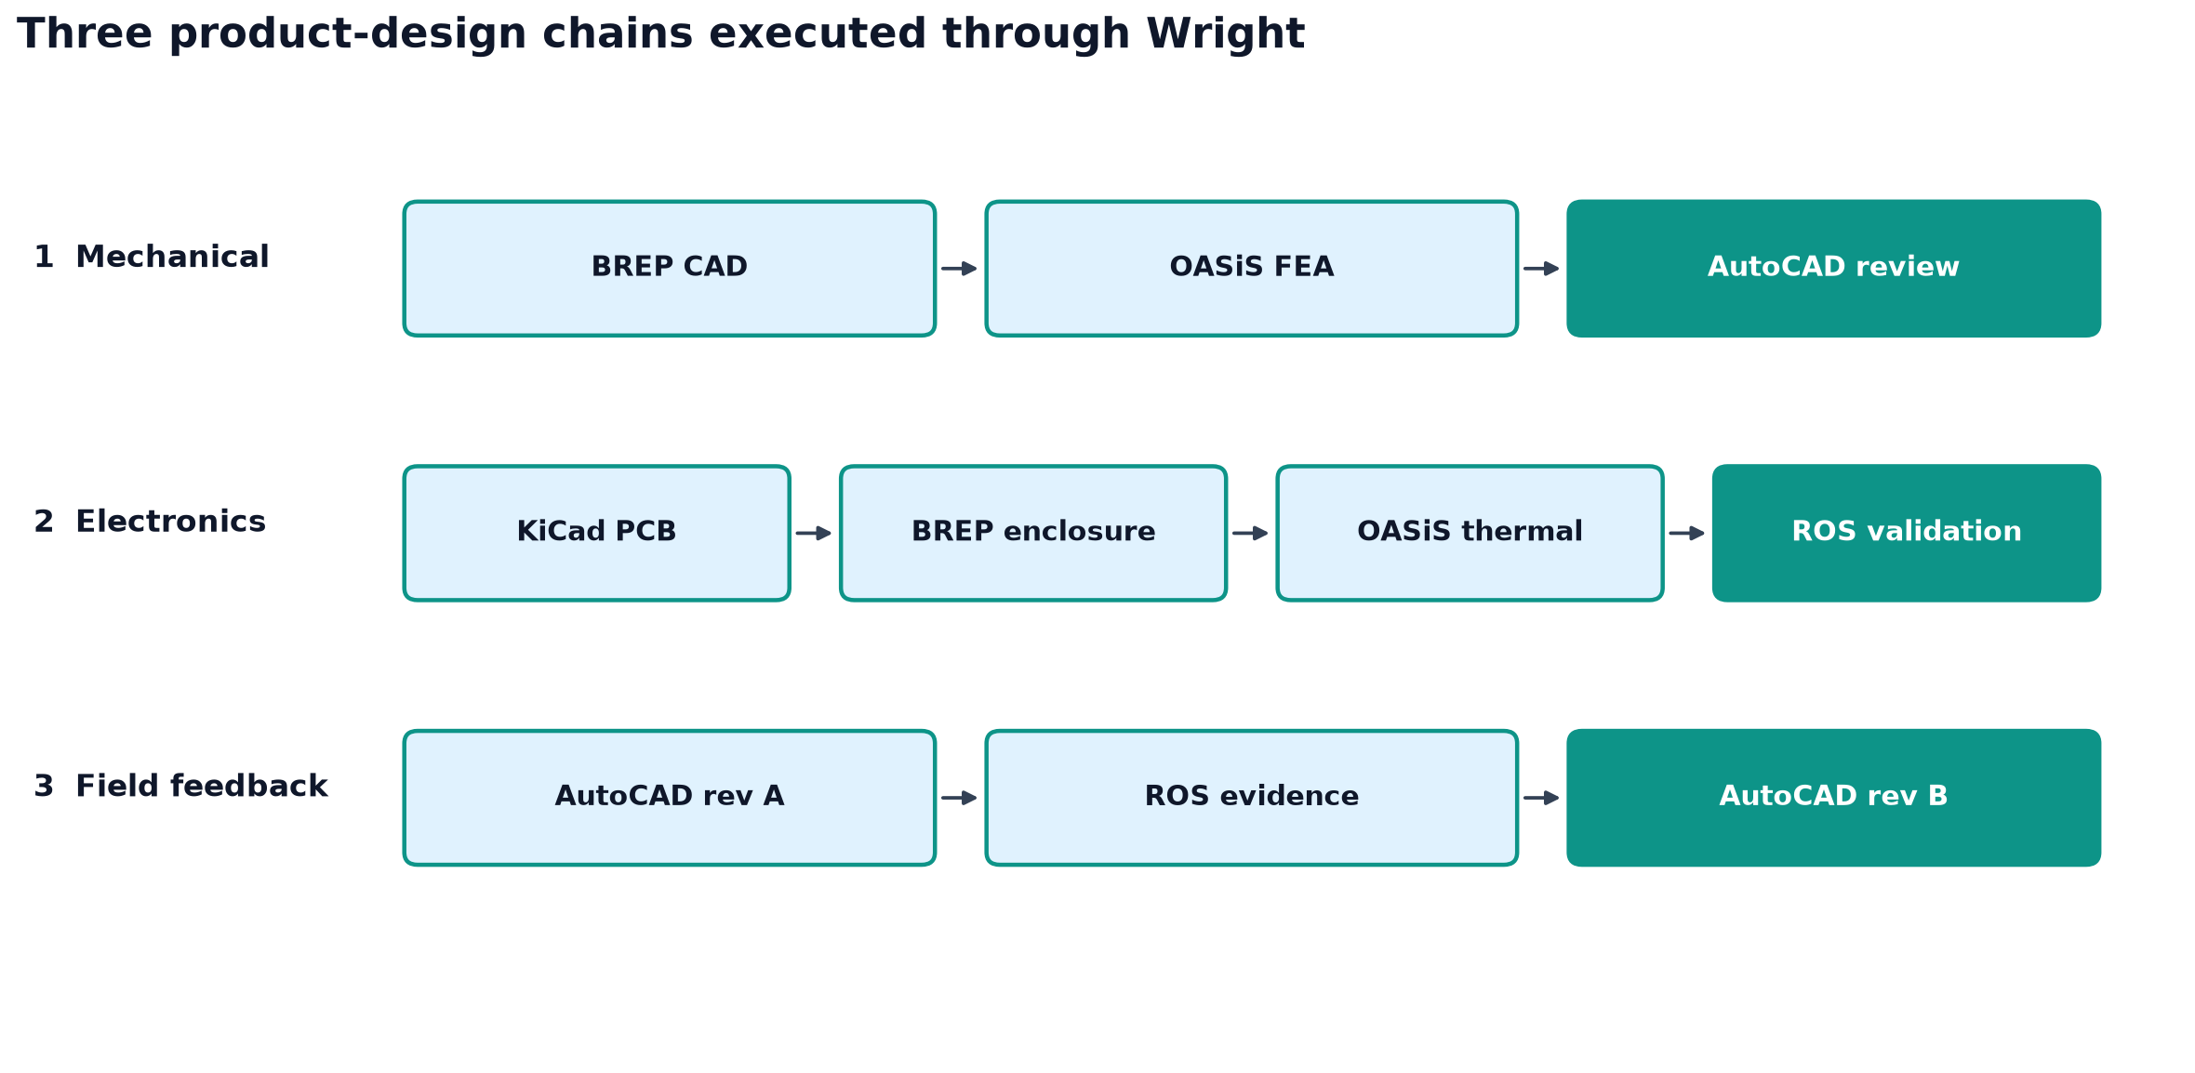
Three product design chains executed through Wright. Each arrow represents a validated artifact handoff.
Control | Observed result
Gateway execution | 30 calls passed; no failed calls
Workspace scope | 5 enabled servers; 114 visible tools
Handoff integrity | 7 accepted manifests; 7 corrupt variants rejected
Cleanup | Passed after all server processes stopped

Chain 1 Mechanical CAD to FEA to review drawing
BREP MCP created an aluminum bracket with two mounting holes, OASiS performed a two dimensional equivalent solid section structural screening calculation, and AutoCAD MCP produced the review drawing. The handoff bound the geometry, material, units and revision before simulation and again before drawing review.
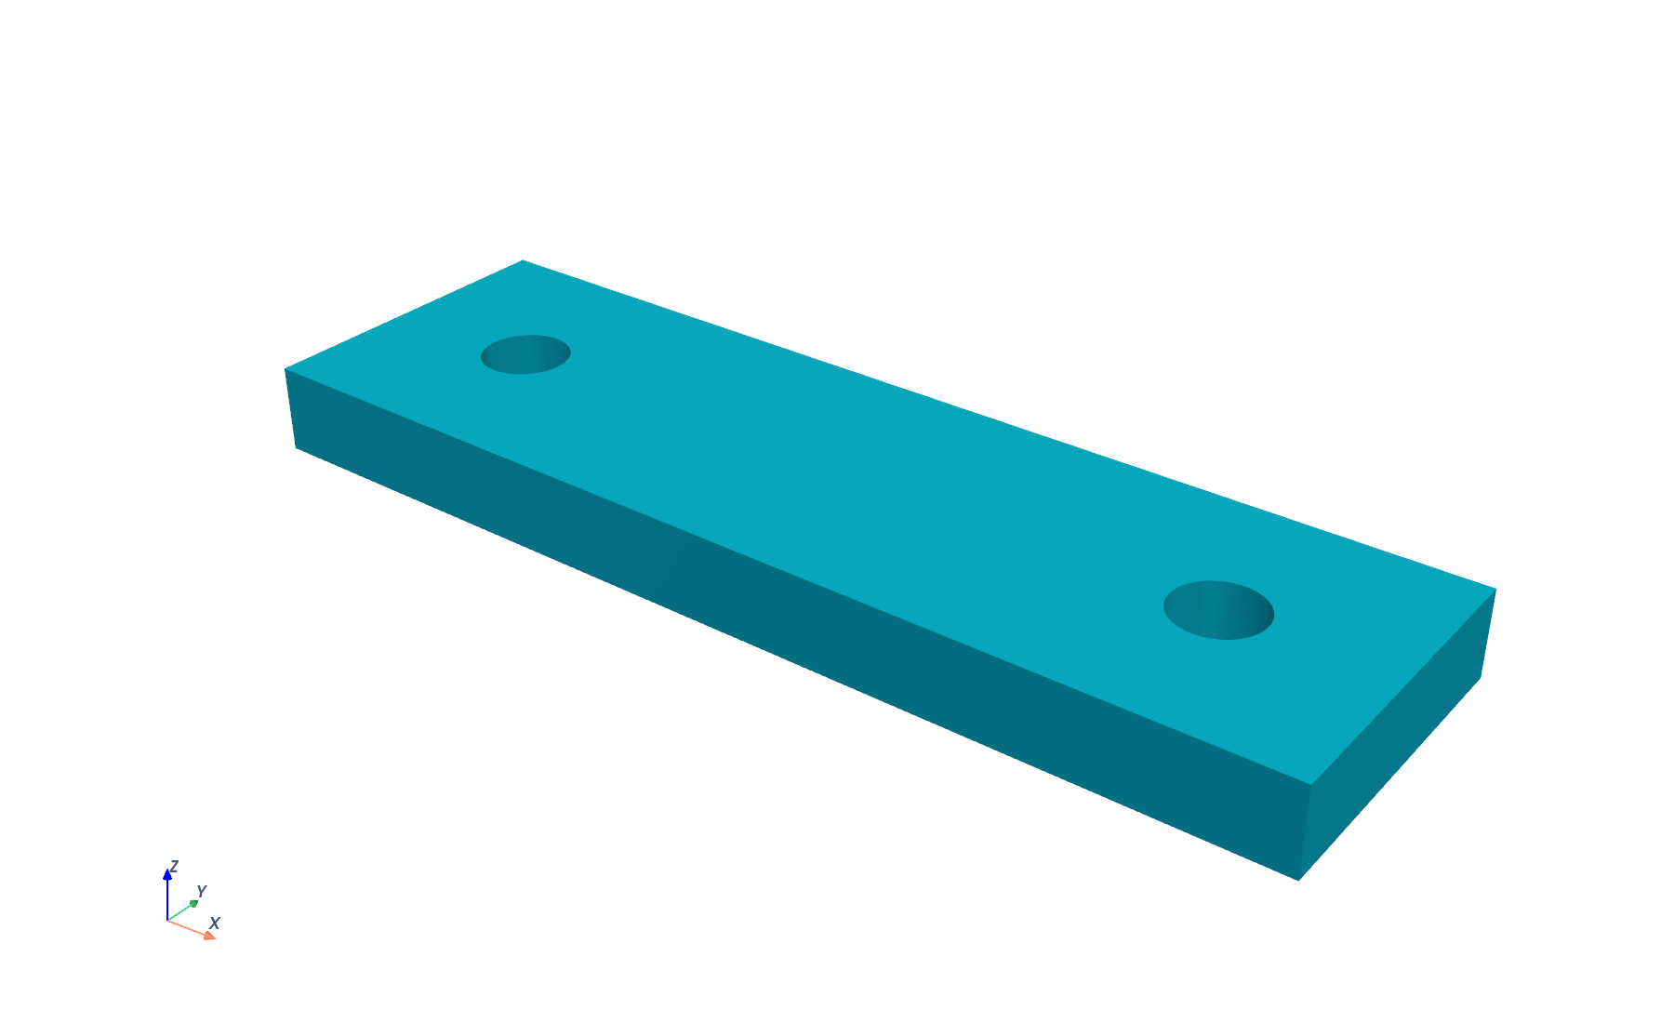
Captured BREP STL. The 100 by 30 by 8 millimetre body contains two 4 millimetre radius through holes.
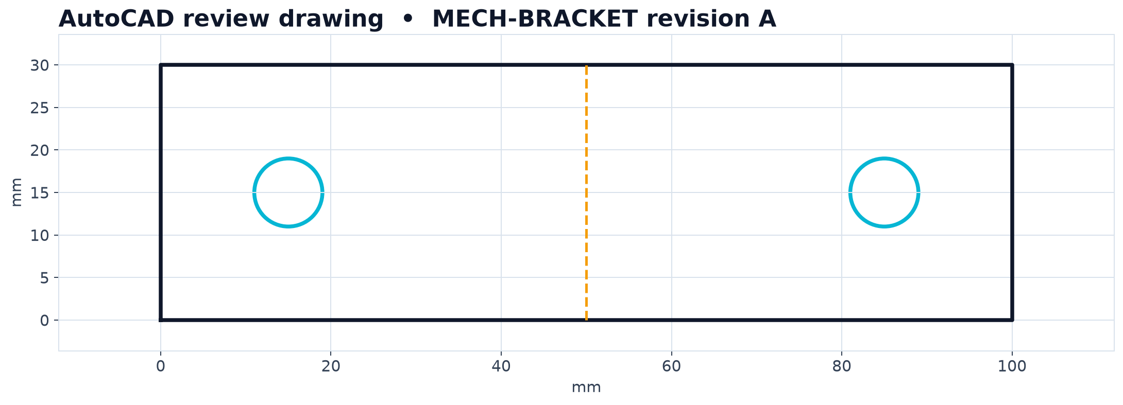
Captured AutoCAD DXF geometry with the same envelope and hole locations.

Chain 1 Structural screening result
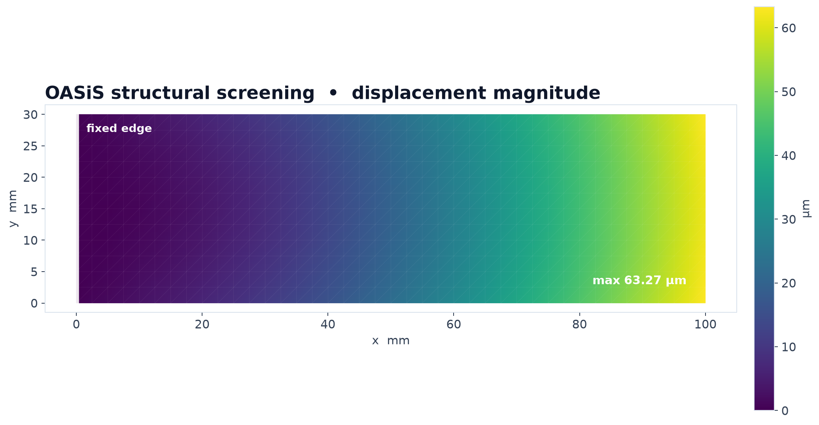
Displacement magnitude rendered from the exact VTU file recorded in the authoritative evidence.
Check | Observed result
STL volume | 23196.09 mm³; analytic expectation 23195.75 mm³
Structural model | 41 by 13 node plane screening mesh; aluminum properties; 250 N end load
Maximum displacement | 63.27 µm
Fixed boundary | 0 micrometres maximum at constrained edge
Engineering limit. This is a screening model. It confirms the automated simulation and result handling behave coherently; physical validation, detailed joint treatment and mounting hole stress concentration remain outside this qualification.

Chain 2 Electronics design to enclosure to thermal validation
KiCad MCP created a 50 by 40 millimetre controller board and placed R1 at its center. It then audited the board and exported the complete fabrication package. BREP MCP consumed the board envelope to generate a 60 by 50 by 15 millimetre enclosure envelope.
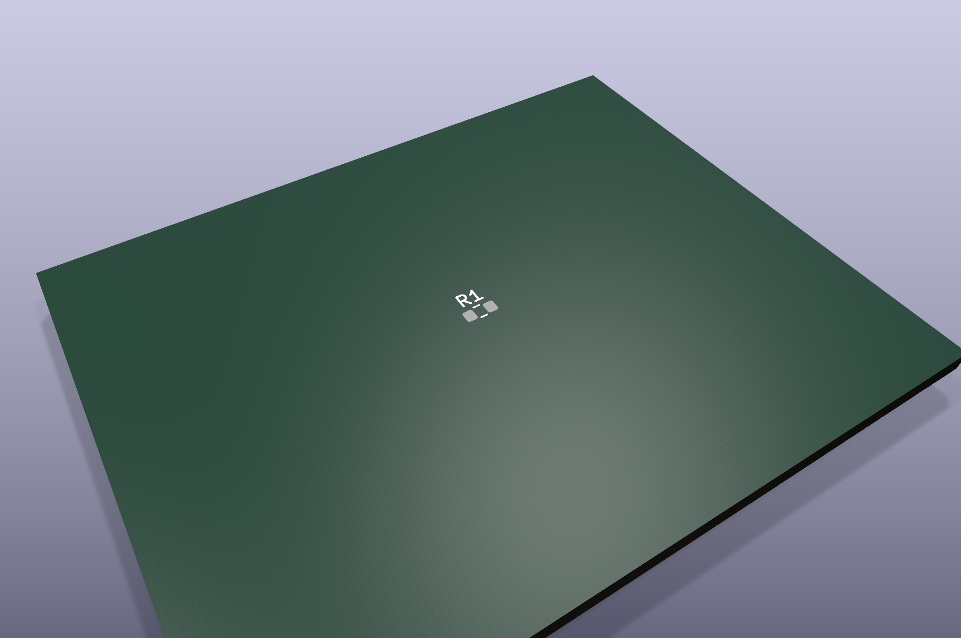
KiCad 3D render of the captured PCB output with R1 at the board center.
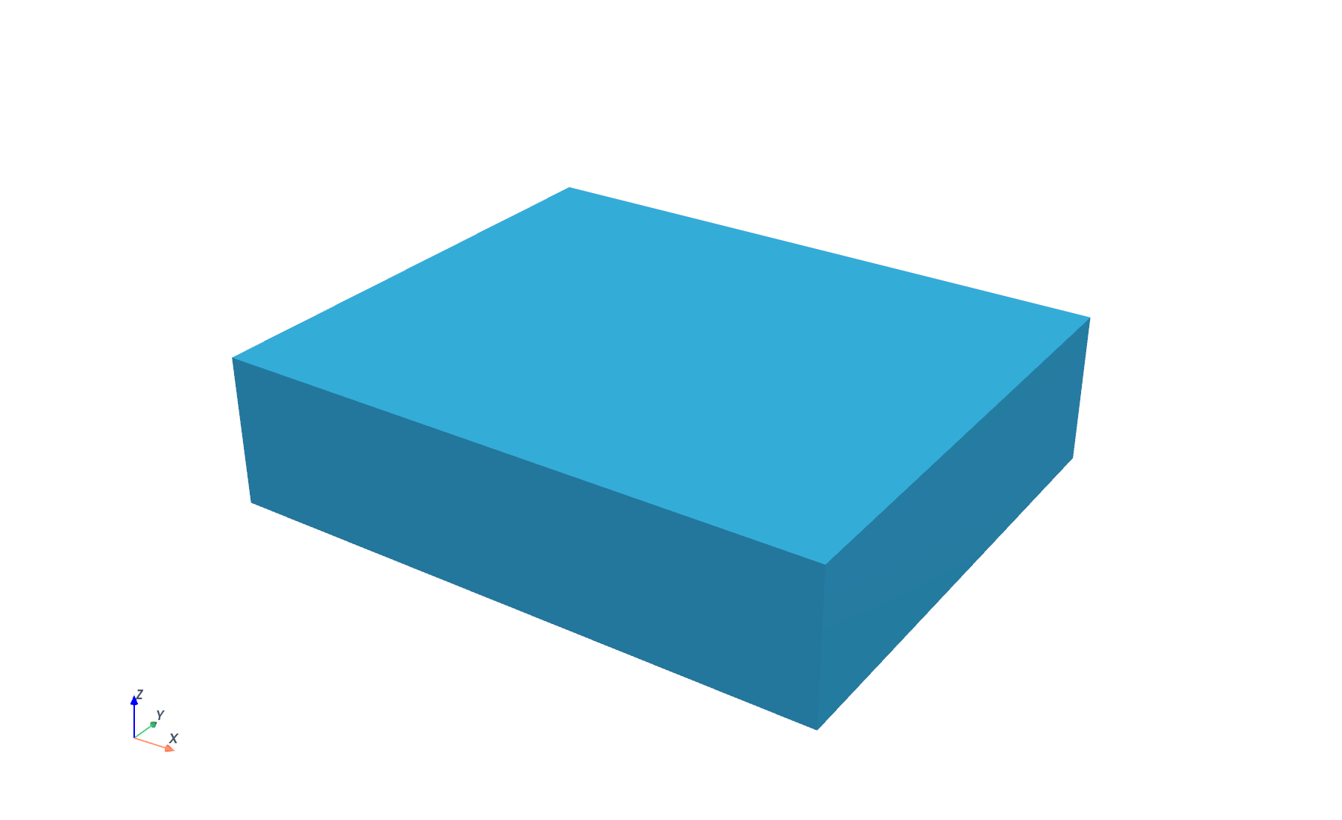
Captured BREP enclosure envelope used by the thermal handoff.

Chain 2 Thermal and test evidence
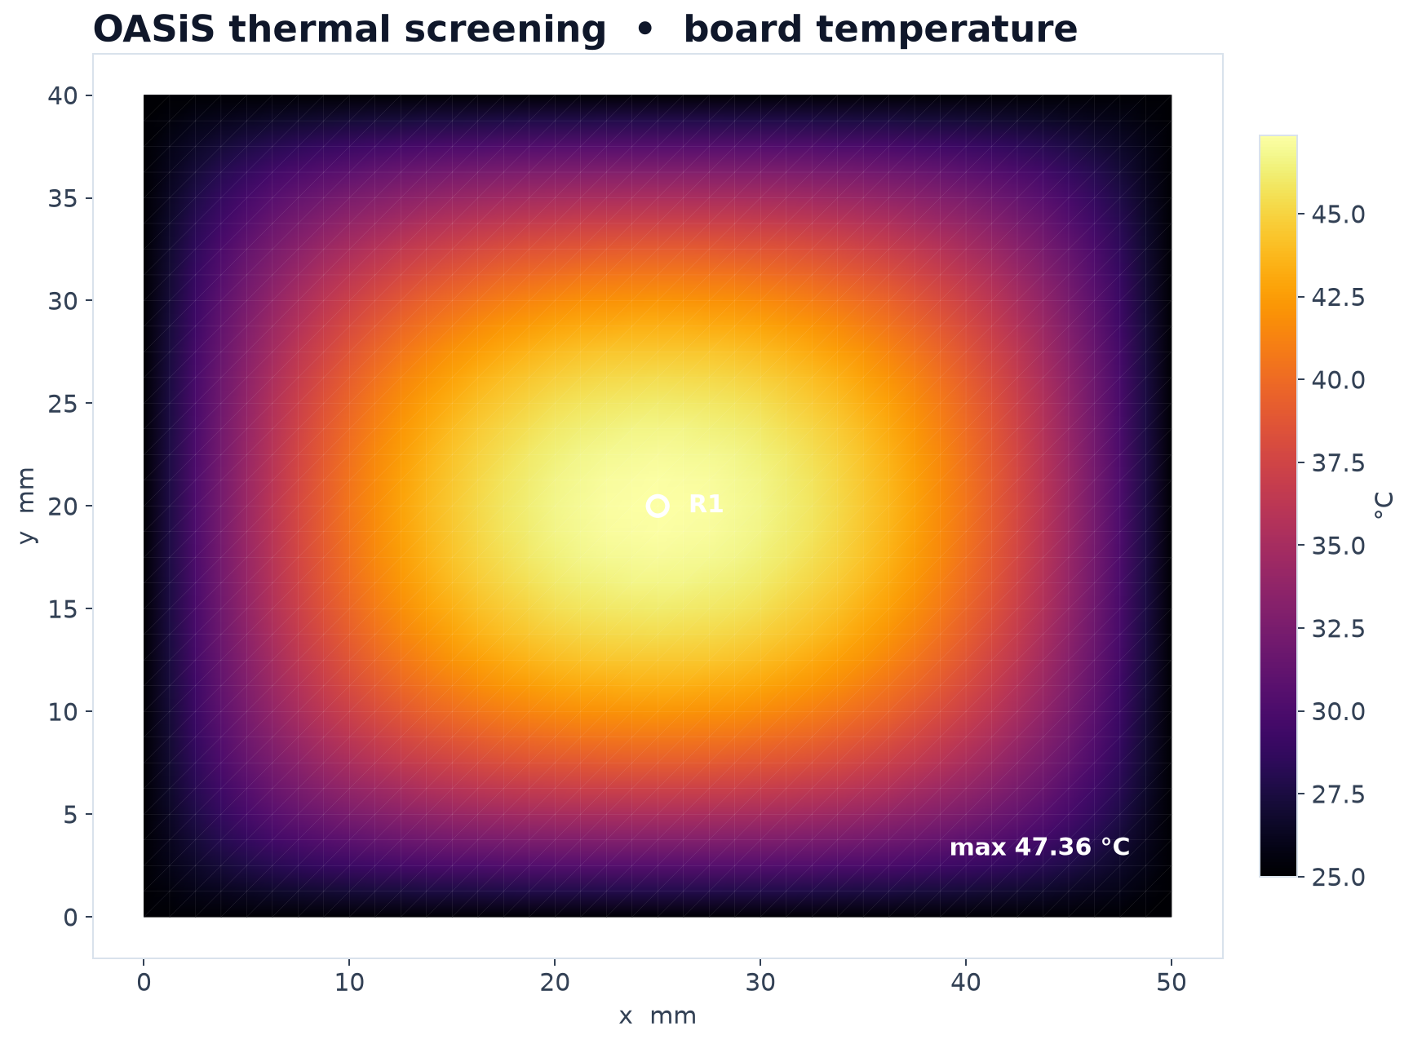
Temperature field rendered from the exact VTU file recorded in the authoritative evidence.
Check | Observed result
Fabrication package | 24 Gerber plots and 1 drill file in a ZIP archive
Boundary temperature | 298.15 K | 25.00 °C
Maximum temperature | 320.514 K | 47.36 °C
Validation limit | 358.15 K | 85.00 °C | passed
ROS trace | Returned the design ID, revision and board, enclosure and simulation hashes
Engineering limit. The thermal solve is a board level screening case with fixed ambient edges and a uniform source term. It proves the chain and evidence binding, not a detailed electronics thermal design.

Chain 3 Field evidence to controlled revision
AutoCAD MCP produced revision A of a field bracket. ROSBag MCP retrieved a deterministic test record for that exact drawing revision. The measured deflection exceeded the allowable value and triggered a second handoff to AutoCAD MCP, which released revision B with a thicker section while preserving revision A.
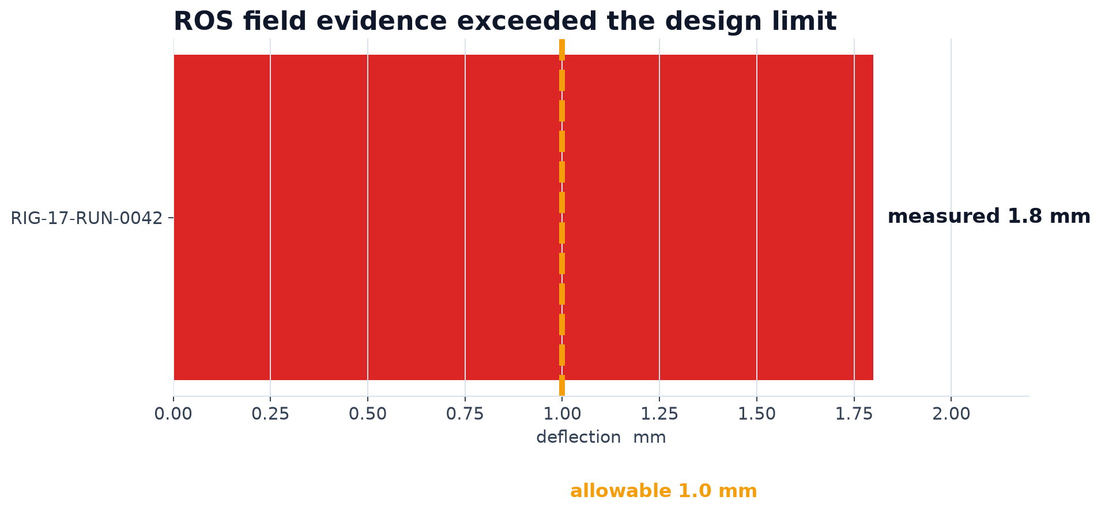
Field result RIG 17 RUN 0042 recorded 1.8 millimetres against a 1.0 millimetre allowable limit.
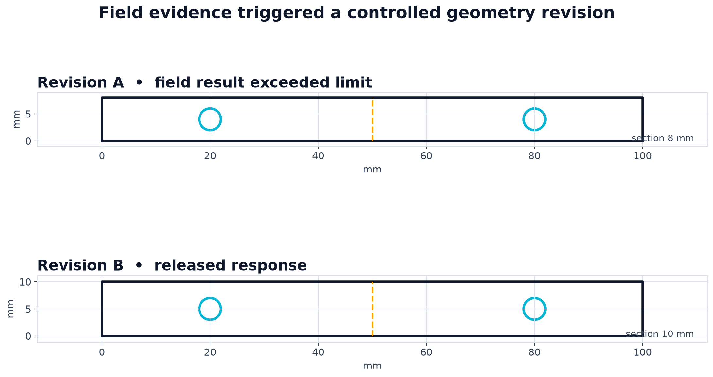
Captured DXF revisions. Revision B increases the section from 8 to 10 millimetres and retains two mounting holes.

Evidence integrity and practical limits
The passing evidence is committed as process-chains-linux.json at Wright commit bef9f077. Its embedded canonical digest recomputes to fb676615fe7542f6d022c0aa967056c8aac8a9d687e2dca356bfcc02298f7950. The file itself hashes to efb9d53c4aae186b7c6812ff9700f829579b0a84e5fff9bec29ab372fb229d4a.
Evidence control | Status
Artifact parsers | Independent STL, STEP, DXF, VTU, KiCad PCB, Gerber and ROS 2 bag checks passed
Handoff manifests | Identity, revision, units and artifact hashes verified; corrupt copies rejected
Deterministic outputs | Mechanical STL, enclosure STL and both VTU captures match the authoritative evidence hashes
Failed attempts retained | Attempt 1 exposed an obsolete KiCad API assumption; attempt 2 exposed a Gerber edge tolerance assumption
Automated checks | 26 focused tests passed; Ruff, Python compilation and diff checks passed

Current limits
- Qualification covers the declared Linux container scopes; host application and licensed desktop workflows need separate environments.
- The FEA cases are numerical screening examples and do not establish physical product validation.
- KiCad design rule closure was not part of this simple single component board scenario.
- Repeat user adoption has not yet been measured, and MHS physical device operation remains unqualified.

Recommended next work
The immediate priority is to keep the ten qualified integrations dependable while adding servers only after they pass the same evidence based process. The three chains should become repeatable regression scenarios rather than one time demonstrations.
Priority | Action | Completion evidence
1 | Schedule recurring requalification for the ten curated servers | Current launch, schema, artifact oracle and platform evidence
2 | Promote the three chains into maintained product design scenarios | Stable inputs, tool calls, handoff manifests and output thresholds
3 | Add candidates one at a time from the follow up queue | Clean container pass and a demonstrated role in a realistic engineering workflow
4 | Expand realism in the electronics and mechanical cases | KiCad DRC, richer assemblies, nonlinear or three dimensional CAE and physical comparison data
5 | Measure repeat use and operator friction | Observed completion rate, intervention rate and failure reasons

Decision for the next cycle
Use the current ten server portfolio as the supported engineering baseline. Requalify it on a fixed cadence, treat the three chains as regression evidence, and require every newly curated server to improve a real design chain before it appears in Wright’s default shortlist.

