05/09/26 - Revisions Needed
SA UI ANDYAN YUNG MGA INSPO PAKI AYOS YUNG UI ALL SIDE MGA TEXT AND PALETTE SA LAHAT NG SIDE NG ADMIN CUSTOMER AND STAFF, THANK YOU!

CUSTOMER SIDE

- Need Homepage first - too overwhelming kapag menu agad pag open ng app.
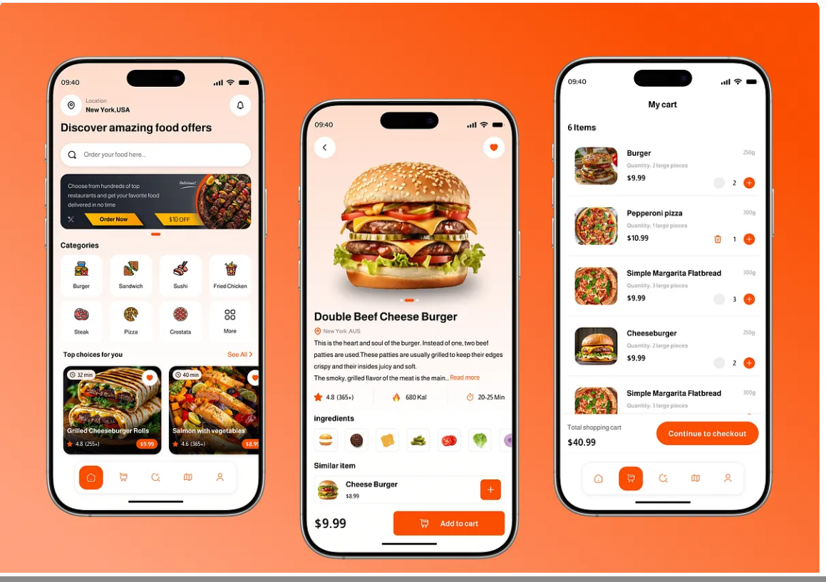

- In homepage, add intro / welcome for engagement.
- In homepage, add engaging banners like limited offers, for summer, etc. etc. (editable by admin - picture of banner and banner name)


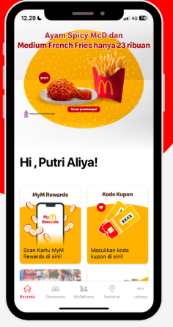
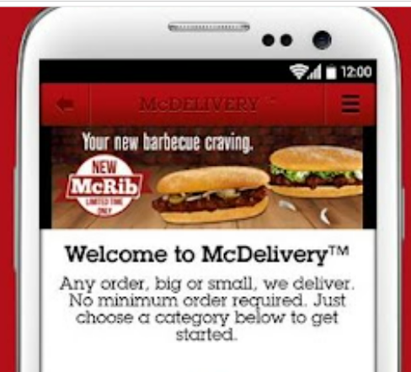
INSPO: CLIENT LOGO:

- Favorites - remove in selection bar. Palipat po under profile > “my favorites”
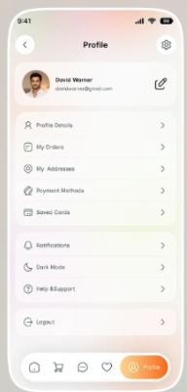
Kasi too crowded and masikip na yung selection bar. Overwhelming.

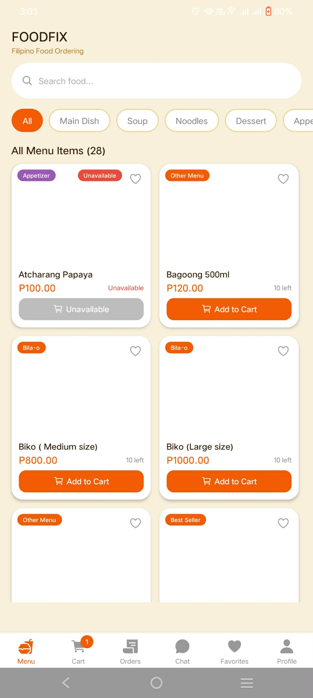
PROBLEM: INSPO:

- Categories Selection: should be dropdown instead of mag s-swipe pa para makita yung ibang categories.

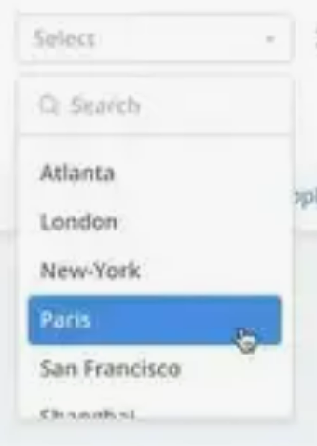

PROBLEM: INSPO:

- Modify Profile layout: too much unnecessary space on both sides. Taking up too much space vertically and plain lang.
- COPY THE INSPO na lang po.

PROBLEM: INSPO:

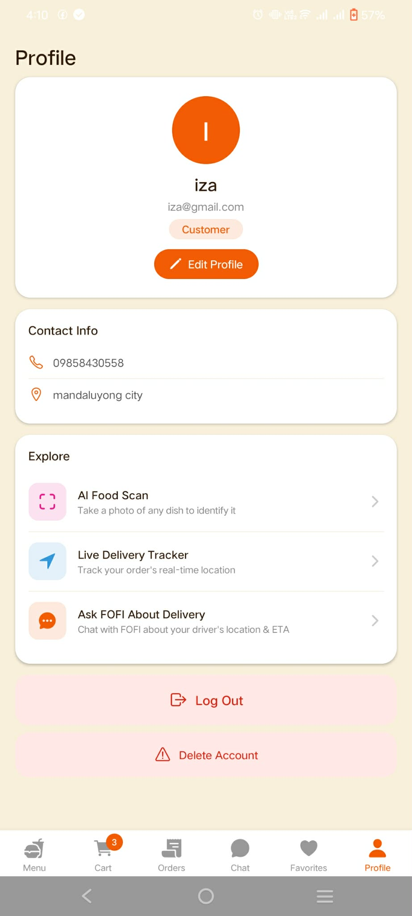

- Add to Cart: Pagkapindot ng add to cart, deretso add to cart siya which is need pa isa isahin kapag maraming order.

PROBLEM: IDEA:
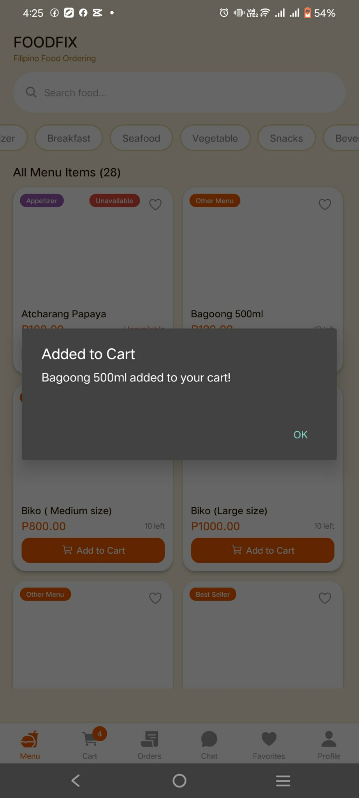
Small popup sa baba ng quantity. Tapos add to cart or cancel
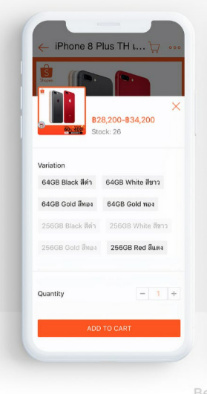

- Chatbox not seen: hindi nakikita yung tinatype. Need pang ibaba yung keyboard to see and send.
- Another problem: hindi na lumalabas yung new messages
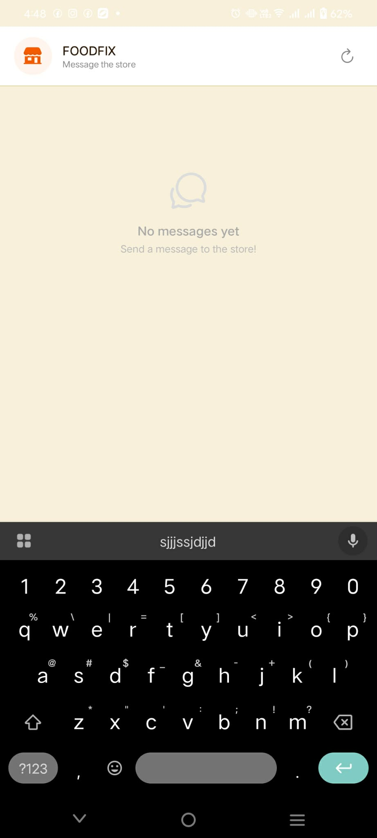

- Make each menu clickable
- Pag pinindot yung isang menu,small popup lang about that menu. Wag na po yung another whole page pa, like pasilip lang kung ano ba yung menu na yun.POPUP PREVIEW*

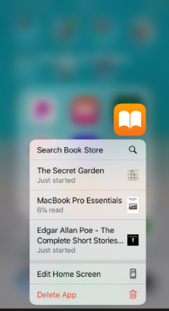
IDEA:

- Cart: add picture beside the name of order, not engaging and boring if name, price, quantity lng

IDEA:

- Ratings & Review:
- Pakilagay ito sa pag after ng order ng customer and if hindi nakapag review after ng order pwede pa rin dapat mag review pag pumunta sa orders. Tas dapat makikita ng admin yung ratings and review

- Yung Ai Deliver assistant pare parehas lang ng reply kahit anong imessage. Please fix po

- ORDER UI INSPO

- ORDER HISTORY - Please edit the order details page, ang overwhelming ng mga nakalagay. walang emphasis, border, and bold text. Copy na lang po nasa image
- ORDER TRACKING - copy na lang po yung tracking, and add connection line din po from location of customer and rider.
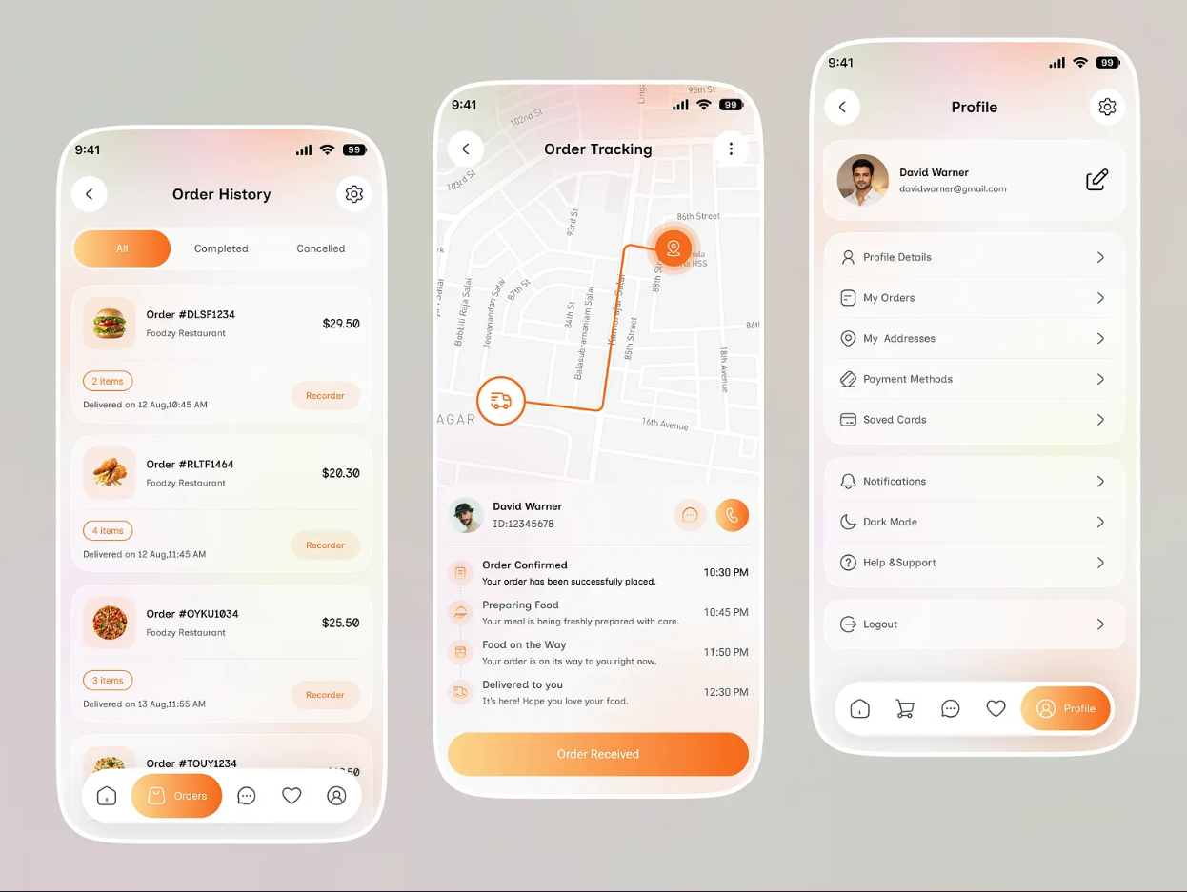

12. Admin had also webview kase kailangan daw po ng admin ng malaking screen so pwede daw po ma view ang admin sa web or laptop

13 And also may mobile view daw po sa laptop para di na mag share screen ng phone pag nag present po

