SULTAN KUDARAT STATE UNIVERSITY
ACCESS, EJC Montilla, Tacurong City, Sultan Kudarat

PROJECT PROPOSAL

UniTrack
Real-Time Faculty & Staff Locator

A Mobile-Based Geographic Information System
for Sultan Kudarat State University

Proposed by:
CHRISTIAN KETH AGUACITO

February 2026

TABLE OF CONTENTS
1. Executive Summary...................................3
2. Project Overview....................................4
3. Problem Statement...................................5
4. Objectives..........................................6
5. Scope and Limitations...............................7
6. Proposed Features...................................8
7. Application User Interface Design...................10
8. Technical Stack (Free & Open-Source)................14
9. System Architecture.................................15
10. Privacy & Security Measures........................16
11. Development Roadmap................................17
12. Project Timeline...................................18
13. Cost Analysis: Zero-Budget Implementation..........19
14. Risk Assessment and Mitigation.....................20
15. Expected Outcomes..................................21
16. Evaluation Criteria................................22
17. Future Expansion: IoT & Kiosk Integration..........23
18. Conclusion.........................................25
19. References.........................................26

1. Executive Summary
UniTrack is an innovative mobile-based Geographic Information System (GIS) designed specifically for Sultan Kudarat State University (SKSU) to enhance campus communication and efficiency. The application addresses a persistent challenge faced by students: locating faculty members and staff in real-time across the university's multiple buildings and facilities.
The system employs a 'Google Maps' style interface powered by OpenStreetMap (completely free and open-source) that allows students to view the real-time locations of teachers and staff within campus boundaries, provided the staff member has explicitly granted permission through a privacy-first consent mechanism.
Key features include a Staff Module (the 'Beacon') with privacy controls and status presets, a Student Module (the 'Seeker') with live map visualization and navigation, and an Administrative Module for department management.
TOTAL PROJECT COST: PHP 0.00 (Completely Free)
The system is built entirely on free and open-source technologies including Flutter, OpenStreetMap, and Firebase's free tier—resulting in zero development and operational costs. UniTrack represents SKSU's commitment to digital transformation and creating a more connected, efficient campus environment while maintaining the highest standards of privacy and data protection.

2. Project Overview
UniTrack is a mobile-based geographic information system (GIS) designed to bridge the communication gap between students and university personnel at Sultan Kudarat State University. The application provides a live 'Google Maps' style interface where students can view the real-time location of teachers and staff within campus bounds, provided the staff member has granted permission.

2.1 Project Title
UniTrack – Real-Time Faculty & Staff Locator for Sultan Kudarat State University

2.2 Project Type
Mobile Application Development (Android & iOS) with Real-Time GIS Integration

2.3 Target Users
- Students of Sultan Kudarat State University (Primary Users)
- Faculty Members and Teaching Staff
- Administrative Staff and Personnel
- University Administrators and Department Heads

2.4 Target Deployment
The system will be deployed across all SKSU campuses, initially piloting at the Main Campus (ACCESS, EJC Montilla, Tacurong City) before expanding to satellite campuses.

3. Problem Statement
Students at Sultan Kudarat State University often waste significant time walking to faculty offices only to find that the teacher is in a meeting, conducting a class in a different building, or temporarily off-campus. The current methods of locating faculty members present several challenges:
- Inefficient Communication Channels: Email responses are often delayed, and physical bulletin boards with faculty schedules are frequently outdated or not accessible in real-time.
- Time Wastage: Students spend considerable time moving between buildings searching for available faculty, reducing productive academic hours.
- Missed Consultation Opportunities: Students miss valuable consultation time due to inability to locate faculty during their available hours.
- Physical Traffic Congestion: Faculty rooms become overcrowded during peak hours as students congregate hoping to catch their professors.
- Lack of Real-Time Information: No existing system provides live updates on faculty availability and location within the campus.

4. Objectives

4.1 General Objective
To develop and implement a mobile-based real-time faculty and staff location system for Sultan Kudarat State University that enhances campus communication efficiency while maintaining strict privacy controls—all at zero cost using free and open-source technologies.

4.2 Specific Objectives
1. To implement a live map interface using OpenStreetMap (free, open-source) for real-time visualization of faculty locations within SKSU campus boundaries.
2. To provide staff with comprehensive privacy controls including a 'Visibility Toggle' to control when they are trackable.
3. To reduce the time students spend searching for staff members by at least 60%.
4. To implement geofencing technology that automatically disables tracking once a staff member leaves the university perimeter.
5. To create a searchable directory system that allows students to filter staff by Department, Name, or Current Availability.
6. To develop an administrative module for department management and anonymized analytics.
7. To ensure full compliance with data privacy regulations including the Data Privacy Act of 2012 (RA 10173).
8. To achieve zero-cost implementation using only free and open-source technologies.

5. Scope and Limitations

5.1 Project Scope
- Development of cross-platform mobile applications for Android and iOS devices
- Integration with OpenStreetMap and Flutter Map for free, open-source location visualization
- Implementation of Firebase free tier backend for real-time data synchronization
- Development of three user modules: Staff, Student, and Administrative
- Implementation of geofencing for SKSU campus boundaries
- Integration with university email system for authentication
- Development of privacy controls and consent mechanisms
- Zero-cost deployment using free and open-source technologies only

5.2 Limitations
- The system requires active internet connectivity for real-time tracking
- GPS accuracy may vary depending on device hardware and environmental factors
- Initial deployment will be limited to the SKSU Main Campus
- The system does not track indoor floor levels (single-plane tracking only)
- Battery consumption may increase on staff devices when tracking is enabled
- The system requires voluntary participation from faculty and staff

6. Proposed Features

6.1 Staff Module (The 'Beacon')
The Staff Module serves as the location broadcasting component of the system, giving faculty and staff complete control over their visibility.
- Privacy Toggle: A master ON/OFF switch for location broadcasting. Staff can instantly enable or disable their visibility with a single tap.
- Status Presets: Manual status updates including: 'Available for Consultation,' 'In a Class,' 'In a Meeting,' 'Break Time,' 'Office Hours,' and 'Do Not Disturb.'
- Availability Status: Rich availability indicators (Available, Busy, In Meeting, Teaching, On Break, Out of Office, Do Not Disturb) with color-coded display visible to students in real-time.
- Auto-Kill Timer: Automatically turns off tracking after office hours based on customizable schedule settings.
- Quick Messages: Pre-set messages that can be broadcast to searching students (e.g., 'Back in 10 minutes,' 'See me tomorrow').
- Location Override: Ability to manually set a static location when GPS signal is weak (e.g., 'Currently at Admin Building').
- Schedule Integration: Optional sync with class schedules to automatically update status during teaching hours.
- Custom Status Message: Add personalized messages to your status (e.g., 'Available until 3PM', 'In room 201').

6.2 Student Module (The 'Seeker')
The Student Module provides the search and visualization interface for locating faculty and staff.
- Searchable Directory: Filter staff by Department, Name, Subject Taught, or Current Availability status.
- Live Map View: Real-time map showing moving markers (avatars) of online staff members with smooth animations using OpenStreetMap.
- One-Tap Navigation: Get walking directions from the student's current location to the staff member using open-source routing.
- Favorites List: Save frequently consulted faculty members for quick access.
- Notification Alerts: Opt-in notifications when a specific faculty member comes online or becomes available.
- Estimated Walking Time: Display estimated time to reach the faculty member based on current distance.
- Office Hours Display: View faculty consultation hours and schedule information.
- Offline Mode: Access cached faculty data and campus maps even without internet connection using SQLite local storage.
- Push Notifications: Receive important announcements and updates directly on your device.
- Onboarding Tutorial: Interactive guided tour for new users to learn all app features quickly.
- In-App Updates: Automatic notification and download of new app versions without visiting external stores.

6.3 Administrative Module
- Department Management: Manage the list of authorized faculty and staff accounts, assign departments, and control access levels.
- User Verification: Approve or reject registration requests from faculty and staff.
- Analytics Dashboard: View anonymized heatmaps of student-staff interaction points and peak consultation times.
- Campus Boundary Management: Define and update the geofencing polygon coordinates for campus boundaries.
- System Configuration: Configure default privacy settings, tracking intervals, and notification preferences.
- Report Generation: Generate usage reports for administrative review and system improvement.

7. Application User Interface Design
The following wireframes and mockups illustrate the proposed user interface design for UniTrack. The design follows modern mobile UI/UX principles with a focus on simplicity, accessibility, and intuitive navigation.

7.1 Login Screen
The login screen provides secure authentication using SKSU email credentials. Users can choose their role (Student or Faculty) for appropriate access.
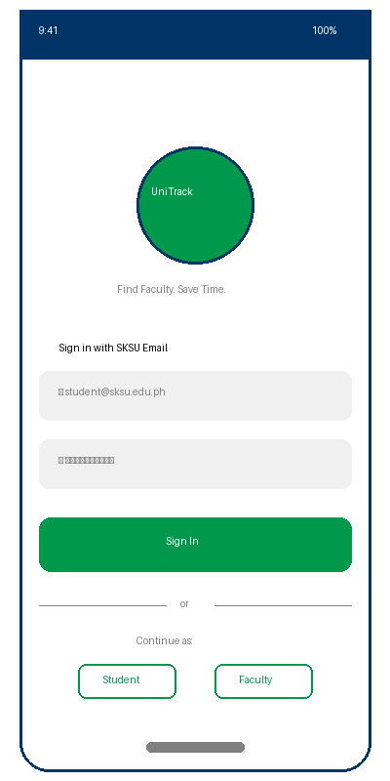
Figure 7.1: UniTrack Login Screen

7.2 Staff Dashboard (Beacon Module)
The Staff Dashboard features a prominent privacy toggle, status selection, and quick message options. Faculty members have full control over their visibility and can set their availability status with one tap.
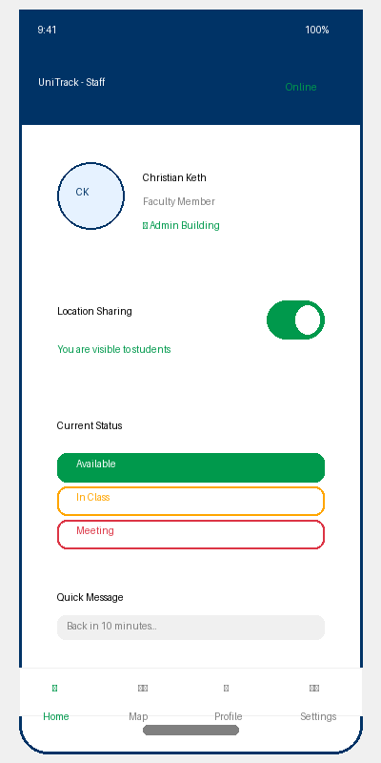
Figure 7.2: Staff Dashboard with Privacy Controls

7.3 Faculty Directory (Seeker Module)
Students can search and filter faculty members by name, department, or availability status. Each listing shows the faculty member's current status with color-coded indicators for quick identification.
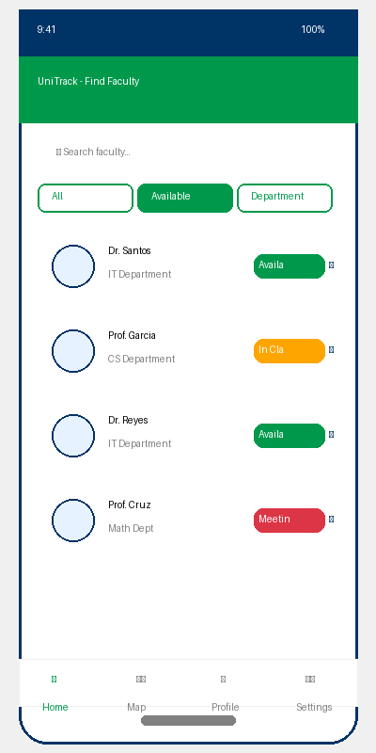
Figure 7.3: Faculty Directory with Search and Filters

7.4 Live Campus Map
The live map displays the SKSU campus with building overlays and real-time faculty location markers. Markers are color-coded by availability status, and students can tap on any marker to view details and get directions.
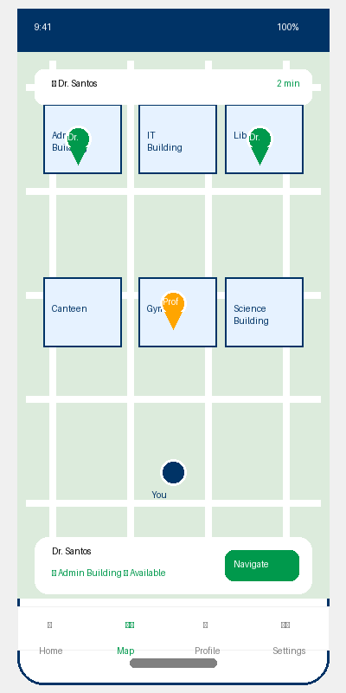
Figure 7.4: Live Campus Map with Faculty Locations

7.5 Navigation & Directions
When a student selects a faculty member, the app provides turn-by-turn walking directions with estimated arrival time. The route is displayed on the map with clear visual guidance.
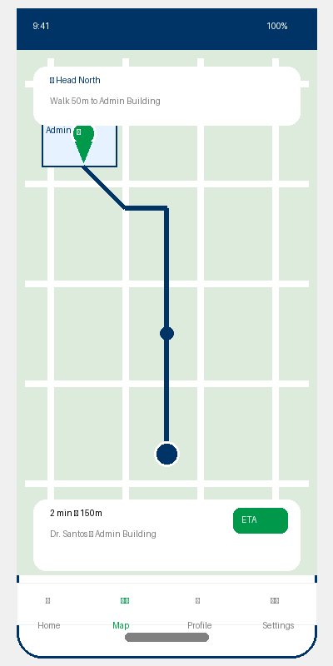
Figure 7.5: Navigation Screen with Walking Directions

7.6 Privacy Settings
Faculty members have granular control over their privacy settings, including auto-off timers, campus-only restrictions, and message preferences. All settings are clearly labeled with toggle switches.
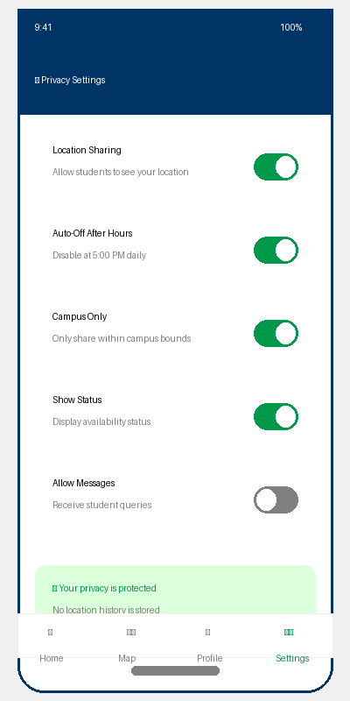
Figure 7.6: Privacy Settings Panel

7.7 Admin Dashboard
The administrative dashboard provides an overview of system usage, active faculty, student activity statistics, and quick access to management functions.
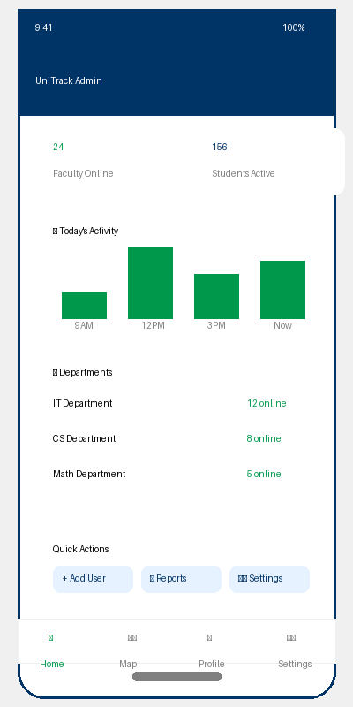
Figure 7.7: Administrative Dashboard

7.8 Design Principles
- Color Scheme: Green (#009933) for online/available status, Orange for busy, Red for unavailable, and Dark Blue (#003366) for headers and navigation.
- Typography: Clean, readable fonts with clear hierarchy. Large touch targets for mobile usability.
- Privacy Indicators: Prominent visual feedback when location sharing is active, with clear ON/OFF states.
- Accessibility: High contrast colors, readable font sizes, and support for screen readers.
- Responsive Design: Adapts to different screen sizes across Android and iOS devices.

8. Technical Stack (Free & Open-Source)
UniTrack is built entirely on free and open-source technologies, ensuring zero licensing costs while maintaining professional-grade quality and scalability:

Component | Technology | Justification
Frontend | Flutter (Dart) | Free, open-source cross-platform development
Map Engine | OpenStreetMap + Flutter Map | Free mapping with no API costs
Backend/Database | Firebase Spark (Free Tier) | Free real-time NoSQL database
Authentication | Firebase Auth (Free) | Free unlimited user authentication
Location Services | Geolocator Package | Free Flutter GPS tracking package
Hosting | Firebase Hosting (Free) | Free hosting with SSL included

8.1 Development Tools (All Free/Open-Source)
- IDE: Visual Studio Code (Free, Open-Source) with Flutter extensions
- Version Control: Git with GitHub Free repositories
- UI/UX Design: Figma Free Tier (3 projects)
- Project Management: Trello Free Tier / GitHub Projects
- Testing: Flutter Test Framework (built-in), Android Emulator (free)
- CI/CD: GitHub Actions Free Tier (2,000 minutes/month)

9. System Architecture

9.1 High-Level Architecture
UniTrack follows a client-server architecture with real-time synchronization capabilities:
1. Data Acquisition: The Staff mobile app retrieves GPS coordinates via the device's location services.
2. Privacy Check: Before transmission, the app verifies that the Privacy Toggle is ON and the device is within the geofenced campus boundary.
3. Transmission: If conditions are met, coordinates are pushed to Firebase Firestore via secure HTTPS connection.
4. Cloud Processing: Firebase processes incoming data, validates geofence boundaries, and triggers notifications.
5. Synchronization: Student apps 'listen' to Firebase Firestore streams using real-time listeners.
6. Rendering: The Flutter Map package with OpenStreetMap renders the movement of markers on the student's screen.

9.2 Database Schema
- users: Stores user profiles, roles, department affiliations, and preferences
- locations: Real-time location data with coordinates and timestamp (overwritten, not logged)
- departments: Department information and authorized personnel
- geofences: Campus boundary polygon coordinates
- analytics: Anonymized interaction data for reporting

10. Privacy & Security Measures
UniTrack is designed with privacy as a foundational principle, ensuring compliance with the Data Privacy Act of 2012 (Republic Act No. 10173).

10.1 Core Privacy Principles
- Opt-in Only: Location tracking is disabled by default. Staff must explicitly enable tracking.
- No History Logging: The system only stores the current coordinate. Past locations are immediately overwritten.
- Campus Boundary Enforcement: Geofencing automatically stops tracking outside the SKSU campus.
- Minimal Data Collection: Only essential data is collected. No behavioral tracking.
- User Control: Staff can disable tracking at any time with immediate effect.

10.2 Security Measures
- Encrypted Transmission: All data uses TLS 1.3 encryption via HTTPS.
- Authentication: Firebase Authentication with university email verification.
- Role-Based Access Control: Different access levels for students, staff, and administrators.
- Audit Logging: Administrative actions are logged for accountability.

11. Development Roadmap
Phase 1: Planning and Design (Weeks 1-4)
- Requirements gathering and stakeholder interviews
- System architecture design
- UI/UX wireframe and prototype development
- Database schema design
- Privacy impact assessment
Phase 2: Core Development (Weeks 5-12)
- Firebase project setup
- User authentication module
- Staff module with privacy controls
- Student module with map integration
- Real-time location synchronization
- Geofencing logic
Phase 3: Feature Enhancement (Weeks 13-16)
- Administrative module
- Analytics dashboard
- Notification system
- Navigation feature
- Status presets and messaging
Phase 4: Testing and QA (Weeks 17-20)
- Unit testing
- Integration testing
- User acceptance testing with SKSU users
- Performance and security testing
- Bug fixes and optimization
Phase 5: Deployment and Launch (Weeks 21-24)
- APK distribution setup
- Production environment
- User training
- Pilot launch
- Full campus rollout

12. Project Timeline

Phase | Duration | Start | End | Deliverables
Planning & Design | 4 weeks | Week 1 | Week 4 | SRS, Wireframes
Core Development | 8 weeks | Week 5 | Week 12 | Working Modules
Feature Enhancement | 4 weeks | Week 13 | Week 16 | Complete Features
Testing & QA | 4 weeks | Week 17 | Week 20 | Test Reports
Deployment | 4 weeks | Week 21 | Week 24 | Live Application

Total Project Duration: 24 weeks (approximately 6 months)

13. Cost Analysis: Zero-Budget Implementation
One of the key advantages of UniTrack is that it can be developed and deployed entirely using free and open-source technologies, requiring no financial investment.

Component | Free Solution | Cost
Development IDE | Visual Studio Code (Open-Source) | FREE
Map Engine | OpenStreetMap + Flutter Map | FREE
Backend Database | Firebase Firestore (Spark Free Plan) | FREE
Authentication | Firebase Auth (Unlimited users) | FREE
Cloud Hosting | Firebase Hosting (10GB storage) | FREE
UI/UX Design | Figma Free Tier | FREE
Version Control | GitHub Free | FREE
CI/CD Pipeline | GitHub Actions (2,000 min/month) | FREE
App Distribution | Direct APK / GitHub Releases | FREE

TOTAL PROJECT COST: PHP 0.00

14. Risk Assessment and Mitigation

Risk | Probability | Impact | Mitigation Strategy
Low faculty adoption | Medium | High | Awareness campaigns; privacy emphasis
GPS accuracy issues | Medium | Medium | Location smoothing; manual override
Battery drain | High | Medium | Optimized polling frequency
Privacy concerns | Medium | High | Transparent policy; user control
Technical failures | Low | High | Redundant systems; backups
Firebase limits exceeded | Low | Medium | Monitor usage; optimize queries

15. Expected Outcomes
- Improved Time Management: Students will save an estimated 60% of time previously spent searching for faculty.
- Reduced Physical Traffic: Faculty rooms will experience reduced congestion.
- Enhanced Communication: Real-time status updates improve student-faculty communication.
- Modernized Campus: SKSU positioned as a tech-forward institution.
- Data-Driven Insights: Anonymized analytics help optimize consultation hours.
- Zero-Cost Implementation: Complete project delivery without financial investment.

16. Evaluation Criteria
Success will be measured against the following KPIs:
- User Adoption Rate: 70% faculty and 80% students within first semester
- Time Savings: 60% reduction in time spent locating faculty
- System Uptime: 99.5% availability during operational hours
- User Satisfaction: 4.0/5.0 average rating
- Privacy Compliance: Zero privacy incidents or data breaches
- Response Time: Location updates visible within 3 seconds

17. Future Expansion: IoT & Kiosk Integration
UniTrack is designed with scalability in mind, allowing for future integration with Internet of Things (IoT) devices and campus kiosk systems. This expansion will transform the mobile application into a comprehensive campus-wide information ecosystem.

17.1 Campus Kiosk Integration
- Interactive Kiosk Displays: Large touchscreen displays strategically placed at campus entrances, lobbies, and common areas showing real-time faculty availability.
- Digital Faculty Board: Dedicated screens outside department offices displaying all faculty members with their current status, location, and availability.
- Wayfinding Stations: Touch-enabled maps helping visitors and new students navigate to faculty offices with step-by-step directions.
- QR Code Check-in: Faculty members can update their status by scanning QR codes at office doors or kiosk stations.
- Announcement Integration: Kiosks can display campus-wide announcements, schedules, and emergency notifications alongside faculty locator.
- Visitor Registration: Guests can register at kiosks and notify faculty of their arrival automatically.

17.2 IoT Sensor Integration
- Bluetooth Beacons: Low-energy Bluetooth beacons installed in buildings for precise indoor location detection, improving accuracy beyond GPS.
- NFC Door Tags: Near Field Communication tags at office doors allowing faculty to tap their phones to instantly update their status.
- Smart Room Sensors: Occupancy sensors in offices and meeting rooms that automatically detect faculty presence and update status.
- Environmental Sensors: Temperature, humidity, and air quality sensors that can indicate if a room is actively in use.
- Smart Scheduling Displays: E-ink or LCD displays outside offices showing real-time availability synced with UniTrack.

17.3 API & Integration Hub
UniTrack will provide a RESTful API enabling integration with:
- Third-party Kiosk Hardware: Standard API endpoints for commercial kiosk manufacturers to display UniTrack data.
- Campus Management Systems: Integration with existing university ERP, class scheduling, and room booking systems.
- Digital Signage Networks: Push faculty availability data to existing digital signage infrastructure.
- Mobile Web Portal: Responsive web version accessible from any device without app installation.
- Analytics Dashboard: Anonymized traffic patterns and consultation trends for campus planning.

IoT Component | Estimated Units | Estimated Cost
Touchscreen Kiosk (32") | 5-10 units | PHP 25,000-50,000 each
Bluetooth Beacons | 50-100 units | PHP 500-1,000 each
NFC Door Tags | 100-200 units | PHP 50-100 each
Smart Room Sensors | 20-50 units | PHP 2,000-5,000 each
API Server Hosting | Cloud-based | PHP 0-5,000/month
Note: IoT expansion is optional and can be implemented incrementally based on budget availability. The core mobile application remains completely free.

18. Conclusion
UniTrack represents a significant step forward in modernizing campus operations at Sultan Kudarat State University. By leveraging free and open-source technologies, the system addresses student-faculty connectivity challenges while maintaining privacy—all at zero cost.
The privacy-first design ensures faculty maintain complete control over their visibility with robust safeguards including opt-in consent, geofencing, and zero historical tracking.
With a realistic 24-week timeline and completely free technology stack, UniTrack is positioned for successful implementation. The use of OpenStreetMap, Firebase free tier, and Flutter ensures professional-grade quality without licensing fees.
UniTrack will not only solve the immediate problem of locating faculty but will establish SKSU as a leader in educational technology innovation in the SOCCSKSARGEN region and beyond.

19. References
[1] OpenStreetMap Foundation. (2026). OpenStreetMap Documentation. https://wiki.openstreetmap.org
[2] Flutter Map Package. (2026). https://pub.dev/packages/flutter_map
[3] Firebase Documentation. (2026). https://firebase.google.com/docs
[4] Flutter Documentation. (2026). https://docs.flutter.dev
[5] Republic Act No. 10173 - Data Privacy Act of 2012. Official Gazette of the Philippines.
[6] National Privacy Commission. (2024). Guidelines on Privacy Impact Assessment.
[7] Sultan Kudarat State University. (2026). SKSU Strategic Development Plan.
[8] Geolocator Flutter Package. (2026). https://pub.dev/packages/geolocator
[9] Internet of Things in Education: A Review. IEEE Access. (2024).
[10] Smart Campus Solutions: Best Practices for Digital Transformation. (2025).

