**PDF Download 2D Apple Games by Tutorials:Beginning 2D iOS,tvOS,macOSwatchOSGame DevelopmentwithSwift 3 Full ePub**

Bookdetails

* Author :raywenderlich.com Team
* Pages :676 pages
* Publisher : RazewareLLC 2016-12-14
* Language : English

●ISBN-10:1942878281

* ISBN-13 :9781942878285
* <http://pdf.solidbooks.club/?book=0230368891>

BookSynopsis

Learn How toMake 2D

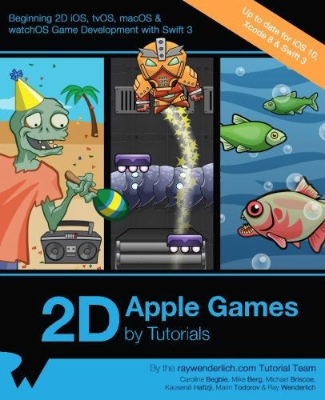

Games for iOS,tvOS,watchOSandmacOS!Learnhow tomake games for allthe majorApple platformsinSwift,usingApple s built-in2D game framework: Sprite

Kit.Through a series of mini-gamesandchallenges, youwill go from beginnertoadvancedandlearneverything you needtomakeyour own game!Bythe timeyou’re finishedreadingthisbook, you will have made 6complete mini-games, fromanactiongame to a puzzlegame to a towerdefensegame!TopicsCoveredin 2DApple Games by TutorialsSprites: Get startedquicklyandget your imagesontoyour screen.ManualMovement: Move spritesmanuallywith a crashcourseon 2D math.Actions: Learnhow tomove spritesthe

“easyway"usingSpriteKitactions.ScenesandTransitions: Make multiplescreensin your appandmovebetweenthem.Camera: UseSprite Kit’sbuilt-incamera

tocontrol your view.Labels:Learn how todisplaytext forlives,scoresandmore inyour game.Physics: Add

realistic physicsbehaviorintoyour games.BeyondSprites:Add videonodes,core imagefilters,andcustom shapes.

Particle Systems: Addexplosions,starfields,andotherspecial effects.Adding“Juice??: Take your gamefromgood togreat bypolishingit until it shines.

Online Gaming: Addmultiplayerfeaturesto yourgame withApple’sGameCenter.Tile Maps: Makegamesthat use tile mapswith

obstacles,power-ups,andmore.tvOS: Learn how toportyour game tothe AppleTVand work withtheremote.watchOS: Takeadvantage of the uniquefeatures of the Apple Watch.macOS: Learn how tobring2D gamingtothe desktop.

And muchmore,including abonus chapter on creatingyour own 2D game art!