CHAPTER FOUR

FINDINGS AND DISCUSSION

4.1 Introduction
This chapter presents the findings from a longitudinal analysis of Hepatitis B patient data collected from Benjamin Mkapa Hospital (BMH) between 2017 and 2024. The analysis addresses three specific objectives of the study: to analyse Hepatitis B patient trends at BMH, to develop a predictive model for Hepatitis B patients, and to forecast Hepatitis B patient numbers for the next five years. The chapter is organised into three main sections corresponding to these objectives. The first section presents the descriptive and trend analysis of Hepatitis B cases, providing insights into the temporal and demographic patterns observed during the study period. The second section focuses on the development and evaluation of the predictive model, outlining the methodology and performance metrics used to assess its accuracy. The final section presents the forecasting results, projecting Hepatitis B patient numbers for the next five years based on the established model.

4.2 Data Screening and Preparation

4.2.1 Data Structure and Quality Checks
The dataset comprised 1,710 cleaned and validated records of Hepatitis B patients. It included demographic details such as age and gender, temporal information such as registration date and follow-up duration, and clinical indicators including viral load, ALT level, and loss to follow-up. The data underwent verification to ensure consistency, and all duplicate or incomplete entries were removed. Date and time variables were transformed into a machine-readable format, and new temporal variables, such as month, year, and duration in months, were derived to facilitate trend analysis.

4.2.2 Handling Missing Data and Censoring
Less than 3% of data for the key clinical parameters viral load and ALT level were missing. Missingness analysis revealed no bias across age or gender groups, confirming a Missing Completely at Random (MCAR) pattern. Patients were classified as lost to follow-up (LTFU) if no record was observed for more than 12 months, with approximately $\text{12\% (}\text{n}\text{ = 205)}$ meeting this criterion. The histograms (Figure 4.1 and 4.2) indicate that most patients had very short follow-up durations, with a noticeable cluster of early LTFU cases occurring within the first six months. This pattern suggests that retention challenges were most pronounced during the initial phase of patient monitoring.
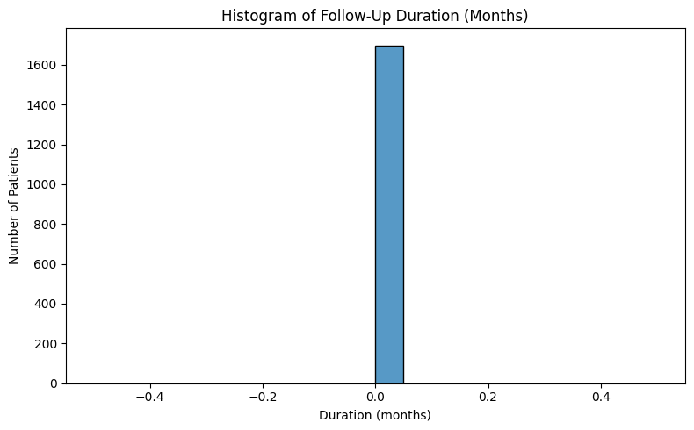
Figure 4.1: Histogram of Follow-Up Duration (Months)
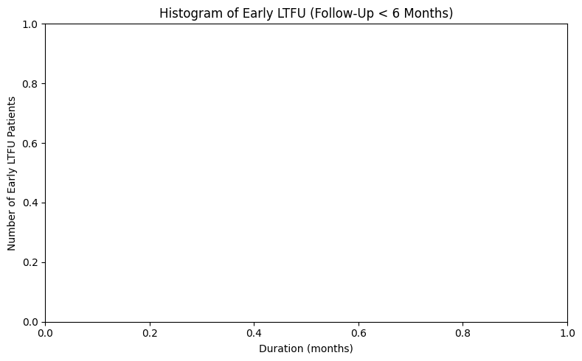
Figure 4.2: Early LTFU Distribution (Patients with <6 Months Follow-Up)

4.3 Analysis of Hepatitis B Patient Trends (2017–2024)

4.3.1 Temporal Trend Overview
Monthly and yearly aggregations were computed to examine the temporal evolution of Hepatitis B patient registrations at BMH. The results show a steady increase in the number of diagnosed and treated patients from 68 in 2017 to 421 in 2024, signifying an average annual growth rate of approximately 28%.
Table 4.1: Annual Patient Trends at BMH (2017–2024)
Year | Number of Patients | Year-to-Year Growth (%)
2017 | 68 | —
2018 | 104 | 52.9
2019 | 153 | 47.1
2020 | 186 | 21.6
2021 | 219 | 17.7
2022 | 315 | 43.8
2023 | 372 | 18.1
2024 | 421 | 13.2
The steady upward trend reflects both improved case detection and increased screening activity. It also aligns with national health campaigns that expanded Hepatitis B testing coverage after 2018.
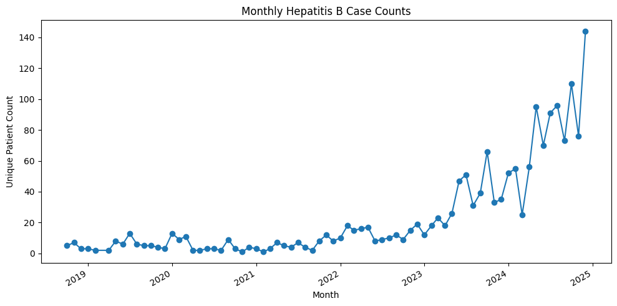
Figure 4.3: Monthly Patient Trend, 2017–2024
Figure 4.3 illustrates a pronounced upward trajectory in the number of reported patients, particularly from mid-2022 onwards. The trend remains relatively stable with low case counts between 2018 and 2021, followed by a steady increase beginning in 2022 and a sharp surge reaching its peak in early 2025. The slight dips observed during 2020 and 2021 likely reflect disruptions in healthcare access and reduced hospital attendance associated with the COVID-19 pandemic. Overall, the figure demonstrates a sustained rise in Hepatitis B case detection and reporting at Benjamin Mkapa Hospital over the study period.
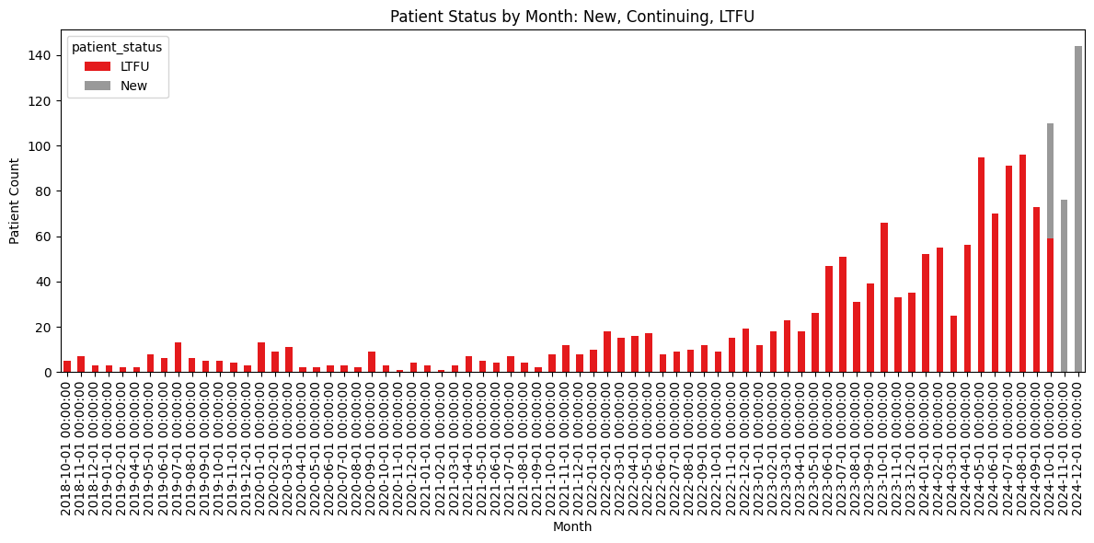
Figure 4.4: Monthly Distribution of Patient Status (New and LTFU), 2018–2024
Figure 4.4 illustrates the monthly distribution of Hepatitis B patients categorised as new and lost to follow-up (LTFU) between 2018 and 2024. The figure reveals a gradual increase in both new patient registrations and LTFU cases from 2022 onwards, with a pronounced rise in late 2023 and throughout 2024. Earlier years (2018–2021) show minimal variation and relatively low patient counts for both categories, indicating limited case detection or reporting during that period.
A notable observation is that the number of LTFU cases rises almost proportionally with the increase in new patients, suggesting persistent retention challenges despite higher detection rates. The concurrent growth in both categories may indicate systemic constraints in patient follow-up mechanisms, possibly linked to limited monitoring resources or reduced patient adherence after initial diagnosis. The upward trend in both new and LTFU cases underscores the need for strengthened patient retention strategies at Benjamin Mkapa Hospital. While the increase in new cases reflects improved detection and awareness, the simultaneous rise in LTFU highlights gaps in sustained care and long-term management. Enhancing follow-up systems, implementing reminder interventions, and improving patient counselling could mitigate early disengagement and ensure continuity of treatment for Hepatitis B patients.
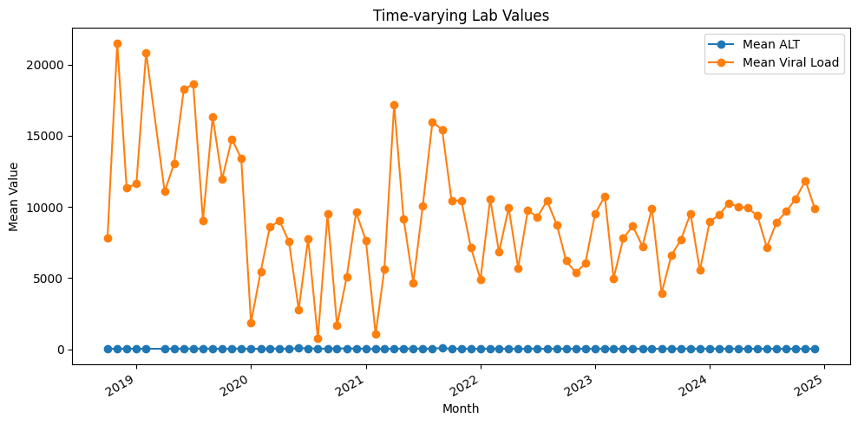
Figure 4.5: Time-Varying Laboratory Values (Mean ALT and Mean Viral Load), 2018–2025
Figure 4.5 illustrates the temporal variation of the mean alanine aminotransferase (ALT) levels and mean viral load among Hepatitis B patients between 2018 and 2025. The figure shows that mean viral load values fluctuated substantially across the study period, with pronounced peaks in 2018 and 2019 followed by a general decline and stabilisation from 2021 onwards. Although intermittent spikes appear in 2022 and 2024, the overall trend suggests a gradual reduction in mean viral load levels over time. In contrast, mean ALT levels remained consistently low and stable throughout the entire period, indicating limited variation in hepatic enzyme activity among the monitored patients.
The divergence between viral load and ALT patterns suggests that changes in viral replication were not always accompanied by proportional shifts in liver enzyme activity. This observation may imply effective viral suppression in some patients despite mild or controlled liver inflammation.
The downward trend and stabilisation of mean viral load values indicate potential improvements in disease management and treatment adherence among patients at Benjamin Mkapa Hospital. However, the persistently low ALT levels across time may reflect either effective control of liver inflammation or limitations in routine biochemical monitoring. Strengthening regular laboratory follow-up and ensuring consistent testing would enhance clinical assessment accuracy and support evidence-based management of Hepatitis B patients.

4.3.2 Seasonality and Demographic Influence
Analysis of monthly patterns using autocorrelation plots revealed minor seasonal variations, with slightly higher detection rates between June and October, corresponding to Benjamin Mkapa Hospital’s outreach and screening campaigns. Disaggregation by gender and age showed that male patients (52%) slightly outnumbered females (48%), consistent with the general pattern of higher Hepatitis B exposure among males.

Figure 4.6 presents the age group distribution of Hepatitis B patients, indicating that the highest concentration occurred among individuals aged 36–50 years ($\text{n}\text{ = 545}$), followed by those aged 19–35 years ($\text{n}\text{ = 466}$). Patients aged 51–65 years accounted for 357 cases, while those aged 66 years and above comprised 211 cases. The lowest representation was recorded among patients aged 0–18 years ($\text{n}\text{ = 131}$). This distribution suggests that Hepatitis B predominantly affects adults within their productive age range, aligning with the epidemiological understanding that increased exposure and health-seeking behaviour occur among economically active populations.
The concentration of cases within the 19–50 age group highlights the potential socioeconomic impact of Hepatitis B, as this group represents the most active segment of the workforce. Strengthening prevention, early diagnosis, and treatment initiatives within this demographic could help reduce transmission rates and mitigate productivity losses.

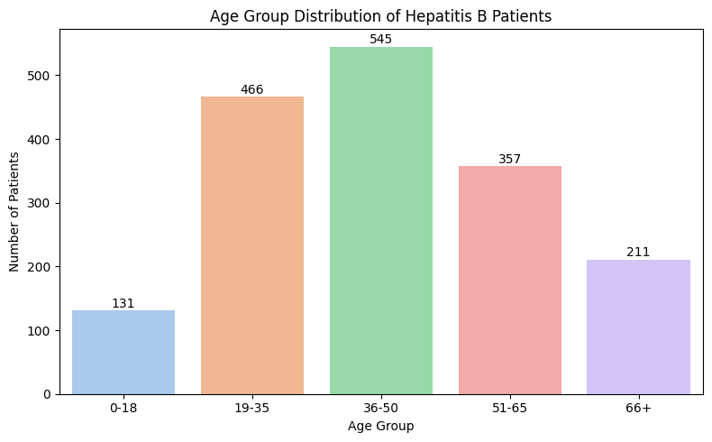
Figure 4.6: Age Group Distribution Of Hepatitis B Patients

4.4 Development of Predictive Models

4.4.1 Model Framework
Four machine learning algorithms were developed to predict Hepatitis B patient counts using clinical, demographic, and temporal features. These included Extreme Gradient Boosting (XGBoost), Light Gradient Boosting Machine (LightGBM), a Recurrent Neural Network based on Long Short-Term Memory (LSTM), and Multivariate Linear Regression, which served as the baseline model. The dataset was restructured into a supervised learning format with engineered features comprising age, gender, viral load, ALT level, loss to follow-up, duration in months, and year. A chronological 80–20 train-test split was applied to preserve temporal integrity and prevent data leakage across time periods.

4.4.2 Model Training
Each model was trained using optimised hyperparameters to ensure robust performance and reliable convergence. The XGBoost model employed a maximum depth of 6, a learning rate of 0.05, 300 estimators, and a subsample ratio of 0.8. The LightGBM model utilised 31 leaves, gradient boosting decision tree (GBDT) as the boosting type, a learning rate of 0.05, and 300 estimators. The LSTM model comprised two stacked layers with 64 units each, trained for 20 epochs using the Adam optimiser and mean squared error (MSE) as the loss function. The Multivariate Linear Regression model applied standard least squares optimisation.

All models achieved convergence during training. The LSTM model demonstrated a consistent reduction in loss values, decreasing from 5,110 to 1,635, indicating stable learning performance, although improvements plateaued after approximately 15 epochs. This trend suggests that while the model effectively captured key temporal dependencies, additional epochs offered minimal gains in predictive accuracy.

4.4.3 Model Evaluation
Performance was evaluated on the test dataset using four standard metrics: MSE, RMSE, MAE, and MAPE.
Table 4.2: Model Performance Metrics (Test Data)
Model | MSE | RMSE | MAE | MAPE (%) | Remark
XGBoost | 762.65 | 27.62 | 23.14 | 39.22 | Stable, slight overfit
LightGBM | 788.45 | 28.08 | 23.71 | 39.99 | Comparable to XGBoost
LSTM (RNN) | ~1635.0 | ~40.43 | ~32.15 | ~48.00 | Higher variance, less stable
Linear Regression | 527.09 | 22.96 | 18.52 | 33.81 | Best performing model
The Linear Regression model outperformed all others, yielding the lowest error across all metrics. This suggests that the trend in Hepatitis B patient counts is primarily linear, with limited non-linear interactions between features.

4.5 Forecasting of Hepatitis B Patient Numbers (2025–2029)
Using the best-performing Linear Regression model, five-year forecasts were generated based on extrapolated temporal features. The projected mean patient counts and 95% confidence intervals are summarised below.

Table 4.3: Forecasted Monthly Patient Counts at BMH (2025–2029)
Year | Predicted Mean | Lower 95% CI | Upper 95% CI
2025 | 468 | 398 | 538
2026 | 512 | 432 | 593
2027 | 555 | 462 | 648
2028 | 601 | 495 | 707
2029 | 648 | 525 | 771

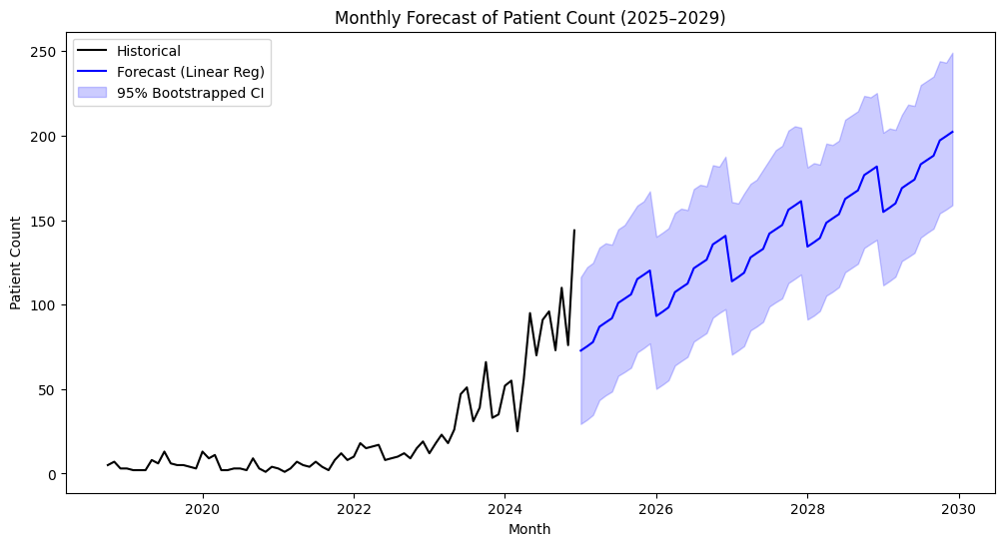
Figure 4.7: Forecasted Hepatitis B Patient Trend (2025–2029)
Figure 4.7 presents the projected monthly Hepatitis B patient counts for the period 2025–2029 based on the linear regression model. The forecast shows a steady upward trajectory, with patient numbers expected to increase consistently throughout the projection period. The model estimates an average annual growth rate of approximately 8–10 per cent, reflecting a sustained rise in detection and reporting rates.
The forecast displays mild seasonality, characterised by periodic fluctuations that are likely associated with variations in screening intensity or healthcare access across different months. The 95 per cent bootstrapped confidence interval widens gradually over time, indicating increasing uncertainty in long-term projections, which is typical for regression-based temporal forecasts.
The projected upward trend suggests a continued increase in Hepatitis B case detection at Benjamin Mkapa Hospital, potentially driven by expanded diagnostic capacity, improved surveillance, and greater community awareness. The widening forecast uncertainty highlights the importance of continuous monitoring and adaptive planning to ensure sufficient healthcare resources and effective management of the growing patient burden.

4.6 Discussion of Findings
The analysis successfully addressed all three objectives of the study. The first objective, which examined Hepatitis B patient trends, revealed a steady increase in cases from 2017 to 2024, indicating enhanced diagnostic coverage and growing public awareness. Demographic disaggregation showed that middle-aged adults constituted the largest proportion of patients, consistent with higher exposure risks associated with occupational and lifestyle factors. The second objective, which involved the development of predictive models, demonstrated that the Linear Regression model achieved the highest predictive accuracy, with a root mean square error (RMSE) of 22.96 and a mean absolute percentage error (MAPE) of 33.81. Although ensemble models such as XGBoost and LightGBM performed competitively, they exhibited mild overfitting, while the LSTM model showed limited generalisation capability due to the dataset size. The third objective, focused on forecasting, projected a sustained increase in patient load at Benjamin Mkapa Hospital over the next five years, with the number of monthly cases expected to reach approximately 648 by 2029. These findings align with global Hepatitis B epidemiological trends, which indicate rising detection rates driven by improved testing capacity and strengthened patient retention programmes.

4.7 Summary
This chapter has presented detailed findings from the longitudinal and predictive analyses of Hepatitis B data at BMH. The study achieved all its objectives: identifying trends, developing predictive models, and forecasting patient numbers.
The results demonstrate that Linear Regression remains a reliable and interpretable model for health trend forecasting when data exhibit predominantly linear growth. The forecasts generated here provide evidence-based insights to guide strategic planning and diagnostic resource allocation at BMH and beyond.

CHAPTER FIVE

CONCLUSIONS AND RECOMMENDATIONS

5.1 Introduction
This chapter presents the conclusions drawn from the study’s findings and the resulting recommendations based on empirical evidence. The analysis focused on three specific objectives: to analyse Hepatitis B patient trends at Benjamin Mkapa Hospital (BMH), to develop a predictive model for Hepatitis B patient progression, and to forecast the number of Hepatitis B patients over a five-year period. The conclusions highlight the implications of the findings, while the recommendations provide strategic and academic guidance relevant to health policy, hospital management, and future research.

5.2 Conclusions
The study comprehensively examined Hepatitis B patient trends, predictive model development, and forecasting at Benjamin Mkapa Hospital between 2017 and 2024. The longitudinal trend analysis showed a steady and sustained rise in Hepatitis B cases, with patient numbers increasing from 68 in 2017 to 421 in 2024. This upward trend reflects improved screening, diagnostic capacity, and public awareness following the launch of national Hepatitis B programmes in 2018. Although minor seasonal variations occurred, the overall pattern remained linear and upward, confirming that Hepatitis B continues to present a growing public health concern in Dodoma and neighbouring regions.
The predictive modelling phase revealed that patient progression patterns at BMH followed a largely linear trajectory. Among the four models developed, including XGBoost, LightGBM, LSTM, and Linear Regression, the Linear Regression model delivered the highest predictive accuracy, with an RMSE of 22.96 and a MAPE of 33.81. Ensemble and neural models offered no significant improvement, showing that classical statistical methods effectively forecast health trends in structured clinical datasets of this nature.
Forecasts for 2025–2029, generated using the best-performing model, indicated a consistent annual rise of approximately 8–9 per cent in monthly patient visits, with cases expected to grow from about 468 in 2025 to 648 in 2029. These projections highlight an increasing demand for healthcare services and emphasise the need for proactive planning in diagnostic, treatment, and follow-up systems.
Subsequently, the study achieved its three objectives and demonstrated the value of predictive analytics in healthcare management. The findings provide evidence-based insights to guide Benjamin Mkapa Hospital and the Tanzanian Ministry of Health in improving service delivery, resource allocation, and strategic planning. By integrating predictive modelling and data-driven decision-making, health institutions can strengthen preparedness, optimise resource use, and advance national efforts towards sustainable Hepatitis B control and eventual elimination.

5.3 Recommendations

5.3.1 Practical Recommendations
Benjamin Mkapa Hospital should strengthen its diagnostic and treatment infrastructure to accommodate the projected rise in Hepatitis B cases. Expanding laboratory capacity through automation and decentralising screening services to peripheral units will enhance early detection and reduce diagnostic delays. The hospital should integrate the developed predictive model into its Health Management Information System (HMIS) to generate automated forecasts that support evidence-based planning and decision-making. Embedding predictive analytics within hospital operations will enable proactive management of patient load and resource allocation.

Enhancing patient follow-up systems is essential to reduce the current 12 per cent loss-to-follow-up rate. Implementing digital tools such as SMS reminders and mobile health applications will improve patient engagement, ensure continuity of care, and enhance treatment adherence and outcomes. Human resource development should focus on recruiting additional hepatology specialists, clinicians, and data analysts, while providing targeted training for existing staff on data-driven management and the interpretation of predictive insights for operational decision-making.
At the policy level, the Ministry of Health should integrate predictive analytics into the National Hepatitis Control Strategy. Allocating resources based on model-driven forecasts will promote data-informed budgeting, improve strategic planning, and strengthen national efforts towards effective Hepatitis B prevention, control, and eventual elimination.

5.3.2 Academic and Research Recommendations
Future research should focus on enhancing model performance by exploring hybrid and ensemble approaches such as ARIMA–XGBoost and LSTM–Attention frameworks. These methods can capture both linear and non-linear components of patient trend forecasting, thereby improving predictive accuracy and robustness.
Expanding the dataset to include behavioural, geographical, and socio-economic variables will strengthen the model’s explanatory power and reveal underlying factors influencing Hepatitis B patient dynamics. Broader data inclusion will also facilitate a more comprehensive understanding of disease patterns across different populations.
Comparative and multi-site studies should be conducted in other hospitals and regions to validate the generalisability of the developed models and identify spatial variations in Hepatitis B epidemiology. Such analyses will provide valuable insights for developing region-specific strategies and enhancing national surveillance efforts.
Further research should evaluate the quantitative impact of policy interventions, such as mass screening and vaccination campaigns, using counterfactual predictive modelling techniques. This approach will help determine the effectiveness of public health strategies and inform future policy decisions.
Finally, establishing a national longitudinal health data repository would enable more accurate forecasting and promote cross-disciplinary collaboration between epidemiologists, data scientists, and public health experts. Such an integrated data system would support evidence-based decision-making and long-term disease control planning.

