4.4.5 Sub system decomposition

Subsystem decompositions will help to reduce the complexity of the system. The subsystems can be considered as packages holding related classes or objects. The CIS under consideration is decomposed in to subsystems as shown by the following diagram. These subsystems are further decomposed into other subsystems.

4.4.5.1 Deployment view

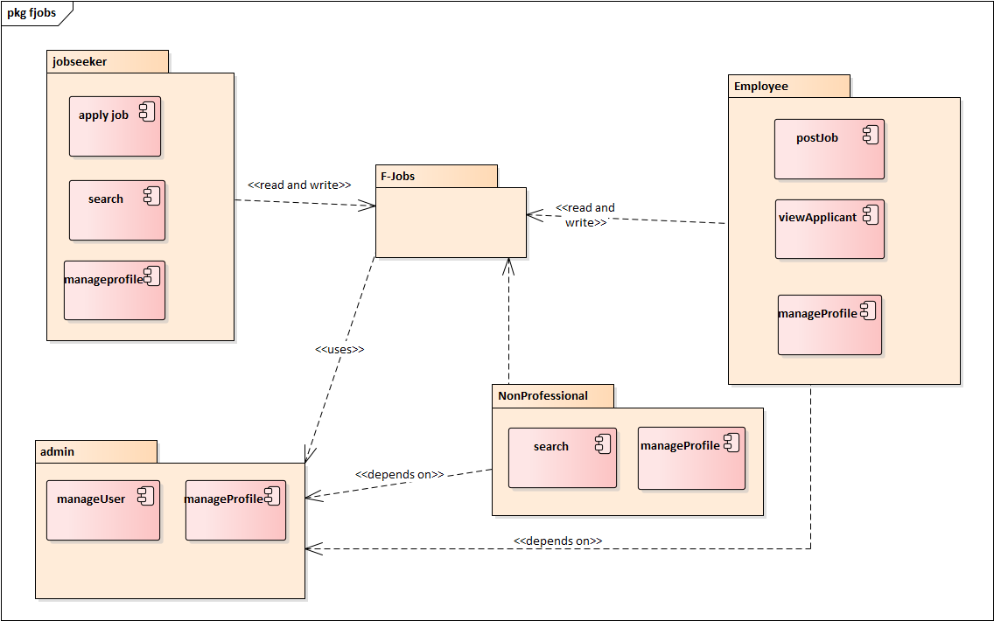

Figure 4.16- Deployment view

4.4.5.2 Sub system description

|  |  |  |
| --- | --- | --- |
| Admin | Responsible to provide an interface for manage user and manage profile | Menu  Nonprofessional seeker  Employer |
| Nonprofessional | Responsible to provide an interface for search and manage profile | Nonprofessional seeker  Menu |
| Jobseeker | Responsible to provide an interface for search job, Apply job and manage their profile | Menu  Application  Job List |
| Employee | Responsible to provide an interface for post job, view Applicant and manage profile | Job List  Jobseeker  Application  Menu |

4.1 Table of subsystem decomposition

4.4.6 hardware/software mapping

The system will have two processes, deployed in single or separate machine, that run in parallel, Namely, web server process and the database process. The database process, which runs on Server database engine, is responsible for maintaining storing an updated map information. Where us the web server process is responsible to host a restless web service that accepts a Request from the mobile application and send the updated information from the database server.

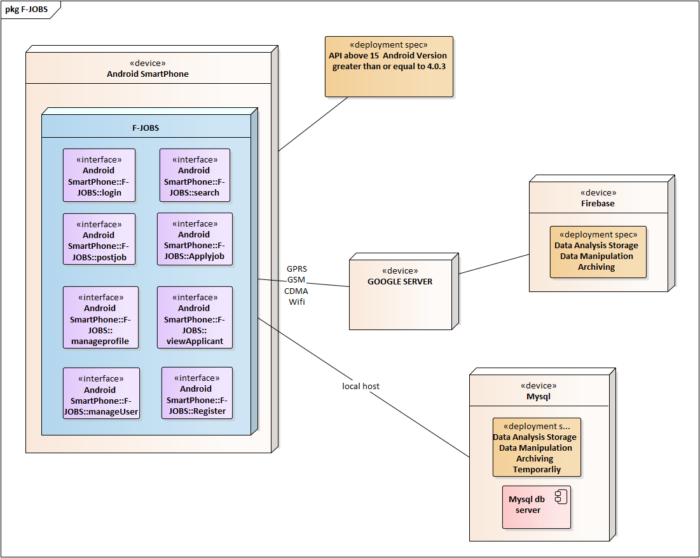

Figure 4.16- hardware/software mapping

**4.4.10 Deployment diagram**

The following deployment diagram shows the F-JOBS. In the first node, which is the Users smartphone with the second node, F-JOBS pre-installed. The system contains the following interfaces inside it:

* Log In
* Post Job
* Search
* Apply job
* Manage profile
* Manage user
* Register
* View Applicant

The third node show the Google server is used to connect us with firebase. The fourth node is Firebase is where our data analysis, store, manipulate and archived. Moreover, the fifth node is MySQL that needs to data analysis, store, manipulate and archived temporarily.



Figure 4.28 deploymentdiagram