**Computer Graphics – Lab 4**

**Gavan Burke**

**12326202**

**Overview:**

* The hierarchy should be constructed from at least 5 teapots.
* Show a one-to-one relationship.
* Show a one-to-many relationship.
* Keyboard control of the translation of the root object.
* Interesting/Inventive/Unusual Structure.

The first thing I did come up with an ‘interesting’ structure. I first decided that I would make a clock, with the numbers being a one-to-one relationship and the hands being one-to-many. This idea wasn’t exactly interesting so I came up with a new one to make a gaelic player out of teapots, kicking a ball made up also of teapots.

In this model, most of the person is made up of one-to-one relationships except for the persons pelvis and upper torso. The legs and arms are one-to-one as well as the head.

The ball consists of five teapots, with the centre teapot being the root of the one-to-many relationships in this structure.

To make the man was relatively simple. What I did was began with his pelvis and worked up the body. The upper torso is a one-to-many relationship with the arms and head as well as the persons midrif.

The code for the root and the child was provided so what I did was analyse the code and figure out how to use it to create a structure. I saw how the child was connected to the parent through this line:

mat4 global2 = global1*local2;

So basically, if I wanted a teapot to have the root as a parent, I would multiply its local mat4 by the roots global.

**Code for root:**

// Root of the Hierarchy

mat4 view = identity_mat4 ();

mat4 persp_proj = perspective(90, (float)width/(float)height, 0.1, 100.0);

mat4 local1 = identity_mat4 ();

local1 = rotate_z_deg (local1, 0.0);

local1 = translate (local1, vec3 (-50.0, 0.0, -80.0f));

// for the root, we orient it in global space

mat4 global1 = local1;

glUniformMatrix4fv (proj_mat_location, 1, GL_FALSE, persp_proj.m);

glUniformMatrix4fv (view_mat_location, 1, GL_FALSE, view.m);

glUniformMatrix4fv (matrix_location, 1, GL_FALSE, global1.m);

glDrawArrays (GL_TRIANGLES, 0, teapot_vertex_count);

**Code for the child:**

mat4 local2 = identity_mat4 ();

local2 = translate (local2, vec3 (0.0, 10.0, 0.0));

// global of the child is got by pre-multiplying the local of the child by the global of the parent

mat4 global2 = global1*local2;

glUniformMatrix4fv (matrix_location, 1, GL_FALSE, global2.m);

glDrawArrays (GL_TRIANGLES, 0, teapot_vertex_count);

**One-to-one relationships:**

One-to-one was very similar to one-to-many, except the only difference is that you would multiply the local mat4 by the predecessor’s global mat4.

Only one teapot should inherit this nodes global value for it to be a one-to-one relationship.

**Key press function:**

I only have two buttons that do anything in my program. The ‘x’ button does all the movement of the nodes depending on where each structure is.

When pressed, the ball begins to fall from the persons hand. As it falls, it rotates slowly. When the ball falls below a certain point, it begins to rise in a north-west direction as the persons foot, a one-to-one relationship, kicks it. The balls rotation speeds up after being kicked.

To combat the ball descending again after going higher than the point mentioned above, I set a flag. The ball will only drop when the flag is set to 0.

I have also implemented an ‘r’ button, which resets each value.

void keypress(unsigned char key, int x, int y) {

switch (key) {

case 'x':

if (ball_fall > -50.0f && ball_flag == 0) {

ball_fall -= 2.0f;

ball_rotate -= 5.0f;

}

else {

ball_flag = 1;

rotatez += 1.0f;

ball_roll += 2.0f;

ball_rotate -= 20.0f;

ball_fall += 3.0f;

}

break;

case 'r':

rotatez = 0.0f;

ball_roll = 0.0f;

ball_rotate = 0.0f;

ball_fall = 20.0f;

ball_flag = 0;

break;

}

}

**Screen Shots:**

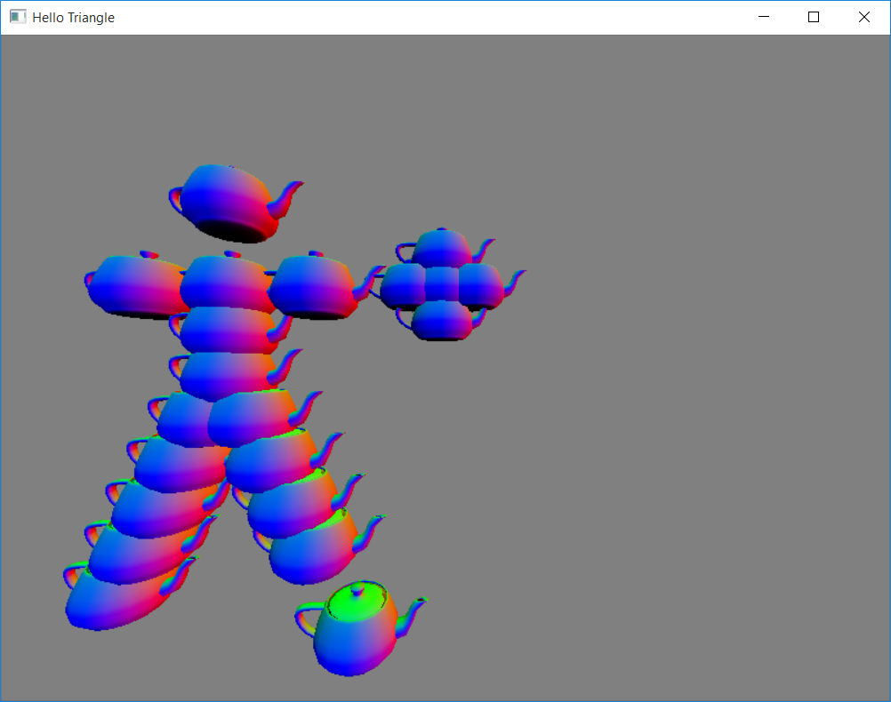

Ball in persons hand.

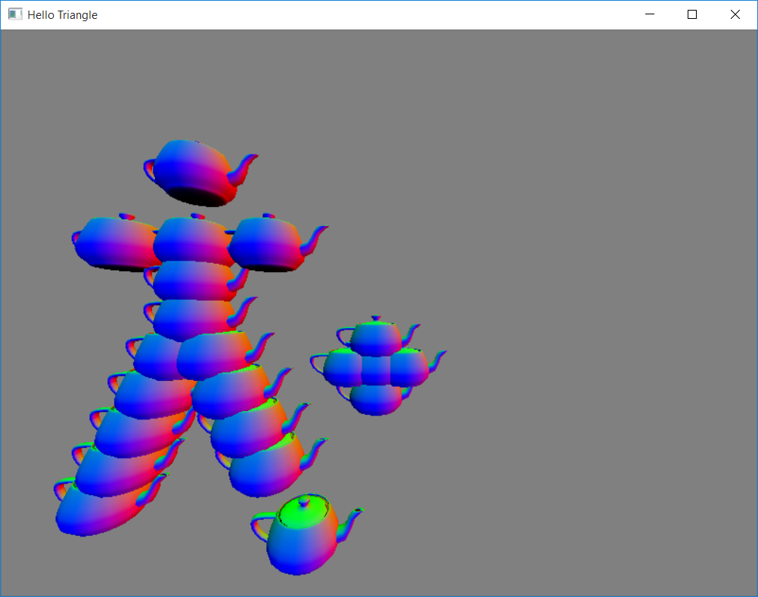

Ball begins its descent.

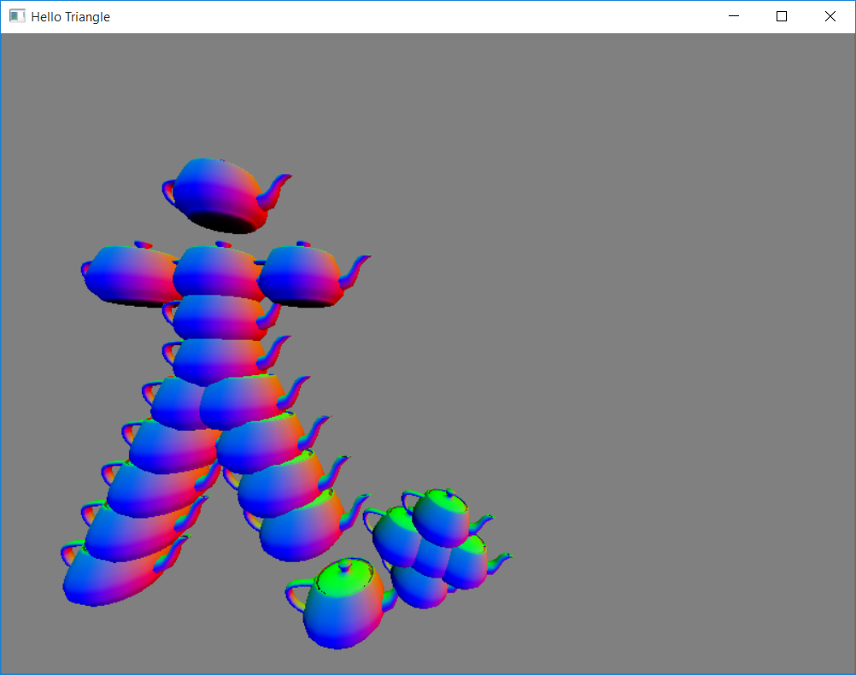

Person’s foot is now kicking the ball. I should note that I have the foot slightly away from the body just so that I could distinguish it as the foot.

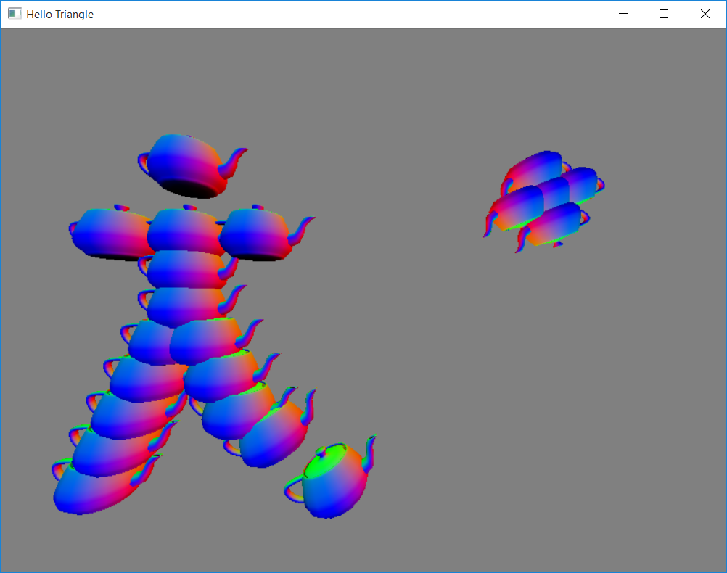

The ball is kicked into the distance as the person follows through with their kick.

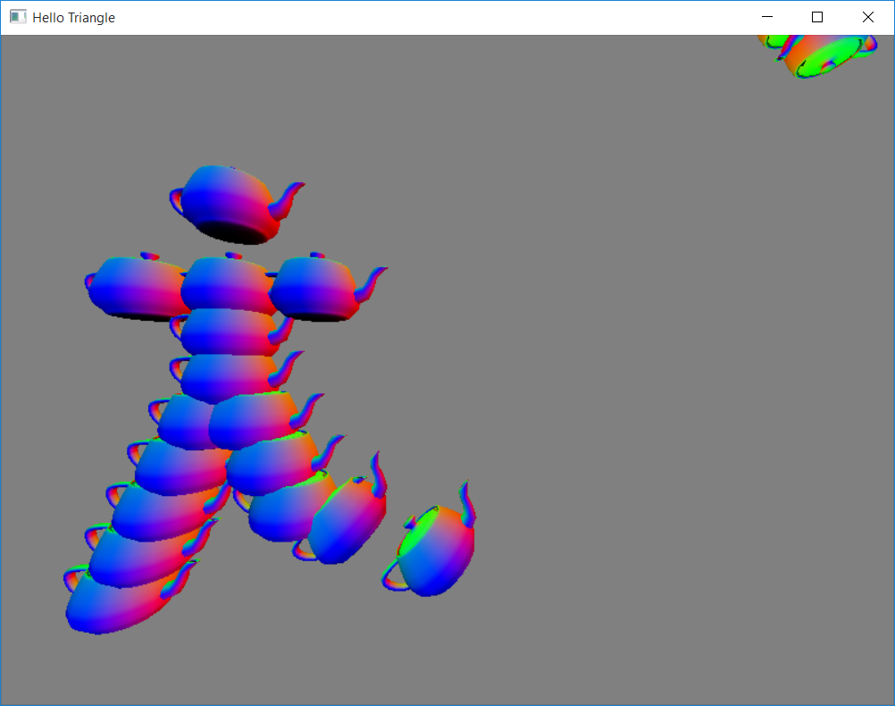

The ball is sent well over the bar which ends up being a brilliant point for the 2016 All-Ireland champions, Wicklow.