

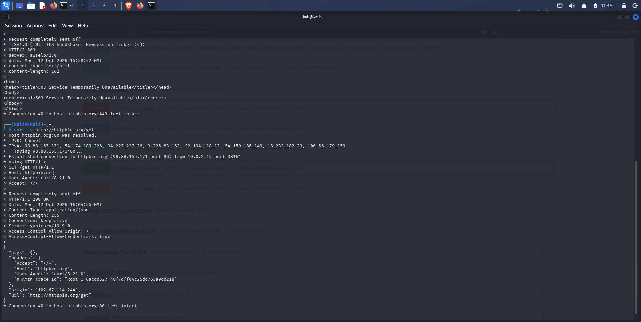

TLS (Transport Layer Security) is the security protocol that protects communication between a web browser and a web server in HTTPS.
TLS plays three main roles:
- Confidentiality (Encryption): Encrypts data exchanged between the browser and server to prevent unauthorized parties from reading it.
- Authentication: Uses digital certificates to help the browser verify the server's identity and confirm it is communicating with the intended website.
- Integrity: Detects unauthorized modification of data while it is transmitted.
In summary: HTTPS = HTTP + TLS. TLS protects HTTP communications against eavesdropping, impersonation, and tampering while data travels across the network.

