Phase C
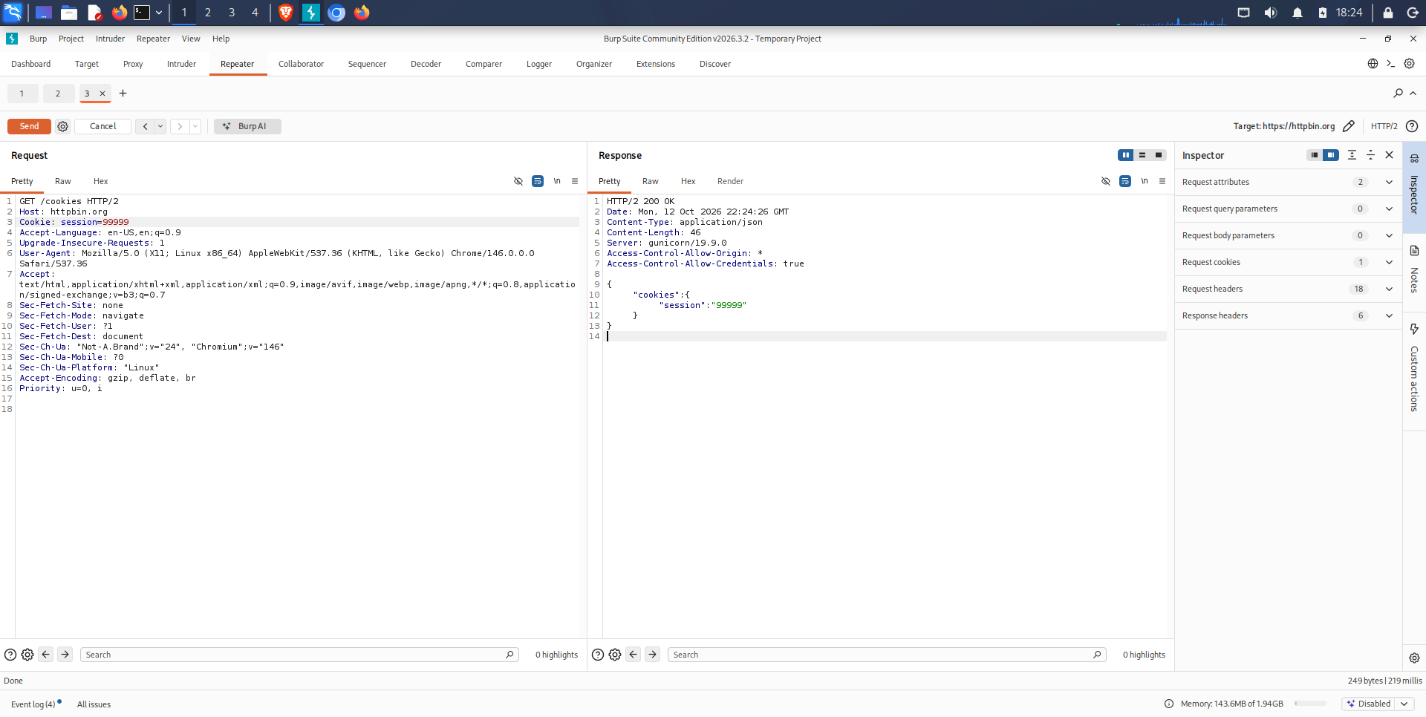

AI Generated Explaination
Phase C — Session Analysis Results
Objective: Examine cookie modification and observe the server's response.
Method: I captured an HTTP request in Burp Suite Repeater and modified the cookie value from session=12345 to session=99999. I then resent the request to https://httpbin.org/cookies.
Observed result: The server returned an HTTP 200 OK response containing the modified cookie value in the JSON response body.
Interpretation: The test confirms that the modified cookie was transmitted to the server and reflected in the response. However, the endpoint does not perform authenticated session validation. Therefore, this result does not demonstrate that the modified value is accepted as a valid authenticated session or that a session-management vulnerability exists.
Cookie security attributes: The Secure, HttpOnly, and SameSite attributes must be examined in the original Set-Cookie response header. Their absence or presence cannot be determined from the response provided for this test.
Conclusion: Cookie modification and transmission were successfully demonstrated. Further testing against an authorized application with a real authentication mechanism would be required to assess session validation and session-management security.

