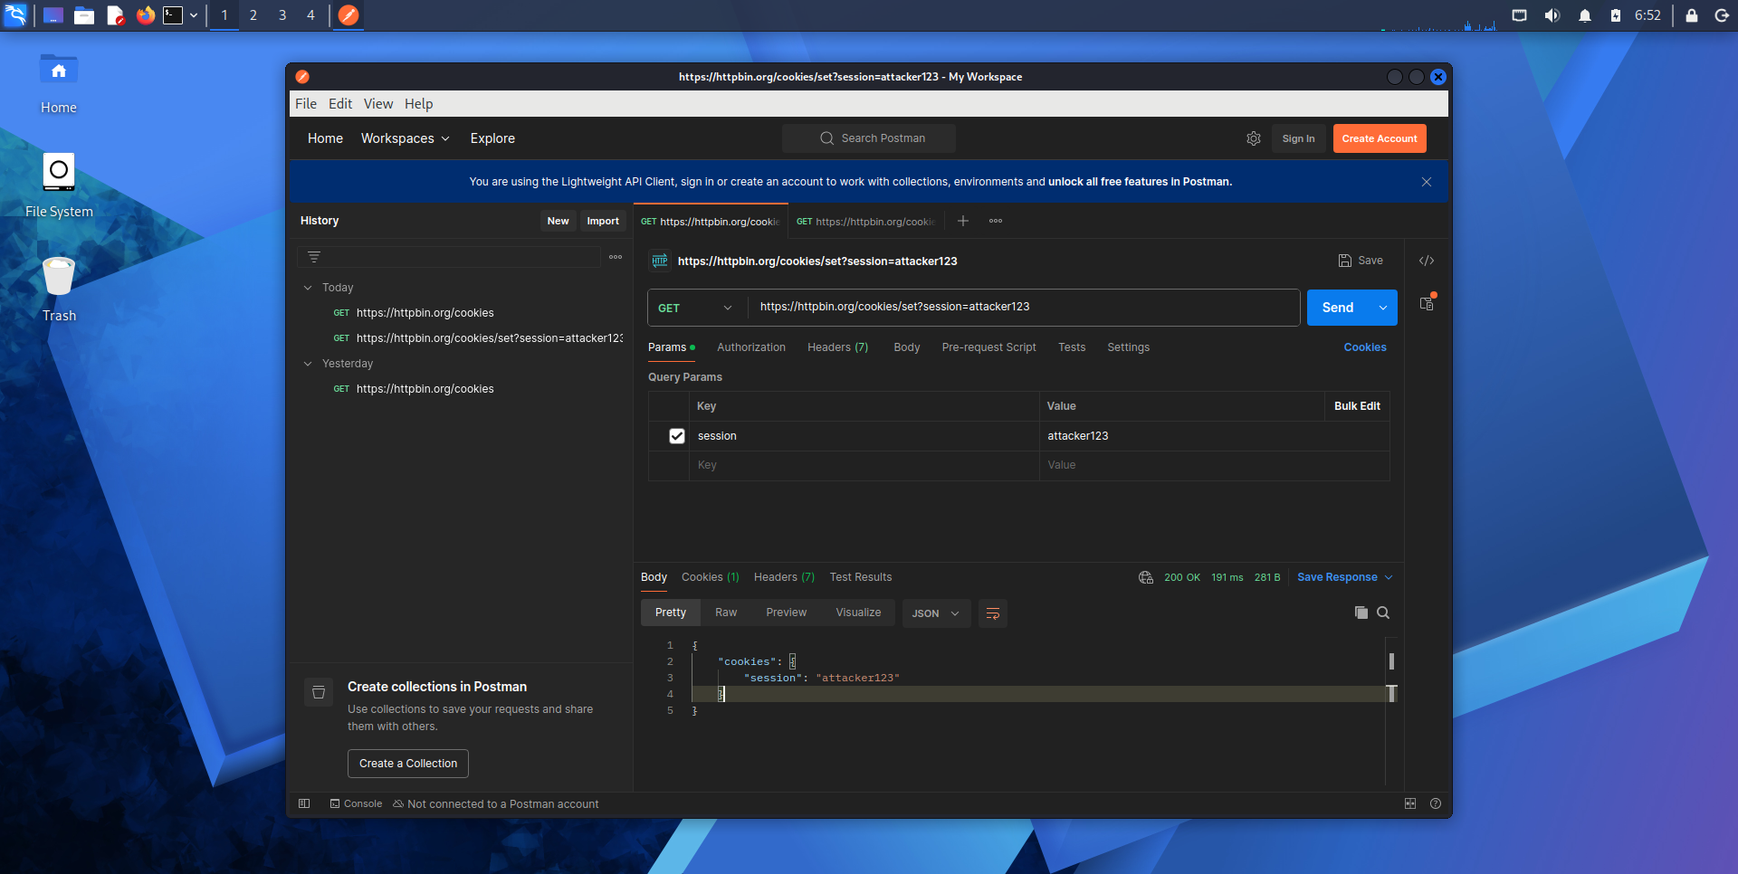

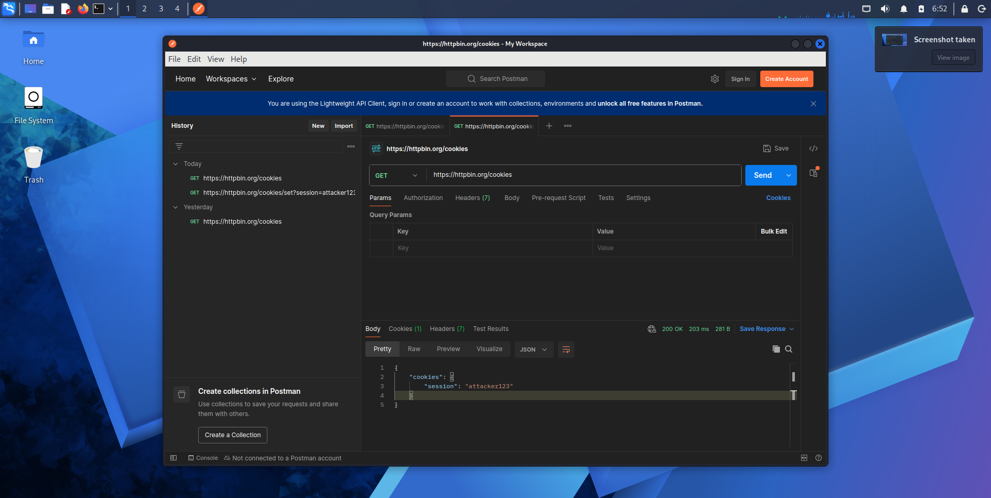

Cookie Manipulation and Session Security
Results: I manually configured the cookie session=attacker123 in Postman and sent a request to the httpbin /cookies endpoint. The server returned the same value in its JSON response, confirming that the client-controlled cookie was transmitted and reflected by the server.
Security analysis: This experiment demonstrates cookie manipulation, but it does not establish an authentication bypass or session-management vulnerability because the endpoint does not validate authenticated sessions.
In a real application, insecure session management could allow attacks such as session fixation if a victim's authenticated session retains an identifier known to an attacker. Predictable or improperly validated session tokens could also expose accounts to unauthorized access.
Recommended mitigations :
- Regenerate session identifiers after successful authentication and privilege changes.
- Use cryptographically secure, unpredictable session identifiers.
- Validate session identifiers and authentication state on the server.
- Set appropriate Secure, HttpOnly, and SameSite cookie attributes.
- Enforce session expiration and invalidate sessions on logout.
Conclusion: The test successfully demonstrated that a client can supply an arbitrary cookie value. Additional testing against an authorized application with a real login mechanism is required to determine whether its session-management controls are vulnerable.

