EncryptEdge Labs
Junior Application Security Engineer Internship Programme

Junior Application Security Engineer
Internship Task Report
Intern Full Name | Abdoul Karim Savadogo
Intern Email | abdoulkarimsavadogo03@gmail.com
Cohort | 2026
Task ID | ASE-APPSEC
Task Title | Application Security Assessment of OWASP Juice Shop (OWASP Top 10, DAST with ZAP, Threat Modelling)
Skill Domain | Web Application Security / DAST / Threat Modelling
Difficulty Level | Beginner
CPE Credits | Per task brief
Guiding Framework(s) | OWASP Top 10 (2021 / 2025), CWE, 5×5 likelihood × impact risk matrix
Submission Date | 12 October 2026
Copyright © 2026 EncryptEdge Labs Limited | Company No. 15830711 | United Kingdom
All activities in this report were performed within authorised lab environments as defined by the task brief.

Executive Summary
Purpose and scope. This report documents a structured application-security assessment of OWASP Juice Shop, a deliberately vulnerable web application, deployed as a Docker container in an isolated Kali Linux lab and reached at http://localhost:3000. The work covered the OWASP Top 10 (Phase A), lab setup (Phase B), a dynamic scan with OWASP ZAP 2.17.0 (Phase C), threat modelling (Phase D), hosted TryHackMe labs (Phase E) and this report (Phase F).
Overall result. Ten findings were recorded: three confirmed by the ZAP scan and seven drawn from the threat model. By severity: 6 Critical, 1 High, 2 Medium, 1 Low. The ZAP scan raised no High-risk alerts. Its confirmed issues are configuration weaknesses: no Content-Security-Policy header and a wildcard CORS policy (both Medium), and a disclosed Unix timestamp (Low). The most serious risks come from the threat model: SQL injection (score 25), then cross-site scripting, broken authentication, broken access control and sensitive data exposure (20 each) and CSRF (16). These were not exploited in this task and the scan did not exercise them, because every endpoint it covered was requested with GET.
What matters most. The confirmed Medium findings are inexpensive to fix and matter beyond their rating: without a CSP, any cross-site scripting flaw has no second line of defence, and user data and authentication tokens are the assets most exposed. For a production system, the first priorities would be:
- Fix the Critical threats first: parameterised queries (SQL injection), server-side authorisation and ownership checks, strong JWT signing and removal of default credentials, and output encoding with a strict CSP (Section 6.1).
- Close the configuration gaps: add a Content-Security-Policy header and replace Access-Control-Allow-Origin: * with an explicit allow-list.
- Build detection and testing into delivery: an automated ZAP baseline and security-header check in CI/CD, plus logging and alerting on failed logins and access-control failures (Section 6.2).
Limitations. Findings 4–10 are modelled risks, not demonstrated exploits. Phase D scored them by likelihood and impact. The ZAP report covers one target and a limited scan: passive alerts plus one active rule, with GET requests only. A hands-on test of the Critical threats is the logical next step.

1.0 Task Overview
Task ID | ASE-APPSEC
Task Title | Application Security Assessment of OWASP Juice Shop (OWASP Top 10, DAST with ZAP, Threat Modelling)
Skill Domain | Web Application Security / DAST / Threat Modelling
Difficulty | Beginner
Duration | Approx. 9 hours (sum of the six phase estimates)
CPE Credits | Per task brief
Tools Used | Kali Linux, Docker, OWASP Juice Shop (bkimminich/juice-shop), OWASP ZAP 2.17.0 (by Checkmarx), web browser, TryHackMe, Claude (report structuring)
Target Platform | OWASP Juice Shop — Docker container on Kali Linux at http://localhost:3000; TryHackMe hosted rooms
Guiding Framework(s) | OWASP Top 10, CWE, 5×5 likelihood × impact risk matrix
Regulatory Alignment | OWASP Top 10 category mappings (2021 and 2025, as tagged by ZAP) and CWE identifiers. No other standards were specified for this task.

1.1 Introduction
This task assesses the security of OWASP Juice Shop, a deliberately vulnerable web application, using a structured application-security workflow: study the OWASP Top 10, deploy an isolated target, scan it with OWASP ZAP, threat-model its assets and complete hosted labs. It matters because an Application Security Engineer has to turn scattered tool output into a prioritised, evidence-based view of risk that developers and business owners can act on. This report consolidates Phases A–E into findings, a risk assessment and remediation guidance.

1.2 Objectives & Learning Outcomes
The objectives of the task and how each was met:
- Understand the OWASP Top 10 and relate it to real incidents — Phase A summarises all ten categories and analyses breach case studies (Facebook 2019, Capital One 2019, Equifax 2017, LinkedIn 2012, TalkTalk 2015).
- Prepare an isolated, reproducible target — Phase B deployed Juice Shop as a Docker container on Kali Linux and confirmed it was running on port 3000.
- Perform dynamic analysis and interpret the results — Phase C scanned http://localhost:3000 with ZAP 2.17.0: 5 alert types (2 Medium, 1 Low, 2 Informational), analysed in Section 4.
- Threat-model the application and prioritise risk — Phase D identified 6 assets and 12 threats, scored them on a 5×5 matrix and proposed mitigations for the high-risk items (Section 5).
- Apply the knowledge in hosted labs — Phase E: six TryHackMe rooms completed (Figure 5).
- Compile a professional report — Phase F: this document, with an executive summary, findings, risk matrix, mitigations and recommendations.

1.3 Scope & Legal Authorisation
All activities in this task were performed within authorised, isolated environments set up for it. No external systems, production networks or third-party infrastructure were targeted.
Authorised environments used:
- Kali Linux virtual machine (local) — analyst workstation hosting Docker and ZAP
- OWASP Juice Shop — Docker container (bkimminich/juice-shop) at http://localhost:3000
- TryHackMe — six hosted rooms listed in Phase E
Confirmation: no external systems, production networks or third-party infrastructure were accessed. The only non-local host in the ZAP data is https://ads.mozilla.org (one POST request, no alerts raised), which appears to be background browser traffic passing through the ZAP proxy; it was not a test target. AI assistance was limited to structuring and wording this report and is declared in Section 2.3.

2.0 Environment & Tool Setup

2.1 Lab Architecture
The lab was a single Kali Linux workstation running Docker, with Juice Shop as the target and ZAP as the scanner, so target and scanner shared one host (localhost).
Component / VM | OS / Version | Role in Lab | Notes
Kali Linux VM | Kali Linux | Analyst workstation; hosts Docker and ZAP | Prompt kali@kali; Docker commands run with sudo
Docker Engine | Docker on Kali host | Container runtime | sudo docker run -d -p 3000:3000 bkimminich/juice-shop
Juice Shop container | bkimminich/juice-shop (Node.js) | Target application | ID 91a7ddf53486, name musing_stonebraker, 0.0.0.0:3000→3000/tcp
OWASP ZAP | 2.17.0 (by Checkmarx) | DAST scanner and proxy | Target http://localhost:3000; report 28 Sep 2026
TryHackMe | Hosted platform | Hosted labs (Phase E) | Profile abdoulkarimsavad
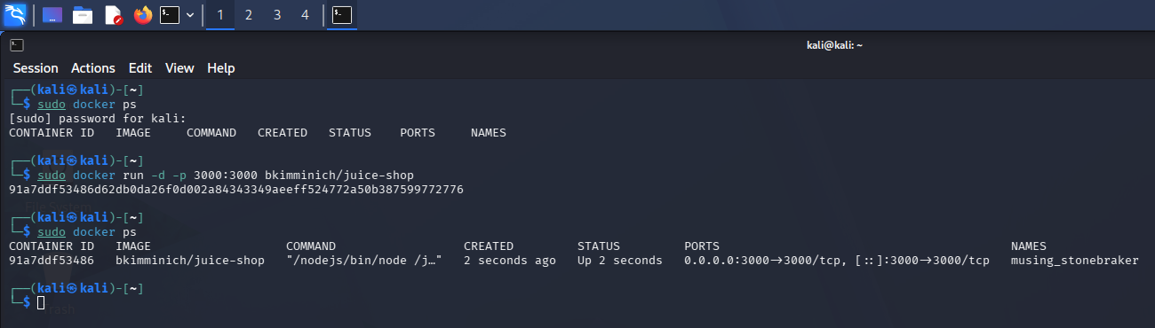
Figure 1 — Juice Shop started on Kali Linux: docker ps is empty, docker run starts the container, and docker ps then shows it Up with port 3000 mapped.

2.2 Tool Configuration
The two tools that needed configuration are described below.
Tool Name | Docker Engine and the OWASP Juice Shop image (bkimminich/juice-shop)
Installation Method | Docker Engine on Kali Linux; Juice Shop image from Docker Hub
Configuration Steps | Container started detached with host port 3000 published to container port 3000: sudo docker run -d -p 3000:3000 bkimminich/juice-shop. No other settings were changed.
Verification | sudo docker ps showed the container with status “Up 2 seconds” and ports 0.0.0.0:3000→3000/tcp (Figure 1).

Tool Name | OWASP ZAP 2.17.0 (by Checkmarx)
Installation Method | Installed on the Kali Linux workstation
Configuration Steps | Target http://localhost:3000. The alerts raised came from passive scanners plus one active rule (User Agent Fuzzer). The HTML report was exported with all contexts, risk levels High to Informational and all confidence levels.
Verification | Report generated 28 Sep 2026, 19:39:03, listing 5 alert types for http://localhost:3000 (Figures 2 and 3).

2.3 AI Tool Usage Declaration
Claude (Anthropic) was used for Phase F, as the task brief allows. It was not used to produce the lab work or evidence.
AI Tool | Used For | What Was NOT Done with AI
Claude (Anthropic) | Structuring the report sections (Executive Summary, Findings, Recommendations), consolidating the Phase A–E evidence into this template, and drafting and refining the report wording. | AI did not deploy the lab, run the ZAP scan, take the screenshots or produce the Phase A–E evidence files. The findings come from the ZAP report and the threat model produced during the task.
The scan output, screenshots and threat model are the intern’s own work; Claude assisted with structure and wording as declared above, and the intern has reviewed the report.

3.0 Methodology — Phase Execution
This section records what was done in each phase and what it showed.

Phase A — Theory & Conceptual Foundation
Phase Objective | Build a conceptual foundation in the OWASP Top 10 by summarising each category and linking it to a real-world incident.
Estimated Time | ~60 minutes
Evidence File(s) | PhaseA_OWASP_Top10_Summary.md

Actions Taken
I reviewed the ten OWASP Top 10 categories and wrote a short summary of each covering what the weakness is, how it arises and how to prevent it: Broken Access Control, Security Misconfiguration, Software Supply Chain Failures, Cryptographic Failures, Injection, Insecure Design, Authentication Failures, Software or Data Integrity Failures, Security Logging and Alerting Failures, and Mishandling of Exceptional Conditions.
For five categories I researched a real breach: the Facebook contact importer (2019, Broken Access Control), Capital One (2019, Security Misconfiguration), Equifax (2017, Supply Chain), LinkedIn (2012, Cryptographic Failures) and TalkTalk (2015, Injection).

Key Observations
Each breach combined a technical weakness with an operational failure: an unpatched Apache Struts and an expired monitoring certificate at Equifax, an over-privileged WAF role and IMDSv1 at Capital One, unsalted SHA-1 password hashes at LinkedIn, unpatched legacy pages and missed earlier attacks at TalkTalk, and missing rate limits and authorisation checks on bulk lookups at Facebook.
Several categories (Insecure Design, Supply Chain, Logging and Alerting) are about process rather than code, which is why threat modelling, patching and monitoring recur in the later phases.

Evidence Produced
Evidence files and artefacts for this phase:
- PhaseA_OWASP_Top10_Summary.md — summary of all ten categories, with five real-world case studies

Phase B — Lab Setup & Environment Preparation
Phase Objective | Deploy an isolated, intentionally vulnerable target (OWASP Juice Shop) on the Kali Linux lab machine.
Estimated Time | ~90 minutes
Evidence File(s) | PhaseB_Docker_JuiceShop.png (Figure 1)

Actions Taken
On Kali Linux I ran sudo docker ps to confirm that no containers were running, then started Juice Shop with sudo docker run -d -p 3000:3000 bkimminich/juice-shop. Docker returned the container ID (91a7ddf53486…), and a second sudo docker ps showed the container, named musing_stonebraker, with status “Up 2 seconds” and port 3000 mapped to the host (Figure 1).

Key Observations
The container was published on 0.0.0.0:3000 (and [::]:3000), which exposes it on all host interfaces. For a deliberately vulnerable application, binding to loopback with -p 127.0.0.1:3000:3000 would keep it reachable only from the lab machine. The target was reachable at http://localhost:3000 and served as the scan target in Phase C.

Evidence Produced
Evidence files and artefacts for this phase:
- PhaseB_Docker_JuiceShop.png — terminal screenshot of the container start-up (Figure 1)

Phase C — Core Technical Execution
Phase Objective | Run a dynamic scan against the target and analyse the results.
Estimated Time | ~120 minutes
Evidence File(s) | PhaseC_ZAP_Report.html (Figures 2 and 3)

Actions Taken
I scanned http://localhost:3000 with ZAP 2.17.0 and exported the HTML report (generated 28 Sep 2026, 19:39:03) with all risk and confidence levels included. ZAP saw 67 endpoints on the target, all requested with GET, and raised 5 alert types with 5 instances each: 2 Medium, 1 Low and 2 Informational, and none High (Figures 2 and 3).

Key Observations
The scan surfaced configuration and information-disclosure weaknesses, not injection or authentication flaws. That reflects the scan rather than the application: the alerts came from passive scanners plus one active rule, and every request was a GET, so input-driven attacks such as SQL injection were not exercised. Juice Shop is deliberately vulnerable, and the threats scored in Phase D remain unverified by this scan.
The two Medium alerts are tagged SYSTEMIC by ZAP, meaning they apply across the application rather than to a single page.

Evidence Produced
Evidence files and artefacts for this phase:
- PhaseC_ZAP_Report.html — full ZAP scanning report
- Figure 2 — alert counts by risk, confidence and type; Figure 3 — alert list

Detailed Technical Walkthrough
The scan details, outputs, decisions and anomalies behind the Phase C results:
- Configuration: target http://localhost:3000 (the Phase B container); ZAP 2.17.0; report parameters were all contexts, risk levels High to Informational, and all confidence levels.
- Outputs: alerts by risk were High 0, Medium 2, Low 1, Informational 2 (Figure 2). By type: Content Security Policy (CSP) Header Not Set (Medium, High confidence); Cross-Domain Misconfiguration (Medium, Medium confidence); Timestamp Disclosure – Unix (Low, Low confidence); Modern Web Application and User Agent Fuzzer (Informational) (Figure 3).
- Decisions: the two Informational alerts describe the application rather than a weakness, so they are not listed as findings. Modern Web Application only indicates a JavaScript single-page app (the standard spider found no links, so ZAP suggests its Client Spider), and User Agent Fuzzer found no difference to report. The Unix timestamp is kept as a Low finding: 1666666667 decodes to 24 Oct 2022 22:57:47 UTC and, being a round number, looks like a constant in the page rather than server time.
- Anomalies: ZAP also recorded https://ads.mozilla.org (one POST endpoint), which is background browser traffic and not a test target; no alerts were raised for it. ZAP’s insights show 91% memory use, 2 logged errors, 11 warnings and 10% slow responses on the target. The report still completed, but a memory-constrained scan may be less thorough. The sample response for /sitemap.xml was the application’s HTML front page, consistent with a single-page app serving index.html for unknown routes.
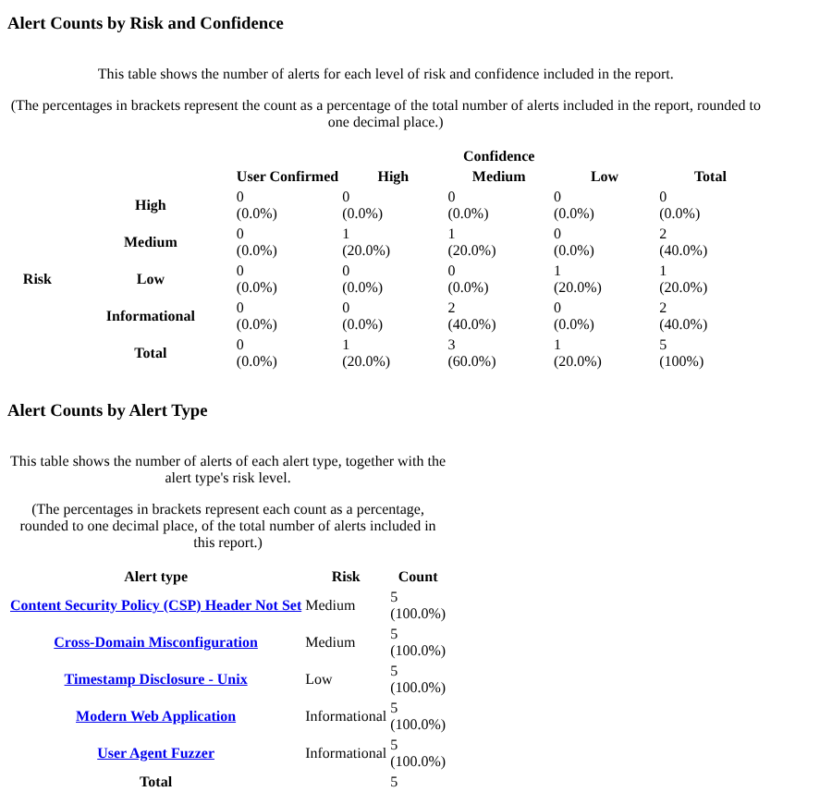
Figure 2 — ZAP report summary: alert counts by risk and confidence (top) and by alert type (bottom). No High alerts; 2 Medium, 1 Low, 2 Informational.
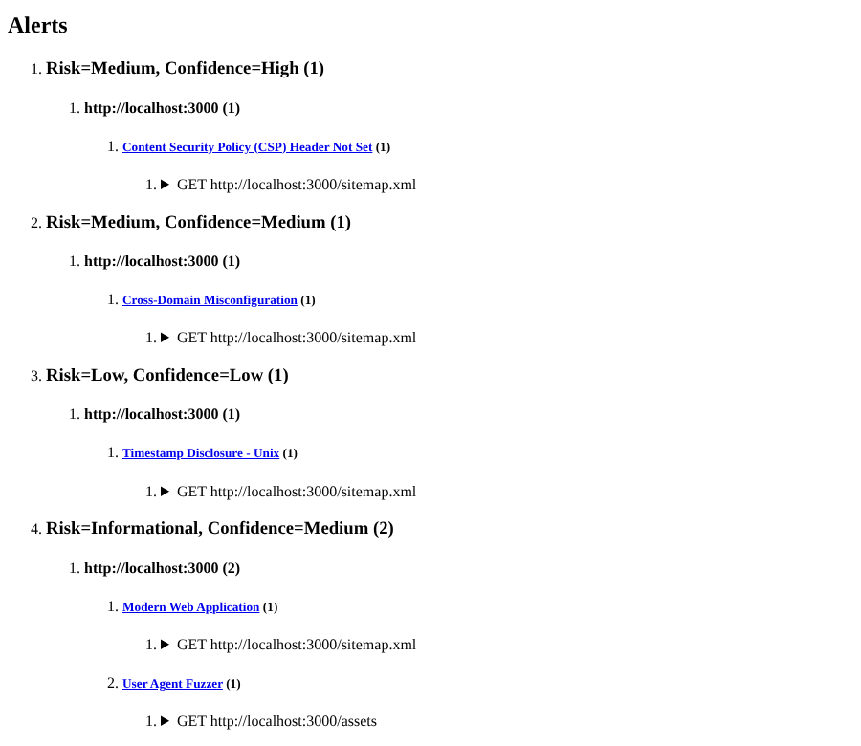
Figure 3 — ZAP alert list for http://localhost:3000, grouped by risk and confidence.

Phase D — Independent Extension & Threat Modelling
Phase Objective | Threat-model OWASP Juice Shop: identify assets and threats, build a risk matrix and propose mitigations for the high-risk items.
Estimated Time | ~90–120 minutes
Evidence File(s) | PhaseD_ThreatModel.md (Figure 4)

Actions Taken
I followed a four-step method: (1) identified six key assets: user data (A1), payment information (A2), authentication tokens (A3), admin functions (A4), application files and configuration (A5) and service availability (A6); (2) listed twelve threats, from SQL injection (T1) to insufficient logging and monitoring (T12); (3) scored each threat on a 5×5 likelihood × impact matrix (Figure 4); and (4) proposed mitigations for the high-risk items.

Key Observations
Six threats reach the Critical band (15–25): SQL injection (25), then broken authentication, cross-site scripting, broken access control and sensitive data exposure (20 each), and CSRF (16). Brute force (12) is High, and five threats score 6–9 (Medium). The top threats converge on the same assets, user data and authentication tokens, so one weakness such as XSS stealing the JWT cookie can chain into account takeover.
The Phase C finding “CSP header not set” links directly to T3: without a CSP an XSS flaw has no second line of defence.
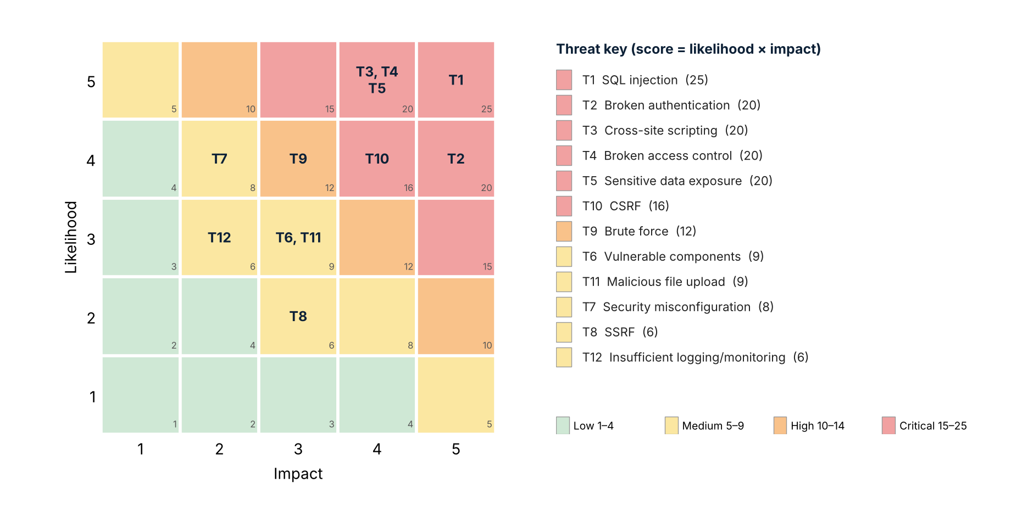
Figure 4 — Risk heat-map from the Phase D threat model: likelihood × impact for T1–T12 (score in each cell’s corner).

Evidence Produced
Evidence files and artefacts for this phase:
- PhaseD_ThreatModel.md — assets, threat list, risk matrix and mitigation table
- Figure 4 — risk heat-map of the twelve threats

Phase E — Hosted Lab Integration
Phase Objective | Consolidate and apply web security knowledge through hosted TryHackMe labs.
Estimated Time | ~90–120 minutes
Evidence File(s) | PhaseE_TryHackMe_Profile.png (Figure 5)

Actions Taken
I completed six TryHackMe rooms, shown on the profile’s Completed rooms tab (Figure 5): Pentesting Fundamentals, Offensive Security Intro, Defensive Security Intro, Careers in Cyber, Web Application Basics and Web Security Essentials. Five are rated Easy; Careers in Cyber is an information room.

Key Observations
The rooms cover the ground used in this project: pentest ethics and methodology, how web applications work (HTTP, URLs, request methods, response codes and headers) and common web risks. That vocabulary underpinned the header and CORS findings in Phase C and the OWASP-style threats in Phase D. The profile shows 6 completed rooms and a 2-day streak.
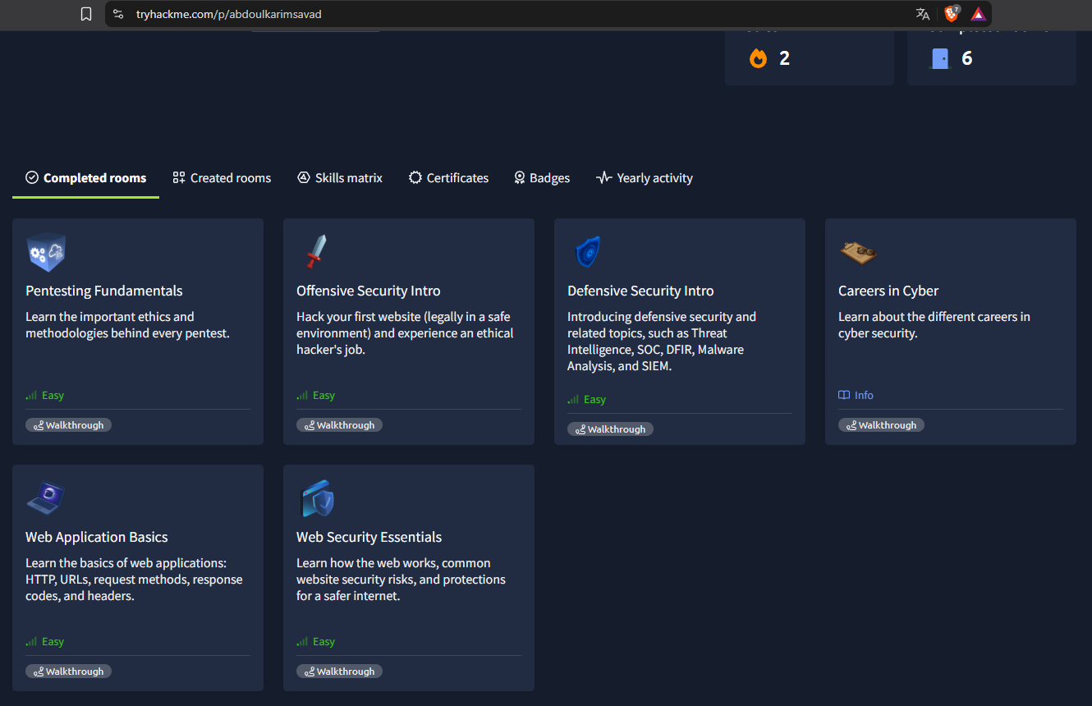
Figure 5 — TryHackMe profile (abdoulkarimsavad): six completed rooms.

Evidence Produced
Evidence files and artefacts for this phase:
- PhaseE_TryHackMe_Profile.png — TryHackMe profile, Completed rooms tab (Figure 5)

Phase F — Documentation & Reporting
Phase Objective | Compile all findings into a professional report.
Estimated Time | ~90 minutes
Evidence File(s) | ASE_APPSEC_Report.pdf

Actions Taken
I consolidated the Phase A–E evidence (the OWASP summary, lab screenshot, ZAP report, threat model and TryHackMe profile) into the EncryptEdge Labs report template. Claude helped structure the Executive Summary, Findings and Recommendations sections and refine the wording, as declared in Section 2.3. I then embedded the screenshots and risk matrix, added mitigation strategies and exported the report as ASE_APPSEC_Report.pdf.

Key Observations
The ZAP findings and the threat model use different scales, so the three scanner findings were given likelihood and impact scores in Section 5.1 to fit the same matrix. The template’s score guide (15–25 = Critical) puts CSRF (score 16) in the Critical band, whereas the Phase D sheet labelled it High; this report uses the template scale.

Evidence Produced
Evidence files and artefacts for this phase:
- ASE_APPSEC_Report.pdf — this report

4.0 Findings
Ten findings are recorded. Findings 1–3 were confirmed by the Phase C ZAP scan against the live Juice Shop instance. Findings 4–10 come from the Phase D threat model; they are rated by likelihood and impact and were not exploited in this task. The two Informational ZAP alerts (Modern Web Application, User Agent Fuzzer) are described in Phase C and are not listed as findings.

4.1 Findings Summary
# | Finding Title | Type / Category | Framework Ref.* | Phase Identified | Severity / Impact | Evidence Ref.
1 | Content Security Policy (CSP) header not set | Security Misconfiguration (confirmed, ZAP) | A02:2025 / CWE-693 | Phase C | Medium | Fig. 2–3
2 | Permissive CORS policy (wildcard origin) | Broken Access Control / misconfiguration (confirmed, ZAP) | A01:2025 / CWE-264 | Phase C | Medium | Fig. 2–3
3 | Unix timestamp disclosure | Information disclosure (confirmed, ZAP) | A01:2025 / CWE-497 | Phase C | Low | Fig. 2–3
4 | SQL injection (T1) | Injection (threat model) | A05:2025 / CWE-89 | Phase D | Critical | Fig. 4
5 | Cross-site scripting (T3) | Injection (threat model) | A05:2025 / CWE-79 | Phase D | Critical | Fig. 4
6 | Broken authentication (T2) | Authentication failure (threat model) | A07:2025 / CWE-287 | Phase D | Critical | Fig. 4
7 | Broken access control (T4) | Broken Access Control (threat model) | A01:2025 / CWE-284 | Phase D | Critical | Fig. 4
8 | Sensitive data exposure (T5) | Cryptographic failure / misconfiguration (threat model) | A04:2025, A02:2025 / CWE-200 | Phase D | Critical | Fig. 4
9 | Cross-site request forgery (T10) | Broken Access Control (threat model) | A01:2025 / CWE-352 | Phase D | Critical (score 16) | Fig. 4
10 | Brute force (T9) | Authentication failure (threat model) | A07:2025 / CWE-307 | Phase D | High | Fig. 4
* Framework Ref: OWASP Top 10:2025 category numbers (as used in Phase A and in ZAP’s tags) and CWE identifiers.

4.2 Detailed Finding Analysis
Detailed analysis of the five findings that matter most for this assessment: the three confirmed scanner findings, plus SQL injection and cross-site scripting. Findings 6–10 are covered in Sections 5 and 6.

Finding 1: Content Security Policy (CSP) header not set
Finding Title | Content Security Policy (CSP) header not set
Type / Category | Security Misconfiguration (confirmed by ZAP passive scan)
Description | The application does not send a Content-Security-Policy header. ZAP raised the alert on 5 instances and tagged it SYSTEMIC; the example URL is GET http://localhost:3000/sitemap.xml. Without a CSP the browser has no policy limiting which scripts, frames or other resources a page may load.
How Identified | ZAP 2.17.0 passive rule “Content Security Policy (CSP) Header Not Set” during the Phase C scan of http://localhost:3000 (Figures 2 and 3).
Framework Reference | OWASP A02:2025 Security Misconfiguration (A05:2021) / CWE-693 / WASC-15
Business / Operational Impact | Removes a key defence-in-depth control against cross-site scripting and data injection. If an XSS flaw exists (Finding 5), nothing stops injected script from loading and running, which puts user data and authentication tokens at risk (confidentiality, integrity).
Severity / Impact | Medium (ZAP confidence: High)
Evidence Reference | Figures 2 and 3; PhaseC_ZAP_Report.html

Finding 2: Permissive CORS policy (wildcard origin)
Finding Title | Permissive CORS policy (wildcard origin)
Type / Category | Broken Access Control / misconfiguration (confirmed by ZAP passive scan)
Description | Responses carry the header Access-Control-Allow-Origin: *, so scripts from any origin may read them. ZAP raised the alert on 5 instances (example: GET http://localhost:3000/sitemap.xml).
How Identified | ZAP passive rule “Cross-Domain Misconfiguration”; the evidence field shows the wildcard header in the HTTP response (Figures 2 and 3).
Framework Reference | OWASP A01:2025 Broken Access Control (A01:2021) / CWE-264 / WASC-14
Business / Operational Impact | Any third-party site can make a visitor’s browser read data returned by unauthenticated endpoints. ZAP notes that browsers do not share authenticated (credentialed) responses under a wildcard, which limits the risk, but data protected only by network position or exposed on unauthenticated APIs could be read by an attacker’s page (confidentiality).
Severity / Impact | Medium (ZAP confidence: Medium)
Evidence Reference | Figures 2 and 3; PhaseC_ZAP_Report.html

Finding 3: Unix timestamp disclosure
Finding Title | Unix timestamp disclosure
Type / Category | Information disclosure (confirmed by ZAP passive scan)
Description | A Unix timestamp, 1666666667 (24 Oct 2022 22:57:47 UTC), appears in responses (5 instances). The round value suggests a constant in the application rather than live server time.
How Identified | ZAP passive rule “Timestamp Disclosure – Unix”; the evidence field shows 1666666667 (Figures 2 and 3).
Framework Reference | OWASP A01:2025 per ZAP’s tags (A01:2021) / CWE-497 / WASC-13
Business / Operational Impact | Timestamps can help an attacker fingerprint systems or predict time-based values. Here the practical impact is minimal unless the value proves sensitive; ZAP recommends confirming this manually (confidentiality, low).
Severity / Impact | Low (ZAP confidence: Low)
Evidence Reference | Figures 2 and 3; PhaseC_ZAP_Report.html

Finding 4: SQL injection (T1)
Finding Title | SQL injection (T1)
Type / Category | Injection (threat model; not exploited in this task)
Description | SQL injection was the highest-scoring threat. Juice Shop stores data in an SQLite database (asset A6), and any endpoint that builds queries from user input could let an attacker change a query to read or modify data, including user records and password hashes (A1, A3). The Phase C scan used GET requests only and raised no SQL injection alert, so this threat is modelled, not confirmed.
How Identified | Phase D threat modelling: asset and threat identification and the 5×5 risk matrix (Figure 4).
Framework Reference | OWASP A05:2025 Injection (A03:2021) / CWE-89
Business / Operational Impact | Possible disclosure of all stored user data and credentials, tampering with accounts or orders, and loss of availability. Phase A’s TalkTalk case (2015) shows the scale: SQLMap against legacy pages exposed the records of 156,959 customers.
Severity / Impact | Critical (likelihood 5 × impact 5 = 25)
Evidence Reference | Figure 4; PhaseD_ThreatModel.md

Finding 5: Cross-site scripting (T3)
Finding Title | Cross-site scripting (T3)
Type / Category | Injection (threat model; not exploited in this task)
Description | XSS was scored Critical. The authentication token is a JWT kept in a cookie (asset A3); if that cookie is readable by script, injected JavaScript could steal it or act as the user. The Phase C scan did not test for XSS, so this is a modelled threat.
How Identified | Phase D threat modelling (Figure 4), read together with the Phase C CSP finding (Finding 1).
Framework Reference | OWASP A05:2025 Injection (A03:2021) / CWE-79
Business / Operational Impact | Session or token theft, account takeover, defacement and malicious redirects (confidentiality, integrity). Finding 1 amplifies the impact because no CSP limits what injected script can do.
Severity / Impact | Critical (likelihood 5 × impact 4 = 20)
Evidence Reference | Figure 4; PhaseD_ThreatModel.md

5.0 Risk Assessment & Threat Model
This section maps the findings to business assets and scores them, then sets out where defensive controls can detect or prevent each one and what happens if the risks stay open. Likelihood and impact for Findings 4–10 come from the Phase D threat model (Figure 4); Findings 1–3 were not scored in Phase D, so their scores are assessed here from the ZAP rating and context.

5.1 Risk Matrix
Risk score = likelihood × impact (each 1–5). Business assets are the Phase D asset IDs: A1 user data, A2 payment information, A3 authentication tokens, A4 admin functions, A5 application files and configuration, A6 service availability.
Finding / Risk | Business Asset | Framework Ref. | Likelihood 1–5 | Impact 1–5 | Score | Rating
1. CSP header not set | A1, A3 — user data and tokens | A02:2025 / CWE-693 | 3 | 3 | 9 | Medium
2. Permissive CORS policy | A1, A6 — API responses | A01:2025 / CWE-264 | 3 | 3 | 9 | Medium
3. Unix timestamp disclosure | A5 — application files and config | A01:2025 / CWE-497 | 2 | 1 | 2 | Low
4. SQL injection (T1) | A1, A3, A6 — user data, tokens, database | A05:2025 / CWE-89 | 5 | 5 | 25 | Critical
5. Cross-site scripting (T3) | A1, A3 — user data, JWT cookie | A05:2025 / CWE-79 | 5 | 4 | 20 | Critical
6. Broken authentication (T2) | A3, A4 — tokens, admin functions | A07:2025 / CWE-287 | 4 | 5 | 20 | Critical
7. Broken access control (T4) | A1, A4 — user data, admin functions | A01:2025 / CWE-284 | 5 | 4 | 20 | Critical
8. Sensitive data exposure (T5) | A1, A5 — user data, files and backups | A04:2025 / CWE-200 | 5 | 4 | 20 | Critical
9. CSRF (T10) | A1, A2 — user data, payments | A01:2025 / CWE-352 | 4 | 4 | 16 | Critical
10. Brute force (T9) | A3 — authentication tokens | A07:2025 / CWE-307 | 4 | 3 | 12 | High
Score guide: 1–4 = Low | 5–9 = Medium | 10–14 = High | 15–25 = Critical
Phase D also scored five threats in the Medium band: vulnerable components (T6, 9), malicious file upload (T11, 9), security misconfiguration (T7, 8), SSRF (T8, 6) and insufficient logging and monitoring (T12, 6). They are shown in Figure 4 and addressed by the strategic recommendations in Section 6.2. CSRF (T10, score 16) was labelled High in Phase D but is Critical on this scale.

5.2 Defensive Opportunities & Coverage Gaps
Where a control could prevent, detect or reduce each finding:
Finding / Gap | Observable / Trigger | Recommended Control | Tool / Implementation
1. CSP header not set | Responses without a Content-Security-Policy header; CSP violation reports once enabled | Send a restrictive CSP application-wide; trial it in Report-Only mode first | Express helmet or reverse-proxy header config; ZAP baseline and header check in CI
2. Permissive CORS policy | Access-Control-Allow-Origin: * in responses; unexpected Origin headers in access logs | Explicit origin allow-list; no wildcard on endpoints returning user data | cors middleware configuration; reverse-proxy rule; log the Origin header
3. Timestamp disclosure | Unix timestamps in response bodies | Review and remove timestamps clients do not need | Manual review; ZAP passive rule
4. SQL injection | SQL errors in logs; quote and UNION patterns in parameters; unusual query volume | Parameterised queries, server-side validation, least-privilege DB account, generic error messages | ORM bind parameters; SAST in CI; WAF as defence in depth; DB audit logging
5. Cross-site scripting | Script tags or event handlers in inputs; CSP violation reports | Context-aware output encoding; avoid innerHTML and bypassSecurityTrust on untrusted data; CSP; HttpOnly and Secure cookies | Angular sanitiser; CSP; SAST and lint rules
6. Broken authentication | Repeated failed logins; tokens with alg=none or odd claims | Strong random JWT secret, reject alg=none, short expiry, remove default credentials, MFA for admin | JWT library settings; rate limiter; SIEM alert on failed logins
7. Broken access control | Requests for other users’ object IDs; spikes of 401/403 responses | Server-side authorisation and ownership check on every request; deny by default; unguessable IDs | Authorisation middleware; automated tests for object-level access
8. Sensitive data exposure | Requests to /ftp, backups or /metrics from outside | Remove public listings and backups; restrict /metrics; bcrypt or argon2 with salt; HTTPS and HSTS | Reverse-proxy ACLs; forced-browsing checks in ZAP
9–10. CSRF and brute force | State-changing requests with a foreign Origin or Referer; many failures per account or IP | Anti-CSRF tokens and SameSite cookies; rate limiting, lockout or back-off, CAPTCHA | Rate-limit middleware; CSRF token library; SIEM alerting

5.3 Risk Exposure Over Time
What happens if the three most serious risks stay open:

Risk 1 — SQL injection (Finding 4): a single injectable parameter lets an attacker read the whole database, including user data, payment information and password hashes, and automated tools make such flaws easy to find (TalkTalk, 2015: SQLMap located injectable fields and 156,959 customers’ records were taken). The exposure compounds over time: stolen hashes enable credential stuffing against other sites, and a breach brings regulatory scrutiny and reputational damage.

Risk 2 — Missing CSP and permissive CORS combined with XSS (Findings 1, 2, 5): these two Medium gaps are cheap to fix now but weaken every other control. With no CSP any XSS flaw runs unconstrained, and with a wildcard CORS policy other sites can read unauthenticated responses. ZAP tagged both as systemic, so every page added to the application inherits them, and users’ tokens stay one injected script away from theft.

Risk 3 — Broken authentication and access control (Findings 6, 7): weak token signing, guessable credentials and missing ownership checks allow account takeover and privilege escalation up to admin functions (A4). Facebook’s 2019 contact-importer case (Phase A) shows how missing authorisation and rate limits on one API let attackers harvest data on hundreds of millions of users. Without logging and alerting (T12), the weakness can persist unnoticed and the exposure grows every day.

6.0 Recommendations
Each recommendation traces to a finding in Section 4. Priority follows the risk rating: Critical = Immediate, Medium and High = Short-term, Low = Long-term.

6.1 Technical Remediation
# | Finding | Specific Remediation Action | Priority | Standard / Reference
1 | CSP header not set | Send a Content-Security-Policy header on every response, for example default-src 'self'; script-src 'self'; object-src 'none'; base-uri 'self'; frame-ancestors 'self'. Deploy it first as Content-Security-Policy-Report-Only, fix the violations, then enforce (Express: helmet.contentSecurityPolicy). | Short-term | OWASP CSP Cheat Sheet / CWE-693
2 | Permissive CORS policy | Replace Access-Control-Allow-Origin: * with an explicit allow-list, for example cors({ origin: ['https://shop.example.com'] }), or remove CORS headers so the Same Origin Policy applies. Do not expose user-specific data on unauthenticated endpoints. | Short-term | A01:2025 / CWE-264
3 | Unix timestamp disclosure | Confirm that 1666666667 is not sensitive (ZAP’s recommendation) and remove timestamps that clients do not need. | Long-term | CWE-497
4 | SQL injection | Use parameterised queries or ORM bind parameters for every query, validate input on the server, run the database account with least privilege and return generic error messages. | Immediate | OWASP SQL Injection Prevention Cheat Sheet / CWE-89
5 | Cross-site scripting | Apply context-aware output encoding, avoid innerHTML and Angular bypassSecurityTrust on untrusted data, sanitise input, deploy the CSP from Finding 1 and set HttpOnly and Secure on cookies. | Immediate | OWASP XSS Prevention Cheat Sheet / CWE-79
6 | Broken authentication | Sign JWTs with a strong random secret, reject alg=none, use short token expiry, remove default and guessable credentials and require MFA for admin accounts. | Immediate | OWASP Authentication Cheat Sheet / CWE-287
7 | Broken access control | Enforce authorisation on the server for every request, check object ownership, deny by default and use unguessable identifiers. | Immediate | OWASP Authorization Cheat Sheet / CWE-284
8 | Sensitive data exposure | Remove public file listings and backups (such as /ftp), restrict /metrics to internal access, hash passwords with bcrypt or argon2 plus salt, and enforce HTTPS with HSTS. | Immediate | OWASP Password Storage Cheat Sheet / CWE-200
9 | Cross-site request forgery | Add anti-CSRF tokens, set SameSite=Lax or Strict on cookies, require the current password for sensitive changes and use POST or PUT, never GET, for state changes. | Short-term | OWASP CSRF Prevention Cheat Sheet / CWE-352
10 | Brute force | Apply rate limiting, account lockout or exponential back-off and CAPTCHA, and alert on repeated failures. | Short-term | A07:2025 / CWE-307

6.2 Strategic & Operational Improvements
Beyond the individual fixes, these improvements would prevent similar findings from recurring:
- Automate security checks in CI/CD: run a ZAP baseline scan and a security-header check on every build, failing it when a CSP is missing or CORS is a wildcard; add SAST for injection and XSS patterns and dependency scanning for vulnerable components (T6; the Equifax lesson from Phase A).
- Threat-model new features: make threat modelling a standing step of the secure development lifecycle for critical components, as Phase A’s Insecure Design category recommends, and repeat the Phase D exercise when the application changes.
- Widen test coverage: the Phase C scan made only GET requests. Add authenticated scans of POST and PUT endpoints and manual testing of the Critical threats (T1–T5, T10) to confirm or refute them.
- Detect and respond: centralise logging and alerting for failed logins, access-control failures and input-validation failures (T12), and define an incident-response plan.
- Harden deployment defaults: manage headers, CORS, cookie flags and secrets as configuration under version control, and bind intentionally vulnerable lab targets to 127.0.0.1 (Phase B observation).

7.0 Reflection
Reflections on the assessment, grounded in the findings above.

Q1 Which finding presents the greatest risk, and why?
SQL injection (Finding 4, score 25). It combines the highest likelihood and impact: one injectable input can expose every user record and password hash in the database, and tools like SQLMap automate the discovery, as TalkTalk’s 2015 breach showed. I should be clear that this is a modelled threat in Phase D, not an exploit I demonstrated.

Q2 How did the scan results compare with the threat model?
They complement each other. ZAP confirmed three real configuration gaps (no CSP, wildcard CORS, a disclosed timestamp) but found nothing in the Critical band, because the alerts came from passive checks plus one active rule and every request was a GET. The threat model reached the more serious risks (injection, authentication, access control) by reasoning about assets and attack paths. The two meet at XSS: the missing CSP makes the modelled XSS threat worse.

Q3 How would you explain the key risks to a non-technical stakeholder?
The shop has no automatic checks stopping attackers from tampering with what its web pages do, and the way it is built could let a stranger ask the database for customers’ details or act as another user. Two easy fixes, adding a browser safety setting and restricting which sites may read our data, reduce the damage if something slips through. The more serious weaknesses need developer time to fix and a proper test to confirm. Left alone, they put customer data, trust and regulatory standing at risk.

Q4 What would you do differently or next?
I would run an authenticated, active ZAP scan covering POST and PUT endpoints, then test the Critical threats by hand to confirm them. I would also add the ZAP baseline and header check to a CI pipeline, and start the lab container bound to 127.0.0.1 rather than all interfaces.

8.0 Deliverables Submission Checklist
Deliverables for each phase, with the evidence filenames used in this report.

✓ | Phase | Deliverable Description | Your Filename | Status
☑ | Phase A | OWASP Top 10 summary with real-world breach case studies | PhaseA_OWASP_Top10_Summary.md | Complete
☑ | Phase B | Lab setup screenshot: Juice Shop container running on Kali Linux (Figure 1) | PhaseB_Docker_JuiceShop.png | Complete
☑ | Phase C | ZAP scan report for http://localhost:3000 | PhaseC_ZAP_Report.html | Complete
☑ | Phase D | Threat model: assets, threats, risk matrix and mitigations | PhaseD_ThreatModel.md | Complete
☑ | Phase E | TryHackMe completed-rooms screenshot (Figure 5) | PhaseE_TryHackMe_Profile.png | Complete
☑ | Phase F | This report, exported as PDF | ASE_APPSEC_Report.pdf | Complete

Submission naming:
- Report PDF: ASE_APPSEC_Report.pdf (name given in the Phase F brief)
- Evidence files: PhaseA_OWASP_Top10_Summary.md, PhaseB_Docker_JuiceShop.png, PhaseC_ZAP_Report.html, PhaseD_ThreatModel.md, PhaseE_TryHackMe_Profile.png

9.0 Additional Observations
Additional observations from the task:
- Tool behaviour: ZAP reported 91% memory use, 2 errors and 11 warnings during the scan, and still produced the report. Docker published the Juice Shop container on all interfaces (0.0.0.0:3000); -p 127.0.0.1:3000:3000 would limit it to the lab machine.
- Connections: the missing CSP (ZAP) links to the XSS threat (T3), and the wildcard CORS policy to broken access control (T4). The Phase A case studies show the same controls recurring: patching, least privilege and logging.
- Scoring notes: Findings 1–3 were scored in this report because Phase D did not cover them. CSRF (T10, score 16) was labelled High in Phase D; this report uses the template’s score guide, which makes it Critical.

Declaration & Sign-Off
I confirm that:
- All work in this report is my own except where AI usage is explicitly declared in Section 2.3.
- All technical activities were performed exclusively within the authorised environments listed in Section 1.3.
- No external systems, production networks, or third-party infrastructure were accessed during this task.
- I have reviewed this report for accuracy, completeness, and professional presentation before submission.

Intern Full Name | Signature | Date of Submission
Abdoul Karim Savadogo |  | 12 October 2026

EncryptEdge Labs Limited — Junior Application Security Engineer Internship Programme
Company No. 15830711 | United Kingdom | encryptedgelabs.com
Copyright © 2026 EncryptEdge Labs. All rights reserved. | Report Template v3.0

