Automation Landscape Report
Johannesburg Moringa Daily Capsule Line
Current state on the ISA-95 levels, PLC or DCS, data transport through load-shedding, and data integrity for the move to an integrated MES/SCADA architecture
Ubuntu Naturals Johannesburg | for the engineering and quality management teams | 8 November 2026
Contents
Executive summary 2
1 Introduction, scope and method 2
2 The ISA-95 pyramid and the current state 3
3 PLC or DCS for the upgrade 6
4 Data transport protocols 8
5 Network architecture 9
6 Regulation and data integrity 11
7 Recommendations 13
8 Phased commissioning 14
9 Limitations and authorship 14
10 Glossary 15
11 References 15

Word count: 3,399 (body text from the executive summary to Section 9; the contents list, tables, figure and table captions, glossary and references are excluded).

Executive summary
Ubuntu Naturals' Johannesburg plant is the group's Tier 1 encapsulation site and its manufacturing execution system (MES) anchor. The Moringa Daily capsule line still runs on standalone programmable logic controllers (PLCs). Each machine keeps its own settings, and the batch record is kept by hand. This report maps the line onto the five ISA-95 levels, compares PLC and distributed control system (DCS) architectures, recommends data transport that survives load-shedding, and sets out what the South African Health Products Regulatory Authority (SAHPRA) will expect of a computerised system.
No site survey or records were available to the author. The description of the line in Section 2 is an assumption, marked as such, and engineering must confirm it before anything is bought. The design choices that follow are the author's and are labelled as choices.
The line has working controllers at Levels 0 and 1. Level 2 exists only as a panel screen on each machine, so there is no central SCADA (supervisory control and data acquisition). Level 3 does not exist, so there is no MES and the batch record stays on paper. That is where transcription errors and data integrity findings come from. Level 4, the enterprise system, is not connected to the floor.
The report makes four decisions.
1. Buy PLC-based control under one validated central SCADA, not a DCS. The line is discrete and sequential, the staff know PLCs, and the quality benefits come from the SCADA and MES layers, not from the controller family.
2. Place an edge node between the SCADA and the MES, on an uninterruptible power supply (UPS). It holds a historian and a store-and-forward buffer, so a power cut or a lost network link delays a record but never loses one.
3. Use OPC UA from controllers to SCADA and edge, and MQTT with Sparkplug B over TLS from the edge to the MES. Keep Modbus behind a gateway for old meters and drives. Use WebSockets only for read-only dashboards, outside the GMP data path.
4. Validate the system under GAMP 5 with named log-ins, audit trails and one synchronised clock, so that each ALCOA+ data integrity attribute is built into the design instead of checked afterwards.
For the quality manager: a SAHPRA inspector will ask who did what, when, and whether the record could have been changed without trace. The electronic batch record, the audit trails and the edge buffer answer those questions. Section 7 gives every action an engineering column and a quality column. Section 8 phases the work so that Moringa Daily keeps shipping while it is done.

1 Introduction, scope and method

1.1 The plant and the line
Johannesburg is Ubuntu Naturals' Tier 1 encapsulation plant in South Africa. It is Stage 4 of the Ubuntu value chain and hosts the group's MES. The Moringa Daily line blends Moringa leaf powder, fills it into capsules, inspects the capsules and packs them for pan-African and selected export markets. The plant is regulated by SAHPRA.

1.2 Why this report is needed
Three exposures sit behind this report. The first is a failed inspection. An inspector expects computerised systems to meet international data integrity standards, and the standalone PLCs and paper records cannot show that. The second is lost market access, because the regional markets the product ships to increasingly ask for the same evidence. The third is manual batch records, which are slow to review and easy to get wrong. Capital approval and procurement both wait for this report.

1.3 Scope, evidence and method
The report covers the line from blending to packed product, with the clean-room heating, ventilation and air conditioning (HVAC) that serves it. It covers the interfaces to the enterprise resource planning (ERP) system but not the ERP itself.
Three kinds of statement appear in the report. Facts about standards and technologies come from published sources listed in Section 11. Facts about the line are assumptions, because no survey was available, and each is marked (A). Scores, weights, sizes and the architecture are the author's design choices, and each is labelled as one. The lectures L1, L2, L6, L8 and L11 are the reference frame, with L2 for ALCOA+ and cybersecurity and L11 for the regulatory framework.

2 The ISA-95 pyramid and the current state

2.1 The five levels in capsule manufacturing
ISA-95, published as IEC 62264, divides manufacturing systems into five levels. Table 1 gives a working definition of each level and an example from a capsule line.
Table 1. The ISA-95 levels, defined and illustrated from capsule manufacturing.
Level | Definition (author's wording) | Capsule line example
0 | The physical process and the devices that sense or act on it. | Load cells under the blender, the capsule-filling tooling, a motor on the polisher.
1 | Control: logic that reads Level 0 and drives it in real time. | The filler's PLC holding capsule weight inside its set limits.
2 | Supervision: seeing, alarming and recording the process across machines. | A SCADA screen showing blender, filler and packing status with alarms and trends.
3 | Manufacturing operations: running the batch, with recipes, materials, people and records. | An MES issuing the batch, checking the weighed powder and building the electronic batch record.
4 | Business planning: orders, stock, finance and release. | The ERP raising the Moringa Daily order and receiving the finished-goods stock.

2.2 What is on the floor
Table 2 lists the systems the author assumes are on the line, from the brief's description of standalone PLCs and manual batch records. Every row is an assumption (A) until engineering confirms it. No model numbers, quantities or outage figures are given, because none are known.
Table 2. Assumed current state of the Moringa Daily line, placed on the ISA-95 levels.
System (assumed) | Controller and operator interface | How records are kept | Level
Powder blender (A) | Standalone PLC, panel HMI | Paper batch record; settings on the panel | 1, panel only at 2
Capsule filler (A) | OEM standalone PLC, panel HMI | Paper; counts and weight checks written by hand | 1, panel only at 2
Checkweigher and metal detector (A) | Embedded controller of the instrument | Reject counts read from the instrument and noted on paper | 1
Packing line: counter, capper, induction sealer, labeller (A) | Standalone PLC on each machine | Paper; batch and expiry codes entered by hand | 1, panel only at 2
Clean-room HVAC (A) | Separate controller or building management panel | Chart or manual log of temperature, humidity and pressure | 1
Sensors, drives, motors, tooling (A) | Wired to the PLCs above | None of their own | 0
ERP (A) | Group enterprise system | Orders and stock, with no live link to the floor | 4
MES and central SCADA | None | Not applicable | 3 and 2, empty

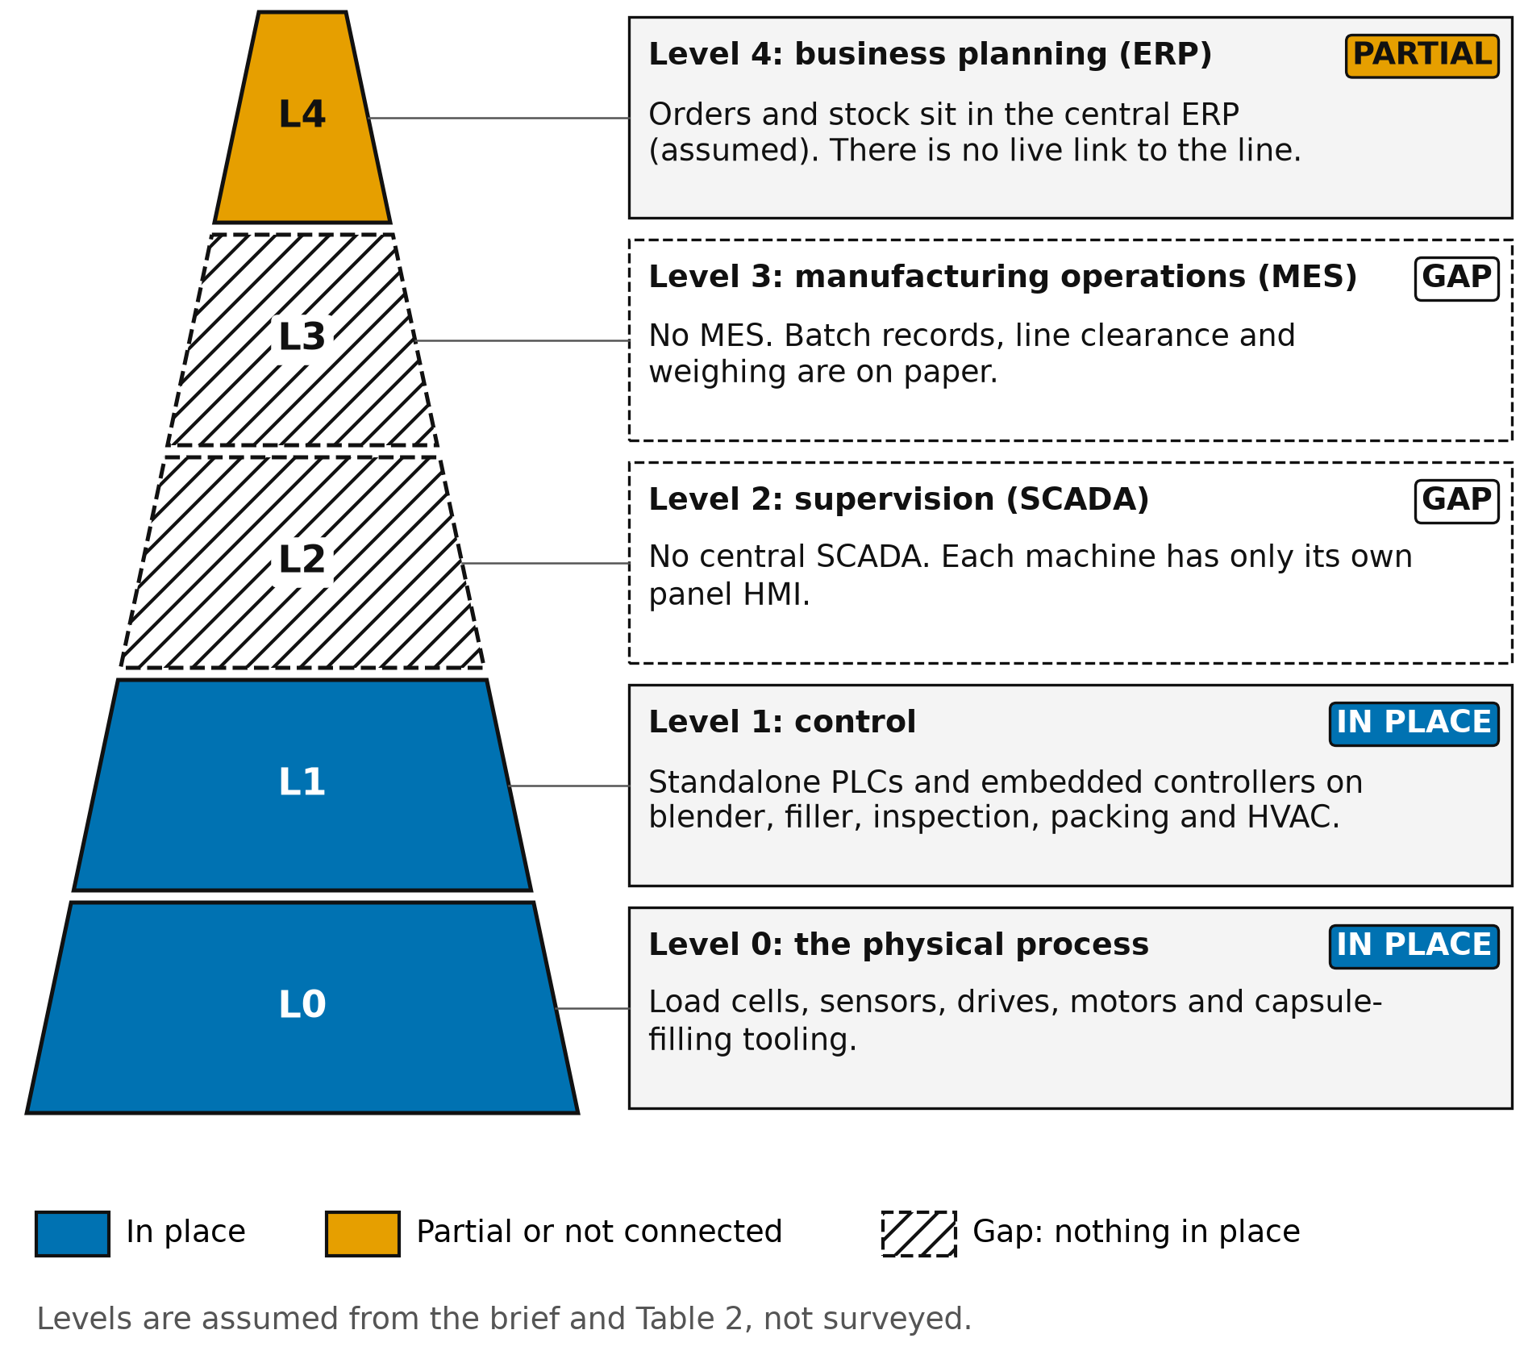
Figure 1. The ISA-95 pyramid for Johannesburg. Hatched levels are gaps. Levels are assumed, not surveyed.

2.3 The gaps, level by level
The empty levels matter more than the occupied ones. Table 3 names each gap, says why it matters at a SAHPRA inspection, and scores maturity from 0 (nothing) to 5 (validated and integrated). The scores are the author's judgement, not measurements.
Table 3. Gap analysis by level, with maturity scored by the author (0 to 5).
Level | Capability missing | Why it matters at inspection | Now | Target
4 | Live exchange of orders, materials and release status with the floor | Release rests on re-keyed data, so the inspector cannot follow a batch from order to shipment. | 2 | 4
3 | Any MES: electronic batch record, weighing control, line clearance, review by exception | The batch record is the primary GMP evidence. On paper it is open to omission, late entry and transcription error. | 0 | 4
2 | Central SCADA with user log-ins, alarms and trends | Settings and alarms live on separate panels, so there is no single audit trail and no common clock. | 1 | 4
1 | Controllers that expose data securely and keep time | Standalone PLCs cannot be read in a controlled way, and their internal clocks drift unseen. | 3 | 4
0 | Calibrated, monitored instruments | Manual transfer of weights and readings breaks the chain from sensor to record. | 3 | 4

Three consequences follow. First, the gap at Level 3 is the one an inspector will find first, because the batch record is what they ask to see. Second, the gap at Level 2 is the one that makes Level 3 impossible to fill. An MES needs live, trustworthy data, and a panel on each machine cannot supply it. Third, Level 1 is not a clean pass. The PLCs work, but a PLC that cannot be read securely or time-synchronised is a data integrity weakness, so the oldest ones must be assessed.

2.4 Closing the gaps in order
The gaps close in a fixed order because each depends on the one before. The network, time source and edge node come first, since nothing else can be trusted without them. The SCADA follows, because it needs the network and the controllers' data. The MES follows the SCADA, because the electronic batch record needs live process data. The ERP link comes last, because it only exchanges what the MES has already made reliable. The validation work runs alongside every step.
The scores in Table 3 show where effort should go. Levels 0 and 1 need assessment and modest upgrades, so they move by one point. Levels 2 and 3 move by three and four points, and that is where most of the budget and validation effort belongs. The target of 4, not 5, is deliberate. A score of 5 would mean the systems are integrated across the whole group, and that depends on the other Ubuntu Naturals sites, which this report does not cover.

3 PLC or DCS for the upgrade
A PLC began as a discrete logic controller and a DCS as an integrated system for continuous and batch process plants. Today both families overlap. The comparison in Table 4 draws on vendor documentation for the main platforms (Siemens SIMATIC S7 and PCS 7, Rockwell Automation ControlLogix and PlantPAx, Emerson DeltaV) and on the ISA-88 batch standard. Cost entries are qualitative because there are no quotations.
Table 4. PLC with SCADA and MES compared with a DCS, for a capsule line.
Criterion | PLC with SCADA and MES | DCS
Design origin | Discrete, fast logic: filling, counting, packing. | Continuous and batch process control with one integrated database.
Scalability | Grows by adding controllers and SCADA tags. Each addition is engineered in more than one tool. | Grows inside one engineering database. Licensing often steps up per tag or node.
Cost | Lower hardware and licence cost. Existing PLCs may be kept where supported. | Higher up-front cost, and a full replacement of existing control.
GxP suitability | Can be validated, but audit trail and user management must be built in the SCADA and MES layer. | Audit trail and electronic records are usually built in. Validation effort is still required.
Vendor lock-in | Moderate. IEC 61131-3 languages are common, but libraries are vendor specific. | High. Engineering tools and controllers are proprietary.
Maintenance complexity | Widely known skills. A small team can maintain it. | Needs specialist training and vendor support.
Connectivity | Current ranges offer an OPC UA server in the controller, for example Siemens S7-1500. | OPC UA is available, usually through the vendor's own gateway.
Redundancy | Available as an option at extra cost. | Redundant controllers and networks are a standard offering.
Batch handling (ISA-88) | The MES holds the recipe and the PLC runs the phases. | A batch engine is part of the system.
Fit to this line | Strong: discrete steps, existing skills, area-by-area migration. | Weak: capability the line does not use, at higher cost.

My choice is PLC-based control under a validated central SCADA, with the MES above it. I considered a hybrid, with a DCS for utilities and PLCs for machines, and rejected it for now.
The reasons come from the plant. The line is a short discrete sequence of blending, filling, inspection and packing, which is what PLCs are built for. The plant already has PLC skills and, I assume, a small engineering team, and a DCS would add a second specialist skill set. The GxP controls the inspector will test, such as audit trails and electronic signatures, live in the SCADA and MES whichever controller is chosen. Load-shedding does not favour either family, because both need power protection and both can buffer. Total cost of ownership also favours PLCs here, since the existing controllers can be kept if they can be read through OPC UA, and the replacement can proceed machine by machine.
The decision should be revisited if Ubuntu Naturals adds tablets or liquids. Tablet compression and coating are still discrete machine work and fit this architecture. Liquid mixing and batching are closer to process control, and a batch engine behind the same OPC UA interface could then be added without replacing what is built now.
The migration path for the existing PLCs is part of the choice. Controllers that offer OPC UA, hold a reliable clock and support user-level password control can stay, and the SCADA simply connects to them. Controllers that fail those tests are replaced during a planned stop. The OEM-supplied filler is a special case. Its program may be locked by the supplier, so the plant should ask the supplier for an OPC UA option or a supported upgrade path before assuming it can be kept.

4 Data transport protocols

4.1 What the plant demands of a protocol
Four demands decide the choice. Resilience means data survives a power cut or a lost link. Edge processing means the protocol works on a small local node. The GxP audit trail means a value arrives with its source time, quality and origin, so it can stand as a record. Limited bandwidth means the wide-area link is shared and sometimes down. Load-shedding blocks of about two to four hours are the planning case, taken from public Eskom schedules. No site outage log was available.

4.2 The four protocols
Modbus is a polling protocol from the 1970s. A master reads 16-bit registers from devices. It is simple and nearly every meter and drive speaks it. It carries no timestamp, no user identity and, in its basic form, no encryption, and it has no memory of a missed poll. A power cut therefore leaves a hole with no trace.
OPC UA (IEC 62541) is a client-server and publish-subscribe standard with an information model. Each value carries a source timestamp and a status code. Sessions can be signed and encrypted with certificates, and servers can raise audit events. Subscriptions queue changes for a while, and a Historical Access service lets a client ask for what it missed. It is heavier than Modbus but runs well on an edge computer.
MQTT is a lightweight publish-subscribe protocol. A client holds messages while the link is down and sends them on reconnection, and its quality-of-service levels control delivery. Sparkplug B, an Eclipse specification, adds a fixed topic structure, birth and death messages and a sequence number on every message, so a receiver can detect a gap. The payload carries a timestamp, but the audit meaning of the data depends on how the sender fills it in.
WebSockets (RFC 6455) give a two-way channel over one TCP connection and suit live browser dashboards. They define no data model and no buffering, so every GxP property would have to be written into the application.
The audit-trail consequence differs for each protocol. With Modbus, the receiving system stamps the time of the poll, not the time of the event, so a record built from it is not contemporaneous. With OPC UA, the source timestamp and status code travel with the value, so the record can say when the controller saw it and whether it was good. With MQTT, the sequence numbers prove completeness, but the MES must trust the edge node to have stamped the data correctly, which is why the edge node itself is validated. With WebSockets, nothing in the protocol supports a record, so nothing from it may enter the batch record.

4.3 Decision matrix
Table 5 scores each protocol from 1 (poor) to 5 (strong) against the four demands plus security. The weights and scores are the author's design judgement, not test results, and a pilot should check them.
Table 5. Protocol decision matrix. Weights and scores are the author's judgement.
Criterion (weight) | Modbus | OPC UA | MQTT with Sparkplug B | WebSockets
Load-shedding resilience (30%) | 2 | 3 | 5 | 2
GxP audit trail and data integrity (25%) | 1 | 5 | 3 | 2
Fit for edge processing (15%) | 3 | 5 | 4 | 3
Limited bandwidth (15%) | 4 | 3 | 5 | 4
Security (15%) | 1 | 5 | 4 | 3
Weighted score (out of 5) | 2.05 | 4.10 | 4.20 | 2.60

MQTT and OPC UA score almost the same, and that is the finding. They are strong in different places. OPC UA is strongest at the plant floor, where a value must carry its source time, quality and identity. MQTT is strongest at the wide-area boundary, where links fail and bandwidth is short. So I assign them by boundary, not by rank. Controllers to SCADA and edge use OPC UA. Edge to MES uses MQTT with Sparkplug B. Modbus stays only behind a gateway for older meters and drives, and WebSockets serve read-only dashboards that are not part of the GMP record.

4.4 Store-and-forward at the edge
The edge node is what lets the plant keep processing through an outage. It reads from the SCADA by OPC UA, writes every value with its source timestamp to a local historian, and publishes to the MES over MQTT. If the link to the MES fails, the edge node keeps writing locally and queues messages. On reconnection it sends the backlog in order, marked as historical so that the MES does not treat old data as new. Sequence numbers let the MES prove that nothing is missing.
Two sizes are design choices. The UPS autonomy is four hours for the controllers, servers, switches, time server and edge node, to cover the longest planning block. The local buffer holds seventy-two hours of data, to cover a longer wide-area failure. Both should be sized by the electrical and network engineers once the signal list exists.

4.5 Security and staged migration
Every protocol is secured at its own boundary. OPC UA runs in signed and encrypted mode with certificates managed by the plant. MQTT uses TLS 1.2 or later, with client certificates and a topic access list. Modbus is isolated behind its gateway and never routed beyond Level 1. Migration is staged. In stage one, the gateway and the edge node read the existing PLCs without changing them. In stage two, OPC UA replaces the gateway on every controller that supports it. In stage three, the MES takes over the batch record. Read-only first means control is never put at risk to gain data.

5 Network architecture

5.1 The layered design
Figure 2 runs from field devices at the bottom to the ERP at the top. Each boundary names its protocol, and the dotted lines are firewalls between security zones. Numbered markers show where a data integrity control acts, and the legend ties each to an ALCOA+ attribute. The edge layer, in blue, is the part that carries the site through load-shedding.
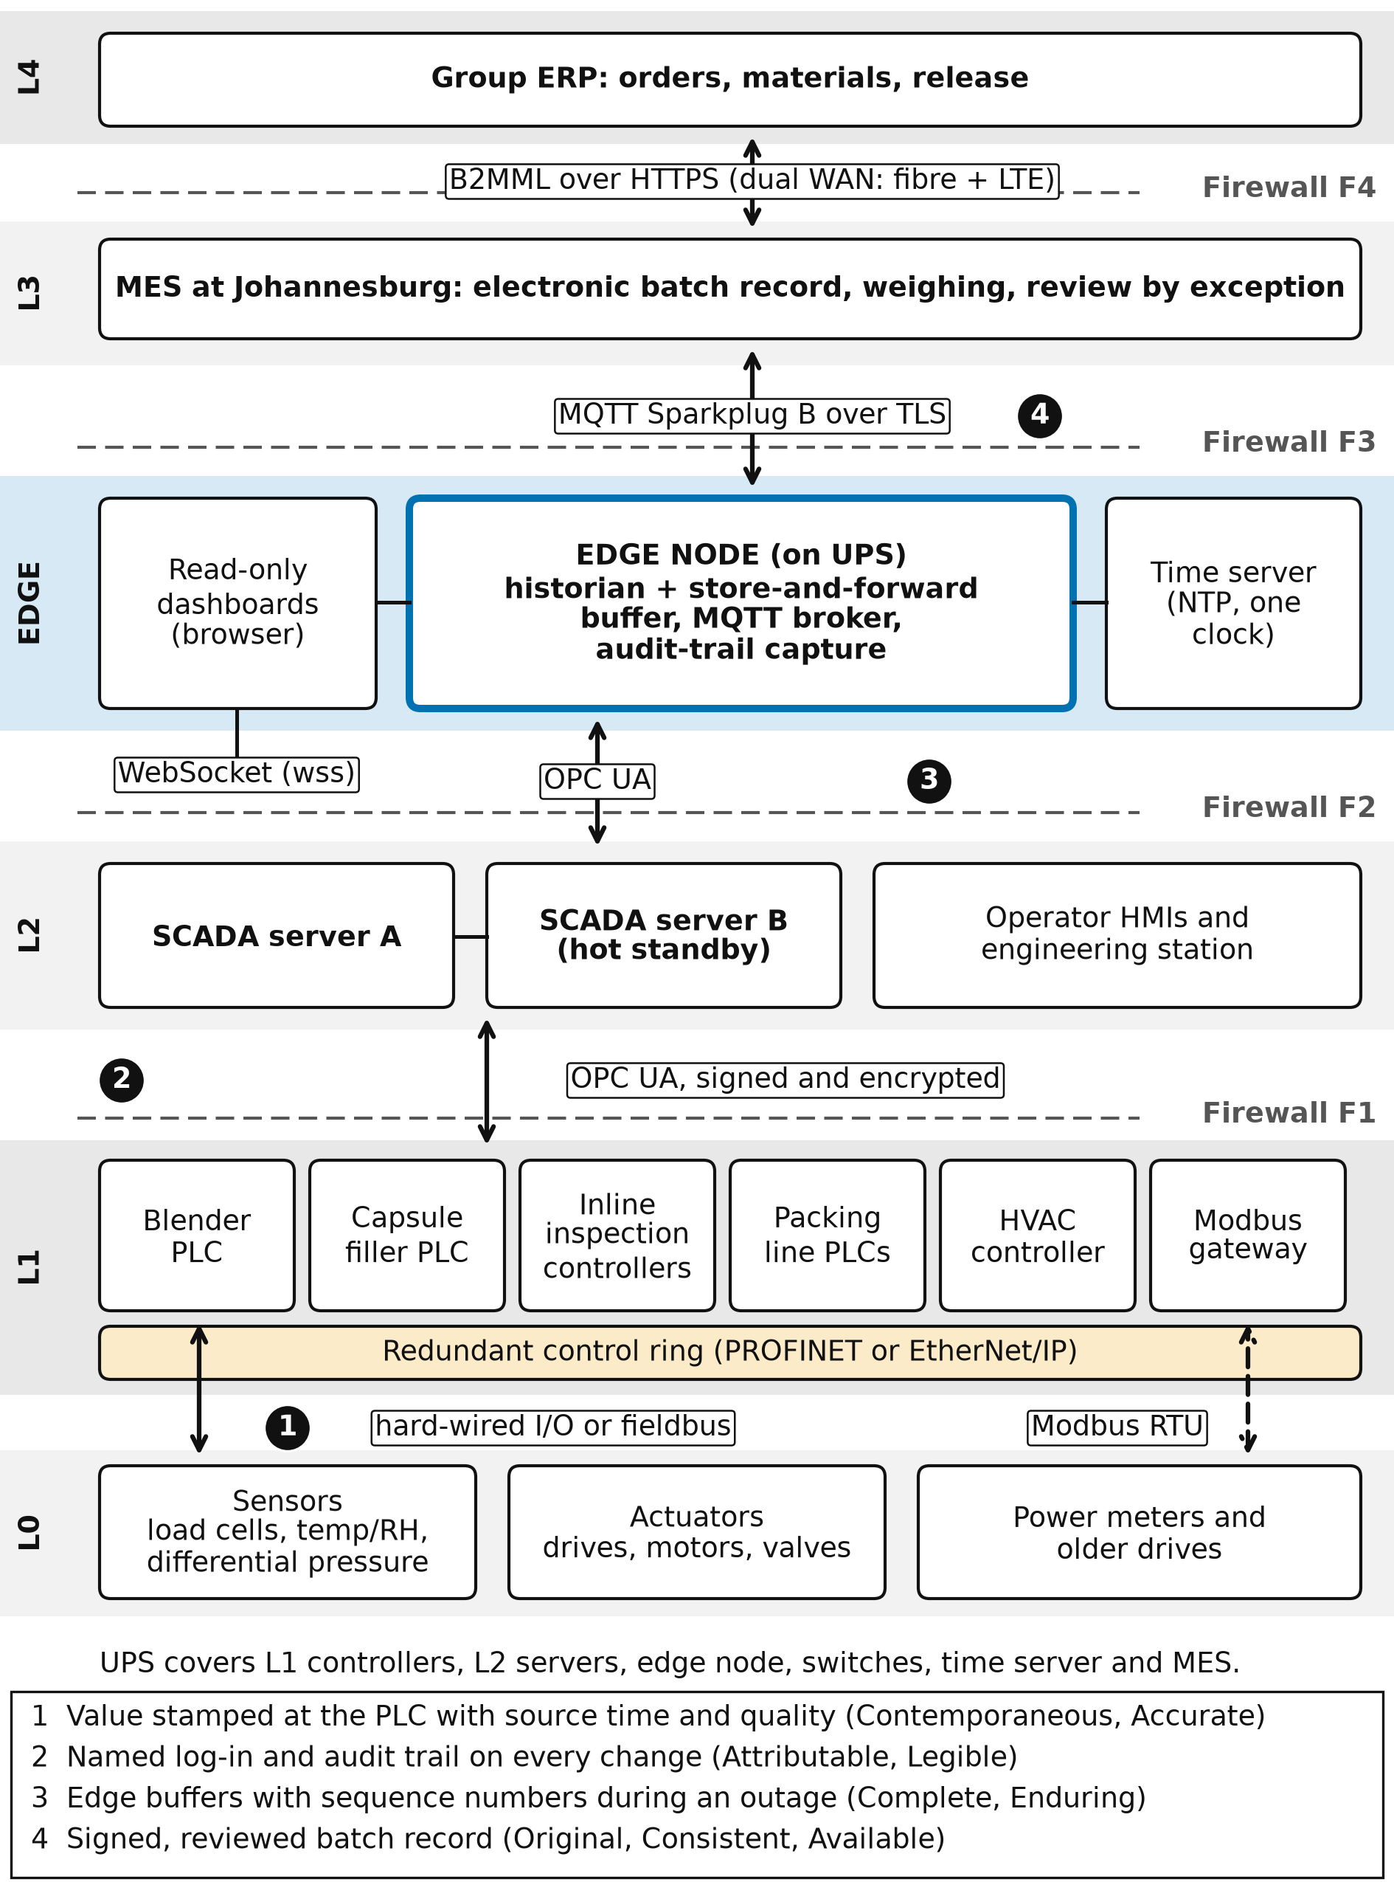
Figure 2. Network architecture from field devices to MES and ERP, with protocols, firewalls, the edge layer and data integrity markers.
Controllers sit on a redundant ring, so one cable fault does not stop the line. The SCADA servers run as a hot-standby pair. The edge node sits in a demilitarised zone between the SCADA and the MES, so no connection from above reaches the controllers directly.
During a load-shedding block the sequence is as follows. The grid fails and the UPS carries the controllers, servers, switches and edge node. The machines stop in a controlled way, and each PLC holds the state of the batch. The edge node keeps logging and alarms the stop. If the MES or the wide-area link is also lost, the edge node queues its messages. When power returns, the machines restart in sequence, not all at once, and the edge node sends its backlog with sequence numbers so that the MES can confirm the batch record has no gap. The operator sees one continuous record, with the outage marked in it.

5.2 Zones and conduits
Table 6 applies the Purdue model and IEC 62443 zones and conduits. Each conduit is a firewall rule set that allows only the named protocol.
Table 6. Security zones and conduits.
Zone | Contains | Conduit and rule
Zone 1: control (L0-L1) | PLCs, I/O, Modbus gateway | F1 to Zone 2: OPC UA only, certificate-based.
Zone 2: supervision (L2) | SCADA pair, operator HMIs, engineering station | F2 to edge: OPC UA from the SCADA only.
Zone 3: edge and DMZ | Edge node, time server, dashboards | F3 to MES: MQTT over TLS, outbound from the edge.
Zone 4: operations (L3) | MES and its database | F4 to ERP: HTTPS with B2MML messages.
Zone 5: enterprise (L4) | ERP, group services | No direct path to Zones 1 or 2.

5.3 Load-shedding resilience: three investment scenarios
How much power protection to buy is a cost question that the plant's own outage log should answer. Table 7 sets out three scenarios in qualitative terms, because no costs or outage data exist. The recommendation is to build scenario A now, log every outage for three months, and decide on scenario B from the log.
Table 7. Resilience investment scenarios. Costs are not quantified.
Scenario | What is protected | Residual risk | Sensitive to
A: UPS on controls and edge | Records, controller state, SCADA, MES, network | Machines and HVAC stop during an outage | Outage length and battery life
B: A plus a generator on a critical circuit | A, plus clean-room HVAC and the MES server room | Fuel supply and generator maintenance | Diesel price and outage frequency
C: B plus battery or solar for the line | The line itself keeps running | Highest capital and system complexity | Capital cost and the value of lost output

6 Regulation and data integrity

6.1 The regulatory frame
SAHPRA's GMP guideline is aligned with the PIC/S Guide to GMP. Its Annex 11 covers computerised systems, and its Annex 15 covers qualification and validation. SAHPRA has been working towards PIC/S accession, and the current edition should be confirmed on its website. The World Health Organization's data integrity guideline, in WHO Technical Report Series 1033, Annex 4, sits alongside it. The PIC/S document PI 041-1 on data management and integrity gives inspectors' detailed expectations. The African Medicines Regulatory Harmonisation (AMRH) programme and the African Medicines Agency are moving regional regulators towards shared expectations, so evidence built for SAHPRA is likely to serve export markets as well.
Annex 11 gives the inspector a short list to test against. It expects a risk-based approach to validation, controlled access, audit trails that record changes and deletions, regular backup with tested restore, electronic signatures that are linked to their records, and a business continuity plan for when the system is unavailable. The last point matters here. A site that loses its records in a power cut has not met it, and load-shedding makes an outage a planned event, not an accident.
21 CFR Part 11, from L11, is the United States rule on electronic records and signatures. It is not binding for South African sales, but it is a widely used yardstick and it asks for the same things: access limits, audit trails and signature binding. I also assume the full GMP guide applies. Quality should confirm the regulatory category of Moringa Daily, because that decides which guide an inspector applies.

6.2 ALCOA+ mapped to the architecture
ALCOA+ means data are Attributable, Legible, Contemporaneous, Original and Accurate, plus Complete, Consistent, Enduring and Available. Table 8 shows, for each attribute, the assumed gap today, the capability that closes it and an example. Risk is scored by the author as high, medium or low, before and after.
Table 8. ALCOA+ mapped to current gaps and to the proposed system. Risk is the author's judgement.
Attribute | Gap today (assumed) | Proposed capability | Example | Risk
Attributable | Initials on paper; shared panel log-ins | Named users, roles, electronic signatures | A recipe change shows user, time, old and new value | H to L
Legible | Handwriting and overwritten corrections | Typed entries, enforced units, no overwrite | A correction keeps the original value visible | M to L
Contemporaneous | Entries written up later | Source timestamps and one NTP clock | The MES refuses back-dated entries | H to L
Original | Paper, then re-keyed to a spreadsheet | First capture is electronic | A checkweigher result enters the record untouched | H to L
Accurate | Hand-copied weights; calibration not checked | Direct capture, range checks, quality codes | A weight from a lapsed-calibration scale is blocked | H to M
Complete | Missing pages; data lost in outages | Store-and-forward and sequence numbers | A gap in sequence raises an alarm | H to L
Consistent | Machine clocks disagree; formats vary | One time source, one batch ID | Filler and packing events sort correctly | M to L
Enduring | Paper in files; PLC memory overwritten | Historian and database with backup and retention | Restore tested every year | M to L
Available | Records found by hand | Searchable records and review by exception | An inspector pulls a batch in minutes | M to L

Three attributes carry most of the risk today. Contemporaneous and Original fail wherever a person writes a value later or re-keys it, and the electronic batch record removes both. Complete fails whenever an outage or a lost link drops data, and the edge buffer removes that. These three are the ones an inspector can test most easily, so they come first in the validation plan.

6.3 Cybersecurity as data integrity
L2 treats cybersecurity as part of data integrity, and the architecture follows that. Access controls come from named accounts, roles and a lock on the engineering station, so only authorised people can change a PLC program or a recipe. Audit trails sit in the SCADA, the edge node and the MES, are time-stamped from one clock and are protected from edit and deletion. Zones and certificates stop an attacker or a careless change from reaching the controllers. Backups are tested, because a record that cannot be restored is not enduring.

6.4 Validation lifecycle
The system should be validated under GAMP 5, which asks for a risk-based approach and a lifecycle of specification, qualification and review. A preliminary outline of the validation master plan follows.
1. Validation plan and risk assessment, with the supplier assessment of the SCADA and MES vendors.
2. User requirements specification, written from the ALCOA+ table, then functional and design specifications.
3. Design qualification: the design is reviewed against the requirements before anything is built.
4. Installation qualification: hardware, software versions, network and time source are checked against the design.
5. Operational qualification: user access, audit trail, signatures, alarms, and a deliberate power cut and network failure to prove store-and-forward.
6. Performance qualification: an agreed number of consecutive production batches run with the electronic record, compared with the paper record.
7. Summary report, change control and periodic review once in routine use.

7 Recommendations
Each recommendation has an engineering action and a quality action, so that neither team needs a translator.
Table 9. Recommendations, with engineering and quality actions.
No. | Engineering action | Quality action | Done when
R1 | Confirm the Table 2 asset list by walking the line. Record each controller type, firmware, clock source and interface. | Review the confirmed list and decide which systems are GMP-critical. | A signed asset register exists.
R2 | Assess every PLC for OPC UA, clock sync and password control. Plan replacement of those that fail. | Approve the risk ranking of the legacy controllers. | Every PLC has a pass or replace decision.
R3 | Install one NTP time source on UPS power and point every device at it. | Add the clock to the procedures and check drift at periodic review. | All timestamps agree within an agreed limit.
R4 | Build the edge node with historian and store-and-forward, on a UPS sized for four hours. | Witness an outage test and approve the loss-free result. | A test power cut loses no record.
R5 | Implement the SCADA with named log-ins, roles and audit trail. Segment the network into the Table 6 zones. | Write the access and review procedures and set the audit trail review frequency. | Operational qualification passed.
R6 | Deploy OPC UA to the SCADA and MQTT with Sparkplug B to the MES. Keep Modbus behind the gateway. | Confirm that transmitted data keep source time and identity. | Data match at source and in the MES.
R7 | Implement the electronic batch record in the MES, with weighing control and line clearance. | Approve the master batch record and the review-by-exception rules. | Performance qualification passed.
R8 | Log every outage for three months, then size scenario B or C from the log. | Record the outage impact on batches in the quality system. | A decision paper exists.

8 Phased commissioning
Moringa Daily must keep shipping, so the legacy PLCs keep running until each machine is proven on the new system. Paper stays the record of authority until performance qualification is passed.
1. Prepare (months 0 to 3): confirm the asset list, write the user requirements, carry out design qualification and survey the network.
2. Observe (months 3 to 6): install the network, time source and edge node. Read from the existing PLCs through gateways without changing control.
3. Supervise (months 6 to 9): commission the SCADA on one area during a planned stop, with a rollback to the old panel.
4. Record (months 9 to 15): extend the SCADA to all machines, introduce the MES and run parallel paper and electronic batches.
5. Retire (months 15 to 18): pass performance qualification, retire paper, and review the resilience decision from the outage log.
The timings are the author's estimate and depend on vendor lead times. At each stage the old control keeps running, so a failed cutover returns to the previous state within the planned stop.

9 Limitations and authorship
This report rests on assumptions, not a site survey. The asset list, the outage pattern, the staffing and the regulatory category of the product must be confirmed before purchase. The maturity scores, risk ratings, protocol weights, sizes and timings are judgements, not measurements, and no costs are quantified. The report does not benchmark Johannesburg against public inspection reports from comparable African facilities, which would strengthen it. The references should be checked against the original documents.
Claude, an AI assistant, helped draft the text and drew the figures. The author is responsible for every statement, and the assumptions, the choices and the recommendations are the author's to confirm or change.

10 Glossary
ALCOA+ | Attributable, Legible, Contemporaneous, Original, Accurate, plus Complete, Consistent, Enduring, Available: the data integrity attributes.
AMRH | African Medicines Regulatory Harmonisation, the programme aligning medicines regulation across Africa.
B2MML | Business To Manufacturing Markup Language, an XML format for ISA-95 messages.
DCS | Distributed control system.
DMZ | Demilitarised zone, a buffer network between two security zones.
ERP | Enterprise resource planning system.
GAMP 5 | Good Automated Manufacturing Practice guide for validating computerised systems (ISPE).
GMP / GxP | Good manufacturing practice, and the family of good practice rules (GxP) that includes it.
HMI | Human-machine interface, the operator screen.
HVAC | Heating, ventilation and air conditioning.
IEC | International Electrotechnical Commission.
ISA-95 | Standard (IEC 62264) for integrating enterprise and control systems.
ISA-88 | Standard for batch control.
MES | Manufacturing execution system.
MQTT | Message Queuing Telemetry Transport, a publish-subscribe protocol.
NTP | Network Time Protocol.
OPC UA | Open Platform Communications Unified Architecture (IEC 62541).
OSD | Oral solid dosage.
PIC/S | Pharmaceutical Inspection Co-operation Scheme.
PLC | Programmable logic controller.
SAHPRA | South African Health Products Regulatory Authority.
SCADA | Supervisory control and data acquisition.
TLS | Transport Layer Security, encryption for network links.
UPS | Uninterruptible power supply.
WAN | Wide-area network.
WHO TRS | World Health Organization Technical Report Series.

11 References
[1] IEC 62264 (ISA-95), Enterprise-control system integration, parts 1 to 5. International Electrotechnical Commission / ISA.
[2] IEC 62443, Industrial communication networks: network and system security. International Electrotechnical Commission.
[3] IEC 62541, OPC Unified Architecture, parts 1 to 14. OPC Foundation.
[4] OASIS, MQTT Version 5.0, OASIS Standard, 2019.
[5] Eclipse Foundation, Sparkplug Specification, version 3.0.
[6] Modbus Organization, Modbus Application Protocol Specification V1.1b3, and Modbus/TCP Security.
[7] Fette, I. and Melnikov, A., The WebSocket Protocol, RFC 6455, IETF, 2011.
[8] ISA-88 (IEC 61512), Batch control, parts 1 to 4.
[9] ISPE, GAMP 5: A Risk-Based Approach to Compliant GxP Computerized Systems, Second Edition, 2022.
[10] PIC/S, Guide to Good Manufacturing Practice for Medicinal Products, PE 009, Annex 11 (Computerised Systems) and Annex 15 (Qualification and Validation).
[11] PIC/S, Good Practices for Data Management and Integrity in Regulated GMP/GDP Environments, PI 041-1, 2021.
[12] World Health Organization, Guideline on data integrity, WHO Technical Report Series No. 1033, Annex 4, 2021.
[13] SAHPRA, Guideline for Good Manufacturing Practice for Medicines (current edition, South African Health Products Regulatory Authority).
[14] US Food and Drug Administration, 21 CFR Part 11, Electronic Records; Electronic Signatures.
[15] MHRA, GxP Data Integrity Guidance and Definitions, 2018.
[16] African Union / AUDA-NEPAD, African Medicines Regulatory Harmonisation initiative, and the African Medicines Agency treaty.
[17] Eskom, load-shedding stages and schedules (public information), for the typical block length.
[18] Siemens, SIMATIC S7-1500 OPC UA documentation; Rockwell Automation, PlantPAx system documentation; Emerson, DeltaV system documentation (vendor documentation consulted for the Table 4 comparison).
[19] Course material: lectures L1, L2 (Data Integrity and Cybersecurity), L6, L8 and L11 (QA / 21 CFR Part 11).

