Automation Landscape Report: Cape Town Rooibos Primary-Processing Line
  - Current state on the ISA-95 levels, control architecture, data transport through load-shedding, and data integrity
Worked example by the DigiSkills programme team, for the Cape Town engineering and quality management teams
2 October 2026
Table of Contents
Executive summary 2
1 Introduction and scope 2
2 What the site’s records show 3
3 The ISA-95 levels and where the line sits 4
4 PLC or DCS for the upgrade 7
5 Data transport protocols 8
6 Network architecture 10
7 Regulation and data integrity 12
8 Recommendations 14
9 Phased commissioning 14
10 Limitations 15
11 Glossary 15
12 References 15

This report is a worked example of an A01 submission. A learner would name the file A01_Automation_Landscape_Report_[YourSurname].pdf. Word count: 3,881 (body text, excluding the contents list, tables, figure captions, glossary and references).

Executive summary
Ubuntu Naturals’ Cape Town plant dries, mills and sieves rooibos for Rooibos Recovery, which is packed and released in Mombasa. The line is instrumented from the field up to batch records, but those records do not yet hold together as evidence a GMP inspector would accept. This report maps what is on the floor onto the ISA-95 levels, recommends what should replace it and how its data should travel through load-shedding, and sets out what SAHPRA will expect.
The evidence is the site’s own records: one week of one-minute meter readings (4 to 10 May 2026) and 30 days of pack-off batch records (April 2026). In that week the grid went down 4 times, for 600 minutes, 480 of them in shift hours; the longest outage lasted 240 minutes. The meter’s logger lost 360 minutes of readings in one overnight gap and wrote one minute twice. For 60 minutes it recorded values up to 1,099 kW, 3.6 times the running load, beside an unsigned note. The batch records name no operator, and their energy field cannot be reconciled with the meter.
None of this stops production. All of it would be found in a data integrity inspection, because each fault breaks an ALCOA+ principle that a validated system is expected to enforce.
The report recommends four decisions.
- Keep PLC control, one controller per process area under a single site SCADA, rather than buying a DCS. The line is small and largely sequential, and the site’s technicians already maintain PLCs.
- Install an edge historian with store-and-forward on the UPS and the genset’s critical circuit, so that neither a grid nor a WAN outage can lose a record.
- Use OPC UA inside the plant and MQTT with Sparkplug B over TLS to the group MES in Johannesburg, keeping Modbus only behind a gateway for the power meters.
- Validate the system under GAMP 5, with audit trails, named user log-ins and one synchronised clock in place before the first record that counts as GMP evidence.
Section 8 turns these into actions for engineering and for quality, and Section 9 phases the work so that the line keeps producing.

1 Introduction and scope

1.1 The line
Cape Town is Ubuntu Naturals’ Tier 1 primary-processing plant in South Africa, at Stage 2 of the group’s value chain. Rooibos arrives from Western Cape smallholder farmer-members. It is dried in a gas-assisted electric drying tunnel, hammer-milled, sieved, and conveyed pneumatically to a pack-off filler that doses the milled material by volume into packs for Mombasa. Dust extraction, compressed air, HVAC and lighting make up the rest of the electrical load.
The drying tunnel matters most to this report. It is the line’s largest electrical load and the one process that cannot simply stop when the grid fails: a tunnel full of part-dried leaf has to be held in a safe state, so the diesel genset carries the tunnel hold and the dust extraction during an outage.

1.2 Why this matters to quality
The milled rooibos is the herbal starting material for Rooibos Recovery. Its drying and milling records become part of the batch history that the quality unit in Mombasa reviews before release, so a gap in Cape Town’s records is a gap in the finished product’s record. As a South African manufacturing site, Cape Town falls under SAHPRA’s GMP inspections, and the product’s African export markets may expect the same evidence as the AMRH harmonisation work progresses. Section 7 sets out what those expectations mean for the automation.

1.3 Scope
The report covers the line from raw-material intake to pack-off, with the utilities that serve it. It does not cover the group ERP or MES themselves, which are owned centrally, or the release decision in Mombasa, but it does cover Cape Town’s interfaces to all three.

1.4 Evidence and method
Two sets of records were analysed. The whole-site meter export gives the load, the ambient temperature and a status label for every minute of one week. The pack-off batch export gives one row per batch with a fill volume, a temperature, an energy reading and the shift. Every figure in this report was computed from those files by a script, so any reader can check it. Descriptions of controllers, panels and networks come from the site survey, which the records cannot confirm. Scores, weights, sizing estimates and the architecture are the author’s design choices. The programme lectures L1, L2, L6, L8 and L11 are the reference frame: L2 for ALCOA+ and data integrity in computerised systems, and L11 for the regulatory framework and 21 CFR Part 11.

2 What the site’s records show
Table 1. Findings from the site’s own records, and what each says about the systems that wrote them.
Finding | Evidence from the records | What it says about the systems
Grid outages | 4 load-shed blocks, 600 minutes in total, 480 of them in shift hours; longest block 240 minutes | Control, records and network must ride through a four-hour outage as a routine event, not an emergency.
Genset load | Mean 48.1 kW during outages, against 49.4 kW at overnight idle; 481 kWh from diesel in the week | The critical circuit carries about the overnight base load. The control system’s own supply must be on it.
Restart | 4 restarts, peaking at 518 kW in one minute against a running mean of 302.8 kW | Every machine restarts at once. Nothing on the line sequences the restart.
Logger gap | 9,720 distinct minutes logged out of 10,080, a coverage of 96.4%; one overnight gap of 360 minutes | The logger writes to a local SD card with no buffer and no alarm. The loss shows only when the rows are counted.
Duplicate | 1 minute written twice: 9,721 rows for 9,720 minutes | The record has no unique key, so a re-write cannot be told apart from a second reading.
Metering fault | 60 minutes questioned in a free-text note, peaking at 1,099 kW | Doubtful values stay in the record with no reason code, no author and no review.
Batch records | 5,400 records over 30 days, one every 8 minutes, 7 fields | No operator, no reviewer, and no unit or location for the temperature field.
Shift pattern | 1,800 Night-shift batch records in April; 0 running minutes before 05:00 in the May week | The two systems disagree about when the line runs.
Energy | Batch energy averages 307.6 kWh a day; the meter logged 5,901 kWh on Monday 4 May | Neither record defines what its meter covers.
Fill volume | 7 of 5,400 doses outside the 490 to 510 ml limits | The measurement is captured; its disposition is not.
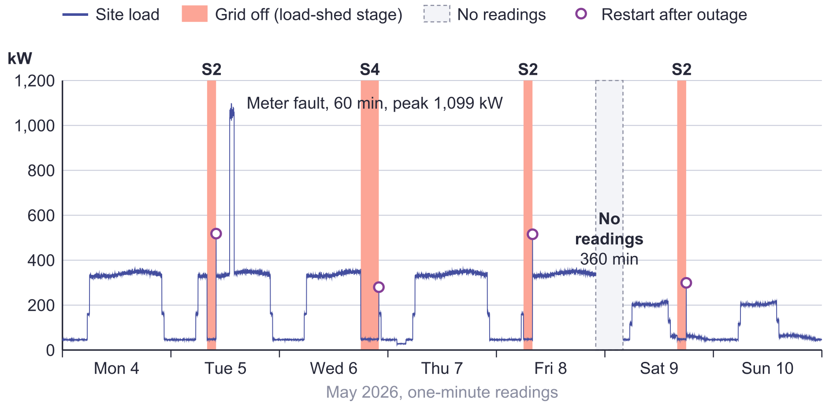
Figure 1. The site meter over the week of 4 May 2026. Shaded bands are load-shedding blocks (S2 and S4 are the Eskom stages the status notes record). The grey band is the logger gap. Circles mark the restart minute after each block.
Figure 1 shows the expected pattern: two weekday shifts from 06:00 to 22:00, a short weekend shift, a base load of about 49.4 kW overnight, and four load-shedding blocks, each ending in a restart spike.
Three features are faults in the record rather than in the process. The six-hour hole on Friday night is the logger, not the plant, and the file gives no sign of it beyond the missing timestamps. It is 1.5 times as long as the longest outage, so the logger loses more data on its own than load-shedding takes from it. The Tuesday spike is a metering fault that someone noticed, but the readings were left in place behind an unsigned note, so a daily total includes them unless the analyst knows to look. The duplicate minute on Wednesday is invisible on the chart and is counted twice by anyone who sums the column.
The outages also say something about control. The genset’s mean load during an outage (48.1 kW) is close to the overnight base load (49.4 kW), so the critical circuit carries the tunnel hold and dust extraction and little else. When the grid returned, the plant drew up to 518 kW in one minute, 1.7 times the running mean of 302.8 kW: every machine restarting at once. A sequenced restart is a control function, and no system on the line owns it today.
The batch records are clean in the sense that matters to a spreadsheet: 5,400 rows, one every 8 minutes for 30 days, with no gaps. But none of their 7 fields says who made the batch, who reviewed it, or what the temperature column measures. They place 1,800 batches on a Night shift in April, while the meter shows the line idle before 05:00 throughout the May week. Either the shift pattern changed, or one system is not timestamping production events. The batch energy field adds up to 307.6 kWh a day, while the meter logged 5,901 kWh on a normal Monday, about 19 times as much, and neither file says what its meter covers. Two systems on one line share no definitions.

3 The ISA-95 levels and where the line sits

3.1 The five levels
ISA-95, published internationally as IEC 62264, defines levels by the decisions each one makes and the time scale it works in, not by the box that does the work. A single panel can hold Level 1 control and a Level 2 display. The value of the model here is that it shows where information has to cross a boundary, because that is where records are lost, altered or never made.
Table 2. The ISA-95 levels, defined with examples from this line.
Level | What it does | On the Cape Town line
0 Physical process | The material and the equipment that transforms it | Leaf moving through the drying tunnel, the mill and the sieves; the burner, motors and fans
1 Sensing and manipulation | Instruments and the controllers that act on them, in milliseconds to seconds | The tunnel air-temperature probe and the controller that trims the burner; the filler’s dose control
2 Monitoring and supervisory control | Displays, alarms, trends and set points across a process area, in seconds to minutes | An operator raising the tunnel set point for a wetter intake lot and reviewing the alarm history
3 Manufacturing operations management | Batch execution, records, quality, maintenance and performance, in minutes to days | The batch record for a lot of milled rooibos: drying profile, yield, deviations and review
4 Business planning and logistics | Orders, inventory and costing, in days to months | The ERP order that sends a lot to Mombasa and books its cost

3.2 Current state and gaps
The group describes Cape Town as instrumented from Level 0 to Level 3, and it is. There are sensors, controllers, a site meter and batch records. What the records in Section 2 show is that these do not yet work as one system. Table 3 places each system on its level, names what is missing, and says why the gap matters at a SAHPRA inspection. Figure 2 shows the same picture as a pyramid, with a maturity score per level.
Table 3. Current state and gaps by ISA-95 level. Maturity runs from 1 (absent or manual) to 5 (integrated, validated and used for improvement) and is the author’s assessment.
Level | On the floor today | What is missing | Why an inspector would care | Maturity
4 | Group ERP at the Nairobi hub; site yields keyed in by hand | No automatic order or yield exchange | A hand-keyed copy between the batch record and the ERP is an unverified transcription. | 2
3 | Batch records exported as flat files | No user identity, audit trail or link to the group MES | The batch record is the GMP record. Without identity and an audit trail it is neither attributable nor reviewable. | 2
2 | A panel HMI per machine; meter logs to an SD card | No site SCADA, historian or common clock | Process data that supports a batch decision must be complete and consistent in time. Section 2 shows it is neither. | 1
1 | One standalone controller per machine | No controller network; restart not sequenced | An unrecorded change to controller logic changes a validated process without a trace. | 3
0 | Process instruments; one whole-site meter | No submetering of the drying tunnel | Tunnel air temperature is likely to be a critical process parameter, so its instrument must be calibrated and traceable. | 3
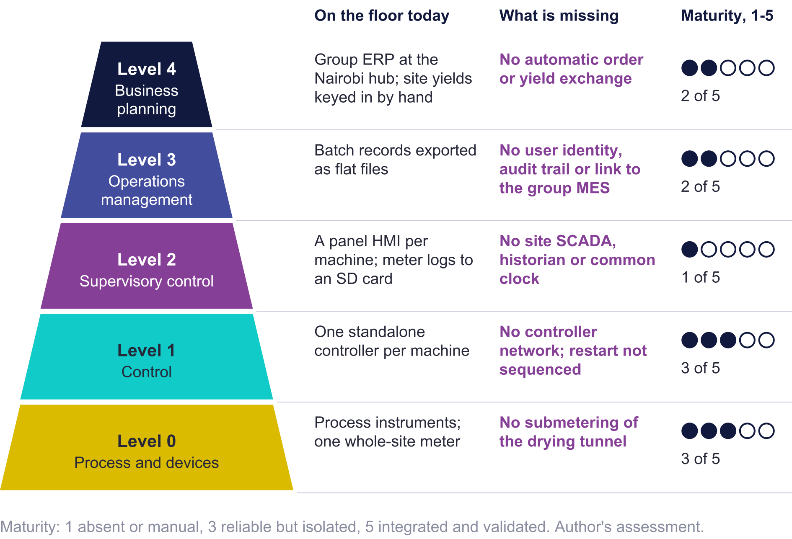
Figure 2. The ISA-95 levels at Cape Town: what is on the floor, what is missing, and the author’s maturity score for each level.
The most serious gaps are at Levels 2 and 3, and they are linked. Level 2 has no site SCADA, historian or common clock, so process data lives on machine panels and an SD card. Level 3 has batch records but no user identity, no audit trail and no link to the group MES in Johannesburg. An inspector who asks for the drying profile behind a released lot will be shown a file that cannot prove who made it, when, or whether it has changed. Level 1 runs the process reliably; its weakness is isolation, with no shared network or clock and no record of logic changes. Level 0 lacks submetering, so the tunnel’s share of the load can only be inferred.

3.3 Closing the gaps in order
The gaps cannot be closed in any order, because some capabilities depend on others.
- One clock and named users (Levels 2 and 3), because every audit trail installed later depends on them.
- An edge historian with store-and-forward (Level 2). It stops records being lost now, before any controller is touched.
- A site SCADA over a controller network (Levels 1 and 2), which needs the clock and named users and feeds the historian.
- Controller upgrades (Level 1), one area at a time, with the sequenced restart and requalification of each area.
- The interface to the group MES and electronic batch records (Level 3), worth validating only once Level 2 data can be trusted.
- Automatic exchange with the ERP (Level 4), last because it adds least to GMP compliance.

4 PLC or DCS for the upgrade

4.1 The comparison
A programmable logic controller (PLC) is a rugged computer that runs control logic for a machine or process area, normally supervised by a separate SCADA package. A distributed control system (DCS) is a single-vendor platform in which controllers, operator stations, historian and engineering tools share one database. Table 4 compares the two against the criteria that decide the choice here.
Table 4. PLC with SCADA compared with a DCS for the Cape Town line.
Criterion | PLC with site SCADA | DCS | What it means at Cape Town
Scalability | Add a controller per area; SCADA licensing grows with signal count | Thousands of loops under one database and one engineering tool | Four process areas and a few hundred signals are well inside PLC scale.
Capital cost | Lower hardware and licence cost per input or output; integration engineering on top | Higher entry cost, with engineering tools built in | DCS entry cost would be spread over very few loops.
GxP suitability | Audit trail, electronic signatures and batch functions are available, but the integrator must configure and validate them | Audit trail, signatures and ISA-88 batch functions are native and consistent | Both can be validated. A DCS is easier to validate; PLC and SCADA are easier to staff.
Vendor lock-in | Moderate: OPC UA lets controllers and SCADA come from different vendors | High: controllers, I/O, software and spares come from one vendor for the plant’s life | A single-vendor DCS ties a Tier 1 site to one service channel in the Western Cape.
Maintenance complexity | Familiar to electricians and technicians; logic in IEC 61131-3 languages | Needs DCS-trained engineers; changes through the vendor’s engineering station | The site’s skills favour PLCs.
Connectivity | OPC UA, MQTT and Modbus are common on current PLCs and SCADA | OPC UA standard; other links through gateways or vendor modules | Either can reach the group MES.
Process fit | Strong for sequences and discrete control; adequate for a handful of PID loops | Strong for many interacting continuous loops | The tunnel has a few loops; most of the line is sequence logic.
Power-loss behaviour | Restart behaviour is set per program and must be designed deliberately | Redundant controllers and supplies are standard; restart is managed system-wide | Load-shedding makes restart design central either way.

4.2 Recommendation
The recommendation is PLC control under a single site SCADA: one modern PLC per process area (drying tunnel, milling and sieving, conveying and pack-off, utilities), networked on a controller ring, supervised by a redundant pair of SCADA servers, with an edge historian beside them.
Four constraints decide it. First, the standalone controllers can be replaced one area at a time in idle windows, whereas a DCS gives most of its value only when the whole plant is on it. Second, the site’s technicians maintain PLCs today, and PLC skills and spares are available locally in the Western Cape. Third, GxP compliance does not require a DCS: a validated, configured SCADA and historian provide audit trails, electronic signatures and access control. Fourth, load-shedding puts the same demands on either architecture. What protects the record is the UPS, the restart logic and the edge buffer, and none of those comes from choosing a DCS.

4.3 The hybrid option
PLC-based process control systems, such as Rockwell’s PlantPAx or Siemens’ PCS 7, put PLC-class controllers under a DCS-style engineering environment with a shared database, an ISA-88 batch engine and a built-in audit trail. They are the realistic alternative and the one to price if the site grows. Cape Town is multi-botanical; if drying lines are added for other botanicals, a shared database and batch engine begin to pay for themselves, so the PLC and SCADA platforms should be chosen now to grow into one without replacing the controllers.

4.4 Total cost of ownership
Without vendor quotations the comparison can only be made by cost element, and Table 5 does that. The DCS saves engineering and validation effort. The PLC option saves on hardware, spares and people. For a line of this size the people and spares costs recur every year, while the engineering savings occur once, so over a ten-year life the comparison favours PLC and SCADA. This is the author’s reasoning, not a costed estimate, and the site should obtain quotations for both before capital is approved.
Table 5. Total cost of ownership by cost element (author’s qualitative assessment).
Cost element | PLC with site SCADA | DCS
Hardware and licences | Lower | Higher
Engineering and integration | Higher: the integrator configures audit trail, batch and alarm handling | Lower for the same functions; each change goes through the vendor’s tools
Validation | Higher: more interfaces to test | Lower: native functions come with vendor documentation
Spares and support | Lower: several local sources | Higher: one vendor, often imported spares
Staff and training | Lower: existing skills | Higher: new skills or a service contract
Cost of a load-shedding block | Set by UPS, genset and restart design, not by architecture | The same

4.5 Migration path
The controllers move one area at a time. Utilities go first, because PLC 4 carries the transfer-switch and genset signals that the restart sequence on every other area needs. The drying tunnel follows, then milling and sieving, then conveying and pack-off. Each cut-over fits an idle window; Section 9 shows that the line is idle for 3,329 minutes in a week. The old controller’s logic is documented before it is removed, so that the new program can be tested against the behaviour it replaces.

5 Data transport protocols

5.1 What the plant needs from a protocol
Five criteria follow from Section 2. Outages are the most frequent threat to the record, so surviving one carries the most weight. The audit trail is what an inspector will test, so it comes next. Security matters because the same links will reach Johannesburg. Bandwidth matters most on the WAN, which is the narrowest link. Edge processing and the size of the supplier ecosystem matter least. The weights in Table 6 are the author’s.

5.2 The four protocols
Modbus, as RTU on serial lines or TCP on Ethernet, is a simple register protocol that nearly every power meter and drive supports. It carries no timestamps, quality codes or data types beyond registers, and its common forms have no authentication or encryption. The poller stamps each reading on arrival, which breaks the Contemporaneous principle whenever there is a delay, and there is no store-and-forward. For GxP use, the first system that reads a Modbus value must timestamp and store it.
OPC UA (IEC 62541) carries every value with source and server timestamps and a quality code, inside a typed information model that can describe the equipment hierarchy. It authenticates applications with X.509 certificates and users with accounts, and can sign and encrypt every message. Subscriptions survive short interruptions but not a four-hour outage, so history across a long gap needs a historian. For GxP it is the strongest of the four, because the timestamp and quality travel with the value.
MQTT (an OASIS standard, now version 5.0) is a publish-subscribe protocol in which clients send messages to a broker. It is light on bandwidth and reports by exception. Persistent sessions and QoS 1 let a client hold unacknowledged messages and resend them when the link returns, which is the basis of store-and-forward. Sparkplug B adds a defined payload with timestamps, sequence numbers, and birth and death certificates that tell the host when an edge node has gone offline. Security comes from TLS and broker access control lists. For GxP, the sequence numbers make a gap detectable.
WebSockets (RFC 6455) give a browser a two-way channel over HTTP, which suits live dashboards. They define no data model, no timestamps and no delivery guarantee across a reconnection. They belong at the top of the stack, for viewing data, not for moving GMP records.
Table 6. Protocol decision matrix. Weights and scores (1 poor to 5 strong) are the author’s; the weighted score is computed from them.
Criterion (weight) | Modbus TCP | OPC UA | MQTT with Sparkplug B | WebSockets
Survives an outage (store-and-forward, session recovery) (30) | 1 | 3 | 5 | 2
Supports the GxP audit trail (timestamp, quality, identity) (25) | 1 | 5 | 3 | 1
Security (authentication, encryption) (20) | 1 | 5 | 4 | 3
Bandwidth on the WAN to Johannesburg (15) | 3 | 2 | 5 | 3
Edge processing and ecosystem (10) | 3 | 4 | 5 | 2
Weighted score out of 100 | 30 | 77 | 86 | 42
MQTT with Sparkplug B scores highest on the plant’s priorities, and OPC UA second. They do not compete here. Inside the plant the network is local, short and on UPS, bandwidth is not a constraint, and OPC UA’s timestamps, quality codes and certificates do most for the record. Across the WAN to Johannesburg the link is narrow and an outage is likely, and MQTT’s report-by-exception and resend on reconnection do most. Modbus stays only where a device offers nothing else, behind a gateway that timestamps and stores each reading as it takes it. WebSockets serve dashboards only.

5.3 Store-and-forward and the edge buffer
The design is sized from the week’s records. The longest grid outage was 240 minutes and the longest loss of readings 360 minutes. The edge historian keeps 7 days locally, a design choice, so the longest outage would use 2.4% of its capacity. At an estimated 400 signals sampled once a second and about 16 bytes per stored value before compression, 7 days of history is about 3.9 GB, which one industrial edge server holds comfortably. These sizing figures are the author’s estimates, to be replaced from the site’s I/O list.
The mechanism has five rules.
- Every value is timestamped by the controller or edge node that reads it, from the site time server, never by the system that receives it later.
- The edge node writes each value to local storage, with a sequence number, before it publishes it.
- A value is deleted locally only after the group broker acknowledges it (MQTT QoS 1 over a persistent session).
- On reconnection the edge sends alarms and events first, then batch records, then process history, oldest first within each class, at a throttled rate so that the backlog does not crowd out live data.
- The group MES checks the sequence numbers. A batch with a gap is marked incomplete and cannot be released until the gap is explained.
The edge node, the controller network switches, the time server and the SCADA servers sit on a UPS with 30 minutes of autonomy, which bridges the transfer to the genset, and on the genset’s critical circuit. The one-minute records cannot show how long the transfer takes, so the UPS must be sized from the genset’s own transfer specification, not from this data.

5.4 Protocol security and staged migration
Each protocol brings its own security risk. Modbus accepts a write from anything that can reach it, so it is confined to one gateway segment with no route upward. OPC UA runs in Sign and Encrypt mode with site-issued certificates, and the edge historian connects as a read-only client. MQTT runs over TLS on one outbound port, with a broker account per site that can publish only under Cape Town’s own namespace.
The migration follows the phases in Section 9. First, the edge node and time server read the existing controllers and meter, read-only. Second, each area moves to OPC UA as its controller is replaced, and its Modbus mapping is retired. Third, the edge connects to the group broker and the interface is validated. Last, every remaining Modbus path is removed except the power meters’ serial links behind the gateway.

6 Network architecture

6.1 Reading the diagram
Figure 3 runs from the field devices at the bottom to the group ERP at the top. The four PLCs share a controller ring, so one cable or switch failure cuts none of them off, and the SCADA servers run as a hot-standby pair. The edge historian reads the controllers through OPC UA and is the only site system that exchanges data with the group, through the DMZ, as MQTT over TLS. The WAN has an LTE backup because a local exchange can lose power during load-shedding even when the plant does not. Elements with a dashed amber outline are on the UPS and the genset’s critical circuit.

6.2 What happens in a load-shedding block
At the start of a block the automatic transfer switch moves the critical circuit to the genset, and the UPS carries the control network, the tunnel and utilities controllers, the servers, the time server and the edge node through the transfer. PLC 4 signals the outage. PLC 1 moves the drying tunnel to its hold state, and PLCs 2 and 3 stop their areas in sequence and record the stop as an event. If the WAN fails too, the edge node keeps writing locally, and SCADA keeps working because nothing in it depends on the WAN.
When the grid returns, PLC 4 waits for a stable supply before it permits a restart, and the areas restart in sequence (utilities, the tunnel, milling, then pack-off) rather than together. That should remove most of the 518 kW one-minute spike seen in the records. The edge node then empties its buffer in the order set in Section 5.3.
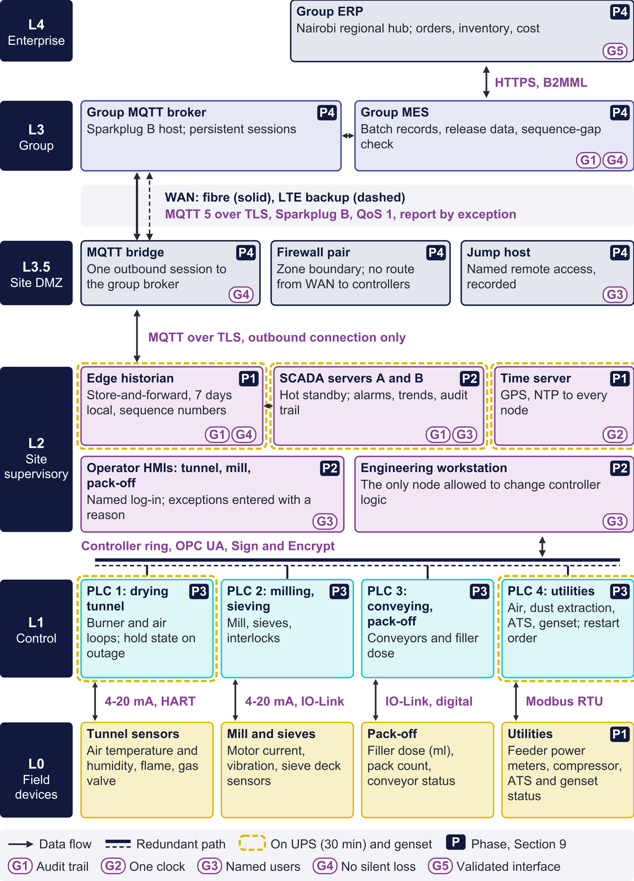
Figure 3. Network architecture for the Cape Town line, from field devices to the group ERP. Protocols are labelled in purple at each boundary. G tags mark data integrity controls; P tags mark the commissioning phase in which each element is installed.

6.3 Zones and conduits
The architecture follows the Purdue model’s segmentation, with security zones and conduits in the sense of IEC 62443. Table 7 lists them. The principle is that nothing outside the site can open a connection to a controller.
Table 7. Security zones and conduits (IEC 62443).
Zone | Contents | Conduit | Controls
Enterprise | Group ERP | To group operations | HTTPS with mutual TLS; group IT controls
Group operations | Group MES, MQTT broker, platform | To the site DMZ over the WAN | MQTT over TLS on one port; broker access lists per site
Site DMZ | Firewall pair, MQTT bridge, jump host | Outbound to the group; inbound to site supervisory | No route from the WAN to controllers; remote access only through the jump host, with named accounts and recorded sessions
Site supervisory | SCADA, historian, HMIs, time server, engineering workstation | To the control zone | OPC UA Sign and Encrypt; only the engineering workstation may change controller logic
Control | PLCs and field devices | To site supervisory only | No route beyond Level 2; Modbus confined to the gateway segment

7 Regulation and data integrity

7.1 The framework
SAHPRA inspects South African manufacturers against its Guide to Good Manufacturing Practice, which follows the PIC/S GMP Guide. Two of its annexes bear on this line: Annex 7, on herbal medicinal products, and Annex 11, on computerised systems. Annex 11 expects a computerised system to be validated for its intended use, to keep an audit trail of GMP-relevant changes and deletions, to control access, and to keep data secure and retrievable for its retention period. The WHO guideline on data integrity (Technical Report Series 1033, Annex 4) and PIC/S PI 041 set out ALCOA+ and how inspectors test it. 21 CFR Part 11, the United States rule on electronic records and signatures, does not govern Cape Town directly, but lecture L11 uses it as the reference for electronic signatures.
The African Medicines Regulatory Harmonisation programme and the African Medicines Agency aim to harmonise GMP expectations and to support regulators relying on one another’s inspections, so evidence that satisfies SAHPRA is evidence other African regulators may also ask to see. Mombasa, where Rooibos Recovery is packed and released, answers to Kenya’s Pharmacy and Poisons Board, which can be expected to ask for the Cape Town records that come with each lot.

7.2 ALCOA+ against the line
Table 8 takes each ALCOA+ principle in turn: the gap the records show today, the capability in the proposed system that closes it, an implementation example, and the compliance risk before and after. The risk ratings are the author’s.
Table 8. ALCOA+ principles: current gaps, proposed capabilities and compliance risk.
Principle | Gap today (evidence) | Proposed capability | Implementation example | Risk now / after
Attributable | Batch records name no operator; the metering-fault note has no author | Named log-in on every HMI; every entry and change recorded against a user | Badge and PIN at the pack-off HMI; no shared operator account | High / low
Legible | A temperature field with no unit or location; status codes undefined | Tag names, units and descriptions from one equipment model | Tunnel air temperature held as a named tag with its unit and instrument number | Medium / low
Contemporaneous | Batch timestamps disagree with the meter about when the line runs | Every value stamped at source from one GPS-disciplined clock | NTP to every controller and the edge node; an alarm if any clock drifts by more than a second | High / low
Original | 1 minute written twice, indistinguishable from a second reading | The historian keeps the first value; re-writes are rejected and logged | A unique key on tag and timestamp; duplicate attempts written to the audit trail | Medium / low
Accurate | 60 minutes of implausible readings left in place | Range and rate checks at the edge; exclusion only through a reviewed workflow | A reading above the feeder’s rating gets a bad-quality code; a person excludes it with a reason and the original is kept | High / low
Complete | A 360-minute gap, found only by counting rows | Store-and-forward with sequence numbers; any gap raises an alarm | A Sparkplug sequence gap marks the batch incomplete in the MES | High / low
Consistent | Batch energy and site energy cannot be reconciled | One equipment and meter model shared by SCADA, historian and MES | Each meter declares the loads it covers; a daily reconciliation report | Medium / low
Enduring | Readings held on an SD card in the logger | Records on redundant servers, backed up and retained for the product’s retention period | Daily backup to the group platform with a tested restore | High / low
Available | Records exported to files by hand | Records retrievable on request for review and inspection | An inspector’s query answered from the historian and MES during the inspection | Medium / low

7.3 Cybersecurity as part of data integrity
Lecture L2 treats cybersecurity and data integrity as one subject, and so does the design. Access is role-based: operators cannot change set points outside validated ranges, supervisors cannot edit logic, and only administrators outside production manage accounts. No production role can switch off or edit an audit trail, and audit-trail review is part of batch review. Backups are tested by restoring them. Patches arrive through the DMZ and are tested before they reach the supervisory zone, and every remote session through the jump host is recorded. A cyber incident that changes a record is a data integrity event and goes through the same deviation process.

7.4 Validation outline
The new system is validated under GAMP 5 (Second Edition). The SCADA, historian and MES interface are configured products (Category 4). The controller programs are written for this line and are treated as custom applications (Category 5). The network and servers are infrastructure (Category 1). The outline of the validation master plan follows.
- User requirements, including the data integrity controls marked G1 to G5 in Figure 3.
- A risk assessment that ranks each function by its impact on product quality and on the record.
- Functional and design specifications, with design qualification against the requirements.
- Factory and site acceptance tests with the suppliers.
- Installation qualification of hardware, software versions and network configuration.
- Operational qualification, including a planned outage test: the grid supply is cut in an idle window, and the test proves that no record is lost, the sequence numbers are continuous, and the restart runs in order.
- Performance qualification over normal production, with batches reviewed from the electronic record.
- Periodic review, with change control for every later modification.

8 Recommendations
Each recommendation has an engineering action and a quality action, so that each team can act on it without the other translating. The phases are those of Section 9.
Table 9. Recommendations with engineering and quality actions.
No. | Recommendation | Engineering action | Quality action | Phase
R1 | One site clock | Install a GPS time server; synchronise every controller, HMI, server and the edge node; alarm on drift | Add clock synchronisation to the user requirements and test it in OQ | P1
R2 | Named users | Create named accounts on every HMI and SCADA client; remove shared log-ins | Approve the role matrix; review access quarterly | P1
R3 | Edge historian with store-and-forward | Install it on the UPS and the critical circuit; connect read-only to the existing controllers and meter | Make the historian the GMP record for process data; write the procedure for reviewing gap alarms | P1
R4 | Submeter the tunnel and the other feeders | Fit feeder meters on Modbus RTU behind the gateway | Record in the equipment model which loads each meter covers | P1
R5 | Redundant site SCADA | Install the server pair and the controller ring | Validate the audit trail, alarm and electronic-signature configuration | P2
R6 | Exception workflow for doubtful data | Add range and rate checks with quality codes at the edge | Write the procedure for reviewed exclusion with a reason, keeping the original | P2
R7 | Replace controllers area by area, with a sequenced restart | Utilities, then the tunnel, milling and pack-off, each in an idle window | Change control and requalification for each area | P3
R8 | Interface to the group MES | Connect the edge to the group broker over MQTT with TLS through the DMZ | Validate the interface; adopt the incomplete-batch rule | P4

9 Phased commissioning
The line must keep producing while the work is done, and the meter records show when it can be touched. In the May week the line was idle for 3,329 minutes, mostly on weekday nights after 22:00 and on weekend afternoons. The planned burner clean (120 minutes early on Thursday) shows that the site already schedules work at night. Every phase uses those windows.
Table 10. Commissioning phases.
Phase | Scope | Effect on production | Exit criterion
P1 Records first | Time server, named users, edge historian, submeters; all connections read-only | None: connections made in idle windows | A full week of records with no unexplained gap
P2 Supervisory layer | SCADA pair, operator HMIs, controller ring, exception workflow | Old panels stay live while operators train on the new HMIs | Operational qualification passed, including the planned outage test
P3 Controllers, area by area | Four PLC replacements with the sequenced restart | One area per weekend window, requalified before Monday | Each area’s first batch reviewed and released
P4 Group integration | MQTT interface to the group MES, electronic batch records, ERP exchange | None at the line | Interface validated; first batch released on electronic records

10 Limitations
The records cover one week in May and one month in April, so seasonal effects, including winter load-shedding patterns and summer drying loads, are not represented. The controller inventory comes from the site survey, not from the records. Scores, weights, sizing and the cost comparison are the author’s judgement and should be replaced by vendor quotations and the site’s own I/O list. One-minute data cannot show events shorter than a minute, including the genset transfer itself. Finally, the report has not benchmarked the design against published inspection findings at comparable African facilities, which a full engagement would do.

11 Glossary
Term | Meaning
ALCOA+ | Attributable, Legible, Contemporaneous, Original, Accurate, plus Complete, Consistent, Enduring and Available: the qualities a GMP record must have
AMRH | African Medicines Regulatory Harmonisation, the programme aligning African medicines regulators
ATS | Automatic transfer switch, which moves loads between grid and genset
B2MML | Business To Manufacturing Markup Language, an XML form of the ISA-95 messages
DCS | Distributed control system
DMZ | Demilitarised zone: a network segment between the plant and outside networks
ERP | Enterprise resource planning (Level 4)
GAMP 5 | ISPE’s guide to a risk-based approach to computerised system validation
GMP, GxP | Good manufacturing practice; GxP covers all the regulated good practices
HMI | Human-machine interface: an operator’s screen
IQ, OQ, PQ | Installation, operational and performance qualification
MES | Manufacturing execution system (Level 3)
MQTT | A publish-subscribe messaging protocol; Sparkplug B defines its payload for industry
NTP | Network Time Protocol
OPC UA | OPC Unified Architecture, an industrial data exchange standard (IEC 62541)
PIC/S | Pharmaceutical Inspection Co-operation Scheme
PLC | Programmable logic controller
QoS | Quality of service: MQTT’s delivery guarantee level
SAHPRA | South African Health Products Regulatory Authority
SCADA | Supervisory control and data acquisition (Level 2)
TLS | Transport Layer Security
UPS | Uninterruptible power supply

12 References
- ISA, ANSI/ISA-95 Enterprise-Control System Integration; IEC 62264.
- IEC 62443, Security for industrial automation and control systems.
- IEC 62541, OPC Unified Architecture.
- OASIS, MQTT Version 5.0 (2019).
- Eclipse Foundation, Sparkplug Specification.
- Modbus Organization, Modbus Application Protocol Specification V1.1b3.
- IETF RFC 6455, The WebSocket Protocol (2011).
- PIC/S PE 009, Guide to Good Manufacturing Practice for Medicinal Products, Annexes 7 and 11.
- PIC/S PI 041-1, Good Practices for Data Management and Integrity in Regulated GMP/GDP Environments (2021).
- SAHPRA, SA Guide to Good Manufacturing Practice for Medicines (SAHPGL-INSP-02), current version.
- WHO Technical Report Series 1033 (2021), Annex 4, Guideline on data integrity.
- ISPE, GAMP 5: A Risk-Based Approach to Compliant GxP Computerized Systems, Second Edition (2022).
- US FDA, 21 CFR Part 11, Electronic Records; Electronic Signatures.
- DigiSkills programme lectures L1, L2 (Data Integrity and Cybersecurity), L6, L8 and L11 (QA and 21 CFR Part 11).
- Ubuntu Naturals Cape Town: whole-site meter export, 4 to 10 May 2026; pack-off batch export, April 2026.

