Custom 32Bit-OpenGL/D3DX9 Texture Render

**Head Down Display Module (HDD).**

Valery Burkin. Flight Labs GmbH. 2011.

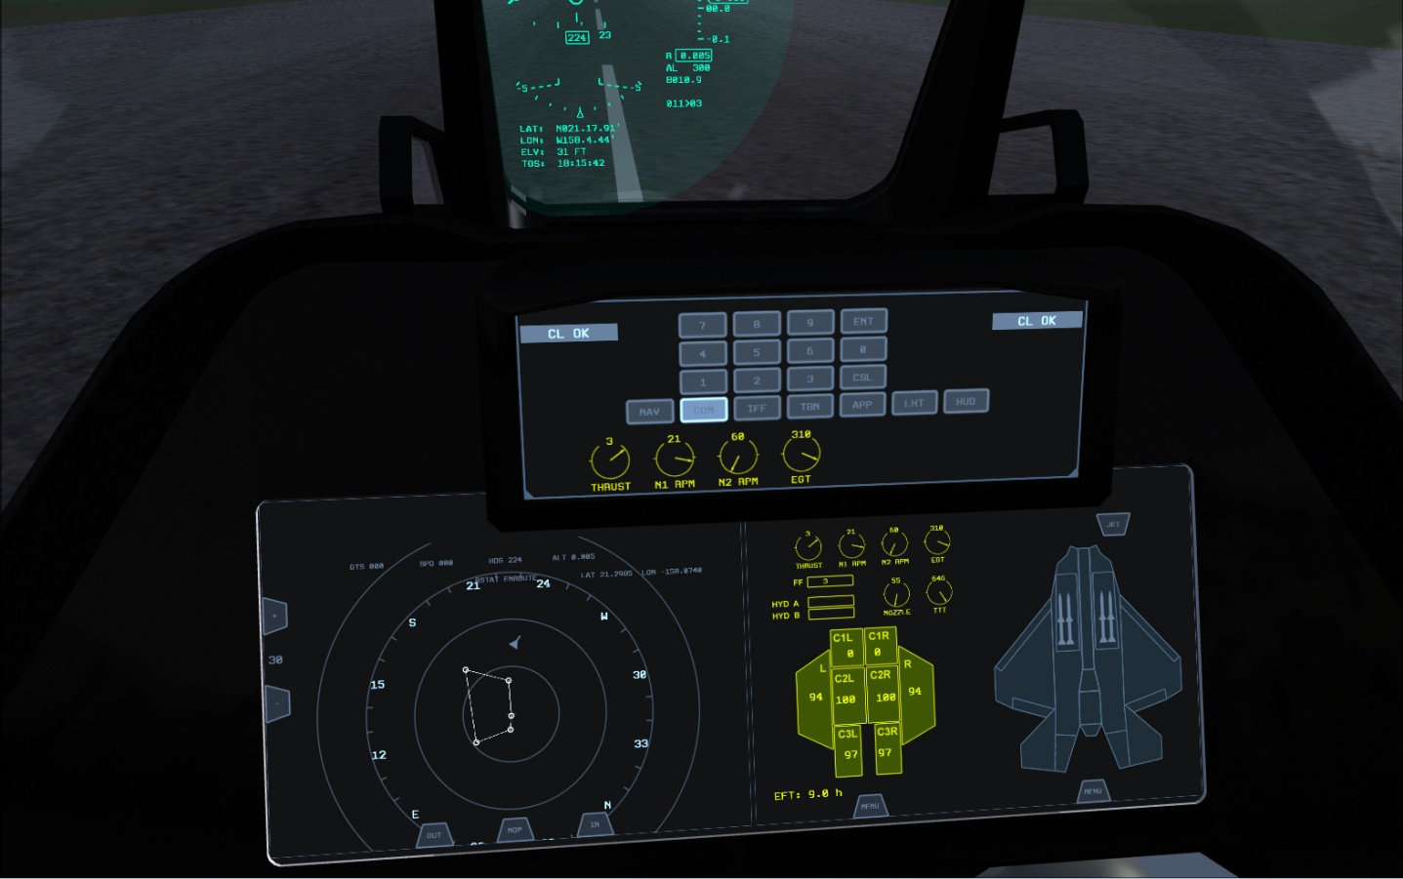

One of the most important functions of Custom D3DX9 library (developed in the scope of FSX extension project) is to provide an efficient method of replacing standard FSX 16Bit-textures (used to display cockpit instrument panels) with custom 32Bit High Quality textures rendered with customer specific graphics libraries e.g. D3DX9 or OpenGL.

The whole advantage of this method is to have professional instrument panels of a real aircraft rendered in an offset buffer, which is eventually shared with FSX as an external 32Bit-Texture. No source code is required to embed the texture into the cockpit model. No CPU copy operation is required to display texture data.

How it is done.

The texture replacement method requires an in-process module e.g. Head Down Display (HDD) to subscribe to a few Custom D3DX9 callback methods, as follows:

__AAVD3D9_RegisterCallback(__AAVD3D9_CALLBACK_CREATE_TEXTURE, (__AAVD3D9_Callback)&__AAVGraphics_D3D9::CreateTexture_Callback, this);

__AAVD3D9_RegisterCallback(__AAVD3D9_CALLBACK_SET_TEXTURE, (__AAVD3D9_Callback)&__AAVGraphics_D3D9::SetTexture_Callback, this);

These callback functions are called whenever the respective D3DX9Device:: methods are called. This gives an opportunity to track down initialization of a certain textures, which were previously tagged by user as cockpit textures and replace the returned pointers with those of customer specific.

The rendering procedures of customer specific textures **can be implemented absolutely asynchronous with the respect to the internal FSX timings**. **Which is very important!** In order to achieve this, an __AAVTextureRender_D3D9:: class is used to manage offset texture buffers in renderable and displayable states in the ring-buffer manner. This way all internal FSX graphics timings have absolutely no influence on how fast customer textures are rendered and displayed inside FSX.

The picture above shows an example of a custom touch-screen glass-cockpit instrument panel, rendered via D3DX9 interface and displayed as a 32Bit-buffer texture. The rendering is performed with 1.5 lower rate comparable with set FSX frame rate. The stand-alone or high-end graphics stations, where multi-core CPUs or multi-GPU cards are used will benefit most, since the rendering of customer specific textures can be done on GPUs which are not used by FSX and most of the time reside idle. The SLI configuration for FSX is not recommended.