Combinatorial Logic

Submitted by
Caleb Burke
658780838
Department of Computer Science
Faculty of Science and Technology
Vancouver Island University

CSCI 355 Digital Logic and Computer Organization

Submitted to
Prof. Ajay Shrestha

September 24, 2024

Table of Contents
Contents
1. Objectives 1
2. Components Required 1
3. Background (You can remove this section) 1
4. Pre-Lab 2
6. Lab Procedure with Deliverables 3
7. Conclusion 6
References 6
Appendix 6

1. Objectives
1. Design multibit adder using Verilog HDL
2. Design multibit comparator using Verilog HDL
3. Interpret waveforms generated with input/output signals

2. Components Required
Power supply, 1 x 7400 Quad 2-Input NAND Gate, 1 x 7402 Quad 2-Input NOR Gate, Breadboard, Digital Circuit Evaluator, Wiring Kit

4. Pre-Lab
4.1 Why is a multi-bit adder processed from the least-significant bit to the mostsignificant bit while a multi-bit comparator is processed from the mostsignificant bit to the least-significant bit?

4.2 Write the decimal number 7129 in different representationsin Verilog HDL: Binary = ?
Octal = ?
Hex = ?
Decimal =

6. Lab Procedure
6.1 N-bit adder
1. fulladder
Verilog main code and testbench code attached.
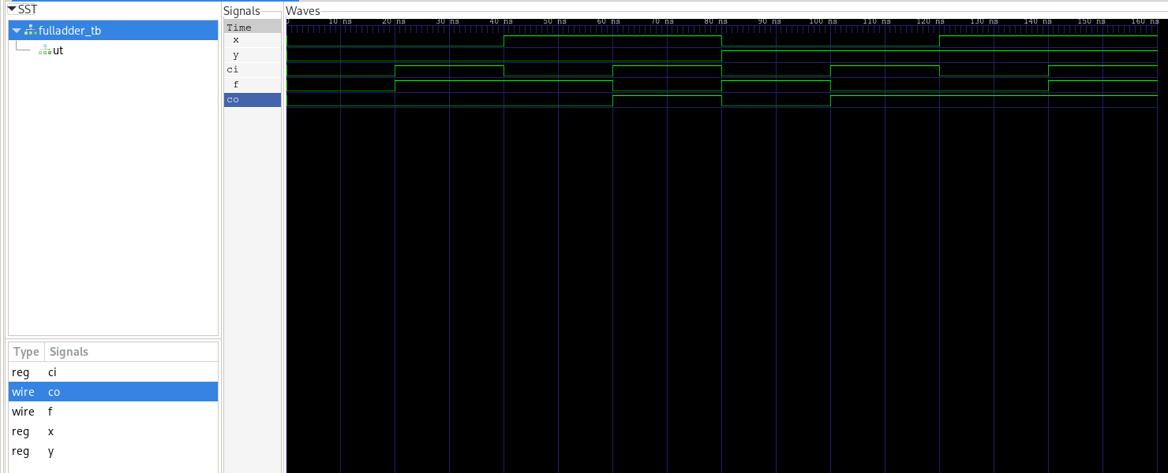
Timing diagram

2. Eight bit adder
Verilog main code and testbench code attached.
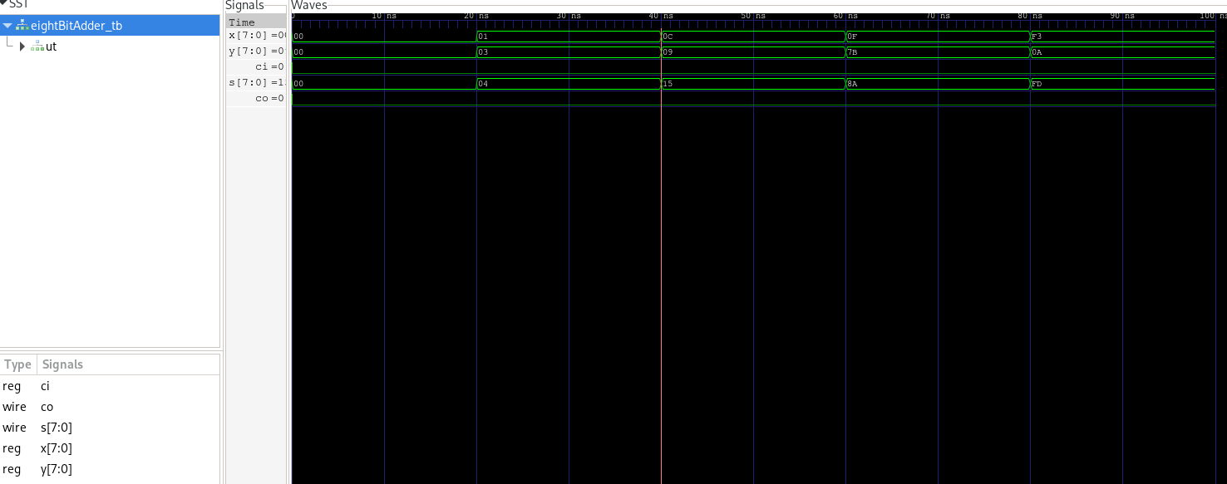
Timing diagram

3. 32 bit adder
Verilog main code and testbench code attached.
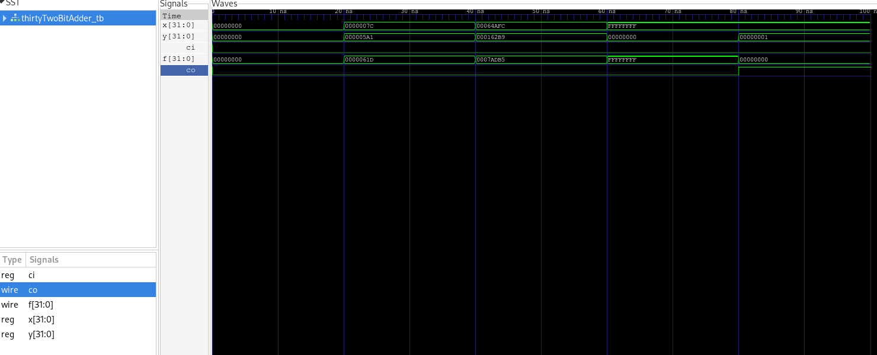
Timing diagram

6.2 Four bit comparator
1. One bit comparator
Verilog main code and testbench code attached.
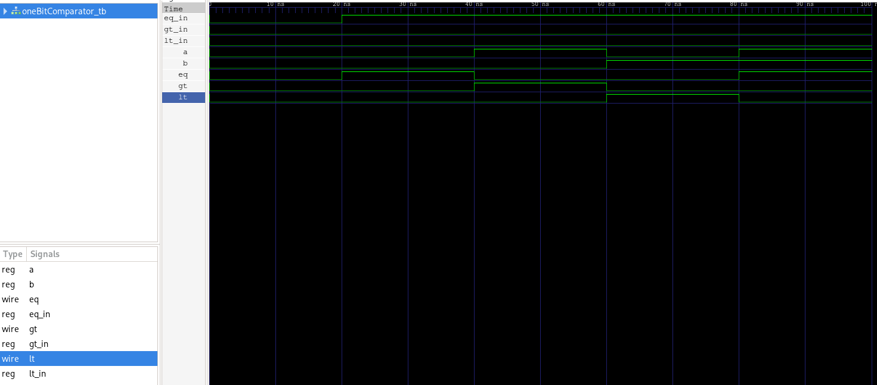
Timing diagram

2. Four bit comparator
Verilog main code and testbench code attached.
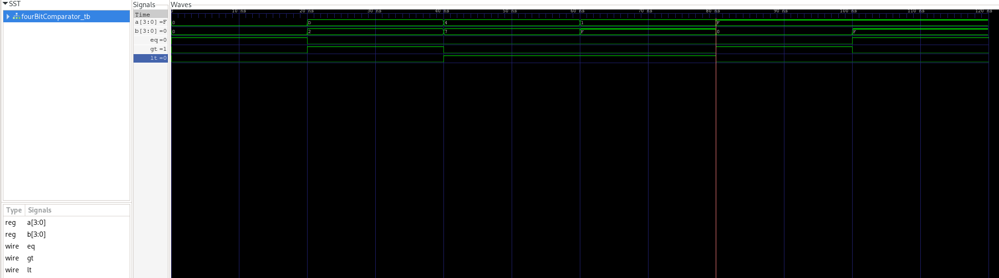
Timing diagram

7. Conclusion

In this lab, I implemented and tested a multi-bit adder and comparator using Verilog HDL. Time diagrams confirmed functionality and reinforced core concepts.

Appendix
Signature: Caleb Burke

