Combinatorial Logic

Submitted by
Caleb Burke
658780838
Department of Computer Science
Faculty of Science and Technology
Vancouver Island University

CSCI 355 Digital Logic and Computer Organization

Submitted to
Prof. Ajay Shrestha

September 24, 2024

Table of Contents
Contents
1. Objectives 1
2. Components Required 1
3. Background (You can remove this section) 1
4. Pre-Lab 2
6. Lab Procedure with Deliverables 3
7. Conclusion 6
References 6
Appendix 6

1. Objectives
I. Familiarization with Full Adder
II. Familiarization with Parity Generator and Checker
III. Construct Full-Adder using NAND and XOR only logics
IV. Construct NAND equivalent for combinational circuit
V. Construct NOR equivalent for combinational circuit

2. Components Required
Power supply, 7400 Quad 2-Input NAND Gate, 7402 Quad 2-Input NOR Gate, 7486 Quad 2- input XOR, Breadboard, Digital Circuit Evaluator, Wiring Kit

4. Pre-Lab

4.1 Boolean Function
4.1.1 Use algebraic manipulation to prove
I. x + yz = (x + y) * (x + z)
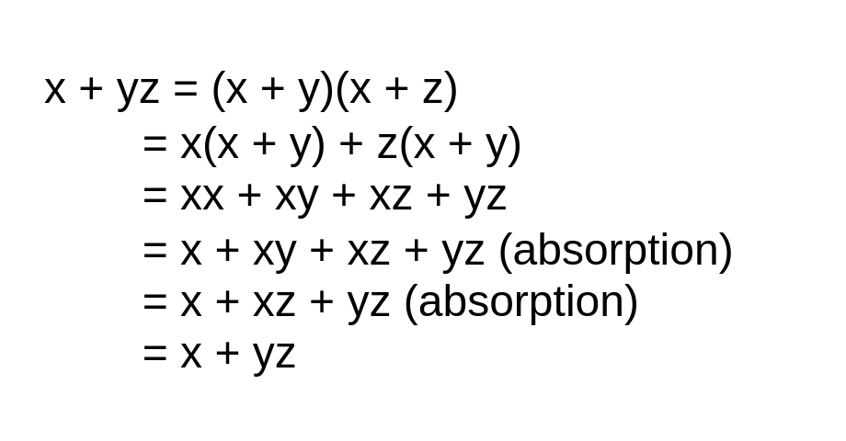

ii. xy + yz + !xz = xy + !xz
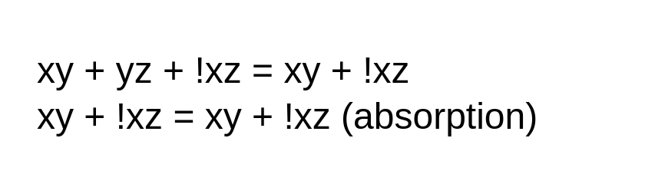

iii. !(((a + b)+ !c + !d)*(!(ab)*!c*!d)) = !(a + b) * c * d + a * b + c + d
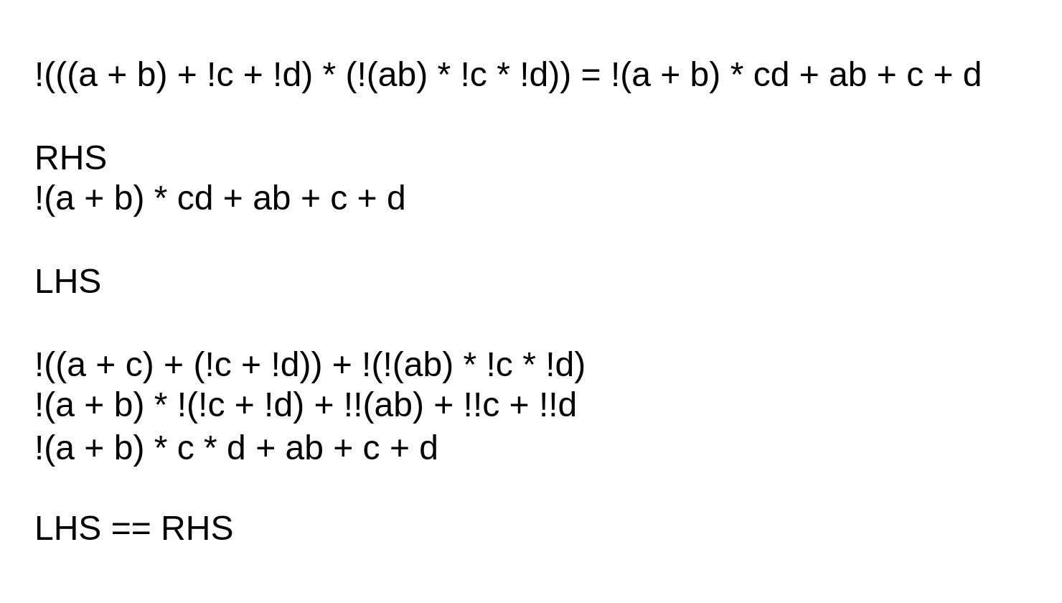

4.1.2 Use algebraic manipulation to find the minimum sum-of-products (SOP) expression for the function:
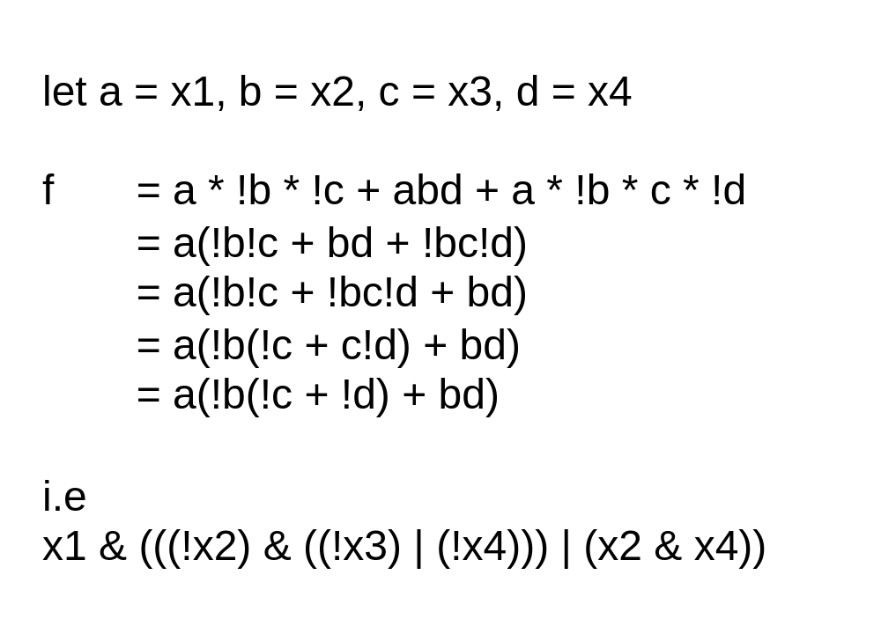

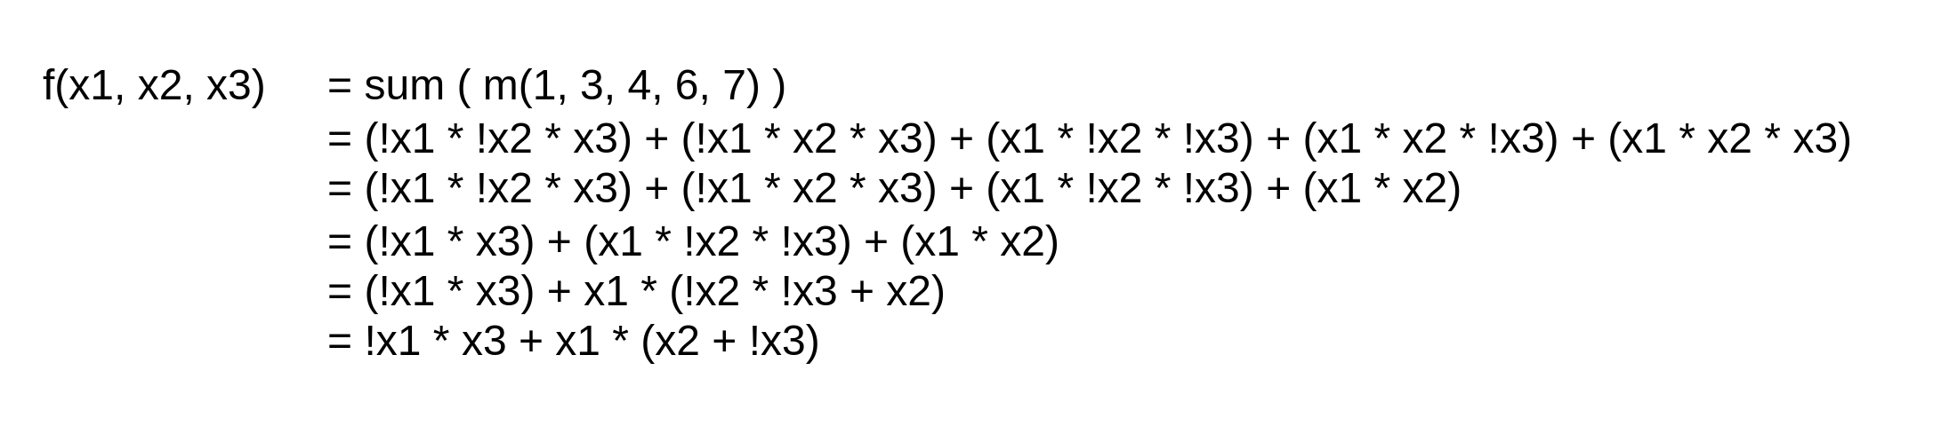
4.1.3 Use algebraic manipulation to find the simplest products-of-sums (POS) circuit that implements the function:
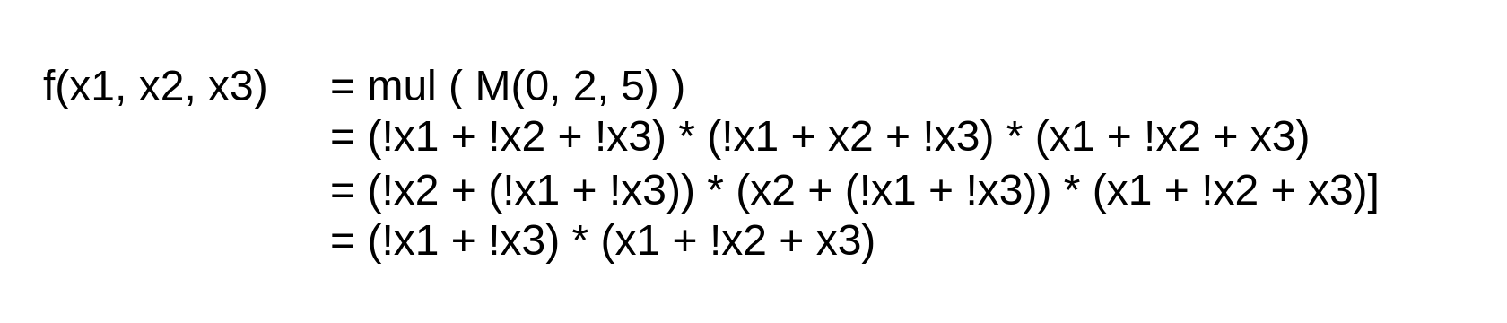

4.1.4 Find the minimum-cost SOP and POS forms for the function
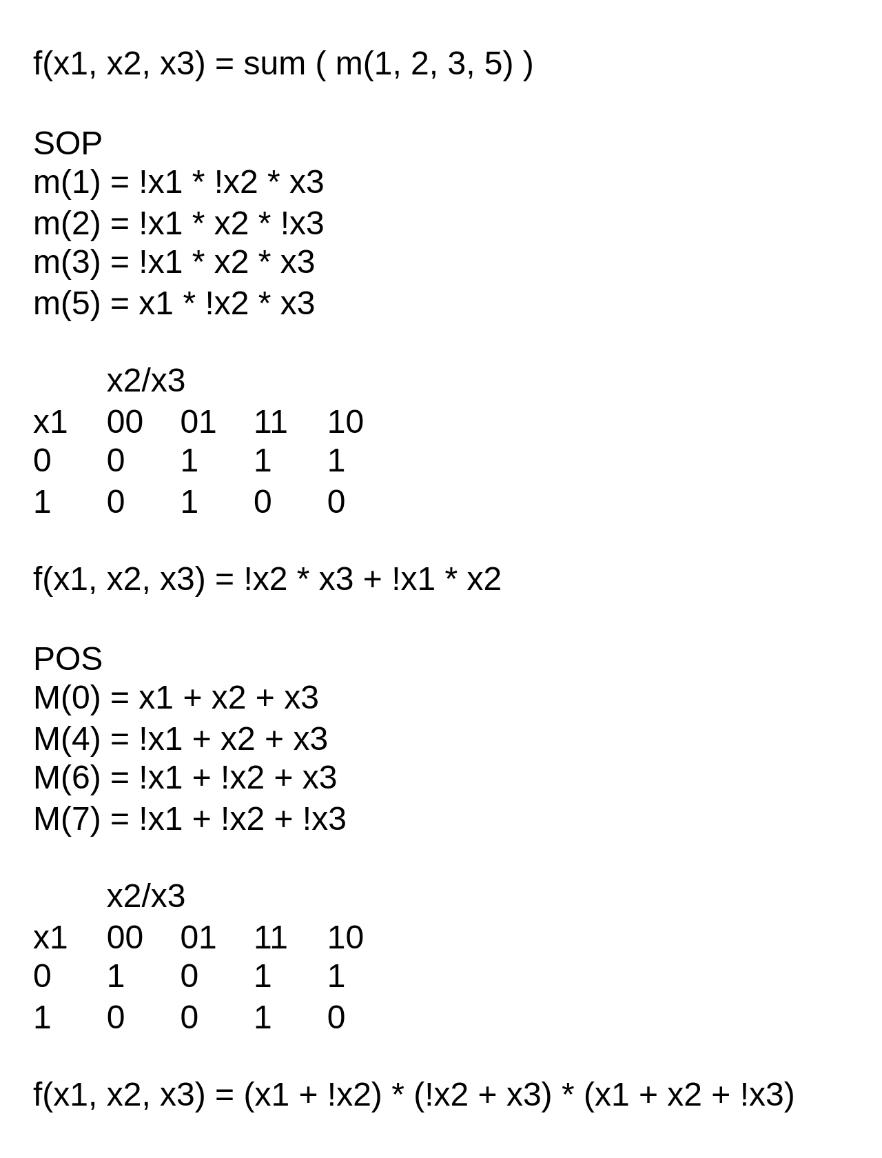
4.2 Full Adder Implementation
Just NAND and XOR
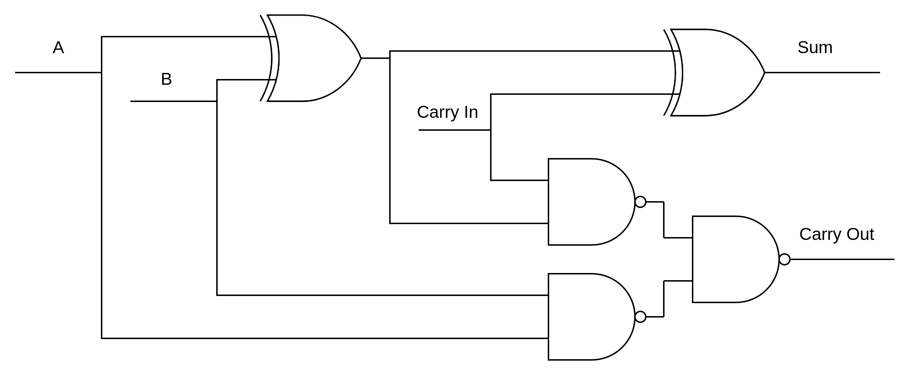
4.3 Parity Generator
The circuit show in 7.2 tells if the 5 input bits are a odd number of 1’s. Return of 1 is odd return of 0 is even. Partiy bit is for error detection, if the number of 1’s is even but parity is 1 some error has occurred. This integrity check works even if the partiy bit its self is corrupted. Note that the partiy bit only gives us info that some data corruption has occurred.

7. Lab Procedure with Deliverables
7.1 Full adder

Picture of circuit
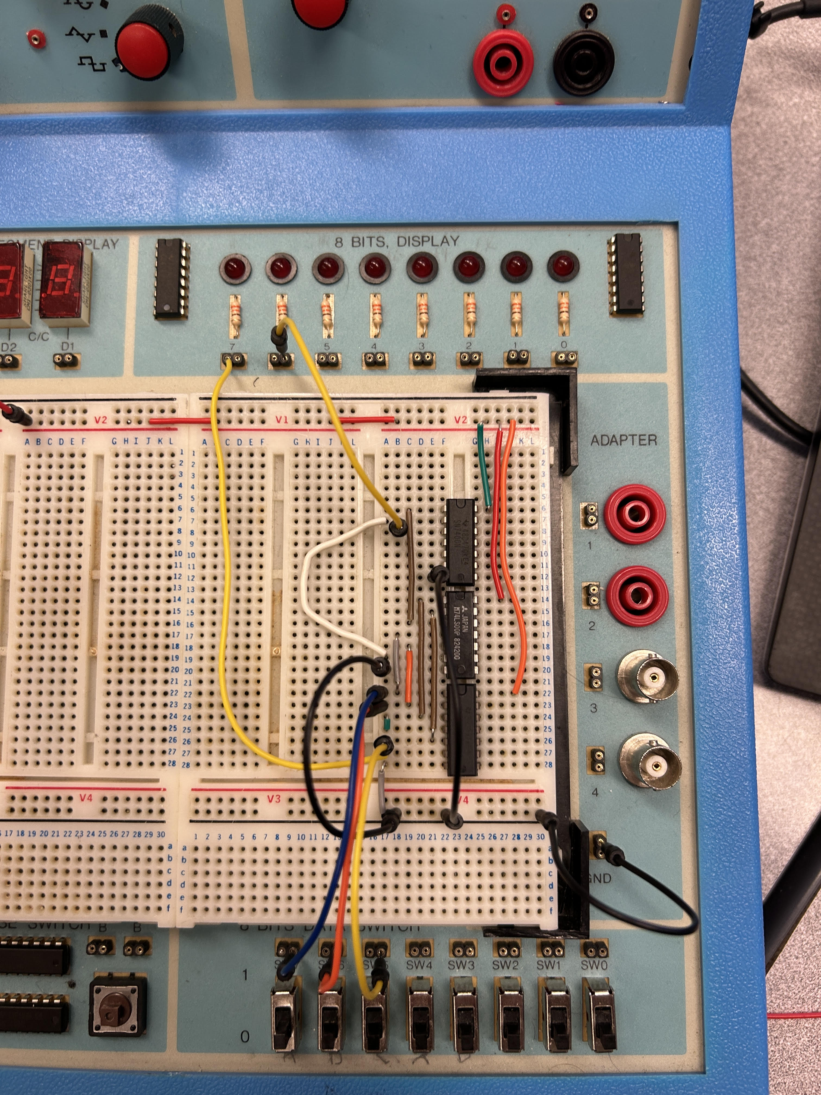

Truth Table
A | B | Cin | S | Cout
0 | 0 | 0 | 0 | 0
0 | 0 | 1 | 1 | 0
0 | 1 | 0 | 1 | 0
0 | 1 | 1 | 0 | 1
1 | 0 | 0 | 1 | 0
1 | 0 | 1 | 0 | 1
1 | 1 | 0 | 0 | 1
1 | 1 | 1 | 1 | 1

7.2 Parity Generator
Picture of circuit
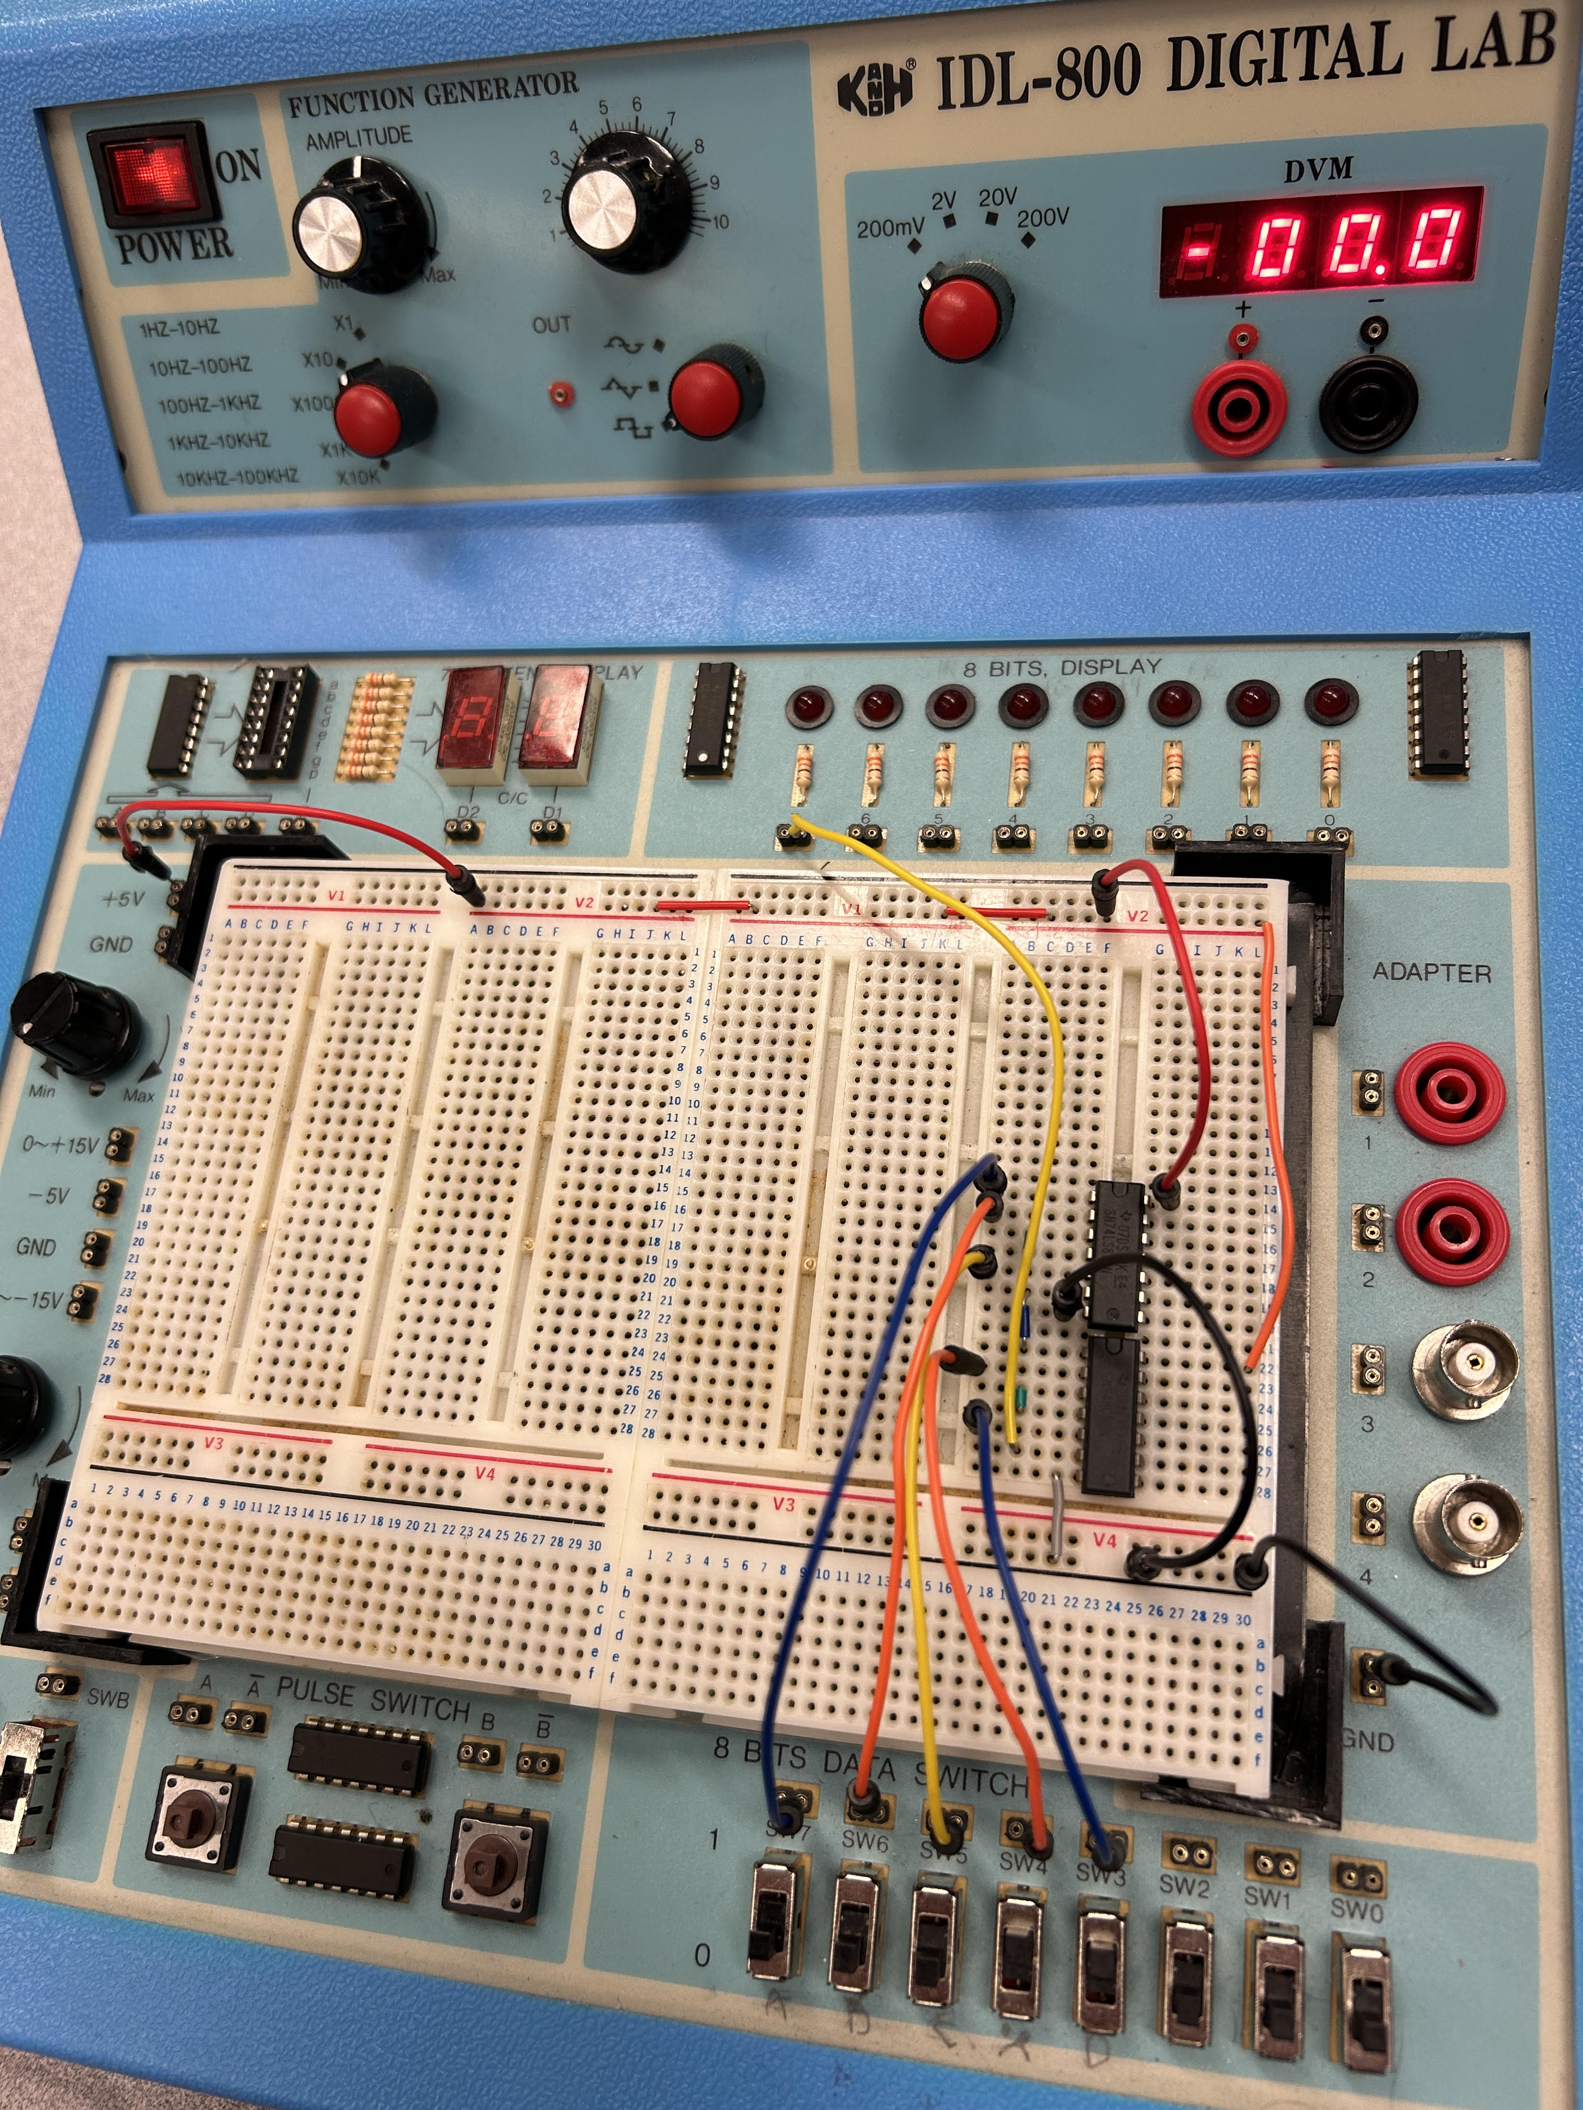

Truth Table
A0 | A1 | A2 | A3 | A4 | X
0 | 0 | 0 | 0 | 0 | 0
0 | 0 | 0 | 0 | 1 | 1
0 | 0 | 0 | 1 | 0 | 1
0 | 0 | 0 | 1 | 1 | 0
0 | 0 | 1 | 0 | 0 | 1
0 | 0 | 1 | 0 | 1 | 0
0 | 0 | 1 | 1 | 0 | 0
0 | 0 | 1 | 1 | 1 | 1
0 | 1 | 0 | 0 | 0 | 1
0 | 1 | 0 | 0 | 1 | 0
0 | 1 | 0 | 1 | 0 | 0
0 | 1 | 0 | 1 | 1 | 1
0 | 1 | 1 | 0 | 0 | 0
0 | 1 | 1 | 0 | 1 | 1
0 | 1 | 1 | 1 | 0 | 1
0 | 1 | 1 | 1 | 1 | 0
1 | 0 | 0 | 0 | 0 | 1
1 | 0 | 0 | 0 | 1 | 0
1 | 0 | 0 | 1 | 0 | 0
1 | 0 | 0 | 1 | 1 | 1
1 | 0 | 1 | 0 | 0 | 0
1 | 0 | 1 | 0 | 1 | 1
1 | 0 | 1 | 1 | 0 | 1
1 | 0 | 1 | 1 | 1 | 0
1 | 1 | 0 | 0 | 0 | 0
1 | 1 | 0 | 0 | 1 | 1
1 | 1 | 0 | 1 | 0 | 1
1 | 1 | 0 | 1 | 1 | 0
1 | 1 | 1 | 0 | 0 | 1
1 | 1 | 1 | 0 | 1 | 0
1 | 1 | 1 | 1 | 0 | 0
1 | 1 | 1 | 1 | 1 | 1

Appendixs
Signature: Caleb Burke

