Combinational Logic and basics of Verilog HDL

Submitted by
Caleb Burke
658780838
Department of Computer Science
Faculty of Science and Technology
Vancouver Island University

CSCI 355 Digital Logic and Computer Organization

Submitted to
Prof. Ajay Shrestha

September 24, 2024

Table of Contents
Contents
1. Objectives 1
2. Components Required 1
3. Background (You can remove this section) 1
4. Pre-Lab 2
6. Lab Procedure with Deliverables 3
7. Conclusion 6
References 6
Appendix 6

1. Objectives
1. Familiarization with Karnaugh Maps
2. Designing a minimum sum-of-products function with Karnaugh map
3. Designing a minimum product-of-sums function with Karnaugh map
4. Familiarization with the basics of Verilog HDL
5. Understanding waveforms generated with input/output signals

4. Pre-Lab
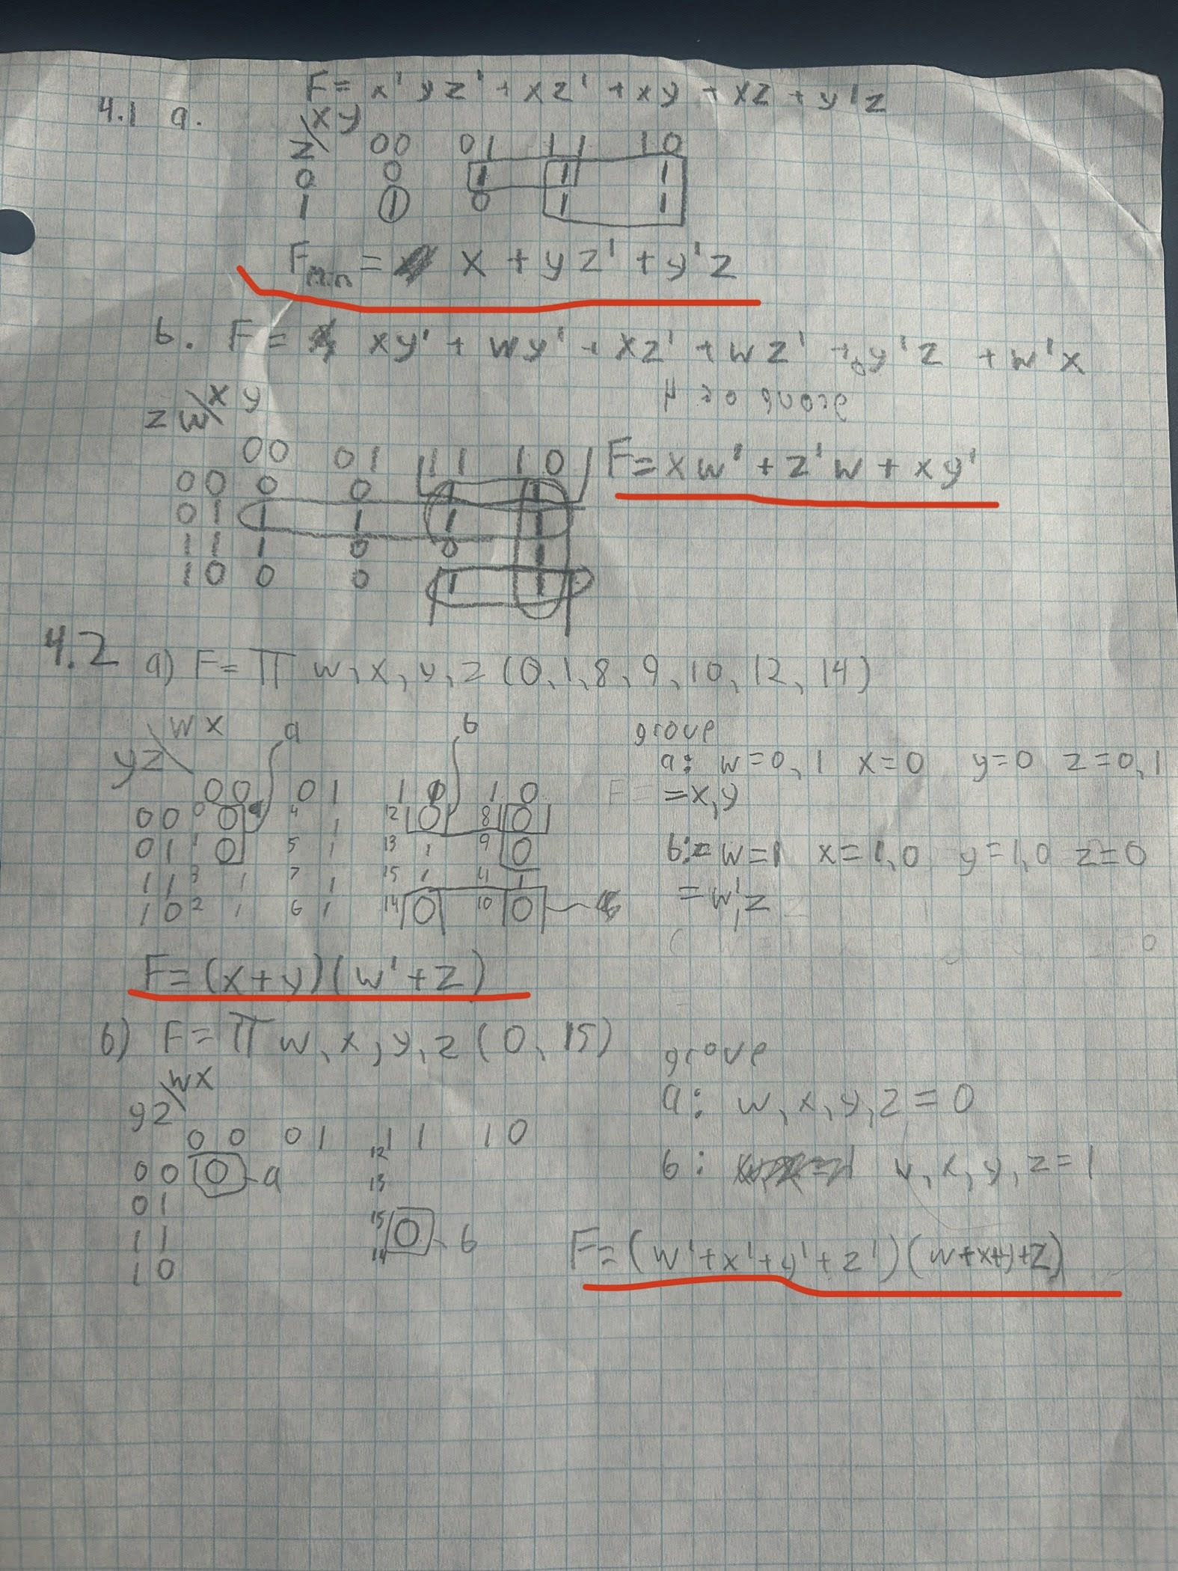

4.3
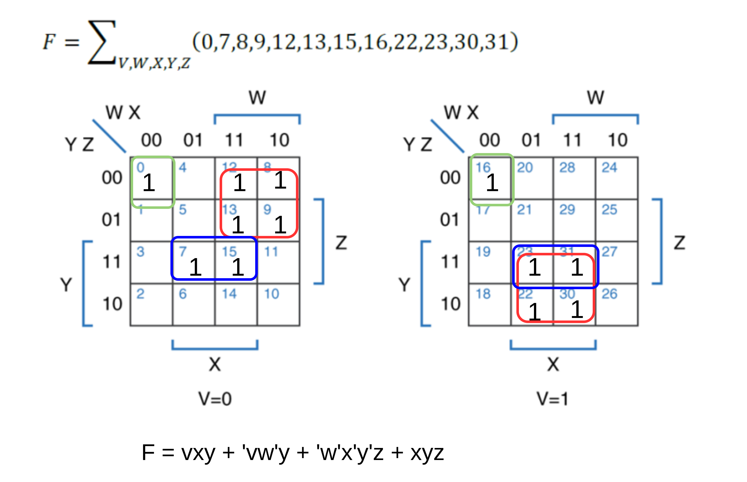
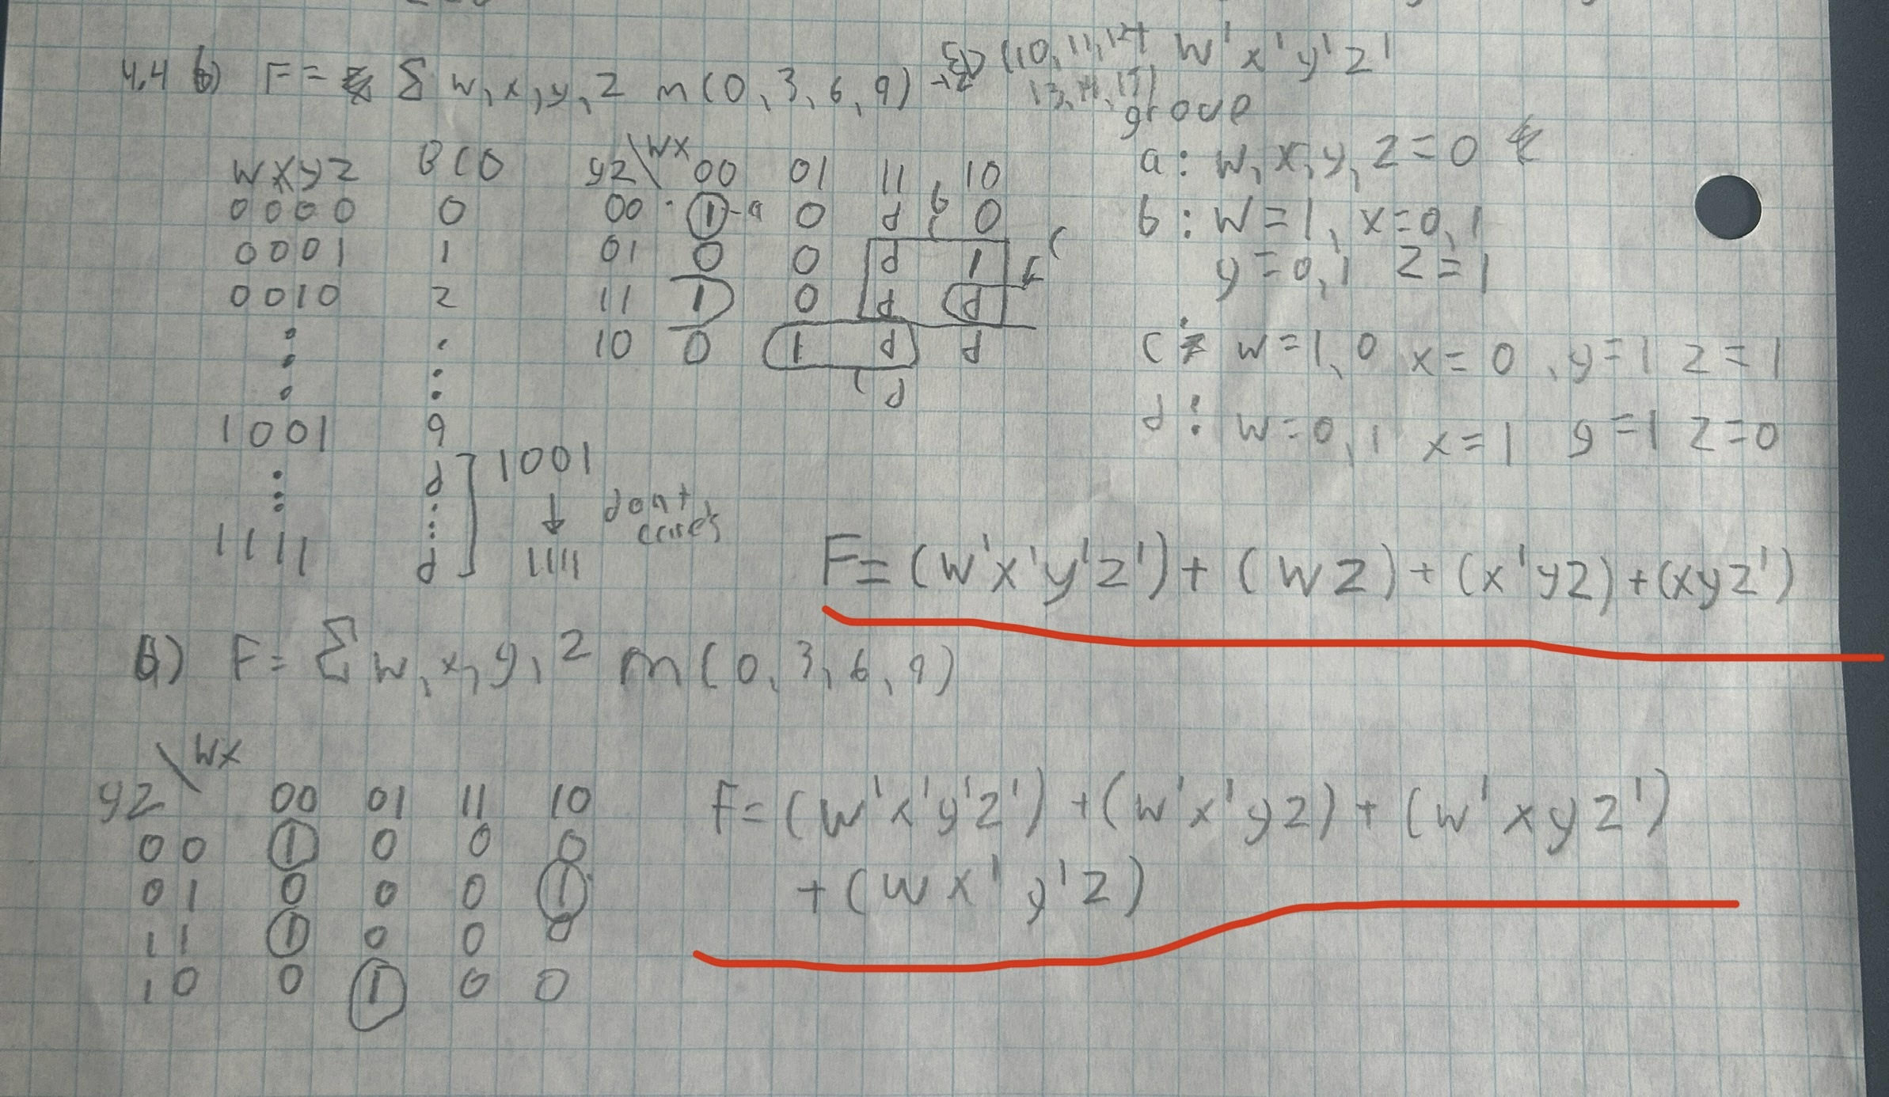

6. Lab Procedure with Deliverables
6.1 Three-Way Light Control using structural Verilog
Main code:
//Structural Specification
module threeWayLight (
x1,x2,x3,f
);
input wire x1,x2,x3;
output wire f;
wire nx1, nx2, nx3, a1, a2, a3, a4;

not(nx1, x1); // ~x1
not(nx2, x2); // ~x2
not(nx3, x3); // ~x3

and(a1, nx1, nx2, x3);
and(a2, nx1, x2, nx3);
and(a3, x1, x2, x3);
and(a4, x1, nx2, nx3);
or(f, a1, a2, a3, a4);

assign o = (~x1 & ~x2 & x3) | (~x1 & x2 & ~x3) | (x1 & x2 & x3) | (x1 & ~x2 & ~x3);

endmodule

Test Bench:
`timescale 1ns/1ns
`include "threeWayLight.v"
module threeWayLight_tb (
);
reg x1, x2, x3;
wire f;

threeWayLight ut(x1, x2, x3, f);

initial begin
$dumpfile("threeWayLight_tb.vcd");
$dumpvars(0, threeWayLight_tb);

x1 = 0;
x2 = 0;
x3 = 0;
#20;
x1 = 0;
x2 = 0;
x3 = 1;
#20;
x1 = 0;
x2 = 1;
x3 = 0;
#20;
x1 = 0;
x2 = 1;
x3 = 1;
#20;
x1 = 1;
x2 = 0;
x3 = 0;
#20;
x1 = 1;
x2 = 0;
x3 = 1;
#20;
x1 = 1;
x2 = 1;
x3 = 0;
#20;
x1 = 1;
x2 = 1;
x3 = 1;
#20;

$display("Test complete");
end

endmodule

Timing diagram
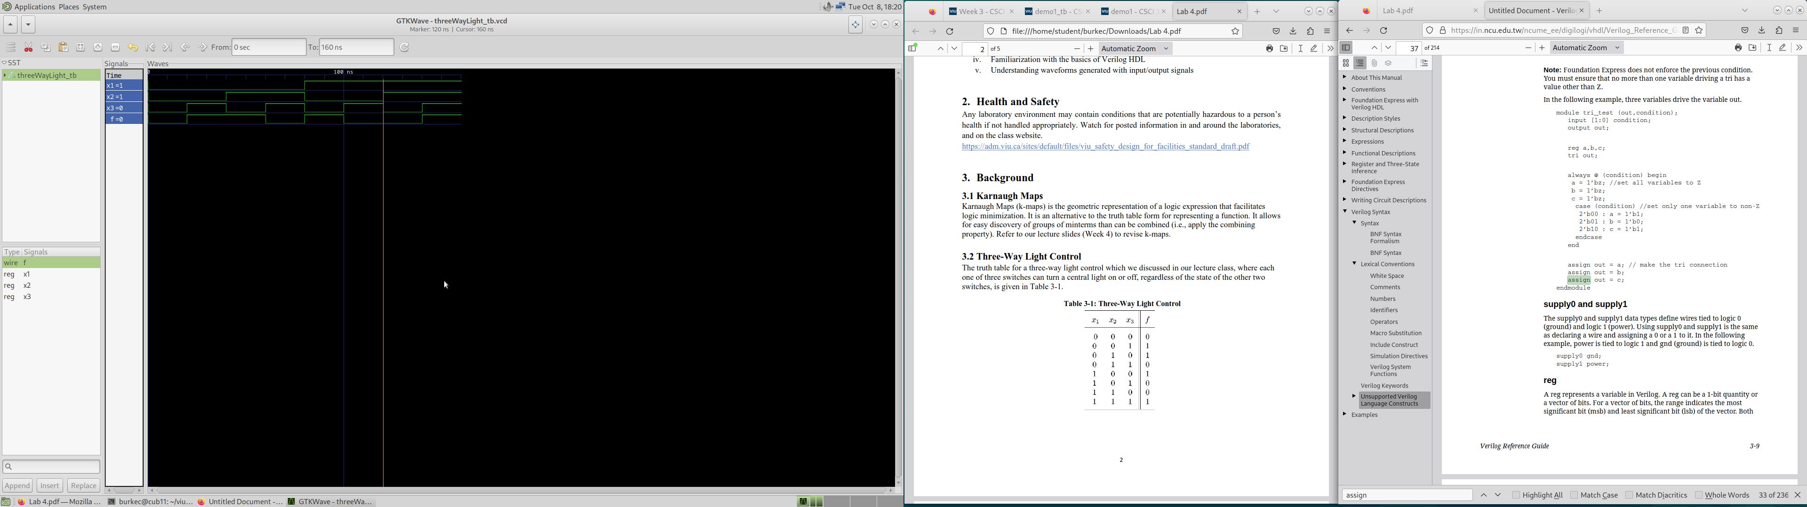
Truth Table
x1 | x2 | x3 | f
0 | 0 | 0 | 0
0 | 0 | 1 | 1
0 | 1 | 0 | 1
0 | 1 | 1 | 0
1 | 0 | 0 | 1
1 | 0 | 1 | 0
1 | 1 | 0 | 0
1 | 1 | 1 | 1

Comparing the truth table and timing digram, the code works as expected.

6.2 Three-Way Light Control using Behavioural Verilog
Main code:
//Structural Specification
module threeWayLightFunc (
x1,x2,x3,f
);
input wire x1,x2,x3;
output wire f;
assign f = (~x1 & ~x2 & x3) | (~x1 & x2 & ~x3) | (x1 & x2 & x3) | (x1 & ~x2 & ~x3);
endmodule

Testbench:
`timescale 1ns/1ns
`include "threeWayLightFunc.v"
module threeWayLightFunc_tb ();
reg x1, x2, x3;
wire f;

threeWayLightFunc ut(x1, x2, x3, f);

initial begin
$dumpfile("threeWayLightFunc_tb.vcd");
$dumpvars(0, threeWayLightFunc_tb);

x1 = 0;
x2 = 0;
x3 = 0;
#20;
x1 = 0;
x2 = 0;
x3 = 1;
#20;
x1 = 0;
x2 = 1;
x3 = 0;
#20;
x1 = 0;
x2 = 1;
x3 = 1;
#20;
x1 = 1;
x2 = 0;
x3 = 0;
#20;
x1 = 1;
x2 = 0;
x3 = 1;
#20;
x1 = 1;
x2 = 1;
x3 = 0;
#20;
x1 = 1;
x2 = 1;
x3 = 1;
#20;

$display("Test complete");
end

endmodule

Timing Diagram

Truth table
x1 | x2 | x3 | f
0 | 0 | 0 | 0
0 | 0 | 1 | 1
0 | 1 | 0 | 1
0 | 1 | 1 | 0
1 | 0 | 0 | 1
1 | 0 | 1 | 0
1 | 1 | 0 | 0
1 | 1 | 1 | 1

Comparing the truth table and timing digram, the code works as expected.

Appendix
Signature: Caleb Burke

