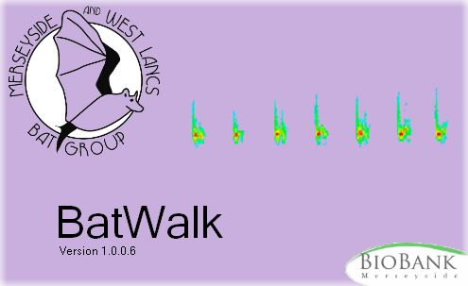

A guide to using BatWalk
Generating biological records of foraging bats

Dr Richard Burkmar & Ben Deed
Merseyside BioBank / Merseyside & West Lancashire Bat Group
Contents
Introduction 4
Equipment and smart phone apps 5
Bat detector and connection lead 5
Sound recording device or app 5
GPS device or app 5
Using the iBats app 6
Phone storage 6
Transferring files to your computer 6
iBats app files 6
Files from other apps 7
Do I need my smart phone to be connected to the internet? 7
Before you go on a bat walk… 7
Doing the bat walk 8
Starting recording 8
Keeping an eye on things 8
No need to stop! 9
Split long walks into sections 9
Using the BatWalk Software 10
Installing BatWalk 10
Quick-start guide 10
Records vs duplicate contacts 12
Saving, loading and exporting records 12
Options 14
Time interval expression 14
Add peak frequency to contact 14
Exclude duplicate contacts from export 14
Standard comment text 15
Text to append to comment on export 15
Bat names 15
A note on sound analysis 15
Acknowledgements 15

Introduction
The inspiration for BatWalk came from the Indicator Bats Program – more commonly known as iBats (www.ibats.org.uk). The Indicator Bats Program is an international programme for monitoring foraging bats based on a strict protocol which mandates a certain type of time expansion bat detector used from a car moving at 15 mph. The strict protocol is necessary to create data that can be used scientifically to generate comparable abundance indices between times and places.
The general idea is to make simultaneous recordings of bat calls encountered and the route taken on a journey (transect). So you end up with two files:
- a sound file with the recordings of bat calls (with a WAV file extension); and
- a GPS file recording the route taken (with a GPX file extension).
Then you analyse the sound file using software (e.g. Wave Surfer or BatSound) that lets you play back the sound and analyse the sonograms (also called spectrograms) to identify the bats. The iBats principle is that because you know how far into the sound file each identified bat was encountered (in terms of time from the start), the precise location of the bat can be extracted from the GPS file by looking at the same time offset from the start of that file. For example, if you identified a Common Pipistrelle 745 seconds into the WAV file, it's location in terms of latitude and longitude (which can be converted into OS grid reference) will be found 745 seconds into the GPX file.
For the Indicator Bats Program you use the iBats website to match up the calls you identify to their position in the GPS file.
During the course of evaluating the iBats protocol and methodology, it occurred to me that the same principles could be applied to recordings of bats using other equipment and on transects other than those made in cars. So I started using a simple frequency division bat detector (a BatBox Batton) liked to my smart phone to record bats I encountered whilst out walking. At the same time, my smart phone also recorded my route (with its built-in GPS) and so I ended up with two files – a WAV file and a GPX file that I could process using the iBat principles.
Because they were made with different equipment and differed from the strict iBats protocol in other respects, I could not use the iBats website to match the two files. In any case, I wanted a simpler method to relate the files. That's where the BatWalk program comes in.
The BatWalk program does all the hard work of matching the time offsets in the WAV file to the locations in the GPX file for you. In addition, it facilitates the generation of well-formed biological records and their export to other programs such as Recorder 6 (as used by many Local Record Centres) or Google Earth.
This technique described here does not generate standardised abundance indices which can be compared scientifically like those produced by the Indicator Bats protocol, but it is an extremely effective and relatively cheap method of producing biological records of foraging bats that can help us to identify important bat foraging areas and promote more efective local bat conservation.

Equipment and smart phone apps

Bat detector and connection lead
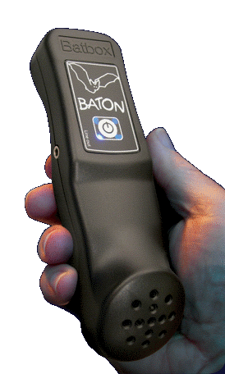
You can use any bat detector that has a 'line out' or headphone socket. Typically this would be a frequency division detector that generates sound that you can record to use afterwards with sound analysis software such as Wave Surfer (which is free) or BatSound (which is not).
You also need a lead to connect this to your recording device. If your recording device is a smart phone, then you may need to get (or make) a special lead to convert from a standard 3.5 mm line out plug (TRS plug) to a plug that will work with the combined headphone/line-in socket that you find on most smart phones (TRRS plug). For more information follow the 'ibatsapplead.pdf' link here: https://sites.google.com/site/ibatsresources/survey-protocols.
BioBank's Ben Deed is adept and making these leads up with his trusty soldering iron. so if you are stuck, talk to him (ben.deed@merseysidebiobank.org.uk).

Sound recording device or app
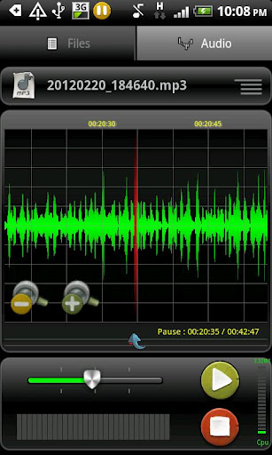
This can be any recording device capable of generating WAV files, but most conveniently, smart phones can be used with an appropriate recording app. I have had good results on my Android smart phone using the free app 'RecForge' (screen shot on the right). I have also used the iBats app for this without problems.
Whatever device and/or app you choose to use, you must be capable of finding the WAV file on the device and transferring it to your computer when you've completed your bat walk.
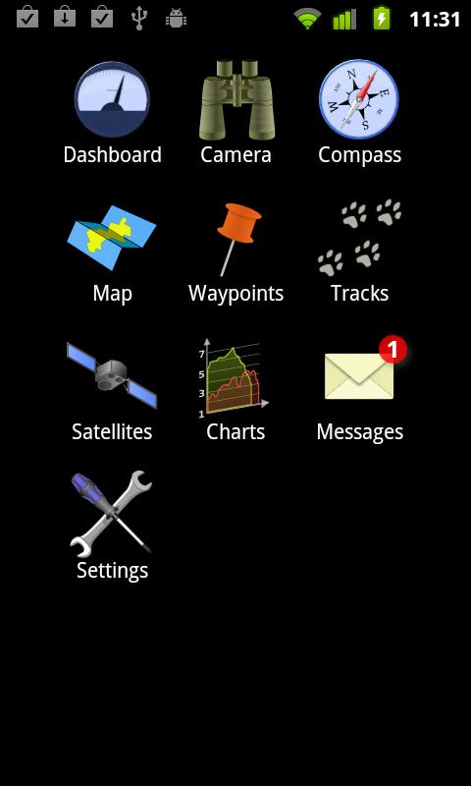
If you are using a recording app that allows you to specify things like sampling rate (as RecForge does for example), you should specify the highest possible sampling rate. Although this leads to larger WAV file sizes, it will give you a better quality recording and therefore more reliable results when you later analyse the file.

GPS device or app
Again you can use any device capable of recording your 'track' such as a traditional hand-held GPS device (like a Garmin), but most conveniently smart phones (which almost all come with built-in GPS hardware) can be used with a GPS app to record your track. I have used a free app called GPS Essentials on my Android smart phone for this (screen shot below). I have also used the iBats app to do it without problems.
As with your sound recording, whatever you choose to use, you must be able to find the track file on the device and, convert it to a GPX file (if necessary) and transfer it to your computer when you have completed your walk. This means that you can't use early hand-held GPS devices that have no means of connecting to a computer.
(Note that with the GPS Essentials application you must use the app to select the completed track file and export it to the GPX format before transferring the file to your computer.)

Using the iBats app

If you are using a smart phone you can use one app – the iBats app – instead of two separate apps to create the GPS track and record the bat sounds from your detector. This has the advantage that you only have to start one app and the sound and GPS files are synchronised precisely (i.e. started at exactly the same time).
There is currently also a disadvantage which is that the iBats app forces you to enter all the information required by the iBats protocol (e.g. name of driver, name of passenger, humidity, bat detector settings and so on) before it will allow you to start the actual recording. You can enter any values for this information because you can discard the file that the iBats app generates to hold it.

Phone storage
WAV sound files generated during a walk can be very large – especially if you use high sampling rates for better sound quality. A walk of an hour and a half might generate a WAV file close to a gigabyte in size. So you must ensure that your phone – more likely your micro SD storage card – has ample capacity to accommodate the files created. Also ensure through your app's configuration options that they use the SD storage and not the phones internal storage to store the files they create.

Transferring files to your computer
After your bat walk, you will need to transfer the two files – WAV file and GPX file - from your device(s) to your computer. If you are using a smart phone and apps, you will have a lead that will allow you to connect your phone to a USB port on your computer. Using this, you should be able to see your phone's SD card as a simple storage device from Windows. (Refer to your phone's documentation if you are not sure how to do this.)
If you are using a smart phone, the location of the GPX and WAV files on your phone's SD card is determined by the app(s) you run (see below). Once you have copied the files from your phone, don’t forget to delete the files on the phone – otherwise they are taking up a lot of space on your phone's SD card unnecessarily.

iBats app files
If you use the iBats application, you will find three files in a sub-folder under this folder - F:\Android\data\com.ibats.app\files (your phone may be mapped to a drive other than 'F'). The sub-folder will have a name something like '2012-07-05T14-17-10Z' which is determined by the date and time you started to record. There will be three files in the sub-folder. The one with the CSV extension contains the iBats protocol parameters (the dummy information you entered before starting the walk) and you can disregard it. The two that you want to copy to your computer are the GPS file with the GPX extension and the sound file with the WAV extension. Copy these two files into a convenient folder on your computer.

Files from other apps
Files created by other apps could be anywhere! Unfortunately many apps don't document where they put them and you may have to find out by searching from Windows Explorer once your phone is connected to your computer. As examples, consider the two apps I have mentioned previously.
WAV files created by the RecForge app will be found in the ' F:\RecForge' folder on your SD card (your phone may be mapped to a drive other than 'F'). There is another file associated with the WAV file (with the extension 'recforge') which can be disregarded.
GPX files created when you export a track from the GPS essentials app are stored straight under the root folder of the SD card (!). In other words straight under 'F:\' (if your phone is mapped to the F drive).

Do I need my smart phone to be connected to the internet?
No. It is a common misconception amongst smart phone users that you need an internet connection in the field (and therefore some sort of 'data bundle' from your service provider) in order to use GPS. This is not the case – the GPS in your phone will work whether or not you are connected to the internet.

The confusion arises because an internet connection often is required if you want to view your position (as recorded by GPS) on a map (or aerial image) on your smart phone when you are in the field. But you don't need to do that in order to record your route as a GPS track.

The iBats app shows your location on a map if you have an internet connection in the field, but it will still work and record your track without that internet connection – it just won't be able to show your position on a map whilst you are doing your bat walk.

Before you go on a bat walk…
You should be thoroughly conversant with operating your recording and GPS devices or apps. Don't try to learn them as you go along. Spend some time experimenting before you attempt to make proper recordings on a bat walk. Get used to:
- the way your device or app starts and stops recording;
- your apps options and settings;
- how to export GPS files to the GPX format if required;
- where files are stored on your phone or device;
- how to transfer files from your phone or device to your computer.

If you are using two apps simultaneously on a smart phone (one for recording and one for GPS), make sure that you are comfortable with how to start them in quick succession and have them both running at the same time.

Doing the bat walk

Starting recording
The most important thing to remember is that your two files – GPX and WAV file – need to be synchronised. In other words you need to start them at the same time. This is easy if you are using a smart phone with the iBats app because it will take care of that for you.
If you are using two separate devices or two separate apps on a smart phone, it is a little more difficult because physically you must start them one after the other. This means that there will be a few seconds difference between them in the times they start recording.
A few seconds (or even a few tens of seconds) is not that important – at walking speed this simply equates to a few metres. That means that the locations that you eventually derive for your bat contacts may be a few metres out. But in terms of the kinds of errors normal for GPS devices like those we are using, this is neither here nor there. Just try to start the two devices or apps as close together as possible.

Keeping an eye on things
If your bat detector is correctly connected to your phone or device and you are confident that your apps (if you are using them) are running correctly, then there's no need to keep checking your devices or phone.
However, I have been caught out before when the lead connecting my bat detector to my phone worked loose. I ended by walking for about 45 minutes (and encountering lots of bats) which never got recorded! Gutting! To avoid ever having to suffer this devastation again, I now like to check, now and again, that the signal from my bat detector is getting through to my recording device.
With the RecForge app I can see that sound is being recorded because it displays the level of the input signal. So to check that this signal is actually coming from my bat detector (rather than the built-in microphone of the phone) I just switch the bat detector off now and again for a second. When I do this, I know that the level displayed by RecForge should drop to absolutely nothing. If it doesn't, then there is a problem with the connection.
Note that turning the bat recorder off does not have any adverse effects on the files being recorded – you just get a blank section in the sound file when you analyse it. As long as the recording device and the GPS device are still running and creating their respective synchronised files (WAV and GPX respectively) then everything is fine. You can even unplug the lead from your bat detector for a while if you wish. This can be useful when using the Batbox Batton because once the connection lead to the sound recorder is plugged in, you cannot hear anything. So if you want to hear the bats in the field, you either need either another bat detector, or you can just unplug your Batton from time to time and use it on its own.
In theory – though I have never done this myself – it would be possible to unplug the lead from your recording device or phone and speak a comment into the recorder, for example a note about the flying behaviour of the bat, before plugging the lead back in again and resuming your recording from the bat detector.

No need to stop!
If you create a recording from your bat detector of an hour-long walk, it can take a long time to identify all the bat contacts when you analyse it later. That time can go up considerably if you stop whenever you see a bat and end up with a very long recording of it!
Remember that by the time you see a bat in the field, you've most likely already got a very good recording of it (unless it's a Brown Long-eared perhaps). On the other hand, you probably want to enjoy your bats when you encounter them, so it's often hard to resist the temptation to stop for a while (but see below).

Split long walks into sections
The recording devices and apps will happily create very large WAV files if you are recording for a long time. This is all well and good until you come to analyse them on your computer. Programs like Wave Surfer can open large WAV files, but the larger the file, the more slowly they open and the more of your computers' memory resources are consumed – sometimes slowing the software down considerably.
For this reason, I would recommend aiming to make sound files that are no more than 20-30 minutes long in the field. The better the specification of your computer, then larger the file sizes it will handle comfortably. If you have a lower-spec computer, then aim to record shorter sound files.
To split a walk into sections, all you have to do is stop at convenient points and stop both the recording of the sound file and the GPS track. Then start to record a new pair of GPX and WAV files as if you were just starting the bat walk.
A good time to stop and start new recordings might be when you are encountering bats foraging in one spot and want to stop to enjoy them for a while.
Importantly, you must pair the WAV and GPX files up correctly when you transfer the files to your computer later, but this should be easily done from the names given to the files by the apps (which are often based on the time they were created), their locations on the storage and file attributes showing creation times.

Using the BatWalk Software

Installing BatWalk
You can get the free BatWalk program here: http://www.gilbert21.org.uk/batwalk/publish.htm
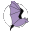
It's a Windows program. Installation should be simple – just follow the prompts. It will create an icon on your desktop like that shown on the right.
Whenever BatWalk starts, it will attempt to connect to the internet to see if there is an update to the software. If it finds one, it downloads and installs it automatically. The program will still work without an internet connection – but obviously it won't install any updates.

Quick-start guide
The starting point for using the BatWalk software is a pair of files: a GPS file with a GPX extension and a sound file with a WAV extension. First you need to open the WAV file in a sound analysis program such as Wave Surfer or BatSound.
Then you need to start BatWalk and open the GPX file. Use the browse button to locate the GPX file corresponding to the WAV file you opened in your sound analysis program.
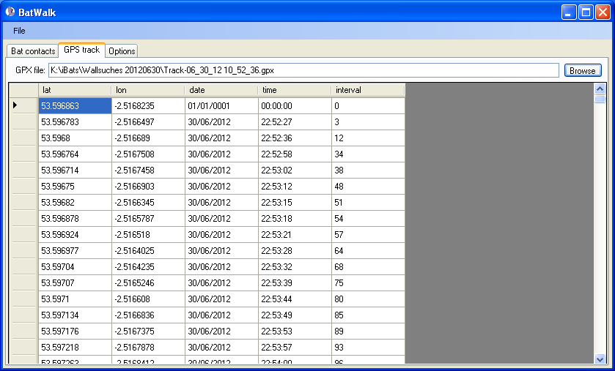
The image above shows the 'GPS track' tab once a GPX file has been opened. Note that the 'interval' column indicates how far into the file (in seconds) each location record was made.
To make a record you scan your WAV file in your sound analysis program until you find the first bat contact. Note the time – from the start of the WAV file - that the bat contact was made. In Wave Surfer this is displayed as shown outlined in red below.
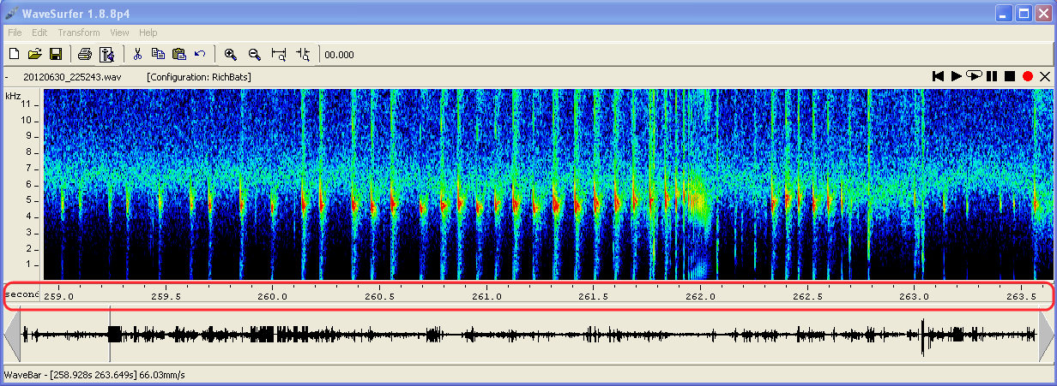
The strong contacts with this bat starts at about 260 seconds into the WAV file. Analyse the sounds to find the peak frequency and anything else that helps you to identify the bat (not covered in this guide). The peak frequency of this contact is 46 khz and the signature is typical of a pipistrelle. Therefore this contact can be identified as a Common Pipistrelle.
Go to the 'Bat contacts' tab in Bat Walk and enter the value 260 into the 'Secs' field and 46 into the 'Peak freq' field then click the 'Add' button. A record of the bat contact is created with the Latitude and Longitude, corresponding eight-figure OS grid reference, date, and other stuff.
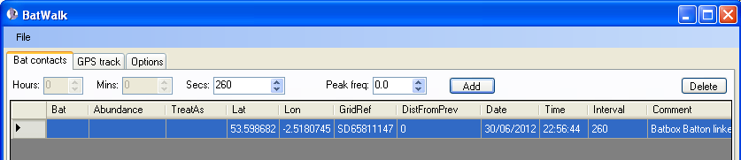
This is the basis of a well-formed biological record. All you really have to do now is name the bat. To do that, click on the empty cell in the 'Bat' column and you will see the following form.
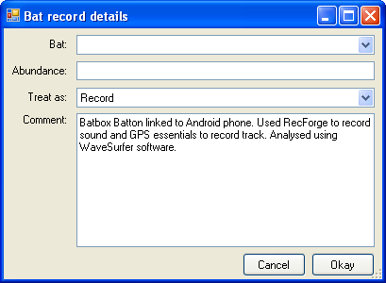
You can type in the name of the bat you identified – in this case Common Pipistrelle – and also give an indication of the number of this species you thought were present judging from the sonogram. Furthermore you can add any sort of comment that you wish (see the section on options for more about comments).

Records vs duplicate contacts
It is not uncommon when analysing a sound file to note a contact with the same bat more than once – especially if you are stationary for any length of time with bats around you. Normally you would want to be able to distinguish – in your final list of records – between bats recorded at different locations and duplicate contacts made at the same place.
The 'Treat as' field lets you do this. The 'Treat as' field has two possible values: 'Record' or 'Duplicate contact'. Although you can use these values in whatever way you see fit, the general idea is to mark records as 'Duplicate contacts' if there is already a record of the same species at pretty much the same location which could be accounted for by a bat you’ve already recorded and marked as a 'Record'.
To help you make the decisions about which records to mark as 'Record' and which to mark as 'Duplicate contact', use the 'DistFromPrev' column that gets a value when you create a record. This field indicates the distance, in metres, that the newly created record is from the previous record. Consider the list below.
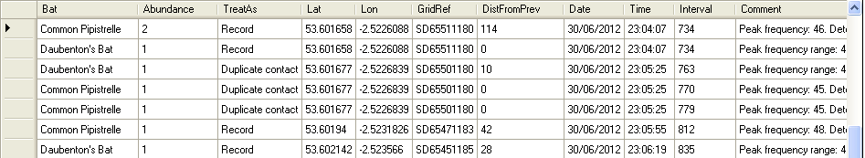
In this example a Pipistrelle has been recorded 114 metres from the previous bat contact and would be interpreted as a record. Next a Daubenton's has been recorded in the same location - it is zero metres from the Pipistrelle record. Clearly it must also treated as a record because it is a different species. The next contact with a Daubenton's is 10 metres away from this pair of records – so close that it is probably best to treat as a duplicate contact. The next two contacts – both Pipistrelles – are zero metres from the duplicate Daubenton's (i.e. recorded in the same place) and therefore also 10 metres from the initial pair of bats, so these also are treated as duplicates of that initial pair.
Next comes a Pipistrelle 42 metres from the last contact. This could, conceivably, be one of the bats recorded before but how to be sure? In any case, when making records of foraging bats, we are normally interested in the extent of the foraging habitat, so it makes sense to treat this as a new record. At what distance you draw the line between considering a contact as a duplicate and a new record is a matter of individual choice and the use to which you will put the records.

Saving, loading and exporting records
Use the 'File->Save' menu item to save the records (and duplicate contacts) shown on the 'Bat contacts' tab to a comma separated values (CSV) file. The file can be saved at any point and later re-opened, so you don't have to process a complete WAV file in a single sitting if you don't want to. The 'Save' and 'Save as' menu items conform to the standard Windows mode of operation.
To load a CSV file of records which you have previously saved, use the 'File-Open' menu item. If you already have some records displayed on the 'Bat contacts' tab, you will be asked if you want to remove these first or to append to them.
If you have Microsoft Excel on your computer and double-click a CSV file, it will normally open directly in Excel. In other words you can treat CSV files like a spreadsheet. Because the Lat/Long coordinates (WGS84 projection) are stored in this file against each record – the file could easily be imported to any GIS you care to name.
You can also export records to a number of formats suitable for use in other software. From the 'File' menu see the 'Export' item. From this, you can export the records on your 'Bat contacts' tab to formats suitable for import into Recorder 6 (which is the database used by most Local Record Centres) and Gilbert 21 (a personal records management program). Very usefully, you can also export your records to a KML file which is Google Earth's format.
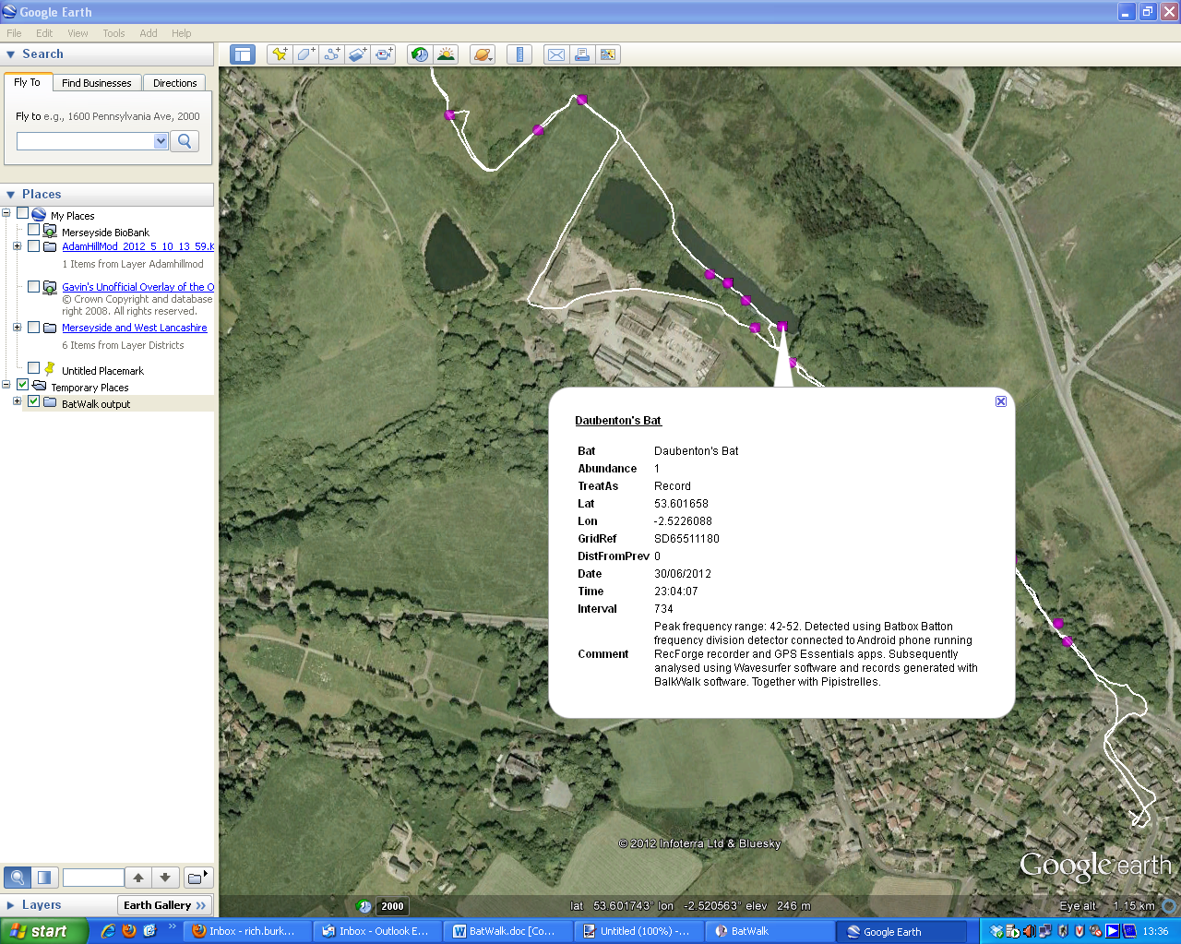
If you have a track file open (on the 'GPS track' tab) when you export to Google Earth, BatWalk creates a KML file that contains both the bat contacts and the track walked. If you don't have the track file open, only the bat contacts are exported. Note that if you have a mis-matched pair of files open (i.e. a track file that doesn't correspond to the bat contacts) the export will still produce a Google Earth KML file, but the track and the records will not correspond.

Options
Certain aspects of the behaviour of BatWalk are configurable from the 'Options' tab shown below.
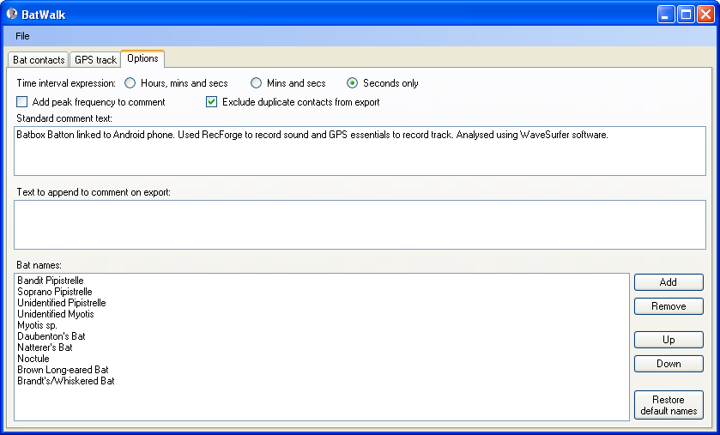

Time interval expression
This allows you to specify how the time interval (from start of WAV file) should be entered when you create a new record. The options you choose here should reflect how the time interval is expressed in the sound analysis program you are using.

Add peak frequency to contact
If you have this option checked, the peak frequency you enter when you create a new record will automatically be added to the front of the comment field in this form: Peak frequency: n. (Where n is the peak frequency you enter.)
If this option is checked, you will be forced to enter a peak frequency when you create a new record. Note however, that you can always edit the text this generates in the comment field. So, for example, if you entered a peak frequency of 50, the text in the comment would be generated as 'Peak frequency: 50.', but you could edit this to something like 'Peak frequency range: 40-60' if you wished.

Exclude duplicate contacts from export
When you export records BatWalk creates files that contain, by default, only those with the 'Treat as' field set to 'Record'. However, you can change this behaviour by un-checking the 'Exclude duplicate contacts from export' checkbox on the Options tab. If you do this, exported files will contain both all contacts –records and duplicate contacts.

Standard comment text
If you place any text in this box, it will be automatically added to a the comment field whenever you create a new record. Note that any text you specify here is remembered from one session to the next. Text is appended after any text automatically created to note peak frequency.

Text to append to comment on export
If you place any text in this box, it will be automatically added to a the comment field when you export records. Note that any text you specify here is remembered from one session to the next. Text is appended after any text already present in the comment field.

Bat names
BatWalk does not impose standards on the naming of bats. This allows you to be flexible in terms of what you record. However if you are planning to export your records to other people – e.g. Local Record Centres or recording schemes – you should make every effort to use standard and unambiguous names.
When you create a new bat record, you can type anything you like into the bat name field, but there is also a drop-down list associated with this field that enables you to select standard names much more quickly. The 'Bat names' option is for managing that list.
You can add a name to the list by using the 'Add' button and specifying the name in dialog which appears. Remove names by selecting them and then clicking the 'Remove' button. Move names up and down in the list by selecting them and using the appropriate buttons.
BatWalk remembers the list you specify from one session to the next, but it also comes prepared with a default list (tailored for the Merseyside & West Lancashire area). You reload all the names from this list at any time by clicking the 'Restore default names' button.

A note on sound analysis
Analysing bat vocalisations to identify species is a huge topic in its own right which is not covered at all in this guide. The Wave Surfer software can be downloaded for free (http://sourceforge.net/projects/wavesurfer/) and there is a guide to using it to analyse bat sounds on the iBats website (go to https://sites.google.com/site/ibatsresources/survey-protocols and look for 'WaveSurferInstructions.pdf').
A forthcoming book by John Russ promises to be a very useful resource for analysing bat calls from recordings - British Bat Calls: A Guide to Species Identification (Pelagic Publishing).

Acknowledgements
This project came about because of a grant awarded by Defra to the Merseyside & West Lancashire Bat group through Merseyside BioBank LRC to enable the bat group to enter into the iBats programme. The grant was part of a series of small grants made by Defra to LRCs (administered by Natural England) called the Defra Fund for Local Biodiversity Recording.
Our thanks to Laura Murdoch who helped us conduct the initial trial of the iBats methodology. Thanks also to the iBats team and John Harrison of the South Lancs Bat Group who have also been very helpful.

