**Solution by bintay1**

function rotateImage(a) {

// Transpose

for(var i = 0;i<a.length;i++){

for(var j = 0;j<i;j++){

// Switch a[i][j] and a[j][i]

// With XOR swap

a[i][j] ^= a[j][i]

a[j][i] ^= a[i][j]

a[i][j] ^= a[j][i]

}

}

// Reverse columns

for(var i in a){

a[i] = a[i].reverse()

}

return a

}

Note this definition of transpose:

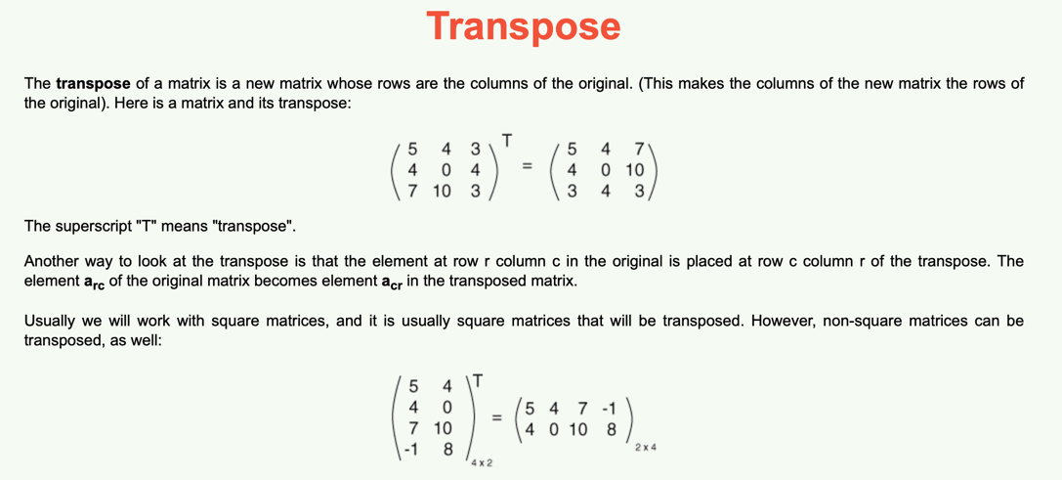

So what we want in this problem is to switch the rows with the columns – that is do a transpose – and then reverse the columns. This is exactly what his solution does. He does a fancy way of swapping two elements using XOR, but it can be done in O(1) space with one extra temp variable.

Here is an explanation of his algorithm:

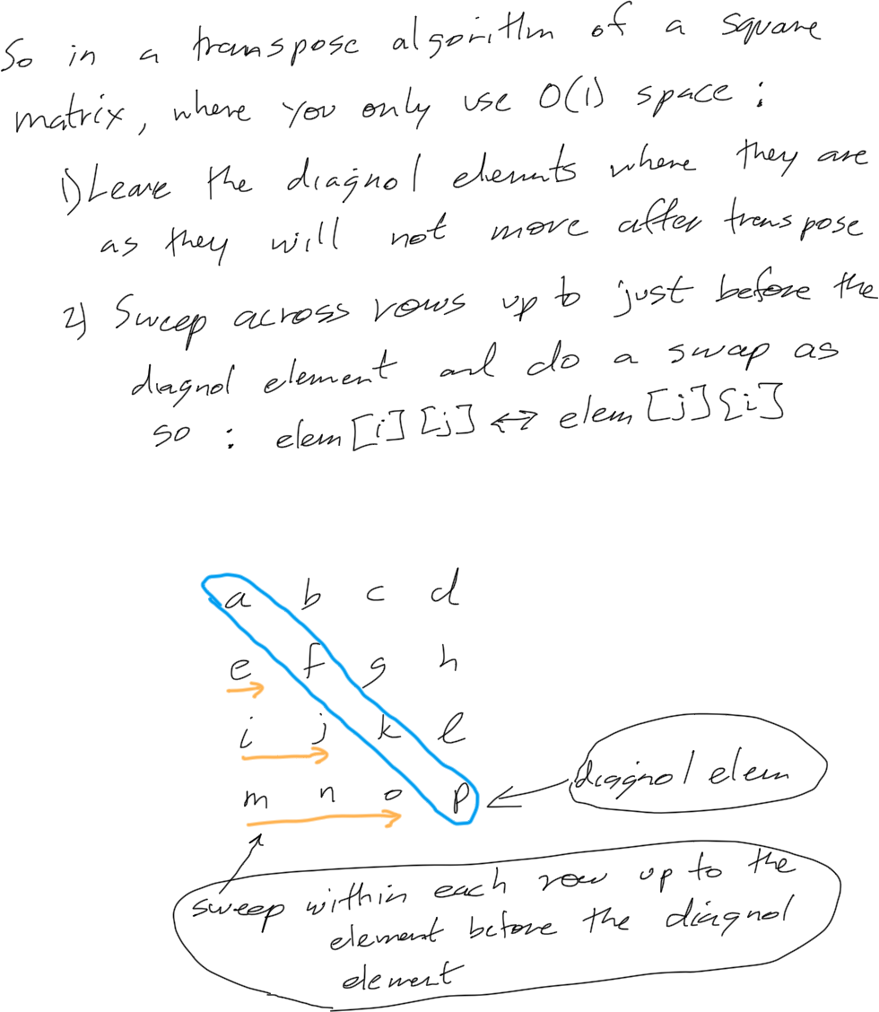

Here is a workout of the algorithm:

