Assignment 1
Q1
1.1
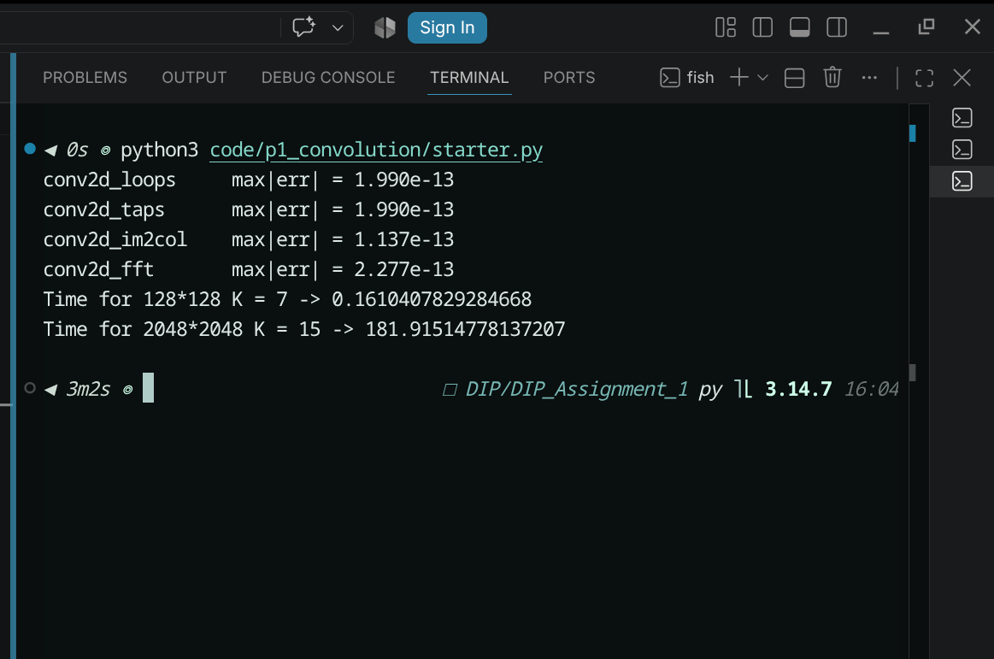
We were asked to run the loops method only for small N and K values like 128*128 and 7*7 as the loops method is O(n*m*kx*ky) where n*m is the dimension of the image and kx ky are the dimension of the image. As it doesn't use any of the numpy vectorization optimization it is very slow and grows at exponential (bi-quadratic rate). On 2048*208 image size which is not that big it took ~3 mins.
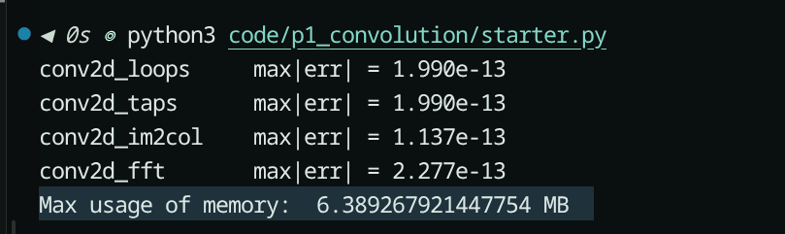
The max usage of memory for im2col is 6MB.

