Large investment with small returns

NASA budget list

Over 25 billion dollars

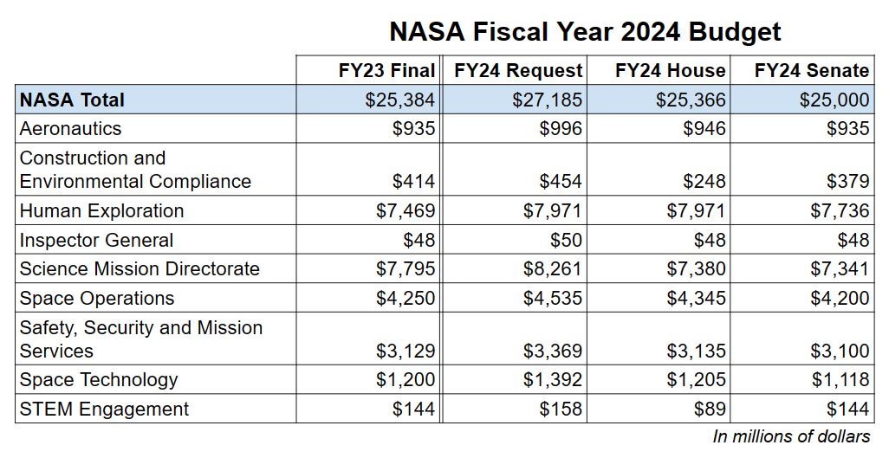

Citi’s 2022 net income 14.8 billion

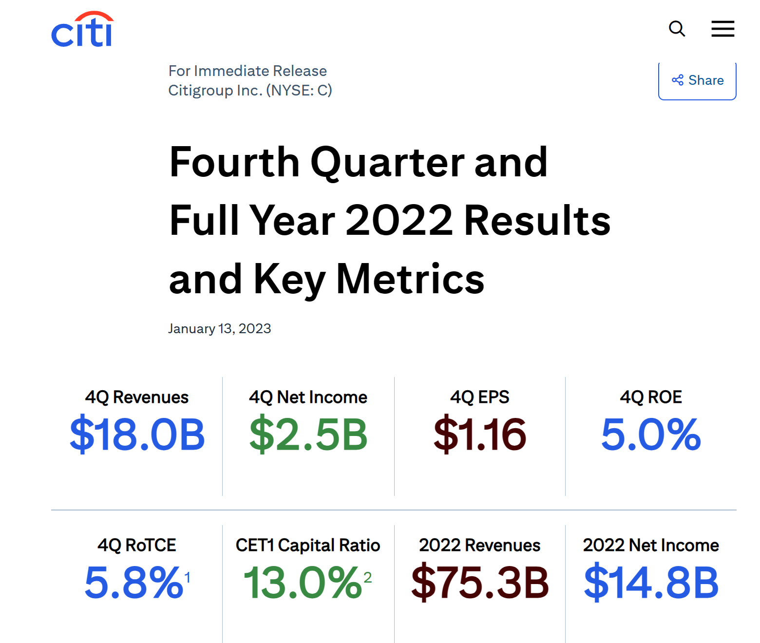

# Explore other planets is still risky

Space missions are a risky business. Just over 50% of lunar missions succeed. Even small satellite missions to Earth’s orbit don’t have a perfect track record, with a success rate somewhere between 40% and 70%.

