**Homework 1_程式修改**

309553048_陳柏丞

* **Execution：**
  + Ubuntu 18.04.5 LTS
    - g++ -std=c++17 -o solver main.cpp
    - ./solver sudoku_9x9.txt out ./MiniSat_v1.14_linux
* **Different Part：**

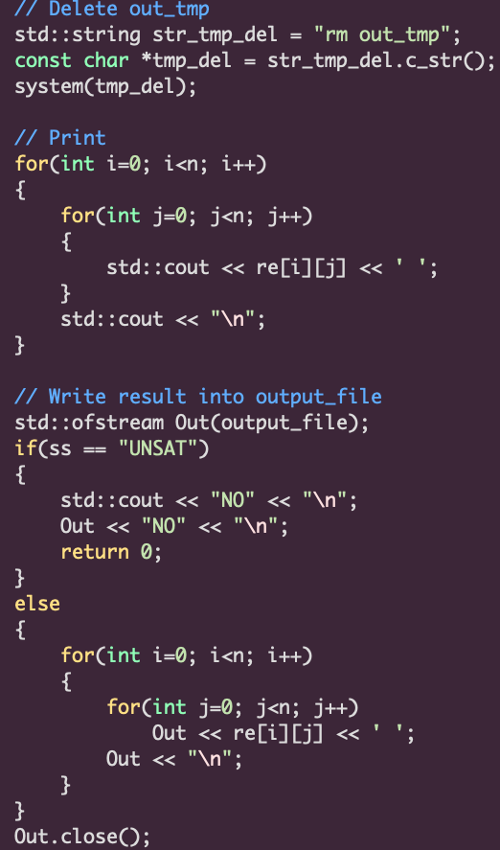

* **Result：**

