**Homework 3**

309553048_陳柏丞

* **Execution：**
  + Ubuntu 18.04.5 LTS
    - ./viterbi <input file> <output file>
* **Abstract：**
  + Main：
    - Init
    - Viterbi with log
    - Traceback
    - Calculate accuracy
* **Implementation：**

Init

#include <bits/stdc++.h>

#define all(x) x.begin(), x.end()

int main(int argc, char* argv[])

{

if (argc < 2) return 0;

std::string input_file = argv[1];

std::string output_file = argv[2];

std::ifstream input(input_file);

std::ofstream output(output_file);

// init

std::vector<std::string> type = {"sunny", "foggy", "rainy"};

std::vector<double> start = {std::log(0.5), std::log(0.25), std::log(0.25)};

std::vector<std::vector<double>> trans = {

{std::log(0.8), std::log(0.15), std::log(0.05)},

{std::log(0.2), std::log(0.5) , std::log(0.3) },

{std::log(0.2), std::log(0.2) , std::log(0.6) }

};

std::vector<std::vector<double>> emis = {

{std::log(0.9), std::log(0.1)},

{std::log(0.7), std::log(0.3)},

{std::log(0.2), std::log(0.8)}

};

int T, N = start.size();

std::vector<int> states, obs;

std::string tmp;

input >> T;

while(input >> tmp)

{

auto it = std::find(all(type), tmp.substr(0, tmp.find(',')));

int state = std::distance(type.begin(), it);

states.push_back(state);

int ob = tmp.substr(tmp.find(',')+1) == "yes" ? 1 : 0;

obs.push_back(ob);

}

input.close();

Viterbi with log

// viterbi with log

std::vector<std::vector<int>> path(T, std::vector<int> (N, 0));

std::vector<std::vector<double>> v(T, std::vector<double> (N));

for(int i=0; i<T; i++)

{

for(int j=0; j<N; j++)

{

if(i==0)

v[i][j] = start[j] + emis[j][obs[i]];

else

{

double p = -10e9;

for(int k=0; k<N; k++)

{

double w = v[i-1][k] + trans[k][j] + emis[j][obs[i]];

if (w >= p) p = w, path[i][j] = k;

}

v[i][j] = p;

}

}

}

Traceback

// traceback

auto it = std::max_element(all(path[T-1]));

int x = std::distance(path[T-1].begin(), it);

std::vector<int> ans;

for(int i=T-1; i>=0; i--)

{

ans.push_back(x);

x = path[i][x];

}

std::reverse(all(ans));

Calculate accuracy

// calculate accuracy

int corr = 0;

for(int i=0; i<ans.size(); i++)

if(states[i] == ans[i]) corr++;

output << (float)corr/T << "\n";

for(auto e:ans)

output << type[e] << "\n";

output << "\n";

output.close();

return 0;

}

* **Result：**

1. input_10.txt

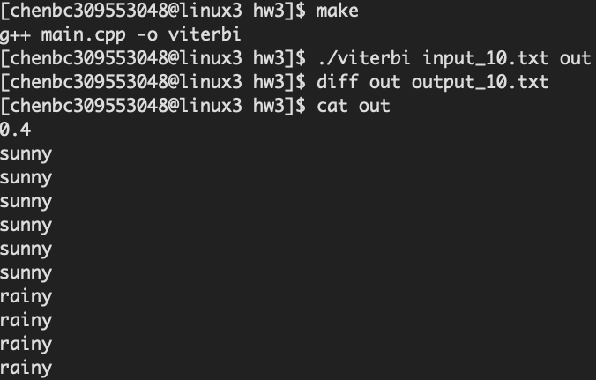

1. input_200.txt

