1. Данные (Вариант 14)

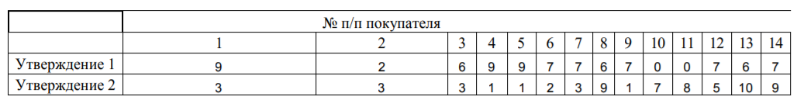

1. Кластеризация

* На 1-м шаге (итерации) центроиды выбираются самостоятельно из уже существующих точек.

Выбранные точки: Кластер 1 = (2, 3), кластер 2 = (7, 9), кластер 3 = (7, 3)

Iteration 1:

Customer 1

Centroid 1 = (X = 2, Y = 3), Distance = 7

Centroid 2 = (X = 7, Y = 9), Distance = 6.324555320336759

Centroid 3 = (X = 7, Y = 3), Distance = 2

Min distance = 2 at centroid 2 = (X = 7, Y = 3)

New centroid = (X = 8, Y = 3)

Customer 2

Centroid 1 = (X = 2, Y = 3), Distance = 0

Centroid 2 = (X = 7, Y = 9), Distance = 7.810249675906654

Centroid 3 = (X = 8, Y = 3), Distance = 6

Min distance = 0 at centroid 0 = (X = 2, Y = 3)

New centroid = (X = 2, Y = 3)

Customer 3

Centroid 1 = (X = 2, Y = 3), Distance = 4

Centroid 2 = (X = 7, Y = 9), Distance = 6.082762530298219

Centroid 3 = (X = 8, Y = 3), Distance = 2

Min distance = 2 at centroid 2 = (X = 8, Y = 3)

New centroid = (X = 7, Y = 3)

Customer 4

Centroid 1 = (X = 2, Y = 3), Distance = 7.280109889280518

Centroid 2 = (X = 7, Y = 9), Distance = 8.246211251235321

Centroid 3 = (X = 7, Y = 3), Distance = 2.8284271247461903

Min distance = 2.8284271247461903 at centroid 2 = (X = 7, Y = 3)

New centroid = (X = 8, Y = 2)

Customer 5

Centroid 1 = (X = 2, Y = 3), Distance = 7.280109889280518

Centroid 2 = (X = 7, Y = 9), Distance = 8.246211251235321

Centroid 3 = (X = 8, Y = 2), Distance = 1.4142135623730951

Min distance = 1.4142135623730951 at centroid 2 = (X = 8, Y = 2)

New centroid = (X = 8.5, Y = 1.5)

Customer 6

Centroid 1 = (X = 2, Y = 3), Distance = 5.0990195135927845

Centroid 2 = (X = 7, Y = 9), Distance = 7

Centroid 3 = (X = 8.5, Y = 1.5), Distance = 1.5811388300841898

Min distance = 1.5811388300841898 at centroid 2 = (X = 8.5, Y = 1.5)

New centroid = (X = 7.75, Y = 1.75)

Customer 7

Centroid 1 = (X = 2, Y = 3), Distance = 5

Centroid 2 = (X = 7, Y = 9), Distance = 6

Centroid 3 = (X = 7.75, Y = 1.75), Distance = 1.4577379737113252

Min distance = 1.4577379737113252 at centroid 2 = (X = 7.75, Y = 1.75)

New centroid = (X = 7.375, Y = 2.375)

Customer 8

Centroid 1 = (X = 2, Y = 3), Distance = 7.211102550927978

Centroid 2 = (X = 7, Y = 9), Distance = 1

Centroid 3 = (X = 7.375, Y = 2.375), Distance = 6.766184301362179

Min distance = 1 at centroid 1 = (X = 7, Y = 9)

New centroid = (X = 6.5, Y = 9)

Customer 9

Centroid 1 = (X = 2, Y = 3), Distance = 5.385164807134504

Centroid 2 = (X = 6.5, Y = 9), Distance = 8.0156097709407

Centroid 3 = (X = 7.375, Y = 2.375), Distance = 1.4252192813739224

Min distance = 1.4252192813739224 at centroid 2 = (X = 7.375, Y = 2.375)

New centroid = (X = 7.1875, Y = 1.6875)

Customer 10

Centroid 1 = (X = 2, Y = 3), Distance = 4.47213595499958

Centroid 2 = (X = 6.5, Y = 9), Distance = 6.800735254367722

Centroid 3 = (X = 7.1875, Y = 1.6875), Distance = 8.937718528796932

Min distance = 4.47213595499958 at centroid 0 = (X = 2, Y = 3)

New centroid = (X = 1, Y = 5)

Customer 11

Centroid 1 = (X = 1, Y = 5), Distance = 3.1622776601683795

Centroid 2 = (X = 6.5, Y = 9), Distance = 6.576473218982953

Centroid 3 = (X = 7.1875, Y = 1.6875), Distance = 9.56597159205483

Min distance = 3.1622776601683795 at centroid 0 = (X = 1, Y = 5)

New centroid = (X = 0.5, Y = 6.5)

Customer 12

Centroid 1 = (X = 0.5, Y = 6.5), Distance = 6.670832032063167

Centroid 2 = (X = 6.5, Y = 9), Distance = 4.031128874149275

Centroid 3 = (X = 7.1875, Y = 1.6875), Distance = 3.317802359996749

Min distance = 3.317802359996749 at centroid 2 = (X = 7.1875, Y = 1.6875)

New centroid = (X = 7.09375, Y = 3.34375)

Customer 13

Centroid 1 = (X = 0.5, Y = 6.5), Distance = 6.519202405202649

Centroid 2 = (X = 6.5, Y = 9), Distance = 1.118033988749895

Centroid 3 = (X = 7.09375, Y = 3.34375), Distance = 6.745513555319565

Min distance = 1.118033988749895 at centroid 1 = (X = 6.5, Y = 9)

New centroid = (X = 6.25, Y = 9.5)

Customer 14

Centroid 1 = (X = 0.5, Y = 6.5), Distance = 6.96419413859206

Centroid 2 = (X = 6.25, Y = 9.5), Distance = 0.9013878188659973

Centroid 3 = (X = 7.09375, Y = 3.34375), Distance = 5.657026880349783

Min distance = 0.9013878188659973 at centroid 1 = (X = 6.25, Y = 9.5)

New centroid = (X = 6.625, Y = 9.25)

Iteration results:

Cluster 1:

Points: (X = 2, Y = 3); (X = 0, Y = 7); (X = 0, Y = 8)

Centroid: (X = 0.5, Y = 6.5)

Cluster 2:

Points: (X = 6, Y = 9);(X = 6, Y = 10);(X = 7, Y = 9)

Centroid: (X = 6.625, Y = 9.25)

Cluster 3:

Points: (X = 9, Y = 3);(X = 6, Y = 3);(X = 9, Y = 1);(X = 9, Y = 1);(X = 7, Y = 2);(X = 7, Y = 3);(X = 7, Y = 1);(X = 7, Y = 5)

Centroid: (X = 7.09375, Y = 3.34375)

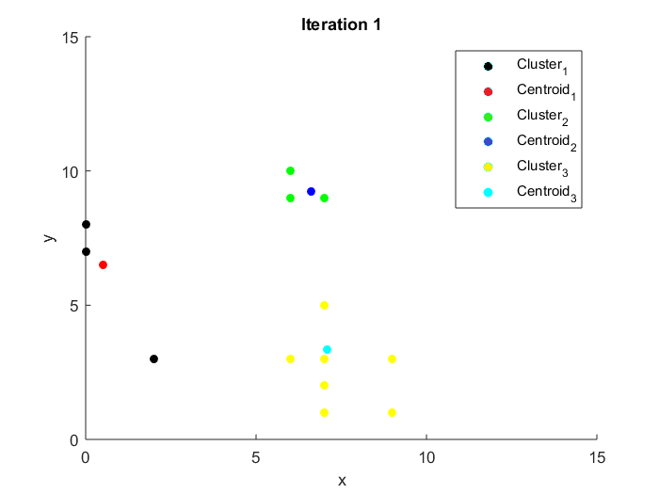

Iteration 2:

Customer 1

Centroid 1 = (X = 0.5, Y = 6.5), Distance = 9.192388155425117

Centroid 2 = (X = 6.625, Y = 9.25), Distance = 6.686039560158166

Centroid 3 = (X = 7.09375, Y = 3.34375), Distance = 1.9369959021639669

Min distance = 1.9369959021639669 at centroid 2 = (X = 7.09375, Y = 3.34375)

New centroid = (X = 8.046875, Y = 3.171875)

Customer 2

Centroid 1 = (X = 0.5, Y = 6.5), Distance = 3.8078865529319543

Centroid 2 = (X = 6.625, Y = 9.25), Distance = 7.775160770041993

Centroid 3 = (X = 8.046875, Y = 3.171875), Distance = 6.049317174793367

Min distance = 3.8078865529319543 at centroid 0 = (X = 0.5, Y = 6.5)

New centroid = (X = 1.25, Y = 4.75)

Customer 3

Centroid 1 = (X = 1.25, Y = 4.75), Distance = 5.062114182829147

Centroid 2 = (X = 6.625, Y = 9.25), Distance = 6.281172263200556

Centroid 3 = (X = 8.046875, Y = 3.171875), Distance = 2.0540784506074736

Min distance = 2.0540784506074736 at centroid 2 = (X = 8.046875, Y = 3.171875)

New centroid = (X = 7.0234375, Y = 3.0859375)

Customer 4

Centroid 1 = (X = 1.25, Y = 4.75), Distance = 8.609587678861281

Centroid 2 = (X = 6.625, Y = 9.25), Distance = 8.585052416846388

Centroid 3 = (X = 7.0234375, Y = 3.0859375), Distance = 2.873662222724254

Min distance = 2.873662222724254 at centroid 2 = (X = 7.0234375, Y = 3.0859375)

New centroid = (X = 8.01171875, Y = 2.04296875)

Customer 5

Centroid 1 = (X = 1.25, Y = 4.75), Distance = 8.609587678861281

Centroid 2 = (X = 6.625, Y = 9.25), Distance = 8.585052416846388

Centroid 3 = (X = 8.01171875, Y = 2.04296875), Distance = 1.436831111362127

Min distance = 1.436831111362127 at centroid 2 = (X = 8.01171875, Y = 2.04296875)

New centroid = (X = 8.505859375, Y = 1.521484375)

Customer 6

Centroid 1 = (X = 1.25, Y = 4.75), Distance = 6.373774391990981

Centroid 2 = (X = 6.625, Y = 9.25), Distance = 7.259691797865802

Centroid 3 = (X = 8.505859375, Y = 1.521484375), Distance = 1.5800600180513813

Min distance = 1.5800600180513813 at centroid 2 = (X = 8.505859375, Y = 1.521484375)

New centroid = (X = 7.7529296875, Y = 1.7607421875)

Customer 7

Centroid 1 = (X = 1.25, Y = 4.75), Distance = 6.010407640085654

Centroid 2 = (X = 6.625, Y = 9.25), Distance = 6.261239893184097

Centroid 3 = (X = 7.7529296875, Y = 1.7607421875), Distance = 1.450056219655339

Min distance = 1.450056219655339 at centroid 2 = (X = 7.7529296875, Y = 1.7607421875)

New centroid = (X = 7.37646484375, Y = 2.38037109375)

Customer 8

Centroid 1 = (X = 1.25, Y = 4.75), Distance = 6.373774391990981

Centroid 2 = (X = 6.625, Y = 9.25), Distance = 0.673145600891813

Centroid 3 = (X = 7.37646484375, Y = 2.38037109375), Distance = 6.761223433857239

Min distance = 0.673145600891813 at centroid 1 = (X = 6.625, Y = 9.25)

New centroid = (X = 6.3125, Y = 9.125)

Customer 9

Centroid 1 = (X = 1.25, Y = 4.75), Distance = 6.864765108872991

Centroid 2 = (X = 6.3125, Y = 9.125), Distance = 8.154034660828957

Centroid 3 = (X = 7.37646484375, Y = 2.38037109375), Distance = 1.4307865441917893

Min distance = 1.4307865441917893 at centroid 2 = (X = 7.37646484375, Y = 2.38037109375)

New centroid = (X = 7.188232421875, Y = 1.690185546875)

Customer 10

Centroid 1 = (X = 1.25, Y = 4.75), Distance = 2.57390753524675

Centroid 2 = (X = 6.3125, Y = 9.125), Distance = 6.660576645456458

Centroid 3 = (X = 7.188232421875, Y = 1.690185546875), Distance = 8.93671163669893

Min distance = 2.57390753524675 at centroid 0 = (X = 1.25, Y = 4.75)

New centroid = (X = 0.625, Y = 5.875)

Customer 11

Centroid 1 = (X = 0.625, Y = 5.875), Distance = 2.2150056433336687

Centroid 2 = (X = 6.3125, Y = 9.125), Distance = 6.411963915213497

Centroid 3 = (X = 7.188232421875, Y = 1.690185546875), Distance = 9.564750063841714

Min distance = 2.2150056433336687 at centroid 0 = (X = 0.625, Y = 5.875)

New centroid = (X = 0.3125, Y = 6.9375)

Customer 12

Centroid 1 = (X = 0.3125, Y = 6.9375), Distance = 6.962511220816811

Centroid 2 = (X = 6.3125, Y = 9.125), Distance = 4.181899239580026

Centroid 3 = (X = 7.188232421875, Y = 1.690185546875), Distance = 3.3151626142257444

Min distance = 3.3151626142257444 at centroid 2 = (X = 7.188232421875, Y = 1.690185546875)

New centroid = (X = 7.0941162109375, Y = 3.3450927734375)

Customer 13

Centroid 1 = (X = 0.3125, Y = 6.9375), Distance = 6.459610088852113

Centroid 2 = (X = 6.3125, Y = 9.125), Distance = 0.9291292967074066

Centroid 3 = (X = 7.0941162109375, Y = 3.3450927734375), Distance = 6.744247954901274

Min distance = 0.9291292967074066 at centroid 1 = (X = 6.3125, Y = 9.125)

New centroid = (X = 6.15625, Y = 9.5625)

Customer 14

Centroid 1 = (X = 0.3125, Y = 6.9375), Distance = 6.998325692621057

Centroid 2 = (X = 6.15625, Y = 9.5625), Distance = 1.014061296224247

Centroid 3 = (X = 7.0941162109375, Y = 3.3450927734375), Distance = 5.655690373613996

Min distance = 1.014061296224247 at centroid 1 = (X = 6.15625, Y = 9.5625)

New centroid = (X = 6.578125, Y = 9.28125)

Iteration results:

Cluster 1:

Points: (X = 2, Y = 3); (X = 0, Y = 7); (X = 0, Y = 8)

Centroid: (X = 0.3125, Y = 6.9375)

Cluster 2:

Points: (X = 6, Y = 9);(X = 6, Y = 10);(X = 7, Y = 9)

Centroid: (X = 6.578125, Y = 9.28125)

Cluster 3:

Points: (X = 9, Y = 3);(X = 6, Y = 3);(X = 9, Y = 1);(X = 9, Y = 1);(X = 7, Y = 2);(X = 7, Y = 3);(X = 7, Y = 1);(X = 7, Y = 5)

Centroid: (X = 7.0941162109375, Y = 3.3450927734375)

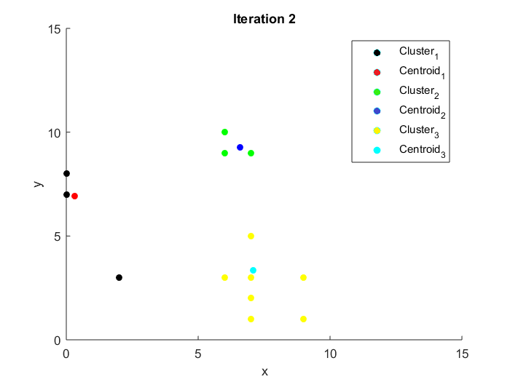

Итого две итерации.

* На 1-м шаге (итерации) в качестве центроидов выбираются первые три точки.

Выбранные точки: Кластер 1 = (9, 3), кластер 2 = (2, 3), кластер 3 = (6, 3)

Iteration 1:

Customer 1

Centroid 1 = (X = 9, Y = 3), Distance = 0

Centroid 2 = (X = 2, Y = 3), Distance = 7

Centroid 3 = (X = 6, Y = 3), Distance = 3

Min distance = 0 at centroid 0 = (X = 9, Y = 3)

New centroid = (X = 9, Y = 3)

Customer 2

Centroid 1 = (X = 9, Y = 3), Distance = 7

Centroid 2 = (X = 2, Y = 3), Distance = 0

Centroid 3 = (X = 6, Y = 3), Distance = 4

Min distance = 0 at centroid 1 = (X = 2, Y = 3)

New centroid = (X = 2, Y = 3)

Customer 3

Centroid 1 = (X = 9, Y = 3), Distance = 3

Centroid 2 = (X = 2, Y = 3), Distance = 4

Centroid 3 = (X = 6, Y = 3), Distance = 0

Min distance = 0 at centroid 2 = (X = 6, Y = 3)

New centroid = (X = 6, Y = 3)

Customer 4

Centroid 1 = (X = 9, Y = 3), Distance = 2

Centroid 2 = (X = 2, Y = 3), Distance = 7.280109889280518

Centroid 3 = (X = 6, Y = 3), Distance = 3.605551275463989

Min distance = 2 at centroid 0 = (X = 9, Y = 3)

New centroid = (X = 9, Y = 2)

Customer 5

Centroid 1 = (X = 9, Y = 2), Distance = 1

Centroid 2 = (X = 2, Y = 3), Distance = 7.280109889280518

Centroid 3 = (X = 6, Y = 3), Distance = 3.605551275463989

Min distance = 1 at centroid 0 = (X = 9, Y = 2)

New centroid = (X = 9, Y = 1.5)

Customer 6

Centroid 1 = (X = 9, Y = 1.5), Distance = 2.0615528128088303

Centroid 2 = (X = 2, Y = 3), Distance = 5.0990195135927845

Centroid 3 = (X = 6, Y = 3), Distance = 1.4142135623730951

Min distance = 1.4142135623730951 at centroid 2 = (X = 6, Y = 3)

New centroid = (X = 6.5, Y = 2.5)

Customer 7

Centroid 1 = (X = 9, Y = 1.5), Distance = 2.5

Centroid 2 = (X = 2, Y = 3), Distance = 5

Centroid 3 = (X = 6.5, Y = 2.5), Distance = 0.7071067811865476

Min distance = 0.7071067811865476 at centroid 2 = (X = 6.5, Y = 2.5)

New centroid = (X = 6.75, Y = 2.75)

Customer 8

Centroid 1 = (X = 9, Y = 1.5), Distance = 8.077747210701755

Centroid 2 = (X = 2, Y = 3), Distance = 7.211102550927978

Centroid 3 = (X = 6.75, Y = 2.75), Distance = 6.294839156007086

Min distance = 6.294839156007086 at centroid 2 = (X = 6.75, Y = 2.75)

New centroid = (X = 6.375, Y = 5.875)

Customer 9

Centroid 1 = (X = 9, Y = 1.5), Distance = 2.0615528128088303

Centroid 2 = (X = 2, Y = 3), Distance = 5.385164807134504

Centroid 3 = (X = 6.375, Y = 5.875), Distance = 4.914900812834375

Min distance = 2.0615528128088303 at centroid 0 = (X = 9, Y = 1.5)

New centroid = (X = 8, Y = 1.25)

Customer 10

Centroid 1 = (X = 8, Y = 1.25), Distance = 9.852030247619016

Centroid 2 = (X = 2, Y = 3), Distance = 4.47213595499958

Centroid 3 = (X = 6.375, Y = 5.875), Distance = 6.473503688112026

Min distance = 4.47213595499958 at centroid 1 = (X = 2, Y = 3)

New centroid = (X = 1, Y = 5)

Customer 11

Centroid 1 = (X = 8, Y = 1.25), Distance = 10.46721070772916

Centroid 2 = (X = 1, Y = 5), Distance = 3.1622776601683795

Centroid 3 = (X = 6.375, Y = 5.875), Distance = 6.719840027857806

Min distance = 3.1622776601683795 at centroid 1 = (X = 1, Y = 5)

New centroid = (X = 0.5, Y = 6.5)

Customer 12

Centroid 1 = (X = 8, Y = 1.25), Distance = 3.881043674065006

Centroid 2 = (X = 0.5, Y = 6.5), Distance = 6.670832032063167

Centroid 3 = (X = 6.375, Y = 5.875), Distance = 1.0752906583803283

Min distance = 1.0752906583803283 at centroid 2 = (X = 6.375, Y = 5.875)

New centroid = (X = 6.6875, Y = 5.4375)

Customer 13

Centroid 1 = (X = 8, Y = 1.25), Distance = 8.97566153550812

Centroid 2 = (X = 0.5, Y = 6.5), Distance = 6.519202405202649

Centroid 3 = (X = 6.6875, Y = 5.4375), Distance = 4.614007206322937

Min distance = 4.614007206322937 at centroid 2 = (X = 6.6875, Y = 5.4375)

New centroid = (X = 6.34375, Y = 7.71875)

Customer 14

Centroid 1 = (X = 8, Y = 1.25), Distance = 7.814249804043892

Centroid 2 = (X = 0.5, Y = 6.5), Distance = 6.96419413859206

Centroid 3 = (X = 6.34375, Y = 7.71875), Distance = 1.4395366007851276

Min distance = 1.4395366007851276 at centroid 2 = (X = 6.34375, Y = 7.71875)

New centroid = (X = 6.671875, Y = 8.359375)

Iteration results:

Cluster 1:

Points: (X = 9, Y = 3); (X = 9, Y = 1); (X = 9, Y = 1); (X = 7, Y = 1)

Centroid: (X = 8, Y = 1.25)

Cluster 2:

Points: (X = 2, Y = 3);(X = 0, Y = 7);(X = 0, Y = 8)

Centroid: (X = 0.5, Y = 6.5)

Cluster 3:

Points: (X = 6, Y = 3);(X = 7, Y = 2);(X = 7, Y = 3);(X = 6, Y = 9);(X = 7, Y = 5);(X = 6, Y = 10);(X = 7, Y = 9)

Centroid: (X = 6.671875, Y = 8.359375)

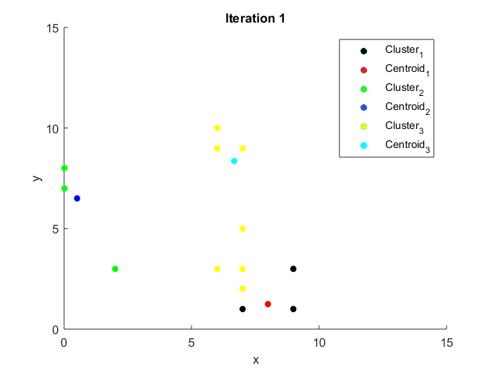

Iteration 2:

Customer 1

Centroid 1 = (X = 8, Y = 1.25), Distance = 2.0155644370746373

Centroid 2 = (X = 0.5, Y = 6.5), Distance = 9.192388155425117

Centroid 3 = (X = 6.671875, Y = 8.359375), Distance = 5.843206859785986

Min distance = 2.0155644370746373 at centroid 0 = (X = 8, Y = 1.25)

New centroid = (X = 8.5, Y = 2.125)

Customer 2

Centroid 1 = (X = 8.5, Y = 2.125), Distance = 6.558629811172453

Centroid 2 = (X = 0.5, Y = 6.5), Distance = 3.8078865529319543

Centroid 3 = (X = 6.671875, Y = 8.359375), Distance = 7.10980424528341

Min distance = 3.8078865529319543 at centroid 1 = (X = 0.5, Y = 6.5)

New centroid = (X = 1.25, Y = 4.75)

Customer 3

Centroid 1 = (X = 8.5, Y = 2.125), Distance = 2.6487025125521364

Centroid 2 = (X = 1.25, Y = 4.75), Distance = 5.062114182829147

Centroid 3 = (X = 6.671875, Y = 8.359375), Distance = 5.401325430507775

Min distance = 2.6487025125521364 at centroid 0 = (X = 8.5, Y = 2.125)

New centroid = (X = 7.25, Y = 2.5625)

Customer 4

Centroid 1 = (X = 7.25, Y = 2.5625), Distance = 2.3460405473904324

Centroid 2 = (X = 1.25, Y = 4.75), Distance = 8.609587678861281

Centroid 3 = (X = 6.671875, Y = 8.359375), Distance = 7.718844888080729

Min distance = 2.3460405473904324 at centroid 0 = (X = 7.25, Y = 2.5625)

New centroid = (X = 8.125, Y = 1.78125)

Customer 5

Centroid 1 = (X = 8.125, Y = 1.78125), Distance = 1.1730202736952162

Centroid 2 = (X = 1.25, Y = 4.75), Distance = 8.609587678861281

Centroid 3 = (X = 6.671875, Y = 8.359375), Distance = 7.718844888080729

Min distance = 1.1730202736952162 at centroid 0 = (X = 8.125, Y = 1.78125)

New centroid = (X = 8.5625, Y = 1.390625)

Customer 6

Centroid 1 = (X = 8.5625, Y = 1.390625), Distance = 1.677123770216438

Centroid 2 = (X = 1.25, Y = 4.75), Distance = 6.373774391990981

Centroid 3 = (X = 6.671875, Y = 8.359375), Distance = 6.367834514672158

Min distance = 1.677123770216438 at centroid 0 = (X = 8.5625, Y = 1.390625)

New centroid = (X = 7.78125, Y = 1.6953125)

Customer 7

Centroid 1 = (X = 7.78125, Y = 1.6953125), Distance = 1.5207107006778935

Centroid 2 = (X = 1.25, Y = 4.75), Distance = 6.010407640085654

Centroid 3 = (X = 6.671875, Y = 8.359375), Distance = 5.36941024752719

Min distance = 1.5207107006778935 at centroid 0 = (X = 7.78125, Y = 1.6953125)

New centroid = (X = 7.390625, Y = 2.34765625)

Customer 8

Centroid 1 = (X = 7.390625, Y = 2.34765625), Distance = 6.796139732141259

Centroid 2 = (X = 1.25, Y = 4.75), Distance = 6.373774391990981

Centroid 3 = (X = 6.671875, Y = 8.359375), Distance = 0.9283406735945593

Min distance = 0.9283406735945593 at centroid 2 = (X = 6.671875, Y = 8.359375)

New centroid = (X = 6.3359375, Y = 8.6796875)

Customer 9

Centroid 1 = (X = 7.390625, Y = 2.34765625), Distance = 1.403126957473579

Centroid 2 = (X = 1.25, Y = 4.75), Distance = 6.864765108872991

Centroid 3 = (X = 6.3359375, Y = 8.6796875), Distance = 7.708344770543317

Min distance = 1.403126957473579 at centroid 0 = (X = 7.390625, Y = 2.34765625)

New centroid = (X = 7.1953125, Y = 1.673828125)

Customer 10

Centroid 1 = (X = 7.1953125, Y = 1.673828125), Distance = 8.952129847957819

Centroid 2 = (X = 1.25, Y = 4.75), Distance = 2.57390753524675

Centroid 3 = (X = 6.3359375, Y = 8.6796875), Distance = 6.554803894973708

Min distance = 2.57390753524675 at centroid 1 = (X = 1.25, Y = 4.75)

New centroid = (X = 0.625, Y = 5.875)

Customer 11

Centroid 1 = (X = 7.1953125, Y = 1.673828125), Distance = 9.580864917359875

Centroid 2 = (X = 0.625, Y = 5.875), Distance = 2.2150056433336687

Centroid 3 = (X = 6.3359375, Y = 8.6796875), Distance = 6.372289941736997

Min distance = 2.2150056433336687 at centroid 1 = (X = 0.625, Y = 5.875)

New centroid = (X = 0.3125, Y = 6.9375)

Customer 12

Centroid 1 = (X = 7.1953125, Y = 1.673828125), Distance = 3.3319013062660283

Centroid 2 = (X = 0.3125, Y = 6.9375), Distance = 6.962511220816811

Centroid 3 = (X = 6.3359375, Y = 8.6796875), Distance = 3.739128120506504

Min distance = 3.3319013062660283 at centroid 0 = (X = 7.1953125, Y = 1.673828125)

New centroid = (X = 7.09765625, Y = 3.3369140625)

Customer 13

Centroid 1 = (X = 7.09765625, Y = 3.3369140625), Distance = 6.752892969215069

Centroid 2 = (X = 0.3125, Y = 6.9375), Distance = 6.459610088852113

Centroid 3 = (X = 6.3359375, Y = 8.6796875), Distance = 1.3623799402378545

Min distance = 1.3623799402378545 at centroid 2 = (X = 6.3359375, Y = 8.6796875)

New centroid = (X = 6.16796875, Y = 9.33984375)

Customer 14

Centroid 1 = (X = 7.09765625, Y = 3.3369140625), Distance = 5.66392788431088

Centroid 2 = (X = 0.3125, Y = 6.9375), Distance = 6.998325692621057

Centroid 3 = (X = 6.16796875, Y = 9.33984375), Distance = 0.8987601322881568

Min distance = 0.8987601322881568 at centroid 2 = (X = 6.16796875, Y = 9.33984375)

New centroid = (X = 6.583984375, Y = 9.169921875)

Iteration results:

Cluster 1:

Points: (X = 9, Y = 3); (X = 6, Y = 3); (X = 9, Y = 1); (X = 9, Y = 1); (X = 7, Y = 2); (X = 7, Y = 3); (X = 7, Y = 1); (X = 7, Y = 5)

Centroid: (X = 7.09765625, Y = 3.3369140625)

Cluster 2:

Points: (X = 2, Y = 3);(X = 0, Y = 7);(X = 0, Y = 8)

Centroid: (X = 0.3125, Y = 6.9375)

Cluster 3:

Points: (X = 6, Y = 9);(X = 6, Y = 10);(X = 7, Y = 9)

Centroid: (X = 6.583984375, Y = 9.169921875)

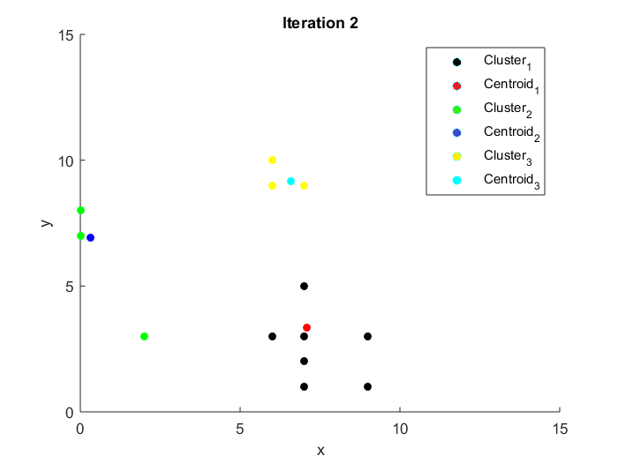

Iteration 3:

Customer 1

Centroid 1 = (X = 7.09765625, Y = 3.3369140625), Distance = 1.9319479363260068

Centroid 2 = (X = 0.3125, Y = 6.9375), Distance = 9.538163476267325

Centroid 3 = (X = 6.583984375, Y = 9.169921875), Distance = 6.62608990610961

Min distance = 1.9319479363260068 at centroid 0 = (X = 7.09765625, Y = 3.3369140625)

New centroid = (X = 8.048828125, Y = 3.16845703125)

Customer 2

Centroid 1 = (X = 8.048828125, Y = 3.16845703125), Distance = 6.051173395067156

Centroid 2 = (X = 0.3125, Y = 6.9375), Distance = 4.283872372048449

Centroid 3 = (X = 6.583984375, Y = 9.169921875), Distance = 7.686406747879509

Min distance = 4.283872372048449 at centroid 1 = (X = 0.3125, Y = 6.9375)

New centroid = (X = 1.15625, Y = 4.96875)

Customer 3

Centroid 1 = (X = 8.048828125, Y = 3.16845703125), Distance = 2.055741826487115

Centroid 2 = (X = 1.15625, Y = 4.96875), Distance = 5.228564872410019

Centroid 3 = (X = 6.583984375, Y = 9.169921875), Distance = 6.197497373444191

Min distance = 2.055741826487115 at centroid 0 = (X = 8.048828125, Y = 3.16845703125)

New centroid = (X = 7.0244140625, Y = 3.084228515625)

Customer 4

Centroid 1 = (X = 7.0244140625, Y = 3.084228515625), Distance = 2.8717500416631223

Centroid 2 = (X = 1.15625, Y = 4.96875), Distance = 8.790642219144173

Centroid 3 = (X = 6.583984375, Y = 9.169921875), Distance = 8.51966871092108

Min distance = 2.8717500416631223 at centroid 0 = (X = 7.0244140625, Y = 3.084228515625)

New centroid = (X = 8.01220703125, Y = 2.0421142578125)

Customer 5

Centroid 1 = (X = 8.01220703125, Y = 2.0421142578125), Distance = 1.4358750208315612

Centroid 2 = (X = 1.15625, Y = 4.96875), Distance = 8.790642219144173

Centroid 3 = (X = 6.583984375, Y = 9.169921875), Distance = 8.51966871092108

Min distance = 1.4358750208315612 at centroid 0 = (X = 8.01220703125, Y = 2.0421142578125)

New centroid = (X = 8.506103515625, Y = 1.52105712890625)

Customer 6

Centroid 1 = (X = 8.506103515625, Y = 1.52105712890625), Distance = 1.580422118786468

Centroid 2 = (X = 1.15625, Y = 4.96875), Distance = 6.554608350237259

Centroid 3 = (X = 6.583984375, Y = 9.169921875), Distance = 7.1819808335756266

Min distance = 1.580422118786468 at centroid 0 = (X = 8.506103515625, Y = 1.52105712890625)

New centroid = (X = 7.7530517578125, Y = 1.760528564453125)

Customer 7

Centroid 1 = (X = 7.7530517578125, Y = 1.760528564453125), Distance = 1.4503021717839104

Centroid 2 = (X = 1.15625, Y = 4.96875), Distance = 6.166473110701125

Centroid 3 = (X = 6.583984375, Y = 9.169921875), Distance = 6.183931188479352

Min distance = 1.4503021717839104 at centroid 0 = (X = 7.7530517578125, Y = 1.760528564453125)

New centroid = (X = 7.37652587890625, Y = 2.3802642822265625)

Customer 8

Centroid 1 = (X = 7.37652587890625, Y = 2.3802642822265625), Distance = 6.761340434297332

Centroid 2 = (X = 1.15625, Y = 4.96875), Distance = 6.301816454404238

Centroid 3 = (X = 6.583984375, Y = 9.169921875), Distance = 0.6082032504415413

Min distance = 0.6082032504415413 at centroid 2 = (X = 6.583984375, Y = 9.169921875)

New centroid = (X = 6.2919921875, Y = 9.0849609375)

Customer 9

Centroid 1 = (X = 7.37652587890625, Y = 2.3802642822265625), Distance = 1.4306995583547693

Centroid 2 = (X = 1.15625, Y = 4.96875), Distance = 7.0640208539471345

Centroid 3 = (X = 6.2919921875, Y = 9.0849609375), Distance = 8.115902194054701

Min distance = 1.4306995583547693 at centroid 0 = (X = 7.37652587890625, Y = 2.3802642822265625)

New centroid = (X = 7.188262939453125, Y = 1.6901321411132812)

Customer 10

Centroid 1 = (X = 7.188262939453125, Y = 1.6901321411132812), Distance = 8.936767914942935

Centroid 2 = (X = 1.15625, Y = 4.96875), Distance = 2.337282743914394

Centroid 3 = (X = 6.2919921875, Y = 9.0849609375), Distance = 6.628440827107225

Min distance = 2.337282743914394 at centroid 1 = (X = 1.15625, Y = 4.96875)

New centroid = (X = 0.578125, Y = 5.984375)

Customer 11

Centroid 1 = (X = 7.188262939453125, Y = 1.6901321411132812), Distance = 9.564808230347692

Centroid 2 = (X = 0.578125, Y = 5.984375), Distance = 2.09689595742135

Centroid 3 = (X = 6.2919921875, Y = 9.0849609375), Distance = 6.38484971815797

Min distance = 2.09689595742135 at centroid 1 = (X = 0.578125, Y = 5.984375)

New centroid = (X = 0.2890625, Y = 6.9921875)

Customer 12

Centroid 1 = (X = 7.188262939453125, Y = 1.6901321411132812), Distance = 3.3152176667095152

Centroid 2 = (X = 0.2890625, Y = 6.9921875), Distance = 7.000392357865557

Centroid 3 = (X = 6.2919921875, Y = 9.0849609375), Distance = 4.145863109590319

Min distance = 3.3152176667095152 at centroid 0 = (X = 7.188262939453125, Y = 1.6901321411132812)

New centroid = (X = 7.0941314697265625, Y = 3.3450660705566406)

Customer 13

Centroid 1 = (X = 7.0941314697265625, Y = 3.3450660705566406), Distance = 6.744276779485139

Centroid 2 = (X = 0.2890625, Y = 6.9921875), Distance = 6.454590859540402

Centroid 3 = (X = 6.2919921875, Y = 9.0849609375), Distance = 0.960497747765144

Min distance = 0.960497747765144 at centroid 2 = (X = 6.2919921875, Y = 9.0849609375)

New centroid = (X = 6.14599609375, Y = 9.54248046875)

Customer 14

Centroid 1 = (X = 7.0941314697265625, Y = 3.3450660705566406), Distance = 5.655717326737838

Centroid 2 = (X = 0.2890625, Y = 6.9921875), Distance = 7.004854970951397

Centroid 3 = (X = 6.14599609375, Y = 9.54248046875), Distance = 1.011735010200536

Min distance = 1.011735010200536 at centroid 2 = (X = 6.14599609375, Y = 9.54248046875)

New centroid = (X = 6.572998046875, Y = 9.271240234375)

Iteration results:

Cluster 1:

Points: (X = 9, Y = 3); (X = 6, Y = 3); (X = 9, Y = 1); (X = 9, Y = 1); (X = 7, Y = 2); (X = 7, Y = 3); (X = 7, Y = 1); (X = 7, Y = 5)

Centroid: (X = 7.0941314697265625, Y = 3.3450660705566406)

Cluster 2:

Points: (X = 2, Y = 3);(X = 0, Y = 7);(X = 0, Y = 8)

Centroid: (X = 0.2890625, Y = 6.9921875)

Cluster 3:

Points: (X = 6, Y = 9);(X = 6, Y = 10);(X = 7, Y = 9)

Centroid: (X = 6.572998046875, Y = 9.271240234375)

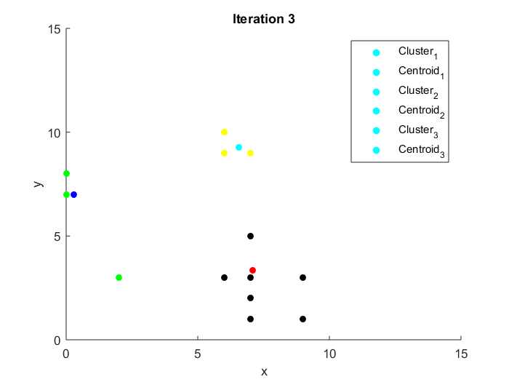

Итого три итерации.

* На 1-м шаге (итерации) центроидами являются следующие точки: (2,2), (5,5), (7,7)

Iteration 1:

Customer 1

Centroid 1 = (X = 2, Y = 2), Distance = 7.0710678118654755

Centroid 2 = (X = 5, Y = 5), Distance = 4.47213595499958

Centroid 3 = (X = 7, Y = 7), Distance = 4.47213595499958

Min distance = 4.47213595499958 at centroid 1 = (X = 5, Y = 5)

New centroid = (X = 7, Y = 4)

Customer 2

Centroid 1 = (X = 2, Y = 2), Distance = 1

Centroid 2 = (X = 7, Y = 4), Distance = 5.0990195135927845

Centroid 3 = (X = 7, Y = 7), Distance = 6.4031242374328485

Min distance = 1 at centroid 0 = (X = 2, Y = 2)

New centroid = (X = 2, Y = 2.5)

Customer 3

Centroid 1 = (X = 2, Y = 2.5), Distance = 4.031128874149275

Centroid 2 = (X = 7, Y = 4), Distance = 1.4142135623730951

Centroid 3 = (X = 7, Y = 7), Distance = 4.123105625617661

Min distance = 1.4142135623730951 at centroid 1 = (X = 7, Y = 4)

New centroid = (X = 6.5, Y = 3.5)

Customer 4

Centroid 1 = (X = 2, Y = 2.5), Distance = 7.158910531638177

Centroid 2 = (X = 6.5, Y = 3.5), Distance = 3.5355339059327378

Centroid 3 = (X = 7, Y = 7), Distance = 6.324555320336759

Min distance = 3.5355339059327378 at centroid 1 = (X = 6.5, Y = 3.5)

New centroid = (X = 7.75, Y = 2.25)

Customer 5

Centroid 1 = (X = 2, Y = 2.5), Distance = 7.158910531638177

Centroid 2 = (X = 7.75, Y = 2.25), Distance = 1.7677669529663689

Centroid 3 = (X = 7, Y = 7), Distance = 6.324555320336759

Min distance = 1.7677669529663689 at centroid 1 = (X = 7.75, Y = 2.25)

New centroid = (X = 8.375, Y = 1.625)

Customer 6

Centroid 1 = (X = 2, Y = 2.5), Distance = 5.024937810560445

Centroid 2 = (X = 8.375, Y = 1.625), Distance = 1.4252192813739224

Centroid 3 = (X = 7, Y = 7), Distance = 5

Min distance = 1.4252192813739224 at centroid 1 = (X = 8.375, Y = 1.625)

New centroid = (X = 7.6875, Y = 1.8125)

Customer 7

Centroid 1 = (X = 2, Y = 2.5), Distance = 5.024937810560445

Centroid 2 = (X = 7.6875, Y = 1.8125), Distance = 1.3721561500062593

Centroid 3 = (X = 7, Y = 7), Distance = 4

Min distance = 1.3721561500062593 at centroid 1 = (X = 7.6875, Y = 1.8125)

New centroid = (X = 7.34375, Y = 2.40625)

Customer 8

Centroid 1 = (X = 2, Y = 2.5), Distance = 7.632168761236874

Centroid 2 = (X = 7.34375, Y = 2.40625), Distance = 6.729279539817022

Centroid 3 = (X = 7, Y = 7), Distance = 2.23606797749979

Min distance = 2.23606797749979 at centroid 2 = (X = 7, Y = 7)

New centroid = (X = 6.5, Y = 8)

Customer 9

Centroid 1 = (X = 2, Y = 2.5), Distance = 5.220153254455275

Centroid 2 = (X = 7.34375, Y = 2.40625), Distance = 1.4476543527375587

Centroid 3 = (X = 6.5, Y = 8), Distance = 7.0178344238090995

Min distance = 1.4476543527375587 at centroid 1 = (X = 7.34375, Y = 2.40625)

New centroid = (X = 7.171875, Y = 1.703125)

Customer 10

Centroid 1 = (X = 2, Y = 2.5), Distance = 4.924428900898052

Centroid 2 = (X = 7.171875, Y = 1.703125), Distance = 8.91586651881072

Centroid 3 = (X = 6.5, Y = 8), Distance = 6.576473218982953

Min distance = 4.924428900898052 at centroid 0 = (X = 2, Y = 2.5)

New centroid = (X = 1, Y = 4.75)

Customer 11

Centroid 1 = (X = 1, Y = 4.75), Distance = 3.400367627183861

Centroid 2 = (X = 7.171875, Y = 1.703125), Distance = 9.543920880919435

Centroid 3 = (X = 6.5, Y = 8), Distance = 6.5

Min distance = 3.400367627183861 at centroid 0 = (X = 1, Y = 4.75)

New centroid = (X = 0.5, Y = 6.375)

Customer 12

Centroid 1 = (X = 0.5, Y = 6.375), Distance = 6.643841132959156

Centroid 2 = (X = 7.171875, Y = 1.703125), Distance = 3.3013521140965865

Centroid 3 = (X = 6.5, Y = 8), Distance = 3.0413812651491097

Min distance = 3.0413812651491097 at centroid 2 = (X = 6.5, Y = 8)

New centroid = (X = 6.75, Y = 6.5)

Customer 13

Centroid 1 = (X = 0.5, Y = 6.375), Distance = 6.587156063127699

Centroid 2 = (X = 7.171875, Y = 1.703125), Distance = 8.379225846177556

Centroid 3 = (X = 6.75, Y = 6.5), Distance = 3.5794552658190883

Min distance = 3.5794552658190883 at centroid 2 = (X = 6.75, Y = 6.5)

New centroid = (X = 6.375, Y = 8.25)

Customer 14

Centroid 1 = (X = 0.5, Y = 6.375), Distance = 7.010037446404977

Centroid 2 = (X = 7.171875, Y = 1.703125), Distance = 7.298898943076963

Centroid 3 = (X = 6.375, Y = 8.25), Distance = 0.9762812094883317

Min distance = 0.9762812094883317 at centroid 2 = (X = 6.375, Y = 8.25)

New centroid = (X = 6.6875, Y = 8.625)

Iteration results:

Cluster 1:

Points: (X = 2, Y = 3); (X = 0, Y = 7); (X = 0, Y = 8)

Centroid: (X = 0.5, Y = 6.375)

Cluster 2:

Points: (X = 9, Y = 3);(X = 6, Y = 3);(X = 9, Y = 1);(X = 9, Y = 1);(X = 7, Y = 2);(X = 7, Y = 3);(X = 7, Y = 1)

Centroid: (X = 7.171875, Y = 1.703125)

Cluster 3:

Points: (X = 6, Y = 9);(X = 7, Y = 5);(X = 6, Y = 10);(X = 7, Y = 9)

Centroid: (X = 6.6875, Y = 8.625)

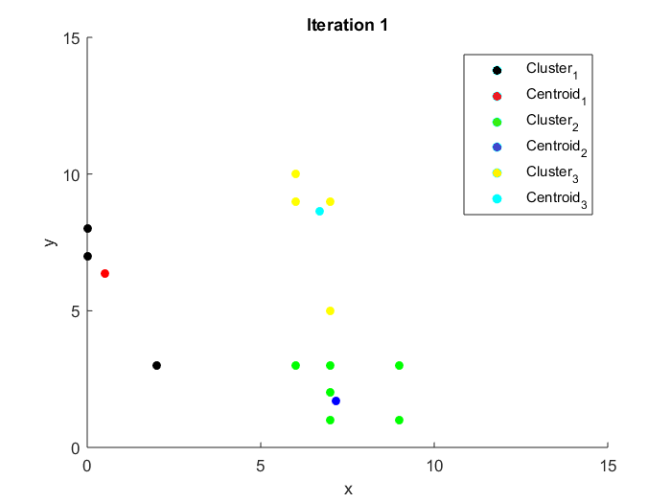

Iteration 2:

Customer 1

Centroid 1 = (X = 0.5, Y = 6.375), Distance = 9.145524861920173

Centroid 2 = (X = 7.171875, Y = 1.703125), Distance = 2.241411559988482

Centroid 3 = (X = 6.6875, Y = 8.625), Distance = 6.0817991786970405

Min distance = 2.241411559988482 at centroid 1 = (X = 7.171875, Y = 1.703125)

New centroid = (X = 8.0859375, Y = 2.3515625)

Customer 2

Centroid 1 = (X = 0.5, Y = 6.375), Distance = 3.6933216756735394

Centroid 2 = (X = 8.0859375, Y = 2.3515625), Distance = 6.120384501427382

Centroid 3 = (X = 6.6875, Y = 8.625), Distance = 7.3221090711624885

Min distance = 3.6933216756735394 at centroid 0 = (X = 0.5, Y = 6.375)

New centroid = (X = 1.25, Y = 4.6875)

Customer 3

Centroid 1 = (X = 1.25, Y = 4.6875), Distance = 5.040848762857303

Centroid 2 = (X = 8.0859375, Y = 2.3515625), Distance = 2.184400706214979

Centroid 3 = (X = 6.6875, Y = 8.625), Distance = 5.6668581462747065

Min distance = 2.184400706214979 at centroid 1 = (X = 8.0859375, Y = 2.3515625)

New centroid = (X = 7.04296875, Y = 2.67578125)

Customer 4

Centroid 1 = (X = 1.25, Y = 4.6875), Distance = 8.582549519227955

Centroid 2 = (X = 7.04296875, Y = 2.67578125), Distance = 2.5764731924334328

Centroid 3 = (X = 6.6875, Y = 8.625), Distance = 7.96795339155545

Min distance = 2.5764731924334328 at centroid 1 = (X = 7.04296875, Y = 2.67578125)

New centroid = (X = 8.021484375, Y = 1.837890625)

Customer 5

Centroid 1 = (X = 1.25, Y = 4.6875), Distance = 8.582549519227955

Centroid 2 = (X = 8.021484375, Y = 1.837890625), Distance = 1.2882365962167164

Centroid 3 = (X = 6.6875, Y = 8.625), Distance = 7.96795339155545

Min distance = 1.2882365962167164 at centroid 1 = (X = 8.021484375, Y = 1.837890625)

New centroid = (X = 8.5107421875, Y = 1.4189453125)

Customer 6

Centroid 1 = (X = 1.25, Y = 4.6875), Distance = 6.347058866120591

Centroid 2 = (X = 8.5107421875, Y = 1.4189453125), Distance = 1.6186310595555764

Centroid 3 = (X = 6.6875, Y = 8.625), Distance = 6.6323661878699065

Min distance = 1.6186310595555764 at centroid 1 = (X = 8.5107421875, Y = 1.4189453125)

New centroid = (X = 7.75537109375, Y = 1.70947265625)

Customer 7

Centroid 1 = (X = 1.25, Y = 4.6875), Distance = 5.992508343757228

Centroid 2 = (X = 7.75537109375, Y = 1.70947265625), Distance = 1.4953415376560306

Centroid 3 = (X = 6.6875, Y = 8.625), Distance = 5.633673867912483

Min distance = 1.4953415376560306 at centroid 1 = (X = 7.75537109375, Y = 1.70947265625)

New centroid = (X = 7.377685546875, Y = 2.354736328125)

Customer 8

Centroid 1 = (X = 1.25, Y = 4.6875), Distance = 6.415618150264244

Centroid 2 = (X = 7.377685546875, Y = 2.354736328125), Distance = 6.786571058701874

Centroid 3 = (X = 6.6875, Y = 8.625), Distance = 0.7831227553838542

Min distance = 0.7831227553838542 at centroid 2 = (X = 6.6875, Y = 8.625)

New centroid = (X = 6.34375, Y = 8.8125)

Customer 9

Centroid 1 = (X = 1.25, Y = 4.6875), Distance = 6.8308239803115995

Centroid 2 = (X = 7.377685546875, Y = 2.354736328125), Distance = 1.4063985534192913

Centroid 3 = (X = 6.34375, Y = 8.8125), Distance = 7.8400140505295015

Min distance = 1.4063985534192913 at centroid 1 = (X = 7.377685546875, Y = 2.354736328125)

New centroid = (X = 7.1888427734375, Y = 1.6773681640625)

Customer 10

Centroid 1 = (X = 1.25, Y = 4.6875), Distance = 2.6287176056016364

Centroid 2 = (X = 7.1888427734375, Y = 1.6773681640625), Distance = 8.944823647347105

Centroid 3 = (X = 6.34375, Y = 8.8125), Distance = 6.597599587160469

Min distance = 2.6287176056016364 at centroid 0 = (X = 1.25, Y = 4.6875)

New centroid = (X = 0.625, Y = 5.84375)

Customer 11

Centroid 1 = (X = 0.625, Y = 5.84375), Distance = 2.245003131957726

Centroid 2 = (X = 7.1888427734375, Y = 1.6773681640625), Distance = 9.573668771898001

Centroid 3 = (X = 6.34375, Y = 8.8125), Distance = 6.395570366472407

Min distance = 2.245003131957726 at centroid 0 = (X = 0.625, Y = 5.84375)

New centroid = (X = 0.3125, Y = 6.921875)

Customer 12

Centroid 1 = (X = 0.3125, Y = 6.921875), Distance = 6.958179342732192

Centroid 2 = (X = 7.1888427734375, Y = 1.6773681640625), Distance = 3.3279939768973392

Centroid 3 = (X = 6.34375, Y = 8.8125), Distance = 3.8685682509812334

Min distance = 3.3279939768973392 at centroid 1 = (X = 7.1888427734375, Y = 1.6773681640625)

New centroid = (X = 7.09442138671875, Y = 3.33868408203125)

Customer 13

Centroid 1 = (X = 0.3125, Y = 6.921875), Distance = 6.467032531665895

Centroid 2 = (X = 7.09442138671875, Y = 3.33868408203125), Distance = 6.750621299605781

Centroid 3 = (X = 6.34375, Y = 8.8125), Distance = 1.23625252780328

Min distance = 1.23625252780328 at centroid 2 = (X = 6.34375, Y = 8.8125)

New centroid = (X = 6.171875, Y = 9.40625)

Customer 14

Centroid 1 = (X = 0.3125, Y = 6.921875), Distance = 7.002946505980536

Centroid 2 = (X = 7.09442138671875, Y = 3.33868408203125), Distance = 5.6621032595066865

Centroid 3 = (X = 6.171875, Y = 9.40625), Distance = 0.9224045089465901

Min distance = 0.9224045089465901 at centroid 2 = (X = 6.171875, Y = 9.40625)

New centroid = (X = 6.5859375, Y = 9.203125)

Iteration results:

Cluster 1:

Points: (X = 2, Y = 3); (X = 0, Y = 7); (X = 0, Y = 8)

Centroid: (X = 0.3125, Y = 6.921875)

Cluster 2:

Points: (X = 9, Y = 3);(X = 6, Y = 3);(X = 9, Y = 1);(X = 9, Y = 1);(X = 7, Y = 2);(X = 7, Y = 3);(X = 7, Y = 1);(X = 7, Y = 5)

Centroid: (X = 7.09442138671875, Y = 3.33868408203125)

Cluster 3:

Points: (X = 6, Y = 9);(X = 6, Y = 10);(X = 7, Y = 9)

Centroid: (X = 6.5859375, Y = 9.203125)

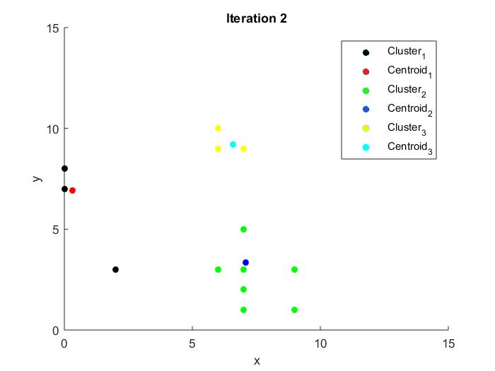

Iteration 3:

Customer 1

Centroid 1 = (X = 0.3125, Y = 6.921875), Distance = 9.531723861171441

Centroid 2 = (X = 7.09442138671875, Y = 3.33868408203125), Distance = 1.935442264397531

Centroid 3 = (X = 6.5859375, Y = 9.203125), Distance = 6.656309602139255

Min distance = 1.935442264397531 at centroid 1 = (X = 7.09442138671875, Y = 3.33868408203125)

New centroid = (X = 8.047210693359375, Y = 3.169342041015625)

Customer 2

Centroid 1 = (X = 0.3125, Y = 6.921875), Distance = 4.269515167513169

Centroid 2 = (X = 8.047210693359375, Y = 3.169342041015625), Distance = 6.049581299291325

Centroid 3 = (X = 6.5859375, Y = 9.203125), Distance = 7.714245427748021

Min distance = 4.269515167513169 at centroid 0 = (X = 0.3125, Y = 6.921875)

New centroid = (X = 1.15625, Y = 4.9609375)

Customer 3

Centroid 1 = (X = 1.15625, Y = 4.9609375), Distance = 5.225628186295524

Centroid 2 = (X = 8.047210693359375, Y = 3.169342041015625), Distance = 2.054202606818595

Centroid 3 = (X = 6.5859375, Y = 9.203125), Distance = 6.230736916250858

Min distance = 2.054202606818595 at centroid 1 = (X = 8.047210693359375, Y = 3.169342041015625)

New centroid = (X = 7.0236053466796875, Y = 3.0846710205078125)

Customer 4

Centroid 1 = (X = 1.15625, Y = 4.9609375), Distance = 8.787117840418794

Centroid 2 = (X = 7.0236053466796875, Y = 3.0846710205078125), Distance = 2.872627558424204

Centroid 3 = (X = 6.5859375, Y = 9.203125), Distance = 8.550962373881156

Min distance = 2.872627558424204 at centroid 1 = (X = 7.0236053466796875, Y = 3.0846710205078125)

New centroid = (X = 8.011802673339844, Y = 2.0423355102539062)

Customer 5

Centroid 1 = (X = 1.15625, Y = 4.9609375), Distance = 8.787117840418794

Centroid 2 = (X = 8.011802673339844, Y = 2.0423355102539062), Distance = 1.436313779212102

Centroid 3 = (X = 6.5859375, Y = 9.203125), Distance = 8.550962373881156

Min distance = 1.436313779212102 at centroid 1 = (X = 8.011802673339844, Y = 2.0423355102539062)

New centroid = (X = 8.505901336669922, Y = 1.5211677551269531)

Customer 6

Centroid 1 = (X = 1.15625, Y = 4.9609375), Distance = 6.551073571667948

Centroid 2 = (X = 8.505901336669922, Y = 1.5211677551269531), Distance = 1.580195922825527

Centroid 3 = (X = 6.5859375, Y = 9.203125), Distance = 7.215016113601636

Min distance = 1.580195922825527 at centroid 1 = (X = 8.505901336669922, Y = 1.5211677551269531)

New centroid = (X = 7.752950668334961, Y = 1.7605838775634766)

Customer 7

Centroid 1 = (X = 1.15625, Y = 4.9609375), Distance = 6.16398328529582

Centroid 2 = (X = 7.752950668334961, Y = 1.7605838775634766), Distance = 1.450202411217707

Centroid 3 = (X = 6.5859375, Y = 9.203125), Distance = 6.216929106844572

Min distance = 1.450202411217707 at centroid 1 = (X = 7.752950668334961, Y = 1.7605838775634766)

New centroid = (X = 7.3764753341674805, Y = 2.3802919387817383)

Customer 8

Centroid 1 = (X = 1.15625, Y = 4.9609375), Distance = 6.306816942119554

Centroid 2 = (X = 7.3764753341674805, Y = 2.3802919387817383), Distance = 6.761303066815561

Centroid 3 = (X = 6.5859375, Y = 9.203125), Distance = 0.6201471757020667

Min distance = 0.6201471757020667 at centroid 2 = (X = 6.5859375, Y = 9.203125)

New centroid = (X = 6.29296875, Y = 9.1015625)

Customer 9

Centroid 1 = (X = 1.15625, Y = 4.9609375), Distance = 7.0596345472982

Centroid 2 = (X = 7.3764753341674805, Y = 2.3802919387817383), Distance = 1.4307129388882893

Centroid 3 = (X = 6.29296875, Y = 9.1015625), Distance = 8.132355632280404

Min distance = 1.4307129388882893 at centroid 1 = (X = 7.3764753341674805, Y = 2.3802919387817383)

New centroid = (X = 7.18823766708374, Y = 1.6901459693908691)

Customer 10

Centroid 1 = (X = 1.15625, Y = 4.9609375), Distance = 2.344075498230859

Centroid 2 = (X = 7.18823766708374, Y = 1.6901459693908691), Distance = 8.936739370981876

Centroid 3 = (X = 6.29296875, Y = 9.1015625), Distance = 6.634607797743798

Min distance = 2.344075498230859 at centroid 0 = (X = 1.15625, Y = 4.9609375)

New centroid = (X = 0.578125, Y = 5.98046875)

Customer 11

Centroid 1 = (X = 0.578125, Y = 5.98046875), Distance = 2.100651086056788

Centroid 2 = (X = 7.18823766708374, Y = 1.6901459693908691), Distance = 9.56478011488376

Centroid 3 = (X = 6.29296875, Y = 9.1015625), Distance = 6.388653663322407

Min distance = 2.100651086056788 at centroid 0 = (X = 0.578125, Y = 5.98046875)

New centroid = (X = 0.2890625, Y = 6.990234375)

Customer 12

Centroid 1 = (X = 0.2890625, Y = 6.990234375), Distance = 6.999836783549878

Centroid 2 = (X = 7.18823766708374, Y = 1.6901459693908691), Distance = 3.315202425682124

Centroid 3 = (X = 6.29296875, Y = 9.1015625), Distance = 4.162055757661448

Min distance = 3.315202425682124 at centroid 1 = (X = 7.18823766708374, Y = 1.6901459693908691)

New centroid = (X = 7.09411883354187, Y = 3.3450729846954346)

Customer 13

Centroid 1 = (X = 0.2890625, Y = 6.990234375), Distance = 6.455501238969588

Centroid 2 = (X = 7.09411883354187, Y = 3.3450729846954346), Distance = 6.7442679069667415

Centroid 3 = (X = 6.29296875, Y = 9.1015625), Distance = 0.944997687765855

Min distance = 0.944997687765855 at centroid 2 = (X = 6.29296875, Y = 9.1015625)

New centroid = (X = 6.146484375, Y = 9.55078125)

Customer 14

Centroid 1 = (X = 0.2890625, Y = 6.990234375), Distance = 7.005415048113702

Centroid 2 = (X = 7.09411883354187, Y = 3.3450729846954346), Distance = 5.655710203259064

Centroid 3 = (X = 6.146484375, Y = 9.55078125), Distance = 1.0157996394322568

Min distance = 1.0157996394322568 at centroid 2 = (X = 6.146484375, Y = 9.55078125)

New centroid = (X = 6.5732421875, Y = 9.275390625)

Iteration results:

Cluster 1:

Points: (X = 2, Y = 3); (X = 0, Y = 7); (X = 0, Y = 8)

Centroid: (X = 0.2890625, Y = 6.990234375)

Cluster 2:

Points: (X = 9, Y = 3);(X = 6, Y = 3);(X = 9, Y = 1);(X = 9, Y = 1);(X = 7, Y = 2);(X = 7, Y = 3);(X = 7, Y = 1);(X = 7, Y = 5)

Centroid: (X = 7.09411883354187, Y = 3.3450729846954346)

Cluster 3:

Points: (X = 6, Y = 9);(X = 6, Y = 10);(X = 7, Y = 9)

Centroid: (X = 6.5732421875, Y = 9.275390625)

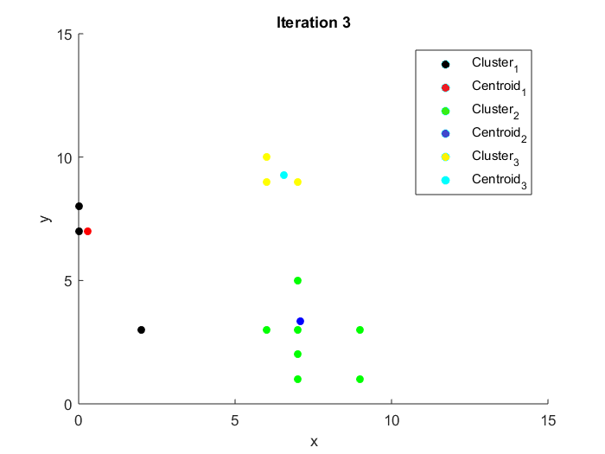

Итого три итерации.

Сравнение составов кластеров в трех разных вариантах:

