Preferences not applying
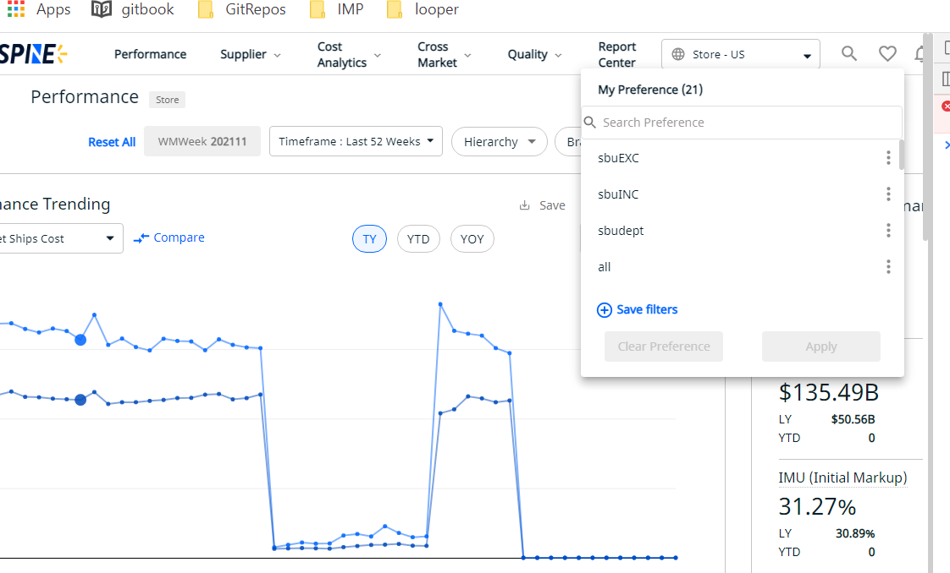
Preferences not showing hierarchies brand and merchant selected in UI
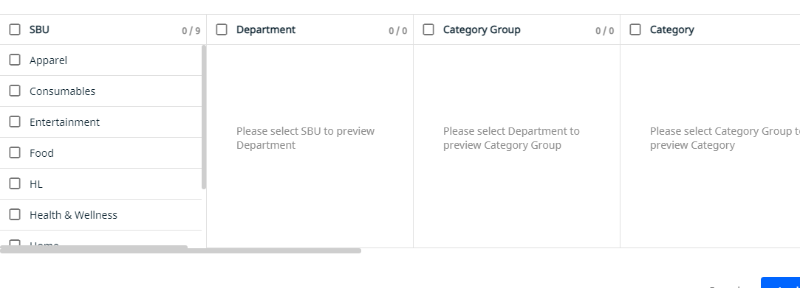
Mass upload not working for preferences
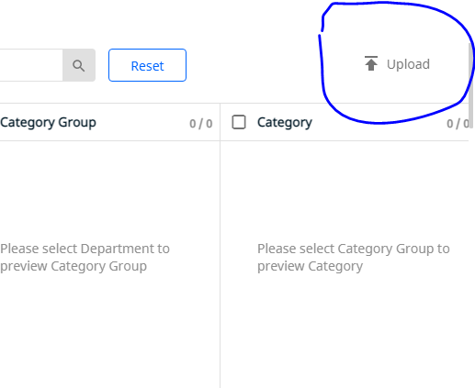
Market not getting applied for preferences when changed from international to US or vice versa
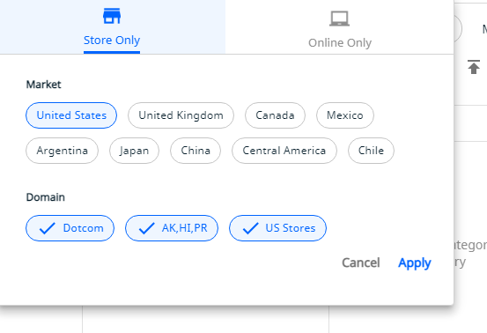
Supplier assessment, grid value and table value do not match for vendor count
Preference save call setting wrong data for hierarchies with different id and name
Old preferences not working in new application.
Hierarchies getting applied on top of each other.

