In Performance page, API calls were getting called twice for globalfilters changes - Fixed
Indexing in trending graph changed from index to week_id
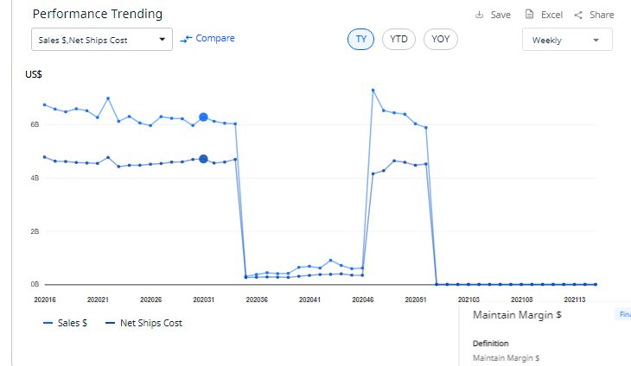
Deployed all the changes for report Level to PROD,
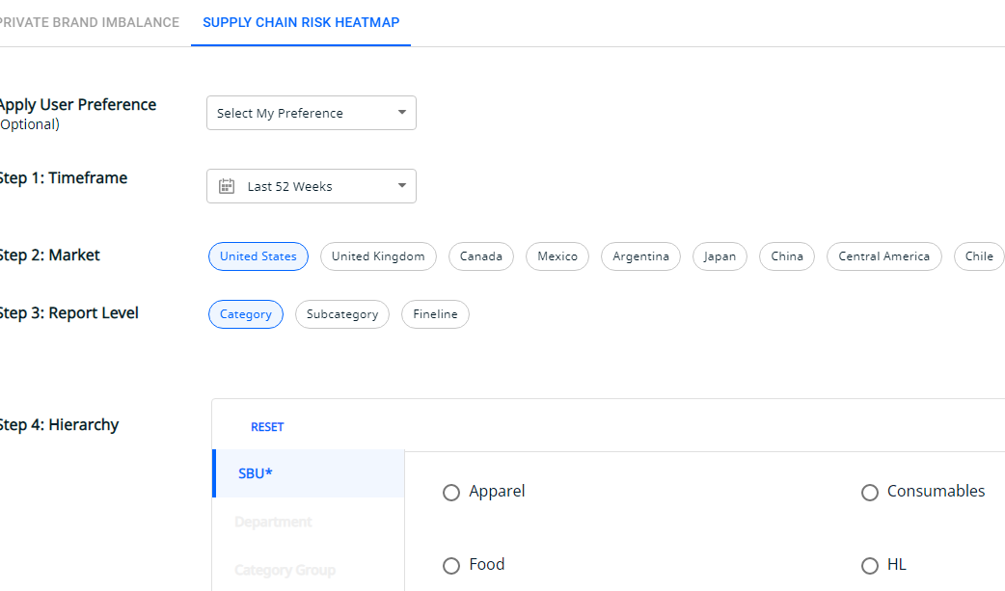

Added netfirst cost field to itemlevel custom columns

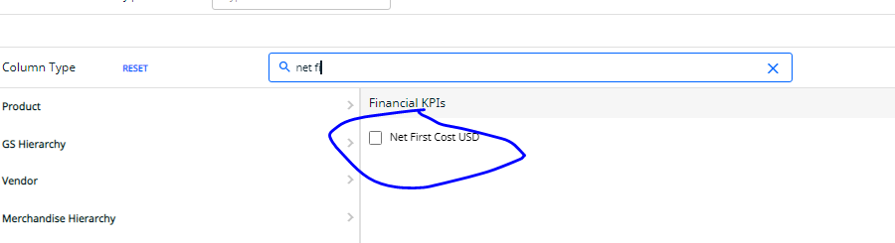
Worked on data ingestion task in which and added logic to show specific market in page

