Adding report level and LAA market changes to QA
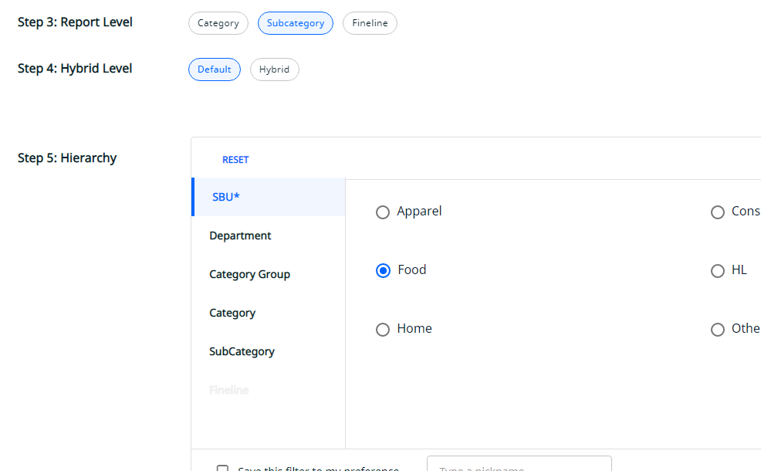

Not showing error popup when error status code is 401
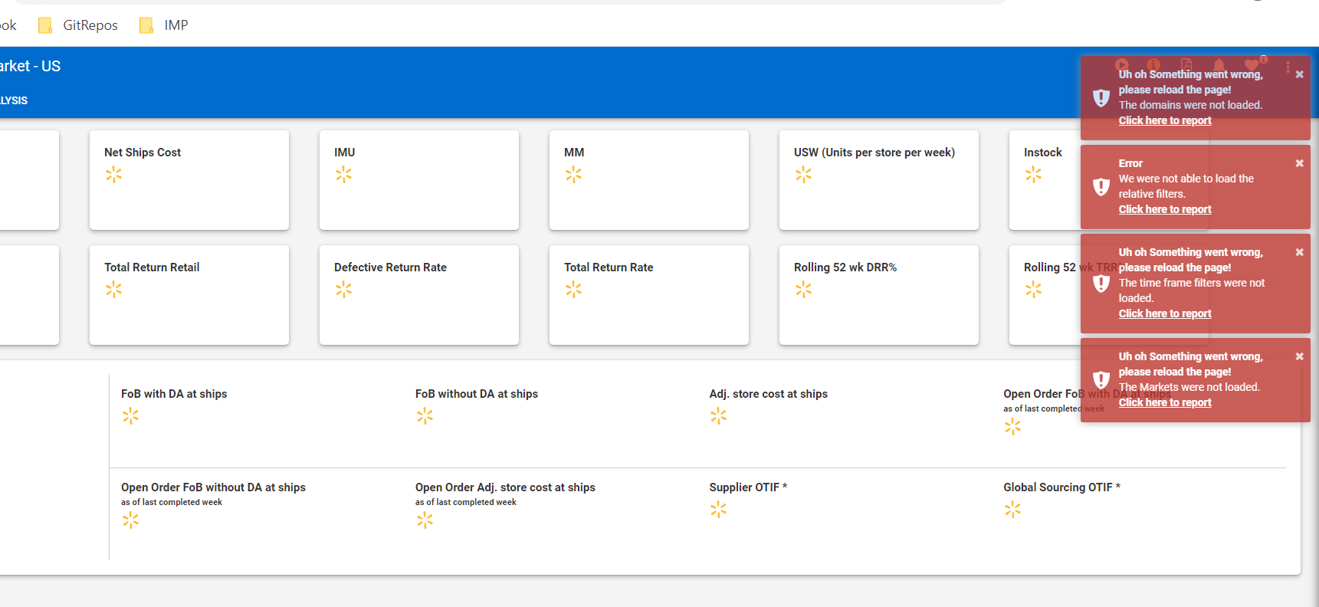

Not showing dotcom only preferences in DI conversion
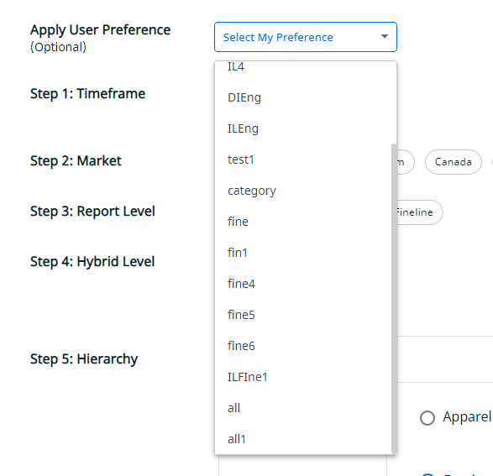

Changing payload while saving preferences in DI conversion to avoid making the preference corrupted in other components.
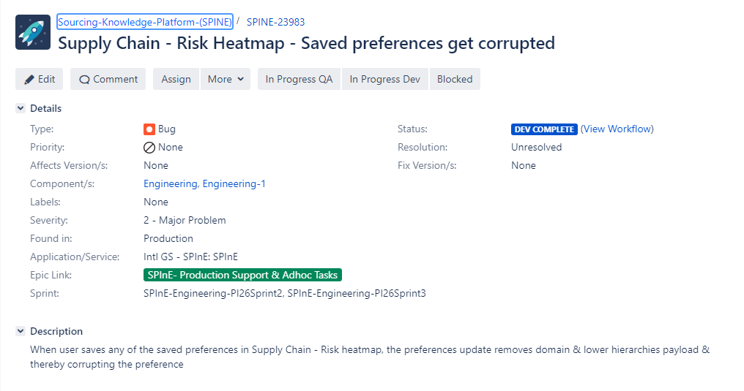

Exploration of production bug in which pdf/excel calls were failing due to static code setting in payload (it turns out to be database issue after exploration)
