GAME

Game Title: NURSiFY

Pag inopen nila yung app mag loloading

1. WELCOME TO NURSiFY

Select your character, enter name

START

Hello nurse (name), you are assigned to be the nurse on duty here in (er,opd) department. Your job is to assess the patients correctly. Goodluck nurse (name)!

1. Rules:

* Every correct answer is worth 10 points while 2 points are deducted for every wrong answer.
* A time limit of 10 seconds for each question.
* At the end of the game the winner will be determined.

1. (click) START

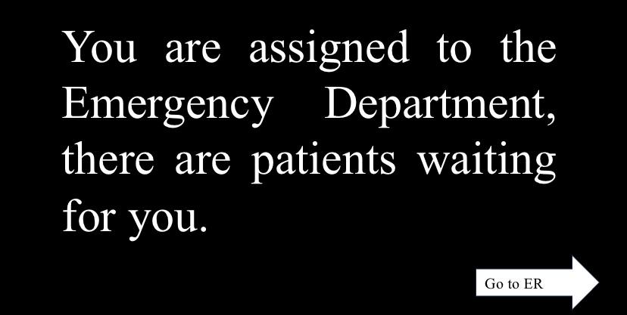

1. EMERGENCY ROOM (select a patient)

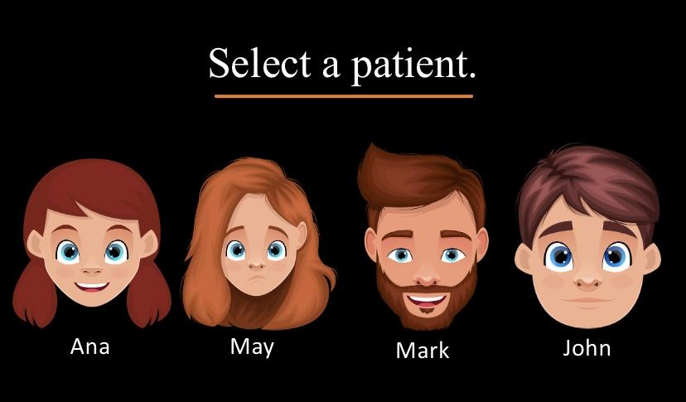

1. May is selected (click) May

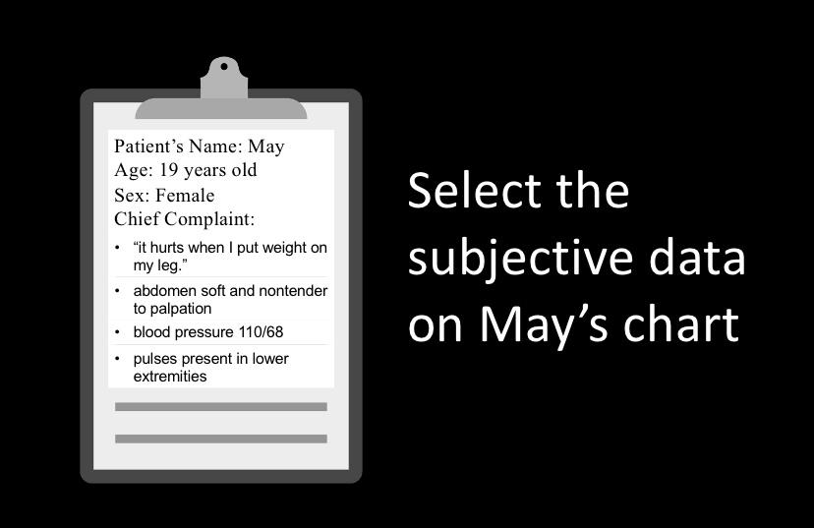

1. Players will choose answer (correct)

* 10 points for every correct answer (first attempt)

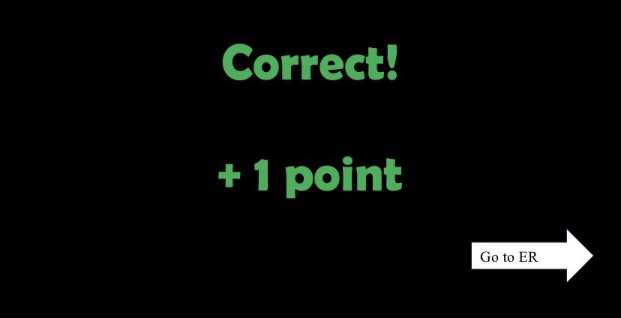

1. Players will choose answer (wrong)

* minus 2 points for every wrong answer

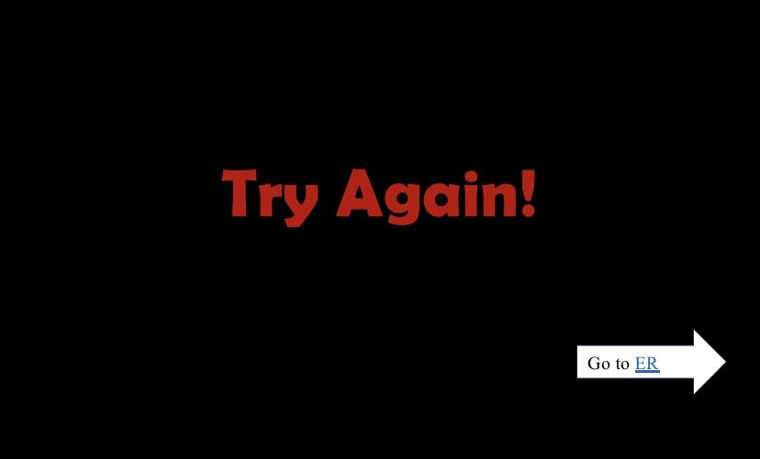

1. Score should be visible for players place it at UPPER RIGHT CORNER

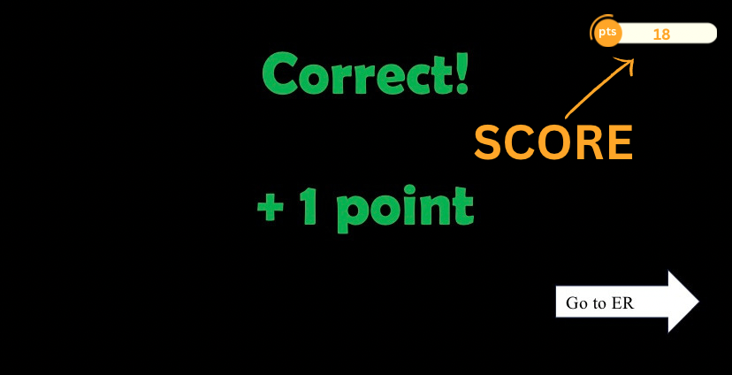

1. there will be ranking at the end of the game

May breakdown den ng ilang seconds ang na consume nila per question

And overall time nila from start to finish

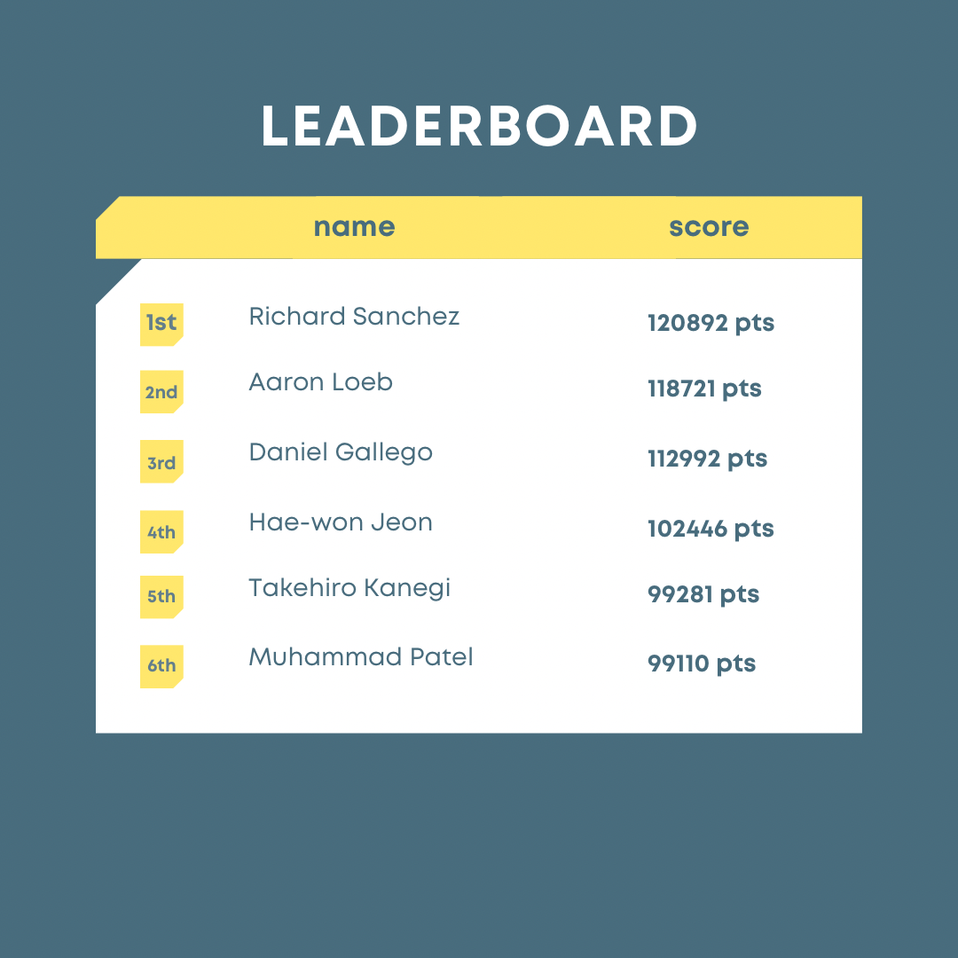

SAMPLE QUESTIONS

Pick patient

> You are assessing Paul's neck

QUESTION 1

Lymph nodes should not be ______ in a

healthy adult patient.

A. Tender

B. Too close together.

C. Palpable

D. Under muscle masses.

> Now, you will examine Paul's thyroid gland

QUESTION 2

To facilitate palpation of the thyroid gland,

you instruct Paul to:

A. Rotate the neck.

B. Hyperextend the neck.

C. Swallow

D. Hold your breath.

QUESTION 3

You should also ensure that this equipment is readily available.

A. Penlight

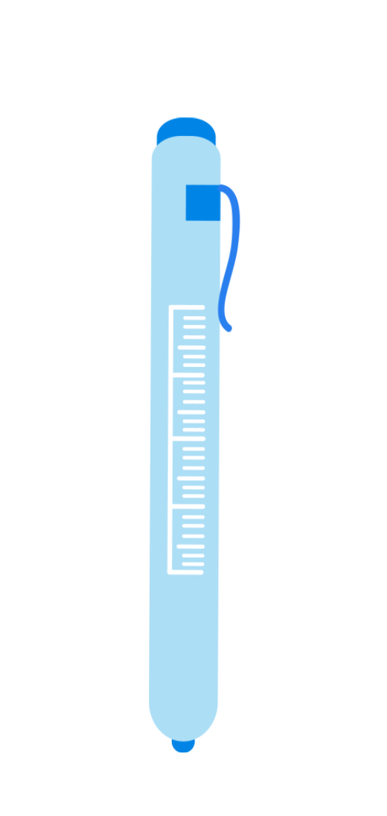

B. Tongue depressor

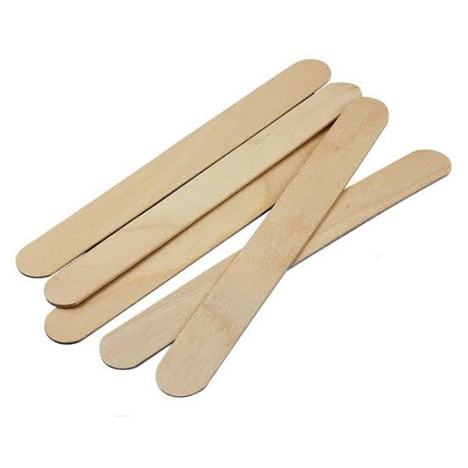

C. Centimeter-scale ruler

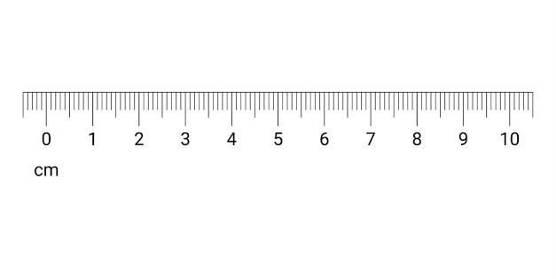

D. Cup of water

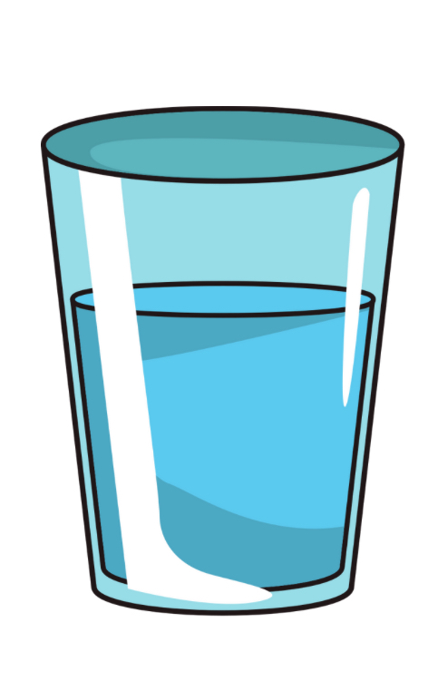

(show picture for every choices)

[questions 1-3, one patient is being examined]

Pick patient

> N: Good day ma’am what brought you to the ERtoday?

P: I have this small lesion on my right arm.  
You noticed that the lesion is fluid filled and small < 1 cm.

QUESTION 4

What type of skin lesion does Ms. Ana have?

A. papule

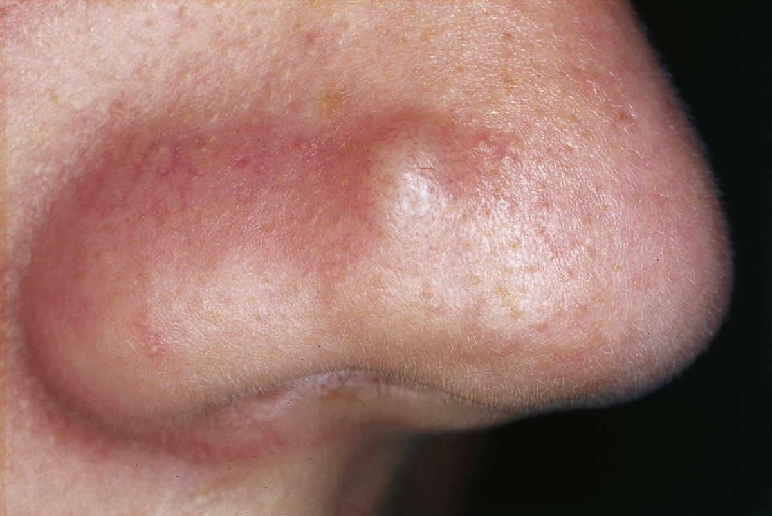

B. vesicle

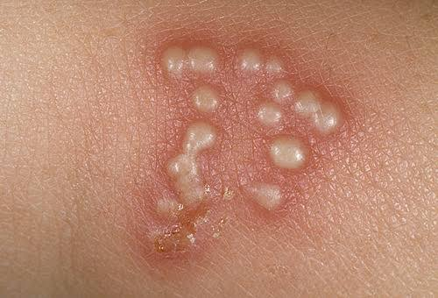

C. pustule

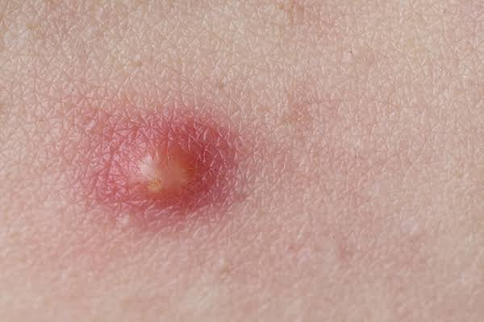

D. macule

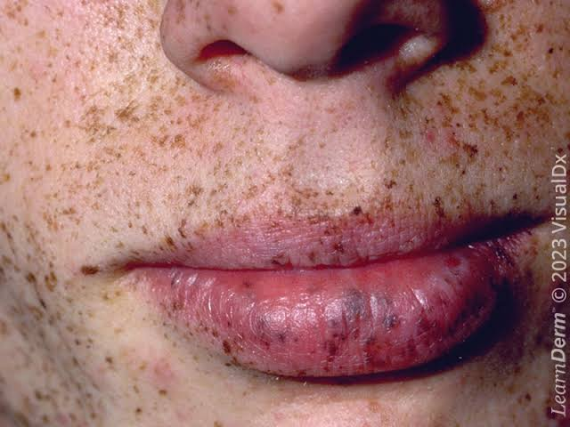

(show picture for every choices)

QUESTION 5

>

What does the condition in the picture

indicate?

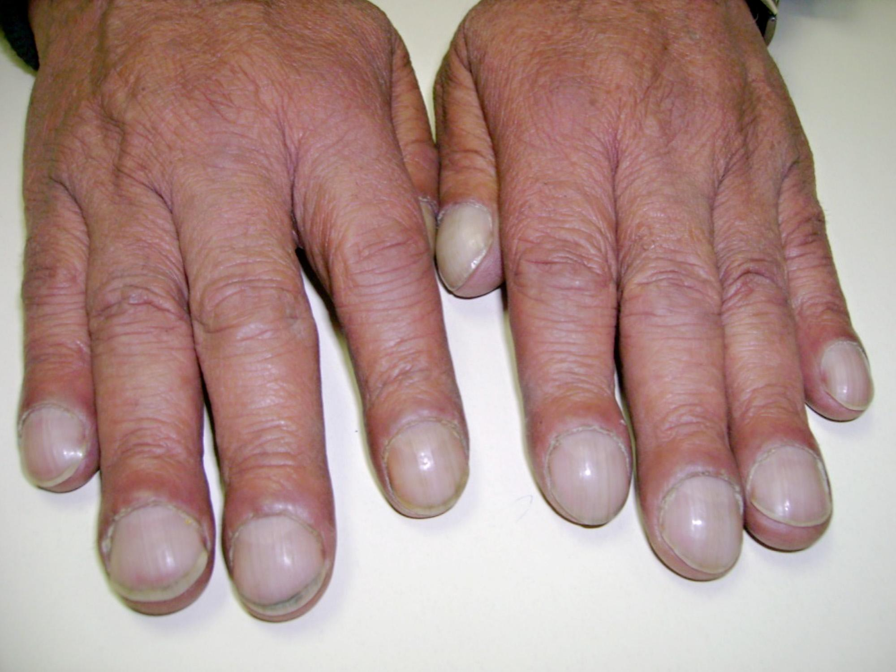

A. not-intact cranial nerve

B. damage to the frontal lobe of the

brain.

C. poor oxygenation

D. dehydration

[show this picture before question 6]

[show for only a minute]

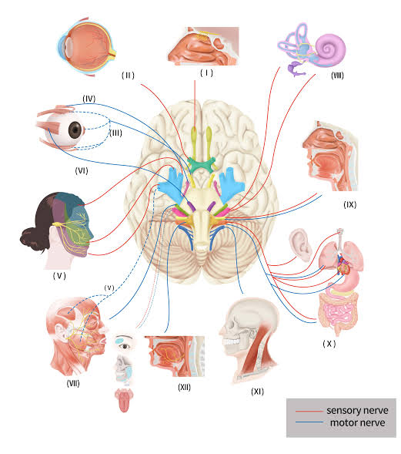

QUESTION 6

> You will assess Rita's cranial nerve. You placed a tongue depressor on her posterior tongue and Rita gags.

The gag reflex is controlled by which of the

following cranial nerves?

A. IX and X

B. IV and VI

C. VIII and IX

D. I and II

QUESTION 7

>

Nurse Regie when doing his head-to-toe

assessment on his client asks him to smile,

frown, wrinkle his forehead, puff cheeks,

raise eyebrows, and close his eyelids. In

doing this the nurse is assessing which cranial

nerve?

A. cranial nerve 5

B. cranial nerve 7

C. cranial nerve 3

D. cranial nerve 4

QUESTION 8

>

When a nurse assesses a client's vision using

either the Snellen chart or newspaper finger-

wiggle test which cranial nerve are they

assessing?

A. cranial nerve 5

B. cranial nerve 7

C. cranial nerve 3

D. cranial nerve 2

QUESTION 9

>

Nurse George has just assessed his client's

articulation, language, and other aspects of

his speech. In doing these which cranial

nerves has he just assessed?

A. cranial nerves 4 and 5

B. cranial nerves 6 and 12

C. cranial nerves 9 and 11

D. cranial nerves 10 and 12

QUESTION 10

> P: Nurse (name), I am having trouble with my balance.

A balance dysfunction is probably due to which nerve:

A. IV

B. V

C. VIII

D. VII

[question 6-10, this picture will serve as their choices]

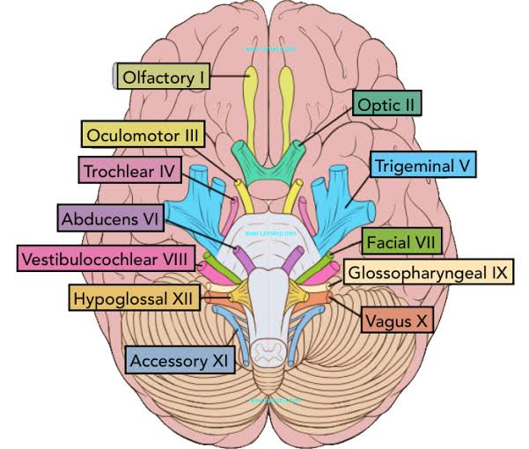

QUESTION 11

>

When assessing a client's eyes the very first thing that a nurse should look at is?

A. eyes internal structures

B. the pupil's reactivity to light

C. eyes external structures

D. color of the irises of the eye

QUESTION 12

>

Three things a nurse needs to check for when doing an examination on the eyes regarding the external structure is?

A. eyelash distribution, coloring, drainage

B. shape of eyes, pupils reactivity, iris's color

C. eyeslash texture, coloring, drainage

D. drainage, possible tumors, irritation

QUESTION 13

>

When performing an assessment on a patient's eyes what might the nurse use the ophthalmoscope for?

A. PERRLA

B. corneal reflex test

C. consensual light reflex test

D. red light reflex

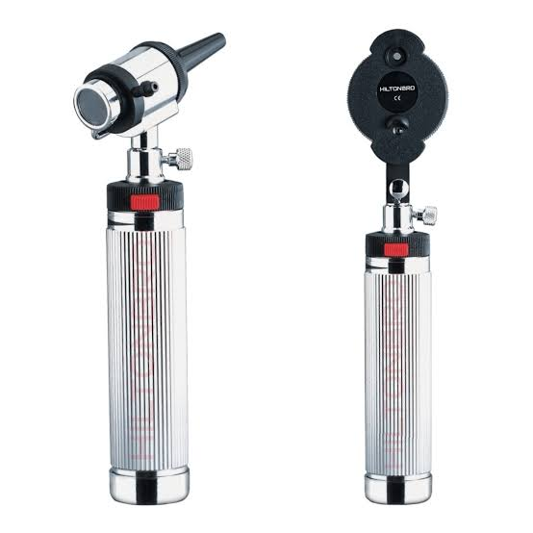

[show picture of ophthalmoscope]

QUESTION 14

>

The clinic nurse notes that the following several eye examinations, the physician has documented a diagnosis of legal blindness in the client's chart. The nurse reviews the results of the Snellen's chart test expecting to note which of the following?

A. 20/20 vision

B. 20/40 vision

C. 20/60 vision

D. 20/200 vision

QUESTION 15

>

The red light reflex is caused by the

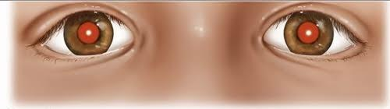

A. refraction of light off the conjunctiva

B. reflection of light off the inner retina

C. reflection of light off the choroids layer

D. condensation of light as it passess through the aqueous humore

[questions 11-15, one patient is being examined]

N:Good morning! What brings you today?

P: I’ve been having difficulty seeing clearly, and my eyes feel uncomfortable.

QUESTION 16

>

When examining the ear with an otoscope, the nurse notes that the tympanic membrane should appear:

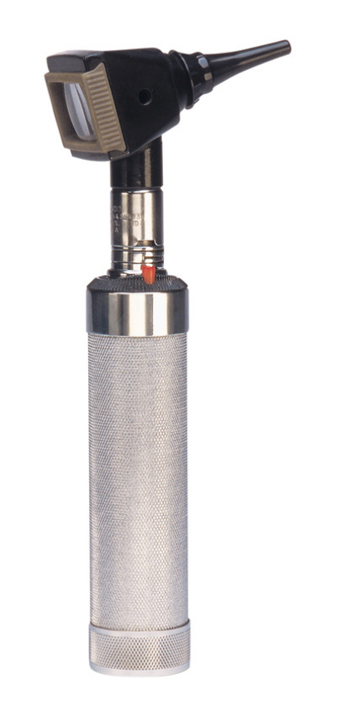

[image of otoscope]

A. light pink with a slight bulge.

B. pearly gray and slightly concave.

C. pulled in at the base of the cone of light.

D. whitish with a small fleck of light in the superior portion.

QUESTION 17

If sound lateralizes to one ear when performing the Weber test, which of the following is occurring?

A. sound is heard LONGER in one ear than the other.

B. higher FREQUENCIES of sound are heard better in one ear

C. sound is heard LOUDER in one ear

D. electrical impulses are amplified in

one ear

QUESTION 18

>

The nurse is performing a voice test to assess hearing. Which of the following describes the accurate procedure for performing this test?

A. Stand 4 feet away from the client to ensure that the client can hear at this distance.

B. Whisper a statement and ask the client to repeat it while covering one ear at a time.

C. Whisper a statement with the examiner back facing the client

D. Whisper a statement while the client blocks both ears.

QUESTION 19

>

A nurse has explained her intention to conduct Weber's test and Rinne's test. Which is the following pieces of equipment will the nurse require?

A. Ophthalmoscope



B. Otoscope



C. Snellen Chart

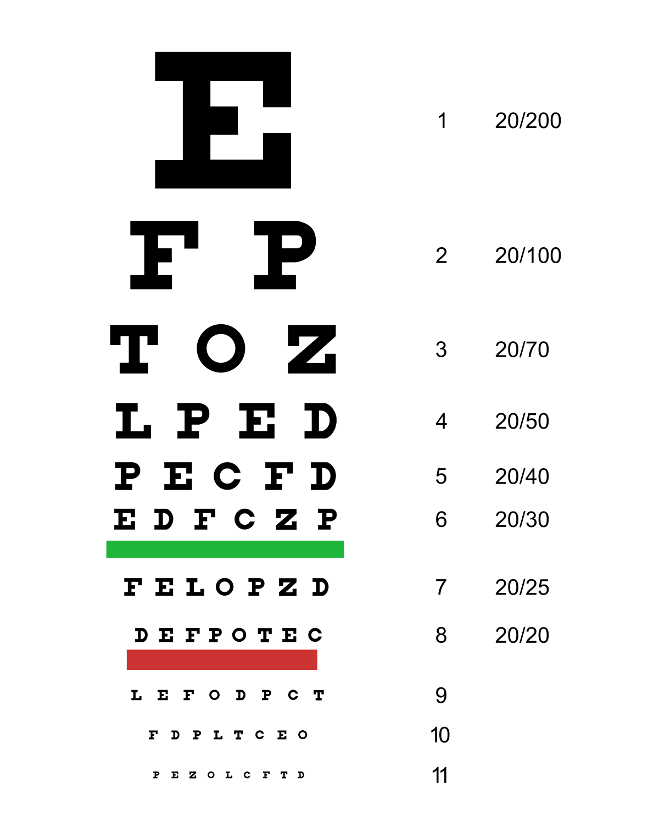

D. Tuning Fork

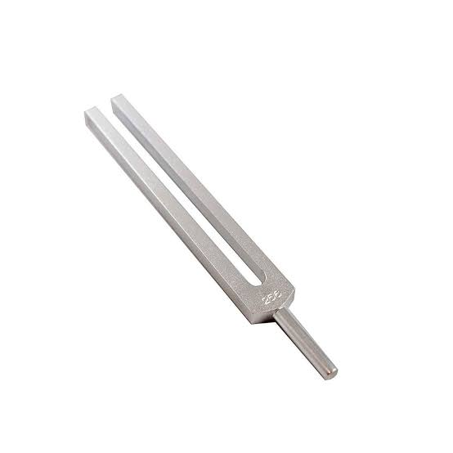

QUESTION 20

>

Nerve deafness would most likely result from an injury or infection that damaged the:

A. Trochlear nerve

B. Vagus nerve

C. Trigeminal nerve

D. Vestibulocochlear nerve

[questions 16-20, one patient is being examined]

N: Good day! What brings you today?

P: I’ve been having some problems with my ears. They feel clogged, and I’m having trouble hearing properly.

N: You noticed some redness and inflammation in the left ear, which could indicate an infection.

NOTE: ALL PICTURES ATTACHED ARE ONLY SAMPLES AND CAN BE CHANGE, IT ONLY SERVES AS GUIDE. THANK YOU

FOR CONVERSATIONS

