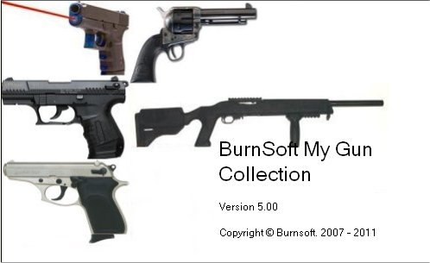

The My Gun Collection (MGC) application was create to help manage your gun collection. Some of the firearm inventory software that is available only keeps track of the name, type, caliber and serial number of the firearm. Which is handy but lacks the ability to keep track of the other details about your collection, such as:

- Accessories
- Ammunition
- Gun Maintenance Details
- Gun Smith Details
- Allows details information about the firearm (weight, length, Condition, Year it was manufactured, where you bought it from, appraised value, and more)
- Storing of pictures of the firearm or schematics of the firearm.
- Additional Notes or comments about the condition.
- Even Buyer information just incase you sold the firearm.
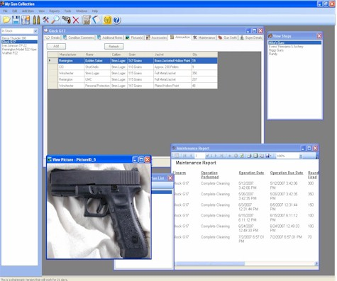
If you are looking for an application that can do the things above, and more, then this is the application that you have been looking for. The My Gun Collection application was carefully designed to allow you to quickly get details about a specific firearm all with the click of the mouse. Some of the other features include:

- Easy to Use interface - the firearms in your collection are listed on the side of the application sorted by the Name alphabetically. You have the option to view all the firearms in stock, the ones you sold or all.
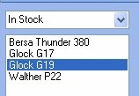
- Ability to save data entry time by using an auto suggest feature for common information (Manufactures, Models, stores, caliber, etc.)
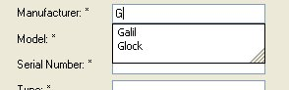
- Ability to print out reports such as: BATFE C&R (Curio and Relic) Bound Book Report, Quick Firearm Inventory Report, Ammunition Inventory Report, and For Sale Flyer.
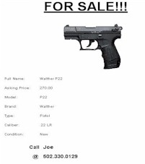 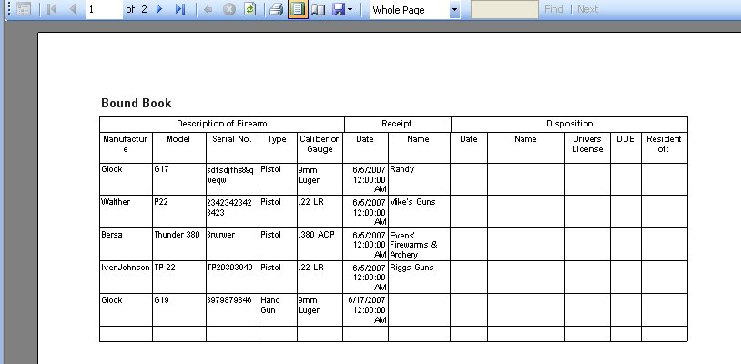
- Keep track of the cost and value (both appraised and realized) of your collection.
- Ability to export of the Reports to PDF or Excel.
- Easy to use Backup and Restore Applications are provided with this application. The Pictures that you provided will also be backed up.
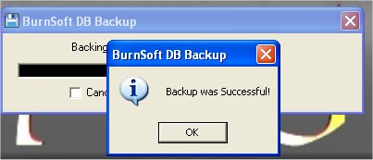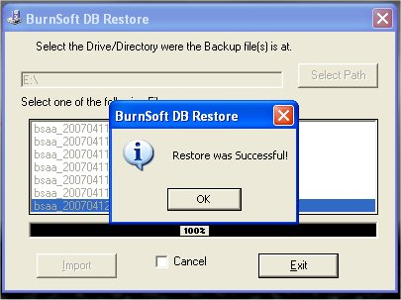
- The ability to lock the application where only you or the person with the password is able accesses the information.
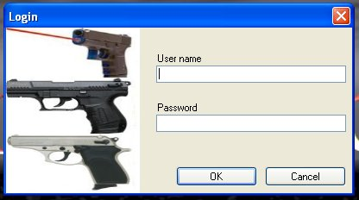
- Great for both collectors that have a small or large firearm collection.

One of the reasons why I created this application was to help me keep track of my firearm collection, the cleaning maintenance that I have done, and the accessories for it. Naturally, more was added to it to make it even more useful. One of the things that I have enjoyed is the picture section. The Pictures that you upload are tied to the firearm that you are viewing; I was able to find and attach schematics of my firearms and attached them to the picture section.

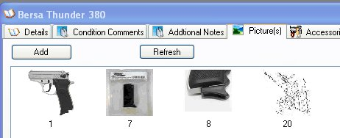

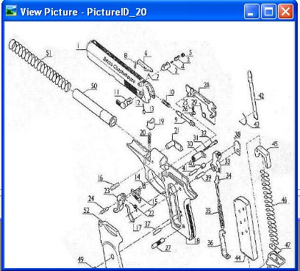

Another useful item that I use on a regular basis is the Ammunition inventory. I usually like to keep a large quantity of ammunition in stock so I can go to the shooting range at any time without having to worry about buying ammunition on my way there.

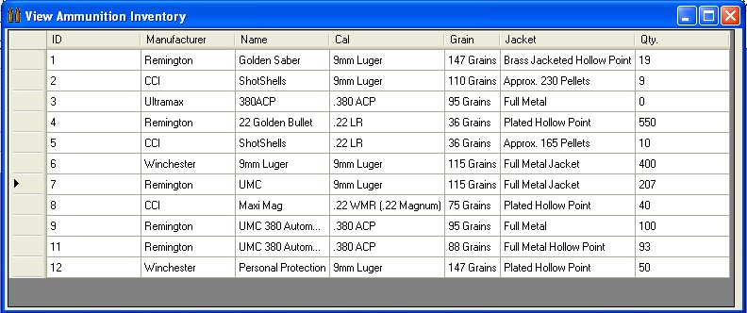

The Ammunition Inventory allows me to keep track of the different kinds of ammunition that I have in stock and how much of it I have left. Did I mention that almost everything in this application ties in together? The ammunition that is in your inventory ties in with the firearm in your collection based on the Caliber Type.

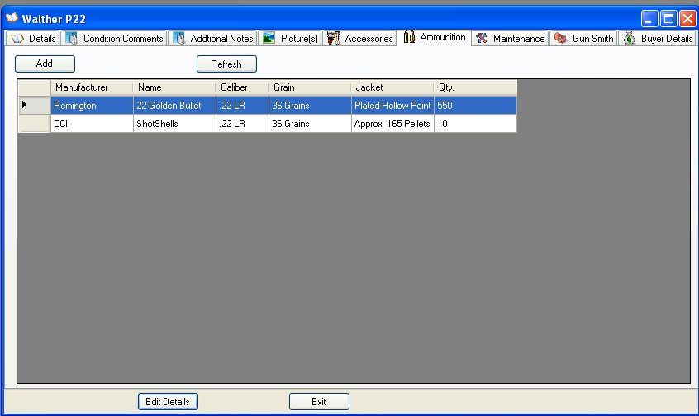

The example above is of a Walther P22, which uses a .22 LR caliber, when I am viewing the details for this firearm, I can click on the Ammunition tab, and it will only display the Ammunition that matches a .22 LR caliber. All the rest of the ammunition will not show since their Calibers do not match up.

Over all, whether or not you have a huge gun collection or just a few firearms on hand, this application can help you keep track of useful information for your own personal gain, and even ATF standards for reports and record keeping.

Upgrades to My Gun Collection:
Upgrades are free! And updating the application is only a few clicks away without any technical knowledge needed.

System Requirements

Supported Operating Systems:
Windows 2000 Service Pack 3; Windows 98; Windows 98 Second Edition; Windows ME; Windows Server 2003; Windows Vista Business; Windows Vista Enterprise; Windows Vista Home Basic; Windows Vista Home Premium; Windows Vista Starter; Windows Vista Ultimate; Windows XP Service Pack 2, Windows 7 Home, Windows 7 Premium, Windows 7 Professional, Runs on both 32-bit and 64-bit Windows OS.

Required Software:
- Microsoft .NET Framework Version 2.0 Redistributable Package
- Windows Installer 3.0 (except for Windows 98/ME, which require Windows Installer 2.0 or later). Windows Installer 3.1 or later is recommended.

Disk Space Requirements: 20 MB

Support:
All shareware applications provided by BurnSoft are supported via:
- Web Forum
- Telephone
- Email
- On-line Chat

Release Notes:

Version 2.1 (Released on 03/16/2008)
- Fixed the "Add picture" function not to error out if you hit cancel while browsing.
- Added the ability to export a Picture to a file.
- Added the ability to Add New Shops to the Database.
- Added the ability to Delete Shops from the Database.
- Added the ability to view the firearms that were bought from a shop while viewing details of a shop.
- Added Backup Setup Options in the Settings Section. Now you can control if you want to be alerted if a backup has not occurred in x number of days, and if you want to have the backup program to delete older backups.
- Added an "Add Ammunition" Button shortcut on the tool bar.
- Added a Wish List section that will allow you to create a wish list on the firearms, accessories, etc that you would like.
- Added the ability to edit and delete items in the wish list as well as a printout report.
- Added an Insurance Report, which will allow you to print out the firearms that you have in your collection and how much you bought them for.
- Added the ability to Ammo Report, now you can have the report sort by Name, Qty, Grains, or Caliber.
- Added the ability to Edit Accessories.
- Added the ability to Copy an Accessory to another firearm to save time and trouble of re-typing redundant information.
- Added the ability to Copy all the Details of a Firearm except for the Serial Number. This is just in case you buy another or new version of a previous firearm that has the same specs as the original.
- Added the ability to Add Pet Loads to the details of the firearm.
- Added the ability to mark the firearm as a C & R Item to the details of the firearm.
- Added the ability to Add/Modify the purchase date of the firearm to the details of the firearm. Before the Purchase date was marked as the date the firearm was entered into the database.
- Added the ability to rename the display name in the collection list. Before the full name was just by Manufacturer and Model, now after you add the firearm, you can rename it to anything you would like to see as the collection display name.

Version 3.0 (Released on 9/9/2008)
- Ability to set the default image for the For Sale Flyer. No longer is the first picture the default Display picture.
- Added New C&R Bound Book Report. It's the same style as the Bound Book Report Except it will only pick out the Firearms that are C&R Qualified.
- Changed the All the Reports to have the Sorting Option at the Top of the Report
- Added the Ability to Sort the Insured by Purchase Price Reports by Price, Caliber, Custom Catalog No. and Type.
- Added the Ability to Sort the Insured by Insured Price Reports by Price, Caliber, Custom Catalog No. and Type.
- Added the Ability to Sort the Insured by Appraised Value Reports by Price, Caliber, Custom Catalog No. and Type.
- Added the Ability to Sort the Bound Book Reports by Normal, C & R Only, Custom Catalog No., Purchase Date, Brand, Caliber, Type, and Gun Shop
- Added the ability to sort the Wish List Reports by Normal, Manufacturer, Place To Buy, Qty., and Value
- Changed the Sort Options for the Ammunition Reports from the Main Menu to the Sorting Option at the Top of the Report. Now you can select how you want it sort from the same window.
- Added the ability to sort the Quick Inventory Report By Default, Manufacturer, Type, and Caliber
- Added the ability to sort the Maintenance Report By Default, Operation Performed, Operation Date, Operation Due Date, and Rounds Fired.
- Added the ability to sort the Gun Smith Report By Default, Gun Smith, Ship Date, and Receive Date.
- Added the ability to sort your gun collection in the main window by C & R and Non C & R
- Added the ADODB.DLL to the Setup program to resolve issues on some machines when you attempt to add a picture to the database.
- Added a new setting called "Backup on Exit". This way when you exit the application it will start the backup program automatically. This is to ensure that your last backup is the most current.
- Set Auto Suggest feature for Stock/Grip Type, Storage Location, Sights, Pet Loads, Metal Finish, Feed, Custom Catalog Number and Action in the Gun Collection Add and Edit Forms
- Fixed - When you are adding or editing a firearm and change the Caliber type, the Caliber was suppose to add it's self to the Caliber table if it didn't exist. This helps with the Auto Suggest Feature when adding or editing a firearm or ammunition inventory.
- Created a Database Cleanup Option that will allow you to remove all the preloaded data in the database. Also added in Safety cleanup rules that will only clear out data that is not in use by the collection. So if you wanted to clean up the Manufacturers and Models in the database, but keep the firearms that are listed in your database. You can still run the cleanup and it will not delete the manufacture and models that you are still using in your collection.
- Removed Barrel Length and Barrel Height, this was not commonly given as the specs from most manufacturers, and useless to a huge majority of the users.
- Include Custom Catalog No. in Quick Inventory Report.
- Moved around the fields in the Add and Edit Firearms forms, everything that is required is now located on the left side for quick and easy fill out. Optional fields are on the right.
- Added the ability to record the Importer of the firearm.
- Added the importer Field to the Bound Book reports.
- Added the ability to View, Edit, Add, and Delete Grip Types.
- Created the Ammo Calculator, which can use when you are entering in maintenance for a firearm, it will allow you to select the ammunition that you used, how much of that brand that you used, and give you a total oh how much was used. It will also take out what was used from the main inventory so you won't have to do it manually.
- Added minor stats while viewing the details of the firearms such as Total Ammunition in the Ammunition section and Total rounds fired and Average Rounds fired in the Maintenance Section.
- Created the Data Loader application, which will download Manufacturers, Models, Grip Types, Firearm Type, Calibers, Nationality and Maintenance Plans from Our Database server. This will add extra content to your database to help out with the Auto Suggest Feature when filling out Information.
- Corporate the Pet Loads with the Ammo in both Individual Ammo and Ammo Calc functions.
- Added Options for Image viewing, now by default it will display the picture in it's original size unless it is longer then the work space, which then it will resize the image accordingly.
- Added the ability to create a custom user name instead of having to use the default admin login name.
- Added the Option to Include and Exclude Pet Loads from Forms.
- Added a Full Detail Report Function that will print out the details of the selected firearm and also display the default picture.
- Along with being able to create your own user id, we have added a Forgot Password feature at login that will allow you to answer a phrase you created to get your password.
- Added a Tool bar for the Ammunition Inventory section that will allow you to add to the current qty, refresh the list, delete the current selected row, and add ammunition to the database. The Old functionality of being able to edit each cell is still active as well.

Version 3.2 (Released on 3/1/2009)

- FIXED - There was a glitch in the Ammunition Inventory Report that would not display the reports unless you had the "Use Personal Markings" enabled for the reports.
- FIXED - There was an issue with linking the Same buyer by Name. If you sold a firearm to an existing customer, it will create a new buyer instead of linking him with his past account.
- Added the Ability to create Custom Reports. This should take care of most the requests that we were getting about being able to create custom reports, however this is a new process which will more then likely be a work in progress.
- Added to Total Rounds in Invetory Status label in the Ammunition Inventory Section. Just incase you where wondering the total number of rounds that you had stock piled.
- Added the ability to access the help file for the specific window that you are viewing by hitting the F1 key. This is available in a majority of the sections on this program.
- FIXED - There was a problem with the My Gun Collection application running properly under Windows Vista. This was resolved by embedding in the application to run as an Administrator. Now under Windows Vista, you will get prompt from the UAC if you wish to run this application as administrator. See Wiki Article KB243 for more information.
- Help File - Updated the Ammunition Inventory Section with the new changes and additions
- Help File - Created a Section for the Custom Reporting Options.
- Database Restore - Added the option to run the main application after a successful restore or not to restart. Default is to run after restore.
- FIXED Application Updater – This application also had an issue when running under Windows Vista, which we applied the same fix that we used for the My Gun Collection application.
- FIXED – The importer field would not display while viewing a firearm, only when you edit the firearm.

Version 4.0.1 (Released on 11/17/2009)

Summary: 6 Fixes, 27 Additions, 1 Change around in Interface.

- FIXED - Importer does not show while viewing a firearm, only when you edit the firearm does it appear.
- FIXED - Insurance Report By Default - Not Set to Landscape by Default
- FIXED - Insurance Report By Insured Value - Not Set to Landscape by Default
- Main Display (Side List ) - Add Sort by Catalog Number Option in drop down
- Simple Inventory List - Needs Sort by for Custom Catalog No
- Added a link to Misc Firearm and Reloading Links. This is just a web link to firearm related sites from our wiki.
- Added REMANUFACTURED DATE and a PLACE OF IMPORT for C&R Collectors.
- Added the Ability to Use Alpha-Numeric (Default setting) or Numeric System for Custom Catalog ID. Since some Collectors use a Alpha-Numeric System for their collection, this was the default notion, however there are those that will just use a numeric system for their catalog. In order to Fix the reports for the Numeric Users we added this option.
- Added the Ability to Delete A Buyer from the List. It will allow you to delete a buyer that does not have a firearm listed to them, if it detects that there is a firearm attached to the buyer it will abort the delete.
- Added the ability to select a previous buyer when you are selling a firearm. This way you do not have to enter in the information again since it will already be on file.
- Added the ability to export the Firearm details, accessories, maintenance details, and Gun Smith Details to an XML file. This method was created for sale and transfers of firearms. If the Sell and buyer both have this program then the seller can export to details of the firearm to the buyer, then the buyer will be able to import the information to their collection. This way you can have a true running detail of the firearm and all that has been done to it from the past owner(s).
- Added the ability to import firearms that where exported to XML from another User of the My Gun Collection program. If you bought or received a firearm from another person or dealer, and they export the details of the firearm to XML, you can import the information that they had listed for that firearm. This way you can actually know how many rounds where fired and the Gun Smith details before you owned the firearm. This can help if a firearm is known for needing a part replaced after 5000 or 1000 rounds.
- Changed the location of the Edit Details, Close, and Full Details Report Buttons from the bottom of the form to a tool bar located at the top. This was done to give us the ability to add more options to this form and more display room for the details.
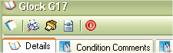
- Added the ability to save the last category for the firearm list that you where viewing. Let's say you had your firearms listed by Non C & R when you exited the program, it will now save that spot for next time you load the program.
- Added the Option to Auto Assign for the Custom ID Field when in Integer/Numeric mode.
- Application Updater - Add the Ability or option to restart the My Gun Collection Application if there are no Updates.
- Added the feature of retaining the last firearm that you viewed or select the firearm that you just added. Before if the Firearm list refreshed, it will select the first firearm in the list, if you had 50 or more firearms it would be a hassle to have to look through the list for the firearm that you just added for you can add pictures and other details. This option will now select the last firearm that was added or the last firearm that was viewed after a refresh.
- FIXED - Compiled the applications to run as x86 mode instead of any CPU. The Any CPU mode was the reason why it would not work under windows 64-Bit, but change it to x86, it will allow the application to run as a true 32-Bit Process which will work in the Windows 64-Bit Environment.
- Added the Ability to Add and Edit the date a firearm was sold. When you are adding the information of who bought the firearm, you can now select the date that it was sold. When you edit a firearm you can now edit the Sold Date.
- Added a visible marker for firearms that were sold. When you click on a firearm and it was sold, there is now a visible marker that will tell you that the item was sold and display the date when the item was sold.
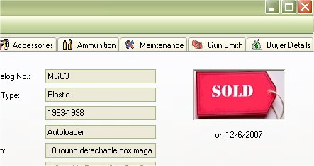
- Added a “Full Detailed Report”, this is an Option next to the Old Detailed Report. The Full Detailed Report will also print out Maintenance, Accessories and Gun Smith Details along with the Regular Details.
The Full Detailed Report is the Gold/Brown Printer Icon ( ).
- Added Quick Links to Detailed Report and Full Detailed Report to the right click menu for the firearm list.
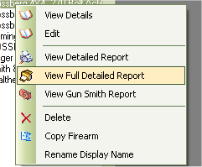
- FIXED – The Ammunition Inventory report to take up most of the Page. Before it would print in Landscape Mode but would not use of the page, this was changed the some of the fields where increased in width to help take up the rest of the page.
- Added the Total Number in Inventory to the end of the Ammunition Inventory Report. Since the regular Inventory window has the total number of rounds in your Ammunition Inventory, this feature was expanded to the Report itself.
- Added Insurance Forms with the Total Sum of the Price of the collection listed at the end of the report.
- Added Total Rounds Fired to the Maintenance Reports
- While viewing the detail of the firearm, you are able to view the ammunition that is available for that firearm, now you can create a report from that same view that will allow you to sort and print the ammunition in that caliber.
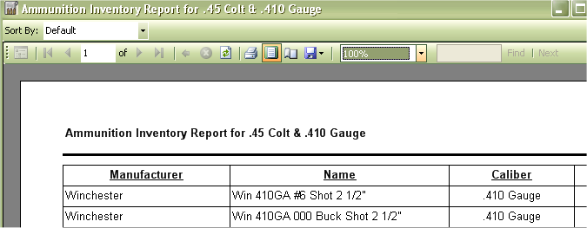
- FIXED – minor Glitch while viewing the details of a firearm in the ammunition section, the total number of rounds was not including Pet loads in the Total.
- Added the Final sale price. The Sale price was originally set as the appraised value, which needed to be set to the final sale price before marking it as sold. Now you can put in the final sale price when you are marking the item as sold. This will update the appraised value field.
- Added the ability to filter by Manufacturer, Caliber and or Grain while viewing the Ammunition inventory List.
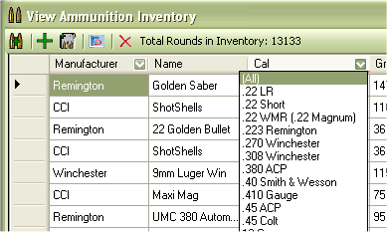
- Added the ability to filter by Manufacturer and or place to Buy while viewing the Wish list.
- While viewing the details of a firearm in the Accessories Tab, you can now filter out by manufacturer.
- While viewing the details of a firearm in the Maintenance Tab, you can now filter out by maintenance plan.
- While viewing the details of a firearm in the Gun Smith Tab, you can now filter out by Gun Smith.
- Modified the wording for Buyers information and Disposition/Sale.
- Modified the Bound Book Report to List Name and Add only if an FFL license is not supplied in the buyers or sellers information, but if the FFL license is present, then it will list Name and FFL.
- Expanded the fields in the Bound Book Report.
- Modified the Edit and Add Buyer forms to allow either FFL or Drivers license to be entered, before the Drivers License was the only thing that was required, now you just have to have one of the two. If they are an FFL, then the Date of Birth/DOB is not required.
- Defined the header in the Bound Book report, had the Description of Firearm, Receipt and Disposition repeat on every page, also defined the table header in grey to help separate it from the rest of the report.
- Added the Ability to change the Report Title in the Bound Book report, this way you can use Bound Book for <your name> or “Firearms Acquisition And Disposition Record for <your name>.
- Added a water mark for your License ID in the Bound Book report. When you define your license ID in the Settings section, you can put CCDW: KY-9999999, or FFL:KY-9999-9999-9999-9999, C&R:KY-9999999999, etc. The way it is listed in the settings will be the way it is listed on the report. If you do not put a license number it will no appear.

Version 5.0.1 (Released on 12/21/2011)

FIXES: 8
ENHANCEMENTS: 28

- FIXED: The Custom Report on the Custom SQL Query section. If you defined a field such as "manufacturer like '%Ruger%'", it will run the query, but it will throw an error if you attempt to save the report query.
- FIXED: The Full and Complete Detail reports will not show any information if I do not have any pictures set. A default Picture will now be added that says "No Image Found", for the firearm when the report is generated.
- FIXED: The while viewing details on a firearm, The more picture that I have for that firearm, the longer it takes to load. Thumbnails are now created for the main image, which will speed up load time and allow you to keep your original picture for viewing.
- FIXED: Issue with the restore.exe application. The Restore application was not reading the directory that you set. Once you did a backup of the database it would be able to restore from that directory. Now it functions as the original restore did.
- ADDED: Added the ability to input the Velocity for the ammunition collection. Now you can input the velocity of the ammunition.
- ADDED: Velocity to the reports and views.
- ADDED: Ammo Used is now a field for the Gun Maintenance section. You can input this manually or if you use the calculator, it will use the name gathered from the list.
- ADDED: Updated the Ammunition Audit section, added an extra input for the store where you bought your ammunition.
- ADDED: Added an Edit Interface for the Gun Smith section. Before you would have to edit the fields though the display grid, now a window will appear allowing your to edit all details.
- ADDED: Added the Ability to search through your in Full Name, Model Name, Serial No., Type, Caliber, Finish, Condition, Custom Catalog ID., Weight, Height, Stock Type, Barrel Length, Action, Feed System, Sights, Purchased Price, Purchased From, Storage Location, Additional Notes, Produced, Pet Loads, Condition Comments. If there is only on result, it will bring up the display window for the firearm.
- ADDED: Added the ability to Edit the Gun Types. Even though in previous versions you were able to manually add the Gun Types when you added the firearm. Which you still can do, but now you can view the list of the Types of Firearms and edit, add or delete from the list manually.
- ADDED: Added the ability to Edit, Add or Delete the Gun Conditions. In Previous Versions, the list of New, 100%, Antique Good, etc was hard coded into the application. Now it is stored in the database where you can manually manage the Firearm Conditions manually.
- ADDED: The Ability to print the accessories for the selected firearm with a running total. This will allow you to print this out for your records or for you to include on any flyers that you print out.
- CHNG: The headers on the reports are now a shade of light gray were they were once transparent; this is just to help define the header when you print out a report.
- ADDED: The running total for the accessories is now also in the Full Detailed Report.
- FIXED: Misspelling on View Maintenance Plan Tool Icon on Main Window.
- FIXED: Issue with Busy Cursor on Bound Book. The Busy cursor would activate when you put your mouse over the tool bar instead of having the arrow cursor
- ADDED: Notification on Custom Catalog ID during add and Edit to alert you when another firearm has the same ID and which firearm(s) have that ID.
- ADDED: The ability to Mark Maintenance Details as Count or Don't Count.
- ADDED: Accessories Report.
- ADDED: Quick N/A fill button for the Firearm Sale form. If you don't remember or have all the details when you sell/sold that firearm, you can use the Quick "N/A" button to will out all the information that is required by the sale form.
- ADDED: Section for Blank Reports. Just in cause you wanted to fill out some things by hand, we have a blank Bound Book, Shooters Card and Shooters Card with Target report Sheet available to print.
- ADDED: Search for your firearms based on the Display Name, Manufacturer, Model Name, Serial No., Type, Caliber, Finish, Condition, Custom Catalog ID., Weight, Height, Stock Type, Barrel Length, Action, Feed System, Sights, Purchased Price, Purchased From, Storage Location, Additional Notes, Produced, Pet Loads, Condition Comments
- ADDED: The Ability to give a picture a name/title and notes for that picture.
- ADDED: Gallery Report - this will allow you to print of all the pictures, Title/Name and notes for all the pictures for the current firearm that you are viewing.
- ADDED: While viewing pictures a tip balloon will display the Name/Title and notes of the picture.
- ADDED: The ability to put an appraised price on the accessories, since some items will gain or lose value and others (like magazines are not commonly apprised), won't gain any cost. This feature was put in to help you figure out a firearms actual cost for your collection or to help sell it.
- ADDED: Total Purchase and Appraised prices to the Accessories Tab View and Report. Initially We were thinking about adding it to the purchase Price, But while performing self appraisals on a firearm with Blue Book, The appraised prices tend to fluctuate, and some accessories are not listed in blue book as a plus or minus add-on, and some are. So If you are one that will self apprise a firearm via Blue Book, you can take the value of the firearm itself, and add the accessories that have an appraised value to it to get the final appraised value of the firearm.
- CHNG: When filtering the side list, the "Cust. Catalog #" filter will now display the Custom Catalog number in the list. EXAMPLE: "MGC101 - Glock 17"
- CHNG: To Add more uniformity when adding a firearm in the actions, Type, Sights and Storage sections, you now have the ability to drop down the list of options as well as type something in.
- CHNG: Changed Pet loads to Caliber #2
- FIXED: The Login Form Losing Focus. If you set the security to prompt for a username and password, it would lose focus when you started the application; this will force you to click on the login form in order to type something in. This has now been fixed.
- CHNG: Changed how you edit and delete information from the maintenance tab while viewing a firearm. Instead of double clicking to edit a field, now when you double click on the data that you want to edit a new window will appear allow you to edit the all the information for that maintenance details.
- ADDED: Added the ability to delete data from the maintenance section by clicking once on the line that you want to delete then left clicking to bring up a menu that will allow you to delete or edit the information. Before you where suppose to be able to select the row and hit your delete button, but that didn't always work.
- FIXED: The Forgot Password answer was converting the answer to lower case and not the same case as the real answer.
- ADDED: The a New Report that is similar to the Quick inventory Report but with Notes and Conditions

