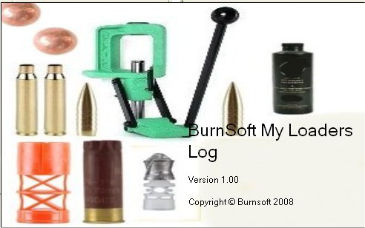

The My Loaders Log (MLL) application was created to help get rid of all the paper work of different logs in a binder and having to look through a collection of reloading manuals to just to find how much powder was used of a certain kind of powder for a certain kind of bullet. With reloading, once you find your groove, the entire process doesn’t take that long as compared to when you first started, why shouldn’t it be the same for looking up information?

The My Loaders Log (MLL) was created to help keep track of my configurations and the configurations from the reloading manuals that I use, along with the inventory my reloading equipment, primers, bullets, powder and cases that I had in stock or was out of.
Since it will store all this information plus the configuration that you used to make a certain kind of ammunition, it will also tell you how many you can make and how much it costs to make based on your inventory. Even if you just wanted this to store your loaders log and not your inventory, it can do that as well.

NOTE: Version 1 was released for Metallic reloading (Rifle & Pistols) only, the next version will include shotgun reloading.

The My Loaders Log (MLL) will keep track of the Qty, Price and Price Per Item/grain for the following Items:
- Primers
- Cases
- Bullets
- Powder (Broken down from pounds into grains)
- WADS
- ShotShell Hulls
- Shots and Slugs

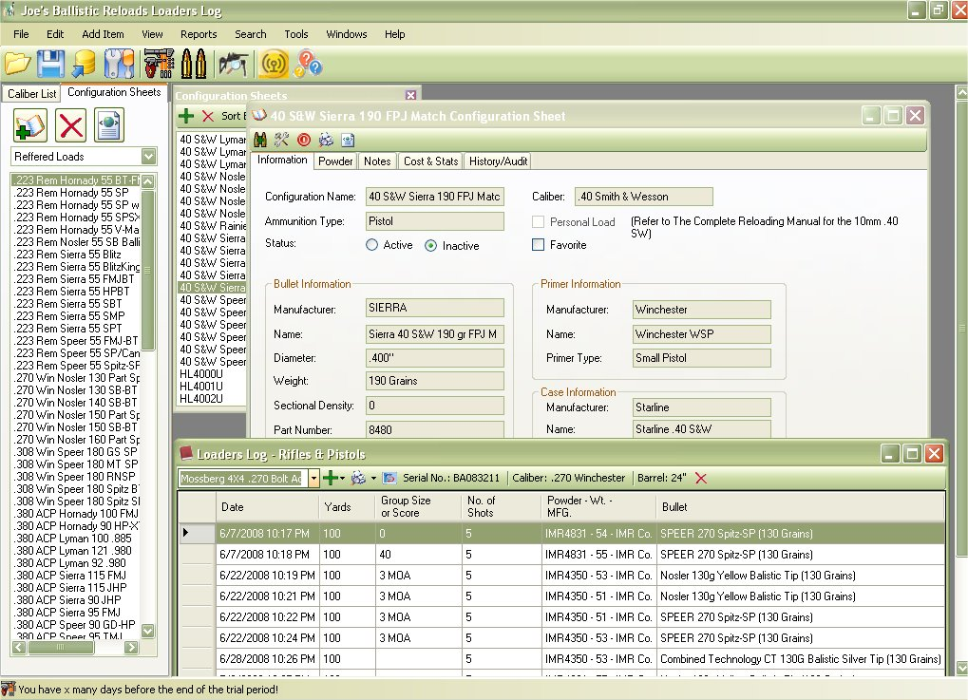

If you are looking for a program that can do the things listed above and more, then this is the application for you! If you are one of our My Gun Collection application users, then this might be a useful application for you as well. This application will allow you to Import your firearm collection from the My Gun Collection application to the small firearm inventory section on this application. Therefore, you do not have to retype information about your firearm in this application and can go straight to the loaders log to enter in information.

We attempted to make this as easy as the My Gun Collection application, with a familiar easy to use interface that include:
- Easy access to your configuration lists that you can sort by certain categories.
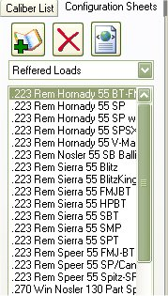
- If viewing the Configuration is a little difficult, then you can select to view the configuration based on the Caliber.
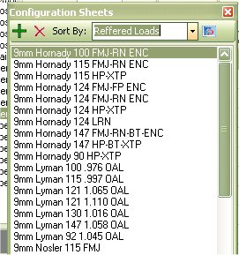
- Auto Suggest feature that will gather information that you already have in the database, this can help you save time in typing, or mistakes your listings.
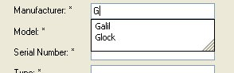
- Ability to Print Reports on your Equipment, Firearms, Bullets, primers, powders, shot, slugs, hulls and cases that are in stock or that are out of stock.
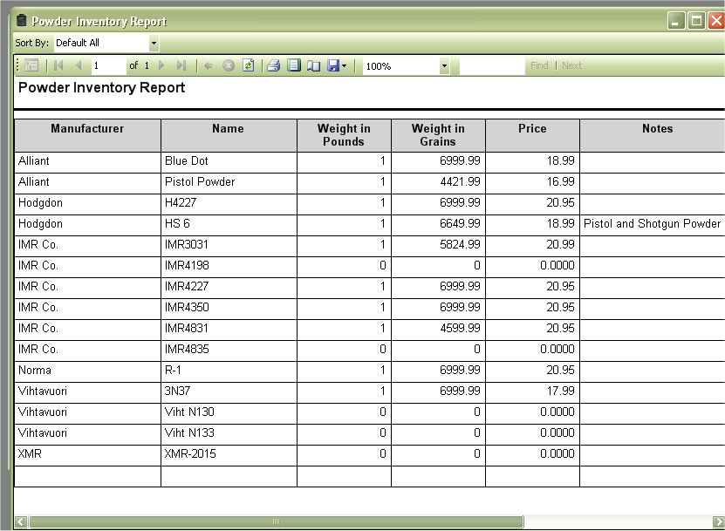
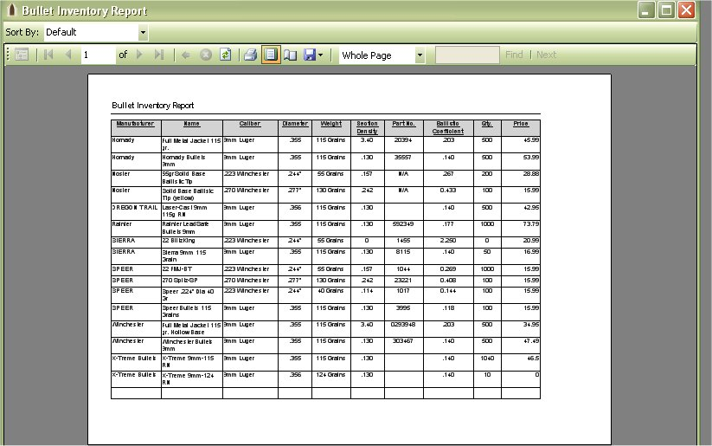
- Ability to save these reports to PDF or Excel
- Easy to use Backup and Restore Applications are provided with this application. The Pictures that you provided will also be backed up.
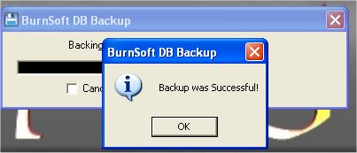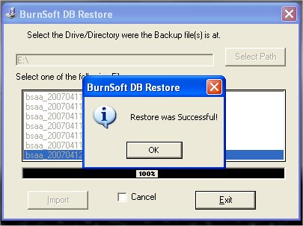
- The ability to lock the application where only you or the person with the password is able accesses the information.
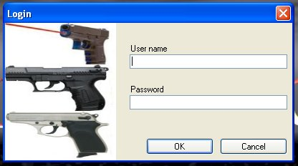

One of the other reasons why I created this application was to get a quick listing of my options from the configurations that I have, both personal and ones that I got from a reloading manual. This application comes with a search function that will allow you to narrow a search down and display the results to print out or to save to file.

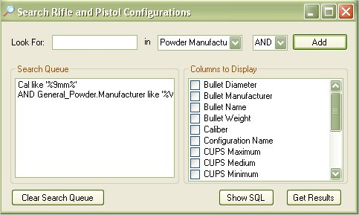
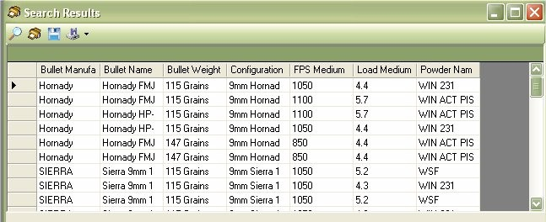

And for those of you that know the SQL query language, you can modify the query for your report.
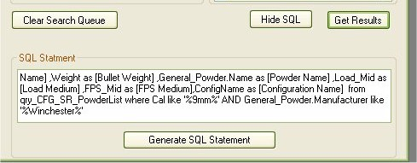

If you do decide to store and track your reloading materials and configurations, then you can also take advantage of the “Make Ready to Use “ feature.
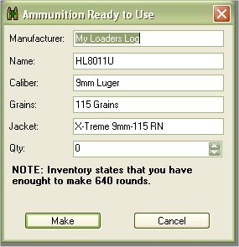

The “Ammunition Ready to Use” feature will tell you how much ammunition that you can make for the selected configuration, once you tell it to make it will also subtract the qty from the materials used in your inventory, to help keep your inventory as up to date as possible without you having to spend a lot of time recounting items.
The ammunition that you make will be stored in the “Ready to Use Ammunition Inventory”

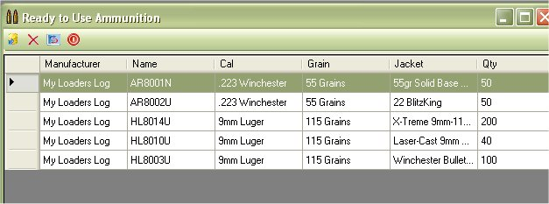

This is just a simple list to help you keep track of the ammunition that you made and should have available to use. If you also the My Gun Collection Application, then it will allow you to move/export this information over to the My Gun Collection application to store in the “Ammunition Inventory” section. Save you from retyping it if you use that feature.

Naturally you will need a Loaders log to track the tests that you did for the ammunition that you created, and it wouldn’t be a loaders log application is it didn’t have a loaders log sheet.

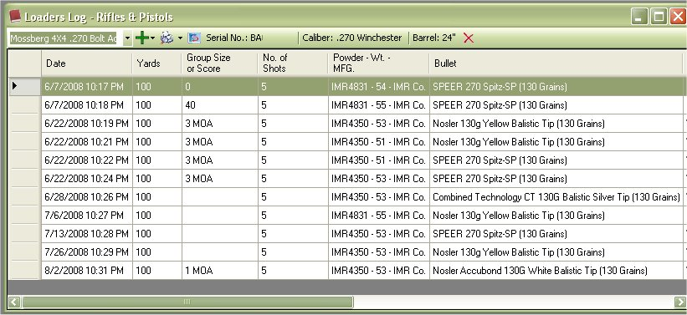

Since this application has a simple list of your firearm, it will allow you to store the loader log results for the selected firearm from the list. From the view you can add a Manual entry or use a configuration. The Manual entry is a free form, just like if you used paper. Adding by the configuration will take the information that you have listed in the configuration and fill out a majority of the form for you. Make it a little quicker process for you. And of course if you wanted to print out this report you can.

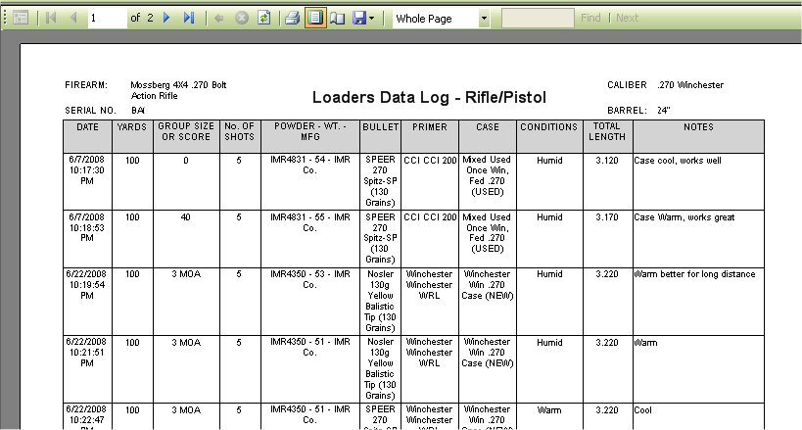

Reloaders tend to share information with each other about their loads or the loads that they have in a manual. This application will also allow you export and import configurations so you can store for another time or share with a friend(s).

It doesn’t matter if you reload for 1 caliber or many calibers, nor does it matter if you want to keep track of inventory or not. This application to allow you to track your Loaders Log only, or you can have your Loaders Log, save your manuals and inventory to this application to track more information and keep things a little more organized.

Upgrades to My Loaders Log:
Upgrades are free! And updating the application is only a few clicks away without any technical knowledge needed.

System Requirements

Supported Operating Systems:
Windows 2000 Service Pack 3; Windows 98; Windows 98 Second Edition; Windows ME; Windows Server 2003; Windows Vista Business; Windows Vista Enterprise; Windows Vista Home Basic; Windows Vista Home Premium; Windows Vista Starter; Windows Vista Ultimate; Windows XP Service Pack 2

Required Software:
- Microsoft .NET Framework Version 2.0 Redistributable Package
- Windows Installer 3.0 (except for Windows 98/ME, which require Windows Installer 2.0 or later). Windows Installer 3.1 or later is recommended.

Disk Space Requirements: 20 MB

Support:
All shareware applications provided by BurnSoft are supported via:
- Web Forum
- Telephone
- Email
- On-line Chat

Release Notes:

