AI-Powered Customer Support Automation System
ABC Technologies | LangGraph Project Documentation

Project Overview
ABC Technologies receives customer support requests for product information, technical issues, billing queries, account management, and refunds. This project implements a LangGraph workflow that classifies each query, routes it to the correct department, retrieves company knowledge, uses SQLite conversation memory, handles high-risk approval, and generates a supervised final response.

Business Requirements Covered
- Accept customer queries.
- Identify the customer issue type.
- Route queries to Sales, Technical Support, Billing, Account, or Memory Recall.
- Retrieve relevant context from company policy, pricing, technical manual, and FAQ documents.
- Store and recall previous customer interactions using SQLite.
- Escalate refund, cancellation, account closure, compensation, and management escalation requests for approval.
- Generate final customer responses through a supervisor validation node.

LangGraph Workflow
The workflow starts with SQLite memory loading, then classifies intent. Department requests use RAG retrieval before reaching a specialized support agent. High-risk requests pass through human approval. All responses are validated by the supervisor and stored in SQLite memory.
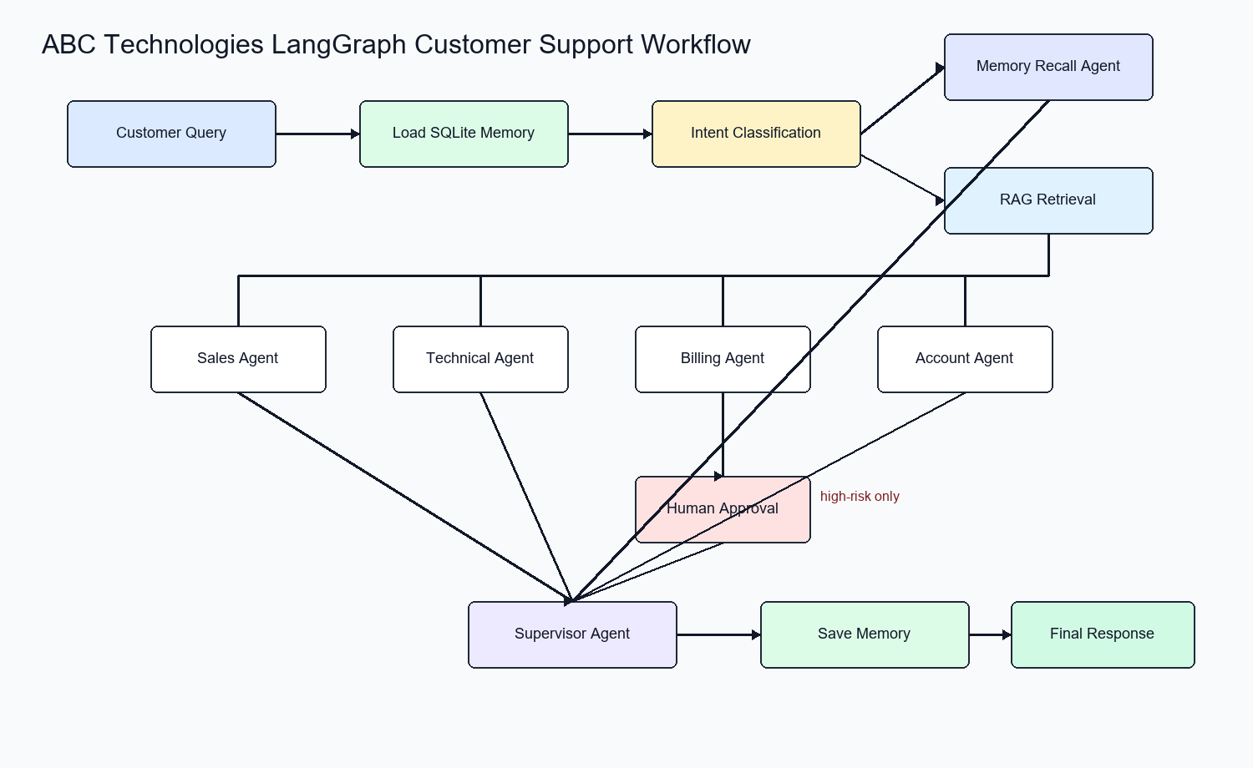

State Structure
State Field | Purpose
customer_id | Identifies the customer for memory storage and recall.
query | Stores the current customer request.
intent | Stores the classified route: Sales, Technical Support, Billing, Account, or Memory Recall.
retrieved_context | Stores RAG snippets from company documents.
conversation_history | Stores recent SQLite memory records.
approval_required / approval_status | Tracks human-in-the-loop review for high-risk requests.
draft_response / final_response | Stores agent and supervisor-generated responses.
trace | Records execution steps for demonstration and debugging.

Task Coverage
Task | Requirement | Implementation
1 | Design LangGraph workflow | Implemented in support_system.py and shown in workflow_diagram.png.
2 | Create State structure | SupportState manages customer, query, context, approval, and response fields.
3 | Intent Classification node | classify_intent categorizes requests by department and memory recall.
4 | Conditional routing | LangGraph conditional edges route requests to the correct node.
5 | Specialized agents | Sales, Technical, Billing, and Account support nodes are implemented.
6 | RAG pipeline | LocalRAG retrieves context from four company documents in data/.
7 | SQLite memory | SQLiteMemory stores and recalls conversations in artifacts/memory.db.
8 | Human-in-the-loop approval | High-risk patterns route to the human_approval node.
9 | Supervisor agent | supervisor validates and finalizes customer responses.
10 | Project demonstration | run_demo.py executes the five required sample queries.

Knowledge Base Documents
- Company Policy Document: refunds, cancellations, account closure, compensation, and escalation rules.
- Pricing Guide: Starter, Professional, and Enterprise plan information.
- Technical Manual: login, file upload, installation, and configuration guidance.
- FAQ Document: password reset, invoices, profile updates, and support hours.

Human-in-the-Loop Approval
The system marks refund requests, subscription cancellation, account closure, compensation, and management escalation as high-risk. These requests are not finalized directly by the support agent; they route to the human approval node before supervisor validation.

SQLite Memory
The SQLite database contains a conversations table with customer ID, query, intent, response, and timestamp. The memory recall query retrieves the customer's most recent previous issue.

Demonstration Results
Query | Expected Path | Actual Route | Result
What are the pricing plans available for your software? | Sales | Sales | Returned plan information from Pricing Guide.
I forgot my account password. | Account | Account | Returned password reset guidance from FAQ.
My application crashes whenever I upload a file. | Technical Support | Technical Support | Returned file upload troubleshooting guidance.
I need a refund for my annual subscription. | Billing with approval | Billing | Routed through human approval before final response.
What was my previous support issue? | Memory recall | Memory Recall | Recalled the previous Billing refund issue from SQLite.

Submission Files
- Source code: src/support_system.py, src/run_demo.py, src/generate_artifacts.py, src/generate_word_doc.py.
- README.md: setup steps and run instructions.
- Workflow diagram: artifacts/workflow_diagram.png.
- Screenshots PDF: artifacts/screenshots.pdf.
- SQLite memory: artifacts/memory.db and artifacts/memory_schema.sql.
- Demo output: artifacts/demo_output.txt.

