Eve

Lean Runtime Architecture

STATUS  Proposed |  | OWNER  Eve maintainers |  | LAST UPDATED  September 25, 2026

Authors | Codex architecture analysis
Reviewers | Eve maintainers (pending review)
Related docs | eve-lean-runtime-plan.md; eve-lean-runtime-architecture.md
Scope | Windows CPU base, optional NVIDIA runtime, upgrade and release gates

1. Abstract
Proposal: ship a fully functional CPU Windows app and offer NVIDIA acceleration as an explicit, version-matched download. Electron owns pack acquisition and validation; Python consumes only a validated runtime directory. The default package omits PyTorch and CUDA libraries after all PyTorch-only call sites are replaced.
This is a design, not a release claim. Quick and Long dictation, history, hotkeys, upgrades, and rollback must remain stable. Package, installed, and model-cache bytes are separate measures. The optional pack is native executable code and must pass provenance, license, integrity, and real-inference gates.

2. Goals and Non-Goals
Goals | Non-goals
Reduce default payload; measure archive and installed bytes | Claim an installer target before packaging
Preserve Quick/Long dictation and saved settings | Change Eve identity, profiles, or hotkeys
Offer explicit verified GPU download | Require system CUDA Toolkit or silent download
Recover safely from failed install and upgrade | Delete existing model caches or user data

3. Background and Problem Statement
On pinned Windows CPython 3.11, the current release site-packages tree measured 4,941,557,529 bytes; PyTorch accounted for 4,644,232,862. A CPU Faster-Whisper closure measured 285,496,116 bytes. The raw difference is 4,656,061,413 bytes (94.2%), before Electron filters and archive compression. No replacement installer has been measured.
CTranslate2 performs inference, while PyTorch currently supplies CUDA DLL paths, GPU diagnostics, and cleanup. Electron and Python both register torch/lib. A CPU-first build must replace those seams and preserve saved CUDA preferences even when CUDA is unavailable; the current settings loader can otherwise revert unrelated values to defaults for the session.

4. Proposed Architecture

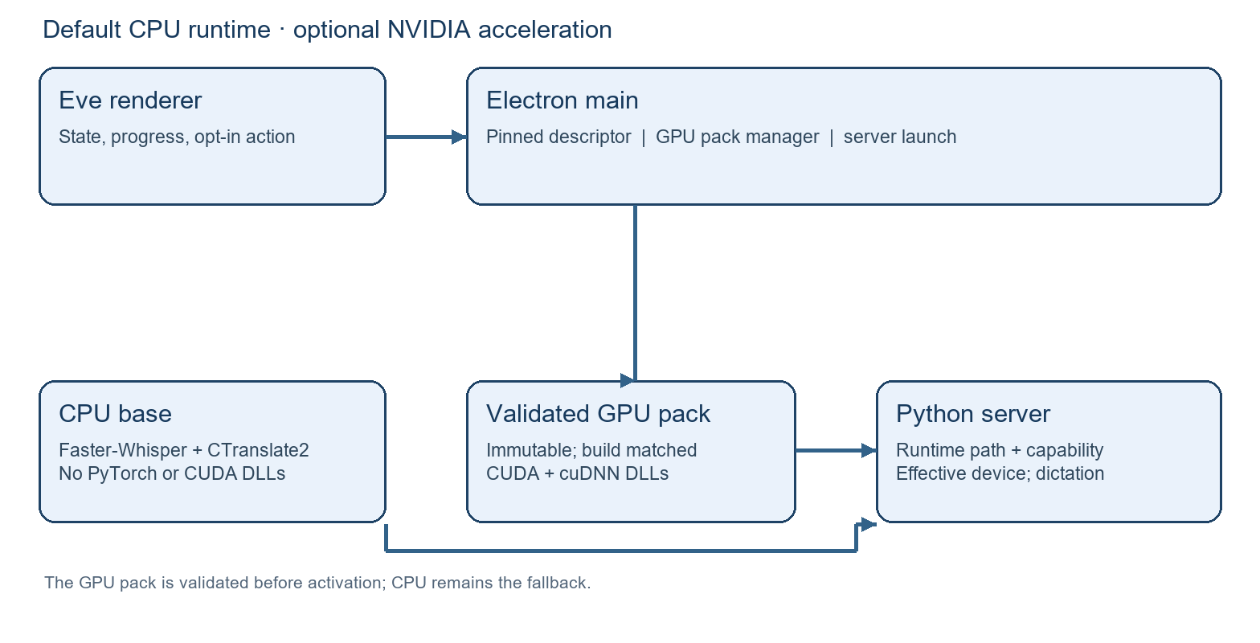
Figure 1. CPU base, optional verified GPU pack, and runtime capability boundary.

Core components

Component | Responsibility | Primary storage | Failure behavior
CPU base | Faster-Whisper + CTranslate2; no Torch | Packaged Python runtime | CPU dictation stays available
GPU pack manager | Fetch, validate, stage, publish | Local immutable pack dirs | Keep prior pack; retry
Runtime resolver | Bind build to validated pack | Pinned app descriptor | Use CPU; show reason
Python adapter | Register DLLs; probe device | Process environment | Report effective CPU
Release verifier | Prove closures and assets | Build artifacts / manifest | Block publication

5. Request Lifecycle
- Launch: Electron reads the trusted pack descriptor shipped with this app build and finds a compatible installed pack. The CPU server can start without a pack or NVIDIA driver.
- Opt-in: a user action starts one bounded download. Verify transport result, exact archive size and hash, member paths, names, sizes, hashes, architecture, version, source, and license record.
- Activation: extract to a staging directory, verify contents, then atomically publish an immutable pack. A failed or interrupted attempt leaves the prior valid pack and CPU path usable.
- Server start: Electron privately resolves a validated directory and passes it to a managed Python process. Python registers DLL search paths before CTranslate2 imports; no path or URL reaches renderer IPC.
- Runtime: CTranslate2 probes actual CUDA availability. Resolve requested device and precision to effective values without rewriting saved preferences; surface fallback reasons in diagnostics.
- Adoption: compare the running server runtime fingerprint before reuse. A stale or unmanaged process cannot silently claim the newly active pack; restart is explicit when required.
- Result: expose pack state, effective device, inference outcome, and bounded error codes. Record no audio, transcript, profile, token, or user model-cache contents in pack telemetry.

6. API and Data Contracts

Primary data contract

Field | Type | Required | Description
schemaVersion | integer | Yes | Descriptor format version
packId | string | Yes | Immutable version/content identity
platform | enum | Yes | Windows x64 only unless separately proven
appBuildRange | string | Yes | Exact supported Eve builds
ctranslate2Id | string | Yes | Pinned wheel/build identity
archive | object | Yes | URL, byte count, SHA-256
members | array | Yes | Allowlisted DLLs, sizes, hashes, sources, notices

Contract guarantees

- The base app pins one trusted descriptor per compatible GPU pack and verifies the complete archive and every extracted DLL before any native load.
- Install attempts are idempotent by pack ID and content hash. Staging is unique; final directories are immutable; concurrent clicks share one attempt.
- Bind OS, architecture, Eve build compatibility, CTranslate2 wheel/build identity, CUDA and cuDNN versions, archive hash, and member hashes to the descriptor.
- Pack state reports installation integrity. Python runtime diagnostics report actual CUDA usability; neither signal alone promises GPU inference.
Contract sketch: see eve-lean-runtime-architecture.md.
Pin a machine-readable descriptor after the GPU payload is approved.

7. Consistency, Idempotency, and Replay

A pack becomes visible only after full validation. A crash before publication leaves CPU or the previous pack usable; repeated install converges on the same content hash. A new app build selects only a compatible pack. Saved requested settings remain durable, while effective device is recalculated at each server start. Do not adopt a healthy server with a mismatched runtime fingerprint.
Scenario | Expected behavior | Reasoning
Repeated install | Reuse same attempt or ready pack | Content-addressed, idempotent
Download or disk error | Retain CPU and previous pack | No active-state mutation
Bad archive/member | Reject before any DLL load | Trust pinned archive and member hashes
App version change | Select compatible pack only | Build-bound descriptor

8. Security and Privacy Considerations

- The renderer can request installation and read safe status only. Main owns the trusted descriptor, download URL, filesystem paths, extraction, and server environment.
- Reject path traversal, links, extra files, wrong architecture, version mismatch, truncation, and hash failure. Never execute a downloaded installer or script; load DLLs only after exact verification.
- The app-pinned manifest is the trust root; a manifest fetched beside the archive is insufficient. Review NVIDIA redistributable terms and maintain source and notice records.
- Default to CPU after any pack error. Do not auto-download, interrupt active recording, clear model caches, or rewrite a saved CUDA preference.
- Store the large binary pack in a machine-local Eve directory, separate from roaming settings and private audio or transcripts. Prune obsolete packs only after rollback policy is defined.

9. Operational Readiness
Signal | SLO or alert | Owner | Launch gate
CPU smoke | Quick + Long transcription pass | Eve release | Required
GPU inference | Real short + long on clean NVIDIA host | Eve release | Required
Pack integrity | All corrupt/version cases rejected | Eve release | Required
Settings upgrade | CUDA preference and unrelated values preserved | Eve release | Required
Footprint | Archive, install, model bytes reported | Eve release | Required
Rollout constraint: publish only after license review, exact asset allowlist, clean install, upgrade, rollback, and compressed-size evidence.

10. Alternatives Considered

Alternative | Why it was considered | Why it was not selected
Two installer editions | Reuses current GPU closure and NSIS | GPU edition retains multi-GB closure; upgrade complexity
CPU only | Smallest and simplest default | Omits requested NVIDIA option
System CUDA required | Avoids downloaded GPU pack | Unreliable prerequisites and support burden
Ship Torch in base | Preserves current path | Dominates measured Python closure

11. Open Questions
- Which exact CUDA/cuDNN DLL set satisfies pinned CTranslate2 4.6.3 on clean Windows NVIDIA hosts, and what is its compressed size?
- Can each binary be redistributed under reviewed terms with source and version provenance?
- What is the supported upgrade and rollback window for a build-matched pack and an already running server?
- What measured archive, installed-directory, startup, and inference budgets should gate promotion?

12. Decision and Next Steps
Adopt the CPU base plus immutable, build-matched GPU pack as the target design. First prove the DLL set, redistribution terms, and real GPU inference; then fix settings resolution and server identity, subtract PyTorch from the release closure, implement verified opt-in installation, and update release controls. Promote only after clean CPU and NVIDIA installer/upgrade tests and measured package results. If the pack proof fails, retain the existing release behavior while revisiting the GPU distribution choice.
Milestone | Deliverable | Exit criteria
M1 | Prove GPU DLL set and terms | Real inference; measured and reviewed pack
M2 | CPU closure + settings migration | No Torch/CUDA in base; CPU tests pass
M3 | Pack manager + runtime binding | Failure/upgrade/rollback matrix passes
M4 | Release candidate | Installer and GPU tests; measured budgets

Raw directory bytes are not installer or installed-directory measurements.

